**Week 10 Lecture notes**

**Linear Algebra**

A continuous form of maths and is applied throughout science and engineering as it allows the modelling of natural phenomena to compute. It helps creating better machine learning algorithms. Helps build better supervised and unsupervised machine learning algorithms.

**Vectors**

Vectors has a magnitude (how long it is) and a direction. Vectors are very convenient to present data. And one of the first steps when making a machine learning model is to render vector data. A vector is defined by components.

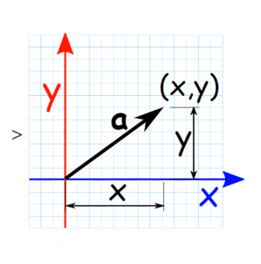Two forces V and W.

Vectors for us (Software Engineers) are a list of numbers.

First number = X axis

Second Number = Y axis

Third Number = Z axis (IF 3D)

**Addition and Subtraction of Vectors**

**To add vectors**

**To Subtract vectors**

**Finding the length of Vectors**

Length of a vector: square root of the magnitude

**Unit Vectors**

Unit Vectors have a magnitude of 1. For example, Vector v = (1, 3) is not a unit vector because its magnitude is not equal to 1

Unit vectors are presented by a small( ^ )at the top

Example:

**Dot Product**

Two vectors can be multiplied using DOT PRODUCT.

Two ways to find DOT PRODUCT

The DOT PRODUCT returns a number as an answer

Two vectors are orthogonal (If the two lines can form a right angle) if they are perpendicular to each other. The DOT PRODUCT will be ZERO.

**Data Visualisation in AI**

**The Connell Trick**

Allows for you to bend and manipulate the data so that you can split the data more accurately