**INTRODUCTION TO ARTIFICIAL INTELLIGENCE COM526**

**WEEK 2 ACTIVITIES**

Note: You will need to combine **Week 1 to Week 5** activities in a portfolio to be submitted as one document for your AE1 assessment. Please insert the number of words for each section.

1. **Machine Learning, a sub-field of AI, can be achieved using different approaches. Describe the concept of**

Base Example: A Child (toddler) comes into contact with a kitten for the first time. The child doesn’t know what it is called and there are three different ways the child could learn the name of this animal. This example I read from “ Artificial intelligence for marketing: practical applications ”

1. **Unsupervised learning and provide one example**: Unsupervised learning is when a machine is given a cluster of data that has not been classified or labelled in anyway by humans to analyse and find patterns or data groupings without any human intervention. Applications of these could be exploiting data, cross selling strategies, image recognition. If we make use of the base example we can use Unsupervised learning for the child to learn the name of the animal. With Unsupervised learning the child will have to be alone to figure things out by itself, it may not get the correct answers but it will learn more and more about the thing it is trying to figure out (such as cats will meow and dogs will bark).
2. **Supervised learning and provide one example:** Supervised learning is a (machine learning) task in which the machine is given training data which has been labelled for a specific output and the algorithm will have to analyse and learn the patterns that lead the input data to the desired output so that it will be able to yield similar/same results when given a data set it has never seen before. If we make use of the base example we can use Supervised learning to teach the child the name of the kitten. Simply point to it repeating a few dozen times the word “kitty”. Supervised learning would be you Pointing at the kitten and calling it a “kitty” (given the child a labelled example).
3. **Reinforcement learning and provide one example:** Reinforcement Learning is essentially a system to allow the machine to self learn, it works by giving “rewards” for doing correct things and “punishments” for doing the incorrect things which trains the robot or machine to know what to do as it wants to achieve “rewards”. If we make use of the base example we can use Reinforcement learning to teach the child the name of the kitten. Simply correct the child when they mistaken the kitten for something other than what it is and praise the child when they get the name correct.
4. **Types of Problems Solved Using Artificial Intelligence**

Different Artificial Intelligence algorithms can be used to solve a category of problems. Differentiate between classification, regression and clustering problems and name some algorithms that can be used to solve each type of problem.

Classification: Predictive problem in which it would predict the class label for any given example data

Regression: Predictive model in which it would predict a relationship between two variables

Clustering: Predictive model which divides the data into groups (clusters), It will split data in a specific way that the points within single clusters will become very similar and points in different clusters will be very different (groups unlabelled data)

Classification is a predictive model which attempts to apply class labels on given example data for example an email (in Gmail) can be labelled as one of three “Primary”, “Promotions”, “Updates”. Regression on the other hand is a predictive model which will generate a continuous quantity, it will predict a discrete value in an integer while classification predictive model is a probability for a class label.

Clustering is similar to Classification in a way that it groups the given example data, but it differs here as it groups them into unlabelled clusters (groups) and ensures that each point/item in the cluster are very similar and the points in other clusters are different. Clustering uses unsupervised learning to function.

1. **Classify the problems below as classification or regression.**

**Regression**

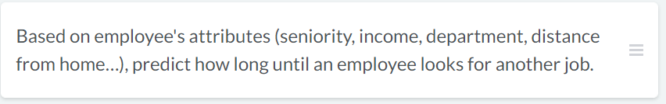

**Classification**

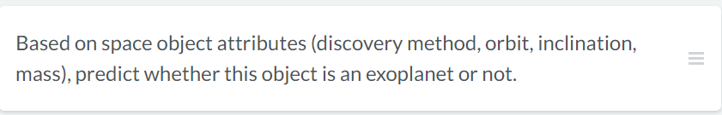

**Classification**

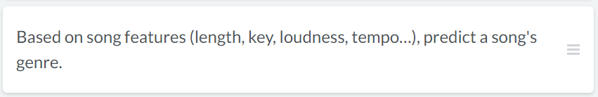

**Regression**

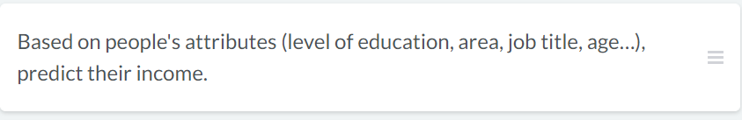

**Classification**

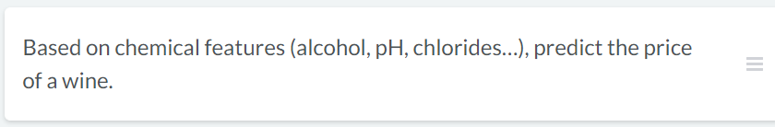

**Classification**

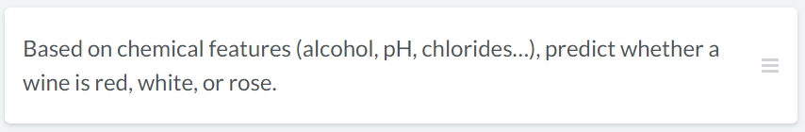

1. **Steps for building a model**

Machine learning is integrated in many of the technologies we use every day. For example, have you noticed that platforms will have personalised recommendations, whether it's another funny video on YouTube or a book by your favourite author on Amazon? These are "recommender systems" and they typically consist of a machine learning model trained on a user's browsing history.

Imagine the recommender system of your favourite online clothing store. They have data on all the clothes you've viewed and the clothes you ended up buying. This is enough to make a model to output personalised clothing recommendation for you. Below are tasks to create this model, however, they are incorrectly ordered.

**Correctly order the tasks.**

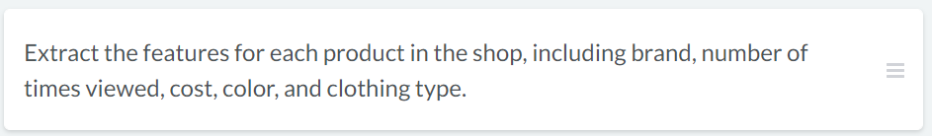

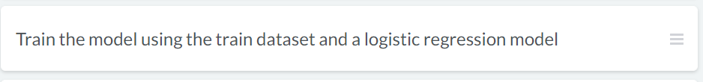

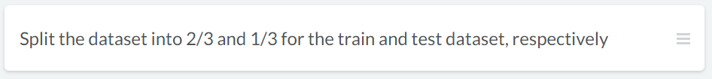

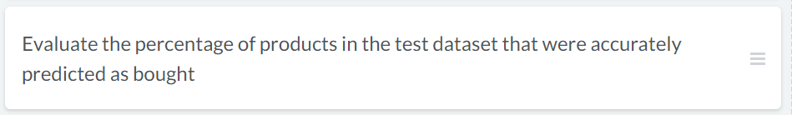

1. **Explain in your own words what is Robotic Process Automation. What are the major differences between RPA and Macros?**