**INTRODUCTION TO ARTIFICIAL INTELLIGENCE COM526**

**WEEK 3 ACTIVITIES**

Note: You will need to combine **Week 1 to Week 5** activities in a portfolio to be submitted as one document for your AE1 assessment. Please insert the number of words for each section. Feel free to be creative and support your answers by adding diagrams, your own drawings, smart charts etc, where appropriate.

The answers to the following tasks must be included in the logbook.

1. What are search algorithms and why are they important in the field of AI? Provide some examples where they could be beneficial.

Search algorithms are a sequence of instructions given to the program to help it efficiently find what ever it is the programmer/user wants. Search algorithms in AI is the method of going from the starting state to the goal state and creating a solution after its done.

When agents are built to act rationally, they are more than likely making use of a kind of search algorithm in the background to create a solution for their problem. Search algorithms are so crucial to allow AI to make decisions especially when there are many outcomes such as in games.

1. Watch the video A* Search Algorithm on YouTube:

[**https://www.youtube.com/watch?v=vP5TkF0xJgI**](https://www.youtube.com/watch?v=vP5TkF0xJgI)

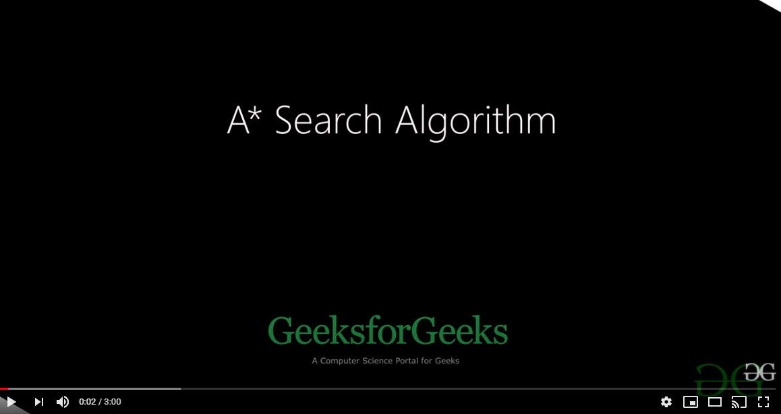

**(Screenshot of video)**

This video is only 3 minutes long, but feel free to pause and watch couple of times until you understand the concept of A* Search algorithm. Have a pen and paper ready as it will be easier to draw any diagrams.

1. In a short paragraph, describe what A* (star) search means (try to use terms such as nodes, goal, cost (least distance, shortest time) and heuristics).

A* algorithm is a path finding algorithm which consists of Nodes, Edges (weighted and unweighted), and a (open) set. It follows the algorithm F(n) (addition of G and H) = G(n) (being the current shortest distance) + H(n) (being the estimate of distance to end) and “n” is the previous node, with this formula the algorithm takes into consideration all the variables (including cost) to find the best path from the starting node and work its way to the end node.

1. Find the best path for the following problem.

You need to find the shortest path between S and G by performing the A* Algorithm on the following figure. You should follow the same approach as in the video or lecture notes and show your calculations/diagrams. Explicitly write down the queue at each step.

S: Start

G: Goal

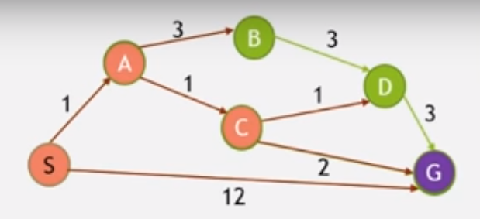

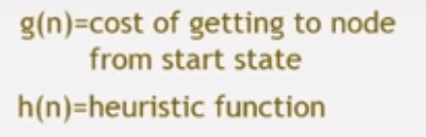 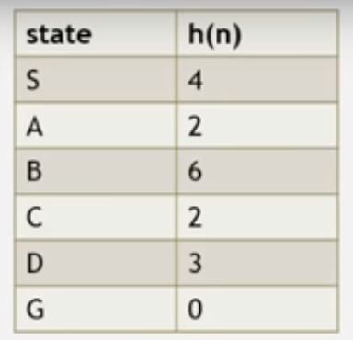

**Best path: ACG**

**Total cost: 4**