**INTRODUCTION TO ARTIFICIAL INTELLIGENCE COM526**

**WEEK 4 ACTIVITIES**

Note: You will need to combine **Week 1 to Week 5** activities in a portfolio to be submitted as one document AE1 in November 2021. Please insert the number of words for each section, include references and examples in each. Feel free to be creative and support your answers by adding diagrams, your own drawings, smart charts etc, where appropriate.

The answers to the following tasks must be included in the portfolio.

1. **Explain the difference in a short paragraph between**
2. **Uninformed and Informed search algorithms (provide some examples)**
   1. Uninformed Search Algorithms are algorithms which have not been provided with any pre-defined information of any sort about the problem (apart from its definition), these algorithms can generally solve any solvable problem but may struggle and be much less efficient. Informed Search Algorithms are able to do very well and efficient as they are given some guidance helping them reach the solutions.
   2. Uninformed Search Algorithms: Depth First Search, Breadth First Search
   3. Informed Search Algorithms: Greedy Search, A* Search, Graph Search

Russell, S, & Norvig, P 2016, Artificial Intelligence: a Modern Approach, EBook, Global Edition : A Modern Approach, Pearson Education, Limited, Harlow. Available from: ProQuest Ebook Central. [26 October 2021].

1. **TREE-SEARCH and GRAPH-SEARCH**

2) For each of the following search strategies, work out the path returned by the search algorithm on the graph shown below. Arrows indicate the possible actions (paths), and values show the cost of actions for you to **perform the uniform cost search**. In all cases, assume ties resolve in such a way **that states with earlier alphabetical order are expanded first** (apart from uniform cost). The start and goal states are shown. **Provide all drawings and search trees that helped you find the solutions.**

1. Depth-first search algorithm.
2. Breadth-first search algorithm.
3. Uniform cost search algorithm.

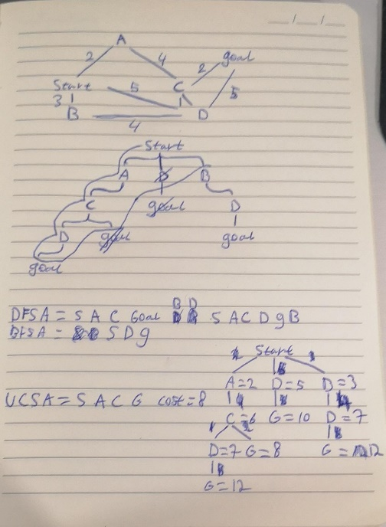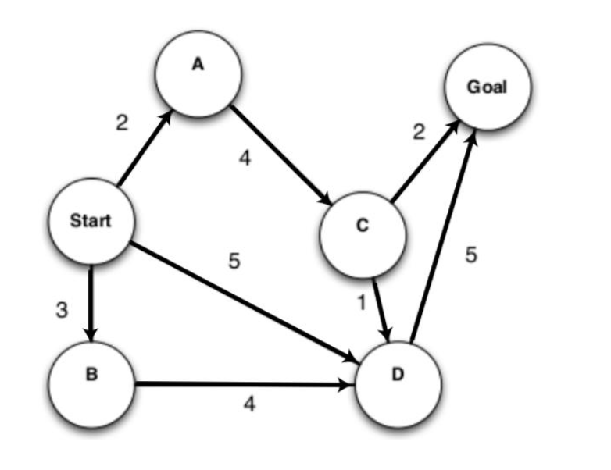

Answers (Solution returned):

1. Depth-first search> Solution is ___Start, A, C, D, Goal, B_
2. Breadth-first search> Solution is ___Start, D, Goal_
3. Uniform cost search> Solution is ___Start, A, C, Goal - Cost = 8_

(Total Number of words: 83)