**P (+x, +y) = 0.2**

**P(+x) = 0.5**

**P (-y OR -x) = 0.6**

Marginal

Distribution are sub-tables which eliminate variables marginalisation

Example:

|  |  |
| --- | --- |
| Y | P |
| +Y | 0.6 |
| -Y | 0.4 |

|  |  |
| --- | --- |
| X | P |
| +X | 0.5 |
| -X | 0.5 |

**Conditional Probabilities:**

P(a|b) = P(a, b) / P(b)

Example:

A = s = 0.2

B = C = 0.5

0.2 / 0.5 = 0.4

|  |  |  |
| --- | --- | --- |
| 1:  a = +x = 0.2  b = +y = 0.6  0.2 / 0.6 = 0.3 | 2:  a = -x = 0.4  b = +y = 0.6  0.4 / 0.6 = 0.6 | 3:  a = -y = 0.3  b = +x = 0.5  0.3 / 0.5 = 0.6 |

**Normalisation trick:**

Exercise:

To Normalise:

We bring or restore to a normal condition and make sure all entries sum up to 1:

Step 1: compute Z = sum over all entries

Step 2: divide every entry by Z

Probabilistic Inference:

Compute a desired probability from other known probabilities, for instance if we want to know the probability of a condition if you have these symptoms.

Generally, compute conditional probabilities

**P (on time | no reported accidents) = 0.90**

These represents the agent’s beliefs given the evidence

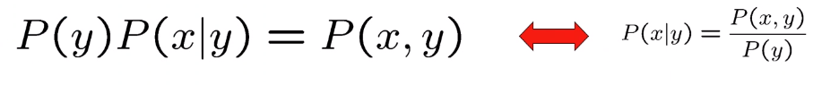

**The Product Rule:**

We multiply it,

The first row would be 0.8 * 0.1 = 0.08

**BAYES Rule:**

Basic concept of adding what we have done so far.

Two ways to factor a join distribution over two variables.

Example:

