MAD Practicals
MAD – Mobile Application Development
ASSIGNMENT QUESTIONS
- Flutter Developed by – Google
- Flutter is optimized for – 2D mobile apps
- Dart can be compiled – both in AOT and JIT
- Type tests to perfrorm in flutter – Unit,Widget,integration
- Widget in flutter comes with specified size- sizedBox
- What is used when we create flutter application – android folder
- function responsible for starting the program – main()
- pubsec.yaml does not contain – project language
- Widget that allows to refresh screen – stateful widget
- Different build modes in flutter – debug,profile,release
- how to link web manifest to web app - using <link> tag
- dart is objectr oriented language – true
- specifity of web workers – they can run in separate thread
- features of service worker- push notification,background sync
- most pouplar tool for auditing PWA - lighthouse
- what services firbase provide – data,api,authentication
- function predefined in dart – main()
- flutter programing language – false
- editors for flutter development – android studio,visual studio,itteliJ Idea
- What In flutter are used as identifier for widgets – Keys

1)Flutter:
It is Google’s UI toolkit for crafting beautiful, natively compiled iOS and Android apps from a single code base
2)Widgets:
Each element on a screen of the Flutter app is a widget.
Widgets are divided into:
- Accessibility: These are the set of widgets that make a flutter app more easily accessible.
- Animation and Motion: These widgets add animation to other widgets.
- Assets, Images, and Icons: These widgets take charge of assets such as display images and show icons.
- Async: These provide async functionality in the flutter application.
- Basics: These are the bundle of widgets that are absolutely necessary for the development of any flutter application.
- Cupertino: These are the ios designed widgets.
- Input: This set of widgets provides input functionality in a flutter application.
- Interaction Models: These widgets are here to manage touch events and route users to different views in the application.
- Layout: This bundle of widgets helps in placing the other widgets on the screen as needed.
- Scrolling: This provides scroll ability to a set of other widgets that are not scrollable by default.
- Styling: This deals with the theme, responsiveness, and sizing of the app.
- Text: This displays text.

There are two types of widgets:
- Stateful Widget
- Stateless Widget

Difference between Stateful and stateless widgets:

Stateful Widgets:
When the widget changes its value, that’s stateful. e.g Checkbox, Radio button, Text field. Override the CreateState() and returns State. Use when users want to change UI dynamically. When the widget’s state changes, the state object calls setState(), telling the framework to redraw the widget.

Stateless Widget:
When there’s no change in widget value then it is called Stateless Widget. eg. Text, Icon, Icon Button, Raised button. Override the build() and return widget. Use when UI remains constant.

Steps to build widgets in the flutter:-
Step 1: Create a virtual device.
Step 2: Create a new project, choose flutter and paste the code in main.dart.
Step 3: Turn on the device.
Step 4: Connect to the device and turn on the device first from selecting the device panel.
Step 5: Run the code

Common Widgets:
  - Scaffold,Container,AppBarColumn,Row,Text,Buttons

Single Child Layout
A widget that aligns its child within itself and optionally sizes itself based on the child's size.
Alignment
A widget that aligns its child within itself and optionally sizes itself based on the child's size
Center
A widget that centers its child within itself.
Container
A convenience widget that combines common painting, positioning, and sizing widgets.
Sizedbox
A box with a specified size.
Aspect ratio
A widget that attempts to size the child to a specific aspect ratio
Expand
A widget that expands a child of a Row, Column, or Flex so that the child fills the available space.
FittedBox
Scales and positions its child within itself according to fi

Icon class in flutter:
An icon is a graphic image representing an application or any specific entity containing meaning for the user.icon class in Flutter is used to show specific icons in our app.
.

Bottom Navigation Bar:
The bottom navigation bar in Flutter can contain multiple items such as text labels, icons, or both. It allows the user to navigate between the top-level views of an app quickly.

Button:
Buttons are the graphical control element that provides a user to trigger an event such as taking actions, making choices, searching for things, and many more

Images at flutter:
A flutter app when built has both assets (resources) and code. Assets are available and deployed during runtime. The asset is a file that can include static data, configuration files, icons, and images.
The Flutter app supports many image formats, such as JPEG, WebP, PNG, GIF, animated WebP/GIF, BMP, and WBMP.
Flutter has an Image widget that allows displaying different types of images in the mobile application.

Charts at flutter:
A chart is a graphical representation of data where data is represented by a symbol such as a line, bar, pie, etc.
- Line Chart
- Bar Chart
- Pie and Donut Chart

Tabs in flutter:
Flutter provides a simple way to create tab layouts using the material library. It’s part of the UI that navigates the user through different routes(ie, pages) when clicked upon. The use of tabs in applications is standard practice.
Navigation and routing:
Navigation and routing are some of the core concepts of all mobile applications, which allows the user to move between different pages.
Gestures:
Gestures are an interesting feature in Flutter that allows us to interact with the mobile app (or any touch-based device).
- When the mobile screen is locked, you slide your finger across the screen to unlock it.
- Tapping a button on your mobile screen, and
- Tapping and holding an app icon on a touch-based device to drag it across screens.
We use all these gestures in everyday life to interact with our phone or touch-based device.Flutter divides the gesture system into two different layers, which are given below:
- Pointers
- Gestures
What is firebase?
Firebase is a Backend-as-a-Service (Baas). It provides developers with a variety of tools and services to help them develop quality apps, grow their user base, and earn profit. It is built on Google’s infrastructure.
Firebase is categorized as a no sql database program, which stores data in JSON-like documents.
- 1. Authentication
It supports authentication using passwords, phone numbers, Google, Facebook, Twitter, and more. The Firebase Authentication (SDK) can be used to manually integrate one or more sign-in methods into an app.

2. Realtime database
Data is synced across all clients in realtime and remains available even when an app goes offline.
- 3. Hosting
Firebase Hosting provides fast hosting for a web app; content is cached into content delivery networks worldwide.

What is Cloud Store?
Cloud storage is a model of computer data storage in which the digital data is stored in logical pools, said to be on "the cloud". The physical storage spans multiple servers, and the physical environment is typically owned and managed by a hosting company.
What is Firestore?
Firestore is a NoSQL document database built for automatic scaling, high performance, and ease of application development.
TESTING
- Unit Testing:
A unit test tests a single function, method, or class. The goal of a unit test is to verify the correctness of a unit of logic under a variety of conditions.
Widget Testing:
A widget test (in other UI frameworks referred to as component test) tests a single widget. The goal of a widget test is to verify that the widget’s UI looks and interacts as expected.
Integration Testing:
An integration test tests a complete app or a large part of an app. The goal of an integration test is to verify that all the widgets and services being tested work together as expected.

What is PWA
PWA stands for Progressive Web Application – a website that looks and behaves just like a mobile app
A progressive web application, commonly known as a progressive web app, is a type of application software delivered through the web, built using common web technologies including HTML, CSS, JavaScript, and WebAssembly.
PWAs can send push notifications, access the hardware of the mobile device, and even work offline or in an unstable connection.

Difference between PWA and Native Application.
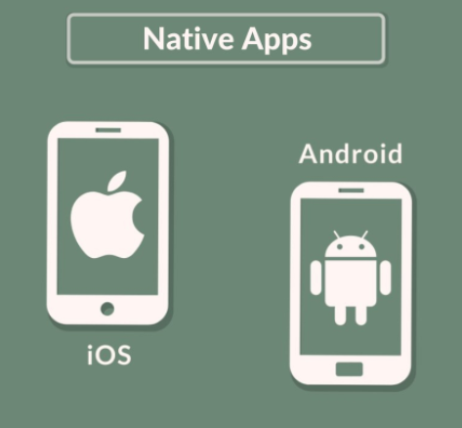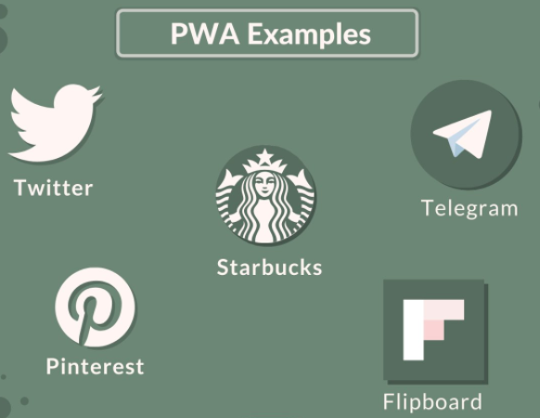
Native apps are written to run on mobile devices, PWAs are written to run inside a web browser. Native apps are developed with the programming languages of each platform (Objective-C and Swift for iOS and Java for Android), whereas, PWA uses HTML, CSS, and JavaScript.

Parameters | PWA | Native
App development | Takes less time | Takes time
Responsiveness | Less Responsive | More Responsive
Development cost | Lower | Higher
Device Features | Low scope of Interaction | High scope of interaction
Download requirement | Only through link | Present
Language | HTML, JavaScript & CSS | For IOS- Obj-C & Swift  For Android- Java & Kotlin
Market launch | Cheap and Easy | Takes time review
Battery Consumption | High | Low

Advantages and Disadvantages of PWA

Advantages-
- Works fine without an internet connection
- Does not have to be downloaded
- Costs of hosting on the app store aren’t necessary
- Compilation of an app into executable files isn’t needed
- Can be crawled by search engines
- Works on multiple platforms
- Makes use of minimal device storage space
Disadvantages-
- High-level battery consumption
- Limited support for hardware functionality
- Need to be hosted on a server since they are web apps
- Not all devices provide the same level of support for PWAs. (eg. Push notification for PWA works on Android but not on iOS)
- No point of convergence for PWAs such as an App store

What is manifest?
A manifest file in computing is a file containing metadata for a group of accompanying files that are part of a set For example, the files of a computer program may have a manifest describing the name, version number, license and the constituent files of the program.
It’s just a JSON file with values like the name of the app or the start URL. These values called members, define how your app appears to the user including the details to make a PWA look with a similar style of an app (the homescreen icon for example) and ensures that it’s discoverable.
PWA manifests include its name, author, icon(s), version, description, and list of all the necessary resources (among other things).

What is Service Worker?
A service worker is a script that your browser runs in the background, separate from a web page, opening the door to features that don't need a web page or user interaction.A service worker is a type of web worker. It's essentially a JavaScript file that runs separately from the main browser thread, intercepting network requests, caching or retrieving resources from the cache, and delivering push messages.

What is meta file
metadata is data that describes other data
The web app manifest contains metadata provided by the web developer that can be used when a web app is added to a user's home screen on Android. This includes things like a high-resolution icon, the web app's name, splash screen colors, and other properties.

what is fetch, event and sync
The main event that you use in a Service Worker is the fetch event. The fetch event runs every time the browser attempts to access content within the scope of the Service Worker.
This is the event type for fetch events dispatched on the service worker global scope. It contains information about the fetch, including the request and how the receiver will treat the response. It provides the event. respondWith() method, which allows us to provide a response to this fetch.

REAL TIME APPLICATION OF FLUTTER: The Firebase Realtime Database is a cloud-hosted database. Data is stored as JSON and synchronized in realtime to every connected client. When you build cross-platform apps Flutter & Firebase, all of your clients can share one Realtime Database instance and automatically receive updates with the newest data.
Google ADS

EXPEIRMENTS LIST
1. Develop a flutter application to make a container with font weight bold and text cente
2. Develop a flutter application to add image from internet
3. Develop a flutter application to add image from system
4. Develop a flutter application to add navigation icon into header with text welcome
5. Develop a flutter application to add button and on pressed write Mad and pwa

6. Develop a flutter application to connect with firebase
Refer exp7
7. Create a html page with pwa service worker
Refer exp
8. Develop a flutter program for basic hello world application
9. Develop a flutter program to add bottom navigation with three menu
10. Develop a flutter program to add navigation of two screens

