The Action Potential as a Propagating Wave

Action Potentials
The membrane of neurons contain pumps that maintain a concentration gradient and thus a potential difference across the membrane. Ion channels allow certain ionic species to pass through the membrane in a direction that depends on the ionic charge and whether the membrane potential is at a more positive or more negative value than the reversal potential for that ionic species. We generally lump together all passive channels into a single leak conductance and leak reversal – these are channels whose properties are independent of (i.e. do not change with) voltage.

The voltage spike, known as the action potential is produced by active channels – channels which change their conductance as a function of voltage. In particular, sodium channels rapidly activate as voltage increases, allowing positively charged sodium ions into the cell and increasing the voltage (depolarizing the membrane) further. Then, more slowly, these sodium channels inactivate at high voltage, reducing the sodium conductance. Meanwhile, potassium channels activate, allowing potassium ions out of the cell, to return the membrane potential to its base level. The original formulation of these processes was produced by Hodgkin and Huxley, so the model is known as the Hodgkin-Huxley model.

The Fitzhugh-Nagumo model
The Hodgkin-Huxley model can be simplified, by assuming the activation of sodium channels, which accelerates the production of a spike, to be immediate. This allows us to write the effect of sodium activation on dV/dt purely in terms of V. It will be cubic in form, crossing the axis dV/dt=0, in 3 points (see formula below).

Furthermore, if the inactivation of sodium, and opening of potassium channels are combined into a single, more slowly varying voltage-dependent variable, w, we have the Fitzhugh-Nagumo model. It is useful, because the activity now only depends on two variables V and w, so its behavior can be more easily visualized and analyzed.

The full equation, including a spatial term for diffusion of ions in space with diffusion constant, D, is:

The equation is written in a way such that the constants B, C, e are dimensionless. The rate of change of w is slower than that of V, which is given by e<<B,C.

The code FHmodel1.m simulates the model with an applied current, but with no diffusive term and no inclusion of space. The phase plane analysis for this code is overleaf.

Phase Plane Analysis for model without space
The figure below shows in green the trajectory of w against V in the Fitzhugh-Nagumo model (from FHmodel1.m) as V and w vary in time together. Because in the model B and C are large compared to e the change in V towards its equilibrium value (the blue line) is always more rapid than the change in w toward its equilibrium value (the red line). Therefore the system spends most of its time near the equilibrium for V but moving along this line in a direction of increasing w when to the right of the red line, or moving along the blue line with decreasing w when to the left of the red line.

This is because the red line marks the boundary, to the left of it dw/dt>0 and to the right of it dw/dt<0. Above the blue line dV/dt<0 and below the blue line dV/dt>0.
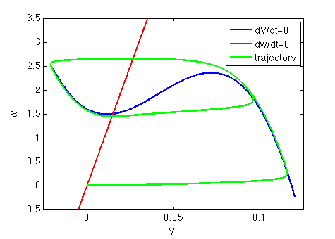
The rapid changes in V compared to w can be seen in the time variation below:
