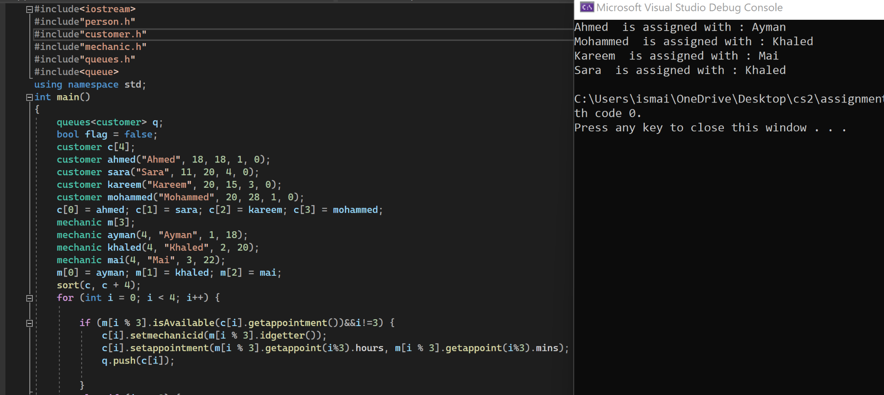

Here it was easier to inout each customer by them selves to show output, I sorted them then inserted them into a queue and checked with the function isAvailable with thr appointment set at c if yes then the mechanic id is set with the corresponding mechanic id and appointment is set. Then it be pushed into an array.

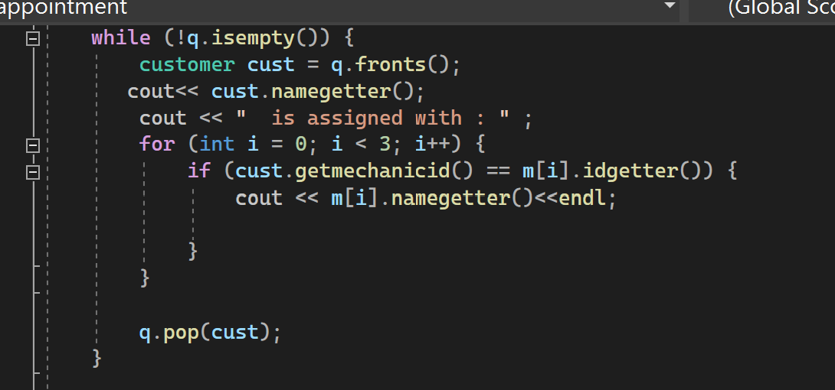Here it with the function isempty in q, it puts in cust the front of the queuebit retrieves the name and then checks if the mechanic id is the same for both if yes it cout the mechanical name and then pops customer to check for the second customer and then when pop front changes.

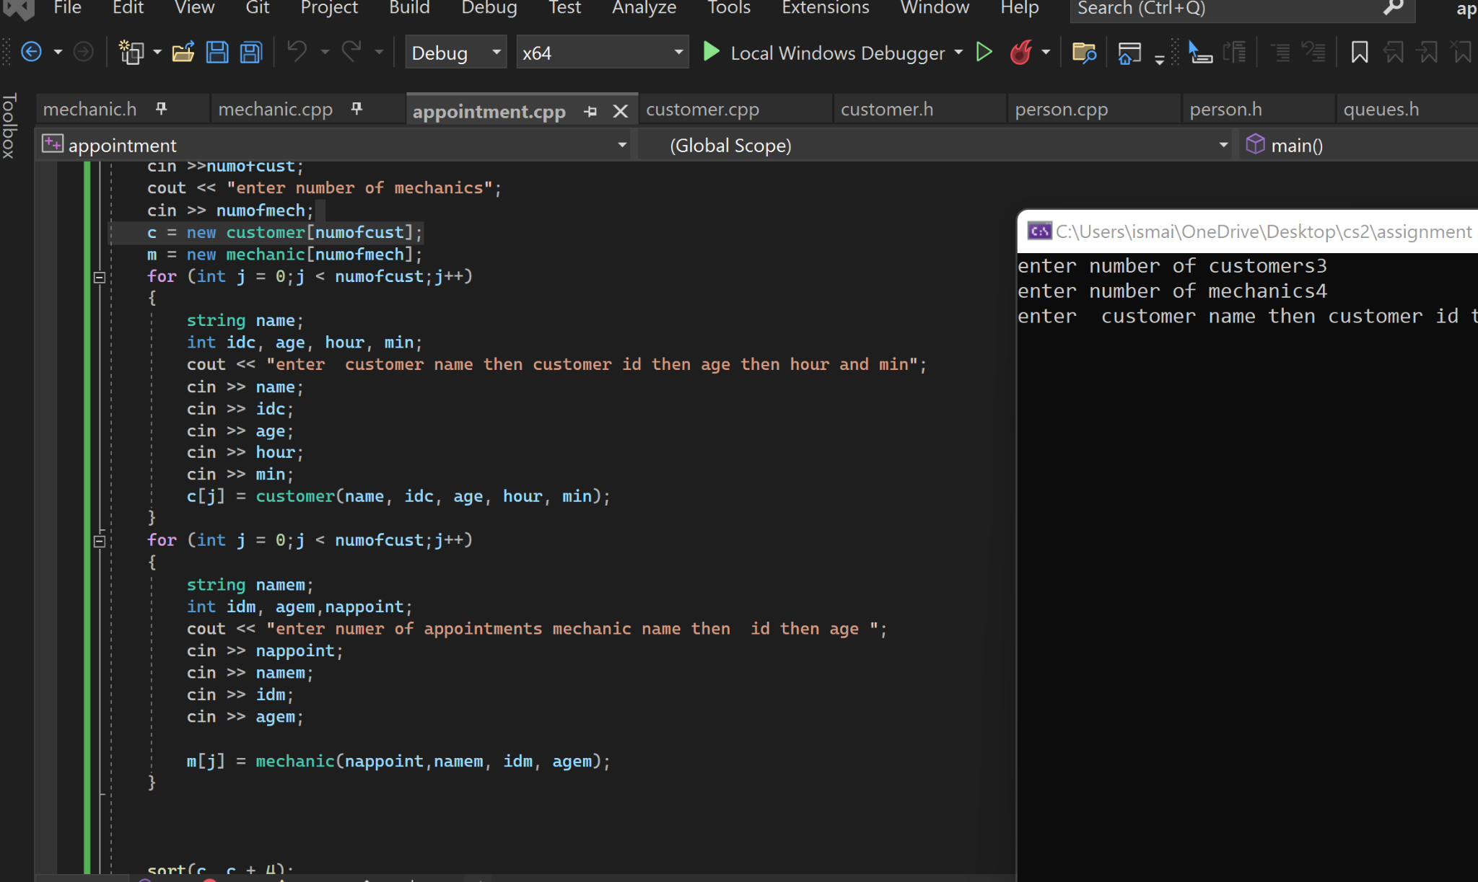

Here for the user to enter both customer and mechanic.

Didnot do the bonus part.

Template for the queue was not linking both .h and .cpp files so I did it in .h only

