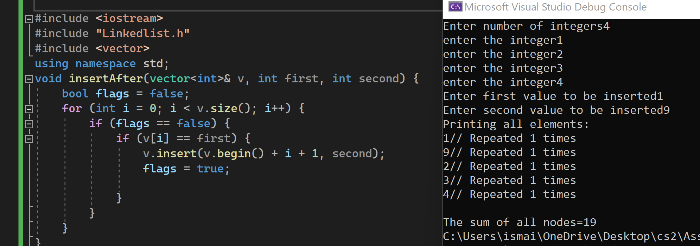

This function adds the second integer after the first which is going to be found.

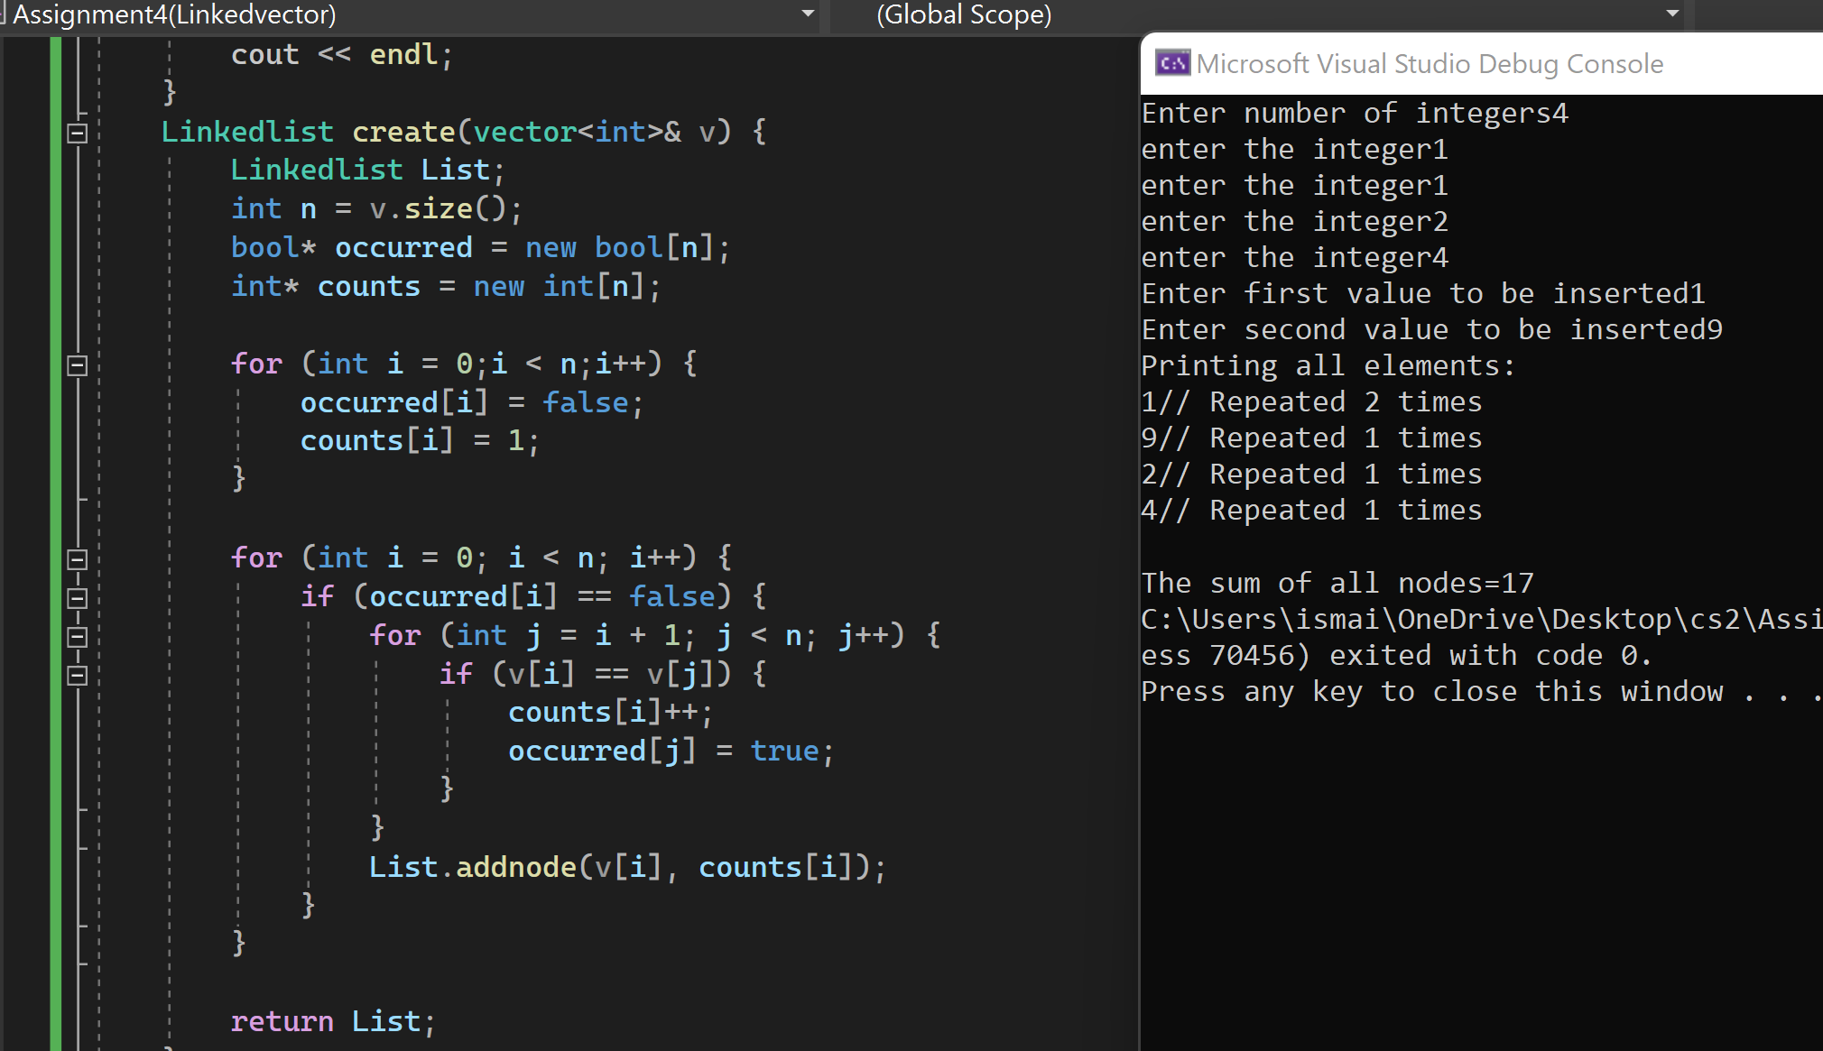

The one above checks along the vector to see if two integers are repeated if it is repeated its corresponding element of J which is one higher than I is turned into true in an array of Booleans. So if its corresponding value is true it does not add the value again. Returning to the function(insertafter) above if the flag is turned true it does not add to the second number which is here 1 so it only adds one 9 and not two nines.

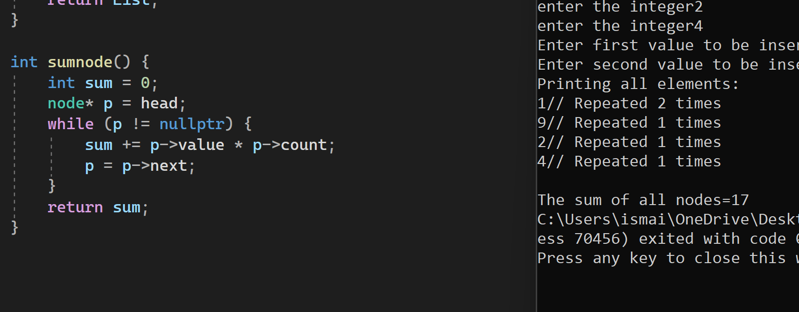

This function adds the occurrences of the nodes to its value which is done by times until it reaches nullpointer.

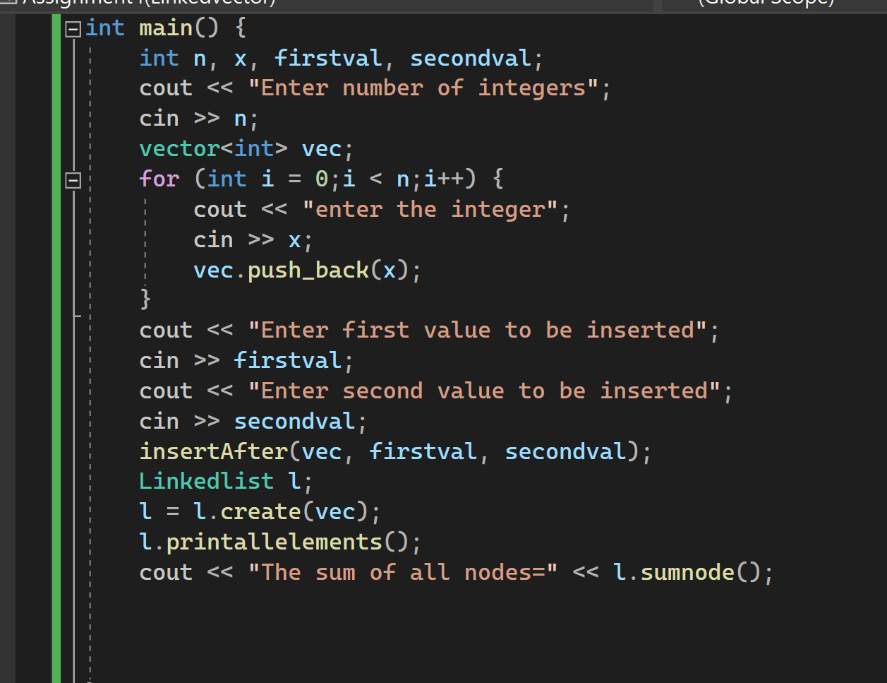

All functions are called here and giving the user the freedom to choose how many numbers inputted and what are they.