Q.1 Install the Apache web server on your Linux machine using the package manager (apt or yum), and confirm the installation by running the command to check its version.
ANS :
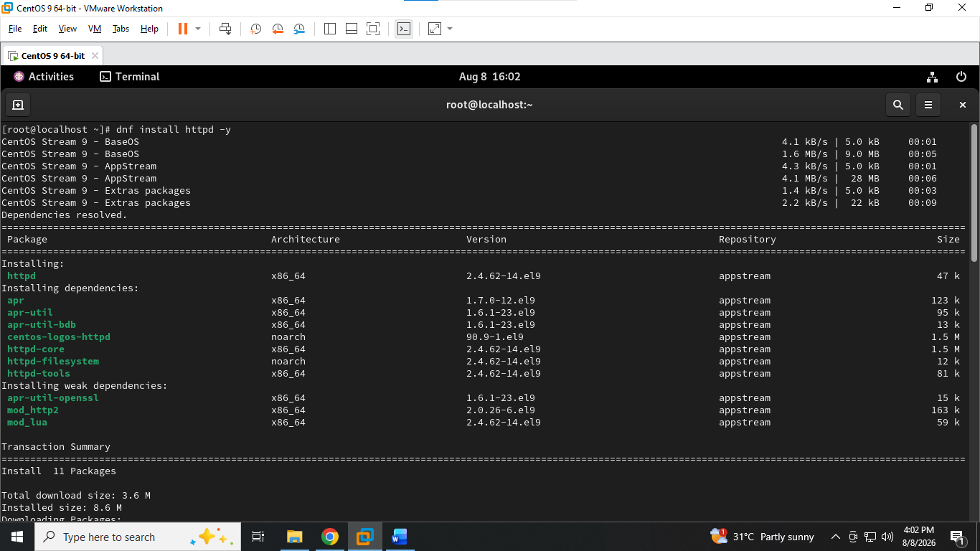
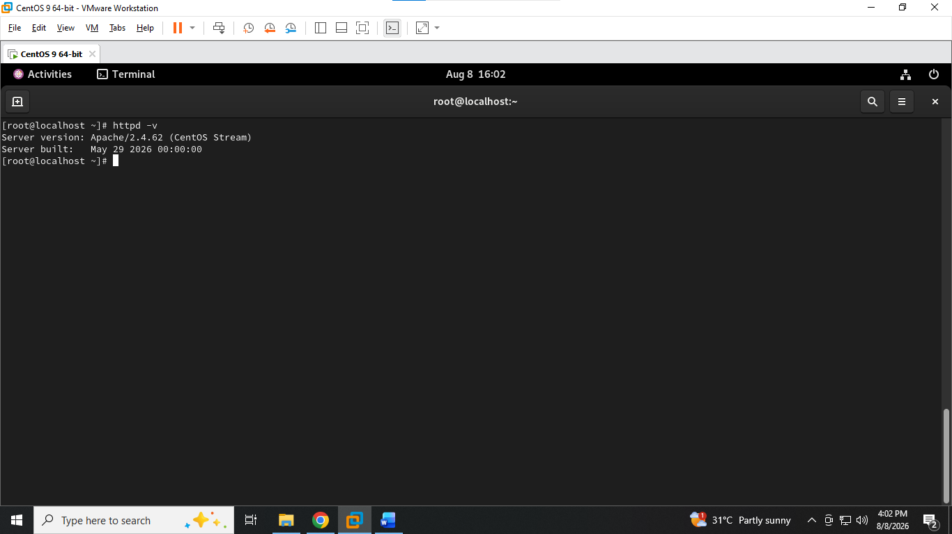

Q.2 Start the Apache service using systemctl, then use systemctl status to verify it is running
ANS :
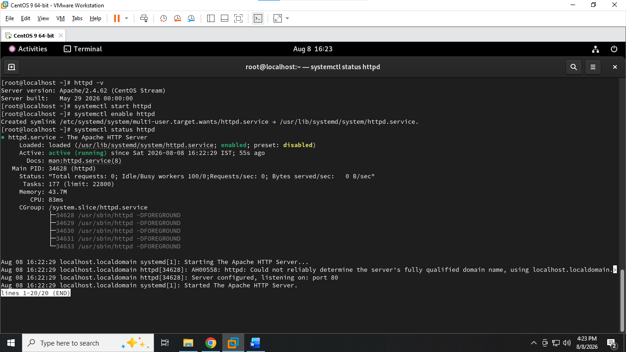

Q.3 Stop and restart the Apache service using systemctl, and observe the difference between stop, start, and restart commands. HintUse 'systemctl stop apache2', 'systemctl start apache2', and 'systemctl restart apache2' (or 'httpd' on some systems).
ANS :
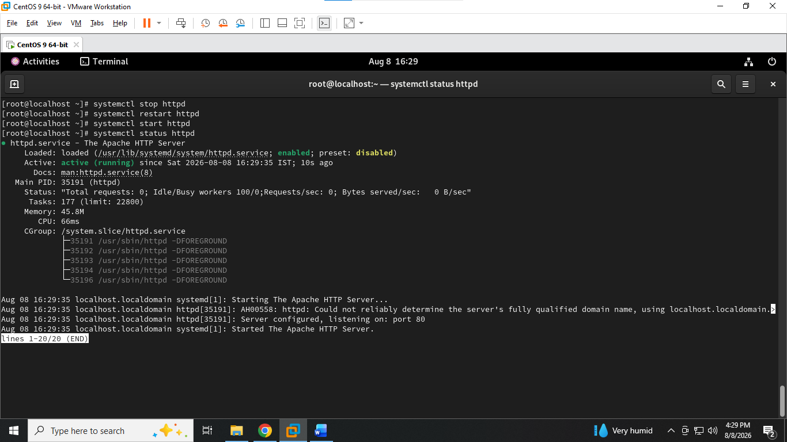

4. Open your browser and access http://localhost or your Linux machine's IP address to verify that the Apache default web page is displayed.
ANS :
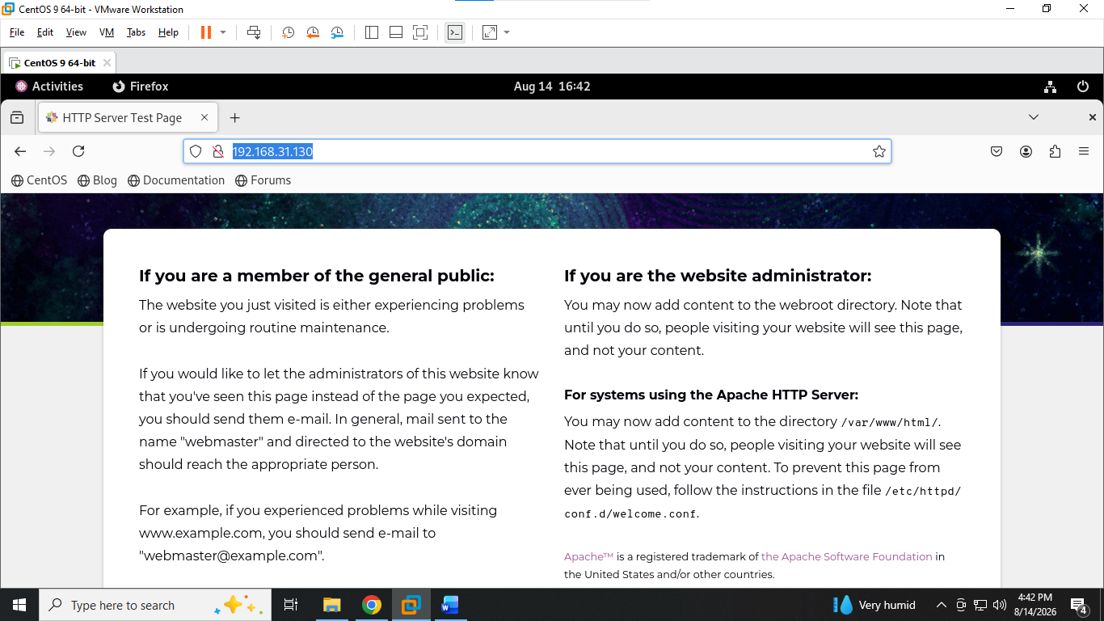

Q.5 Write a short comparison (3-4 lines) between Apache and Nginx web servers, mentioning one key use-case for each based on your research.
ANS : Apache and Nginx are both popular web servers, but they differ in architecture and typical use cases.
Apache is highly flexible and is commonly used for dynamic websites and applications requiring .htaccess support.
Nginx is lightweight and efficient, making it well suited for serving static content and acting as a reverse proxy or load balancer.
In short, Apache emphasizes flexibility, while Nginx emphasizes performance and efficient handling of many concurrent connections.

