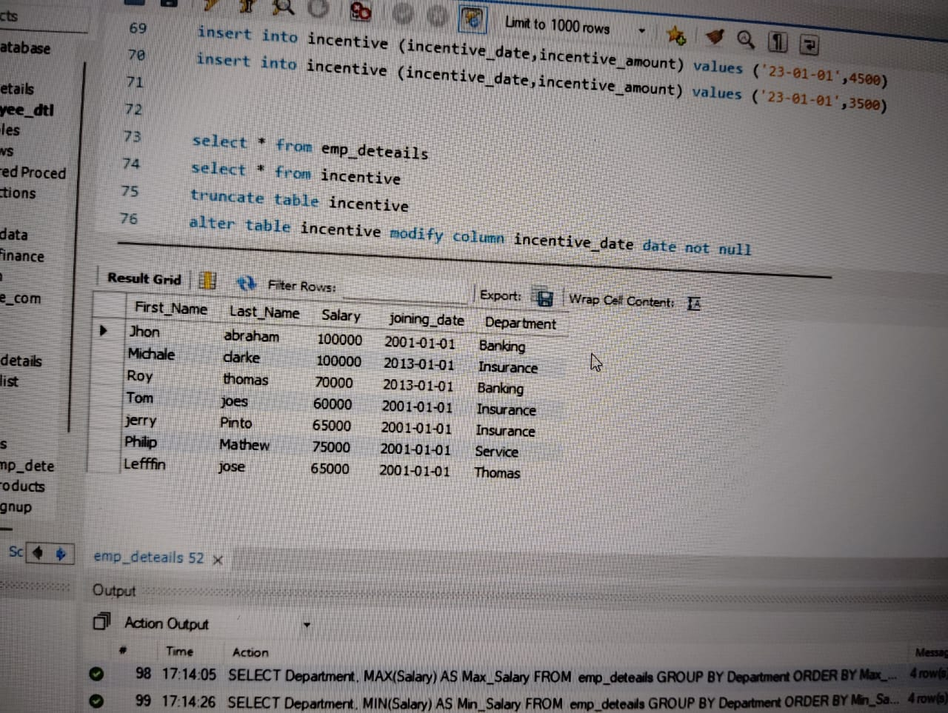

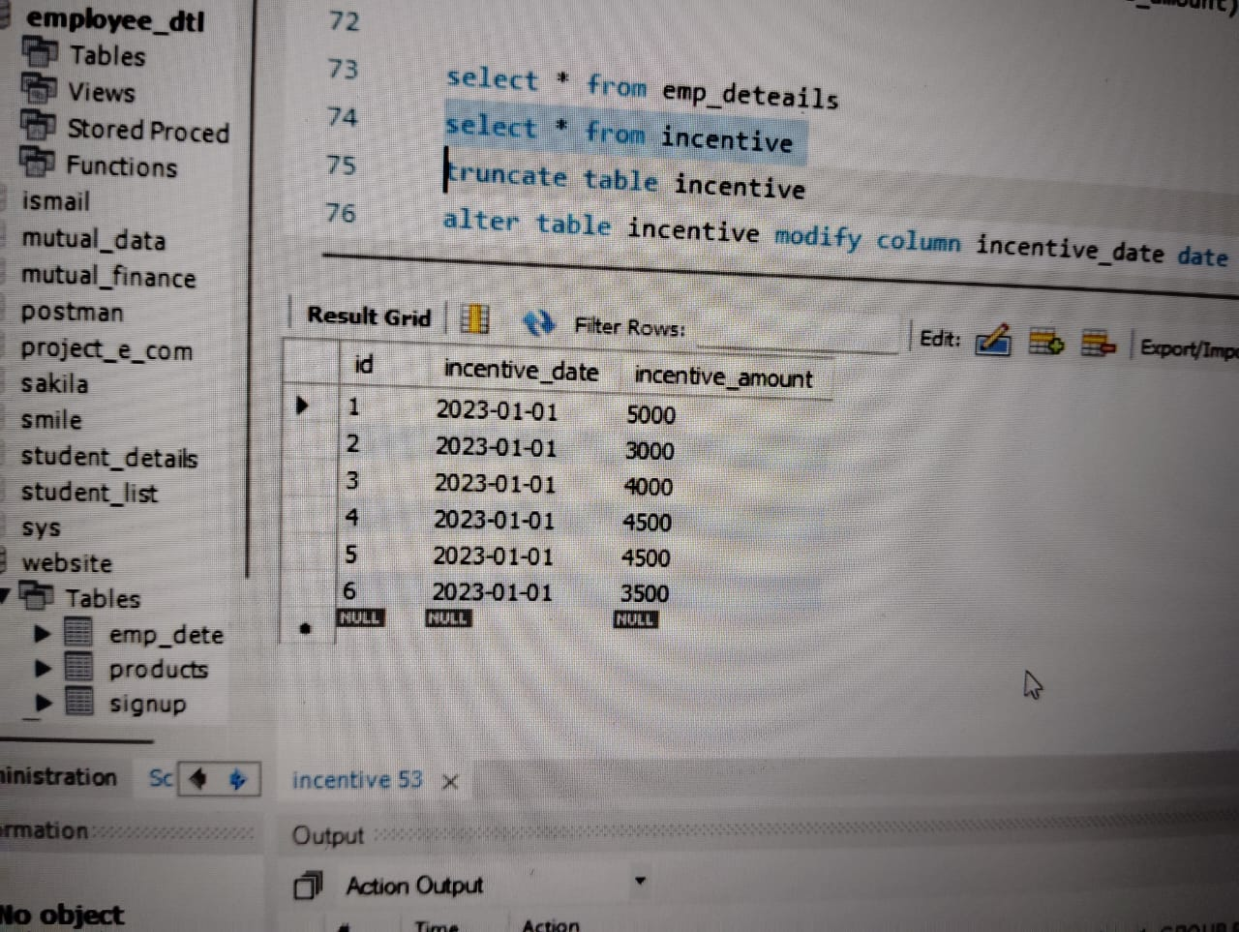

select First_Name,Last_Name from emp_deteails

select upper(First_Name) AS First_Name FROM emp_deteails

SELECT LOWER(First_Name) AS First_Name FROM emp_deteails

select distinct Department from emp_deteails

SELECT LEFT(FIRST_NAME, 3) AS First_Three_Characters FROM emp_deteails

SELECT POSITION('o' IN 'John') AS Position_of_O

SELECT RTRIM(FIRST_NAME) AS First_Name_No_Right_Space FROM emp_deteails

SELECT LTRIM(FIRST_NAME) AS First_Name_No_Left_Space FROM emp_deteails

SELECT LENGTH(FIRST_NAME) AS Name_Length FROM emp_deteails

SELECT REPLACE(FIRST_NAME, 'o', '$') AS Name_With_Replaced_O FROM emp_deteails

SELECT CONCAT(FIRST_NAME, '_', LAST_NAME) AS Full_Name FROM emp_deteails

SELECT * FROM emp_deteails ORDER BY FIRST_NAME ASC

SELECT * FROM emp_deteails ORDER BY FIRST_NAME ASC, SALARY DESC

SELECT * FROM emp_deteails WHERE FIRST_NAME = 'Jhon'

SELECT * FROM emp_deteails WHERE FIRST_NAME IN ('Jhon', 'Roy')

SELECT * FROM emp_deteails WHERE FIRST_NAME NOT IN ('John', 'Roy')

SELECT * FROM emp_deteails WHERE FIRST_NAME LIKE 'n' AND LENGTH(FIRST_NAME) = 4

SELECT * FROM emp_deteails WHERE FIRST_NAME LIKE 'J%' AND LENGTH(FIRST_NAME) = 4

SELECT * FROM emp_deteails WHERE SALARY > 6000

SELECT * FROM emp_deteails WHERE Salary < 800000

SELECT * FROM emp_deteails WHERE Salary BETWEEN 50000 AND 80000

SELECT * FROM emp_deteails WHERE First_Name IN ('Jhon', 'abraham')

SELECT * FROM emp_deteails WHERE YEAR(Joining_Date) = 2013

SELECT * FROM emp_deteails WHERE MONTH(Joining_Date) = 1

SELECT * FROM emp_deteails WHERE Joining_Date < '2013-01-01'

SELECT * FROM emp_deteails WHERE Joining_Date > '2001-01-31'

SELECT Joining_Date FROM emp_deteails

SELECT DATE_FORMAT(Joining_Date, '%Y-%m-%d %H:%i:%s.%f') AS Joining_Date FROM emp_deteails

SELECT DATEDIFF(emp_deteails.JOINING_DATE, incentives.INCENTIVE_DATE) AS Date_Difference FROM emp_deteails, incentives

SELECT CURDATE()

SELECT * FROM emp_deteails WHERE Last_Name LIKE '%\%%'

SELECT REPLACE(Last_Name, '%', ' ') AS Last_Name FROM emp_deteails

SELECT Department, AVG(Salary) AS Avg_Salary FROM emp_deteails GROUP BY Department ORDER BY Avg_Salary ASC

SELECT Department, MAX(Salary) AS Max_Salary FROM emp_deteails GROUP BY Department ORDER BY Max_Salary ASC

SELECT Department, MIN(Salary) AS Min_Salary FROM emp_deteails GROUP BY Department ORDER BY Min_Salary ASC;

SELECT YEAR(Joining_Date) AS Join_Year, MONTH(Joining_Date) AS Join_Month, COUNT(*) AS Num_Employees FROM emp_deteails GROUP BY Join_Year, Join_Month;

SELECT Department, SUM(Salary) AS Total_Salary

FROM emp_deteails

GROUP BY Department

HAVING Total_Salary > 80000

ORDER BY Total_Salary DESC