Date 8th Aug 2023

Salary Certificate

Dear Ajay,

Dubai, UAE

This is to certify that **Mr. Ajay Narayanan Pillai,** Employee Code: E22029C, holder of **India**

Passport No. W3667423, has joined our team as **“Collection Manager”** on **27th March** **2023,** and he is withdrawing a monthly Salary of **AED 10000.00** (UAE Dirhams Ten Thousand).

This letter is issued on behalf of the employees’ request for the purpose of applying for dependent visa of Wife and Daughter in the U.A.E and bears no financial responsibility on Lawgical Group or on any of its authorized signatories.

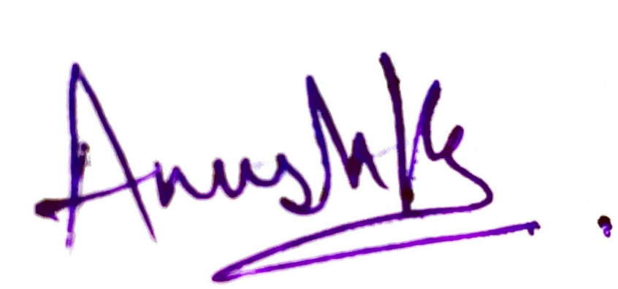

**___________________________**

**Anushka Setia**

**HR & Admin Officer**

**LAWGICAL GROUP LLC**