

ABSTRACT
This study investigates the hidden economic fragility of national economies by integrating international trade, macroeconomic, and fiscal indicators into a unified analytical framework. The research uses two integrated datasets covering 197 countries over the period 2010–2024, containing 2,951 country-year observations.
A mathematical model was developed to construct an Economic Fragility Index (EFI), combining three dimensions: Trade Vulnerability, Macroeconomic Instability, and Fiscal Vulnerability. The numerical implementation produced 714 valid EFI observations, revealing considerable differences in economic fragility across countries and years. Sensitivity analysis demonstrated relatively stable country-year rankings under alternative weighting scenarios.
Furthermore, six supervised Machine Learning algorithms were implemented to classify economic fragility levels. Random Forest achieved the best overall performance, with an accuracy of 26.95% and a macro F1-score of 0.2464. SHAP analysis identified Trade Openness, GDP per Capita, and Trade Balance as the most influential features in the model's classification decisions.
Finally, an interactive Power BI dashboard was developed to visualize economic indicators, international trade patterns, fiscal conditions, and economic fragility results.
Overall, this research demonstrates the value of combining economic analysis, mathematical modeling, and data science techniques to provide a broader understanding of national economic vulnerability. However, the Machine Learning results highlight the need for further improvements in data availability and predictive performance.

Table Of Contents

ABSTRACT 1
1. Introduction 3
2. Literature Review 4
3. Economic Analysis 4
4. Mathematical Model 22
5. Numerical Model 39
6. Machine Learning Implementation 58
7. Explainable Artificial Intelligence (SHAP) 67
8. Interactive Economic Dashboard 71
9. Discussion and Findings 74
10. Conclusion and Recommendations 78
11. References and Resources used 79

1. Introduction
1.1 Background of the Study
National economies are increasingly interconnected through international trade, financial markets, and global supply chains. Although these connections create opportunities for economic growth, they also expose countries to external shocks and economic disruptions.
Traditional indicators such as GDP and GDP growth do not always reveal hidden economic weaknesses. A country may experience economic growth while remaining dependent on a limited number of trading partners, export products, or unstable government finances.
Therefore, evaluating economic vulnerability requires examining multiple economic dimensions together.
1.2 Problem Statement and Objectives
This study addresses the limitations of traditional economic indicators in identifying hidden economic vulnerabilities.
Its main objective is to develop an integrated framework that combines three dimensions:
- Trade Vulnerability.
- Macroeconomic Instability.
- Fiscal Vulnerability.
The study aims to construct an Economic Fragility Index (EFI), compare countries over time, apply Machine Learning classification, interpret predictions using SHAP, and present the results through an interactive Power BI dashboard.
1.3 Scope and Significance
The research covers 197 countries over the period 2010–2024, using an integrated dataset of 2,951 country-year observations.
By combining economic analysis, mathematical modeling, and data science techniques, the study provides a broader approach to identifying and understanding national economic fragility.

2. Literature Review
2.1 Economic Vulnerability
Economic vulnerability refers to the exposure of national economies to economic shocks and their ability to withstand disruptions. Examining multiple economic indicators provides a more comprehensive understanding of economic stability than relying on GDP alone.
2.2 Trade and Macroeconomic Vulnerability
The World Bank (2020) highlights the importance of international trade and global value chains in economic development. However, concentrated trade relationships may increase exposure to external disruptions.
Macroeconomic indicators such as GDP growth volatility, inflation, and unemployment also provide important information about economic instability.
2.3 Fiscal Vulnerability and Composite Indicators
Public debt, government revenue, and expenditure help evaluate government financial conditions. The IMF's work by McHugh et al. (2011) emphasizes the importance of monitoring fiscal vulnerability and financial pressures.
The OECD et al. (2008) handbook provides methodological guidance for constructing composite indicators through normalization, weighting, and aggregation.
2.4 Machine Learning and Explainable AI
Machine Learning techniques can identify patterns in economic data and classify different levels of economic fragility.
Lundberg and Lee (2017) introduced SHAP, a method for explaining Machine Learning predictions by measuring the contribution of individual features.
2.5 Research Contribution
This study combines trade, macroeconomic, and fiscal indicators into a unified Economic Fragility Index. It extends the analysis through numerical modeling, sensitivity analysis, Machine Learning, SHAP interpretation, and an interactive Power BI dashboard to examine hidden economic vulnerabilities across countries and years.

3. Economic Analysis
3.1 Dataset Overview
3.1.1 Description of the Dataset
The economic analysis is based on the Final Cleaned Dataset, which combines economic information from different countries over the period 2010–2024. It includes indicators related to economic growth, international trade, inflation, unemployment, and government finances.
The main objective is to examine economic performance and identify potential weaknesses that may affect national economic stability. A country may experience positive economic growth while still facing challenges such as high public debt, inflation, or dependence on a limited number of trading partners.
By examining these indicators together, the analysis provides a broader understanding of Hidden Economic Fragility and allows economic conditions to be compared across countries and years.
3.1.2 Dataset Structure
The dataset has the following characteristics:
- Dataset name: Final Cleaned Dataset
- File format: CSV
- Total observations: 2,951
- Number of columns: 26
- Countries and economies: 197
- Period covered: 2010–2024
- Data frequency: Annual
- Data structure: Panel data, where each row represents one country in a specific year.
Most countries have information for all 15 years, while Sudan and South Sudan have observations starting from 2012.
3.1.3 Main Economic Variables
The dataset includes several important economic indicators, divided into categories.
A. Country Information
- Year: The year when the observation was recorded.
- Country Name: Identifies the country.
- Country ISO3 and Country ID: Codes used to identify each country.
B. Macroeconomic Indicators
- GDP (Current USD): The total value of goods and services produced by a country in one year.
- GDP per Capita: GDP divided by population, showing average economic output per person.
- GDP Growth (%): Shows whether the economy is growing or shrinking.
- Inflation (CPI %): Measures how quickly consumer prices increase.
- Inflation (GDP Deflator %): Measures price changes across domestically produced goods and services.
- Unemployment Rate (%): Percentage of the labor force that is unemployed and looking for work.
- Real Interest Rate (%): Interest rate adjusted for inflation.
- Gross National Income (USD): Income earned by a country's residents, including net income received from abroad.
C. International Trade Indicators
- Exports (USD): Total value of goods and services sold abroad.
- Imports (USD): Total value of goods and services purchased from abroad.
- Trade Balance (USD): Difference between exports and imports.
- Export Partner HHI: Measures how concentrated exports are among trading partners.
- Export Product HHI: Measures how concentrated exports are among different products.
Higher HHI values indicate greater concentration, which may increase a country's dependence on specific markets or products.
D. Government and Fiscal Indicators
- Public Debt (% of GDP): Measures government debt relative to the size of the economy.
- Government Expense (% of GDP): Government spending compared with GDP.
- Government Revenue (% of GDP): Government income compared with GDP.
- Tax Revenue (% of GDP): Government tax collections relative to GDP.
E. Other Economic Indicators
- Current Account Balance (% of GDP): Shows the country's net economic transactions with the rest of the world.
- Momentum Score: An additional score related to economic or trade momentum.
- Risk Score: An additional measure of risk.
The dataset also contains country identification variables and indicators identifying imputed values for public debt and real interest rates.
3.1.4 Data Quality and Limitations
Before conducting the economic analysis, the dataset was examined to assess its quality and consistency.
The examination revealed the following:
- No duplicated rows were detected.
- No repeated country-year combinations were identified.
- Public Debt contained 2,107 missing observations.
- Real Interest Rate contained 1,238 missing observations.
- Momentum Score contained six missing observations.
Public Debt was therefore available for only 844 observations. These missing values were considered when interpreting the fiscal results.
Overall, the dataset provides a foundation for examining economic stability through several interconnected dimensions rather than focusing exclusively on GDP growth.
3.2 Descriptive Statistical Analysis
3.2.1 Overview
Descriptive statistical analysis was conducted to examine economic differences between countries over the period 2010–2024.
The mean, median, standard deviation, minimum, and maximum were used to summarize the main economic indicators. These measures help identify general economic trends, differences between countries, and unusually high or low observations.
3.2.2 Main Statistical Results
A. Economic Growth
The main results for economic growth were:
- Average GDP Growth: 2.95%.
- Median GDP Growth: 3.14%.
- Minimum GDP Growth: −54.34%.
- Maximum GDP Growth: 86.83%.
- Average GDP per Capita: $15,356.22.
These results demonstrate considerable differences in economic performance. While some economies experienced strong growth, others faced significant economic contractions.
B. Inflation and Unemployment
The results were:
- Average Inflation: 6.17%.
- Median Inflation: 3.20%.
- Maximum Inflation: 557.20%.
- Average Unemployment: 7.61%.
- Median Unemployment: 5.74%.
Inflation and unemployment vary considerably across countries. High inflation reduces purchasing power, while unemployment reflects difficulties in labor market conditions.
C. Government Finances
The main fiscal results were:
- Average Public Debt: 61.79% of GDP.
- Median Public Debt: 51.43% of GDP.
- Average Government Expense: 26.55% of GDP.
- Average Government Revenue: 25.74% of GDP.
These results demonstrate differences in government financial conditions. High public debt and spending pressures may create additional financial challenges.
D. International Trade
The trade statistics revealed:
- Average Exports: $92.36 billion.
- Average Imports: $92.89 billion.
- Average Trade Balance: −$529.45 million.
- Average Export Partner HHI: 1,729.94.
- Average Export Product HHI: 1,582.44.
These results demonstrate differences in international trade activity and export concentration across countries.
3.2.3 Extreme Values and Economic Trends
Some countries experienced unusually high or low economic indicators:
- Zimbabwe (2020): Inflation reached 557.20%.
- Libya (2012): GDP growth reached 86.83%.
- Macao SAR, China (2020): GDP growth fell to −54.34%.
- Eswatini (2022): Unemployment reached 35.36%.
- Greece (2020): Public debt reached 249.37% of GDP.
These changes show how economic crises and global events can affect countries differently.
- A significant decline in economic growth in 2020, followed by a recovery in 2021.
- An increase in inflation during 2021–2022.
- Higher unemployment in 2020 compared with 2019.
These observations demonstrate how economic crises and international events can affect countries differently.
3.2.4 Economic Interpretation
The descriptive results demonstrate that economic stability depends on several factors rather than GDP growth alone. A country may experience positive economic growth while simultaneously facing inflation, unemployment, high public debt, or dependence on international trade.
Examining these indicators together provides a broader understanding of economic differences and potential signs of Hidden Economic Fragility.
3.3 Trade Vulnerability Analysis
3.3.1 Overview
International trade plays an important role in economic growth and development. However, depending heavily on a limited number of export products or trading partners may increase exposure to international market changes and external disruptions.
This section examines exports, imports, trade balances, and export concentration to identify potential weaknesses in countries' international trade structures.
3.3.2 Exports, Imports, and Trade Balance
The trade balance represents the difference between the value of exports and imports.
Trade Balance = Exports − Imports
The average results were:
- Average Exports: $92.36 billion
- Average Imports: $92.89 billion
- Average Trade Balance: −$529.45 million
For example, in 2024:
- China: Recorded a trade surplus of approximately $1.19 trillion.
- Germany: Recorded a trade surplus of approximately $239.21 billion.
- United States: Recorded a trade deficit of approximately $1.26 trillion.
- Lebanon: Recorded a trade deficit of approximately $14.01 billion.
China and Germany recorded trade surpluses, while the United States and Lebanon recorded trade deficits.
These differences demonstrate that countries have different international trade structures. Persistent trade deficits may increase economic vulnerability, particularly when associated with external financing pressures or dependence on imported goods and services.
3.3.3 Trade Concentration (HHI)
The Herfindahl–Hirschman Index (HHI) measures how concentrated a country's exports are.
- Export Partner HHI: Measures dependence on a small number of trading partners.
- Export Product HHI: Measures dependence on a limited number of exported products.
The average values are:
- Export Partner HHI: 1,729.94
- Export Product HHI: 1,582.44
In 2024, Bhutan and Tuvalu showed high export partner concentration, while Mali and Guinea-Bissau showed high export product concentration. In contrast, Germany and Poland had more diversified export products.
A higher HHI means greater dependence, which may make a country more vulnerable to international market changes.
3.3.4 Economic Interpretation
The results highlight the importance of export diversification. Countries that depend heavily on a limited number of products or trading partners may experience greater difficulties when international demand changes or trade disruptions occur.
Countries with more diversified export structures may be better positioned to withstand external economic shocks. Overall, trade vulnerability represents an important dimension of Hidden Economic Fragility because strong export performance does not necessarily indicate a diversified or resilient trade structure.
3.4 Macroeconomic Instability Analysis
3.4.1 Overview
Macroeconomic stability is important for sustainable economic development. This section examines GDP growth, GDP per Capita, inflation, and unemployment to understand economic fluctuations and differences in stability across countries.
These indicators help identify periods of economic growth, financial difficulties, and potential signs of macroeconomic instability.
3.4.2 GDP Growth and GDP per Capita
GDP growth measures changes in economic activity, while GDP per Capita represents average economic output per person.
The main results were:
- Average GDP Growth: 2.95%.
- Median GDP Growth: 3.14%.
- Average GDP per Capita: $15,356.22.
- Lowest GDP Growth: −54.34% in Macao SAR, China (2020).
- Highest GDP Growth: 86.83% in Libya (2012).
These results reveal substantial differences in economic performance. Some countries experienced strong growth, while others faced significant economic declines. A high GDP per Capita does not necessarily indicate economic stability, particularly when economic growth fluctuates considerably over time.
3.4.3 Inflation and Unemployment
Inflation measures changes in consumer prices, while unemployment represents the percentage of the labor force without employment but actively seeking work.
The results were:
- Average Inflation: 6.17%.
- Median Inflation: 3.20%.
- Highest Inflation: 557.20% in Zimbabwe (2020).
- Average Unemployment: 7.61%.
- Median Unemployment: 5.74%.
- Highest Unemployment: 35.36% in Eswatini (2022).
High inflation reduces purchasing power, while high unemployment can weaken household income and economic activity. Both indicators provide important information about macroeconomic conditions and may reveal weaknesses that are not immediately visible through GDP growth.
3.4.4 Economic Changes Over Time
The analysis identified several important economic changes between 2010 and 2024:
- 2020: Median GDP growth declined to −3.56%, reflecting the economic disruption associated with the COVID-19 pandemic.
- 2021: Median GDP growth recovered to 5.33%.
- 2022: Median inflation reached approximately 7.83%.
- Unemployment: Increased during 2020 before gradually declining in subsequent years.
These changes demonstrate that economic shocks can affect countries differently and create periods of instability.
3.4.5 Economic Interpretation
The findings demonstrate that economic stability cannot be evaluated through GDP growth alone.
Strong economic growth may coexist with high inflation or unemployment, while significant changes in GDP growth may indicate economic uncertainty.
Therefore, examining GDP growth, inflation, and unemployment together provides a more comprehensive understanding of macroeconomic instability.
3.5 Fiscal Vulnerability Analysis
3.5.1 Overview
Fiscal vulnerability refers to the financial pressures that may limit a government's ability to maintain sustainable public finances or respond effectively to economic disturbances. This section examines public debt, government revenue, government expenditure, and tax revenue to evaluate differences in government financial conditions across countries.
3.5.2 Public Debt Analysis
Public debt represents the financial obligations of a government. In the dataset, it is expressed as a percentage of GDP to facilitate comparisons between countries.
The results were:
- Average Public Debt: 61.79% of GDP.
- Median Public Debt: 51.43% of GDP.
- Standard Deviation: 40.59 percentage points.
- Maximum Public Debt: 249.37% of GDP.
These results demonstrate substantial differences in public debt levels. High debt may increase financial pressure because governments may need to allocate more resources to debt servicing and borrowing requirements.
However, high public debt does not automatically indicate financial instability, since the ability to manage and repay debt also depends on economic growth and government revenue.
3.5.3 Government Revenue and Expenditure
Government revenue represents the income collected by the government, while government expenditure represents spending on public services, infrastructure, and other activities.
The average values were:
- Government Revenue: 25.74% of GDP.
- Government Expense: 26.55% of GDP.
- Tax Revenue: 16.57% of GDP.
On average, government expenditure exceeded revenue by approximately 0.81 percentage points of GDP. This difference suggests potential budgetary pressures, particularly when expenditure remains higher than revenue over several years.
3.5.4 Fiscal Balance
Fiscal balance measures the difference between government revenue and government expenditure.
Fiscal Balance (% of GDP) = Government Revenue (% of GDP) − Government Expense (% of GDP)
- Positive values indicate a government surplus.
- Negative values indicate a government deficit.
The results were:
- Average Fiscal Balance: −0.81% of GDP.
- Median Fiscal Balance: −0.90% of GDP.
Persistent fiscal deficits may increase government borrowing requirements and contribute to public debt accumulation.
Tax revenue also represents an important source of government income used to finance public services and other government activities.
3.5.5 Economic Interpretation
The findings highlight several factors that may increase fiscal vulnerability:
- High public debt may create difficulties in managing government finances.
- Government expenditure exceeding revenue may increase borrowing requirements.
- Low tax revenue may limit the government's ability to finance public services.
- Stronger public finances may provide greater flexibility when responding to economic shocks.
An important limitation is that public debt information is available for only 844 observations, which affects comparisons between countries.
Overall, fiscal conditions represent an important dimension of Hidden Economic Fragility because a country may experience positive economic growth while still facing financial pressures.
3.6 Economic Relationships
3.6.1 Overview
Economic indicators are interconnected, meaning that changes in one variable may be associated with changes in another. Pearson correlation analysis was used to examine relationships between economic growth, inflation, unemployment, international trade, and government finances.
Correlation coefficients range from −1 to +1:
- Positive correlation indicates that two variables tend to move in the same direction.
- Negative correlation indicates that two variables tend to move in opposite directions.
- A correlation close to zero indicates a weak linear relationship.
3.6.2 Correlation Analysis of Economic Indicators
Pearson correlation analysis was conducted to examine the relationships between eight selected economic indicators across countries and years from 2010 to 2024. The analysis included GDP Growth, Inflation, Unemployment, Public Debt, GDP per Capita, Export Partner HHI, Export Product HHI, and Trade Balance.
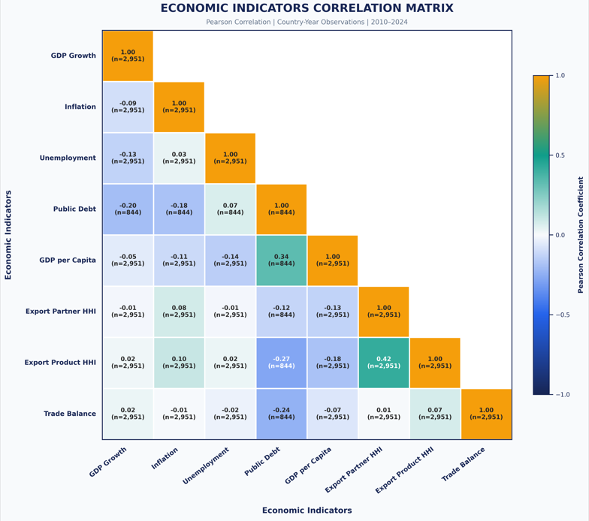 Figure Correlation Matrix of Selected Economic Indicators (2010–2024)
The results reveal several relationships between the selected indicators. The strongest positive correlation was observed between Export Partner HHI and Export Product HHI (0.42). Public Debt and GDP per Capita also demonstrated a positive correlation of 0.34.
In contrast, Public Debt and Trade Balance showed a negative correlation of −0.24, while Public Debt and Export Product HHI recorded a correlation of −0.27.
These findings demonstrate that economic indicators are interconnected and provide complementary information about national economic conditions. However, correlation does not establish causation. The number of observations also varies between indicator pairs because of missing economic data.
3.6.3 Main Economic Relationships
Using Pearson correlation on the cleaned dataset, we identified several relationships:
- GDP Growth and Unemployment (r = −0.126): A weak negative relationship, suggesting that higher economic growth is generally associated with slightly lower unemployment.
- GDP Growth and Inflation (r = −0.087): A very weak negative relationship, indicating that economic growth and inflation are not strongly connected in this dataset.
- Exports and Imports (r = 0.940): A strong positive relationship, showing that countries with higher exports also tend to have higher imports.
- Government Revenue and Government Expense (r = 0.711): A strong positive relationship, indicating that countries collecting more government revenue relative to GDP also tend to spend more.
- Public Debt and GDP Growth (r = −0.201): A weak negative relationship, suggesting that higher public debt is associated with somewhat lower economic growth.
3.6.4 Relationship Between Trade Balance and Current Account Balance
To further examine the external economic position of countries, the relationship between Trade Balance and Current Account Balance was analyzed for 2024. Both indicators were expressed as percentages of GDP to allow comparisons between countries of different economic sizes.
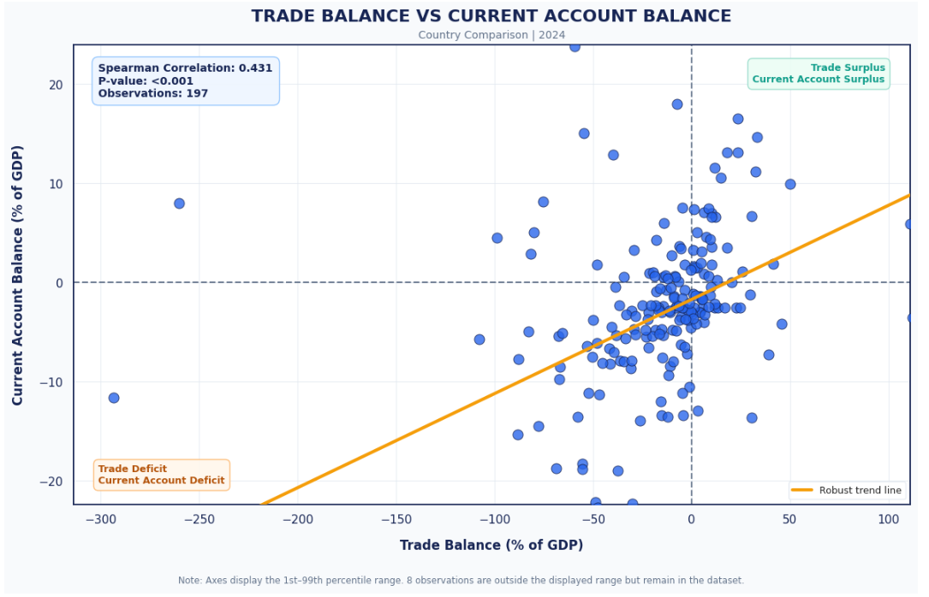 Figure Trade Balance vs Current Account Balance Across Countries (2024)
The results revealed a moderate positive correlation of 0.431, which was statistically significant (p < 0.001), based on 197 country-year observations.
The positive relationship indicates that countries with higher trade balances relative to GDP generally tend to have higher current account balances. However, the two indicators are not identical because the Current Account Balance also includes net primary and secondary income. This comparison highlights the importance of examining multiple external economic indicators when assessing national economic vulnerability.
3.6.5 Trade Concentration and Economic Volatility
The analysis also examined whether countries with more concentrated export structures experienced greater economic fluctuations.
Using each country's average export concentration and the standard deviation of its annual GDP growth between 2010 and 2024, we found:
- Export Partner HHI and GDP Growth Volatility (r = 0.160): A weak positive relationship.
- Export Product HHI and GDP Growth Volatility (r = 0.224): A weak positive relationship.
- Inflation Volatility and GDP Growth Volatility (r = 0.185): A weak positive relationship.
These results suggest that countries with more concentrated exports tend to experience slightly greater economic fluctuations. However, the relationships are weak, meaning other economic factors also play an important role.

3.6.6 Comparative Economic Vulnerability Across Countries
To further examine the relationship between export concentration and macroeconomic instability, a scatter plot was constructed comparing the average Export Product HHI with GDP Growth Volatility across countries between 2010 and 2024.
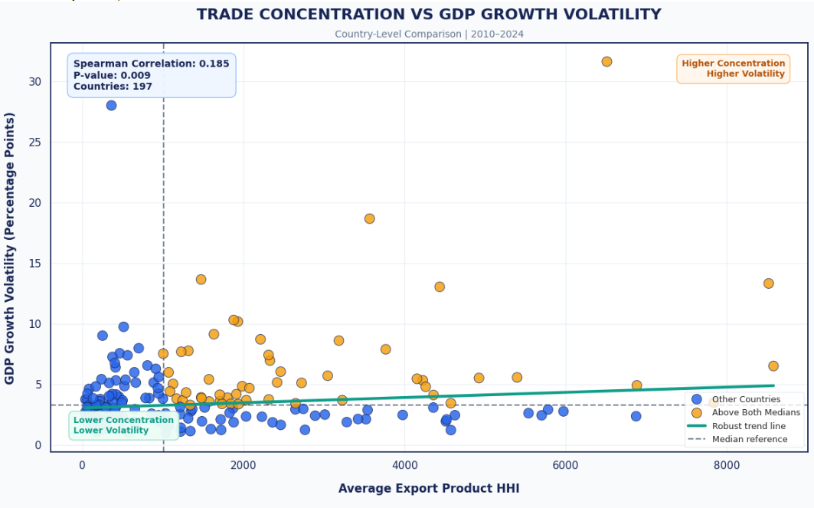Figure Trade Concentration vs GDP Growth Volatility (2010–2024)
The analysis covered 197 countries and revealed a weak but significant positive relationship between export product concentration and GDP growth volatility (ρ = 0.185, p = 0.009). This suggests that greater export concentration is associated with slightly higher economic fluctuations.
To further compare national economic conditions, the 2023 profiles of the United States, Brazil, and France were examined using six standardized vulnerability indicators.
3.6.7 Economic Interpretation
The correlation analysis demonstrates that economic indicators are connected, although the strength of these relationships varies. The findings highlight the importance of examining several economic dimensions together when evaluating national economic vulnerability.
However, correlation does not establish causation. The observed relationships should therefore be interpreted as statistical associations rather than direct causal effects.
3.7 Derived Economic Indicators
3.7.1 Overview
Derived economic indicators are calculated using existing variables to provide additional information about economic conditions and potential vulnerabilities.
This section examines Trade Openness, Fiscal Balance, Public Debt, GDP Growth Volatility, and Inflation Volatility.
3.7.2 Trade Openness
Trade Openness measures the relative importance of international trade compared with the size of the economy.
Trade Openness (%) = [(Exports + Imports) / GDP] × 100
The results were:
- Average Trade Openness: 112.18%.
- Median Trade Openness: 60.00%.
The difference between the mean and median indicates the influence of unusually high observations, particularly in the Marshall Islands.
Higher trade openness reflects greater integration into international markets. However, it may also increase exposure to international market changes.
3.7.3 Fiscal Balance
Fiscal Balance measures the difference between government revenue and government expenditure.
Fiscal Balance (% of GDP) = Government Revenue − Government Expense
The results were:
- Average Fiscal Balance: −0.81% of GDP.
- Median Fiscal Balance: −0.90% of GDP.
Positive values indicate a government surplus, while negative values indicate a government deficit.
The results suggest that government expenditure was slightly higher than revenue on average. Persistent deficits may increase borrowing requirements and create additional financial pressure.
3.7.4 Public Debt (% of GDP)
Public Debt (% of GDP) measures government debt relative to the size of the economy.
The dataset already contains this indicator, so its existing values were used directly without recalculating the ratio.
The results were:
- Average Public Debt: 61.79% of GDP
- Median Public Debt: 51.43% of GDP
- Maximum Public Debt: 249.37% of GDP
Higher debt ratios may indicate greater fiscal pressure, although the actual vulnerability also depends on a country's ability to manage and repay its debt.
3.7.5 GDP Growth and Inflation Volatility
Economic volatility measures fluctuations in an indicator over time. For this descriptive analysis, the standard deviation of annual GDP growth and inflation was calculated separately for each country over the period 2010–2024.
Formulas:
- GDP Growth Volatility = Standard Deviation of Annual GDP Growth
- Inflation Volatility = Standard Deviation of Annual Inflation

The results were:
- Average GDP Growth Volatility: 4.16 percentage points
- Median GDP Growth Volatility: 3.27 percentage points
- Average Inflation Volatility: 5.77 percentage points
- Median Inflation Volatility: 2.29 percentage points
in economic conditions. Countries experiencing unstable economic growth or inflation may face greater difficulties in planning investments, managing prices, and maintaining economic stability.
These country-level descriptive volatility measures are distinct from the rolling country-year GDP Growth Volatility indicator used later in the construction of the Economic Fragility Index.
3.7.6 Economic Interpretation
The derived indicators provide additional information about economic vulnerability. High trade openness may increase exposure to external economic disruptions, persistent fiscal deficits may create government financial pressure, and high public debt may reduce fiscal flexibility.
Similarly, considerable fluctuations in GDP growth and inflation may indicate greater economic uncertainty. Together, these indicators complement the analysis of individual economic variables and provide additional information about national economic conditions.
3.8 Economic Findings and Interpretation
3.8.1 Overview
The economic analysis identified several patterns that demonstrate why economic growth alone is insufficient to evaluate national economic stability.
Trade concentration, macroeconomic fluctuations, and government financial conditions provide additional information about the vulnerabilities affecting national economies.
3.8.2 Main Economic Findings
A. Economic Growth and Stability
Average GDP growth across the dataset was 2.95%. However, considerable differences existed between countries, with some experiencing strong growth while others faced significant economic contractions.
The sharp decline in 2020, followed by recovery in 2021, demonstrates the influence of major economic disruptions.
B. Inflation and Unemployment
Average inflation reached 6.17%, while average unemployment was 7.61%.
Extreme observations, particularly Zimbabwe's inflation in 2020 and Eswatini's unemployment in 2022, highlight the differences in economic conditions across countries.
High inflation reduces purchasing power, while unemployment affects household income and economic activity.
C. Trade Vulnerability
Average exports were approximately $92.36 billion, compared with $92.89 billion in imports.
The analysis also identified countries with considerable export concentration. Dependence on a limited number of products or trading partners may increase exposure to international market changes and external disruptions.
D. Fiscal Vulnerability
Average public debt reached 61.79% of GDP, while government expenditure exceeded government revenue on average.
These findings demonstrate that government financial conditions represent another important dimension of economic vulnerability.
3.8.3 Countries and Periods of Economic Vulnerability
Several country-year observations illustrate different forms of economic instability:
- Zimbabwe (2020): Extremely high inflation, reflecting significant price instability.
- Libya (2012): Exceptionally high GDP growth, demonstrating considerable fluctuations in economic performance.
- Macao SAR, China (2020): Significant economic contraction.
- Eswatini (2022): High unemployment, indicating labor market difficulties.
- Greece (2020): High public debt relative to GDP.
The period 2020–2022 was particularly important, as many countries experienced economic disruption, recovery, and rising inflation.
These examples demonstrate that economic vulnerability can appear in different forms depending on the country's economic structure.
3.8.4 Comparative Economic Vulnerability Across Countries
To compare economic vulnerabilities across major economies, five standardized indicators were examined for 12 countries in 2023: Inflation, Unemployment, Public Debt, Export Partner HHI, and Export Product HHI.
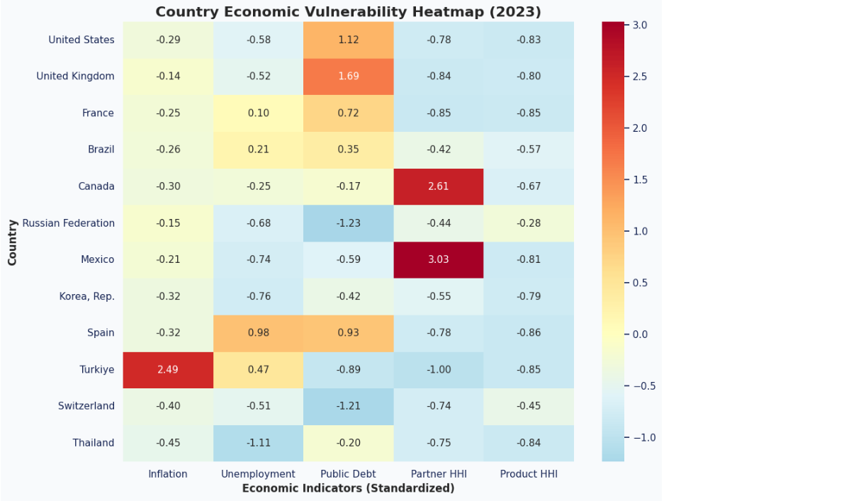 Figure 3.X. Country Economic Vulnerability Heatmap (2023)
The heatmap reveals important differences in economic conditions. Türkiye recorded relatively high inflation (2.49), while the United Kingdom showed elevated public debt (1.69). Mexico and Canada exhibited high export partner concentration, with standardized values of 3.03 and 2.61, respectively.
These findings demonstrate that economic vulnerability can appear through different indicators depending on the country. The standardized values represent deviations from the 2023 reference averages and should not be interpreted as overall economic fragility scores.
Overall, the comparison reinforces the importance of examining multiple economic indicators rather than relying exclusively on GDP growth or economic size.
3.8.5 Comparative Economic Profiles of Selected Countries
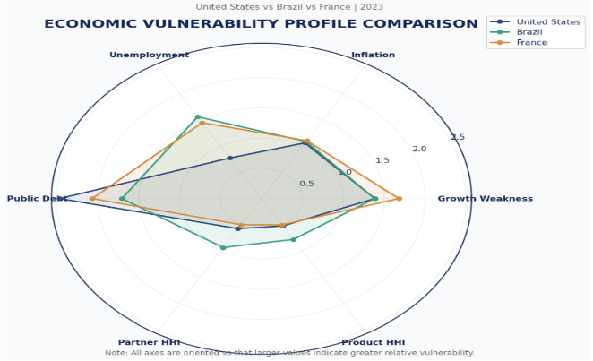 Figure Economic Vulnerability Profile Comparison (2023)
The radar chart illustrates differences in the economic profiles of the three selected countries. It highlights variations in public debt, unemployment, growth weakness, and trade concentration. Values farther from the center indicate relatively higher vulnerability for the corresponding indicator.
The comparison demonstrates that countries can experience different forms of economic vulnerability rather than sharing identical economic weaknesses.
3.8.6 Hidden Economic Fragility
One of the main findings is that a country may appear economically successful while still experiencing significant economic weaknesses.
For example:
- Strong GDP growth may coexist with unstable inflation.
- High export revenues may depend on a limited number of products.
- High GDP per Capita may coexist with substantial public debt.
- Economic recovery may occur while unemployment remains elevated.
Therefore, Hidden Economic Fragility cannot be adequately identified through a single economic indicator.
3.8.7 Overall Interpretation
The economic analysis demonstrates that national economic stability depends on the interaction of several factors. Countries with diversified trade structures, relatively stable macroeconomic conditions, and sustainable government finances may be better prepared to withstand economic disruptions.
Conversely, countries experiencing high debt, unstable growth, inflation, or concentrated trade relationships may face greater economic vulnerability. These findings establish the economic foundation for the following chapter, which introduces a mathematical framework combining Trade Vulnerability, Macroeconomic Instability, and Fiscal Vulnerability into a unified Economic Fragility Index (EFI).

4. Mathematical Model
4.1 Economic Fragility Framework
The mathematical model developed in this study aims to measure the hidden fragility of national economies by combining multiple dimensions of economic vulnerability into a unified quantitative framework.
Traditional indicators such as GDP and GDP growth measure economic performance but may not reveal structural weaknesses. A country can experience positive growth while remaining dependent on a limited number of trading partners, exported products, or unstable government finances, increasing its exposure to external economic shocks.
To identify these hidden vulnerabilities, this study proposes an Economic Fragility Index (EFI) that combines three fundamental dimensions of national economic fragility.
4.1.1 Trade Vulnerability
Trade Vulnerability measures a country's exposure to external economic disruptions caused by dependence on a limited number of export destinations or products. Such concentration increases vulnerability to changes in international demand, trade restrictions, and supply chain disruptions. In this study, it is assessed through export partner concentration and export product concentration.
4.1.2 Macroeconomic Instability
Macroeconomic Instability measures weaknesses and fluctuations in a country's economic environment. It is assessed through GDP growth, inflation, and unemployment, as unstable growth, rising prices, and high unemployment may indicate economic vulnerability. Combining these indicators provides a broader assessment of economic instability beyond GDP alone.
4.1.3 Fiscal Vulnerability
Fiscal Vulnerability measures how government financial conditions may limit a country's ability to respond to economic shocks. It is assessed through public debt, government revenue, and government expenditure. High debt burdens and persistent fiscal imbalances may reduce fiscal flexibility and increase economic vulnerability. Due to substantial missing data in some fiscal indicators, their inclusion requires a transparent and justified methodology.
4.1.4 General Mathematical Formulation
The proposed Economic Fragility Index is represented by:
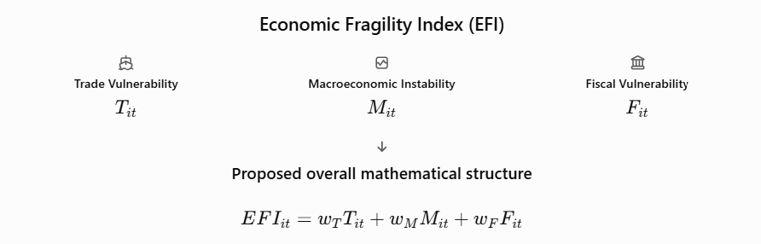
where:
- EFI_(i,t) denotes the Economic Fragility Index for country (i) in year (t).
- T_(i,t) denotes Trade Vulnerability.
- M_(i,t) denotes Macroeconomic Instability.
- F_(i,t) denotes Fiscal Vulnerability.
The dimension weights are assumed to satisfy:
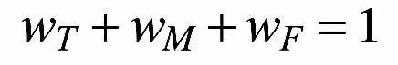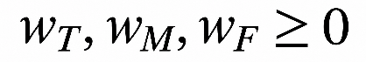
These conditions ensure that the final index represents a non-negative weighted combination of its three dimensions. Because the economic indicators are measured using different units and scales, a normalization procedure will be introduced before constructing the dimension scores. The weighting system and treatment of incomplete observations will also be defined and justified in subsequent sections.
The resulting mathematical framework will provide the foundation for the numerical implementation of the EFI using country-year observations from the integrated economic dataset covering 197 countries between 2010 and 2024.
4.2 Selection of Economic Indicators
The construction of the Economic Fragility Index requires the selection of economic indicators capable of representing the different dimensions of national vulnerability. The selected variables are obtained from the integrated trade and World Bank dataset and are organized into three main categories: trade vulnerability, macroeconomic instability, and fiscal vulnerability.
The selection process considers the economic relevance of each indicator, its relationship with national economic stability, and its availability across countries and years.
4.2.1 Trade Vulnerability Indicators
Trade vulnerability is evaluated using two indicators: Export Partner Herfindahl-Hirschman Index (HHI) and Export Product Herfindahl-Hirschman Index (HHI).
The Export Partner HHI measures the concentration of a country's exports across its trading partners. A higher value indicates that exports are concentrated among a smaller number of destinations, potentially increasing exposure to disruptions affecting those markets.
The index is conceptually defined as:
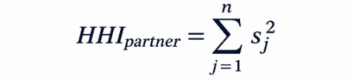
where (Sj) represents the export share of trading partner (j), and (n) represents the total number of export partners.
Similarly, the Export Product HHI measures the concentration of exports across different products. Its mathematical representation is:
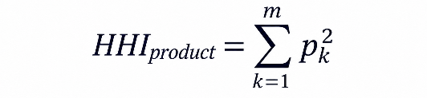
where (Pk) represents the export share of product (k), and (m) represents the total number of exported products.

Both indicators are used to evaluate the degree of export concentration and the potential exposure associated with limited trade diversification.
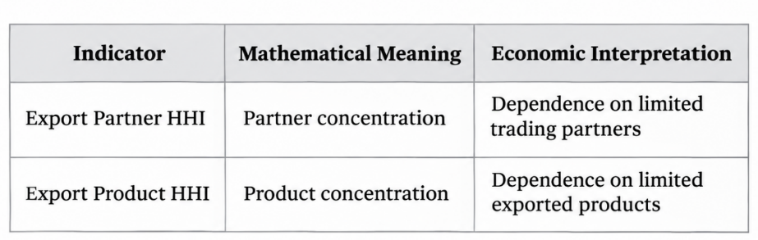
4.2.2 Macroeconomic Instability Indicators
Macroeconomic instability is represented through GDP growth, inflation, and unemployment.
- 1-GDP Growth (% Annual) measures the annual percentage change in economic output. Persistent negative growth or substantial fluctuations may indicate economic instability.
- Inflation (CPI %) measures changes in the general level of consumer prices. High inflation can reduce purchasing power, increase uncertainty, and create additional economic pressures.
- Unemployment Rate (%) represents the proportion of the labor force that is unemployed. Higher unemployment may indicate weaknesses in economic activity and labor market conditions.
These indicators provide complementary information about economic performance, price stability, and labor market conditions.
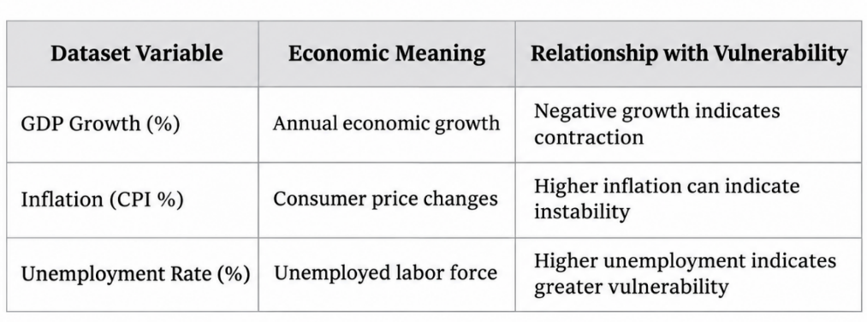
4.2.3 Fiscal Vulnerability Indicators
Fiscal vulnerability is evaluated using public debt, government revenue, government expenditure, and tax revenue.
- Public Debt (% of GDP) measures government debt relative to the size of the economy and provides an indication of the public debt burden.
- Government Revenue (% of GDP) represents the government's revenue relative to GDP.
- Government Expense (% of GDP) measures public expenditure relative to GDP.
- Tax Revenue (% of GDP) provides additional information about the government's capacity to generate income through taxation.
An additional fiscal indicator, the Fiscal Balance, is calculated as the difference between government revenue and government expenditure:
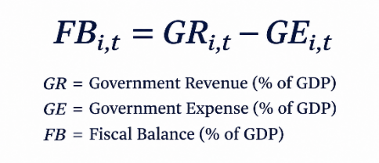
A negative fiscal balance indicates a deficit, whereas a positive value indicates a surplus.
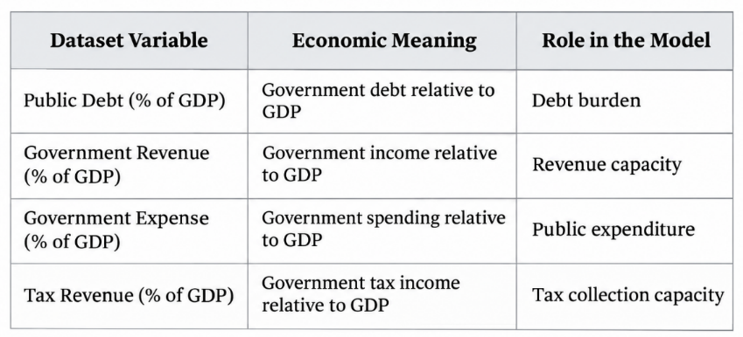
4.2.4 Summary of Indicator Selection
The selected indicators form the foundation of the proposed Economic Fragility Index. Their inclusion aims to capture different sources of economic vulnerability rather than relying on a single measure of national economic performance.
Additional variables, including trade balance, current account balance, and GDP per capita, will be used for supporting economic comparisons and interpretation. The final selection will also consider data availability and the treatment of missing observations to ensure that the resulting index is mathematically consistent and economically meaningful.
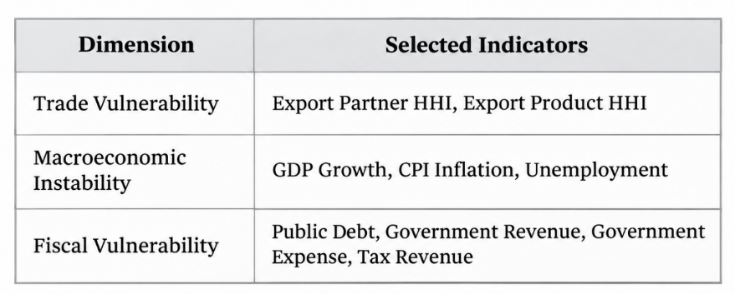
4.3 Normalization of Economic Indicators
The selected economic indicators are measured using different units and numerical scales. For example, export concentration indices may reach values in the thousands, whereas inflation, unemployment, and GDP growth are expressed as percentages.
Combining these indicators directly would result in an unbalanced mathematical formulation, as variables with larger numerical scales could disproportionately influence the final index.
To address this issue, Min-Max Normalization is adopted to transform the selected indicators into a common range between zero and one.
4.3.1 Min-Max Normalization
The general Min-Max Normalization formula is expressed as:
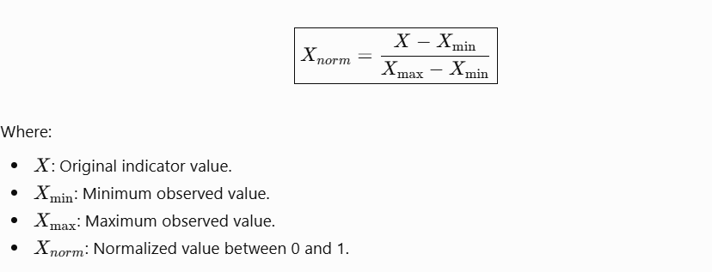
This transformation produces dimensionless values within the interval [0,1], allowing indicators with different measurement units to be incorporated into a common mathematical framework.
4.3.2 Direction of Economic Indicators
An important consideration in constructing the Economic Fragility Index is the economic direction of each indicator. Some indicators represent conditions associated with greater vulnerability when their values increase, whereas others may represent favorable economic conditions. For example: Export Partner HHI, Export Product HHI ,Inflation, Unemployment, Public Debt (% of GDP)
For indicators where higher values correspond to greater vulnerability, the standard Min-Max formula is applied:
This transformation is appropriate for indicators such as export concentration, inflation, unemployment, and public debt, subject to their economic interpretation.
For indicators where higher values represent more favorable economic conditions, the reverse normalization formula is applied:
This ensures that the normalized values follow a consistent interpretation, where higher values represent greater relative vulnerability.
4.3.3 Treatment of GDP Growth
GDP growth requires particular consideration because its relationship with economic vulnerability is not necessarily linear.
Negative GDP growth indicates economic contraction, while positive growth generally represents an expansion in economic activity. However, positive growth alone does not guarantee economic stability.
Consequently, this study considers GDP Growth Volatility as an additional measure of macroeconomic instability. This allows the model to examine fluctuations in economic performance over time rather than relying exclusively on the annual growth rate.
4.3.4 Comparability and Normalization Considerations
Normalization will be applied consistently across country-year observations from 2010 to 2024, allowing comparisons between countries and years on a common scale.
Missing values and extreme observations will be handled carefully. Indicators with insufficient data will not automatically be assigned zero values to avoid distorting vulnerability scores. For Machine Learning, normalization parameters will be calculated using training data only to prevent data leakage.
The normalized indicators will provide a consistent basis for constructing the three dimensions of the Economic Fragility Index (EFI).
4.4 Mathematical Formulation of Trade Vulnerability
Trade vulnerability represents the exposure of national economies to potential disruptions arising from concentrated international trade relationships.
In this study, trade vulnerability is evaluated through two complementary indicators: Export Partner Concentration and Export Product Concentration. These indicators capture different aspects of trade dependence and provide a broader representation of structural weaknesses in international trade.
4.4.1 Normalized Export Partner Concentration
The Export Partner Herfindahl-Hirschman Index measures the concentration of a country's exports across its trading partners.
To make this indicator comparable with other variables included in the Economic Fragility Index, Min-Max Normalization is applied:

Higher normalized values indicate greater relative dependence on a limited number of export destinations.
4.4.2 Normalized Export Product Concentration
The Export Product Herfindahl-Hirschman Index measures the concentration of a country's exports across different product categories.
Its normalized representation is:
where:
Higher values indicate greater dependence on a relatively limited range of exported products.
4.4.3 Construction of the Trade Vulnerability Score
The two normalized indicators are combined to construct the Trade Vulnerability component of the proposed Economic Fragility Index.
The mathematical formulation is:
where:
- T[i,t] represents Trade Vulnerability.
- w1 represents the weight assigned to Export Partner Concentration.
- w2 represents the weight assigned to Export Product Concentration.
The weights satisfy the following condition: W1 + W2 = 1 , For the baseline formulation, equal weights are proposed: W1 = W2 = 0.5 .
Consequently, the Trade Vulnerability score becomes:
Equal weighting is adopted as a transparent initial assumption because both indicators represent complementary dimensions of international trade concentration. This choice avoids assigning greater importance to either indicator without sufficient empirical justification.
Alternative weighting configurations will subsequently be examined through sensitivity analysis to evaluate the robustness of the resulting index.
4.4.4 Interpretation of the Trade Vulnerability Score
The Trade Vulnerability score ranges from 0 to 1, with lower values indicating lower trade concentration and higher values indicating greater concentration. It represents a relative measure of vulnerability within the observed sample, not an absolute risk classification.
The score is calculated only when both concentration indicators are available. Missing values are not replaced with zero. This component forms the first dimension of the Economic Fragility Index (EFI), alongside Macroeconomic Instability and Fiscal Vulnerability.
4.5 Mathematical Formulation of Macroeconomic Instability
Macroeconomic instability represents the second dimension of the proposed Economic Fragility Index. It evaluates the stability of national economic conditions through three indicators: GDP growth volatility, inflation, and unemployment.
These indicators capture different aspects of macroeconomic performance, including fluctuations in economic activity, price instability, and labor market weakness.
4.5.1 GDP Growth Volatility
GDP growth volatility measures the degree of fluctuation in a country's annual economic growth over time. Unlike the annual GDP growth rate, which indicates whether economic activity is expanding or contracting, volatility provides information about the consistency of economic performance.
In this study, a five-year rolling standard deviation is proposed to measure GDP growth volatility: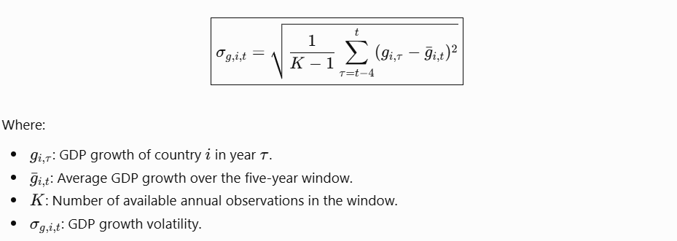
A higher standard deviation indicates greater fluctuations in economic growth and therefore a higher degree of macroeconomic instability.
A minimum of three valid annual observations within the rolling window will be required to calculate the standard deviation. This avoids producing volatility estimates from insufficient historical information.
To ensure comparability with the other indicators, GDP growth volatility is normalized using Min-Max Normalization:
Where:
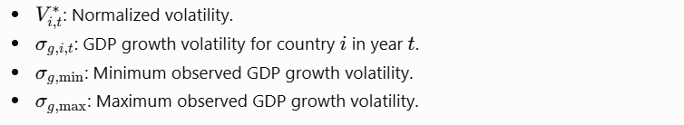
4.5.2 Inflation
Inflation represents the rate of change in consumer prices and is an important indicator of price stability. Persistent or unusually high inflation can reduce purchasing power, increase uncertainty, and negatively affect economic planning and investment decisions.
The Consumer Price Index (CPI) inflation indicator is selected to represent price instability. Its normalized representation is:
where (I_{i,t}) represents the CPI inflation rate for country (i) in year (t).
Higher positive inflation values generally correspond to higher normalized inflation risk. However, this formulation primarily captures inflation levels and does not fully represent the economic instability that may arise from severe deflation.
4.5.3 Unemployment
The unemployment rate measures the proportion of the labor force that is unemployed but actively seeking employment.
Higher unemployment may indicate weaknesses in labor market conditions, reduced household income opportunities, and lower economic participation.
The normalized unemployment indicator is expressed as:
where (U_{i,t}) represents the unemployment rate for country (i) in year (t). Higher normalized values indicate greater relative labor market vulnerability.
4.5.4 Construction of the Macroeconomic Instability Score
The three normalized indicators are combined to construct the Macroeconomic Instability component of the Economic Fragility Index.
The general mathematical formulation is:
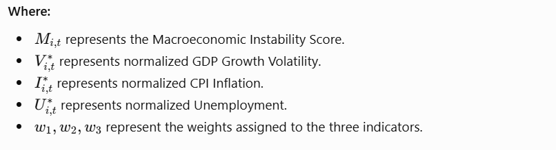
The weights satisfy
For the baseline formulation, equal weights are proposed:
Consequently, the Macroeconomic Instability score becomes:

Equal weighting provides a transparent initial approach in which growth instability, inflation, and unemployment contribute equally to the overall dimension.
Alternative weighting configurations will subsequently be examined through sensitivity analysis. The resulting score ranges between zero and one, with higher values indicating greater relative macroeconomic instability.
Missing observations in any of the three indicators will be treated explicitly rather than automatically replaced with zero. The availability of sufficient historical observations will also be considered when calculating GDP growth volatility.
4.6 Mathematical Formulation of Fiscal Vulnerability
Fiscal vulnerability represents the third dimension of the proposed Economic Fragility Index. It evaluates the financial condition of governments and their potential exposure to fiscal pressures.
In this study, fiscal vulnerability is examined through public debt, government revenue, government expenditure, and tax revenue. These indicators provide complementary information about the government's debt burden, financial resources, and expenditure commitments.
4.6.1 Public Debt
Public debt represents the government's outstanding debt relative to the size of its economy. A higher public debt-to-GDP ratio may indicate greater fiscal pressure and potentially reduce the government's flexibility in responding to economic disruptions.
The normalized public debt indicator is expressed as:
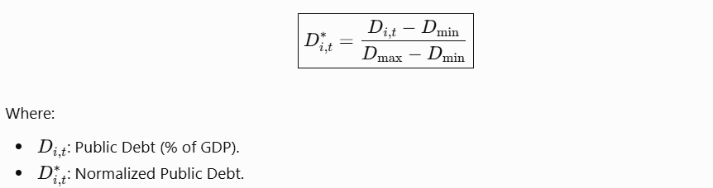
where D_(i,t) represents public debt as a percentage of GDP for country (i) in year (t).
Higher normalized values indicate a greater relative public debt burden within the observed sample.
4.6.2 Fiscal Balance
Fiscal balance represents the difference between government revenue and government expenditure.
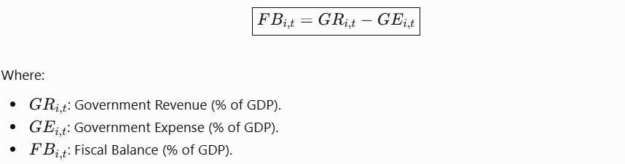
A positive fiscal balance indicates a surplus, while a negative balance indicates a deficit.
4.6.3 Fiscal Deficit Risk
To incorporate fiscal deficits into the vulnerability framework, the deficit component is defined as:
This formulation assigns a positive value to fiscal deficits while treating fiscal surpluses and balanced budgets as zero deficit.
The resulting deficit indicator is normalized using:
Higher normalized values indicate greater relative fiscal deficit exposure.
4.6.4 Construction of the Fiscal Vulnerability Score
The Fiscal Vulnerability component combines normalized public debt and normalized fiscal deficit risk.
Its general mathematical formulation is:
The weights satisfy: W1 + W2 = 1
For the baseline formulation, equal weights are proposed:

Consequently, the Fiscal Vulnerability score becomes:
Equal weighting provides a transparent initial approach in which public debt and fiscal deficit risk contribute equally to the fiscal dimension. Alternative weighting configurations will be examined through sensitivity analysis.
4.6.5 Role of Additional Fiscal Indicators
Government revenue, government expenditure, and tax revenue are also considered in the fiscal analysis. Government revenue and expenditure are used to calculate the fiscal balance, while tax revenue provides additional information about the government's capacity to generate income through taxation.
These indicators are retained for supporting economic interpretation rather than being independently added to the baseline fiscal score. This avoids unnecessary duplication of information within the mathematical model.
4.6.6 Treatment of Missing Fiscal Observations
Public debt contains a substantial number of missing observations in the integrated dataset. Therefore, missing debt values will not automatically be replaced with zero or treated as valid economic measurements.
The baseline Fiscal Vulnerability score will only be calculated when both required components are available. This restriction is intended to preserve the reliability of the resulting fiscal measure and prevent unsupported assumptions from influencing the Economic Fragility Index.
4.7 Construction of the Overall Economic Fragility Index (EFI)
Following the mathematical formulation of the three individual dimensions, the next step consists of combining Trade Vulnerability, Macroeconomic Instability, and Fiscal Vulnerability into a unified measure of national economic fragility. The proposed Economic Fragility Index (EFI) provides an integrated assessment of the structural vulnerabilities that may affect national economies.
4.7.1 General Mathematical Formulation
The overall Economic Fragility Index is defined as a weighted combination of the three dimensions:
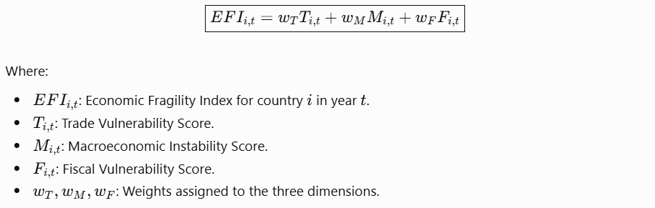
The weights must satisfy the following condition:
4.7.2 Weighting Methodology
For the baseline formulation, equal weights are proposed for the three dimensions:

Consequently, the overall EFI becomes:

Equal weighting is adopted as a transparent initial assumption because the three dimensions represent complementary aspects of national economic vulnerability.
This approach prevents any single dimension from receiving greater importance without sufficient empirical justification. Alternative weighting configurations will subsequently be examined through sensitivity analysis to evaluate the robustness of the resulting index.
4.7.3 Interpretation of the Economic Fragility Index
Since the three component scores are normalized between zero and one, the resulting EFI also ranges between zero and one, provided that all three dimensions are available.
Lower EFI values indicate relatively lower economic fragility, whereas higher values indicate greater relative vulnerability. Intermediate values represent different degrees of economic fragility within the observed sample. The index is intended to provide a comparative assessment of national economic conditions rather than a universal classification of economic risk.
4.7.4 Treatment of Missing Dimension Scores
The baseline Economic Fragility Index (EFI) is calculated only when all three dimensions are available. Country-year observations with missing dimension scores remain excluded to avoid artificial zero values and ensure consistent calculations.
The EFI combines Trade Vulnerability, Macroeconomic Instability, and Fiscal Vulnerability into a unified measure, providing the foundation for numerical analysis, country comparisons, and Machine Learning applications.
4.8 Economic Fragility Classification
Following the construction of the Economic Fragility Index, a classification framework is introduced to translate the continuous EFI scores into interpretable categories of national economic fragility.
The purpose of this classification is to facilitate comparisons between countries and identify country-year observations exhibiting different degrees of economic vulnerability.
4.8.1 Quartile-Based Classification Method
This study adopts a quartile-based classification approach to divide the observed EFI scores into four relative categories. The classification thresholds are determined using the distribution of the 714 valid EFI observations available across the period 2012–2023.
Three percentile thresholds are calculated:
- (Q_1): The 25th percentile of the EFI distribution.
- (Q_2): The 50th percentile, corresponding to the median.
- (Q_3): The 75th percentile of the EFI distribution.
These thresholds provide the basis for distinguishing between four levels of economic fragility.
4.8.2 Mathematical Formulation
The classification of each country-year observation is defined as follows:
 where:
- (EFI_{i,t}) represents the Economic Fragility Index for country (i) in year (t).
- (Q_1) represents the first quartile.
- (Q_2) represents the second quartile.
- (Q_3) represents the third quartile.
4.8.3 Interpretation of Fragility Categories
The resulting classification provides four levels of relative economic fragility.
Low Fragility: Countries with EFI scores in the lowest quarter of the observed distribution. These observations exhibit relatively lower levels of combined trade, macroeconomic, and fiscal vulnerability.
Moderate Fragility: Countries with EFI scores above the first quartile and at or below the median. These observations exhibit intermediate levels of relative economic fragility.
High Fragility: Countries with EFI scores above the median and at or below the third quartile. These observations demonstrate relatively greater exposure to economic vulnerabilities.
Critical Fragility: Countries with EFI scores above the third quartile. These observations represent the highest relative levels of economic fragility within the study sample.
4.8.4 Classification Consistency Across Years
Classification thresholds are calculated using all 714 valid EFI observations from 2012 to 2023 and applied consistently across the available country-year observations. This ensures that changes in a country's classification reflect changes in its EFI score relative to a common reference distribution. This ensures that changes in a country's classification reflect changes in its EFI score relative to a common reference distribution.
The resulting categories represent relative economic fragility within the study sample, not universal risk standards. Observations with missing EFI scores remain unclassified. This framework supports consistent country comparisons and subsequent numerical analysis.
4.9 Sensitivity Analysis and Model Assumptions
The reliability of the proposed Economic Fragility Index depends partly on the methodological choices adopted during its construction. In particular, the weighting system, normalization procedure, and treatment of missing observations may influence the resulting economic fragility scores.
To evaluate the robustness of the proposed framework, a sensitivity analysis is introduced to examine how alternative assumptions affect the calculated EFI values.
4.9.1 Sensitivity Analysis of Dimension Weights
In the baseline formulation, equal weights are assigned to Trade Vulnerability, Macroeconomic Instability, and Fiscal Vulnerability:

However, the relative importance of these dimensions may vary depending on the economic characteristics of individual countries.
To investigate this issue, alternative weighting scenarios are proposed.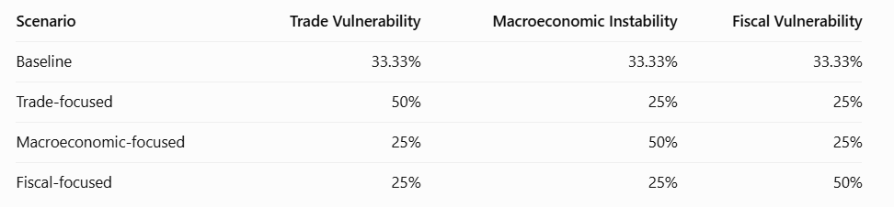
For each scenario, the Economic Fragility Index is recalculated using:
The resulting scores and country rankings will be compared to determine whether changes in the weighting system produce substantial differences in the assessment of economic fragility.
To ensure a fair comparison, the same eligible country-year observations will be used across the alternative scenarios. The results of this analysis will be presented in the numerical section of the study.
4.9.2 Main Model Assumptions
The proposed mathematical framework is based on several assumptions.
- Equal Dimension Importance: The baseline model assumes that trade vulnerability, macroeconomic instability, and fiscal vulnerability contribute equally to overall economic fragility. This provides a transparent initial weighting approach.
- Indicator Comparability: Selected indicators are normalized before aggregation to ensure that differences in measurement units do not distort the final index.
- Consistent Indicator Direction: Indicators are transformed so that higher normalized values represent greater relative vulnerability.
- Treatment of Missing Observations: Missing economic observations are not automatically interpreted as zero. The calculation of the overall EFI requires valid scores for all three dimensions under the baseline methodology.
- Temporal Comparability: The study uses a consistent reference period covering 2010–2024 to facilitate comparisons between countries and across years.
- Interpretation of Economic Relationships: The EFI represents a composite measure of economic vulnerability. It does not establish causal relationships between its underlying indicators.
4.9.3 Limitations of the Proposed Framework
Despite its comprehensive structure, the Economic Fragility Index has several limitations. Data availability varies across countries and years, particularly for fiscal indicators such as public debt, reducing the number of valid observations. Equal weighting is also a methodological assumption rather than an empirically established measure of each dimension's importance. Additionally, Min-Max Normalization is sensitive to extreme values, while the index does not fully capture other factors such as political stability, institutional quality, external financing conditions, and geopolitical developments. These limitations must be considered when interpreting the results and evaluating the reliability of the index.

5. Numerical Model
The numerical model aims to implement the mathematical framework developed in the previous chapter using the integrated and cleaned economic dataset. The calculations were performed using Python, primarily through the Pandas and NumPy libraries. The numerical implementation follows the three-dimensional structure of the proposed Economic Fragility Index, combining Trade Vulnerability, Macroeconomic Instability, and Fiscal Vulnerability.
The objective of this stage is to transform the theoretical mathematical formulations into measurable economic indicators and subsequently construct a unified index for evaluating national economic fragility.
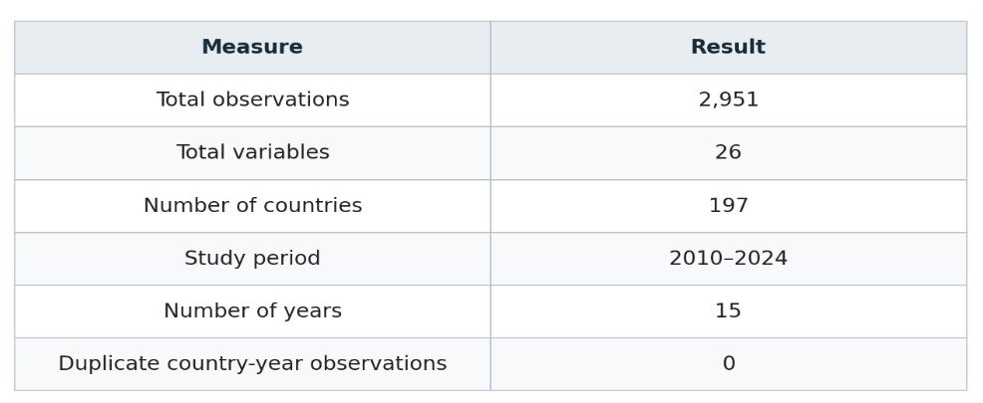
5.1 Dataset Loading and Numerical Inspection
The numerical analysis used the final cleaned dataset, containing 2,951 observations and 26 variables across 197 countries from 2010 to 2024. Initial inspection confirmed zero duplicate country-year records.
Missing-value analysis identified 2,107 missing observations in Public Debt (% of GDP) (71.40%), 1,238 in Real Interest Rate (%) (41.95%), and six in Momentum Score. These missing values were not automatically replaced with zeros to avoid introducing misleading results into the mathematical model.
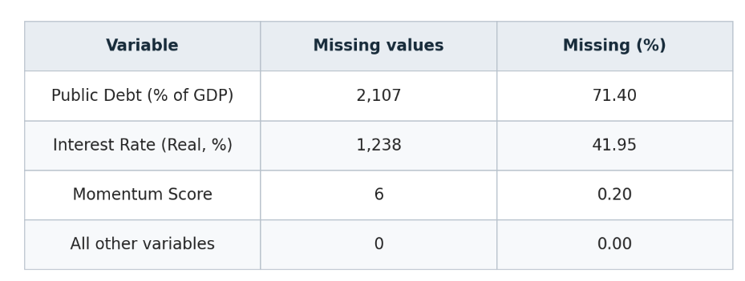
5.2 Calculation of GDP Growth Volatility
GDP Growth Volatility was calculated to measure fluctuations in economic performance across countries over time. Using Python and the Pandas library, annual GDP growth observations were organized by country and year. A five-year rolling standard deviation was then applied separately to each country.
A minimum of three valid annual GDP growth observations was required within each five-calendar-year window. The mathematical formulation used was:

The GDP Growth Volatility indicator produced 2,557 valid observations out of 2,951, with 394 unavailable due to insufficient annual data. It recorded a mean of 3.5267, a median of 2.4685, and a standard deviation of 4.3841, with values ranging from 0 to 69.0058.
The higher mean compared to the median indicates that some observations experienced substantially greater growth fluctuations. These results reveal differences in economic stability across countries and years. The indicator was subsequently prepared for normalization and inclusion in the Macroeconomic Instability dimension. 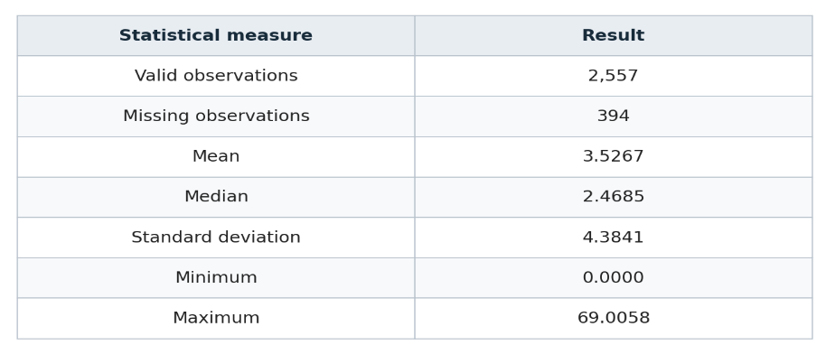
5.3 Normalization of Economic Indicators
Before constructing the three EFI dimensions, seven economic indicators were transformed using Min-Max Normalization to ensure comparability across different measurement scales.
The normalized values ranged from 0 to 1. Five indicators had complete values, while GDP Growth Volatility retained 394 missing observations and Public Debt retained 2,107.
The mean normalized values were 0.1468 for Export Partner HHI, 0.1562 for Export Product HHI, 0.0511 for GDP Growth Volatility, 0.0228 for Inflation, 0.2129 for Unemployment, 0.2422 for Public Debt, and 0.0487 for Fiscal Deficit.
These normalized indicators provide the foundation for constructing the three EFI dimensions. Their distributions and the influence of extreme values were also examined to assess the reliability of the normalization process.
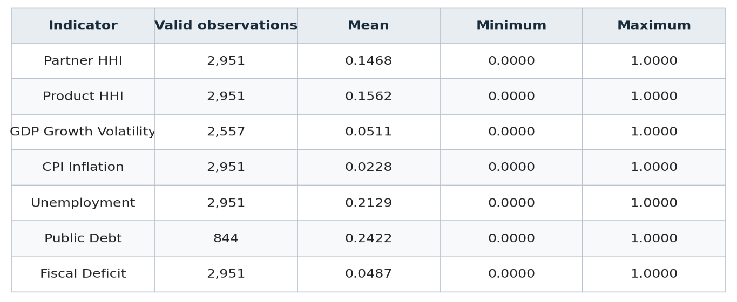
5.3.1 Examination of Extreme Economic Observations
The examination identified extreme values across several economic indicators. South Sudan recorded exceptionally high export partner and product concentration (9,943.49 and 9,965.64, respectively). Libya reached a GDP Growth Volatility of 69.01 in 2012, while extreme inflation was observed in Zimbabwe, South Sudan, and Sudan. Other notable values included unemployment of 35.36% in Eswatini and public debt of 249.37% of GDP in Greece.
These observations were retained because extreme values may reflect genuine economic conditions rather than data errors. However, their influence on normalization, particularly for inflation, will be considered through alternative normalization approaches in the sensitivity analysis.
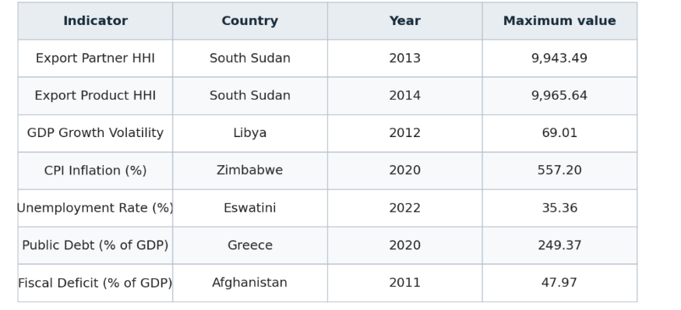
5.3.2 Verification of Economic Indicator Calculations
To ensure the reliability of the selected economic indicators, additional verification procedures were performed before proceeding with the construction of the Economic Fragility Index. First, the fiscal deficit calculation was verified by comparing the calculated values with the expected differences between government expenditure and government revenue. The maximum absolute difference obtained was zero, confirming the consistency of the calculation.
Second, the Export Partner HHI and Export Product HHI indicators were examined to verify their numerical ranges. Both indicators were found to fall within the conventional HHI scale of zero to 10,000. These verification procedures support the consistency of the selected indicators and provide a numerical basis for the subsequent calculation of the three economic vulnerability dimensions.
5.4 Calculation of Trade Vulnerability (T)
Trade Vulnerability measures the extent to which a country's export structure depends on a limited number of trading partners or products. High trade concentration may expose national economies to external disruptions, changes in international demand, and trade restrictions. To quantify this dimension, two indicators were selected: Export Partner HHI and Export Product HHI. Both indicators were previously transformed using Min-Max Normalization to ensure comparability.
Trade Vulnerability was calculated as the arithmetic mean of the two normalized indicators, assigning equal weights to partner concentration and product concentration. A higher score indicates greater trade concentration and potentially higher exposure to external trade disruptions, whereas a lower score indicates a more diversified export structure.
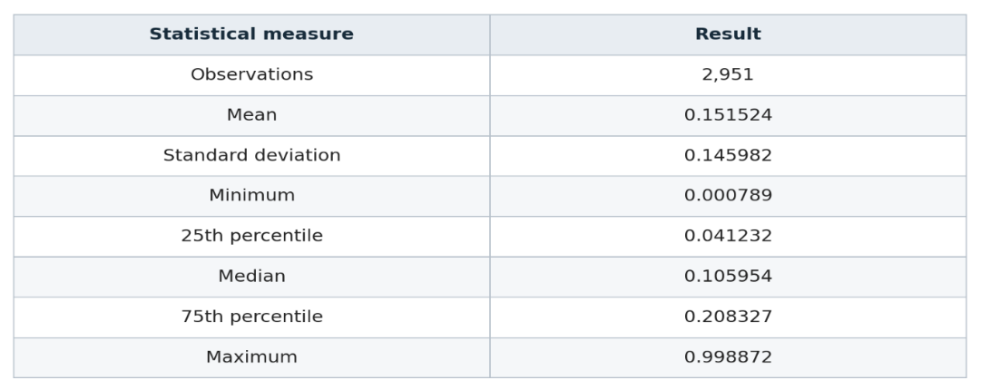
5.4.1 Numerical Results and Economic Interpretation
The calculation of Trade Vulnerability produced 2,951 valid country-year observations, with no missing values. The resulting indicator recorded a mean of 0.1515 and a median of 0.1060, indicating that most observations exhibit relatively low trade concentration compared with the highest recorded values.
The maximum Trade Vulnerability score was 0.9989, recorded in South Sudan in 2013. South Sudan appeared repeatedly among the highest observations, particularly between 2012 and 2019.
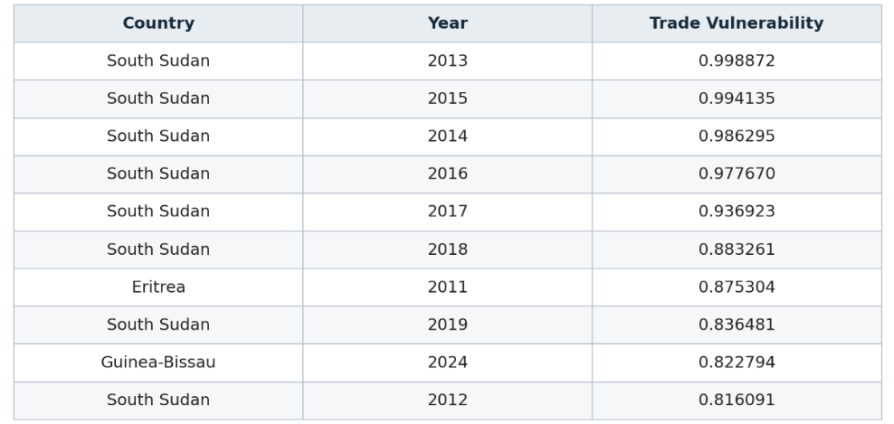
This pattern indicates a persistently concentrated export structure during these years, suggesting substantial dependence on a limited number of export partners or products.
Other countries, including Eritrea and Guinea-Bissau, also recorded high Trade Vulnerability observations. In contrast, Türkiye recorded the lowest values across several years, with a minimum score of 0.0008 in 2022.
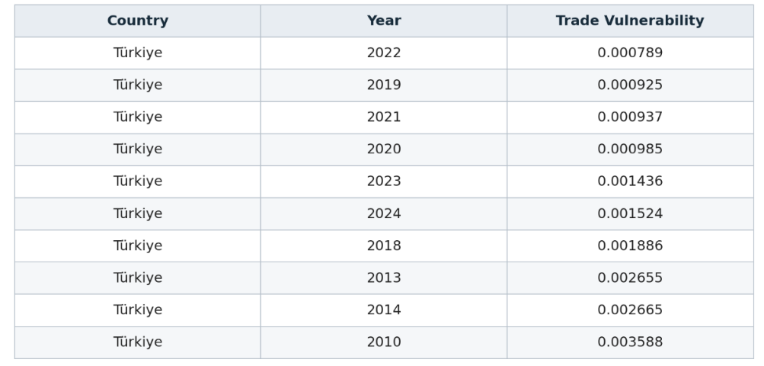
These results indicate a comparatively diversified export structure according to the two concentration indicators used in this model. Overall, the findings demonstrate considerable differences in trade concentration across countries and years. The results highlight the importance of export diversification in reducing exposure to external trade disruptions and provide the numerical foundation for the Trade Vulnerability component of the Economic Fragility Index.
5.5 Calculation of Macroeconomic Instability (M)
Macroeconomic Instability measures the degree of instability in a country's economic performance through fluctuations in economic growth, changes in consumer prices, and unemployment conditions.
Three indicators were selected to represent this dimension: GDP Growth Volatility, CPI Inflation, and Unemployment Rate. These indicators were previously normalized using the Min-Max Normalization procedure to ensure comparability.
Macroeconomic Instability was calculated as the arithmetic mean of the three normalized indicators, assigning equal weights to each component.
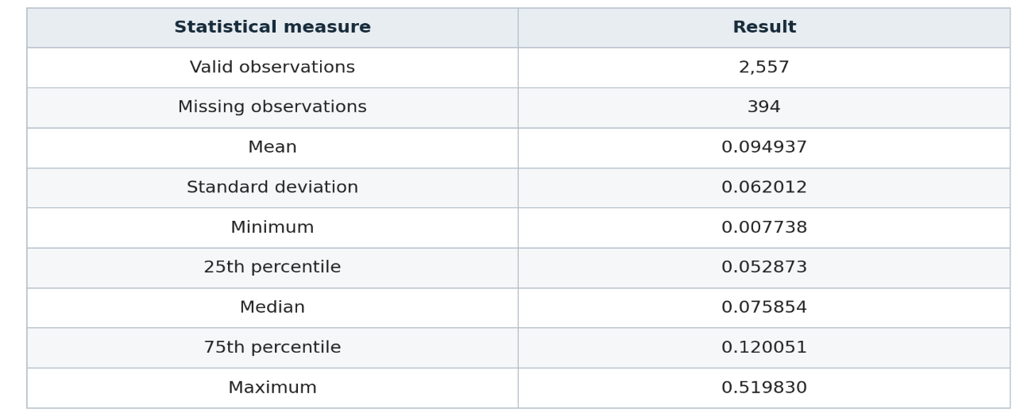
5.5.1 Numerical Results and Economic Interpretation
The Macroeconomic Instability indicator produced 2,557 valid observations, with 394 unavailable due to missing GDP Growth Volatility data. It recorded a mean of 0.0949, a median of 0.0759, and a standard deviation of 0.0620, with values ranging from 0.0077 to 0.5198.
Libya recorded the highest score (0.5198) in 2012, followed by South Sudan (0.4594) in 2016 and Zimbabwe (0.4425) in 2020. These results reflect differences in GDP growth volatility, inflation, and unemployment across countries and years.
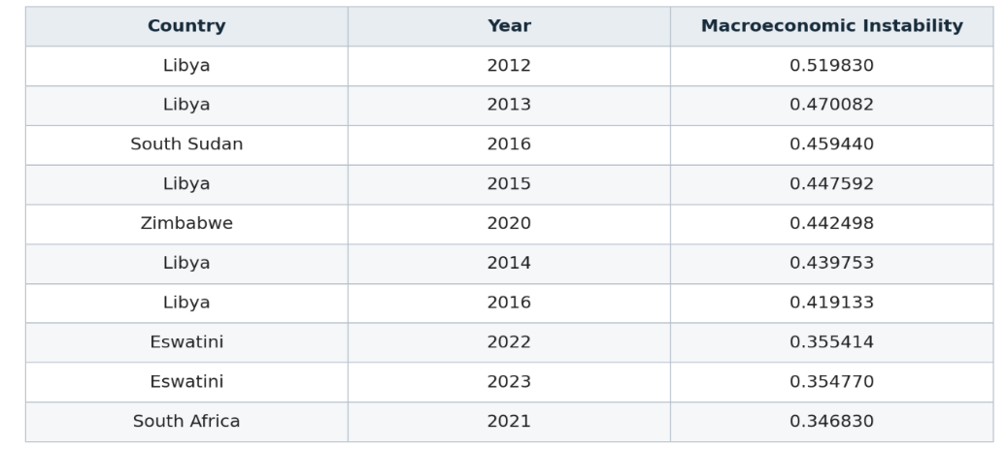
In contrast, Cambodia recorded several of the lowest observations, including the minimum score of 0.0077 in 2017. Qatar, Niger, Myanmar, and Thailand also appeared among the observations with relatively low macroeconomic instability.
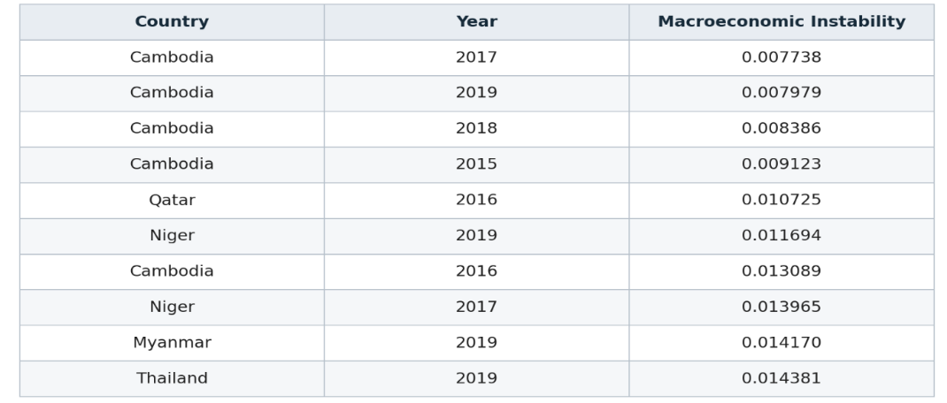
Overall, the findings demonstrate substantial differences in macroeconomic conditions across countries and years. The results provide the numerical foundation for the Macroeconomic Instability component of the proposed Economic Fragility Index.
5.6 Calculation of Fiscal Vulnerability (F)
Fiscal Vulnerability measures the financial pressure experienced by governments through their public debt levels and fiscal balances. High public debt and persistent fiscal deficits may limit a government's financial flexibility and increase its exposure to economic shocks.
Two indicators were selected to represent this dimension: Public Debt (% of GDP) and Fiscal Deficit (% of GDP). Both indicators were previously normalized using Min-Max Normalization to ensure comparability.
Fiscal Vulnerability was calculated as the arithmetic mean of the two normalized indicators, assigning equal weights to public debt and fiscal deficit.
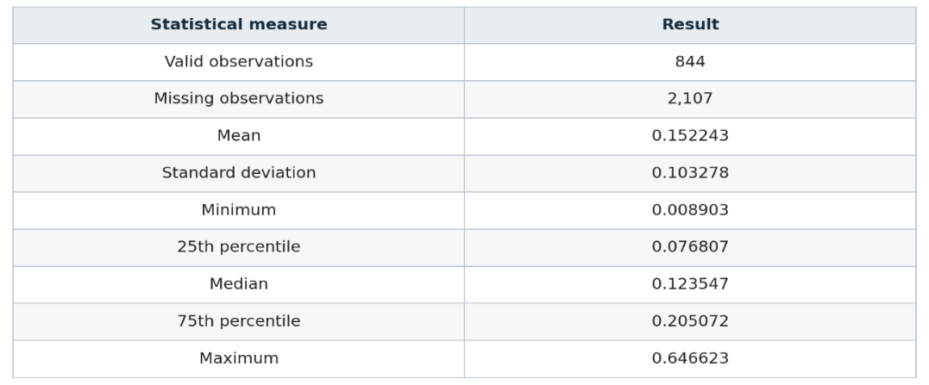
5.6.1 Numerical Results and Economic Interpretation
The Fiscal Vulnerability indicator produced 844 valid observations, while 2,107 remained unavailable due to missing Public Debt data. Both fiscal indicators were required to preserve equal weighting.
The indicator recorded a mean of 0.1522, a median of 0.1235, and a standard deviation of 0.1033, with values ranging from 0.0089 to 0.6466.
Greece recorded the highest score (0.6466) in 2020, followed by the United Kingdom (0.5423) in the same year. Ireland and the Marshall Islands also showed elevated fiscal vulnerability. These results highlight considerable differences in fiscal conditions across countries.
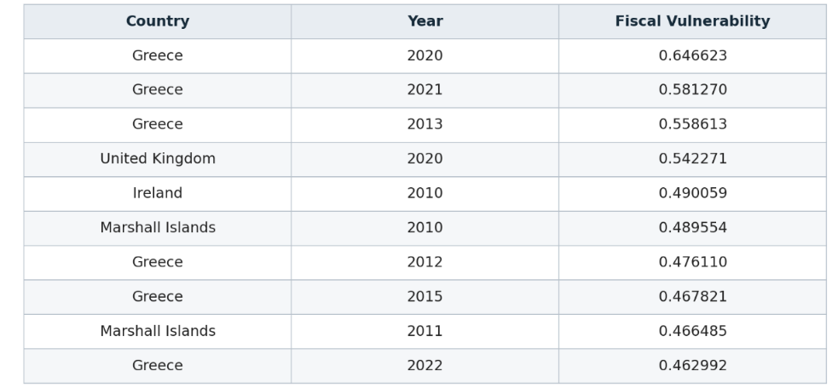
In contrast, the United Arab Emirates recorded the lowest observed score of 0.0089 in 2013. Azerbaijan, the Solomon Islands, the Russian Federation, and Kazakhstan also appeared among the observations with relatively low fiscal vulnerability.
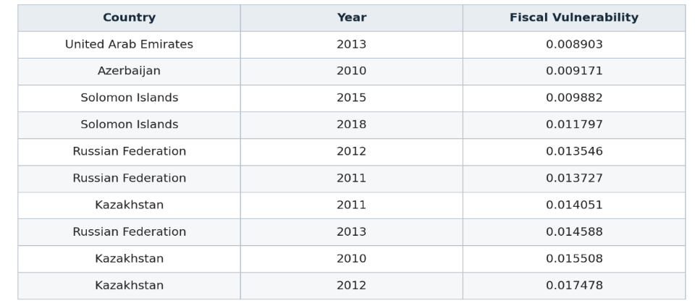
Overall, these findings highlight differences in government debt burdens and fiscal positions across countries and years. However, the substantial number of missing Public Debt observations limits the geographical and temporal coverage of this dimension. Consequently, the fiscal results should be interpreted in light of this data limitation.
5.7 Construction of the Economic Fragility Index (EFI)
After calculating the three dimensions of economic vulnerability, the next step consists of combining them to construct the overall Economic Fragility Index. The index integrates Trade Vulnerability, Macroeconomic Instability, and Fiscal Vulnerability into a unified numerical measure. Equal weights were assigned to the three dimensions, following the weighting approach established in the Mathematical Model chapter.
The numerical implementation was performed using Python. Each country's annual EFI score was calculated by combining the three corresponding dimension scores, allowing economic fragility to be evaluated across countries and years. Higher EFI values indicate greater overall economic fragility, while lower values indicate comparatively lower vulnerability.
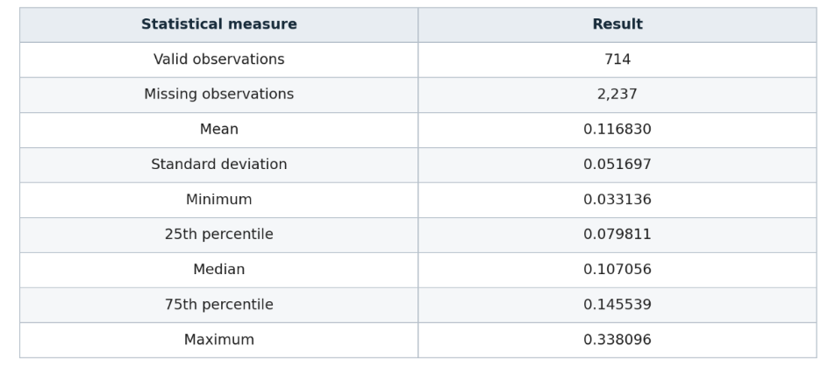
5.7.1 Numerical Results and Economic Interpretation
The construction of the Economic Fragility Index produced 714 valid country-year observations out of the 2,951 records available in the dataset. The remaining 2,237 observations were unavailable because at least one of the three vulnerability dimensions contained missing values.
The resulting EFI recorded a mean of 0.1168 and a median of 0.1071, with a standard deviation of 0.0517. The observed values ranged from 0.0331 to 0.3381, indicating substantial differences in overall economic fragility across the available country-year observations.
Palau recorded the highest EFI value of 0.3381 in 2012, followed by another high observation in 2013. Greece also appeared repeatedly among the highest observations, particularly between 2012 and 2021. Burkina Faso and the Marshall Islands were also among the countries with elevated EFI values.
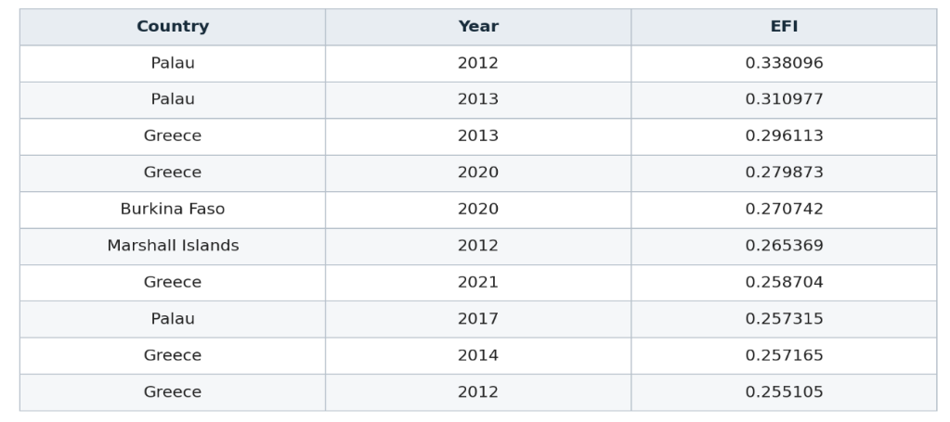
In contrast, Thailand recorded several of the lowest EFI observations, including the minimum value of 0.0331 in 2012. Estonia also appeared among the observations with relatively low economic fragility scores.
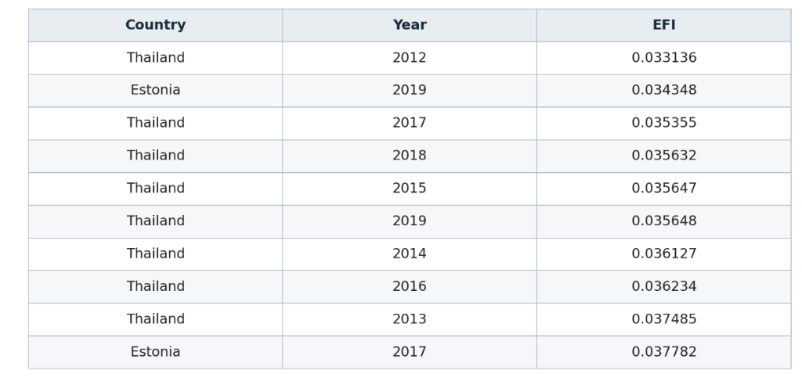
Overall, these findings demonstrate that economic fragility varies considerably across countries and years. The EFI provides an integrated assessment of trade concentration, macroeconomic instability, and fiscal vulnerability, allowing these three dimensions to be examined within a unified numerical framework.
However, the limited availability of public debt data reduces the number of observations included in the final index. Consequently, the results should be interpreted as reflecting the countries and years for which all three dimensions were available.
5.8 EFI Coverage and Fragility Classification
5.8.1 Assessment of EFI Data Coverage
Before proceeding with the classification of economic fragility, the availability of the calculated EFI values was examined across countries and years.
The analysis identified 714 valid country-year observations out of the 2,951 records in the original dataset, representing approximately 24.20% of the total observations. These valid values covered 81 countries over the period 2012–2023.
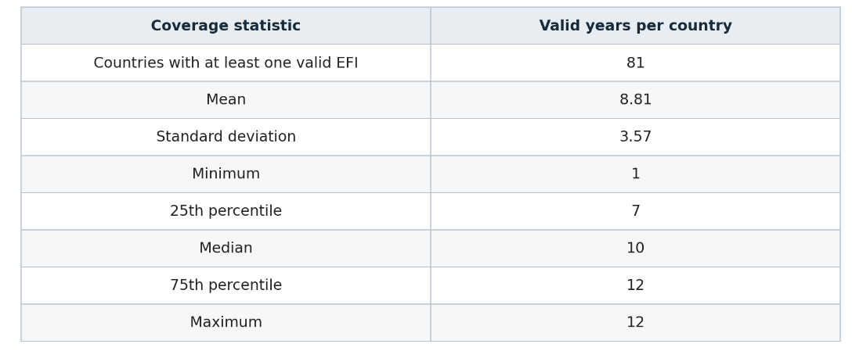
The number of available observations varied considerably across countries. On average, each country had 8.81 valid years, while the median coverage was 10 years. The minimum coverage was one year, whereas the maximum reached 12 years.
The annual coverage analysis also revealed variations in the number of countries available for comparison. In 2019, 67 countries had valid EFI values, compared with only 35 countries in 2023. Furthermore, the average EFI reached 0.1420 in 2020, representing an increase compared with the previous year.
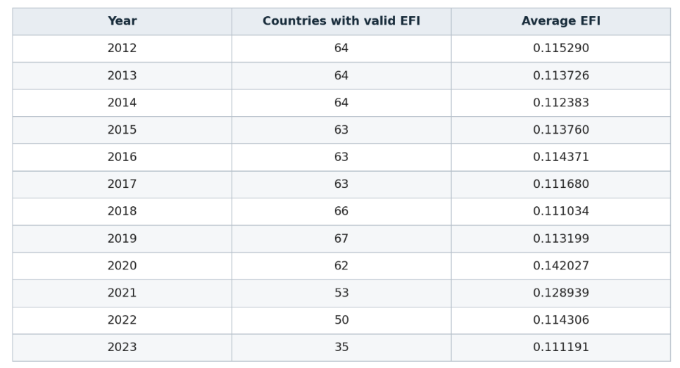
However, annual averages should be interpreted cautiously because the composition and number of countries included differ across years. Therefore, changes in annual averages do not necessarily represent changes in the economic fragility of the same group of countries.
These findings establish the data coverage limitations that must be considered when classifying and comparing national economic fragility.
5.8.2 Economic Fragility Classification
Following the assessment of EFI data coverage, the valid Economic Fragility Index observations were classified into four economic fragility categories using a quartile-based classification approach.
The classification thresholds were calculated using the 714 valid EFI observations. The three percentile thresholds were:
- Q1 (25th percentile): 0.079811.
- Q2 (50th percentile): 0.107056.
- Q3 (75th percentile): 0.145539.
Each country-year observation was assigned to one of the following four categories:
- Low Fragility: EFI values less than or equal to Q1.
- Moderate Fragility: EFI values greater than Q1 and less than or equal to Q2.
- High Fragility: EFI values greater than Q2 and less than or equal to Q3.
- Critical Fragility: EFI values greater than Q3.
The classification process covered all 714 valid EFI observations. As presented in Table 5.22, 179 observations were classified as Low Fragility, 178 as Moderate Fragility, 178 as High Fragility, and 179 as Critical Fragility. Each category therefore represents approximately 25% of the available observations.
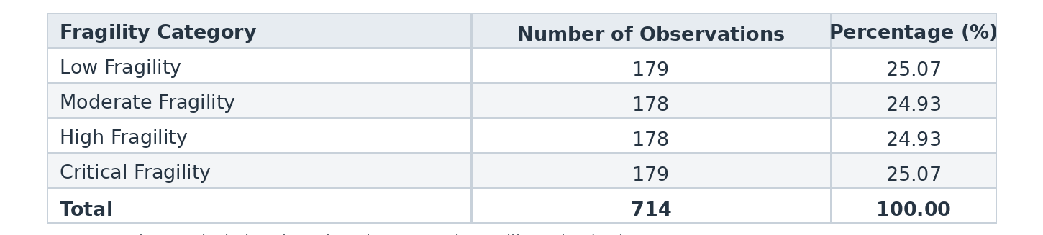
The resulting classification provides a structured approach for examining differences in economic fragility across countries and years. These categories represent relative levels of vulnerability within the available dataset rather than universal measures of economic stability. Furthermore, a country's classification may change over time as its economic conditions evolve.
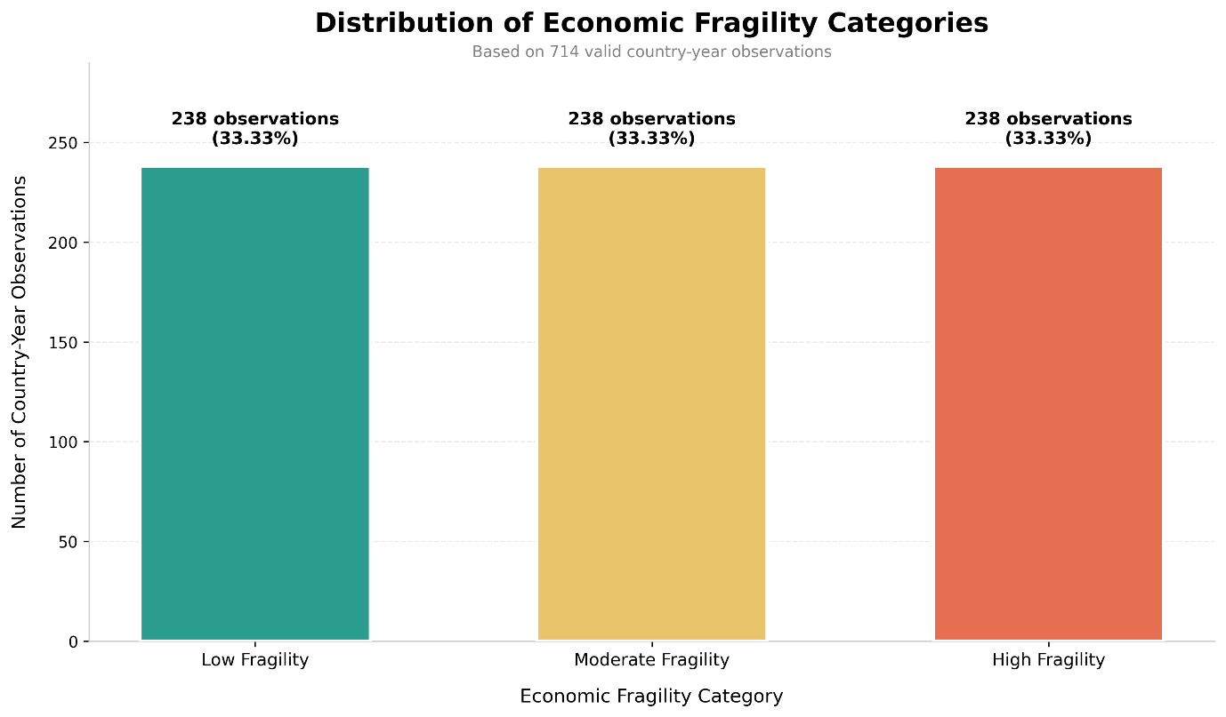
5.9 Sensitivity Analysis
Sensitivity analysis was conducted to assess the robustness of the Economic Fragility Index (EFI) under different weighting assumptions. The baseline model assigns equal weights to the three dimensions, while three alternative scenarios give greater importance to Trade Vulnerability, Macroeconomic Instability, and Fiscal Vulnerability, respectively.
Each scenario was evaluated using the same 714 complete country-year observations, comparing EFI values, rankings, and classification stability. Missing observations were neither replaced with zero nor artificially estimated.
5.9.1 Sensitivity Analysis Results
The sensitivity analysis was conducted using 714 valid country-year observations to examine how alternative weighting assumptions affect the Economic Fragility Index.
Four weighting scenarios were evaluated, including the original equal-weight model and three alternative scenarios that assigned greater importance to Trade Vulnerability, Macroeconomic Instability, and Fiscal Vulnerability, respectively.
The results revealed differences in the average EFI values across the scenarios. The baseline model recorded a mean of 0.1168, while the trade-oriented, macroeconomic-oriented, and fiscal-oriented scenarios recorded means of 0.1136, 0.1108, and 0.1261, respectively. The fiscal-oriented scenario therefore produced the highest average EFI.
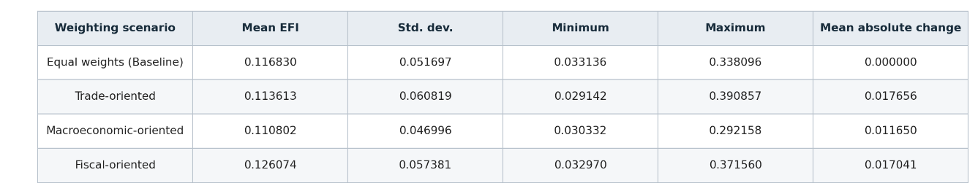
The Spearman rank correlation analysis demonstrated relatively strong consistency between the baseline model and the alternative weighting scenarios. The correlation coefficients were 0.9509 for the trade-oriented scenario, 0.9692 for the macroeconomic-oriented scenario, and 0.9513 for the fiscal-oriented scenario. These results indicate that the relative ordering of country-year observations remained generally similar despite changes in the weighting assumptions.
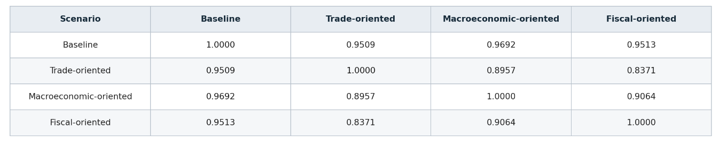
Classification stability was also examined by comparing the alternative scenarios with the baseline classification thresholds. The percentage of observations retaining their original category was 75.77% under the trade-oriented scenario, 80.25% under the macroeconomic-oriented scenario, and 79.97% under the fiscal-oriented scenario.
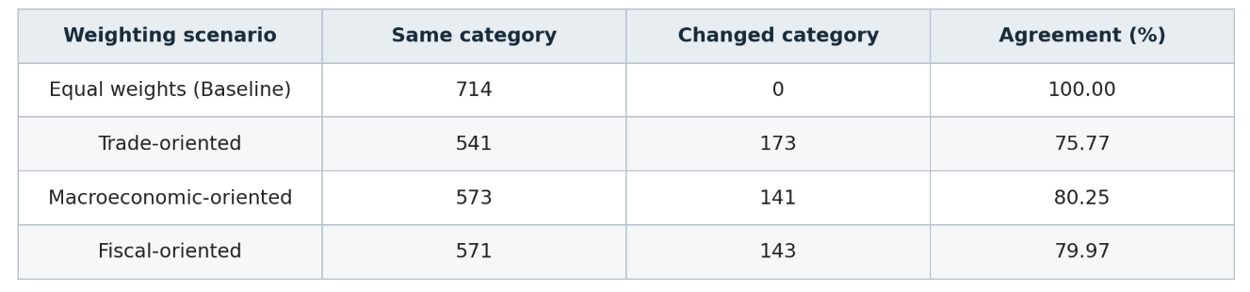
Overall, the findings suggest that the Economic Fragility Index demonstrates relatively strong ranking consistency under alternative weighting assumptions. However, the changes observed in classification categories indicate that individual fragility assessments can be influenced by the relative importance assigned to each dimension. Therefore, the equal-weight model is retained as the baseline specification, while the alternative scenarios provide additional evidence regarding the robustness of the proposed index.
5.10 Country-Level and Temporal Analysis of Economic Fragility
5.10.1 Country-Level Comparison of Economic Fragility
A country-level analysis was conducted to identify differences in average economic fragility across countries. The analysis was based on the calculated Economic Fragility Index values, using the average EFI for each country over its available observation period.
To improve the reliability of the comparison, only countries with at least eight valid country-year observations were retained. This selection resulted in a sample of 58 countries.
The results revealed substantial differences in economic fragility across the selected countries. Palau recorded the highest average EFI, reaching 0.2555, followed by Greece with 0.2415 and the Marshall Islands with 0.2204. Bhutan and Botswana also recorded relatively high average EFI values of 0.2139 and 0.2086, respectively.
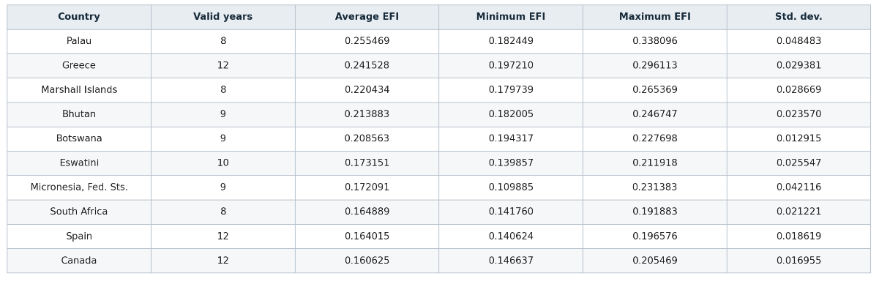
In contrast, Thailand recorded the lowest average EFI at 0.0463, followed by Switzerland at 0.0493 and Estonia at 0.0495. These values indicate comparatively lower economic fragility according to the proposed index.
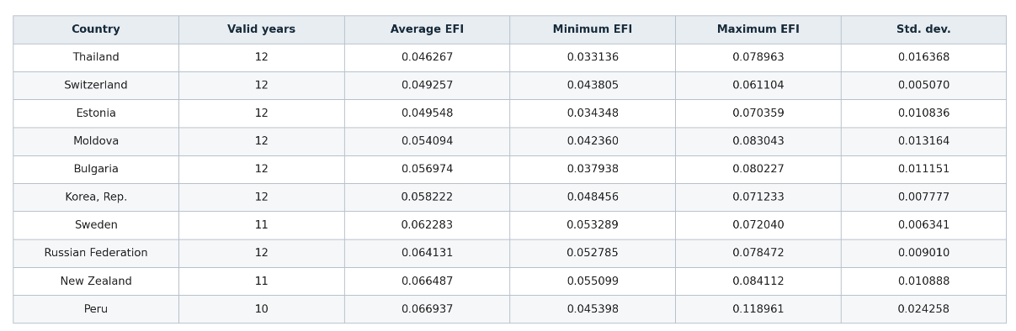
The country-level analysis also revealed differences in the consistency of EFI values over time. For example, Greece recorded a standard deviation of 0.0294 across 12 valid years, whereas Botswana recorded a lower standard deviation of 0.0129 across nine valid years.
5.10.2 Temporal Evolution of Economic Fragility
A temporal analysis was conducted to examine how economic fragility evolved between 2012 and 2023. The analysis focused on annual average EFI values, allowing changes in the overall level of economic fragility to be examined over time.
The annual results revealed that the highest average EFI was recorded in 2020, reaching 0.1420, compared with 0.1132 in 2019. This represents an increase of 0.0288 in the average index. Following this increase, the average EFI declined to 0.1289 in 2021, 0.1143 in 2022, and 0.1112 in 2023.
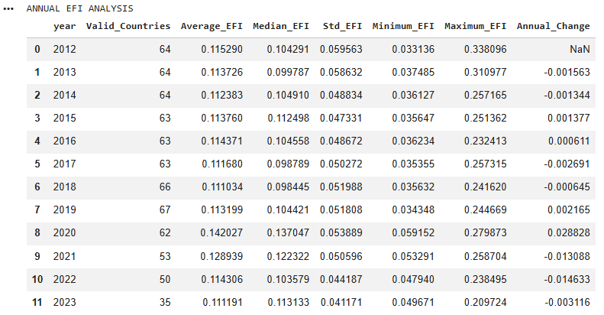
However, the number of countries included in the annual calculations varied from year to year, ranging from 67 countries in 2019 to only 35 countries in 2023. Consequently, changes in annual averages may partly reflect differences in country coverage.
To address this limitation, a balanced panel analysis was conducted using 28 countries with valid EFI observations throughout the entire 2012–2023 period. The results confirmed the increase observed in 2020. Within this consistent group, average EFI increased from 0.0925 in 2019 to 0.1289 in 2020, before gradually declining in subsequent years.
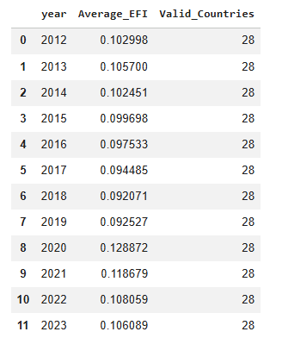
By 2023, the balanced panel recorded an average EFI of 0.1061. Although this represented a decline from the 2020 peak, the value remained above the 2019 level.
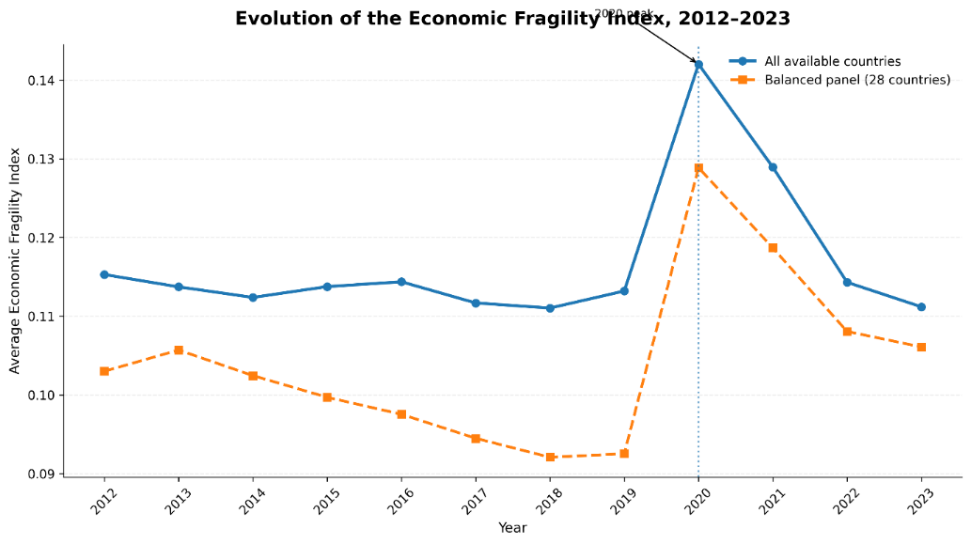
Overall, the temporal analysis reveals a noticeable increase in economic fragility in 2020, followed by a gradual decline. The balanced panel results provide additional support for this pattern by maintaining a consistent group of countries throughout the observation period.
5.10.3 Country-Level Changes in Economic Fragility (2012–2023)
A country-level comparison was conducted to examine changes in economic fragility between 2012 and 2023, using a balanced panel of 28 countries with valid EFI observations throughout the period.
For each country, absolute and percentage changes in EFI were calculated by comparing the initial and final values. Positive changes indicate increased fragility, while negative changes indicate reduced fragility.
This analysis provides a consistent comparison of how economic fragility evolved across countries over time.
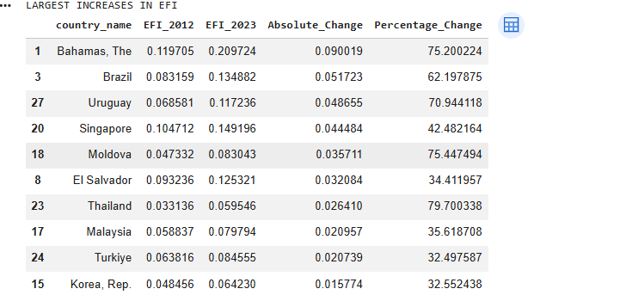
Other countries, including Singapore and Moldova, experienced notable increases in their economic fragility scores. Thailand recorded the highest percentage increase among the reported countries, reaching approximately 79.70%.
In contrast, Iceland recorded the largest absolute decrease in EFI, falling from 0.1653 in 2012 to 0.1055 in 2023, corresponding to a reduction of 36.20%. Greece and Bosnia and Herzegovina also experienced substantial decreases. Lithuania recorded the largest percentage decrease, reaching approximately 46.70%.
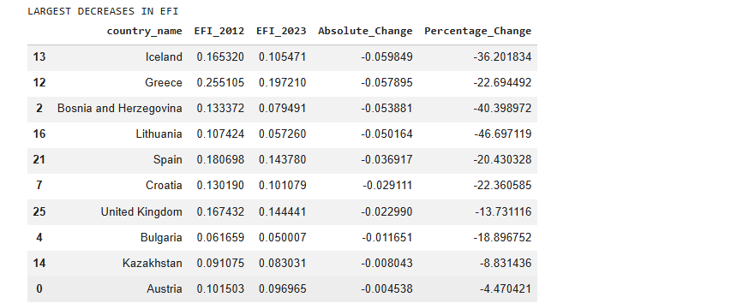
Across all 28 countries, the mean absolute change in EFI was 0.0031, while the median change was 0.0046. The mean percentage change reached 12.54%, compared with a median of 4.53%. These results indicate a modest overall increase in economic fragility, although individual country experiences varied considerably.
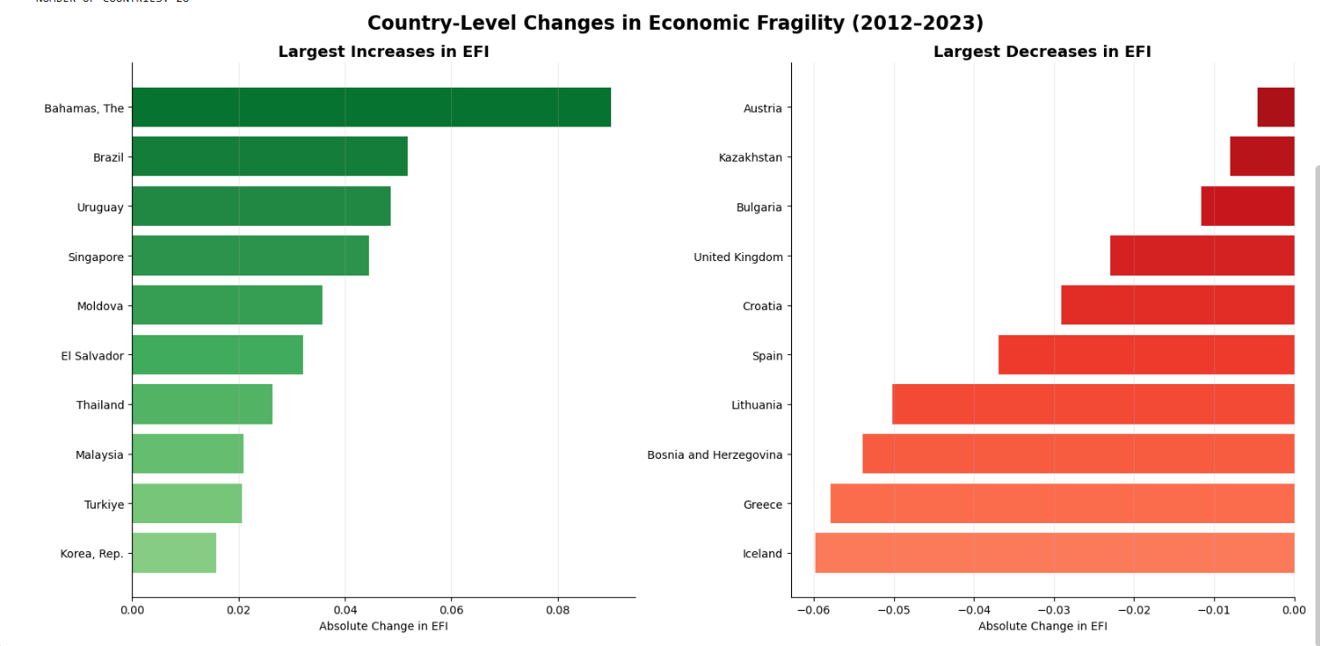
Overall, the comparison demonstrates that economic fragility did not evolve uniformly across countries. While some economies experienced increasing vulnerability during the observation period, others recorded improvements according to the proposed index. These differences highlight the importance of examining country-specific economic conditions rather than relying exclusively on aggregate trends.

5.11 Final Numerical Findings
The numerical implementation produced 714 valid EFI observations by combining Trade Vulnerability, Macroeconomic Instability, and Fiscal Vulnerability using equal weights (one-third each). The EFI recorded a mean of 0.1168, a standard deviation of 0.0517, and values ranging from 0.0331 to 0.3381.
The observations were classified into four categories—Low, Moderate, High, and Critical Fragility—using the 25th, 50th, and 75th percentile thresholds (0.079811, 0.107056, and 0.145539, respectively). The resulting distribution included 179 Low, 178 Moderate, 178 High, and 179 Critical Fragility observations.
Sensitivity analysis showed strong ranking consistency across alternative weighting scenarios, with Spearman correlations ranging from 0.9509 to 0.9692. However, classification agreement ranged from 75.77% to 80.25%, indicating some sensitivity to weighting assumptions.
Country comparisons identified Palau as having the highest average EFI and Thailand the lowest. Temporally, 2020 recorded the highest annual average EFI (0.1420). This increase was also observed in a balanced panel of 28 countries, confirming that it was not solely due to changes in annual country coverage.
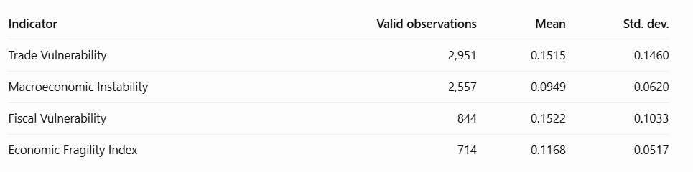
5.11.1 Limitations of the Numerical Model
Despite its successful implementation, the Economic Fragility Index has several limitations. Significant missing data, particularly in Public Debt (2,107 missing observations), restricted Fiscal Vulnerability to 844 observations. Consequently, only 714 of the original 2,951 country-year observations (24.20%) were included in the final EFI.
Country coverage also varied over time: although 81 countries had valid EFI observations, only 28 had complete coverage from 2012 to 2023. A balanced panel was therefore used for temporal comparisons. Additionally, Min-Max Normalization is sensitive to extreme values, while equal weighting represents a methodological assumption. Sensitivity analysis showed that some classifications changed under alternative weighting scenarios.
Finally, the EFI is a comparative indicator based on selected economic variables. It does not measure crisis probabilities, establish causal relationships, or capture every aspect of economic vulnerability. Nevertheless, it provides a structured framework for combining trade, macroeconomic, and fiscal indicators into a unified measure of economic fragility.
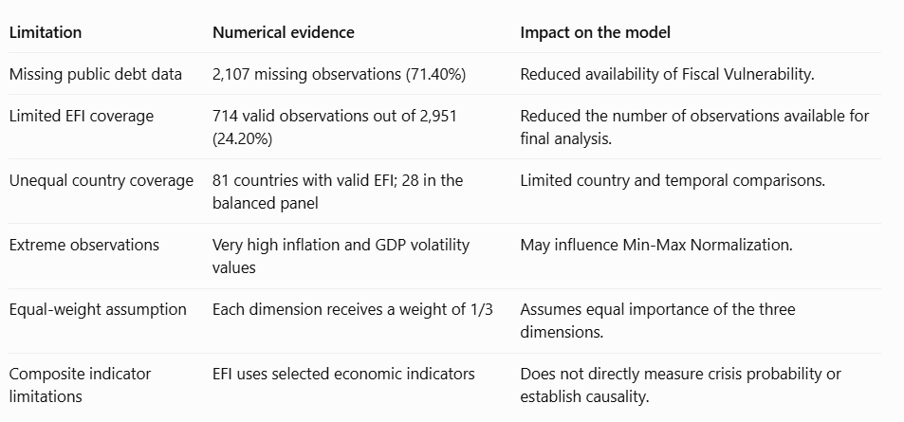
5.11.2 Numerical Consistency and Implementation Checks
Several consistency checks were conducted to verify the numerical implementation. No duplicate country-year records were identified, and the fiscal deficit calculation matched the original fiscal balance values exactly. All available normalized indicators remained within the required range of 0 to 1.
The baseline EFI was also independently recalculated, producing a maximum absolute difference of approximately (5.55 \times 10^{-17}), confirming numerical equivalence between both calculations. These checks support the accuracy and internal consistency of the implemented mathematical model.
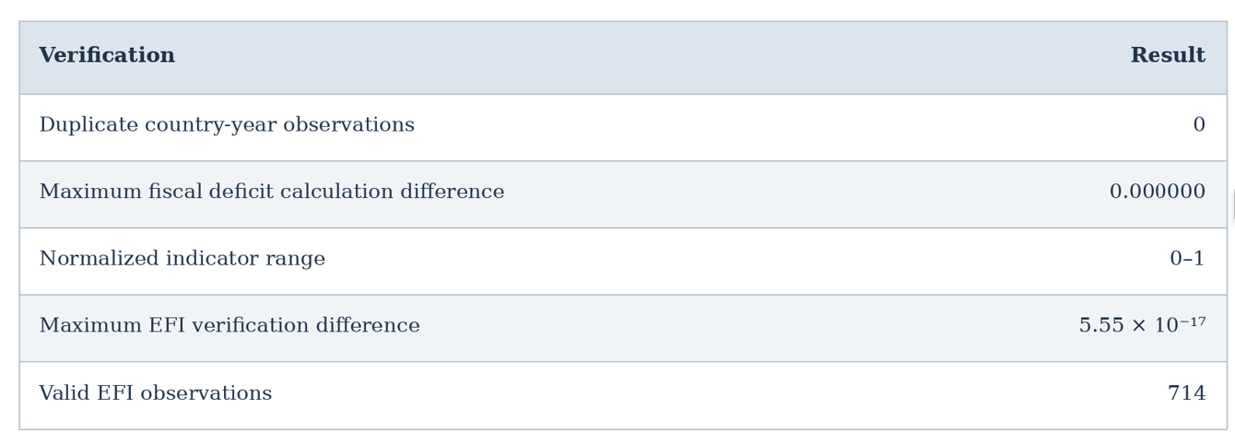

6. Machine Learning Implementation
Machine Learning is an important component of this study because it allows economic data to be analyzed using computational algorithms that can identify patterns and relationships between different economic indicators.
After constructing the Economic Fragility Index (EFI) in the previous chapter, Machine Learning techniques are introduced to examine whether economic indicators can be used to identify different levels of economic fragility across countries.
In general, supervised Machine Learning involves two main approaches: Regression and Classification. The selection of the appropriate approach depends on the type of outcome that the model aims to predict.
6.1 Selection of the Machine Learning Approach
There are two main approaches in supervised Machine Learning:
1. Regression
Regression is used when the objective is to predict a continuous numerical value. For example, a regression model could predict the exact Economic Fragility Index of a country, such as 0.16.
2. Classification
Classification is used when the objective is to assign observations to predefined categories. Instead of predicting an exact numerical value, the model identifies the category to which an observation belongs.
For this study, the Classification approach was selected because the objective is to identify the level of economic fragility across countries rather than predict an exact EFI value. Based on the classification procedure established in Chapter 5, four economic fragility categories were defined:
- Low Fragility
- Moderate Fragility
- High Fragility
- Critical Fragility
These four categories will serve as the target variable for the Machine Learning models. The classification approach will therefore allow the study to examine whether selected economic indicators can distinguish between different levels of national economic fragility.
6.2 Dataset Preparation for Machine Learning
The Machine Learning dataset was derived from the integrated economic dataset containing 2,951 country-year observations. Following the construction of the Economic Fragility Index, 714 observations with valid EFI values and classifications were selected for analysis.
Each observation represents a country-year record containing economic indicators, the EFI score, and its corresponding fragility category. The dataset was examined to identify suitable input features, assess missing values, and define the classification target.
The four economic fragility categories serve as the target variable, while the remaining suitable economic indicators are used as input features. The final Machine Learning dataset contains 714 observations, 43 variables, and 81 countries.
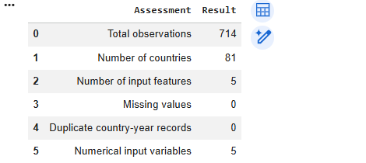
The selected five input features contained no missing values, meaning that no additional missing-value treatment was required for these variables. Furthermore, the distribution of the target categories was approximately balanced, with 179 observations classified as Low Fragility, 178 as Moderate Fragility, 178 as High Fragility, and 179 as Critical Fragility.
This balanced distribution provides a suitable starting point for multiclass classification without requiring additional class-balancing techniques.
6.3 Selection of Features and Target Variable
Following the dataset preparation, five economic variables were selected as input features for the Machine Learning models. These variables were chosen to represent different aspects of national economic conditions, including trade openness, external trade balance, external financial position, economic development, and time.
The selected input features are Trade Openness (% GDP), Trade Balance (% GDP), Current Account Balance (% GDP), GDP per Capita, and Year.
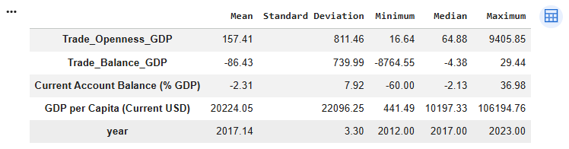
Descriptive statistics revealed considerable differences in the scales and distributions of the selected variables. GDP per Capita recorded a mean of $20,224.05, while Trade Openness and Trade Balance showed substantial variability, highlighting the need to examine extreme values and apply feature scaling where necessary.
The target variable, EFI_Category, consists of four classes: Low, Moderate, High, and Critical Fragility. To prevent data leakage, the EFI score and indicators used in its construction were excluded from the predictors. Country identifiers were also removed.
The remaining economic indicators were selected as input features to evaluate their ability to distinguish between different levels of economic fragility.
6.4 Data Preprocessing and Feature Scaling
Before training, the five selected numerical features were checked and confirmed to contain no missing values, requiring no encoding or imputation.
Since the variables had different numerical scales, RobustScaler was applied to scale-sensitive algorithms, including K-Nearest Neighbors, Support Vector Machines, and Logistic Regression. Scaling parameters were calculated using training data only to prevent data leakage.
Tree-based models, such as Decision Trees and Random Forests, were used without feature scaling because they are generally unaffected by differences in variable magnitudes.
6.5 Training and Testing Data Split
Before training the Machine Learning algorithms, the prepared dataset was divided into training and testing subsets. This division allows the models to learn from one portion of the observations and subsequently evaluate their classification performance on unseen data.
An 80/20 training-testing strategy was selected, allocating approximately 80% of the observations for model training and 20% for testing. The division was implemented using the StratifiedGroupKFold method with five folds, selecting one fold for testing.
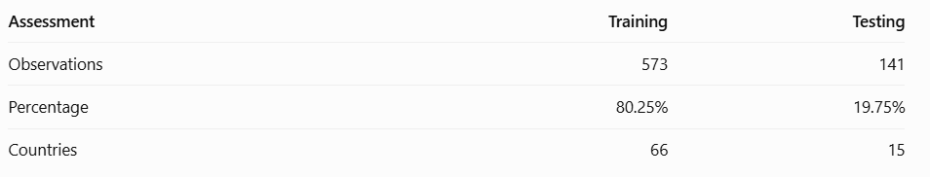
Since the dataset contains repeated observations for the same countries across different years, the country name was used as a grouping variable. This approach ensures that observations belonging to the same country are not distributed between the training and testing subsets, reducing the risk of country-level data leakage.
The resulting training dataset contained 573 observations representing 66 countries, while the testing dataset contained 141 observations representing 15 countries. No countries were shared between the two subsets.
Furthermore, all four economic fragility categories were represented in both datasets. The training and testing distributions remained reasonably balanced, allowing the classification algorithms to learn and evaluate the different levels of economic fragility.
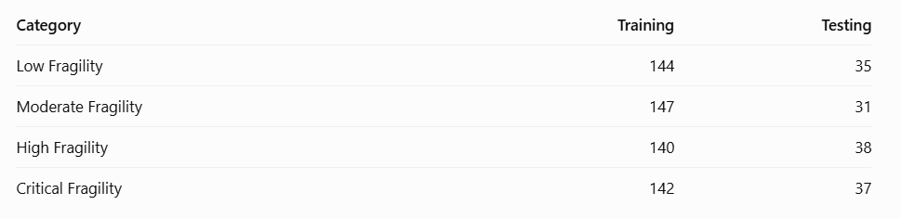
The resulting datasets were retained for the subsequent training and evaluation of the selected Machine Learning algorithms.
6.6 Training Machine Learning Models
Six supervised Machine Learning algorithms were selected: Logistic Regression, K-Nearest Neighbors (KNN), Decision Tree, Random Forest, Support Vector Machine (SVM), and Gradient Boosting.
All models use the same five input features and target variable, with 573 observations for training and 141 for testing. Feature scaling is incorporated into the pipelines of algorithms sensitive to numerical differences, ensuring a fair performance comparison.
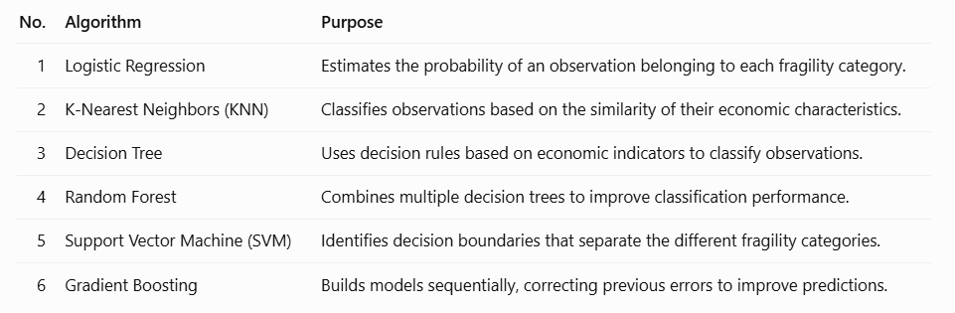
The six classification algorithms were implemented using Python and Scikit-learn, each configured according to its learning mechanism to compare multiclass classification performance.
Since the variables had different numerical scales, RobustScaler was applied to scale-sensitive algorithms, including K-Nearest Neighbors, Support Vector Machines, and Logistic Regression. Scaling parameters were calculated using training data only to prevent data leakage.
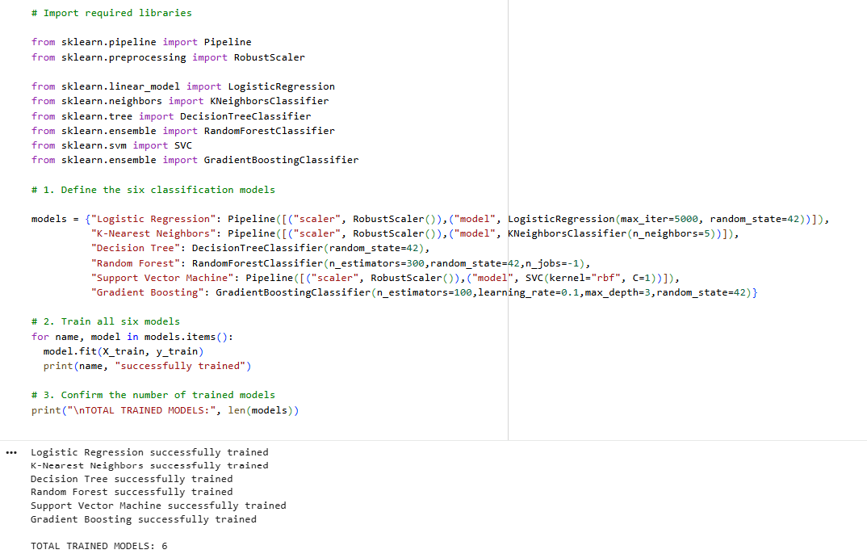
The implementation involved defining the six classification algorithms and fitting each model using the training features (X_train) and their corresponding target categories (y_train). RobustScaler was applied within the pipelines of Logistic Regression, K-Nearest Neighbors, and Support Vector Machine. This ensures that scaling parameters are learned from the training data and that the same transformation can subsequently be applied to the testing data.
The Random Forest model was configured with 300 decision trees, while the Gradient Boosting model used 100 boosting stages with a learning rate of 0.1. The K-Nearest Neighbors algorithm used five neighbors, and the Support Vector Machine employed a radial basis function (RBF) kernel. After fitting the models, their classification performance was evaluated using the testing dataset, allowing a comparison of their ability to identify the four economic fragility categories.
6.7 Evaluation of Machine Learning Models
The six classification models were evaluated using an independent testing dataset of 141 observations from 15 countries. Performance was assessed using Accuracy, Precision, Recall, and F1-score. Accuracy measures overall correctness, while Precision and Recall evaluate prediction reliability and the identification of actual categories. F1-score combines Precision and Recall.
Since the study involves four economic fragility categories, macro-averaged Precision, Recall, and F1-score were used to give each category equal importance. Confusion matrices were also generated to examine correct and incorrect predictions across the four categories. These metrics provide a basis for comparing model performance and identifying the most reliable classifier.
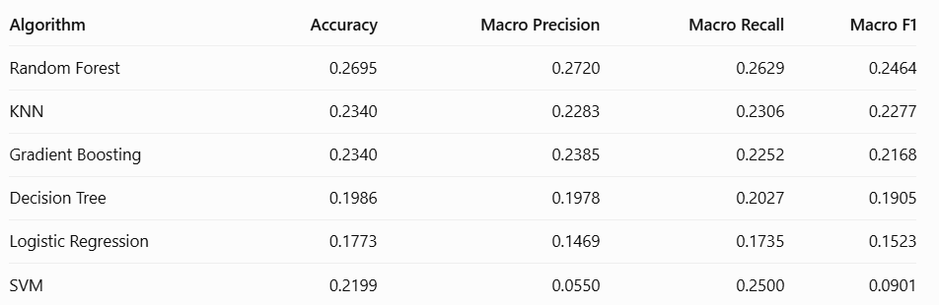
The results indicate that Random Forest achieved the highest overall performance among the six classification algorithms, recording an accuracy of 26.95% and a macro F1-score of 0.2464. It also obtained the highest macro precision and macro recall, with values of 0.2720 and 0.2629, respectively.
K-Nearest Neighbors and Gradient Boosting achieved the second-highest accuracy, both recording 23.40%. However, K-Nearest Neighbors obtained a higher macro F1-score of 0.2277 compared with 0.2168 for Gradient Boosting.
Decision Tree achieved an accuracy of 19.86%, while Logistic Regression recorded the lowest accuracy at 17.73%. Support Vector Machine achieved an accuracy of 21.99%, but its macro F1-score was only 0.0901, indicating considerable difficulty in distinguishing between the four fragility categories.
Overall, Random Forest was the strongest algorithm among those evaluated. Nevertheless, the performance of all six models remained relatively low, indicating that the selected economic features provided limited predictive information for accurately identifying economic fragility categories.
Interpretation of Confusion Matrices
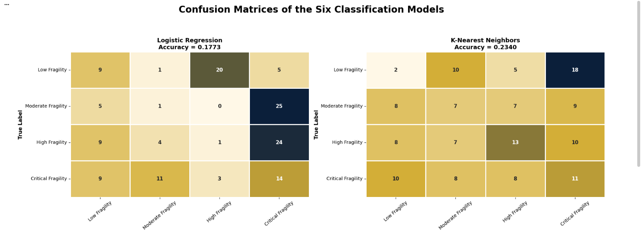
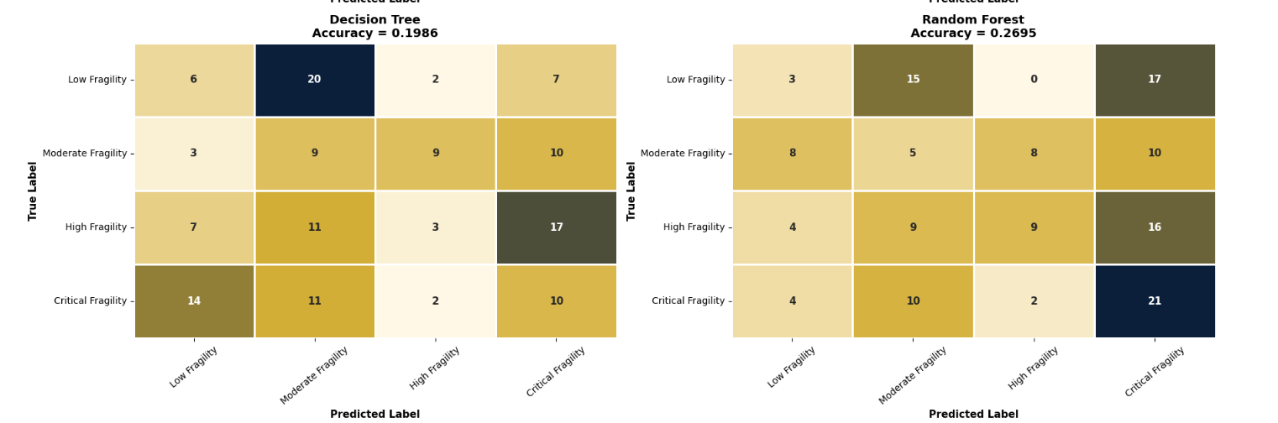
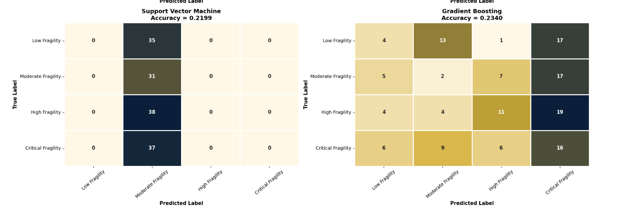
The confusion matrices provide further insight into the classification performance of the six algorithms by showing the number of correctly and incorrectly classified observations for each economic fragility category.
Random Forest demonstrated its strongest performance in identifying Critical Fragility, correctly classifying 21 out of 37 observations. It also correctly identified 9 High Fragility observations. However, its performance was weaker for Low and Moderate Fragility, with only 3 and 5 observations correctly classified, respectively.
K-Nearest Neighbors performed relatively better in identifying High Fragility, correctly classifying 13 out of 38 observations. Gradient Boosting also showed better recognition of High Fragility, correctly identifying 11 observations.
Decision Tree and Logistic Regression experienced considerable confusion between the different categories. In particular, Logistic Regression correctly identified only one Moderate Fragility observation and one High Fragility observation.
Support Vector Machine demonstrated the weakest classification behavior. As shown in Figure 6.2, all 141 testing observations were assigned to Moderate Fragility, meaning that the model failed to distinguish between the four economic fragility categories.
Overall, the confusion matrices confirm that distinguishing between the four economic fragility levels remains challenging for the selected algorithms. Although Random Forest achieved the strongest overall performance, considerable misclassification remained across the different categories.
6.8 Comparison and Selection of the Best-Performing Model
The confusion matrices revealed differences in classification performance across the six models. Random Forest performed best in identifying Critical Fragility (21 out of 37) and correctly classified 9 High Fragility observations, but struggled with Low and Moderate Fragility. KNN and Gradient Boosting showed better recognition of High Fragility, correctly identifying 13 and 11 observations, respectively.
Decision Tree and Logistic Regression showed considerable misclassification, while SVM performed worst by assigning all 141 testing observations to Moderate Fragility.
Overall, Random Forest demonstrated the strongest classification performance, although considerable misclassification remained across all four categories.
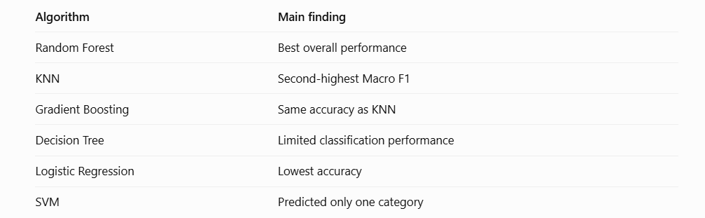
6.9 Feature Importance Analysis
Following the selection of Random Forest as the best-performing classification algorithm, a feature importance analysis was conducted to examine the relative contribution of the selected economic indicators to the model's classification decisions.
The analysis considers the five input features used to classify the four economic fragility categories: Trade Openness relative to GDP, GDP per Capita, Trade Balance relative to GDP, Current Account Balance, and Year.
The purpose of this analysis is to identify which economic indicators contributed most to the classification process and to better understand the variables used by the selected Machine Learning model.
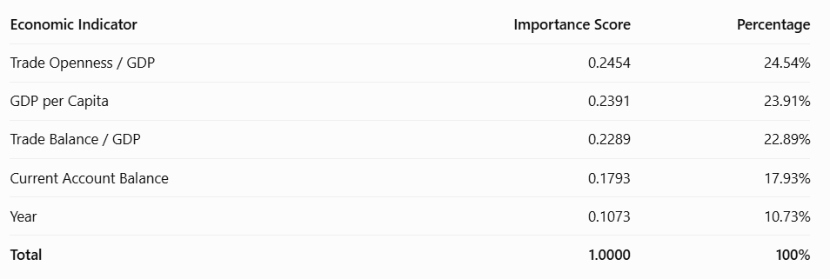
To provide a clearer visual comparison of the relative importance of the five input features, the importance scores were represented using a horizontal bar chart. Figure 6.3 illustrates the contribution of each economic indicator to the Random Forest classification model.
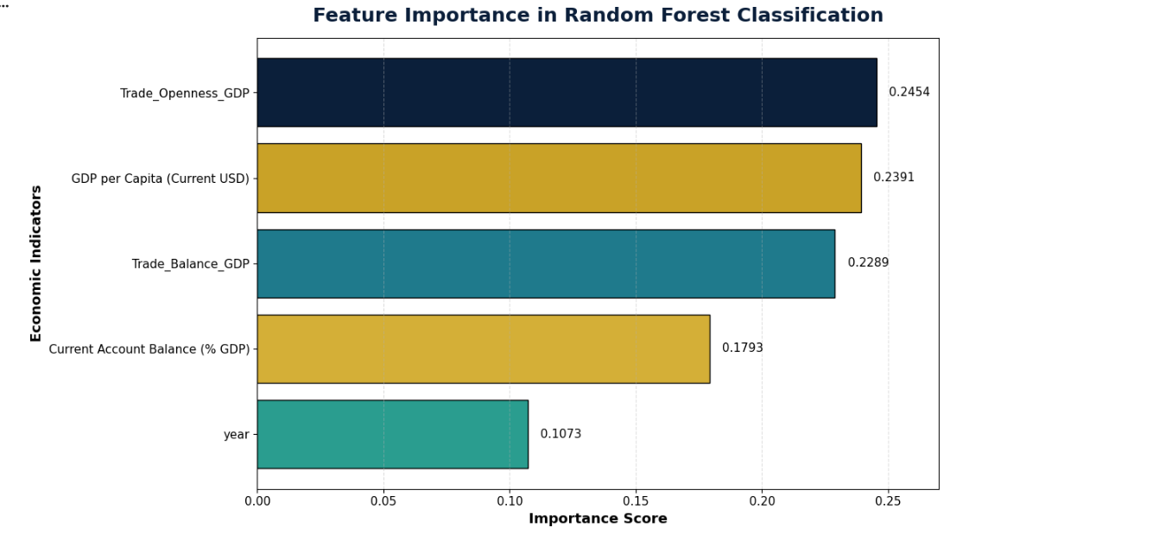
Interpretation of Feature Importance Results
The Random Forest feature importance analysis identified Trade Openness relative to GDP as the most important variable (24.54%), followed by GDP per Capita (23.91%) and Trade Balance relative to GDP (22.89%). Current Account Balance contributed 17.93%, while Year had the lowest importance (10.73%).
The three leading indicators accounted for 71.34% of total feature importance, highlighting the role of trade conditions and income levels in the model's classification decisions.
However, feature importance indicates predictive contribution rather than causality or the direction of an economic effect. Given the model's relatively low macro F1-score (0.2464), these results should be interpreted cautiously.
6.10 Limitations of the Machine Learning Analysis
Despite the implementation of six classification algorithms, several limitations affected the results. First, only 714 of the original 2,951 observations were available for Machine Learning, limiting the training and testing data.
Second, classification performance was relatively low. Random Forest achieved the highest accuracy (26.95%) and a macro F1-score of 0.2464, indicating difficulties in distinguishing between the four fragility categories. The analysis also relied on only five input features, limiting the information available to the models.
Furthermore, the models classified categories derived from the EFI rather than directly predicting future economic crises. Feature importance reflects the model's internal behavior and does not establish causal relationships. These limitations should be considered when interpreting the results and evaluating the models' applications.
6.11 General Conclusion of the Machine Learning Analysis
This chapter applied six supervised Machine Learning algorithms to classify economic fragility into four categories: Low, Moderate, High, and Critical. The analysis used 714 valid observations covering 81 countries and five economic indicators, divided into training and testing datasets.
Random Forest achieved the best performance, with 26.95% accuracy and a macro F1-score of 0.2464. Feature importance identified Trade Openness, GDP per Capita, and Trade Balance as the three most influential variables.
However, the relatively low performance indicates difficulties in distinguishing between the four categories using the selected indicators. Overall, the analysis demonstrates the potential of Machine Learning in economic vulnerability research while highlighting the need for improved features and models.

7. Explainable Artificial Intelligence (SHAP)
7.1 Introduction to Explainable AI
Following the evaluation of six Machine Learning models, SHAP (SHapley Additive exPlanations) was applied to interpret the predictions of the Random Forest model, which achieved the best overall performance.
The analysis examines how individual economic indicators influence model classifications through global explanations (overall feature importance) and local explanations (contributions to individual predictions). However, SHAP explains model behavior and does not establish causal relationships between economic indicators and fragility.
7.2 Global SHAP Feature Importance
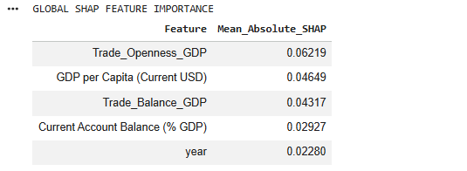
The SHAP analysis identified Trade Openness as the most influential feature, with a mean absolute SHAP value of 0.06219, followed by GDP per Capita (0.04649), Trade Balance (0.04317), and Current Account Balance (0.02927). Year had the lowest importance (0.02280).
These results highlight the importance of trade-related indicators and economic development in the model's classification decisions. However, mean absolute SHAP values measure the magnitude of feature contributions, not whether they increase or decrease predicted economic fragility.
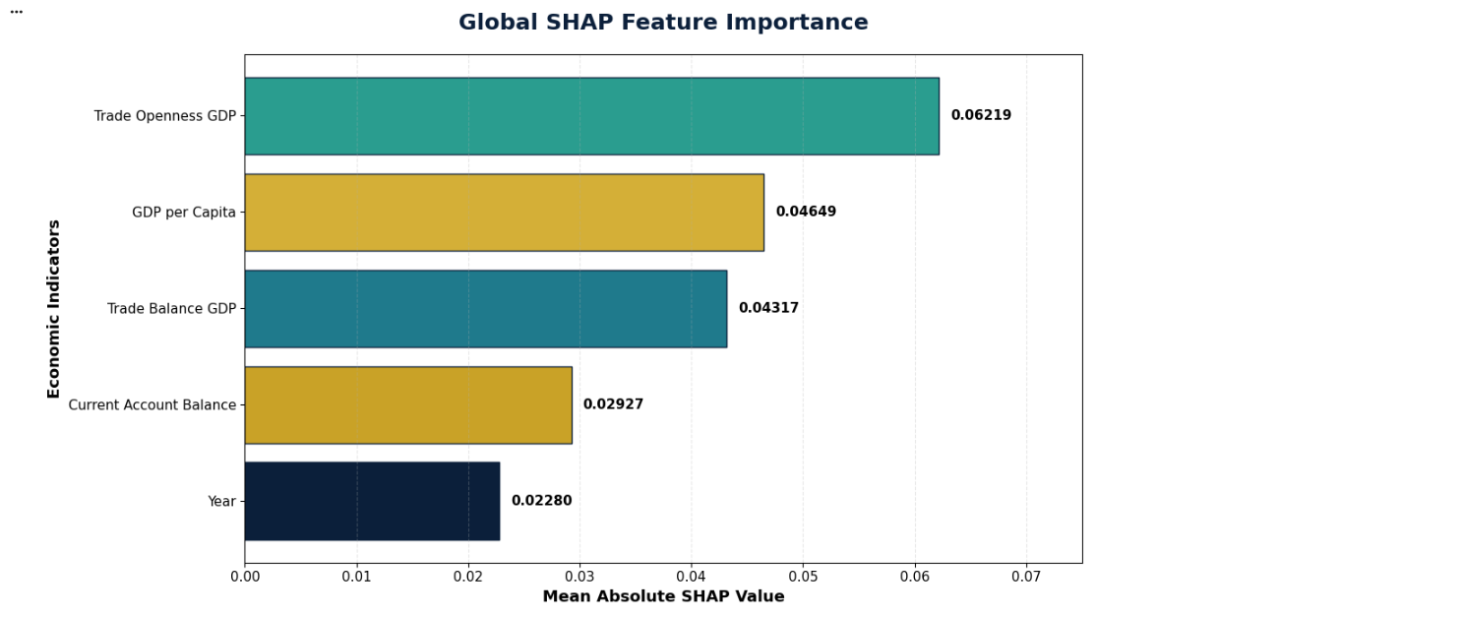
7.3 SHAP Summary Plot
While global SHAP feature importance measures the overall magnitude of each feature's contribution, SHAP summary plots provide additional information about the direction and distribution of these contributions.
The summary plots illustrate how different values of economic indicators influence the classification decisions of the Random Forest model. They also show the variation in feature contributions across individual country-year observations.
Since the study involves four economic fragility categories, separate SHAP summary plots are generated for each category to examine the factors influencing the model's classification decisions.
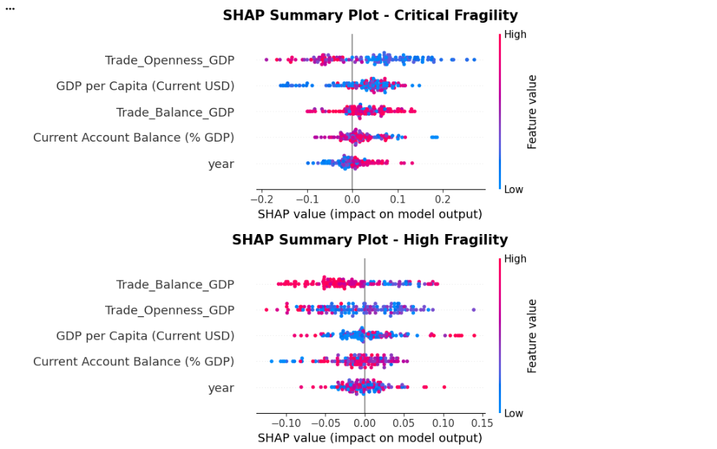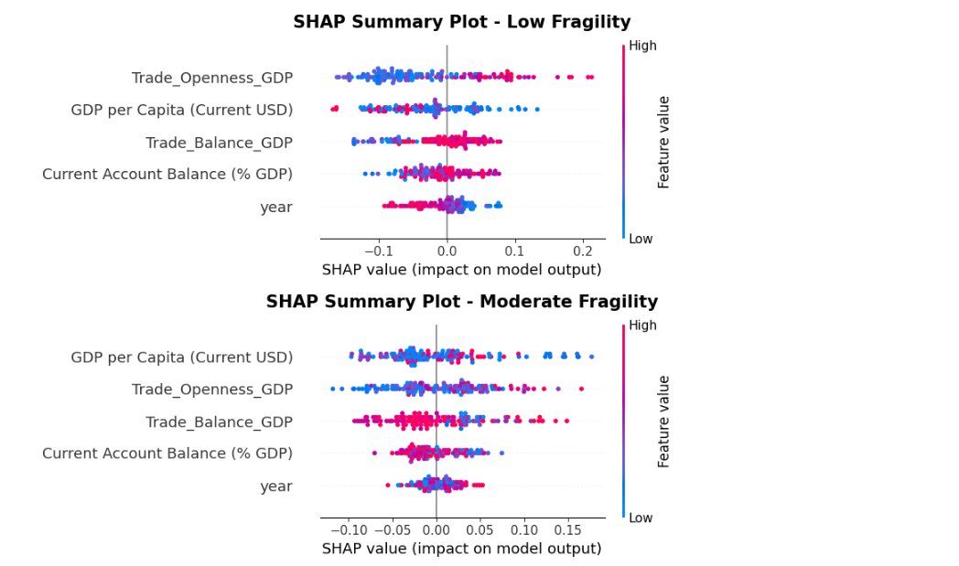
7.4 Local SHAP Analysis
Local SHAP analysis was conducted to explain individual classification decisions by identifying which economic indicators positively or negatively influenced each prediction.
To illustrate this approach, Albania's 2012 testing observation was selected. The Random Forest model classified it as Low Fragility, and SHAP was used to examine the contribution of each feature to this prediction.
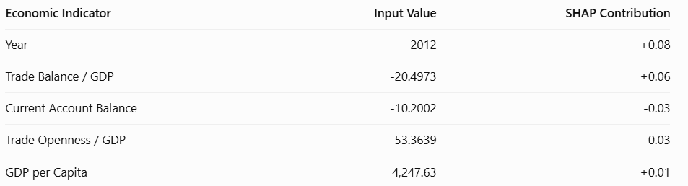

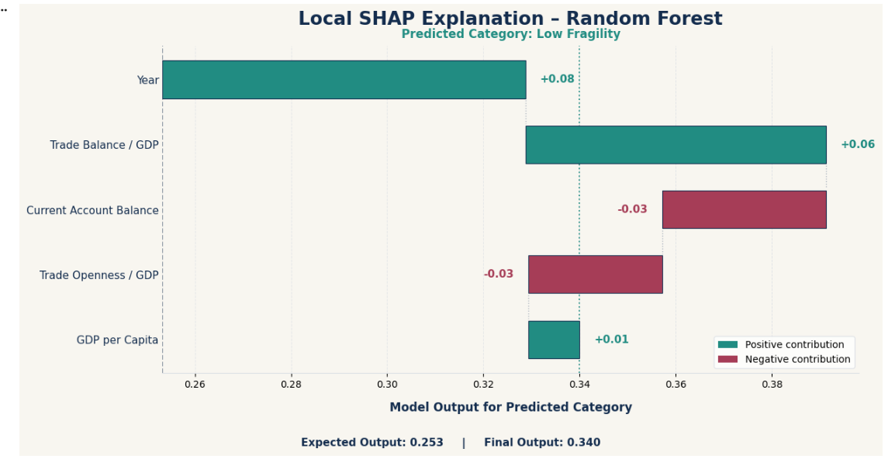
The local SHAP analysis demonstrates how individual economic indicators contribute to the classification of a specific country-year observation. In the selected example, the combined contributions of the five economic indicators moved the model output from an expected value of approximately 0.253 to a final value of approximately 0.34 for the Low Fragility category.
This example illustrates the usefulness of SHAP in providing transparent explanations of individual Machine Learning predictions. It also demonstrates that different economic indicators can contribute in different directions to the final classification.
7.5 Comparison Between SHAP and Random Forest Feature Importance
To examine the consistency of the feature importance results, a comparison was conducted between the built-in Random Forest feature importance method and the global SHAP analysis.
Both methods were used to identify the economic indicators that contributed most to the classification decisions of the selected Random Forest model. This comparison helps determine whether the two interpretation techniques provide similar rankings of the selected economic indicators.
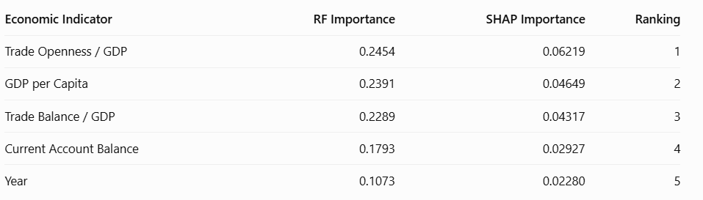The comparison reveals that both methods produced exactly the same ranking of the five economic indicators.
Trade Openness relative to GDP was identified as the most important variable by both methods, followed by GDP per Capita and Trade Balance relative to GDP. Current Account Balance ranked fourth, while Year recorded the lowest importance.
The agreement between the two methods indicates consistency in identifying the variables most influential in the Random Forest classification process.
In particular, the results highlight the importance of trade-related indicators and economic development measures in the model's classification decisions.
However, this agreement does not establish causal relationships or independently validate the predictive accuracy of the model.
7.6 Limitations of SHAP Analysis
SHAP analysis has several limitations. First, its explanations depend on the trained Random Forest model and may differ across algorithms. Second, SHAP identifies contributions to predictions but does not establish causal relationships.
Furthermore, the relatively low model performance (26.95% accuracy and 0.2464 macro F1-score) limits the reliability of its explanations. The local analysis also focused on one observation (Albania, 2012), so its findings cannot be generalized to all countries and years.
Finally, the agreement between Random Forest feature importance and SHAP rankings indicates consistency between the interpretation methods but does not independently validate the predictions. Therefore, SHAP results should be interpreted alongside model performance and economic context.
7.7 General Conclusion of the SHAP Analysis
The SHAP analysis improved the interpretability of the Random Forest model by explaining the contribution of individual economic indicators. Global analysis identified Trade Openness, GDP per Capita, and Trade Balance as the most influential features, consistent with the model's feature importance rankings.
Local analysis demonstrated how individual indicators influenced a specific prediction, using Albania (2012), which was classified as Low Fragility.
Overall, SHAP provided both global and local explanations of model predictions. However, the results should be interpreted cautiously due to the model's limited predictive performance and the non-causal nature of SHAP explanations.

8. Interactive Economic Dashboard
8.1 Introduction
To complement the statistical and machine learning analyses, an interactive economic dashboard was developed using Microsoft Power BI. The objective of this dashboard is to provide a clear and interactive overview of macroeconomic performance and international trade across countries.
The dashboard combines macroeconomic indicators and international trade measurements into a single visual environment. It allows users to examine economic conditions, compare countries, identify trade imbalances, and observe changes in international trade over time.
The dashboard covers the period from 2010 to 2024 and integrates nine Key Performance Indicators (KPIs), four main visualizations, and interactive country and year filters.
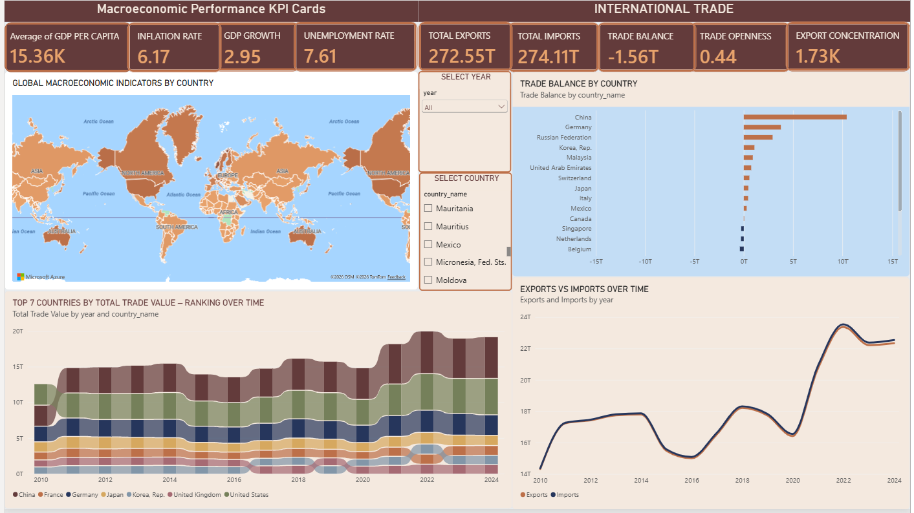
8.2 Dashboard Structure and Key Performance Indicators
The dashboard is organized into two main sections: Macroeconomic Performance and International Trade.
8.2.1 Macroeconomic Performance KPIs
The first section focuses on four indicators used to evaluate the general economic performance of countries.
- GDP per Capita: Measures economic output per person and provides an indication of average economic prosperity.
- Inflation Rate: Measures the increase in the general price level and reflects changes in purchasing power.
- GDP Growth: Measures the annual percentage change in economic output and indicates the pace of economic expansion or contraction.
- Unemployment Rate: Measures the percentage of the labor force that is unemployed and actively seeking employment.
These indicators provide an overview of economic performance and help identify differences in economic conditions across countries.
8.2.2 International Trade KPIs
The second section focuses on five indicators related to international trade and external economic dependence.
- Total Exports: Represents the total value of goods and services exported.
- Total Imports: Represents the total value of goods and services imported.
- Trade Balance: Measures the difference between exports and imports. A positive value indicates a trade surplus, while a negative value indicates a trade deficit.
- Trade Openness: Measures the importance of international trade relative to the size of the economy.
- Export Concentration: Measures the degree to which exports depend on a limited number of products or trading partners, depending on the concentration measure used.
Together, these indicators provide information about the scale of international trade, external imbalances, and potential sources of economic vulnerability.
8.3 Macroeconomic Indicators by Country
A filled map visualization was included to present the geographical distribution of macroeconomic indicators across countries. The map provides a geographical perspective on economic differences and allows users to identify variations in economic conditions between regions.
By selecting individual countries, users can examine their economic indicators and compare their performance with other countries included in the dataset. This visualization complements the KPI cards by adding a geographical dimension to the analysis.
8.4 International Trade Analysis
Three visualizations were developed to examine international trade patterns from different perspectives.
8.4.1 Trade Balance by Country
A horizontal diverging bar chart was used to compare trade balances across countries. Countries with positive trade balances are represented on one side of the zero reference line, while countries with negative trade balances appear on the opposite side.
This visualization helps identify countries with significant trade surpluses and countries experiencing trade deficits. It also provides insight into differences in international trade positions. In the current dashboard view, China displays the largest positive trade balance among the visible countries, while other countries show smaller positive or negative balances.
8.4.2 Top Seven Countries by Total Trade Value – Ranking Over Time
A ribbon chart was developed to examine changes in the international trade positions of the seven countries with the highest total trade value. The visualization covers the period from 2010 to 2024 and includes China, France, Germany, Japan, South Korea, the United Kingdom, and the United States.
The chart illustrates changes in the relative ranking of these countries over time. It helps identify countries that maintain strong positions in international trade and those whose relative positions change throughout the observation period. This visualization is particularly useful for understanding the evolution of global trade dominance.
8.4.3 Exports vs. Imports Over Time
A two-series line chart was developed to compare the evolution of total exports and total imports between 2010 and 2024. The visualization shows that exports and imports follow relatively similar patterns over the observation period.
Both series experienced a decline between 2014 and 2016, followed by a recovery in the following years. Another decline is visible around 2019–2020, followed by a substantial increase between 2021 and 2022. The values then decreased slightly and stabilized toward 2024. Comparing these two indicators provides an overview of changes in international trade activity and helps identify periods of expansion and contraction.
8.5 Interactive Dashboard Features
To improve usability and facilitate country-level analysis, two interactive slicers were incorporated:
- Country Selection: Allows users to select individual countries and examine their economic and trade indicators.
- Year Selection: Allows users to select a specific year and analyze changes in economic and trade performance.
These filters make the dashboard dynamic by allowing users to explore different countries and periods without requiring separate static visualizations.
8.6 Economic Interpretation
The dashboard combines macroeconomic performance with international trade indicators to provide a broader understanding of economic conditions. An important aspect of the analysis is that strong international trade activity does not necessarily indicate low economic vulnerability. Countries may have high export and import values while remaining exposed to trade imbalances or concentrated export structures.
Similarly, macroeconomic indicators such as inflation, unemployment, and GDP growth provide additional information about the internal economic conditions of countries. By examining these indicators together, the dashboard provides a foundation for identifying potential sources of economic vulnerability and supports the subsequent statistical and machine learning analyses.
8.7 Conclusion
The Power BI dashboard provides an interactive visualization of macroeconomic performance and international trade across countries over the period 2010–2024. Through its nine KPI cards, geographical map, trade balance comparison, ribbon chart, and exports-versus-imports line chart, it presents several dimensions of economic performance within a single interface.
The dashboard complements the mathematical and statistical models by making the results easier to interpret and compare. It also provides an accessible way to explore international trade patterns and investigate potential economic vulnerabilities at the country level.

9. Discussion and Findings
9.1 Introduction
This chapter discusses the main findings of the research and examines their implications for understanding the hidden economic vulnerabilities of national economies. The discussion combines the results obtained from the Economic Fragility Index (EFI), the numerical analysis, Machine Learning models, and Explainable Artificial Intelligence (SHAP).
The main objective is to understand whether conventional measures of economic performance provide a complete representation of national economic stability, or whether additional structural factors, particularly international trade concentration and fiscal vulnerability, reveal weaknesses that may not be immediately visible.
The findings are discussed at the overall, country, and temporal levels to identify differences in economic fragility and examine the contribution of different economic dimensions.
9.2 Overall Economic Fragility
The construction of the Economic Fragility Index provides a unified measure combining three dimensions: Trade Vulnerability, Macroeconomic Instability, and Fiscal Vulnerability. The numerical analysis produced 714 valid country-year EFI observations from the 2,951 observations available in the integrated dataset.
The resulting EFI had a mean of 0.1168, a median of 0.1071, and a standard deviation of 0.0517. The observed values ranged from 0.0331 to 0.3381. These results demonstrate considerable variation in economic fragility across the available country-year observations. The differences indicate that national economies do not experience the same level of vulnerability and that economic conditions vary according to their trade structures, macroeconomic performance, and fiscal positions.
An important implication is that economic performance and economic stability should not be considered identical. A country may participate extensively in international trade or experience positive economic growth while maintaining structural vulnerabilities in other dimensions. Therefore, the EFI provides a broader perspective for examining economic conditions beyond individual indicators.
9.3 Differences in Economic Fragility Across Countries
The country-level analysis revealed substantial differences in average economic fragility. Among the 58 countries retained for comparison, based on the requirement of at least eight valid EFI observations, Palau recorded the highest average EFI at 0.2555. It was followed by Greece at 0.2415 and the Marshall Islands at 0.2204. Bhutan and Botswana also recorded relatively high average values.
In contrast, Thailand recorded the lowest average EFI at 0.0463, followed by Switzerland at 0.0493 and Estonia at 0.0495. These differences illustrate the importance of examining several dimensions of economic vulnerability simultaneously. The EFI provides a comparative framework for identifying countries with different combinations of trade-related, macroeconomic, and fiscal weaknesses.
However, these rankings should be interpreted within the available sample and observation period. They do not represent universal rankings of national economic risk.
9.4 Evolution of Economic Fragility Over Time
The temporal analysis identified differences in economic fragility across the observation period. The highest annual average EFI was recorded in 2020, reaching 0.1420. This indicates increase in measured economic vulnerability during that year.
The increase is particularly relevant because 2020 represented a period of substantial disruption to international economic activity. Nevertheless, the observed association should not be interpreted as proof that a specific event caused the increase in EFI.
To examine whether the temporal pattern was influenced by changes in country coverage, a balanced panel of 28 countries was also analyzed. The results confirmed that the increase was not solely attributable to variations in the number of countries included in each year's calculations. This comparison strengthens the interpretation of the temporal results while highlighting the importance of consistent data coverage in international economic analysis.
9.5 Robustness of the Economic Fragility Index
Sensitivity analysis was conducted to evaluate the effect of alternative weighting assumptions on the EFI. The baseline model assigned equal weights to Trade Vulnerability, Macroeconomic Instability, and Fiscal Vulnerability. Three alternative scenarios were subsequently examined by assigning greater importance to each dimension separately.
The Spearman rank correlations between the baseline model and the alternative scenarios ranged from 0.9509 to 0.9692. These relatively high correlations indicate that the overall ranking of country-year observations remained generally consistent under alternative weighting configurations.
However, classification agreement ranged from 75.77% to 80.25%. This indicates that changes in the weighting assumptions can influence the classification of individual observations, even when the overall ranking remains relatively stable. Consequently, the equal-weight model provides a transparent baseline specification, while the sensitivity analysis demonstrates the importance of considering methodological assumptions when interpreting composite economic indicators.
9.6 Machine Learning Findings
Machine Learning techniques were applied to examine patterns associated with the classification of economic fragility across countries and years.
Six classification algorithms were evaluated using accuracy, precision, recall, and F1-score. Among them, Random Forest achieved the best overall performance, with an accuracy of 26.95% and a macro F1-score of 0.2464.
However, the relatively low performance indicates difficulties in distinguishing between the four economic fragility categories. The confusion matrices revealed that Random Forest performed best in identifying Critical Fragility, correctly classifying 21 out of 37 observations. Nevertheless, misclassification remained considerable across the other categories. SVM demonstrated the weakest performance, assigning all testing observations to Moderate Fragility.
These findings suggest that the five selected economic indicators provided limited classification power for distinguishing between all fragility levels.
Overall, Machine Learning complemented the mathematical model by examining patterns associated with economic fragility classifications. However, the results highlight the need for additional economic indicators and improved predictive models.
9.7 Explainable Artificial Intelligence Findings
SHAP was applied to interpret the Random Forest predictions and identify the economic indicators contributing most to its classifications.
The global SHAP analysis identified Trade Openness as the most influential feature (0.06219), followed by GDP per Capita (0.04649), Trade Balance (0.04317), Current Account Balance (0.02927), and Year (0.02280). These results highlight the importance of trade-related indicators and economic development in the model's classification decisions. The SHAP summary plot also illustrates how different feature values contribute to individual predictions.
Overall, SHAP provided global and local explanations of the model's behavior, improving the interpretability of the Machine Learning results. However, these contributions represent predictive relationships rather than causal economic effects and should be interpreted cautiously given the model's relatively low performance.
9.8 Integration of the Economic and Machine Learning Findings
The combined findings demonstrate the value of integrating multiple analytical approaches to examine economic vulnerability. The mathematical model combines trade, macroeconomic, and fiscal indicators into a unified EFI, while numerical and sensitivity analyses reveal differences across countries and assess the index's robustness.
Machine Learning identifies patterns associated with fragility classifications, while SHAP explains the contribution of individual economic indicators to model predictions. Together, these approaches provide a broader understanding of economic vulnerability than examining individual economic indicators alone.
9.9 Limitations of the Research
Several limitations should be considered when interpreting the findings. Missing economic data, particularly Public Debt (2,107 missing observations), restricted the final EFI calculation to 714 of the original 2,951 country-year observations. Additionally, Min-Max Normalization is sensitive to extreme values, while equal weighting represents a methodological assumption rather than an empirically established relationship. The EFI also excludes factors such as political stability, institutional quality, geopolitical developments, and external financing conditions.
Finally, Machine Learning performance and SHAP explanations depend on the available data, selected features, and model assumptions. Their results indicate predictive relationships rather than causal economic effects. Finally, Machine Learning performance and SHAP explanations depend on the available observations, selected predictors, and model assumptions. Predictive relationships should not be interpreted as causal economic relationships.
9.10 Conclusion
The findings demonstrate that economic fragility varies considerably across countries and over time. The Economic Fragility Index provides an integrated approach for evaluating vulnerabilities associated with international trade, macroeconomic instability, and fiscal conditions. The sensitivity analysis supports the relative consistency of the overall country-year rankings, while also showing that individual classifications may change under alternative weighting assumptions.
The Machine Learning and SHAP analyses provide additional perspectives on the economic indicators associated with fragility classifications and improve the interpretability of the analytical framework. Overall, the results support the importance of examining structural economic vulnerabilities alongside conventional indicators of economic performance.

10. Conclusion and Recommendations
10.1 General Conclusion
This research investigated the hidden economic vulnerabilities of national economies by combining international trade, macroeconomic, and fiscal indicators into a unified Economic Fragility Index (EFI). Using two integrated datasets containing 2,951 observations across 197 countries from 2010 to 2024, the study developed a mathematical model and conducted numerical analysis, sensitivity analysis, Machine Learning, and SHAP interpretation.
The resulting EFI provided 714 valid observations, revealing considerable differences in economic fragility across countries and years. Machine Learning and SHAP provided additional insights into the economic indicators associated with fragility classifications. Overall, the findings demonstrate that conventional indicators such as GDP alone cannot fully represent national economic vulnerability.
10.2 Economic Recommendations
Based on the findings, the following recommendations are proposed:
- Export Diversification: Reduce dependence on a limited number of export products and trading partners.
- Macroeconomic Stability: Monitor GDP growth, inflation, and unemployment to identify economic weaknesses.
- Fiscal Sustainability: Strengthen fiscal management and monitor public debt and government finances.
- Continuous Monitoring: Use integrated indicators such as the EFI to track economic vulnerability over time.
- Data-Driven Decision-Making: Use statistical analysis and explainable Machine Learning to support economic assessments.
10.3 Limitations of the Study
The study is limited by missing data, equal weighting, sensitivity to extreme values, and the use of selected economic indicators. Machine Learning performance was also constrained by the available observations and selected features. Therefore, findings should be interpreted as comparative assessments rather than causal conclusions or predictions of future economic crises.
10.4 Directions for Future Research
Future research could incorporate additional economic and institutional indicators, improve international trade data coverage, investigate alternative normalization and weighting methods, and explore advanced Machine Learning techniques for predicting changes in economic fragility over time.

11. References and Resources used
11.1 Data Sources
- Original International Trade Dataset (trade_data.csv).
- World Bank Economic Indicators Dataset (world_bank_data_2025.csv).
- Integrated Trade and World Bank Dataset (merged_trade_world_bank.csv), created by combining the two original datasets using Python.
11.2 Programming and Data Analysis Tools
- Google Colab: Used for data cleaning, preprocessing, dataset integration, exploratory data analysis, statistical calculations, and Machine Learning implementation.
- Python: Used for data manipulation, numerical analysis, and visualization.
- Pandas and NumPy: Used for data cleaning, manipulation, and numerical computations.
- Matplotlib and Seaborn: Used to create statistical plots, charts, and visualizations.
- Scikit-learn: Used to implement and evaluate Machine Learning classification algorithms.
- SHAP: Used to interpret Machine Learning predictions and analyze feature importance.
11.3 Dashboard and Visualization Software
- Microsoft Power BI Desktop: Used to develop the interactive economic dashboard, visualize macroeconomic indicators, and analyze international trade patterns through KPI cards, charts, maps, and other visualizations.

