CS412 – Homework 3 Report
Smiling Face Classification with Transfer Learning

Name: İsmet Kaan Sezal
Student ID: 32466
Notebook Link: https://colab.research.google.com/drive/1hzwASXRyNkTj98H1qTRFpUaZbwWHod39?usp=sharing

1. Introduction
In this homework, the goal is to build a binary image classifier that predicts whether a person is smiling or not using face images.
The dataset used in this project is a subset of the CelebA dataset, which contains labeled facial images with attributes.
Instead of training a network from scratch, transfer learning is used. A pretrained VGG-16 model trained on ImageNet is adapted for the smiling classification task. Two different transfer learning strategies are evaluated and compared based on validation and test performance.

2. Method

2.1 Dataset and Preprocessing

The dataset contains face images and a binary label called Smiling.
The data is split as follows:
• Training set: 80%
• Validation set: 10%
• Test set: 10%

Images are resized to 224×224 to match the VGG-16 input size.

2.2 Data Augmentation

To reduce overfitting and improve generalization, data augmentation is applied only to the training set so that our model doesn’t learn unwanted patterns (Ex. only faces that look to the right are smiling):
• RandomHorizontalFlip
• Light ColorJitter (brightness and contrast)

All images are converted to tensors and normalized using mean and standard deviation [0.5, 0.5, 0.5].

3. Model Architecture

The base model is VGG-16 pretrained on ImageNet.
The original classification head is removed and replaced with a new binary classifier:

• Final layer output size = 1
• No Sigmoid activation is applied inside the model

This is because BCEWithLogitsLoss is used, which internally applies the sigmoid function.

4. Training Strategies

Two fine-tuning strategies are evaluated:

Strategy 1 – Pure Transfer Learning

• All convolutional layers are frozen
• Only the classifier head is trained

Strategy 2 – Partial Fine-Tuning

• Early convolutional layers are frozen
• The last convolutional block + classifier head are trainable

Both strategies are trained using:

• Loss: BCEWithLogitsLoss
• Learning rate: 0.0001
• Epochs: 10

5. Results

5.1 Training and Validation Performance
Strategy 1:
- Training loss decreases steadily
- Validation loss starts increasing after a few epochs
- Indicates overfitting
- Best validation accuracy: 0.8573

Strategy 2:
- Lower training and validation loss
- Higher and more stable validation accuracy
- Best validation accuracy: 0.9157
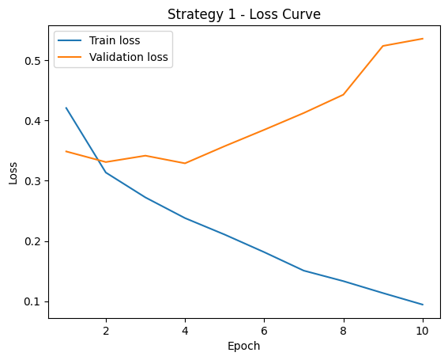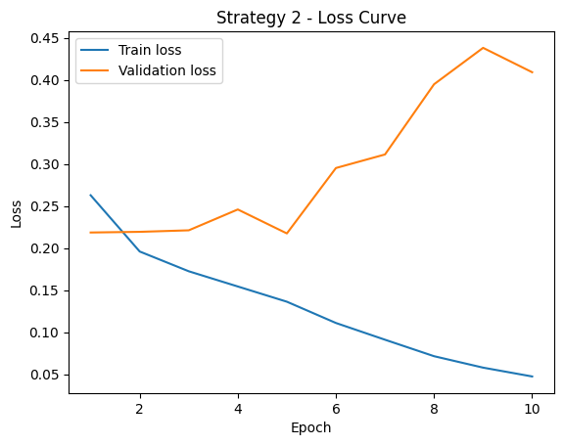
Fig1. Fig2.
Loss curves clearly show that Strategy 2 converges better and generalizes more effectively.

5.2 Training Time Comparison
Strategy | Training Time (seconds)
Strategy 1 | 2562 s
Strategy 2 | 2721 s
Strategy 2 takes slightly longer due to more trainable parameters but provides better performance.
5.3 Test Set Evaluation
Based on validation results, Strategy 2 is selected as the best model.
- Test accuracy: 0.9123

Confusion Matrix (Test Set)
- True Negatives: 1468
- False Positives: 146
- False Negatives: 117
- True Positives: 1269 As shown in Fig. 3
The confusion matrix shows balanced performance for both classes, with slightly more false positives than false negatives.
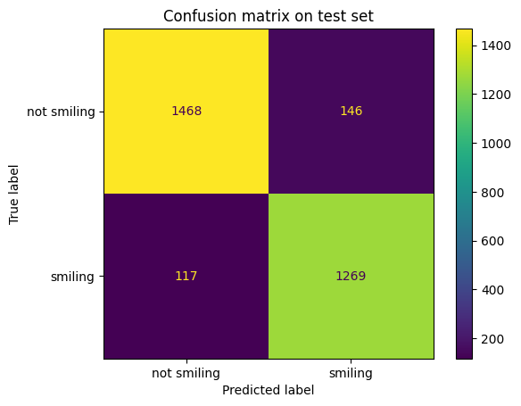

Fig. 3

In addition to quantitative metrics, we also inspected several correctly and incorrectly classified samples from the test set. While many errors occur for faces with neutral or ambiguous expressions, the model generally performs well on clear smiling and non-smiling cases.

6. Discussion

Effect of Data Augmentation
Data augmentation had a clear positive effect on the model’s generalization ability.
By applying random horizontal flipping and small color jittering, the training images were slightly different at each epoch, even though the labels stayed the same. This prevented the model from memorizing exact visual details such as face direction, lighting conditions, or background colors.
As a result, the model was encouraged to focus on more meaningful facial features related to smiling, such as mouth shape.This effect was especially noticeable in Strategy 2, where fine-tuning was applied. Without augmentation, the deeper layers could easily overfit to specific training examples. Augmentation helped reduce this risk and improved validation and test performance.

Transfer Learning vs Fine-Tuning
The comparison between Strategy 1 and Strategy 2 highlights the difference between pure transfer learning and partial fine-tuning.
In Strategy 1, all convolutional layers were frozen and only the classifier head was trained. This approach converged quickly but started to overfit after a few epochs, as shown by increasing validation loss while training loss continued to decrease.
In Strategy 2, the last convolutional block was unfrozen, allowing higher-level features to adapt to the target dataset. This resulted in better validation accuracy and more stable performance. The model could better capture task-specific facial patterns related to smiling. Although Strategy 2 required longer training time, the performance improvement shows that partial fine-tuning is more effective than using fixed pretrained features for this problem.

Typical Errors
An analysis of incorrect predictions revealed that many misclassified samples contained neutral or very subtle facial expressions. In these cases, the difference between smiling and not smiling was visually ambiguous.
These errors highlight the difficulty of binary facial expression classification. Even for human observers, such cases can be hard to judge. Despite these limitations, the model performed well on clear examples, indicating that most errors occur in borderline or ambiguous situations rather than systematic failures.

7. Conclusion
In this project, a smiling classifier was successfully built using transfer learning.
Among the evaluated strategies, fine-tuning the last convolutional block together with the classifier head produced the best results.
The final model achieved over 91% accuracy on the test set, demonstrating the effectiveness of transfer learning combined with limited fine-tuning and data augmentation.

