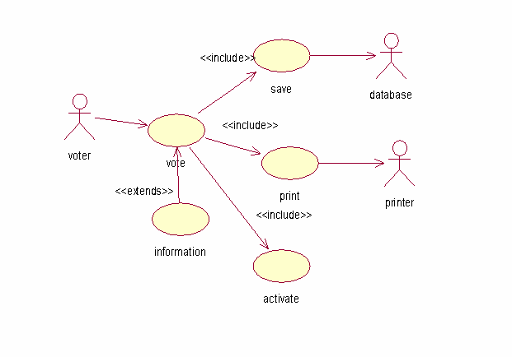

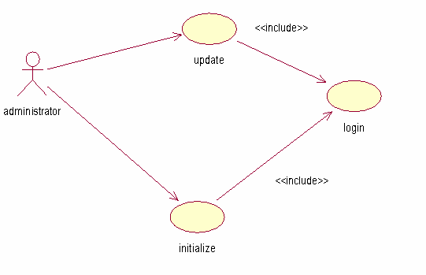

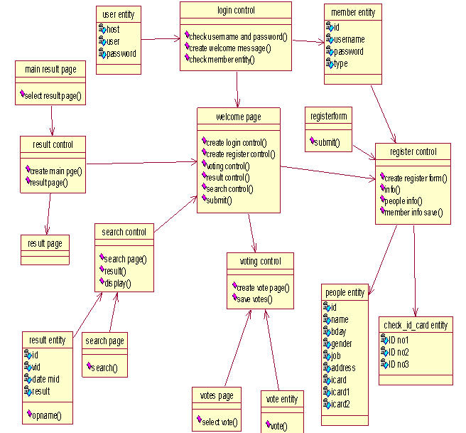

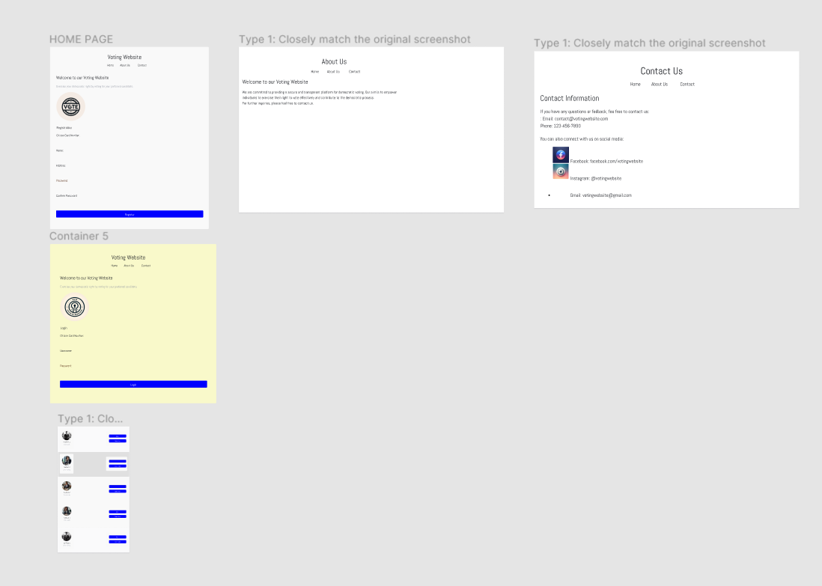

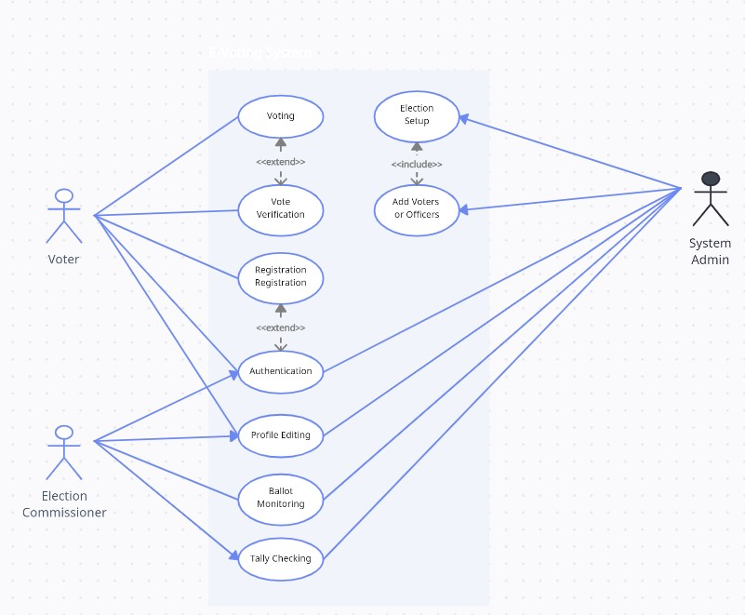

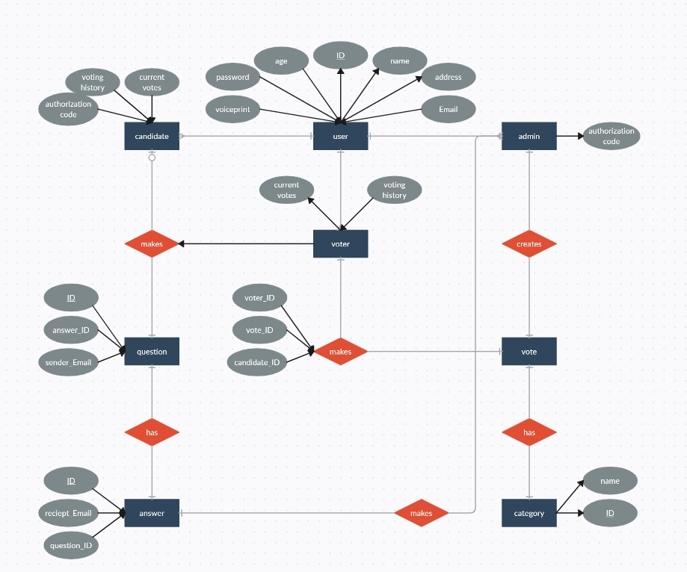

|  |  |  |  |
| --- | --- | --- | --- |
| **S. N** | **Tasks** | **Status** | **Progress (%)** |
| 1. | Project Selection | Completed | 100% |
| 2. | Feasibility Study | Completed | 100% |
| 3. | Requirement Gathering | Completed | 100% |
| 4. | Time Estimation | Completed | 100% |
| 5. | Research on similar projects | Completed | 100% |
| 6. | Design system use case diagram | Completed | 100% |
| 7. | Develop SRS system | Completed | 100% |
| 8. | Develop wireframes | Completed | 60% |
| 9. | Finalize initial ERD | Completed | 100% |
| 10. | Develop admin panel | Not completed | 0% |
| 11. | Develop feedback form | Partially completed | 10% |
| 12. | Finalize interim report | Completed | 80% |

