Project Title: AI-Enhanced Online Marketplace for IELTS Tutoring: Connecting Learners and Verified Instructors in Uzbekistan
Course: BSc (Hons) Business Information Systems Project
Name: Ismoil Turgunpulatov
Email: iturgunpulatov@students.wiut.uz
Supervisor: Nargiza Akramova

Content
Rationale for the Project ________________________________________________2
Objectives____________________________________________________________3
Methodology and Approach _____________________________________________4
Scope and Deliverables _________________________________________________5
Limitations___________________________________________________________7
Project Plan (Gantt Chart) _______________________________________________8
Timeline Explanation ___________________________________________________8
Reference List_________________________________________________________10
Rationale for the Project
The need to have mastery over the English language especially in IELTS certification has exploded tremendously in the fast changing environment of education in Uzbekistan. According to the recent statistics, the success rate in IELTS among the Uzbek young generation has been growing by five times due to the desire to study abroad and get a job. The market of digital English language in the country has been forecasted to increase consistently between the years 2025 and 2031 due to a young population that would desire to improve their global competitiveness. Nevertheless, lack of access to qualified tutors and the expensive nature of face-to-face sessions as well as unreliability when verifying the credentials of the tutors are some of the obstacles many learners have to encounter. Conventional tutoring is not always flexible, and the problem is worsened by the timing and the distance of the students as well as the geographical barriers in a country where the gap between the urban and rural areas remains an issue.
This project will solve these issues by creating an online marketplace platform that can be reformed on the local success experience such as Connected.uz, but influenced by IELTS preparation. The learners (users) have the opportunity to book 30-minute virtual sessions and have the chance to pay easily, whereas instructors (the holders of the IELTS certificate) are also able to self-register, get their credentials verified by the administration, and receive commissions without being recruited. The platform stands apart as it uses AI to have personal tutor matching, where their goal is relevant to the learners (i.e. target band scores). This will not only democratize the delivery of quality education but will also offer income-generating opportunities to the certified professionals in the Uzbekistan gig economy.
Rationale: The project will be aligned with the BIS learning outcomes as it will show the analysis of business needs (e.g., what is missing in the market of edtech), the design and implementation of the system (e.g., the web app, which will have AI integration), and critical evaluation. The motivation is based on the fact that current educational inequities in Uzbekistan are real-life problems, and more than 33 million individuals, with a young demographic, are in need of inexpensive skill building instruments. Value: The learners receive efficient and validated tutoring; the instructors receive a monetization tool; the market can be provided with a localized edtech solution in the context of increasing cyber threats in the digital environment of Uzbekistan, where more than 12 million cyberattacks were reported in 2024. Related work: Like Preply or AmazingTalker, which provide tutor marketplaces with additional features like video calls and payment options, do not focus on Uzbekistan (e.g. local languages or payment facilities, such as Uzcard). The current project is innovative as it focuses on AI-based matching and strong security to reduce the vulnerability that is typical of online education platforms.
Objectives
The objectives are SMART (Specific, Measurable, Achievable, Relevant, Timely) and balanced across business, computing, and project management scopes:
- To carry out market research through surveys and interviews with a minimum of 50 potential users (learners and instructors) in Uzbekistan and determine the key requirements and finish the analysis by November 2025.
- To create a secure web application prototype with the main functions (user registration, instructor verification, booking/payment system) and attain 90% functionality by February 2026.
- To implement AI algorithms to match tutors and learners according to such criteria as band goals and availability, 85% accuracy in recommendations by March 2026.
- To conduct a usability testing involving 20 beta users, this is necessary to make sure that the platform meets a minimum of basic security standards (e.g., OWASP guidelines) and create actionable reports by April 2026.
- In order to have the project under control with Agile methodologies, the achievement of all milestones and records on the progress of the project needed to be made to provide a final assessment with reference to the efficient use of time.
Methodology and Approach
An Agile approach will be used in the project to facilitate an iterative development style, the flexibility to use the feedback, and quick adjustment to the new requirements. This model is appropriate to edtech projects as it can be refined continuously by the users input as opposed to the inflexibility of Waterfall.
The first steps will include the discovery of facts with the help of primary research (surveys via Google Forms of the WIUT students and the local IELTS centers) and secondary research (the analysis of websites such as Preply). To assess the Uzbek edtech market, business analysis will be performed with the help of such tools as SWOT. As concerns design, the system architecture will be detailed by UML diagrams and wireframes. The development will be structured on the full-stack approach: the frontend will be based on React.js and will provide a responsive user interface, the backend will be based on Node.js/Express(might me .net) and will work with APIs and AI integration, and the storage of user profiles and bookings will be stored in PostgreSql.
Resourses: Open-source software (VS Code, GitHub to keep track of versioning), free API (Stripe sandbox to accept payments, Zoom to have a video conference), and the computing infrastructure of WIUT.
Justification: It is an inexpensive, scalable stack that conforms to the typical edtech deployments, which provides an adequate level of security against other vulnerabilities like data breaches typical of Uzbekistan.
Scope and Deliverables
The project aims at designing an online marketplace that would scale and become more affordable and accessible to SMB-like users in Uzbekistan (e.g. freelance instructors and individual learners).
In-Scope:
- Two-sided marketplace: Students purchase/reserve 30 minutes sessions; teachers add certificates to the files to be checked by the administration (manually by dashboard).
- Core features: User dashboard, real-time booking, integrated payment (e.g., via Payme/Uzcard APIs), video call.
- AI enhancement: AI-based matching instructors based on learner preference (e.g., desired IELTS module, band score).
- Security: (OAuth 2.0 authentication, HTTPS, and data encryption) will provide a solution to cyber risks in education platforms.
- User-friendly HCI: Responsive design for desktop/mobile.
- Reporting: Dashboard for learners (progress tracking) and instructors (income dashboards).

Deliverables:
- Functional prototype: Including frontend/backend, database integration, and AI.
- Market analysis: SWOT.
- User documentation: Guides and FAQs.
- Testing artifacts: Usability test results, security audit summary.
- Compliance-ready features: Basic adherence to data protection standards, exportable reports in PDF/CSV.
Out-of-Scope:
- Native mobile application development (emphasizes responsive web; additional expansion is possible in the future).
- Next-generation functionalities such as automated certificate OCR (manual verification to keep it complex).
- More language support beyond English/Uzbek (planned for post-launch).
- Big-scale distributed systems (not initially focused on SMB).
Technical Specifications:
Monolithic architecture to facilitate simplified development (e.g. single system which manages authentication, bookings, AI matching). Protection of the information in PostgreSQL tables; confidentiality, with GDPR-inspired indicators, considering the fact that Uzbekistan is turning into the most popular target of cybercrime.
Preparedness to the market and User Interaction:
Pre-launch surveys to get feedback; post-beta webinars to perform user onboarding, the target audience is the edtech development of Uzbekistan.

Limitations
Technological Limitations:
The platform itself is initially on web-based vulnerabilities and simple security, but might not cover mobile-specific threats in case the users can access it through apps further. The cybersecurity environment in Uzbekistan is characterized by the weakness in the digital platforms and the increasing number of cyberattacks on the education systems. To extend to AI-based certification fraud detection, high-level ML might be required, which might be expensive in terms of resources.
Resource Constraints:
Budget constraints will mean access to high-quality APIs (e.g. full Stripe integration); time constraints (200 hours total) might mean that extras are put second after core features. The human resources are individual, which may delay the testing.
Mitigations:
- Phased approach: Core MVP first, then AI enhancements.
- Open-source tools to reduce costs.
- Collaborations: Seek WIUT feedback or partnerships with local IELTS centers.
- Incremental scaling: Use milestone-based planning to align with available resources.

Project Plan (Gantt Chart)
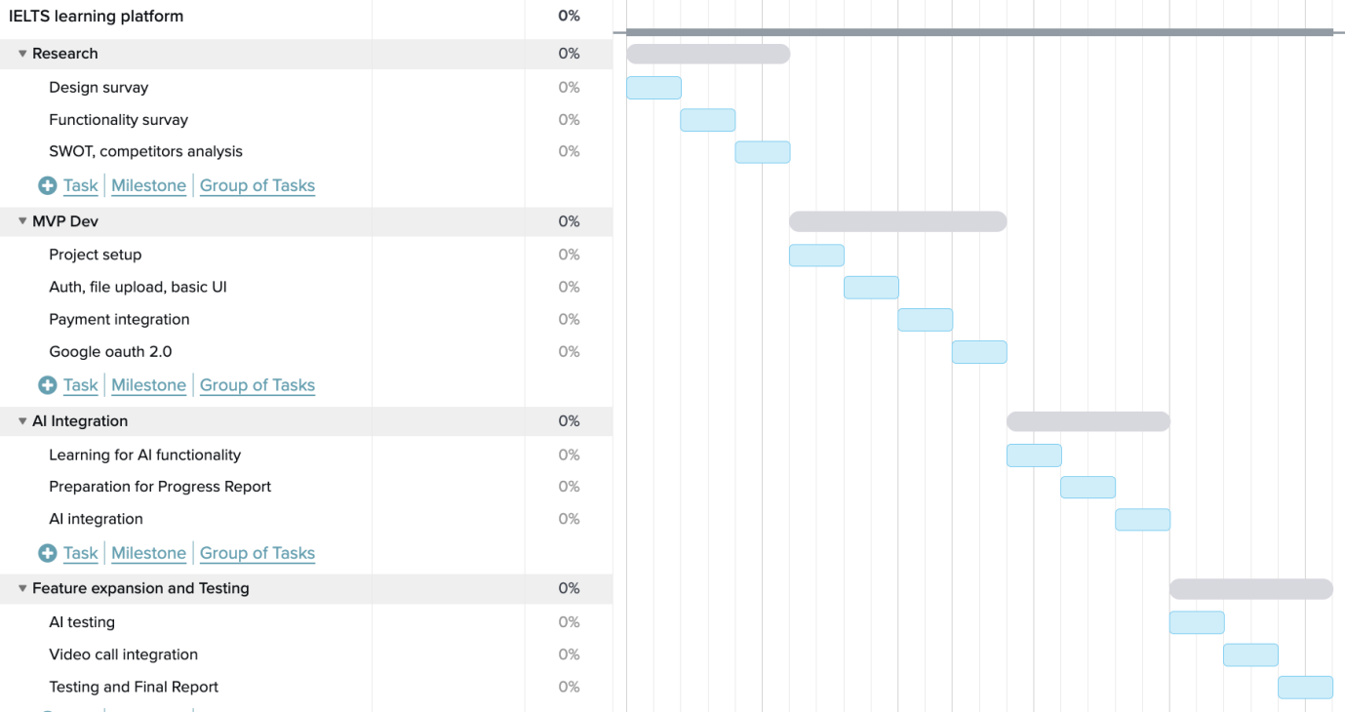
Timeline Explanation
Market Research (September to October):
Objective: Gather data on IELTS demand and user needs.
Activities: Surveys/interviews, competitor analysis (e.g., Preply features like tutor reviews).
MVP Development (November to December):
Objective: Build core platform.
Activities: Frontend/backend setup, basic booking/payment integration; aim for 60% functionality.
AI Integration (January to February):
Objective: Enhance matching. Activities: Implement ML algorithms, test accuracy.
Feature Expansion and Initial Testing (March to April):
Objective: Refine and validate.
Activities: Usability testing, security checks; prepare for Viva.
Preparation for Beta Testing (After April):
Objective: Final polish. Activities: Feedback incorporation, documentation.

Reference
British Counsil. (no date). English impact. https://www.britishcouncil.org. Available from https://www.britishcouncil.org/sites/default/files/british_council_english_impact_report_-_uzbekistan_min.pdf [Accessed 21 October 2025].
Imed Bouchrika. (2023). 15 Best Online Tutoring Platforms in 2024. Research.com. Available from https://research.com/software/best-online-tutoring-platforms [Accessed 21 October 2025].
kunu.uz. (2024). Uzbekistan sees fivefold growth in IELTS success among youth. Kun.uz. Available from https://kun.uz/en/news/2024/12/14/uzbekistan-sees-fivefold-growth-in-ielts-success-among-youth.
Leader, M. (2021). Cybersecurity Risks in eLearning | Virtru. www.virtru.com. Available from https://www.virtru.com/blog/data-centric-security/education/elearning [Accessed 21 October 2025].
scale.jobs. (2025). 10 Best Freelance Tutoring Platforms 2025. Scale.jobs. Available from https://scale.jobs/blog/10-best-freelance-tutoring-platforms-2025 [Accessed 21 October 2025].
States, U. (2025). Biggest Cyberattack Risks in the Education Sector. https://www.uscsinstitute.org/cybersecurity-insights/blog/biggest-cyberattack-risks-in-the-education-sector. Available from https://www.uscsinstitute.org/cybersecurity-insights/blog/biggest-cyberattack-risks-in-the-education-sector [Accessed 21 October 2025].
Wright, P. (2025). Uzbekistan’s Cybercrime Crisis. Medium. Available from https://medium.com/@city.paul/uzbekistans-cybercrime-crisis-52673478190f [Accessed 21 October 2025].
YoCoach Chef. (2025). Best Online Tutoring Platforms: A Complete Guide for 2025. Yo!Coach Blog. Available from https://www.yo-coach.com/blog/best-online-tutoring-platforms/ [Accessed 21 October 2025].

