**Git Cheetsheet**

**Isobel Lennox**

**=======================================================**

**Contributing to a REPO (first setting up)**

1. Fork Repo:

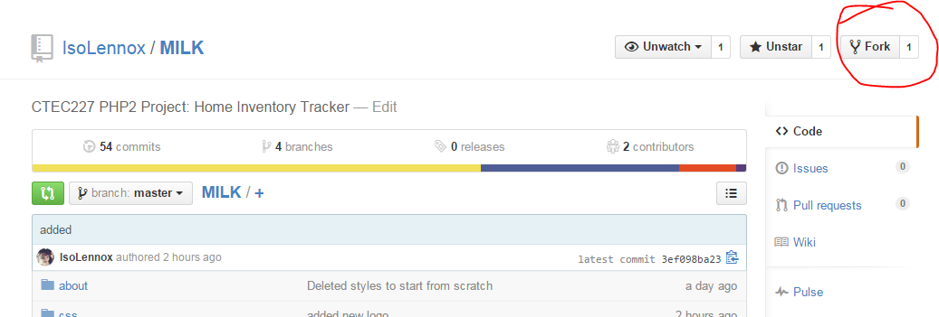

2. Clone repo (make sure you are in the directory you want this project downloaded into):

**$ git clone**YOUR_SSH_URL

3. Make a repo an upstream to contribute to:

**$ git remote add upstream (THEIR_SSH-URL)**

**$ git checkout master**

**$ git fetch upstream**

**$ git merge upstream/master**

**==========================================================**

**Daily WorkFlow**

**Moving around**

Change Directories

**$ cd path/to/directory**

look at your files:

**$ ls**

Open file:

**$ .\index.php --edit**

**Getting Latest Project Files:**

|  |  |
| --- | --- |
| Merge from main repo if contributing:  **$ git fetch upstream**  **$ git merge upstream/master** | Pull from main repo if you own it:  **$ git pull origin** |

**Working With Branches:**

|  |  |
| --- | --- |
| Switch to a branch:  **$ git checkout branchname**  To see your branches:  **$ git branch**  CREATE and switch to new branch  **$ git checkout -b branchname** | Merge files from one branch to another:  **[master]$ git merge sandbox**  **(marges sandbox branch into master branch)** |

**Adding/Committing Files:**

|  |  |
| --- | --- |
| Add new files to project before commiting:  **$ git add \*** | Commit File:  **$ git commit -a -m "Message about what I changed"** |

**Push to Server for the rest of your team to work with:**

1. **$git push origin master**
2. **If you do not own the main repo, don’t forget to make a pull request**

