ADVANCED AI-POWERED
SIGN LANGUAGE TRANSLATOR
Master Build Handbook
From first camera frame to datasets, model training, APIs, UI, offline deployment, testing, and final demo
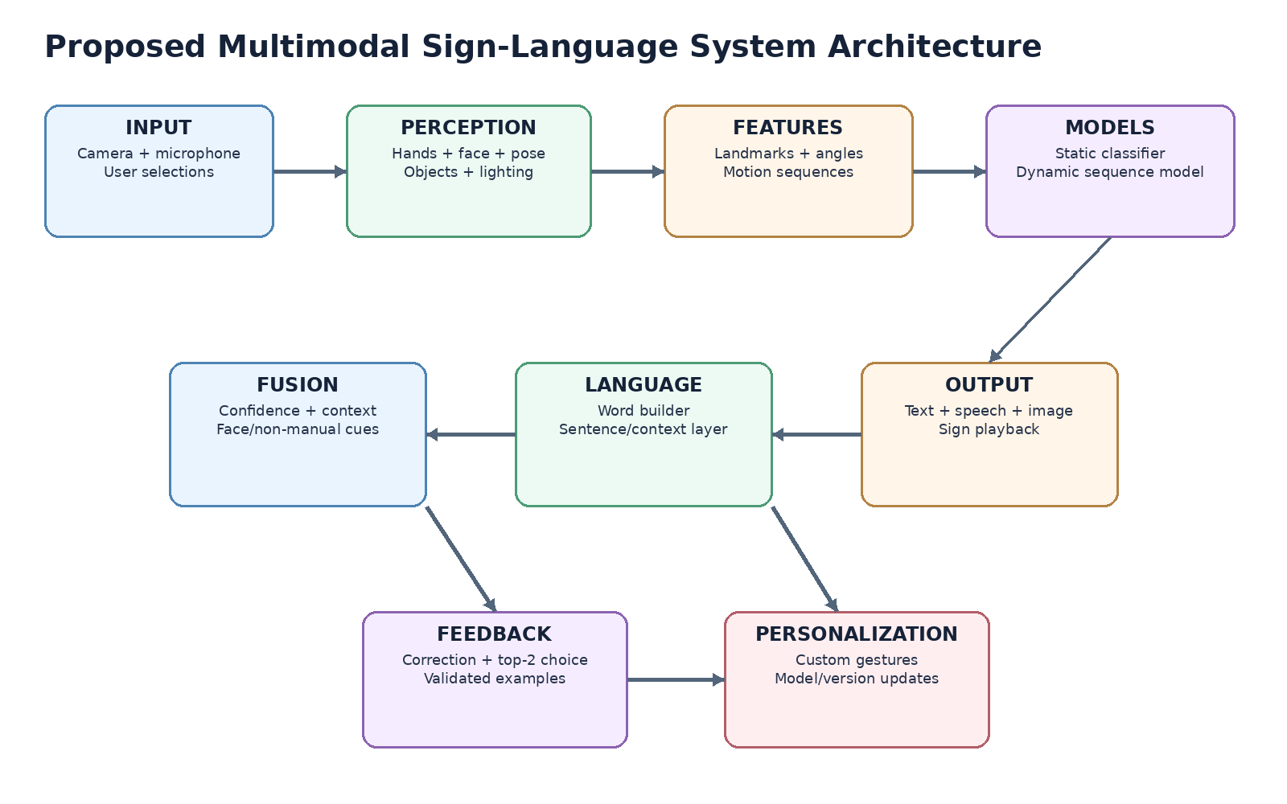
2026 PREMIUM EDITION • BUILD BLUEPRINT • TRAINING GUIDE • VIVA READY
Resource links reviewed and core official references re-verified: 28 September 2026

Executive Project Blueprint
A one-page view of what you are building, what must work first, and how the advanced features fit together.
Project goal | Enable a signer and a non-signer to communicate using camera-based sign recognition, speech/text output, reverse sign playback and accessible visual feedback.
Core MVP | A-Z/fingerspelling + selected static/dynamic word signs + hand landmarks + word formation + confidence rejection + correction + text/TTS.
Advanced intelligence | Facial/non-manual cues, object context, next-word suggestions, custom gestures, multiple model packs, low-light robustness and offline speech.
Engineering principle | Recognition must fail safely: uncertain frames are rejected or shown as choices; user corrections are stored as validated feedback, not blindly used for automatic retraining.
Definition of success
A working demo is more important than claiming every research feature. Build a stable landmark-based translator first; add advanced modules only after the MVP is measurable, reproducible and usable.
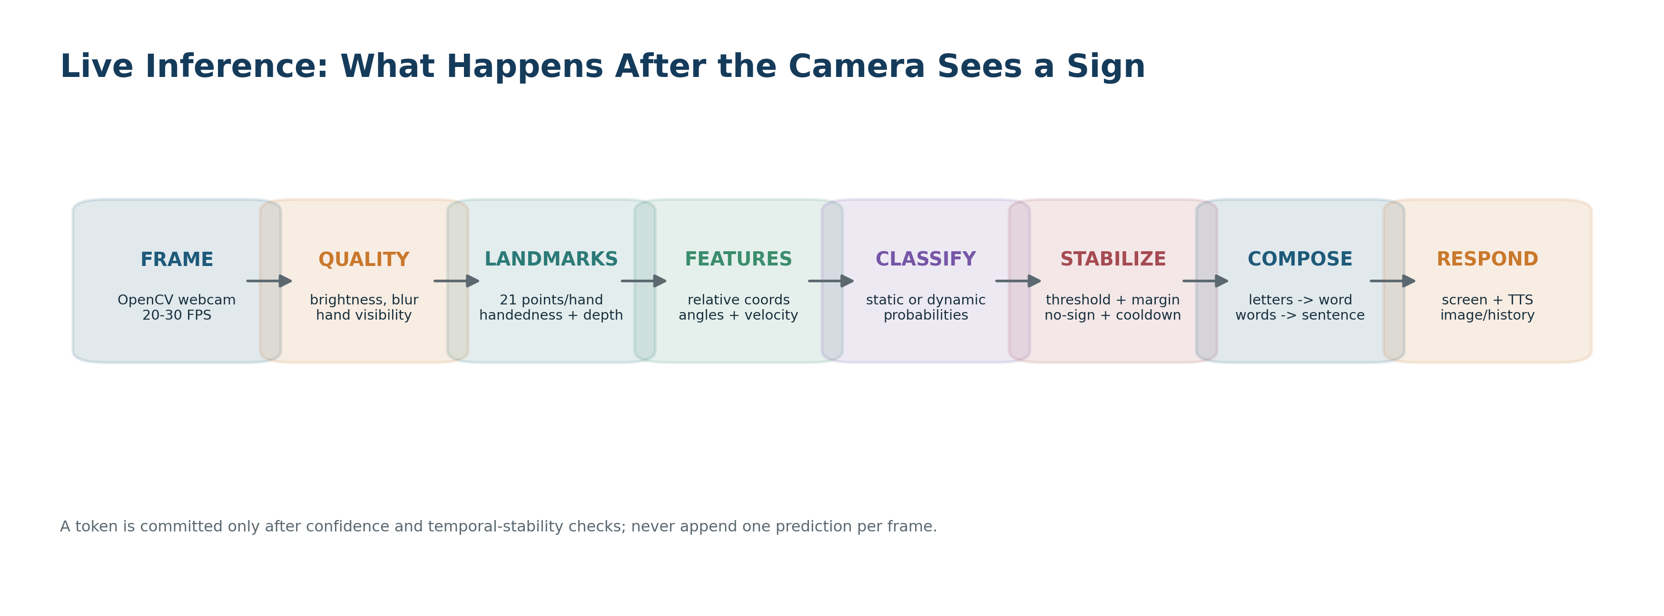

How to Use This Handbook
Recommended reading order
Read Sections 1-6 first. Then build Phase 0 through Phase 4 before touching face context, object detection, multilingual support, or adaptive training. Every advanced feature in this handbook is preserved, but the build order is intentionally staged so you always have a working demo.

This document is both a design specification and a beginner implementation guide. It separates three ideas that are often mixed together: (1) what the final system should do, (2) what you should build for the first working version, and (3) what belongs to advanced research extensions.
- Core/MVP: camera, hand landmarks, alphabet/static sign recognition, direct word gestures, word formation, confidence handling, text and speech output.
- Advanced: dynamic sequence recognition, face/non-manual cues, object context, two-way translation, custom gestures, offline speech, learning mode, low-light support.
- Research/Future: full continuous sign-language translation, automatic sentence grammar generation, generative sign avatars, safe continual learning from user history.

Table of Contents
1. Project Definition and Scope | 20. Backend / APIs / Real-Time
2. Complete Feature Specification | 21. Local Database Design
3. Recommended System Architecture | 22. Full Tech Stack
4. Camera Input to Final Output | 23. GitHub Repositories
5. Dataset to Trained Model | 24. Project Folder Structure
6. Dataset Strategy and Data Sources | 25. Exact Build Roadmap
7. Hand Landmarks | 26. Initial Development Setup
8. Static Sign / Alphabet Model | 27. Record Your Own Training Data
9. Dynamic Word / Motion Model | 28. Testing and Evaluation
10. Word Formation and Sentence State | 29. Common Failure Modes
11. Confidence and Correction | 30. Prebuilt vs Build Yourself
12. Face and Non-Manual Cues | 31. Model and Dataset Versioning
13. Object Context Module | 32. Suggested Python Modules
14. Low-Light and Robustness | 33. Final Demo Scenario
15. Custom Gestures / Personalization | 34. Viva Questions
16. Multiple Sign Languages | 35. Verified Resource Links
17. Two-Way Translation | 36. First 7 Concrete Tasks
18. Offline Speech Components | 37. Source and Licensing Notes
19. UI/UX Design
38–43. Requirements → Build Sessions | 44–48. Claims → Handoff Package

1. Project Definition and Scope

1.1 One-sentence definition
An offline-capable, multimodal sign-language communication system that recognizes fingerspelling, static signs, dynamic gestures, hand motion and selected non-manual/contextual cues, converts them into text/speech/image outputs, and supports reverse communication, learning, correction, and user-defined gestures.

1.2 What makes this different from a basic sign detector
Basic student project | Your intended system
Predicts A/B/C from a hand image | Recognizes alphabets plus complete gestures/words and motion
Single image | Uses video sequences for dynamic signs
One prediction replaces the previous one | Builds letters into words and words into sentences
No uncertainty handling | Rejects uncertain predictions and asks the user to choose
Hands only | Can combine hands, face/non-manual cues, body motion and objects
One fixed vocabulary | Supports language packs and personal/custom gestures
Online-only demo | Core recognition can run locally/offline
No feedback loop | Correction can become reviewed personalization data

Important terminology
A sign language is a language with its own vocabulary and grammar. A custom personal gesture set is not automatically a new sign language. In the UI and report, call it a custom gesture vocabulary or personal gesture pack unless it follows a real language standard.

2. Complete Feature Specification: Why It Exists and How to Implement It
Feature | Why it is useful | Implementation approach | Stage
A-Z alphabet/fingerspelling | Lets a user spell names or words not present in the word vocabulary. | Detect hand landmarks, normalize them, classify the alphabet sign, then append stable letters to a word buffer. Use a language-specific alphabet dataset; do not mix ISL and ASL alphabets. | MVP
Direct word/gesture recognition | Users should not have to spell common words letter-by-letter. | Create word classes such as hello, come, I, you, thanks. Static words use landmark/image classifiers; motion signs use sequence models. | MVP
Word formation | Prevents each new letter from erasing the previous letter. | Maintain a stateful text buffer. Add a letter only after confidence/stability rules; use space/confirm gesture or idle timeout to close a word. | MVP
Static signs | Handles signs defined mainly by hand shape and pose. | Single-frame or short-window normalized landmarks -> MLP classifier. A CNN image baseline may be used for comparison. | MVP
Dynamic signs | Handles signs whose meaning depends on motion. | Collect fixed-length or resampled landmark sequences and train an LSTM/GRU/Transformer. Use velocity/direction features and sequence smoothing. | Core+
Model training | Allows the system to learn your selected signs instead of relying on hard-coded rules. | Separate data collection, preprocessing, training, evaluation and export scripts. Track model version, vocabulary and metrics. | MVP
Multiple sign languages | Avoids forcing all users into one sign system. | Keep separate language packs: vocabulary, label map, model weights, reverse-sign media and grammar settings. User selects the active pack. | Advanced
Custom personal gesture vocabulary | Lets a user create shortcuts or gestures meaningful to them. | Record 20-50 examples/sequences per custom class, validate quality, then train a small per-user classifier/head without overwriting the global model. | Advanced
Wrong-detection correction / undo | Makes the system recover gracefully from mistakes. | Keep prediction history and allow Undo, Delete, Redo and Replace. Store confirmed corrections separately from raw predictions. | MVP
Hand landmark/keypoint recognition | Improves robustness by modeling finger/joint geometry instead of only raw pixels. | Use MediaPipe Hand Landmarker/Holistic. Each hand has 21 landmarks; derive wrist-relative normalized coordinates, distances, angles, handedness and movement. | MVP
Confidence-based top-2 choice | Avoids confidently speaking the wrong word. | Apply a threshold and top-1/top-2 probability margin. If uncertain, show two candidates and let the user choose by touch or left/right gesture. | MVP
Face/non-manual cue support | Captures eyebrow, mouth, head and facial information that can be meaningful in signed communication. | Use MediaPipe Face Landmarker landmarks/blendshapes; select relevant features and fuse them with hand predictions. Do not use facial emotion as a replacement for linguistic evidence. | Advanced
Next-word/statement assistance | Reduces effort when the intended continuation is predictable. | Use previous accepted tokens with a small n-gram or local language model. Suggestions must remain optional and visually separated from recognized signs. | Advanced
Two-way translation | Allows both the signer and non-signer to communicate. | Sign -> text/speech in one direction. Speech/text -> sign clips/pose animation in the reverse direction. Start with a dictionary of verified sign videos. | Advanced
Offline operation | Supports classrooms, hospitals or travel with weak connectivity and protects camera data. | Keep MediaPipe, recognition models, SQLite, TTS/STT and sign assets local. Optional cloud features should fail gracefully. | Core+
Learning mode | Lets non-signers learn and practice. | Display a reference sign clip/image, ask the learner to imitate it, compare landmarks/sequence to the reference, and provide limited feedback. | Advanced
Low-light detection/enhancement | Improves usability in poor lighting. | Calculate luminance/blur. If poor, apply gamma/CLAHE and denoising to the inference frame, increase camera exposure where possible, and show a lighting warning. | Core+
History-assisted personalization | Uses validated past interactions to adapt to an individual user. | Save only user-approved samples/corrections. Periodically train a personal model or calibration layer; never automatically learn every prediction. | Advanced
Image-based output | Helps users who understand images better than text. | Map recognized concepts to icons/pictograms/images. Keep the text/speech output too because not every word has a safe pictorial equivalent. | Advanced
Interruption/turn handling | Makes two-way conversation recover after pauses or interruptions. | Maintain a conversation state machine: signer turn, listener turn, paused, waiting for clarification, resumed. Preserve unfinished buffers. | Advanced
Object-context recognition | Uses held/nearby objects to disambiguate meaning. | Run a lightweight object detector on sampled frames. Pass object labels/confidence as context features; do not let an object override a clear hand sign. | Research+

3. Recommended System Architecture
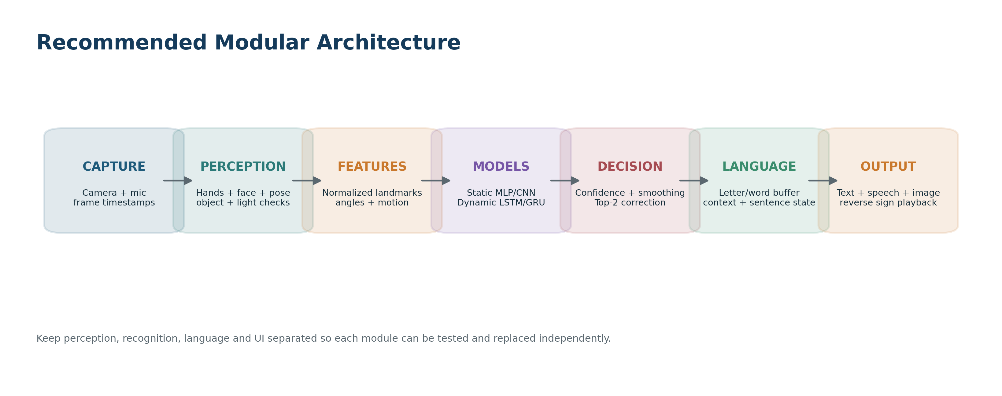

3.1 Modular design
- Capture layer: webcam/microphone, timestamp, frame-rate control and camera settings.
- Perception layer: hand landmarks, face landmarks/blendshapes, optional pose landmarks, object detection and lighting/blur checks.
- Feature layer: normalized coordinates, distances, angles, velocities, sequence windows and masks.
- Recognition layer: static classifier plus dynamic sequence classifier.
- Fusion/decision layer: confidence threshold, temporal smoothing, top-2 ambiguity handling and optional contextual cues.
- Language layer: letter buffer, word buffer, sentence builder, punctuation/spacing and next-word suggestions.
- Output layer: text, local TTS, image/pictogram, and reverse sign playback.
- Feedback/personalization layer: undo/correction, validated training examples, custom vocabulary and model-version management.

3.2 Why not one giant model?
A single end-to-end model is attractive in research, but it makes a first mini-project difficult to debug. A modular system lets you independently verify camera capture, landmark quality, static recognition, dynamic recognition and sentence formation. It also lets you ship a working MVP while more advanced components are still experimental.

4. From Camera Input to Final Output - Step by Step
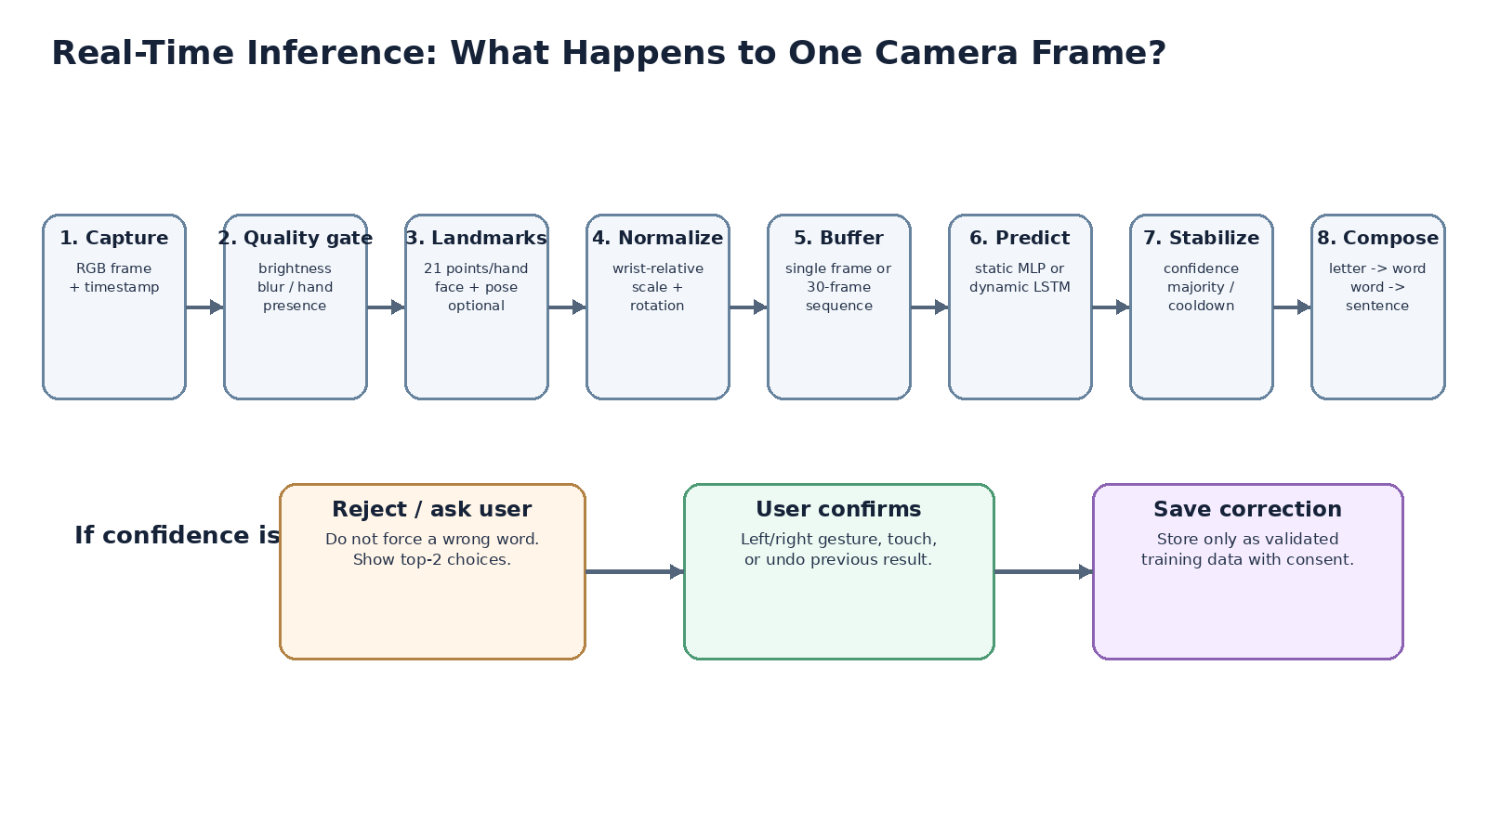

4.1 Camera capture
OpenCV or the browser captures frames. Each frame gets a timestamp. You normally process 20-30 FPS for a smooth UI, but the model may sample fewer frames to save compute.

4.2 Quality checks
Measure brightness, blur and whether one/two hands are visible. Poor frames can be ignored instead of becoming wrong training/prediction examples.

4.3 Landmark extraction
MediaPipe finds 21 3D-relative landmarks per hand. Holistic/Face Landmarker can also provide pose and face points. The image does not go directly into your LSTM if you choose a landmark-based pipeline.

4.4 Normalization
Translate coordinates so the wrist (or hand center) becomes the origin, scale by a stable hand distance, optionally rotate into a consistent orientation, and preserve handedness.

4.5 Feature engineering
Use x/y/z coordinates plus optional joint angles, fingertip distances, finger-open states and frame-to-frame velocity. Keep the feature definition identical in training and inference.

4.6 Static/dynamic routing
If the sign is static, predict from the current normalized hand pose or short stable window. If motion is detected or the active class set is dynamic, place frames into a sequence buffer.

4.7 Classification
The model outputs a probability per class. Example: come 0.84, home 0.08, go 0.03.

4.8 Stability and rejection
Require several consistent frames and a confidence threshold. Do not append a token every frame. Use cooldown/debounce rules so one sign is added once.

4.9 Word and sentence builder
Letters accumulate into a word; complete signs append as tokens. A confirm/space gesture, timeout or UI button can commit the current word.

4.10 Output
Render text, speak it locally, show an optional pictogram, save history, and expose correction controls.

5. From Dataset to Trained Model - Beginner Training Pipeline
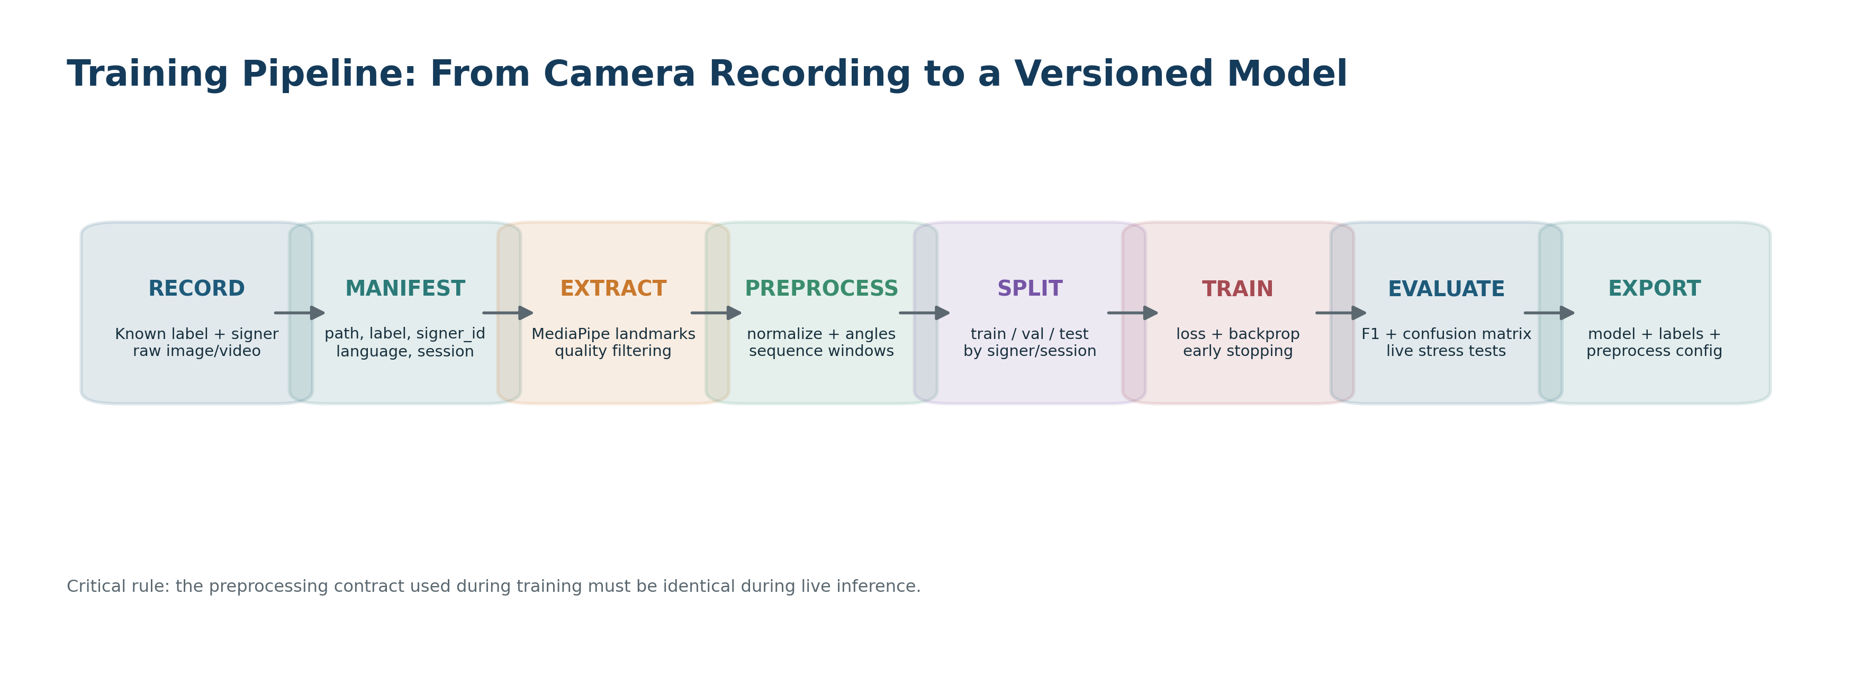
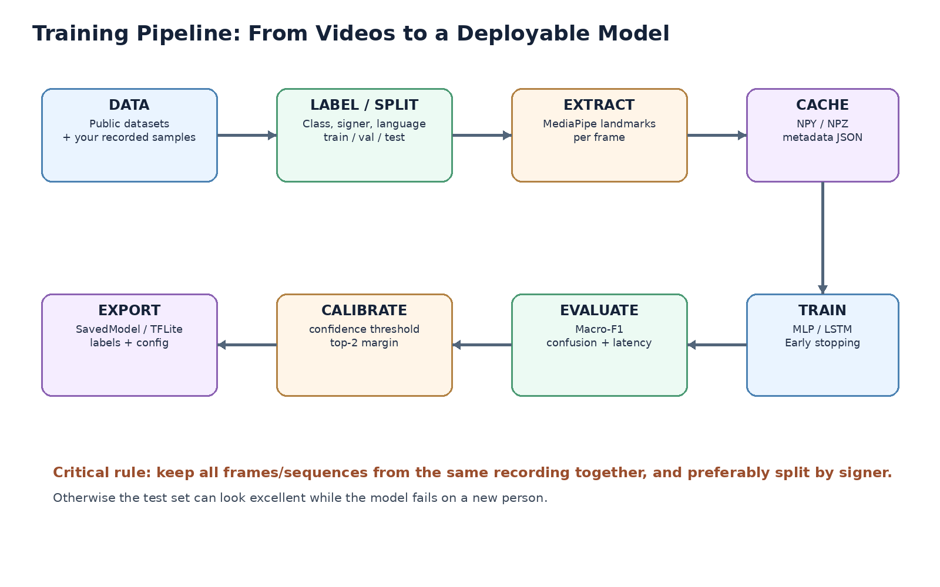

5.1 The idea in plain English
Training is not the camera directly "going into the dataset." There are two separate modes. In data-collection mode, camera recordings are saved and labeled. In training mode, those saved samples are processed into features and used to optimize model weights. In live mode, the trained weights only perform inference.
Mode | Input | What happens | Output
Collection | Camera video | Record examples with a known label | Raw clips + metadata
Preprocessing | Saved clips | Extract/normalize landmarks and create sequences | NPY/NPZ features
Training | Features + labels | Model learns parameters using loss/backpropagation | Best model checkpoint
Evaluation | Unseen test split | Measure generalization and errors | Metrics + confusion matrix
Inference | Live camera | Apply same preprocessing, then model.predict | Prediction + confidence

5.2 Minimum dataset rules
- Never split individual frames from the same video across train and test. Split at the video/sequence level.
- For a general-user model, prefer signer-independent evaluation: people in the test set should not also appear in the training set.
- Capture different lighting, backgrounds, distances, sleeves, hand sizes and speeds.
- Add a NO_SIGN / IDLE class or rejection logic so ordinary hand movement is not converted into words.
- For two-hand signs, preserve left/right hand identity and handle temporarily missing landmarks.
- Keep a CSV/JSON manifest containing path, label, signer_id, language, static/dynamic, split and source/license.

5.3 Suggested sample counts
Use case | Practical starting point | Better target
Static alphabet / custom static sign | 200-500 varied images or 50-100 short captures per class | Multiple signers; 500+ varied samples/class
Dynamic word | 30-50 sequences/class for a prototype | 100+ sequences/class across multiple signers
Personal custom gesture | 20-30 sequences/class | 40-60 sequences/class with different sessions
Validation/Test | At least 15%/15% by sequence | Signer-independent split when possible

6. Dataset Strategy and Recommended Data Sources
Best starting combination
For an India-focused mini-project: use an ISL alphabet dataset for A-Z/fingerspelling, INCLUDE/INCLUDE-50 for word-level ISL reference/training, and your own small camera-recorded dataset for the exact words and custom gestures used in the demo. Use WLASL/AUTSL mainly to learn architectures or test multilingual modularity, not to mix labels into ISL.

Dataset | Language / type | What it contains | How to use it | Link
INCLUDE / AI4Bharat | Indian Sign Language; isolated words | 4,287 videos, 263 word classes; official baseline code extracts MediaPipe Hands + BlazePose keypoints. | Primary word-level ISL reference/training. | Open resource
INCLUDE information page | Indian Sign Language | Dataset + baseline links and citation. | Dataset access/reference. | Open resource
ISL Alphabet (Ayesha Hannure) | ISL fingerspelling alphabet | 12,700 images, 26 classes, Apache-2.0 repository. | Good starting image set for alphabet baseline. | Open resource
RealSign ISL Alphabet | ISL fingerspelling alphabet | Multiple signers and explicit train/validation/test directories. | Alternative/validation alphabet dataset; check current license terms before redistribution. | Open resource
WLASL | American Sign Language; isolated words | 2,000 ASL words, video-based. | Architecture research and multilingual extension; dataset links can require maintenance. | Open resource
AUTSL | Turkish Sign Language | 226 signs, 43 signers, 36,302 videos; multimodal dataset. | Excellent dynamic-sequence benchmark/reference. | Open resource
Sign Language Datasets toolkit | Multiple sign languages | TFDS-style loaders for multiple corpora and pose variants. | Learn standardized multi-dataset handling. | Open resource
Your own project dataset | Your selected ISL words/custom gestures | Recorded using the same camera pipeline you will demo. | Essential for exact vocabulary and real classroom/demo conditions. | Local data you record

6.1 Do not blindly merge languages
ASL, ISL, Turkish Sign Language and other sign languages are not interchangeable label sources. Keep language-specific class IDs and model packs. A word translated to the same English text can have a different sign, motion or grammar in another sign language.

6.2 Face dataset correction: ORL/Yale
The ORL/AT&T and Yale face datasets were designed mainly for face recognition/identity experiments. They are old, small, and not a suitable primary source for linguistic facial/non-manual sign cues. For this project, use MediaPipe Face Landmarker features and collect/annotate face+sign examples in the sign dataset itself. If later you explicitly study expression recognition, choose a modern expression dataset with the right license and demographics.

7. Hand Landmarks: The Core Accuracy Feature
MediaPipe provides 21 landmarks for each detected hand. Each point has normalized x/y and a relative z/depth signal. With two hands, the raw hand vector can be 21 x 3 x 2 = 126 numeric values before derived features.
Feature family | Example | Why it helps
Relative coordinates | x_i - x_wrist, y_i - y_wrist | Reduces dependence on where the hand appears in the frame.
Scale normalization | divide by palm width / wrist-to-middle-MCP distance | Reduces dependence on hand size and camera distance.
Angles | angle at PIP/DIP/MCP joints | Describes finger bending more directly than raw coordinates.
Distances | thumb tip to index tip | Useful for pinch/open/closed relationships.
Velocity | landmark_t - landmark_t-1 | Important for dynamic direction and speed.
Handedness | left vs right | Prevents mirrored signs from being confused.
Visibility/missing mask | 0/1 for hand present | Lets sequence model handle temporary tracking loss.

# Conceptual normalization (not final production code)
wrist = landmarks[0]
relative = landmarks - wrist
scale = distance(landmarks[5], landmarks[17]) + 1e-6
normalized = relative / scale
feature_vector = normalized.flatten()

Training/inference consistency
If training uses normalized landmarks but live inference sends raw landmarks, the model will fail even though the code runs. Put preprocessing in one reusable module and call the same function from both training and real-time inference.

8. Static Sign / Alphabet Model
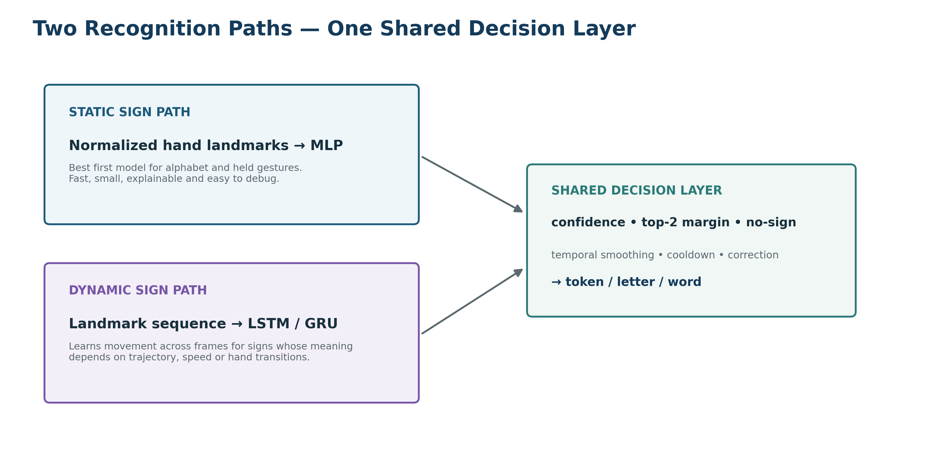

8.1 Recommended model
For landmark input, start with a small multilayer perceptron (MLP), not a heavy CNN. A CNN is useful when training directly on cropped hand images, but landmarks already convert the image into structured coordinates. Keep a CNN baseline only if your faculty expects a CNN comparison.
Input: 63 features (one hand) or 126 features (two hands)
-> Dense(128, ReLU)
-> BatchNormalization
-> Dropout(0.30)
-> Dense(64, ReLU)
-> Dropout(0.20)
-> Dense(number_of_classes, Softmax)

8.2 Beginner training steps
1. Collect/load labeled samples.
2. Extract landmarks and discard samples where the expected hand is not detected.
3. Normalize landmarks.
4. Create X (features) and y (class labels).
5. Split by recording/signer into train, validation and test.
6. Encode labels.
7. Build the MLP.
8. Train with categorical cross-entropy and Adam.
9. Use EarlyStopping and ModelCheckpoint.
10. Evaluate on the untouched test set.
11. Export model + labels.json + preprocessing_config.json.
12. Test with live camera before adding UI complexity.
# Keras skeleton
model = keras.Sequential([
keras.layers.Input(shape=(feature_dim,)),
keras.layers.Dense(128, activation="relu"),
keras.layers.BatchNormalization(),
keras.layers.Dropout(0.30),
keras.layers.Dense(64, activation="relu"),
keras.layers.Dropout(0.20),
keras.layers.Dense(num_classes, activation="softmax"),
])
model.compile(optimizer="adam", loss="sparse_categorical_crossentropy", metrics=["accuracy"])

9. Dynamic Word / Motion Model
A dynamic sign is not one image; it is a time series. The system therefore stores a sliding window such as 30 frames. Each frame contains hand (and optionally selected pose/face) features. The result might have shape (30, 126) for two-hand landmarks.
Example input tensor for one sample
sequence.shape = (30, 126)
Model idea
Masking
-> LSTM(128, return_sequences=True)
-> Dropout(0.30)
-> LSTM(64)
-> Dense(64, ReLU)
-> Dense(num_dynamic_signs, Softmax)

Start with LSTM because it is straightforward to train and explain in a viva. Later, benchmark GRU or a small temporal Transformer. Do not choose a Transformer only because it sounds more advanced; use validation metrics and latency to justify it.

9.1 Handling different sign durations
- Resample each clip to a fixed number of frames (simple starting approach).
- Or pad shorter sequences and use masking.
- For live recognition, use a sliding window and only accept predictions after temporal stability.
- For future continuous signing, add sign-boundary segmentation or CTC/online continuous SLR instead of assuming one clip equals one word.

10. Word Formation and Sentence State
Recognition and text composition should be separate. The classifier predicts tokens; a state machine decides whether and when a token is committed.
state = {
"current_letters": [],
"sentence_tokens": [],
"last_token": None,
"last_commit_time": 0,
"mode": "alphabet" | "word",
}
# Accept a token only after N stable frames.
# Use a cooldown so the same held sign is not appended 20 times.
# A SPACE/CONFIRM gesture or button commits current_letters as a word.

- Alphabet mode: append stable letters; Backspace removes the latest letter; Confirm commits word.
- Word mode: append a recognized word once; a blank/no-sign interval separates repeated identical words.
- Hybrid mode: user can switch between word recognition and fingerspelling.
- Never let next-word prediction silently modify recognized text. Suggestions should require user acceptance.

11. Confidence, Wrong-Detection Handling and Top-2 Selection
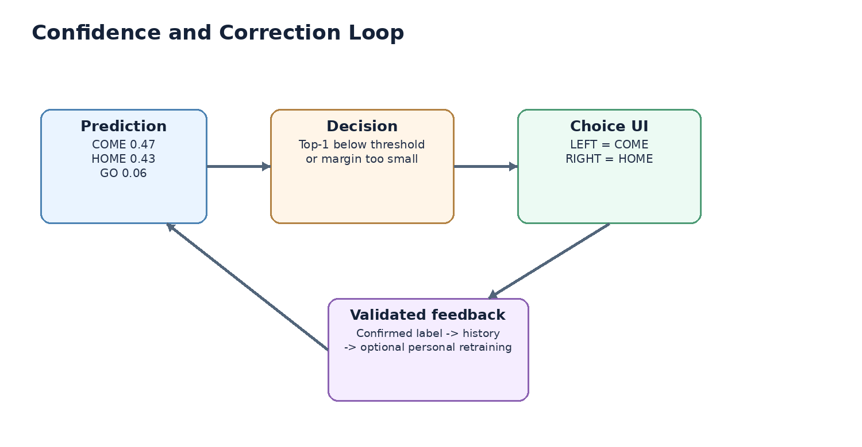
Condition | Action
Top-1 >= accept threshold AND margin to top-2 is large | Accept only after temporal stability.
Top-1 below threshold | Reject as uncertain; do not add text.
Top-1 and top-2 are close | Show two candidate choices.
User chooses candidate | Commit chosen token and mark as confirmed feedback.
User presses Undo | Remove last committed token; log correction.
Repeated low confidence | Ask for slower sign / better lighting / reposition hands.

Thresholds should be tuned on validation data. Example values such as 0.70 are starting points, not universal truths. Also inspect calibration: a model that outputs 0.95 for wrong predictions needs stronger rejection logic.

12. Face and Non-Manual Cue Integration
Signed languages can use non-manual signals such as eyebrow motion, mouth shapes, head movement and facial configuration. Your face module should therefore be framed as non-manual/context feature extraction, not as a generic "angry/happy person" detector.
- Use MediaPipe Face Landmarker for face landmarks and optional blendshape coefficients.
- Select a small subset: eyebrow raise/lower, eye blink/squint, mouth opening/smile/frown proxies, head orientation.
- Normalize and aggregate them across the same time window as the hand sequence.
- Fuse late: first obtain a hand-model prediction, then use face/context features to re-rank ambiguous classes or feed a small fusion network.
- Validate that face features actually improve macro-F1; if they do not, keep them as a demonstrated research module rather than forcing them into the final classifier.
Scientific safety
A face expression is not a reliable stand-alone indicator of a person's intent or emotion. In your report, say that facial/non-manual cues are auxiliary features and that the recognized hand/sequence remains primary evidence.

13. Object Context Module
A lightweight object detector can recognize common objects in the scene. For example, if a detected object is chocolate and the signer performs a gesture associated with eating/wanting, the language layer may rank related interpretations higher. This is contextual assistance, not proof of meaning.
1. Run object detection only every few frames (for example 2-5 FPS) to reduce load.
2. Keep objects with confidence above a threshold.
3. Convert recent object labels into a small context vector.
4. Feed context only to the re-ranking/language layer, not directly into the core hand landmark classifier initially.
5. Display contextual interpretation as a suggestion until you validate it thoroughly.
Recommended engine: a nano-sized Ultralytics YOLO model. Pin a tested model version in requirements; current Ultralytics releases expose detection, pose, classification and export through one package.

14. Low-Light and Robustness Pipeline
Problem | Detection | Response
Too dark | Mean/median luminance below threshold | Gamma correction / CLAHE; warn user; try camera exposure.
Motion blur | Variance of Laplacian low | Ask user to hold briefly; reduce acceptance until stable.
Hand partially outside frame | Landmark visibility / bounding box near edge | UI overlay guides hand back into capture zone.
Busy background | Landmark instability / false detections | Use landmarks rather than background pixels; optional hand crop.
Tracking jitter | Large unexplained frame jumps | Temporal smoothing and median filters.
One hand missing in two-hand sign | Missing-hand mask | Do not commit prediction; wait briefly or reject.

# Simple low-light idea
gray = cv2.cvtColor(frame, cv2.COLOR_BGR2GRAY)
brightness = gray.mean()
if brightness < LOW_LIGHT_THRESHOLD:
# enhance luminance channel (gamma/CLAHE) for inference
enhanced = enhance_low_light(frame)
else:
enhanced = frame

15. Custom Gestures and Safe Personalization

15.1 Custom gesture workflow
1. User selects Add Custom Gesture.
2. User enters a label/meaning, e.g. "medicine" or a personal shortcut.
3. App records multiple examples across slightly different positions/speeds.
4. Quality checker rejects samples with missing landmarks or extreme blur.
5. Features are saved under a user-specific dataset folder.
6. A lightweight personal classifier/head is trained or fine-tuned.
7. Validation examples are tested before activation.
8. New model version is saved; user can roll back.

15.2 History should not automatically train the model
Raw prediction history contains mistakes, uncertain samples and accidental movements. If you retrain on all of it, the model can teach itself its own errors. Only save a training example after explicit confirmation or correction, then review/batch it before retraining.

16. Multiple Sign Languages: Architecture
models/
isl/
static.keras
dynamic.keras
labels.json
reverse_signs/
asl/
static.keras
dynamic.keras
labels.json
custom/<profile_id>/
custom.keras
labels.json

- Each language pack owns its own label vocabulary and reverse-sign assets.
- Do not translate labels by name and assume the physical sign is the same.
- UI exposes Active Sign Language and Spoken Output Language as separate settings.
- A later research model can share a common landmark encoder but should still have language-specific heads.

17. Two-Way Translation

17.1 Sign -> text/speech
This is the primary pipeline: camera -> landmarks -> sign prediction -> word/sentence builder -> text -> TTS.

17.2 Speech/text -> sign
For a mini-project, use a verified sign dictionary before attempting generative sign video. Speech is transcribed, normalized to supported tokens, then matching sign clips or pose animations are played in sequence. Unsupported words can fall back to fingerspelling.
Approach | Difficulty | Recommendation
Stored sign image | Low | Good for alphabet/learning screen, not dynamic words.
Stored sign video clips | Low-Medium | Recommended MVP for reverse translation.
3D avatar from pose sequences | High | Advanced/future; useful research reference.
Generative video | Very High | Do not make this a dependency for the mini-project demo.

18. Offline Speech Components
Function | Recommended option | Why
Text-to-speech prototype | pyttsx3 / OS speech voices | Very easy and offline.
Higher-quality local TTS | Piper | Fast local neural TTS; multiple voices depending on availability.
Speech-to-text | whisper.cpp | Can run Whisper models fully offline; supports CPU and several accelerators.
Online optional fallback | Cloud speech/TTS | Only if internet is available and privacy policy permits it.

19. UI/UX Design
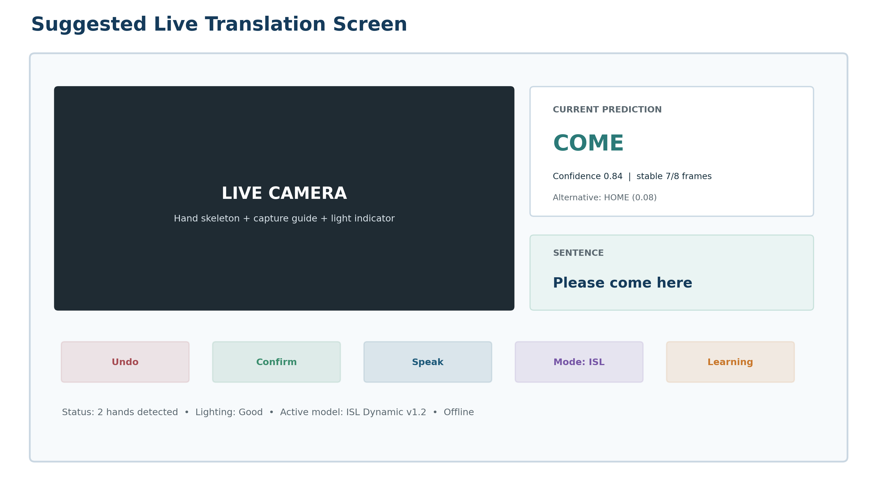
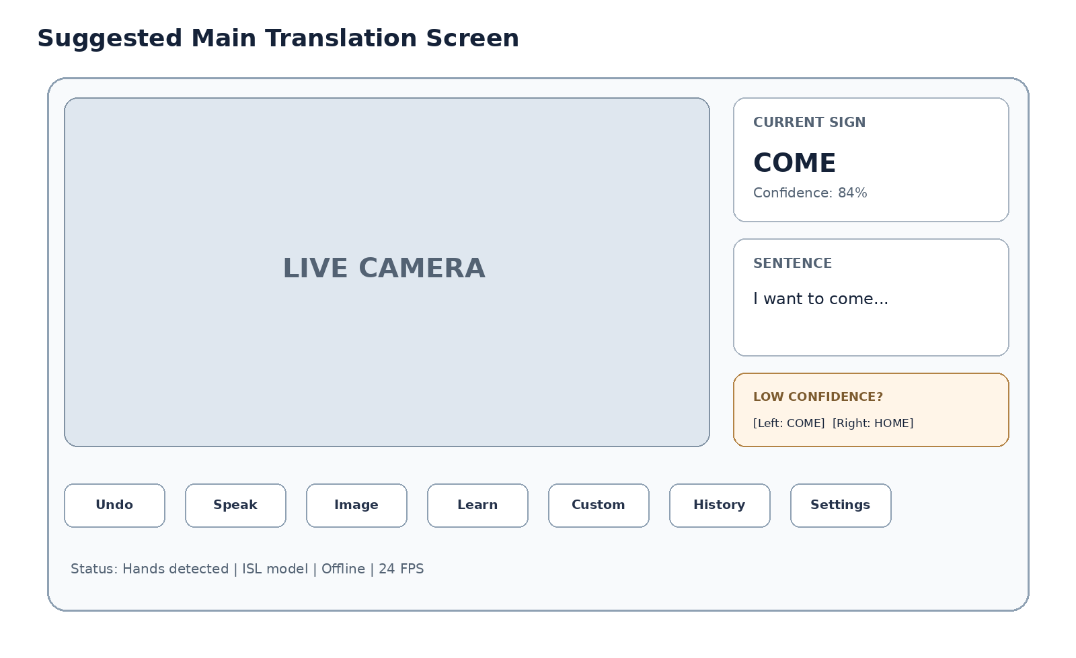
- Large live camera panel with landmark overlay toggle.
- Current recognized token, confidence and active model/language.
- Sentence/output panel with Undo, Backspace, Clear and Speak.
- Low-confidence candidate panel appears only when needed.
- Modes: Translate, Learn, Custom Gestures, History, Model/Settings.
- Visible statuses: hand detected, two hands required, low light, offline/online, FPS.
- Do not crowd the main screen with training controls; keep training/admin screens separate.

19.1 Learning mode screen
- Reference sign video/image on left.
- Learner camera on right.
- Landmark overlay and similarity score.
- Simple feedback: hand too low, rotate hand, missing second hand, movement too fast.
- Progress by sign; avoid claiming linguistic correctness from a single geometric similarity score.

20. Backend, APIs and Real-Time Communication
Recommended application split: React/Vite frontend for the interface, FastAPI Python backend for model inference and data services, and WebSocket for low-latency streaming predictions. For the earliest prototype, you can run OpenCV directly in Python; move to the web UI after the recognition loop works.
Endpoint | Method | Purpose
/api/health | GET | Check backend, model and camera service state.
/api/models | GET | List installed language/model packs.
/api/models/activate | POST | Switch active sign-language model.
/ws/recognize | WebSocket | Stream frames/features and return live predictions.
/api/corrections | POST | Save undo/replacement/confirmed labels.
/api/history | GET | Return translation history.
/api/custom-gestures/session | POST | Create recording session for a custom class.
/api/custom-gestures/train | POST | Train/update personal custom classifier.
/api/speech/transcribe | POST | Offline/optional STT.
/api/speech/synthesize | POST | Text-to-speech output.
/api/reverse-sign/{lang}/{token} | GET | Return matching sign clip/image/pose asset.

# WebSocket response example
{
"timestamp": 1720000000.12,
"mode": "dynamic_word",
"top1": {"label": "COME", "confidence": 0.84},
"top2": {"label": "HOME", "confidence": 0.08},
"accepted": true,
"hands": 2,
"low_light": false
}

21. Local Database Design
Table | Important fields | Purpose
model_versions | id, language, type, path, version, metrics_json, active | Track reproducible deployed models.
gesture_classes | id, language, label, static_dynamic, source | Vocabulary registry.
sessions | id, started_at, language, mode | Translation conversation.
predictions | session_id, token, confidence, accepted, timestamp | History/debugging.
corrections | prediction_id, old_label, new_label, confirmed | Validated feedback.
custom_samples | profile_id, label, feature_path, quality, approved | Personal training data.
settings | key, value | Thresholds, language, UI options.

Use SQLite for the mini-project. Store large videos/features as files; keep paths and metadata in SQLite rather than putting video blobs directly in the database.

22. Recommended Full Tech Stack
Layer | Technology | Use
Language | Python 3.x | Model training, computer vision, backend.
Computer vision | OpenCV | Camera capture, frame transforms, brightness/blur checks.
Landmarks | MediaPipe Tasks / Hand + Face/Holistic | Hands, pose and facial/non-manual feature extraction.
Deep learning | TensorFlow / Keras | MLP and LSTM models; easy TFLite export.
Classical ML / metrics | scikit-learn | Splits, metrics, confusion matrix, baseline classifiers.
Object context | Ultralytics YOLO | Pretrained object detection.
Backend | FastAPI | REST + WebSocket inference services.
Frontend | React + Vite | Responsive, component-based UI.
Database | SQLite | Local history/config/model metadata.
STT offline | whisper.cpp | Offline speech recognition.
TTS offline | Piper / pyttsx3 | Speech output.
Model deployment | Keras / TFLite / ONNX as needed | Local model loading and optimization.
Version control | Git + GitHub | Code, issues, documentation; do not commit huge raw datasets.

Version strategy
Do not install "latest everything" on the final presentation day. Once the pipeline works, freeze tested package versions in requirements.txt (and optionally requirements-lock.txt). Keep the raw model file and label map together.

23. GitHub Repositories and Reference Projects to Use
Google MediaPipe - Official landmark framework. Use as the foundation for hands/face/pose. Repository
MediaPipe Samples - Official examples. Start from Python/vision examples before third-party code. Repository
Kazuhito00 Hand Gesture Recognition - MediaPipe + keypoint classifiers. Excellent simple reference for static keypoint classification and gesture history. Repository
AI4Bharat INCLUDE - Indian Sign Language baseline. Very relevant: keypoint extraction, training and pretrained models for INCLUDE. Repository
Sooryak12 Indian SLR - ISL word-level LSTM project. Useful architecture reference for keypoints + temporal model. Do not copy metrics blindly. Repository
shivanjay36 ISL Translator - Custom collection + LSTM. Useful practical reference for collection, training, smoothing and offline TTS. Repository
WLASL - ASL word dataset + baselines. Reference for word-level video SLR and dynamic models. Repository
Sign Language Processing - pose - Pose-format toolkit. Useful for saving/processing sign pose sequences and future interoperability. Repository
Sign Language Processing - datasets - Multi-language dataset loaders. Useful reference for multilingual dataset organization. Repository
SLRT - Advanced SLR/translation research code. Future reference for continuous SLR and sign translation; too complex for first MVP. Repository
Ultralytics - Object detector. Context-object module. Check license before any commercial redistribution. Repository
OpenCV - Computer vision library. Camera/video and image preprocessing. Repository
TensorFlow - Deep-learning framework. Training and exporting Keras models. Repository
whisper.cpp - Offline STT. Local speech-to-text for reverse communication. Repository
Piper - Offline TTS. Local neural speech synthesis. Repository
FastAPI - Backend. REST and WebSocket services. Repository

23.1 How to use external repositories correctly
Use external repositories as engineering references, not as a collection of code to copy blindly. This keeps your model pipeline understandable, reproducible and defensible during the viva.
Rule | What you should do
Start from official libraries first | Use MediaPipe/OpenCV/TensorFlow/FastAPI documentation as the base; use student repositories mainly to study workflow and file structure.
Keep sign languages separated | Never merge ASL, ISL or another sign language merely because labels have the same English word. Preserve language, source and class metadata.
Reuse ideas, not unknown metrics | Re-run training/evaluation on your own split and report your own results. A repository accuracy number is not evidence for your system.
Record version + license | Pin the repository/commit or release you used and keep LICENSE/CITATION notes beside the dataset or model reference.
Make the core yours | Your contribution should remain visible: preprocessing contract, vocabulary, static/dynamic models, uncertainty handling, word state, personalization, evaluation and integration.
Repository rule for your report
For every borrowed component, write one line stating what you reused and one line stating what your team implemented or trained. This makes the contribution immediately clear to evaluators.

24. Recommended Project Folder Structure
sign-translator/
├─ README.md
├─ requirements.txt
├─ .env.example
├─ configs/
│ ├─ app.yaml
│ ├─ model_static.yaml
│ └─ model_dynamic.yaml
├─ data/
│ ├─ external/
│ ├─ raw/
│ ├─ manifests/
│ ├─ landmarks/
│ ├─ sequences/
│ └─ splits/
├─ models/
│ ├─ isl/
│ ├─ asl/
│ └─ custom/
├─ training/
│ ├─ collect_static.py
│ ├─ collect_dynamic.py
│ ├─ extract_landmarks.py
│ ├─ train_static.py
│ ├─ train_dynamic.py
│ ├─ evaluate.py
│ └─ export_model.py
├─ backend/
│ ├─ main.py
│ ├─ api/
│ ├─ services/
│ │ ├─ camera_service.py
│ │ ├─ landmark_service.py
│ │ ├─ recognition_service.py
│ │ ├─ sentence_service.py
│ │ ├─ speech_service.py
│ │ └─ personalization_service.py
│ ├─ db/
│ └─ schemas/
├─ frontend/
│ └─ React/Vite app
├─ assets/
│ ├─ reverse_signs/
│ └─ pictograms/
├─ tests/
└─ docs/

25. Exact Build Roadmap - What You Should Do First
Phase | Deliverable
Phase 0 - Environment smoke test | Create venv, install OpenCV + MediaPipe + TensorFlow, open webcam, draw hand landmarks. No ML training yet.
Phase 1 - Static alphabet baseline | Collect/load 5-10 alphabet classes first, extract normalized landmarks, train MLP, run webcam prediction.
Phase 2 - Full alphabet + word buffer | Expand to A-Z, add stable prediction, cooldown, Backspace/Confirm and word formation.
Phase 3 - Direct static words | Add 5-10 common direct word gestures and language selector structure.
Phase 4 - Dynamic words | Record 5-10 dynamic words, build 30-frame sequence dataset, train LSTM, combine with static route.
Phase 5 - Confidence/correction | Top-2 UI, rejection, Undo/Redo, correction logging.
Phase 6 - Product UI/backend | FastAPI, WebSocket, React main translation screen, SQLite history.
Phase 7 - Face/non-manual features | Add selected face blendshapes/head motion; validate whether they improve ambiguous classes.
Phase 8 - Offline speech + reverse translation | TTS, STT, stored sign clips, fingerspelling fallback.
Phase 9 - Low light + robustness | Lighting diagnostics, enhancement, blur/out-of-frame guidance.
Phase 10 - Custom gestures | Recording wizard, personal dataset, per-user model/head and rollback.
Phase 11 - Object context | YOLO context, re-ranking/suggestion only.
Phase 12 - Learning mode and turn handling | Practice screen, conversation state, interruption/resume.
Phase 13 - Evaluation/report/demo hardening | Signer-independent test, latency/FPS, ablation tests, screenshots, final demo script.

Do not skip this rule
Do not begin Phase 7-12 until Phase 4-6 are stable. Your final project is much stronger with 10 features that work reliably than 20 buttons connected to unvalidated models.

26. Initial Development Setup
# Windows PowerShell example
python -m venv .venv
.venv\Scripts\activate
python -m pip install --upgrade pip
pip install opencv-python mediapipe numpy pandas scikit-learn matplotlib tensorflow fastapi uvicorn websockets python-multipart sqlalchemy
# Optional modules later
pip install ultralytics pyttsx3 piper-tts

If MediaPipe/TensorFlow compatibility conflicts with your installed Python version, create a clean Python environment and pin versions that are known to work together. Do not repair a broken environment by repeatedly upgrading random packages.

26.1 First smoke-test milestones
- Webcam opens and closes cleanly.
- One hand produces 21 landmarks.
- Two hands produce separate handedness labels.
- Feature vector length is consistent every frame.
- A saved NPY file can be loaded back with the same shape.
- A toy 3-class model trains and predicts.
- Live inference stays responsive without UI/backend.

27. How to Record Your Own Training Data
1. Choose one sign-language pack and one class label.
2. Record multiple sessions, not 100 identical samples in one sitting.
3. Use at least 2-3 distances and slightly different camera angles.
4. Change background and lighting deliberately.
5. For dynamic signs, start recording a short neutral lead-in, perform the sign, then neutral lead-out.
6. Record signer ID and session ID in metadata.
7. Immediately preview samples and delete corrupted/incorrect labels.
8. Extract landmarks into a separate processed folder; never overwrite the raw videos.
9. Create train/val/test split once and version the manifest.
manifest.csv
path,label,language,signer_id,session_id,type,split
raw/s01/day1/come_001.mp4,COME,ISL,S01,D1,dynamic,train
raw/s02/day1/come_001.mp4,COME,ISL,S02,D1,dynamic,val
raw/s03/day1/come_001.mp4,COME,ISL,S03,D1,dynamic,test

28. Testing and Evaluation: What Numbers to Report
Metric | Why
Accuracy | Easy overall measure; can hide weak minority classes.
Precision per class | Of predictions labeled X, how many were really X?
Recall per class | Of real X examples, how many did the model detect?
Macro F1 | Treats each class equally; important when class counts differ.
Confusion matrix | Shows which signs are confused with each other.
Top-2 accuracy | Useful for your two-candidate clarification feature.
Rejection coverage | How often the system refuses low-confidence inputs.
Latency | Milliseconds from frame/sequence to prediction.
FPS | Real-time responsiveness on demo laptop.
Signer-independent score | Shows whether it generalizes to a new person.
Low-light score | Compare normal vs enhanced low-light test subset.
Ablation | Hands-only vs hands+face/context to prove advanced modules add value.

Do not report one accuracy number from your own training samples. Keep an untouched test split. For a fair mini-project demo, also ask someone who was not in the training recordings to perform the signs.

29. Common Failure Modes and How to Prevent Them
Failure | Cause | Fix
High test accuracy, poor live performance | Data leakage / same signer and background | Signer/session split; collect varied real camera samples.
One sign repeats many times | Prediction made every frame | Temporal stability + cooldown + neutral/blank separator.
Model predicts a sign when no sign is intended | No rejection/no-sign data | Add NO_SIGN class and confidence threshold.
Two similar signs confuse | Landmark geometry too similar | Angles + motion + second hand + face cues where linguistic.
Works only in bright room | Training data too clean | Collect low-light examples + enhancement + quality gate.
Dynamic model misses fast signs | Sequence sampling mismatch | Temporal resampling, velocity features, variable-speed augmentation.
Custom training ruins base model | Fine-tuning everything on tiny user data | Separate personal head/model and preserve base checkpoint.
Sentence sounds unnatural | Recognition tokens != spoken-language grammar | Keep recognized gloss/tokens separate from optional language post-processing.
App freezes | All models run every frame on UI thread | Sample heavy modules, asynchronous workers/WebSocket, profile latency.
Wrong dataset claim | Mixing ASL/ISL labels | Track language and source in manifest and model metadata.

30. What Should Be Prebuilt vs What You Should Build Yourself
Use prebuilt | Build yourselves
MediaPipe hand/face/pose landmark detectors | Your sign vocabulary and label map
OpenCV camera/image functions | Your preprocessing/normalization contract
Pretrained object detector | Your context fusion/re-ranking rules
Offline STT/TTS engine | Your two-way conversation logic
Public ISL/SL datasets | Your exact demo/custom gesture dataset
TensorFlow/Keras layers | Your trained static/dynamic classifier weights
React/FastAPI frameworks | Your UI flow, WebSocket schema and correction workflow

Using a pretrained hand detector is not cheating. Your AIML contribution is the sign-recognition dataset processing, classifier/sequence model, evaluation, fusion, confidence handling and system integration.

31. Model and Dataset Versioning
models/isl/dynamic/v1.2/
model.keras
labels.json
preprocessing.json
metrics.json
dataset_manifest_sha.txt
README.md

- Every model must know which labels it predicts.
- Never replace model.keras without also updating the matching labels/preprocessing config.
- Record train/val/test metrics and date.
- Use Git for code/configs, not multi-GB datasets.
- Store dataset download/license notes in docs/datasets.md.

32. Suggested Internal Python Modules
Module | Main responsibility
camera.py | Read frames, set resolution/FPS, timestamp.
quality.py | Brightness, blur, frame validity.
landmarks.py | MediaPipe hand/face/pose extraction.
features.py | Normalization, angles, velocities, masks.
static_model.py | Load and run static classifier.
dynamic_model.py | Sequence buffer and dynamic inference.
decision.py | Confidence, smoothing, top-2, cooldown.
composer.py | Letters -> words -> sentence state.
context.py | Object/face/context fusion.
speech.py | STT/TTS local services.
history.py | SQLite persistence.
personalize.py | Custom gesture dataset/training/versioning.

33. Final Demo Scenario
1. Start app offline and show the active ISL model.
2. Perform 2-3 alphabet signs and show letters forming a word.
3. Perform a direct static word.
4. Perform a dynamic word and show motion-based prediction.
5. Demonstrate confidence ambiguity: two candidates appear; select one using left/right hand or touch.
6. Undo a wrong word and show corrected sentence.
7. Press Speak to produce audio.
8. Show reverse mode: speak/type a supported phrase and play sign clips/fingerspelling.
9. Switch to low-light mode or darken the scene and show the warning/enhancement.
10. Open Learning mode for one sign.
11. Record one custom gesture and show the personalization workflow (you can pretrain it before demo if live training is slow).
12. Only if stable: demonstrate object context or facial/non-manual cue comparison.

34. Viva Questions You Should Be Ready For
Q: Why MediaPipe?
A: It gives real-time hand/face/pose landmarks locally, reducing background dependence and making the downstream model smaller.
Q: Why MLP for static signs?
A: The input is already structured landmarks, so a dense classifier is an efficient baseline; CNN is more natural for raw images.
Q: Why LSTM for dynamic signs?
A: The class depends on the order/motion of features over time; LSTM models temporal dependencies.
Q: What is the difference between static and dynamic?
A: Static meaning is mainly captured by a pose; dynamic meaning also depends on movement trajectory/time.
Q: How do you prevent duplicate letters?
A: Stable-frame requirement, cooldown, neutral/no-sign separation and explicit commit state.
Q: How do you handle uncertainty?
A: Confidence threshold, top-1/top-2 margin, rejection and user clarification.
Q: Why not train from every scan?
A: Unconfirmed predictions may be wrong and would create self-reinforcing label noise; only validated samples enter personalization.
Q: How do you test generalization?
A: Use held-out sequences and preferably unseen signers, plus live testing with a person not used for training.
Q: Why are ORL/Yale not enough for face cues?
A: They were built for face identity/recognition experiments, not sign-language non-manual feature modeling.
Q: How is object detection used safely?
A: As context for re-ranking/suggestion; it does not override a clear sign recognition.
Q: Is this full sign language translation?
A: The MVP is isolated sign/fingerspelling recognition plus sentence composition; continuous language translation is a future research extension unless fully implemented and evaluated.

35. Verified Resource Links
MediaPipe: https://github.com/google-ai-edge/mediapipe
MediaPipe samples: https://github.com/google-ai-edge/mediapipe-samples
MediaPipe Holistic guide: https://developers.google.com/mediapipe/solutions/vision/holistic_landmarker
OpenCV: https://github.com/opencv/opencv
TensorFlow: https://github.com/tensorflow/tensorflow
Keras documentation: https://keras.io/
scikit-learn metrics: https://scikit-learn.org/stable/modules/model_evaluation.html
FastAPI: https://fastapi.tiangolo.com/
FastAPI WebSockets: https://fastapi.tiangolo.com/advanced/websockets/
React: https://react.dev/
Vite: https://vite.dev/
Python SQLite: https://docs.python.org/3/library/sqlite3.html
AI4Bharat INCLUDE: https://github.com/AI4Bharat/INCLUDE
ISL Alphabet dataset: https://github.com/ayesha-hannure/Indian-Sign-Language-dataset
RealSign ISL alphabet: https://github.com/RealSign62/RealSign-Indian-Sign-Language-Dataset
WLASL: https://github.com/dxli94/WLASL
Sign Language Processing datasets: https://github.com/sign-language-processing/datasets
Pose-format: https://github.com/sign-language-processing/pose
SLRT advanced research: https://github.com/FangyunWei/SLRT
Kazuhito00 hand gesture repo: https://github.com/Kazuhito00/hand-gesture-recognition-using-mediapipe
ISL Translator reference: https://github.com/shivanjay36/ISL_Translator
Indian word-level SLR reference: https://github.com/Sooryak12/Indian-Sign-Language-Recognition
Ultralytics: https://github.com/ultralytics/ultralytics
whisper.cpp: https://github.com/ggml-org/whisper.cpp
Piper TTS: https://github.com/OHF-Voice/piper1-gpl

36. Your First 7 Concrete Tasks
Start here
Do these seven tasks before adding any more project features.

1. Create the project folder structure and Python virtual environment.
2. Build camera + MediaPipe hand landmark demo and save one frame of landmark coordinates.
3. Choose the primary sign language for Phase 1 (recommended: ISL for your context) and freeze the first 5 alphabet/gesture classes.
4. Create data-collection script and record a small clean dataset with signer/session metadata.
5. Write one shared preprocessing function that converts landmarks to normalized feature vectors.
6. Train a 5-class static MLP and measure test accuracy/macro-F1 plus live behavior.
7. Only after that works, expand to full A-Z and implement word buffering/cooldown.
At that point the foundation is proven. The next development step is the dynamic 30-frame word model, followed by confidence/correction and the final UI/backend.

37. Source and Licensing Notes
- External repositories and datasets can change. Recheck availability and license terms before your final submission or redistribution.
- Academic/demo use does not remove license obligations. Keep LICENSE/CITATION details for datasets and third-party models.
- Ultralytics uses AGPL/commercial licensing options; review its current license if your project becomes a distributed/commercial product.
- User-recorded face/hand/video data is personal data. Obtain consent, keep storage local where possible, and provide a delete-data option.
- Do not claim a model supports an entire sign language because it recognizes a limited vocabulary. State the number of supported signs and evaluation conditions.
BUILD PRINCIPLE
Make the hand/sequence recognition reliable first. Every other intelligent feature should improve that working core, not hide a weak core.

38. Functional and Non-Functional Requirements
This section converts the idea into requirements that can be tested. It is useful for your project report, implementation review and final evaluation.
ID | Requirement | Priority | How to verify
FR-01 | Recognize configured alphabet/fingerspelling classes from a live camera. | Must | Run a labelled test set and a live signer test; record per-class precision/recall/F1.
FR-02 | Recognize selected direct static and dynamic word gestures. | Must | Show at least one static and one motion-dependent word in the demo.
FR-03 | Build letters into words without replacing the previous letter. | Must | Spell a multi-letter word and verify ordered accumulation.
FR-04 | Reject low-confidence/no-sign frames instead of speaking every frame. | Must | Move hands naturally; system should remain idle unless a stable sign is present.
FR-05 | Allow undo/correction and top-2 ambiguity selection. | Must | Force an ambiguous sample, then correct it through UI/gesture selection.
FR-06 | Output recognized content as text and speech. | Must | Translate a short signed phrase and trigger local TTS.
FR-07 | Support model/language packs without mixing language labels. | Should | Switch between configured packs while preserving separate label maps.
FR-08 | Allow recording of a personal custom gesture class. | Should | Record labelled examples, train/register the personal class, then test it.
FR-09 | Provide reverse text/speech-to-sign playback for supported vocabulary. | Should | Speak/type a supported phrase and show stored sign clip/image sequence.
FR-10 | Keep validated history for review and optional future personalization. | Should | Correction is stored with consent and traceable to model version.

38.1 Non-functional requirements
Quality | Target / design rule | Why it matters
Latency | Measure and report median + p95 inference latency on the actual demo laptop; optimize rather than claiming a universal number. | A translator must feel responsive in live conversation.
Offline core | Hand recognition, word builder, correction and at least one speech output path should continue without internet. | Demonstrates robustness and accessibility.
Privacy | Camera/face recordings are not stored by default; any training capture requires explicit consent. | Video and biometric-like landmarks are sensitive.
Reproducibility | Every model folder contains model file, labels, preprocessing config, metrics and dataset/version hash. | Prevents “works only on my laptop” confusion.
Usability | Large prediction text, visible confidence state, clear correction buttons and camera guidance. | Users should not need ML knowledge to operate it.
Safety | Do not infer emotion/intent from face alone; contextual modules may re-rank only when evidence is strong and user-correctable. | Avoids unsupported claims and harmful misinterpretation.

39. Model Selection and Experimental Design
A strong AIML mini-project should show not only a final model but also why that model was chosen. The experiments below give you a clean, defendable comparison plan.
Model / feature set | Use it for | Strength | Limitation | Recommendation
Landmark MLP | Static alphabet / held signs | Very fast, small, interpretable, easy first model | Does not model motion | Primary static baseline
Image CNN | Static cropped hand images | Learns appearance and texture | Sensitive to background/lighting; heavier | Comparison baseline only
LSTM | Dynamic signs | Simple sequence model; easy to explain | Can be slower on long sequences | Primary dynamic baseline
GRU | Dynamic signs | Fewer parameters than LSTM | May or may not improve accuracy | Benchmark after LSTM
Temporal Transformer | Larger sequence experiments | Strong long-range modeling | More data/compute/tuning | Research extension, not MVP dependency
Context re-ranker | Top-k sign candidates + context | Can resolve ambiguity without changing vision model | Context can also introduce bias/errors | Use only after classifier is stable

39.1 Recommended ablation study
Experiment | Features | Question answered
E0 | Raw normalized x/y/z landmarks | What is the simplest baseline?
E1 | E0 + joint angles + fingertip distances | Do geometric features reduce confusions?
E2 | E1 + temporal smoothing/cooldown | Does live stability improve without retraining?
E3 | Dynamic sequence model | How much does motion help dynamic classes?
E4 | E3 + selected face/non-manual features | Do non-manual cues help only the classes that linguistically need them?
E5 | E4 + object/context re-ranking | Does context reduce ambiguity, and when does it hurt?
What makes this academically strong
Report E0/E1/E2 even if advanced modules are unfinished. A measured comparison with a clear test split is stronger than an unverified claim of “AI improves accuracy.”

40. Data Collection, Consent and Privacy Design
Because the project can process hand, face, voice and camera data, privacy should be designed into the system from the beginning rather than added at the end.
Data | Default handling | Training use | Retention rule
Live camera frames | Process in memory; do not save by default | Only when user explicitly enters data-collection mode | Delete temporary buffers after session
Hand landmarks | May be kept briefly for inference/session state | Can be saved as features if consented | Prefer landmarks over raw video when raw imagery is unnecessary
Face landmarks/blendshapes | Use only for selected non-manual cues | Do not build identity recognition | Do not label personality/emotion as ground truth
Voice audio | Process locally where possible | Not required for sign-recognition training | Do not retain unless user explicitly saves it
Corrections/history | Store accepted token + confidence + model version | Use only confirmed/corrected examples | Provide clear/delete history option

40.1 Safe personalization workflow
1. User corrects or confirms a prediction.
2. System stores the sample as VERIFIED_FEEDBACK, separate from the original training set.
3. A minimum amount of reviewed feedback is accumulated before retraining.
4. A new candidate model is trained and evaluated against the previous model.
5. Only promote the candidate if it improves chosen metrics without severe class regressions.
6. Keep rollback to the previous model version.

41. Deployment and Performance Strategy
Profile | Runs where | Recommended components | Purpose
Development | Laptop with Python environment | OpenCV + MediaPipe + TensorFlow/Keras + FastAPI + React | Training, debugging, feature work
Final offline demo | Same laptop, frozen environment | Exported models + local backend + local STT/TTS + SQLite | Reliable presentation without internet dependency
Future edge/mobile | TFLite / ONNX / LiteRT-capable device | Quantized static/dynamic models + optimized landmark tasks | Lower power and portable deployment

Performance measurements to record on the final machine:
- Camera FPS before and after inference
- Median and p95 static-model inference latency
- Median and p95 dynamic-window inference latency
- Peak RAM/VRAM during demo
- Model size on disk
- Cold-start time
- Percentage of frames rejected as low quality/no-sign

42. Definition of Done and Acceptance Checklist
Gate | Pass condition
Data gate | Dataset manifest exists; no train/test leakage; labels/languages are documented.
Static gate | A-Z or chosen alphabet subset works in saved test data and live camera with visible confidence.
Dynamic gate | At least a small dynamic vocabulary demonstrates motion-aware recognition, not single-frame guessing.
State gate | Repeated frames do not repeatedly append the same token; word/sentence state behaves correctly.
Uncertainty gate | No-sign and low-confidence inputs are rejected; top-2 selection can resolve an ambiguous case.
Accessibility gate | Recognized output can be read and spoken; controls are large and understandable.
Offline gate | Core demo continues with internet disabled.
Evaluation gate | Accuracy plus macro F1, per-class precision/recall, confusion matrix and live failure cases are documented.
Reproducibility gate | requirements lock/freeze, config and model versions are saved.
Demo gate | A 2-3 minute scripted scenario can be repeated twice without code edits.
Rule for the final presentation
If an advanced module is experimental, label it “prototype/extension” and show the working core first. Never let one unstable feature make the entire demo appear broken.

43. Beginner Build Sessions — What to Code in Order
Use this as your actual development checklist. Finish one session before moving to the next.
Session | Build | Output you must see before continuing
1 | Python environment + OpenCV webcam | Live camera window opens reliably.
2 | MediaPipe Hand Landmarker | 21 landmarks are drawn and left/right handedness is printed.
3 | Feature extractor + normalization | Same sign gives similar normalized numbers at different screen positions.
4 | Data collector + manifest.csv | Record examples for 5 easy classes with signer/session metadata.
5 | Static MLP training script | Training/validation curves + saved model + labels.json.
6 | Live static inference | Stable predictions with confidence; NO_SIGN does not spam text.
7 | Word buffer/state machine | Letters form a word; undo/confirm work.
8 | Expand alphabet + common direct signs | More classes without breaking old ones; confusion matrix reviewed.
9 | Dynamic capture + sequence dataset | Fixed/padded sequence tensors generated correctly.
10 | LSTM/GRU dynamic model | At least 3-5 motion signs recognized from held-out clips.
11 | FastAPI/WebSocket + UI | Camera/prediction/status visible in polished interface.
12 | Top-2 correction + history | Ambiguous prediction can be selected and stored as verified feedback.
13 | Offline TTS/STT + reverse clips | Two-way demo works for supported vocabulary.
14 | Low-light + learning mode + optional context | Only after the core passes acceptance gates.

44. What You Can Claim — and What You Should Not Claim
Good project wording | Avoid this wording
“The system recognizes a configured vocabulary of isolated static and dynamic signs.” | “It translates all sign language.”
“Facial/non-manual cues are optional contextual features for selected signs.” | “The AI reads the signer’s emotion and knows what they mean.”
“Object detection can re-rank ambiguous sign candidates in constrained scenarios.” | “Holding any object lets the system understand the complete sentence automatically.”
“Validated corrections can be used for controlled personalization/retraining.” | “Every scan automatically trains the model and makes it smarter.”
“Multiple language/model packs can be supported as separate vocabularies.” | “One model automatically understands all sign languages.”
“Core recognition is designed to run offline on the demo device.” | “Every advanced feature is guaranteed to work offline on any device.”

45. Final Demo Scorecard
Minute | Demonstrate | What evaluator should understand
0:00-0:25 | Problem + live camera + hand skeleton | This is a real-time AIML system, not a prerecorded UI.
0:25-0:55 | A-Z / fingerspelling forms one word | State machine prevents letter replacement and duplicate frames.
0:55-1:25 | Direct dynamic word gesture | Motion sequence model is separate from static classification.
1:25-1:50 | Intentionally ambiguous sign → top-2 choice → correction | The system knows when it is uncertain and gives control to the user.
1:50-2:10 | Speak recognized sentence + reverse sign clip | Two-way accessibility workflow.
2:10-2:30 | Turn internet off / show offline status | Core does not depend on cloud connectivity.
2:30-3:00 | Metrics + architecture + future module | Project is evaluated and extensible, not just visually impressive.

46. Mini-Project Glossary
Term | Meaning in this project
Landmark | A detected anatomical point such as wrist, MCP/PIP/DIP joint or fingertip.
Feature | A numeric value given to the classifier, e.g. normalized x/y/z, angle, distance or velocity.
Static sign | A sign that can be classified mainly from hand configuration at one time or a short stable window.
Dynamic sign | A sign whose meaning depends on movement across several frames.
Sequence window | The last N frames of feature vectors used by a temporal model.
Confidence | Model probability/score used with thresholds; not a guarantee that a prediction is correct.
Top-2 margin | Difference between the two highest class scores; small margin indicates ambiguity.
Temporal smoothing | Combining predictions across frames so one noisy frame does not change the output.
Signer-independent split | Testing on people not used to train the model.
Data leakage | Information from validation/test data accidentally enters training, giving misleading metrics.
Macro F1 | Average F1 across classes, treating each class equally.
Non-manual cue | Face/head/body information that can be linguistically relevant in signed communication.
Inference | Using a trained model to make a prediction on new input.
Model pack | A language/vocabulary-specific bundle: model, label map, preprocessing config and metadata.

47. 2026 Verified Core References — Recommended Starting Set
These are the sources to keep pinned in your project README. They cover the main computer-vision, sign-language, speech and backend components.
Resource | Why you need it | Link
MediaPipe Hand Landmarker — official Python guide | 21 landmarks/hand, handedness, image/video/live-stream modes. | Open official resource
MediaPipe Face Landmarker — official Python guide | 3D landmarks and optional blendshape scores for selected non-manual cues. | Open official resource
AI4Bharat INCLUDE | Indian Sign Language isolated-word dataset baseline; keypoint extraction and training/evaluation code. | Open official resource
ISL Alphabet dataset — Ayesha Hannure | 26-class ISL alphabet image dataset; Apache-2.0 repository. | Open official resource
WLASL | Large word-level ASL video benchmark useful for temporal-model reference; do not mix ASL labels into ISL. | Open official resource
Ultralytics YOLO | Optional object-context detector; check current license obligations before distribution. | Open official resource
whisper.cpp | Offline/local speech-to-text option. | Open official resource
Open Home Foundation Piper | Current fast local neural TTS project; review GPL/model voice licenses for your use. | Open official resource
FastAPI | Backend REST/WebSocket service. | Open official resource
React | Frontend UI. | Open official resource

48. Project Handoff Package
At the end of the mini-project, submit or archive these items together so the work is reproducible.
- README.md with project problem, supported vocabulary, screenshots, setup and demo commands.
- requirements.txt or locked environment file used on the final demo machine.
- configs/ containing camera/model/threshold settings.
- dataset manifest(s) and a data-source/license note; do not redistribute datasets unless their license allows it.
- training scripts, evaluation script and saved plots/metrics.
- models/<language>/<type>/<version>/ with model, labels, preprocessing.json and metrics.json.
- backend and frontend source code.
- sample test videos that you are permitted to share.
- final report/PPT and a 2-3 minute demo recording as fallback evidence.
- known limitations and future-work list.
Final build principle
Do not judge the project by the number of features written in the report. Judge it by whether every implemented feature has a clear purpose, a reproducible pipeline, measurable evidence, graceful failure handling and a convincing live demonstration.

