A MODELLING COMPANION FOR UNDERGRADUATE TEACHING

Response surfaces and symbolic regression
  - Four chemical-engineering case studies
This guide explains the engineering problems and modelling decisions behind four annotated Google Colab notebooks. It connects the variables and governing equations to the fitted surrogates, independent evaluation and engineering interpretation.
Method | Introductory problem | Advanced problem
Response surface methodology (RSM) | Batch esterification yield | Selective CSTR: yield and productivity
Symbolic regression (SR) | Viscous-liquid pressure loss | CO₂ uptake from humid gas

Purpose of the guide
Read each problem statement before executing the corresponding notebook. Use the equations to understand what the code computes, and use the worked results to judge whether the resulting model supports its intended decision. This is a modelling explanation, not a second line-by-line code listing.
TEACHING USE ONLY
All observations, chemical parameters and operating scenarios are synthetic. No real catalyst, adsorbent, laboratory experiment or commercial process simulator has been validated by these exercises. These materials must not be used as operating instructions or a validated process-design basis.

Copyright © 2026 Yuanjing Zhao, University of Surrey. All rights reserved.
The copyright notice applies to the original teaching text, diagrams and accompanying instructional materials. Referenced publications, software and third-party materials remain subject to their respective rights and licences.

READER ORIENTATION

What each notebook is designed to teach
The four cases follow the same sequence: define the input–output task, generate noisy observations, fit candidate models, select using validation data, open the independent evaluation sets and interpret the engineering consequences. The notation and numerical settings below match the supplied worked notebooks.
Case / notebook | Question to resolve | Method actually used
1 · 01_RSM_Batch_Esterification.ipynb | Which settings maximise isolated yield in a fixed-duration batch? | Linear and full-quadratic least squares; bounded optimisation and confirmation.
2 · 02_RSM_Selective_CSTR.ipynb | How do desired-product yield and reactor productivity trade off? | Quadratic concentration surrogate; exact output identities; finite sampled Pareto analysis.
3 · 03_SR_Pipe_Pressure_Loss.ipynb | Which multiplicative scaling explains pressure loss? | Enumeration of 729 integer-exponent structures, with a fitted coefficient per structure.
4 · 04_SR_Humid_CO2_Adsorption.ipynb | Which equilibrium and transient forms explain uptake? | Selection among 18 supplied physical templates, each fitted by nonlinear least squares.

Data allocation in the worked editions
Case | Training | Validation | Test | Separate challenge
1 | 17 | 12 | 100 | None
2 | 29 | 30 | 200 | 200; temperature 355–375 K
3 | 150 | 50 | 100 | 100; diameter 8–10 mm
4 | 600 / 60 groups | 200 / 20 groups | 200 / 20 groups | 200 / 20 groups; 348–368 K

For adsorption, a group is one temperature–gas-composition condition observed at ten times. The other cases use one independently generated observation per row, apart from the explicitly replicated RSM centre points. Additional confirmation runs and screening candidates are not included in the table.
DO NOT CONFUSE THE CORE SR EXERCISES WITH PYSR
The core SR notebooks use finite, restricted expression spaces. Optional PySR cells introduce a different evolutionary search and are disabled by default. Their outputs were not part of the supplied execution check. A finite grammar cannot discover an expression outside the grammar by merely running longer.

Navigation: foundations and validation → Case 1 → Case 2 → Case 3 → Case 4 → comparative interpretation → references. All displayed equations are native, editable Word equation objects.

SHARED FOUNDATION

What is being learnt?
A surrogate represents a specified input–output relationship over a declared operating domain. In these lessons, the reference relationship is a disclosed synthetic generator rather than an expensive simulation. This makes errors against the hidden mean response measurable without claiming validation against a real plant.
$$y_{obs,i}=f\left(x_{i}\right)+ε_{i}, \hat{y}=g_{S}\left(x;θ\right)$$ | (1)
Here, x is the vector of independent inputs, f is the generating relationship, S specifies the surrogate structure and θ contains its fitted constants. The additive observation model applies directly to the RSM cases; the SR cases instead use the multiplicative model on the next page.

RSM: specify a local polynomial, then fit its coefficients
y=β0+j=1dβjxj+j=1dβjjxj2+j<k​βjkxjxk | (2)
The full quadratic contains an intercept, main effects, squared terms and pairwise interactions. It has 10 coefficients for three inputs and 15 for four inputs. It is nonlinear in the physical inputs but linear in its coefficients. RSM also includes experimental design, diagnostics and operating-point improvement; it is not just the name of a polynomial [1,2].
$$\hat{β}=\underset{β}{arg min} ∥y-Xβ∥_{2}^{2}$$ | (3)
X is the design matrix formed from the chosen polynomial terms. The notebooks use ordinary least squares, with every designed training run retained. Coding puts input scales on a comparable basis; it does not add physical information [5].

SR: choose structure as well as numerical constants
$${\hat{θ}}_{S}=\underset{θ}{arg min} L_{train}\left(S,θ\right)$$ | (4)
For each permitted structure, fit its constants on training data. Then use validation error and a declared simplicity rule to choose a structure. General evolutionary SR can also alter expression trees by mutation and recombination; that is a separate optional extension, not the core algorithm used here [4,15].
A STRUCTURE IS A MODELLING ASSUMPTION
A low error is evidence for predictive adequacy under the tested conditions. It is not proof that a recovered term is an elementary mechanism, nor permission to extrapolate into a different physical regime.

SHARED FOUNDATION

Noise, data separation and credible evaluation

Design data around the intended generalisation task
The RSM designs use replicated centre points to estimate repeatability. Latin hypercube sampling supplies independent validation, test and challenge conditions, and the SR training conditions. LHS stratifies each input range without enumerating every multidimensional combination [2,3]. All time points from an adsorption condition remain in one partition [14,15].
Dataset | Permitted use
Training | Estimate coefficients; choose the best numerical starting point using training loss.
Validation | Choose polynomial degree or symbolic structure; apply the predeclared simplicity rule.
Test | Report in-domain performance after freezing structure and coefficients.
Challenge | Report extrapolation separately; do not relabel it as normal test performance.

Match the noise model to the observation
Case 1 adds normal noise with a standard deviation of one yield percentage point. Case 2 adds normal noise of 0.005 mol L⁻¹ to the single measured concentration, then derives yield and productivity. Cases 3 and 4 use positive, mean-preserving lognormal scatter:
$$y_{obs}=y_{true}exp\left(σz-σ^{2}/2\right), z∼N\left(0,1\right)$$ | (5)
$$E\left[y_{obs}∣x\right]=y_{true}, CV=\sqrt{exp\left(σ^{2}\right)-1}$$ | (6)
The log-noise standard deviation σ is 0.03 for pressure loss and 0.05 for uptake. CV is the coefficient of variation; the resulting relative scatter is approximately 3% and 5%. This known synthetic noise model justifies the log correction used in those notebooks; it would need to be assessed for a real instrument.

Always state the reference used in an error metric
RMSE=1ni​yi-yi2, R2=1-i​yi-yi2i​yi-y2 | (7)
Errors against new noisy observations include observation scatter. Errors against the noise-free generator assess recovery of the synthetic mean response. Also inspect residuals, physical violations and decision-relevant errors. The synthetic truth is an instructor audit, not an extra training target.
Changing the seed, noise or domain creates a new experiment. Do not choose a seed because it gives a preferred equation. Any redesign after inspecting the test set requires a fresh independent evaluation [14].

CASE 1 · INTRODUCTORY RSM

Batch esterification: define the decision
Companion notebook: 01_RSM_Batch_Esterification.ipynb
Engineering question. What combination of reaction temperature, alcohol-to-acid molar ratio and catalyst loading maximises isolated ester yield after a fixed 90-minute batch? The decision is an operating recommendation within the stated box, not a kinetic mechanism or a complete reactor design.
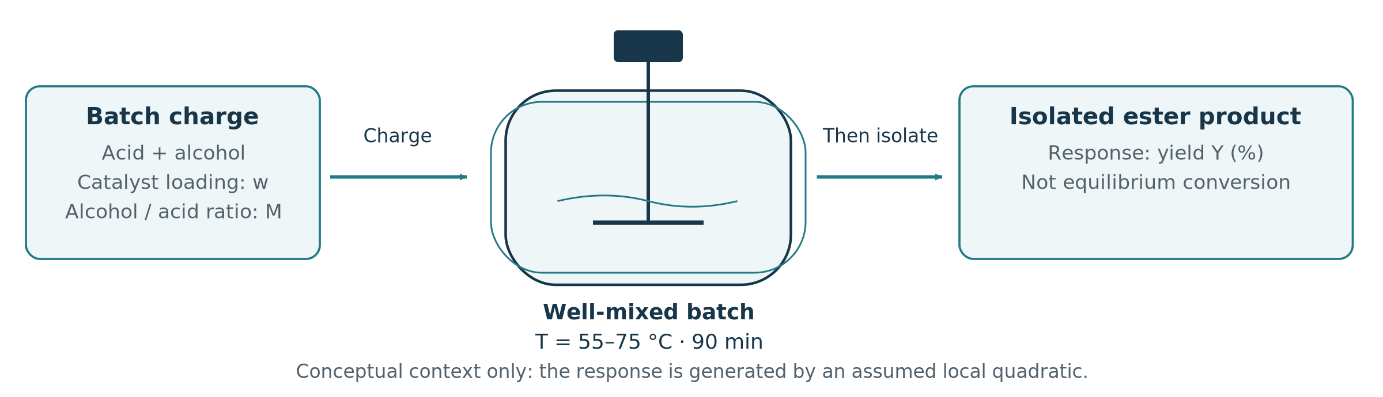
Figure 1. Conceptual batch experiment. Charge composition and temperature are set before the run; isolated yield is assessed after 90 minutes. No continuous feed is assumed.
Independent input | Symbol | Low / centre / high
Temperature | T | 55 / 65 / 75 °C
Alcohol-to-acid molar ratio | M | 1.5 / 3.0 / 4.5
Catalyst loading relative to initial acid mass | w | 0.5 / 1.0 / 1.5 mass %

Response and model boundary
The response Y is isolated product yield, expressed as a percentage of theoretical yield. It includes whatever local performance variation the illustrative empirical response represents; it is not labelled as equilibrium conversion. Mixing, batch duration and the liquid-phase operating regime are fixed.
Temperature, ratio and catalyst loading are treated as separately adjustable experimental factors. No specific acid, alcohol or catalyst is claimed. The synthetic coefficients are chosen to give interactions, curvature and a maximum inside the domain.

Why use RSM here?
A three-factor quadratic is compact enough to inspect term by term and rich enough to represent a local curved optimum. The case deliberately generates a quadratic mean response, so it tests experimental design, coefficient estimation and confirmation under noise rather than discovery of an unknown functional family [1,2,15].
SUCCESS CRITERION
A successful model yields a defensible in-domain recommendation, an uncertainty-aware interpretation and an independent confirmation. A high training R² alone is not the task.

CASE 1 · MODEL SPECIFICATION

From coded factors to a fitted surface

1. Define the coordinates and synthetic mean
$$x_{1}=\frac{T-65}{10}, x_{2}=\frac{M-3}{1.5}, x_{3}=\frac{w-1.0}{0.5}$$ | (8)
Here T is the numerical temperature in °C and w is the numerical catalyst loading in mass %. The temperature numerator represents a difference. Each coded factor is dimensionless and spans −1 to +1.
$$Y_{true}=88+4x_{1}+3x_{2}+2x_{3}-5x_{1}^{2}-4x_{2}^{2}-3x_{3}^{2}+2x_{1}x_{2}-1.5x_{1}x_{3}+x_{2}x_{3}$$ | (9)
Add independent normal noise with standard deviation 1 percentage point. At the design centre the noise-free response is 88%. This generating equation is disclosed for teaching but is not supplied as fixed fitted coefficients.

2. Use the designed observations to estimate coefficients
The Box–Behnken training design contains 12 non-centre runs plus five independent centre replicates. At each non-centre setting, two coded factors take ±1 and the remaining factor is zero. Fit all 17 observations; use 12 separately generated validation observations to compare a four-coefficient linear model against the ten-coefficient full quadratic [2,15].

3. Examine lack of fit and conditional effects
$$F_{LOF}=\frac{SS_{LOF}/ν_{LOF}}{SS_{PE}/ν_{PE}}, SS_{LOF}=SS_{res}-SS_{PE}$$ | (10)
Pure error (PE) is within-setting replicate variation. For the full quadratic, the pure-error and lack-of-fit degrees of freedom are 4 and 3. The supplied run gives p = 0.0762: failure to reject lack of fit is not proof that the model is correct, particularly with few replicates [6,15].
$$\frac{∂Y_{true}}{∂x_{1}}=4-10x_{1}+2x_{2}-1.5x_{3}$$ | (11)
The temperature effect depends on temperature itself and on both other factors. The main-effect coefficient is therefore not a universal sensitivity. Divide this coded derivative by 10 K to express it per degree at a fixed ratio and catalyst loading.
The design omits the corners of the three-factor cube. Being inside the numerical factor bounds does not mean every combination has equal experimental support. Inspect residuals and predictive uncertainty at the recommendation.

CASE 1 · INTERPRETATION

A reliable recommendation, not just a fitted maximum
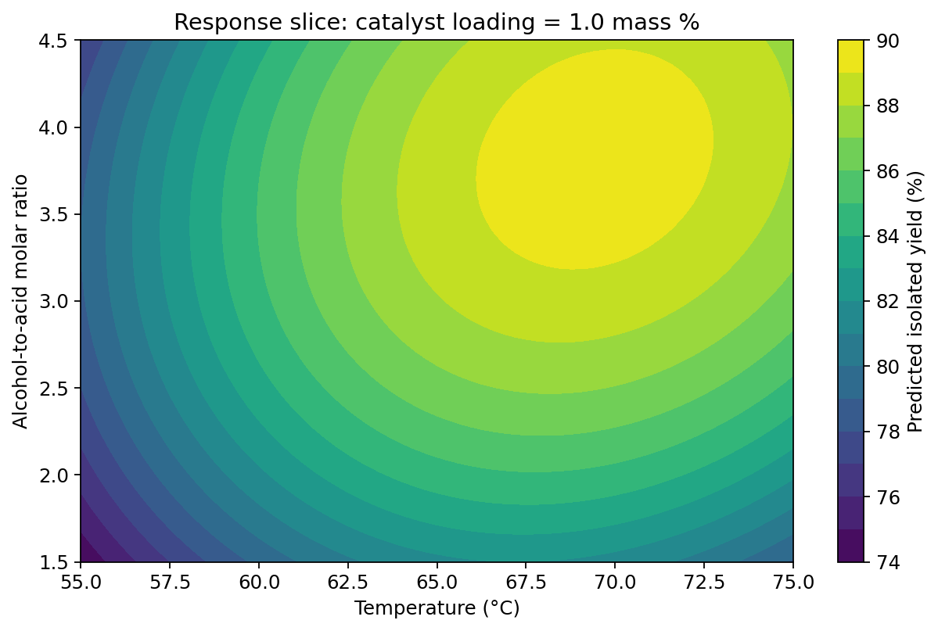
Figure 2. Saved notebook result: fitted yield contours with catalyst loading fixed at its centre. This is a two-input slice, not the full three-input optimisation.
Check | Saved result | Interpretation
Validation RMSE | Linear 3.568; quadratic 0.815 percentage points | The validation set selects the quadratic.
Test RMSE | 1.183 against observations; 0.369 against truth | Separate observation scatter from mean-surface error.
Recommended settings | 69.10 °C; ratio 3.865; catalyst 1.150 mass % | Prediction 89.82%; generator evaluation 89.99%.

$$x_{opt}=\underset{x∈{\left[-1,1\right]}^{3}}{arg max} \hat{Y}\left(x\right)$$ | (12)
The noise-free benchmark is 69.60 °C, ratio 3.792 and catalyst loading 1.153 mass %, giving 90.018% yield. The surrogate recommendation loses only 0.0273 percentage points relative to this synthetic benchmark. These digits describe one seeded run, not experimental precision.
Six new confirmation observations give a mean of 90.220% and a sample standard deviation of 1.578 percentage points. The notebook also distinguishes confidence intervals for a mean response from wider prediction intervals for a new observation; both are conditional on the regression and noise assumptions [5,15].
Discussion: force the linear model, double the noise, or vary catalyst loading in the contour plot. Explain changes to the recommendation without selecting a favourable seed. Report the prediction and confirmation result together.

CASE 2 · ADVANCED RSM

Selective CSTR: distinguish yield from productivity
Companion notebook: 02_RSM_Selective_CSTR.ipynb
Engineering question. How should a continuous stirred-tank reactor be operated when A forms the desired intermediate B, but B can subsequently form undesired C? Feed conversion is not enough: the reactor must retain useful product while maintaining throughput [7].
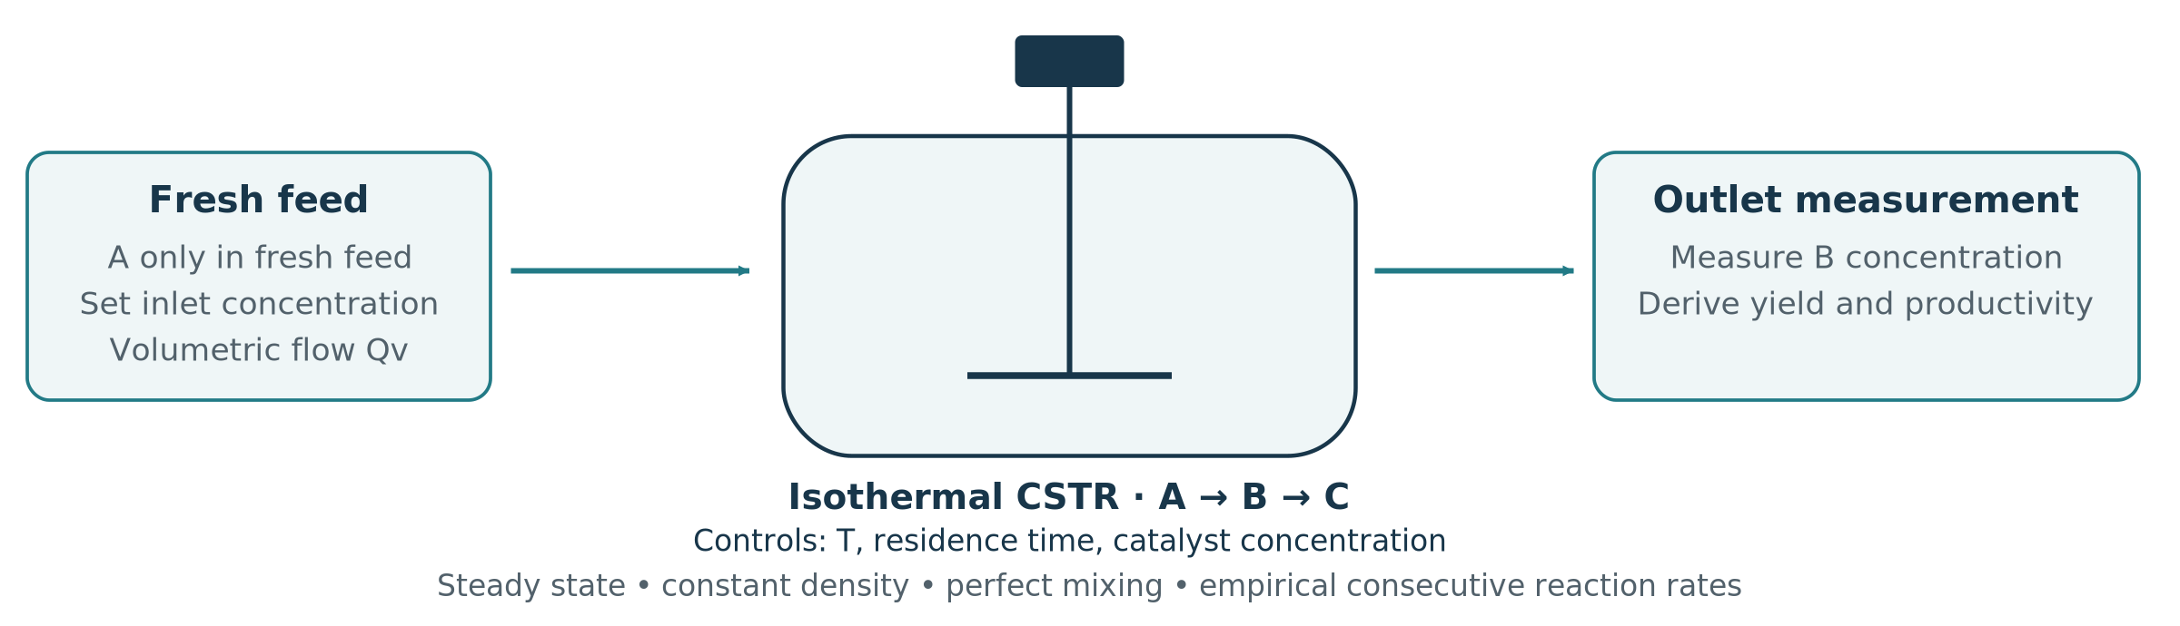
Figure 3. Selective-reactor boundary. Only A enters in the fresh feed. The primary observation is the outlet B concentration; yield and productivity are derived from it.
Independent input | Symbol | Domain
Reactor temperature | T | 335–355 K
Residence time | τ | 1–5 min
Inlet concentration of A | C_{A0} | 0.5–1.5 mol L⁻¹
Catalyst concentration | c_{cat} | 0.5–1.5 g L⁻¹

$$τ=\frac{V}{Q_{v}}, Y_{B}=\frac{C_{B}}{C_{A0}}, P_{B}=\frac{C_{B}}{τ}$$ | (13)
V is the liquid reactor volume and Qᵥ is volumetric flow. Y_{B} is feed-based molar yield (a fraction, not a percentage unless multiplied by 100). P_{B} is volumetric productivity in mol L⁻¹ min⁻¹. C_{B} is the primary response in mol L⁻¹.

Assumptions and choice of surrogate
Assume steady state, perfect mixing, constant density and an isothermal reactor; no B or C is present in the fresh feed. The lumped sequence uses one-to-one stoichiometric bookkeeping, with empirical rate orders. The nonlinear balance model generates the data; the surrogate is only a local quadratic approximation [7,15].
Treating residence time as a decision input implicitly changes throughput at fixed volume, or volume at fixed flow. This lesson uses volumetric productivity and does not include reactor capital cost or catalyst deactivation.

CASE 2 · GOVERNING MODEL

Generate observations from nonlinear reactor physics

1. Rates and temperature dependence
$$A→B→C, a=\frac{c_{cat}}{1 g L^{-1}}$$ |  |  | (14)
$$r_{1}=a k_{1}\left(T\right)C_{A}, r_{2}=a k_{2}\left(T\right)C_{B}^{2}$$ |  |  | (15)
$$k_{i}\left(T\right)=k_{i,ref}exp​\left[-\frac{E_{i}}{R}\left(\frac{1}{T}-\frac{1}{T_{ref}}\right)\right]$$ |  |  | (16)
Teaching parameter | First reaction | Second reaction
Reference temperature | 345 K | 345 K
Reference rate coefficient | k_{1,ref} = 0.35 min⁻¹ | k_{2,ref} = 0.25 L mol⁻¹ min⁻¹
Apparent activation energy | E₁ = 35 kJ mol⁻¹ | E₂ = 60 kJ mol⁻¹

Use R = 8.314462618 J mol⁻¹ K⁻¹ and convert the energies to J mol⁻¹ in the exponential. Both rates have units mol L⁻¹ min⁻¹. The B-squared rate is an empirical assumption; the arrow notation does not assert an elementary molecular step.

2. Solve the steady-state balances
$$0=\frac{C_{A0}-C_{A}}{τ}-r_{1}, 0=-\frac{C_{B}}{τ}+r_{1}-r_{2}$$ | (17)
$$C_{A}=\frac{C_{A0}}{1+τak_{1}}, G=τak_{1}C_{A}$$ | (18)
$$C_{B}=\frac{2G}{1+\sqrt{1+4τak_{2}G}}$$ | (19)
G has concentration units. The last expression is the positive solution of the B balance, written to avoid subtracting two nearly equal numbers. It approaches G as the second-reaction contribution tends to zero. The balance structure follows standard multiple-reaction CSTR analysis; all numerical rate parameters are instructional assumptions [7,15].

3. Add the concentration measurement error
$$C_{B,obs}=C_{B,true}+ε_{C}, ε_{C}∼N\left(0,σ_{C}^{2}\right)$$ | (20)
Use a concentration standard deviation σ_{C} = 0.005 mol L⁻¹. Compute observed yield and productivity from that same concentration. At T = 345 K, τ = 3 min, C_{A0} = 1 mol L⁻¹ and c_{cat} = 1 g L⁻¹, the generator gives C_{B} = 0.3951 mol L⁻¹ and P_{B} = 0.1317 mol L⁻¹ min⁻¹.
CASE 2 · SURROGATE CONSTRUCTION

Preserve exact relationships between the outputs
Use a four-factor Box–Behnken design: 24 non-centre runs and five centre replicates. The coded centres are [345 K, 3 min, 1 mol L⁻¹, 1 g L⁻¹], with half-ranges [10 K, 2 min, 0.5 mol L⁻¹, 0.5 g L⁻¹]. Fit all 29 training observations. A separate 30-point validation set compares the five-coefficient linear and 15-coefficient full-quadratic models [2,15].

Fit concentration once; derive the other outputs
$${\hat{C}}_{B}=g_{RSM}\left(T,τ,C_{A0},c_{cat}\right), {\hat{Y}}_{B}=\frac{{\hat{C}}_{B}}{C_{A0}}, {\hat{P}}_{B}=\frac{{\hat{C}}_{B}}{τ}$$ | (21)
$${\hat{P}}_{B}=\frac{C_{A0}{\hat{Y}}_{B}}{τ}$$ | (22)
This identity is exact for the adopted definitions. Three independently fitted response surfaces need not satisfy it. The notebook deliberately compares the two approaches to demonstrate algebraic consistency; it does not claim that separate fits must have larger error for every output.

The response errors are related, not independent
$$Var\left(Y_{B,obs}∣x\right)=\frac{σ_{C}^{2}}{C_{A0}^{2}}, Var\left(P_{B,obs}∣x\right)=\frac{σ_{C}^{2}}{τ^{2}}$$ | (23)
$$Cov\left(Y_{B,obs},P_{B,obs}∣x\right)=\frac{σ_{C}^{2}}{C_{A0}τ}$$ | (24)
These expressions assume exact inputs and noise only in the measured concentration. A fixed concentration error produces a larger productivity error at short residence time. Good concentration RMSE therefore does not by itself establish a reliable productivity decision.

Screen a finite set, then verify the chosen decisions
The notebook evaluates 6,001 candidate settings with the frozen surrogate, including the centre. It screens predictions for non-negative concentration not exceeding the feed concentration, identifies sampled non-dominated yield–productivity points, and selects three recommendations: highest sampled yield, highest sampled productivity and an equal-weight compromise.
$$x_{comp}=\underset{x∈P}{arg min} \left[{\left(1-{\tilde{Y}}_{B}\right)}^{2}+{\left(1-{\tilde{P}}_{B}\right)}^{2}\right]$$ | (25)
The tildes denote separate min–max normalisation over all retained admissible sampled candidates; the compromise is then chosen from the Pareto subset 𝒫. Equal weight is a stated preference. This finite set is not a globally proven continuous Pareto frontier; recommendations are subsequently recomputed with the nonlinear reactor model.

CASE 2 · INTERPRETATION

Check the decision against the original reactor
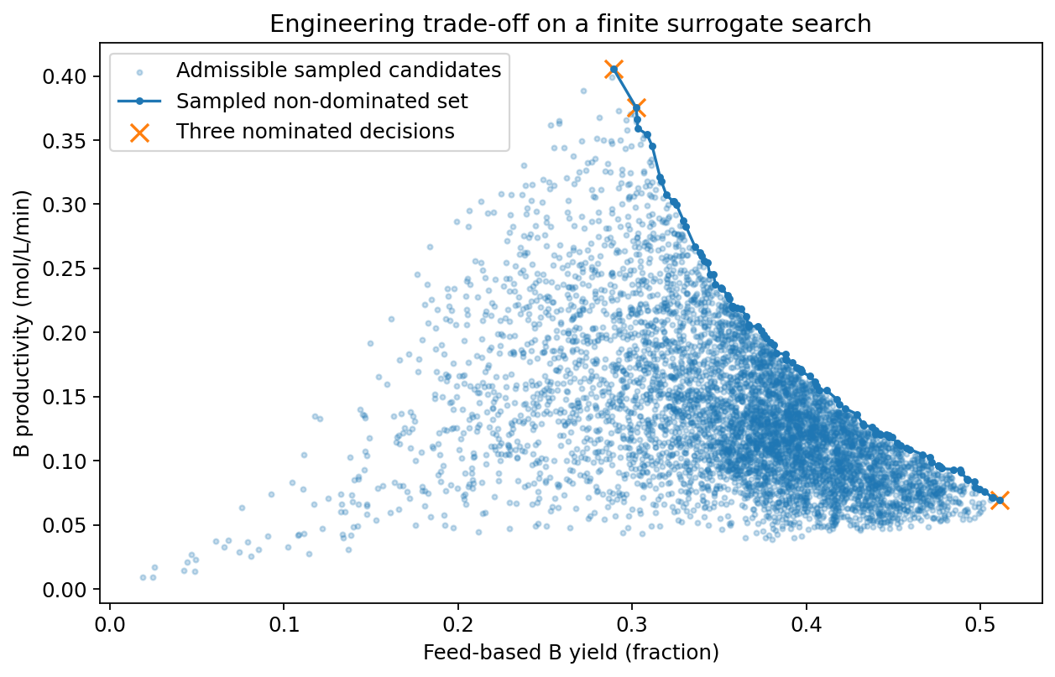
Figure 4. Saved notebook result: finite sampled yield–productivity trade-off. These are surrogate predictions before verification with the nonlinear balance model.
Recommendation | Predicted / verified yield | Predicted / verified productivity
Highest sampled yield | 0.5109 / 0.4879 | 0.06955 / 0.06643
Highest sampled productivity | 0.2891 / 0.3147 | 0.40584 / 0.44168
Equal-weight compromise | 0.3022 / 0.3302 | 0.37572 / 0.41053

Yield is a fraction. Productivity is in mol L⁻¹ min⁻¹. Values are taken from the delivered notebook output; recommendations are sampled choices, not claims of global optimality.
The selected quadratic has concentration test RMSE of 0.01259 mol L⁻¹ against noisy observations and 0.01138 mol L⁻¹ against the generator. The latter rises to 0.03200 mol L⁻¹ in the separate 355–375 K challenge. The true-yield test RMSE is 0.01508, equivalent to 1.51 percentage points.
The compromise productivity is underpredicted by about 8.5% relative to its verified value. This is why average fit quality, feasibility and local decision accuracy must be assessed separately. An interior model can also have significant lack of fit because the generating reactor is not quadratic.
Discussion: explain why maximum yield and maximum productivity differ; compare exact-identity and independent-output fits; repeat screening over a narrower range. Preserve a new evaluation set when revising the surrogate.

CASE 3 · INTRODUCTORY SR

Pressure loss: recover an engineering scaling
Companion notebook: 03_SR_Pipe_Pressure_Loss.ipynb
Engineering question. Can a compact expression identify how flow rate, internal diameter and viscosity determine pressure loss in a viscous-liquid line? The intended output is the pressure drop across one straight measurement section, not the pressure requirement of a complete piping network.
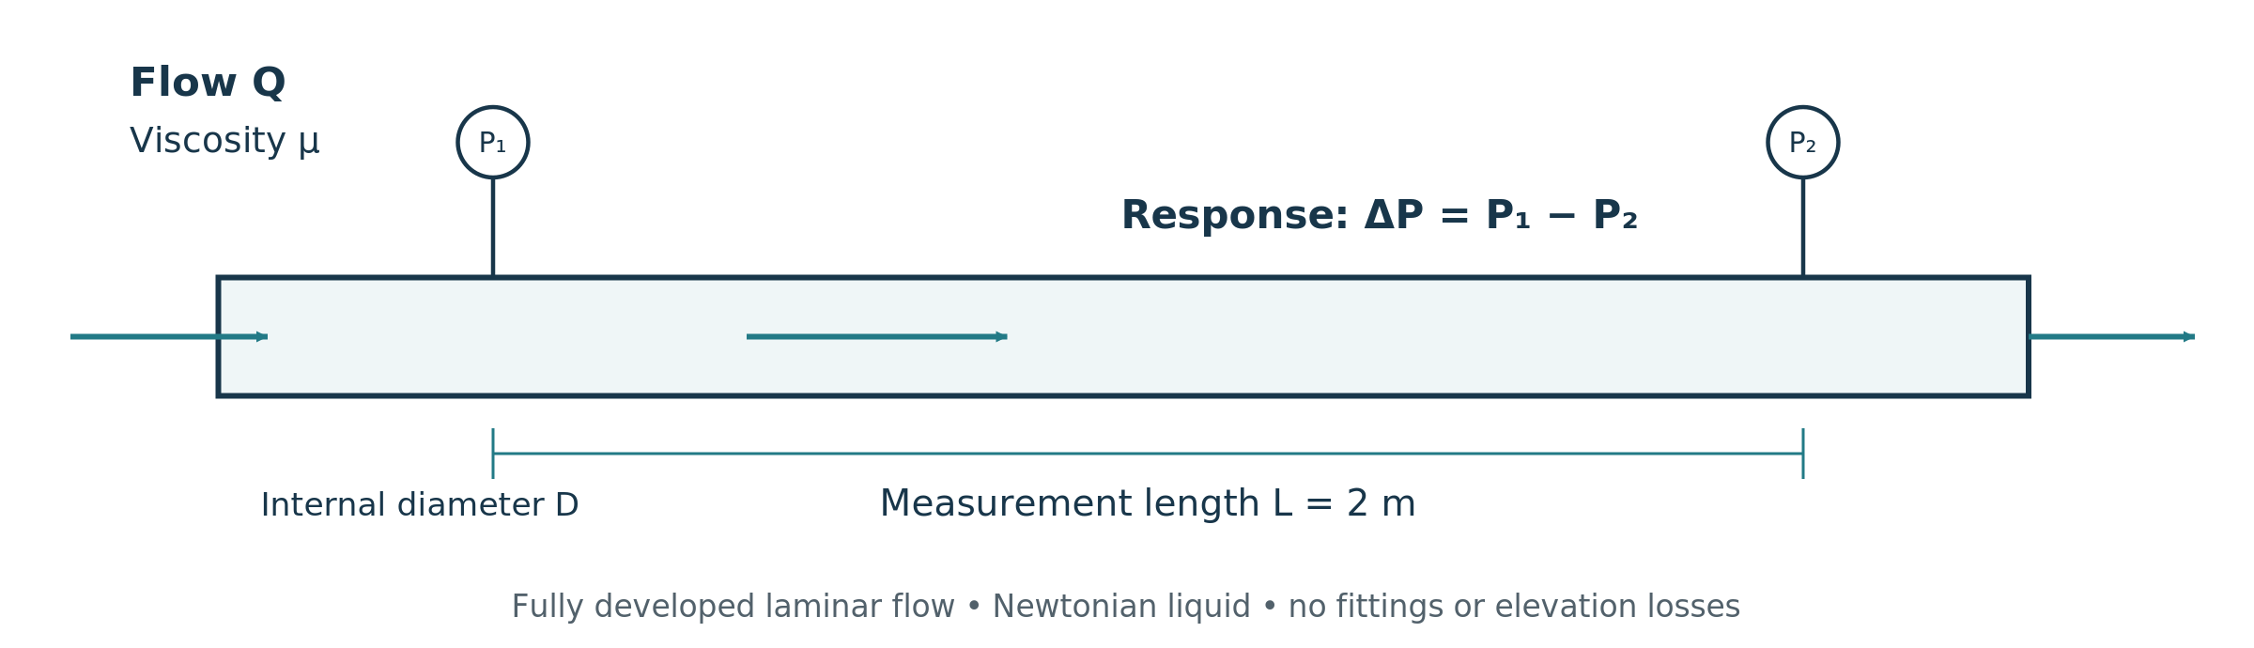
Figure 5. Straight-pipe measurement boundary. Pressure taps define the 2 m section; the flow is assumed fully developed before the upstream tap.
Independent input | Symbol | Domain / reference
Volumetric flow | Q | 0.1–0.6 L min⁻¹; Q₀ = 0.3 L min⁻¹
Internal diameter | D | 4–8 mm; D₀ = 6 mm
Dynamic viscosity | μ | 5–20 mPa s; μ₀ = 10 mPa s

Assumptions make the target relationship identifiable
Use a horizontal circular pipe of length L = 2 m and fluid density ρ = 1000 kg m⁻³. Assume steady, fully developed, incompressible Newtonian laminar flow, no slip and spatially uniform viscosity. Exclude fittings, entrance losses, elevation changes and transient acceleration [8].
$$ΔP=\frac{128μLQ}{πD^{4}}, Re=\frac{4ρQ}{πμD}$$ | (26)
The Hagen–Poiseuille equation generates the noise-free response. Convert Q to m³ s⁻¹, D to metres and μ to Pa s before evaluating it. The maximum Reynolds number in the chosen input box is approximately 637. The reference-condition pressure drop is 3143.8 Pa [8,15].
WHY THIS IS NOT MERELY A PRESSURE CALCULATION
Students receive noisy multivariable observations. The core search is not given the correct exponent triple: it must compare alternative structures. The instructor knows the generating law and uses it only to explain and audit the outcome.

CASE 3 · RESTRICTED SYMBOLIC SEARCH

Search 729 structures and fit one constant per structure

1. Define dimensionless variables without hiding the amplitude
$$u=Q/Q_{0}, v=D/D_{0}, w=μ/μ_{0}, y=ΔP/\left(1000 Pa\right)$$ | (27)
The output reference is 1000 Pa, not the exact generator value 3143.8 Pa. The coefficient must therefore be estimated from the noisy training data rather than being normalised away.
$$\hat{y}=A u^{p_{Q}}v^{p_{D}}w^{p_{μ}}, p_{Q},p_{D},p_{μ}∈\{-5,-4,…,3\}$$ | (28)
Nine allowed powers for each of three variables give 9³ = 729 structures. A zero exponent removes an input; negative exponents permit reciprocal relationships. The multiplicative integer-power family is supplied knowledge, not an independently discovered property.

2. Estimate a positive amplitude using the noise model
$$l_{i}=lny_{obs,i}+\frac{σ^{2}}{2}, σ=0.03$$ | (29)
lnA=1ntraini​li-pQlnui-pDlnvi-pμlnwi | (30)
For a fixed exponent triple, this is the least-squares optimum for the intercept in corrected log space. Exponentiating the fitted intercept keeps A positive. The log objective gives relative-scale deviations a more balanced role than unscaled pressure errors.

3. Choose the expression on validation data
Use 150 training points and 50 validation points sampled by LHS. Score each fitted expression by validation log-RMSE. Retain those within 0.002 of the minimum score and prefer the smallest declared complexity; use validation error to break any remaining tie.
C=1+j∈{Q,D,μ}, pj≠0​pj+2 | (31)
This is a within-search complexity proxy, not a universal count of expression-tree nodes. Freeze both powers and amplitude before evaluating 100 test points and the separate 100-point diameter challenge. The challenge changes only D to 8–10 mm.
WHAT IS SUPPLIED, WHAT IS LEARNT
Supplied: three inputs, physical references, a multiplicative family, integer exponent bounds and the noise model. Learnt: which powers and inputs are supported, plus the amplitude. Optional PySR performs a different evolutionary search over operator-built expressions [4,15].

CASE 3 · INTERPRETATION

The equation should explain the design sensitivity
$$\frac{\hat{ΔP}}{1000 Pa}=3.143005\left(\frac{Q}{Q_{0}}\right){\left(\frac{D}{D_{0}}\right)}^{-4}\left(\frac{μ}{μ_{0}}\right)$$ | (32)
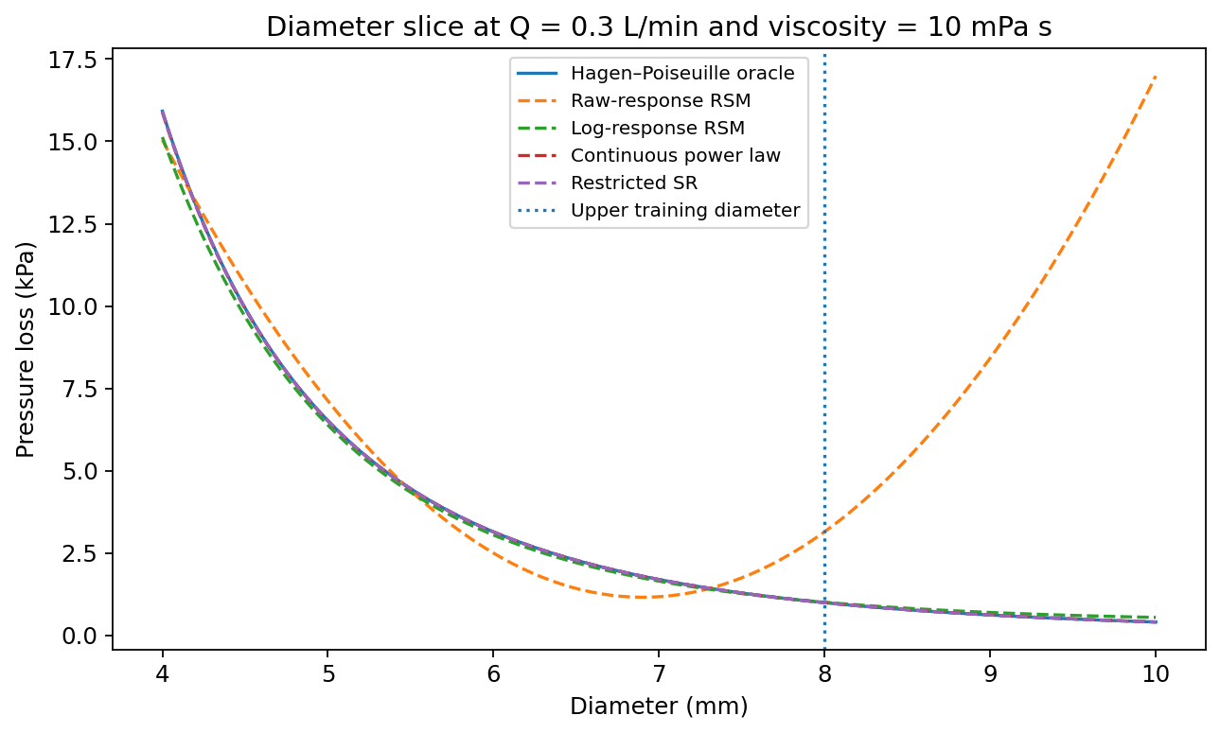
Figure 6. Saved notebook result: diameter sensitivity at fixed reference flow and viscosity. Predictions outside the fitted diameter range are a separate diagnostic.
Model | Test RMSE: noisy / true (Pa) | Non-positive test predictions
Raw-response quadratic | 1303.90 / 1378.46 | 6
Log-response quadratic | 535.54 / 361.42 | 0
Continuous power law | 301.26 / 20.10 | 0
Restricted SR | 301.75 / 2.45 | 0

The selected exponent triple is (1, −4, 1). Doubling diameter at fixed flow and viscosity therefore divides predicted pressure loss by 16. The raw quadratic nevertheless has test R² = 0.964 against noisy observations: a seemingly high aggregate statistic hides low-pressure errors and unphysical predictions.
The continuous power-law baseline preselects a log-linear family but estimates real-valued exponents; it is not free-form SR. The notebook also bootstraps the amplitude conditional on the selected integer powers. Those intervals exclude structure-selection uncertainty and omitted physical effects.
Do not infer reliable turbulent, non-Newtonian or entrance-region predictions. The very small error against synthetic truth is helped by exact-family inclusion and a single fitted amplitude. It is not evidence that real pipeline measurements have negligible uncertainty.

CASE 4 · ADVANCED SR

Humid-gas adsorption: equilibrium and uptake rate
Companion notebook: 04_SR_Humid_CO2_Adsorption.ipynb
Engineering question. Which compact relationship describes how temperature, CO₂ pressure, water-vapour pressure and exposure time jointly determine CO₂ uptake? The process context is an adsorption step that could precede carbon utilisation, but the model boundary is one lumped sorbent sample.
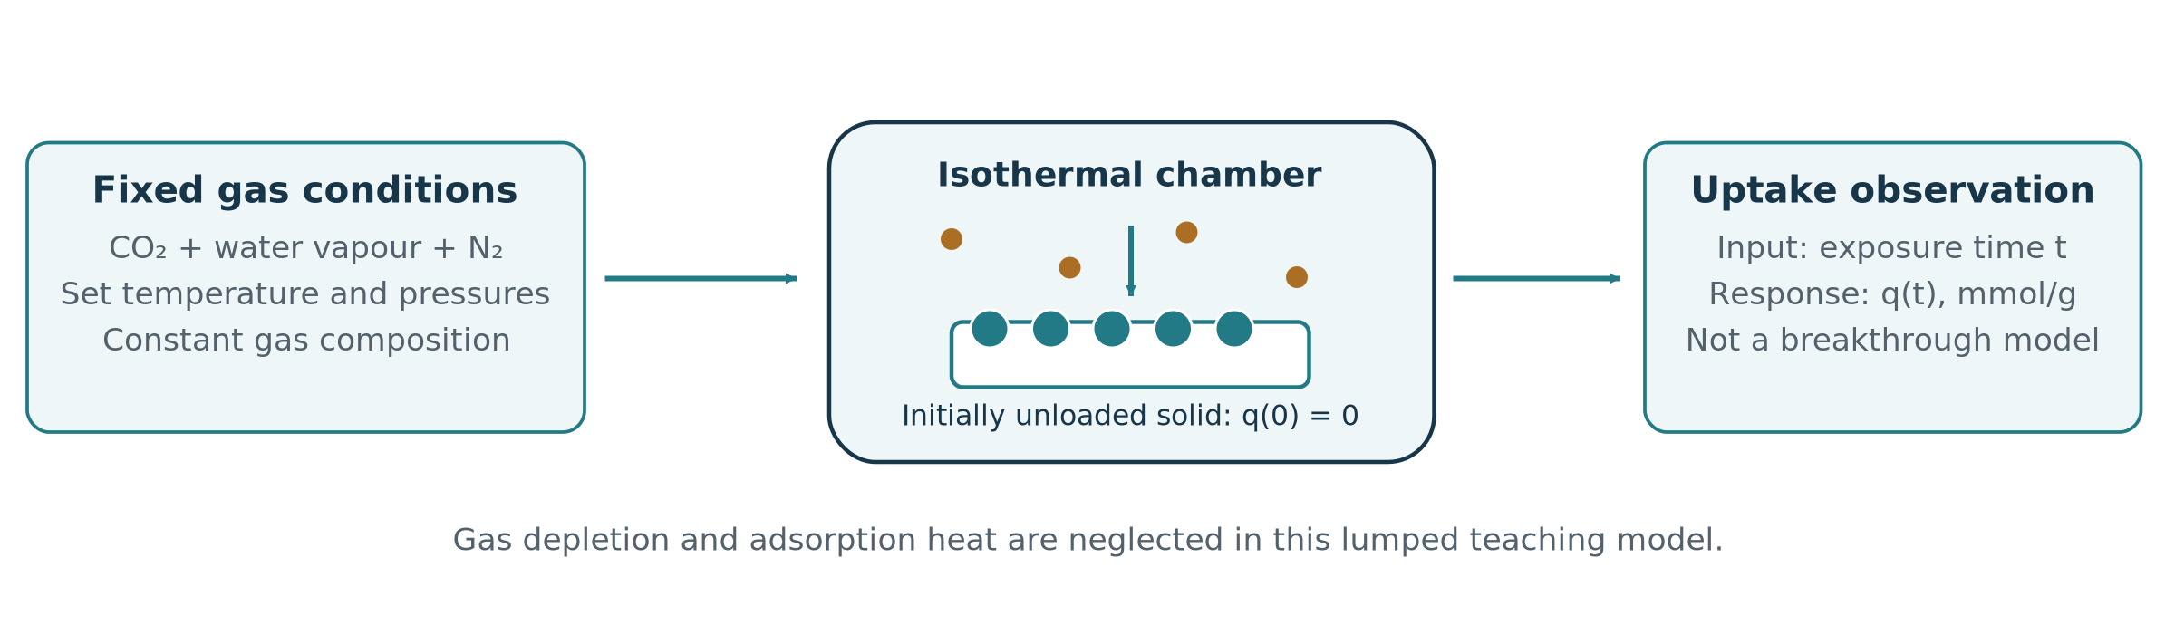
Figure 7. Lumped uptake experiment with maintained gas conditions. Composition does not deplete during a run, and the measured response is solid-phase uptake rather than an outlet breakthrough curve.
Independent input | Symbol | Training domain
Absolute temperature | T | 298–348 K
CO₂ partial pressure | p_{C} | 0.03–0.25 bar
Water-vapour partial pressure | p_{W} | 0.001–0.025 bar
Exposure time | t | 5–300 s

Response and boundary conditions
The response q is CO₂ uptake in mmol g⁻¹ of adsorbent. Assume an initially unloaded solid, fixed temperature and externally maintained gas partial pressures. Nitrogen is treated as a non-competing balance gas at 1 bar total pressure. No material-specific parameter values are claimed.

Why this needs a richer family than a quadratic
The hypothetical generator combines saturation in CO₂ pressure, competition from water, temperature-dependent equilibrium and finite-time approach to equilibrium. Temperature can reduce capacity while accelerating uptake. A statement that “higher temperature improves adsorption” is therefore incomplete unless exposure time and the response definition are stated [9–12,15].
NOT A FULL CAPTURE-PROCESS MODEL
The lesson omits axial transport, gas depletion, adsorption heat, pressure loss, regeneration and cyclic operation. A high uptake prediction alone does not establish capture fraction, working capacity, cycle productivity or separation energy.

CASE 4 · GOVERNING MODEL

Construct a synthetic equilibrium–kinetic response

1. Competitive equilibrium
$$q_{eq}=\frac{q_{s} b_{C}\left(T\right)p_{C}}{1+b_{C}\left(T\right)p_{C}+b_{W}\left(T\right)p_{W}}$$ | (33)
q_{s} is the saturation capacity; b_{C} and b_{W} are affinity coefficients in bar⁻¹, so every denominator term is dimensionless. The competitive Langmuir form represents shared-site competition. Its application to this hypothetical CO₂–water pair is a teaching assumption, not validation of a real material [9,10].
$$b_{j}\left(T\right)=b_{j,0}exp​\left[\frac{H_{j}}{R}\left(\frac{1}{T}-\frac{1}{T_{0}}\right)\right], j∈\{C,W\}$$ | (34)
The positive H values are magnitudes of assumed exothermic adsorption energies. With this sign convention the affinity coefficients decrease as temperature increases.

2. Effective approach to equilibrium
$$\frac{dq}{dt}=k\left(T\right)\left(q_{eq}-q\right), q\left(0\right)=0$$ | (35)
$$q\left(t\right)=q_{eq}\left[1-exp\{-k\left(T\right)t\}\right]$$ | (36)
$$k\left(T\right)=k_{0}exp​\left[-\frac{E_{k}}{R}\left(\frac{1}{T}-\frac{1}{T_{0}}\right)\right]$$ | (37)
The linear-driving-force approximation uses an effective relaxation coefficient, not an automatically identifiable elementary rate constant. The stated solution requires constant conditions during the exposure [11,12].
Teaching parameter | Assumed value
Reference temperature; capacity | T₀ = 318 K; q_{s} = 3 mmol g⁻¹
Affinity coefficients at T₀ | b_{C,0} = 5 bar⁻¹; b_{W,0} = 30 bar⁻¹
Adsorption energy magnitudes | H_{C} = 25; H_{W} = 35 kJ mol⁻¹
Reference relaxation rate; energy | k₀ = 0.015 s⁻¹; E_{k} = 18 kJ mol⁻¹

Add mean-preserving lognormal noise with σ = 0.05. At 318 K, p_{C} = 0.1 bar and p_{W} = 0.01 bar, q_{eq} = 0.8333 mmol g⁻¹ and q(100 s) = 0.6474 mmol g⁻¹. These provide unit and implementation checks before any fitting.

CASE 4 · SYMBOLIC MODEL SPACE

Eighteen templates: a restricted equation search
The core method combines three equilibrium families, three temperature-dependence options and two time-response families. The resulting 3 × 3 × 2 = 18 structures are defined before model selection.
Structural choice | Alternatives
Equilibrium family | Linear in CO₂ pressure; CO₂ saturation; CO₂–water competition.
Temperature dependence | None; equilibrium only; equilibrium and relaxation rate.
Time response | Exponential relaxation; rational approach to saturation.

Scaled coordinates
$$v=\left(1000 K\right)\left(\frac{1}{T}-\frac{1}{318 K}\right), u=\frac{p_{C}}{0.1 bar}$$ | (38)
$$w=\frac{p_{W}}{0.01 bar}, s=\frac{t}{100 s}$$ | (39)
All four coordinates are dimensionless. Inverse temperature allows Arrhenius-like and equilibrium-energy terms to be represented by exponentials with fitted dimensionless slopes.

The competitive family illustrates the construction
$${\hat{q}}_{eq}=\frac{{\hat{q}}_{s}B_{C}\left(v\right)u}{1+B_{C}\left(v\right)u+B_{W}\left(v\right)w}$$ | (40)
$$B_{C}\left(v\right)=B_{C,0}e^{h_{C}v}, B_{W}\left(v\right)=B_{W,0}e^{h_{W}v}, K\left(v\right)=K_{0}e^{-e_{k}v}$$ | (41)
$$F_{exp}=1-e^{-K\left(v\right)s}, F_{rat}=\frac{K\left(v\right)s}{1+K\left(v\right)s}, \hat{q}={\hat{q}}_{eq}F$$ | (42)
For the saturating family, omit the water term. For the linear family, use a fitted amplitude times u and its permitted temperature dependence. Missing temperature effects are set to zero; they are not secretly estimated. Positive scale constants are fitted in logarithmic coordinates, while temperature slopes may be positive or negative within stated bounds.
BUILT-IN BEHAVIOUR MUST NOT BE DESCRIBED AS DISCOVERY
Both time-response templates impose zero uptake at zero time. Positivity follows from their parameterisation. The selected competitive model encodes water inhibition. These are properties of the supplied candidate families, not independent experimental discoveries.

CASE 4 · FITTING AND VALIDATION

Separate gas conditions and numerical fitting decisions

Keep whole uptake curves together
Generate 60 training, 20 validation and 20 test gas conditions by LHS in temperature and the two partial pressures. At every condition, evaluate ten geometrically spaced times from 5 to 300 s. Keep the complete curve in one partition; measurement errors are independently sampled, but generalisation is assessed to new gas conditions [3,14,15].
Partition | Gas conditions | Rows | Temperature
Training | 60 | 600 | 298–348 K
Validation | 20 | 200 | 298–348 K
Test | 20 | 200 | 298–348 K
Challenge | 20 | 200 | 348–368 K

Fit constants inside each structure
LS=1ntraini​ln​qSxi;θqref-ln​qobs,iqref-σ222 | (43)
q_{ref} = 1 mmol g⁻¹ makes the logarithms dimensionless. For each structure, use three initial guesses and bounded nonlinear least squares. The notebook allows up to 1,800 function evaluations per attempt. It retains the converged finite fit with the smallest training objective; validation is not used to choose a starting guess [13,15].
The fitted log-scale constants have bounds −8 to 6 and the temperature slopes −10 to 10. These are numerical safeguards, not experimentally established physical intervals. Failed fits are reported; near-bound parameters are flagged.

Select, then quantify conditional uncertainty
Score the trained structures on validation log-RMSE. Among candidates within 0.003 of the best score, prefer the smaller declared within-grammar complexity. Freeze the winning structure and constants before opening test or challenge outcomes. The complexity score is not directly comparable with the pipe case or an RSM coefficient count.
Covθ≈sl2JTJ†, sl2=i​ri2n-p | (44)
J is the training residual Jacobian, p is the fitted parameter count, and † denotes the Moore–Penrose pseudoinverse. The notebook reports local approximate 95% intervals using ±1.96 standard errors. These are conditional on structure, noise assumptions and local linearisation; they do not quantify uncertainty across all possible adsorption models.

CASE 4 · WORKED RESULT

Read the fitted equation in its actual coordinates
For the saved seeded run, validation selects competitive equilibrium, temperature dependence in both equilibrium and rate, and exponential relaxation. All three numerical starts converge for this candidate, with no reported bound hits. Its seven fitted parameters give the following expression.
$$\frac{\hat{q}}{1 mmol g^{-1}}=\frac{3.07358 B_{C}\left(v\right)u}{1+B_{C}\left(v\right)u+B_{W}\left(v\right)w}\left[1-e^{-K\left(v\right)s}\right]$$ | (45)
$$B_{C}\left(v\right)=0.483147 e^{2.95462v}, B_{W}\left(v\right)=0.313225 e^{4.02362v}$$ | (46)
$$K\left(v\right)=1.51498 e^{-2.16807v}$$ | (47)
The coordinate definitions are those on the preceding pages. In particular, the fitted scaled affinity coefficient B_{C,0} is not b_{C,0} in bar⁻¹: divide it by the pressure reference of 0.1 bar to recover that physical coefficient.
Quantity at 318 K | Generating assumption | Fitted value
Capacity, mmol g⁻¹ | 3.000 | 3.074
CO₂ affinity, bar⁻¹ | 5.000 | 4.831
Water affinity, bar⁻¹ | 30.000 | 31.322
Effective rate, s⁻¹ | 0.01500 | 0.01515
Rate energy, kJ mol⁻¹ | 18.000 | 18.026

Independent test performance
Model | RMSE: observed / true (mmol g⁻¹) | Negative test predictions
Raw-response quadratic | 0.07972 / 0.07619 | 6
Log-response quadratic | 0.17926 / 0.17939 | 0
Structured SR | 0.02796 / 0.00394 | 0

The selected structure has validation log-RMSE 0.04824, versus 0.06723 for the competing rational-time variant. Its test relative RMSE is 4.84% against observations. In the hotter challenge it is 5.51%. These are results for the disclosed synthetic generator, whose correct family is available in the grammar.
The local Jacobian has rank 7 of 7 and condition number about 104.5. Full numerical rank is not proof of global identifiability or real-mechanism recovery. Fitted effective parameters must be interpreted only within this model and operating range.

CASE 4 · INTERPRETATION

Interpret uptake curves before comparing materials
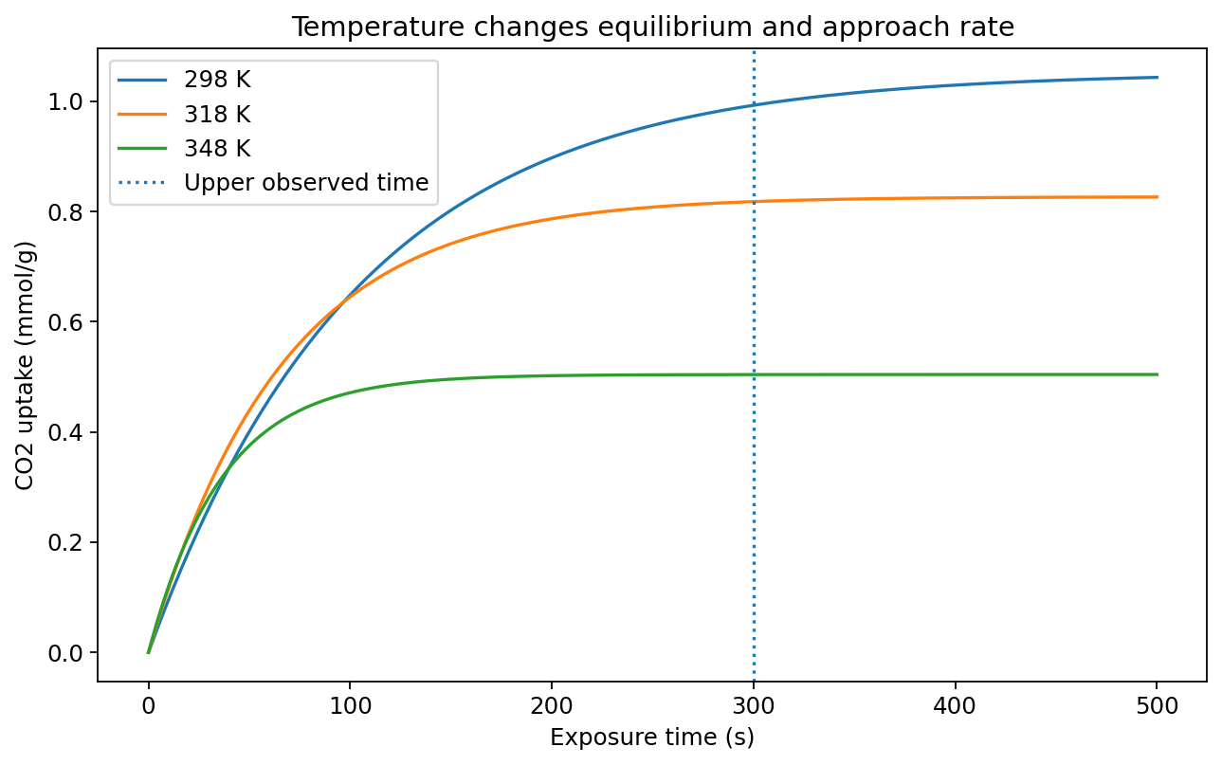
Figure 8. Saved notebook result: temperature effects at stated exposure times. Changing temperature affects both equilibrium uptake and the speed of approaching it.

What to inspect after running the code
Read the candidate table before focusing on the winner. Compare water-competitive and water-free models, and distinguish equilibrium-only temperature dependence from temperature-dependent relaxation. Then inspect complete held-out curves and condition-level errors rather than treating 200 test rows as 200 new gas conditions.
The physical audit checks finite predictions, non-negative uptake, zero-time behaviour, increasing uptake with time and non-increasing uptake with water for the selected competitive model. Passing these tests is useful, but the relevant properties were largely built into the supplied templates. A real material could exhibit water-assisted uptake or other behaviour absent from this grammar.

Questions for the advanced lesson
Structure: Remove the competitive option and explain where residuals increase. More optimiser iterations cannot recover a humidity term that is absent from every candidate.
Generalisation: Explain why a row-wise random split answers a weaker question than holding out complete gas conditions.
Engineering scope: List the additional transport, heat and cycle information needed before using an uptake relationship in a capture-plant design.
Optional evolutionary extension: use the separately labelled PySR exercise to compare a different operator-based search. Its success is not assumed, and repeated tuning against the same test set invalidates an independent comparison [4,14,15].

ACROSS THE FOUR CASES

What should a student be able to defend?
Case | Knowledge supplied | What the data determine | Main limit
Batch RSM | Quadratic family; operating box; additive-noise model. | Polynomial coefficients and a validated local recommendation. | The generator deliberately belongs to the fitted family.
CSTR RSM | Polynomial family and exact definitions of yield/productivity. | Approximate concentration response and sampled operating trade-offs. | Nonlinear physics is only approximated locally.
Pipe SR | Multiplicative integer-power grammar and physical references. | Exponent structure, selected inputs and amplitude. | No claim of validity outside the laminar Newtonian model.
Adsorption SR | Equilibrium, temperature and time-response template alternatives. | Selected combination and fitted effective parameters. | Correct-template inclusion and omitted transport physics.

A compact modelling report should state four things
The problem: Identify each independent input, units, bounds, output and intended decision. State what remains fixed and which mechanisms are excluded.
The method: Specify the training design, observation-noise model, preprocessing, expression family, loss function and model-selection rule. Distinguish fitted coefficients from selected structure.
The evidence: Present independent errors, diagnostic plots, physical checks and any confirmation. Label whether a number is a noisy observation, a surrogate prediction or a generator evaluation.
The claim: Explain where the surrogate is useful and where it has not been verified. Do not equate an interpretable expression with a proven chemical mechanism.

Fair comparisons and reproducibility
All baselines within a case use the same noisy training observations and held-out conditions, but they may use different transformations, losses and physical priors. Report those differences. These lessons are not a universal ranking of RSM and SR. A useful engineering model is one whose error and assumptions are acceptable for the decision.
The supplied default seed is 20261010, with separate streams for design and noise. Archive the executed notebook, software-version table, generated observations, model specification and result files. Numerical values in this guide are transcribed from the delivered saved outputs; slight differences may arise when environments or settings change.
TEACHING CONCLUSION
RSM is a disciplined route from designed experiments to a local response surface. Restricted SR adds a transparent choice among allowed equation structures. Both require trustworthy data separation, explicit physical scope and verification of consequential predictions.

REFERENCES

Methods, statistical design and reactor modelling
Numbered references support the general methods and governing model forms. All chemical parameter values and reported numerical results are synthetic and originate from the accompanying teaching notebooks. Web documentation was checked on 10 October 2026; source titles retain their original spelling.
[1] NIST/SEMATECH. e-Handbook of Statistical Methods, Section 5.3.3.6, “Response surface designs”. National Institute of Standards and Technology.
Quadratic response-surface structure and experimental-design context. Source record
[2] NIST/SEMATECH. e-Handbook of Statistical Methods, Section 5.3.3.6.2, “Box–Behnken designs”. National Institute of Standards and Technology.
Three-level designs for fitting second-order response surfaces. Source record
[3] McKay, M. D., Beckman, R. J. and Conover, W. J. (1979). Comparison of three methods for selecting values of input variables in the analysis of output from a computer code. Technometrics, 21(2), 239–245. DOI: 10.1080/00401706.1979.10489755.
Original source for Latin hypercube sampling. Source record
[4] Cranmer, M. (2023). Interpretable Machine Learning for Science with PySR and SymbolicRegression.jl. arXiv:2305.01582.
Evolutionary expression search and numerical constant optimisation. This is the optional extension, not the finite core searches. Source record
[5] statsmodels developers. “Ordinary Least Squares (OLS)” and “OLSResults.get_prediction”. Official statsmodels documentation.
Least-squares estimation and conditional mean-response / observation prediction intervals. Source record
[6] NIST/SEMATECH. e-Handbook of Statistical Methods, Section 4.4.4.6, “How can I test whether any significant terms are missing or misspecified in the functional part of the model?”
Replicate-based pure-error and lack-of-fit assessment. Source record
[7] Fogler, H. S. Elements of Chemical Reaction Engineering, sixth-edition online resources. Chapter 8, “Multiple Reactions”. University of Michigan.
Multiple-reaction balances, yield and selectivity; not a source of the invented CSTR parameters. Source record

REFERENCES AND RIGHTS

Transport, adsorption and numerical implementation
[8] SimScale. “Laminar Pipe Flow (Hagen Poiseuille) | Validation Case”. Official simulation validation documentation; updated 30 July 2025.
Analytical laminar-pipe reference and modelling assumptions; no SimScale simulation is run in this lesson. Source record
[9] Langmuir, I. (1918). The adsorption of gases on plane surfaces of glass, mica and platinum. Journal of the American Chemical Society, 40(9), 1361–1403. DOI: 10.1021/ja02242a004.
Foundational adsorption-isotherm reference. Source record
[10] CADET developers. “Multi Component Langmuir”. Official CADET documentation, v5.1.X.
Competitive-site model structure; its use for the hypothetical humid-gas system is an instructional assumption. Source record
[11] Glueckauf, E. (1955). Theory of chromatography. Part 10.—Formulæ for diffusion into spheres and their application to chromatography. Transactions of the Faraday Society, 51, 1540–1551. DOI: 10.1039/TF9555101540.
Classical diffusion and approximate uptake-model context. Source record
[12] CADET developers. “Binding models”, section “Linear Driving Force (LDF)”. Official CADET documentation, v5.1.X.
Relaxation towards equilibrium and distinction from elementary binding kinetics. Source record
[13] SciPy developers. “scipy.optimize.least_squares”. Official SciPy reference documentation.
Bounded nonlinear least-squares implementation used inside each adsorption candidate. Source record
[14] scikit-learn developers. “Cross-validation: evaluating estimator performance”. Official scikit-learn User Guide, Section 3.1.
Independent testing, model selection and grouping related observations. Source record
Teaching use only. Copyright © 2026 Yuanjing Zhao, University of Surrey. All rights reserved. Referenced software and third-party works retain their original licences and ownership. The synthetic examples do not constitute validated process-design or operating guidance.

