e-Baligya – Digital Marketplace for Fishery Vendors with Face

Verification System

A Capstone Project Presented to the Faculty of
College of Information and Communications Technology STI West Negros University

In Partial Fulfilment
of the Requirements for the Degree Bachelor of Science in Information Technology

Carl Bryan Sacudit Joshua Cundangan Jessa Gonzaga
Lyl Baligasa

December 2025

ENDORSEMENT FORM FOR ORAL DEFENSE

TITLE OF PROJECT: e-Baligya: Digital Marketplace for Fishery
Vendors with Face Verification

NAME OF PROPONENTS: Carl Bryan Sacudit
Joshua Cundangan Jessa Gonzaga
Lyl Baligasa

In Partial Fulfilment of the Requirements
for the degree Bachelor of Science in Information Technology has been examined and is recommended for Oral Defense.

ENDORSED BY: ANDREW C. BRAZA
Capstone Adviser APPROVED FOR ORAL DEFENSE:

ARIEL T. SUMAGAYSAY
Capstone Project Coordinator

NOTED BY:

MAE B. LODANA, PhD TM
CICT Dean December 2025

APPROVAL SHEET

This capstone project titled e-Baligya Digital Marketplace for Fishery Vendors with Face Verification System, prepared and submitted by Carl Bryan Sacudit, Joshua Cundangan, Jessa Gonzaga, and Lyl Baligasa, in partial fulfillment of the requirements for the degree of Bachelor of Science in Information Technology, has been examined and is recommended for acceptance and approval.

ANDREW C. BRAZA
Capstone Project Adviser

Accepted and approved by the Capstone Project Review Panel in partial fulfillment of the requirements for the degree of Bachelor of Science in Information Technology

DANLY GONZALES JOHN CHRISTOPHR REGUINDIN
Panel Member Panel Member

WINNA BUCAO
Lead Panelist

APPROVED:

ARIEL T. SUMAGAYSAY MAE B. LODANA, PhD TM
Capstone Project Coordinator CICT Dean December 2025

ACKNOWLEDGEMENTS

The researchers would like to extend their heartfelt gratitude to the individuals and groups who contributed to the successful completion of this capstone project.

We, the researchers, would like to express our deepest gratitude to our academic faculty, advisers, and mentors for their invaluable guidance, wisdom, and protection throughout this journey. Their grace has given us the strength and knowledge to persevere and accomplish this work. A special thanks to Sir Ariel T Sumagaysay, our Capstone Project Coordinator, and Sir Andrew Braza, our Capstone Project Consultant, for their expertise, constructive feedback, and unwavering support. Their insights have greatly shaped the direction and quality of our study.

The researchers are equally grateful to the Capstone Project Review Panel for their thorough evaluation and suggestions, which greatly improved the overall quality of the work. Sincere appreciation is extended to the faculty members who provided additional insights and expertise, helping strengthen the project’s foundations.

The researchers also thank their parents and guardians for their unwavering emotional and financial support, as well as their encouragement and understanding during challenging moments. Friends and classmates are also acknowledged for their motivation and collaboration, offering valuable feedback and assistance throughout the research process. Our profound thanks also go to our group members Carl Bryan Sacudit, Joshua Cundangan, Jessa Gonzaga, and Lyl Baligasa for their dedication and teamwork.

Lastly, the researchers express their gratitude to anyone who directly or indirectly contributed to the completion of this Study, your support has been invaluable.

ABSTRACT

Title of Project: e-Baligya: Digital Marketplace for Fishery vendors with Face Verification System

Researchers: Carl Bryan Sacudit
Joshua Cundangan Jessa Gonzaga
Lyl Baligasa

Degree: Bachelor of Science in Information Technology Date of Completion: June 2026
Keywords: Digital Platforms, Small-Scale Seafood, Sustainability, E- commerce, Community Empowerment, Real-time Data Sharing

Limited market access, reliance on manual selling practices, and the presence of middlemen continue to affect the income and efficiency of local fishery vendors in Bacolod City and nearby areas of Negros. Traditional face-to-face transactions and manual record-keeping often result in unstable pricing, limited customer reach, and slow order processing. To address these challenges, this study developed e-Baligya, a digital marketplace designed to support fishery vendors through a web-based management system and a mobile application for vendors and customers. The system enables digital product listing, inventory management, order and bidding transactions, and real-time monitoring of sales activities. To improve system security and user trust, face verification and One-Time Password (OTP) authentication through email were integrated to strengthen account verification and prevent unauthorized access. Developed using React, React Native, and Firebase, the system was evaluated through functional, integration, usability, performance, and security testing. Results indicate that e-Baligya effectively supports end-to-end transaction processing, improves operational efficiency, and provides a secure and organized platform for digital seafood trading.

Title Page

TABLE OF CONTENTS

Page
i

Endorsement Form for Oral Defense ii
Approval Sheet iii
Acknowledgement iv
Abstract v
Table of Contents vi

List of Tables List of Figures
List of Appendices
viii ix x

CHAPTER I – INTRODUCTION 1
Project Context 3
Purpose and Description 3
Objectives 4
Scope and Limitations 4
CHAPTER II – REVIEW OF RELATED 6
LITERATURE/STUDIES/SYSTEM
Foreign Related Literature 6
Local Related Literature 8
Foreign Related Studies 9
Local Related Studies 14
Synthesis 15
CHAPTER III – METHODOLOGY 16
Technical Background 16
Requirement Analysis 21
Ethical Considerations 22
Requirements Documentation 24
Design of Software, System, Product, and/or Processes 26
Development 43

CHAPTER IV – RESULTS AND DISCUSSION 44
Testing 45
Implementation Plan 48
Implementation Result 49
CHAPTER V – CONCLUSIONS AND RECOMMENDATION 50
Conclusions 50
Recommendations 51
REFERENCES 52

 | LIST OF TABLES
Table |  | Page
1 | Technologies Used | 16
2 | Software Resources | 17
3 | Hardware Resources | 18
4 | Calendar of Activities for Second Semester, School Year 2024-2025 | 19
5 | Calendar of Activities for First Semester, School Year 2025-2026 | 20
6 | PIECES Framework | 21
7 | Summary of System Evaluation | 47
8 | Implementation Plan Schedule | 48
9 | Summary of System Dry Run | 50

 | LIST OF FIGURES
Figure |  | Page
1 | Project Framework of VERIFIME | 27
2 | Login Page | 28
3 | Dashboard | 29
4 | Manage Payroll Page | 29
5 | Manage Establishment Screen | 30
6 | Manage PWD List Screen | 30
7 | Pending Application Page | 31
8 | PWD Renewal Screen | 31
9 | Application Dashboard | 32
10 | Verify ID through Scanning | 33
11 | Login Screen for Establishments | 33
12 | PWD Registration using OCR | 34
13 | Data Flow Diagram Level 0 | 35
14 | Data Flow Diagram Level 1 | 36
15 | Data Flow Diagram Level 2 | 37
16 | Super Admin Flowchart | 38
17 | Admin Flowchart | 39
18 | User Flowchart | 40
19 | Network Framework | 42

LIST OF APPENDICES

Appendix Page
- Benefactor’s Location Map 54
- Interview Guide/Survey Questionnaire 55
- E-Baligya Registration Form 56
- Pictures (Data Gathering, System Evaluation, & Dry Run) 57
- Relevance Source Code 58
- System Evaluation Result 59
- System Dry Run Result 60
- Adviser’s Acceptance Form
- Advisee and Adviser Agreement 61

CHAPTER I INTRODUCTION

The fishery sector is a cornerstone of the Philippine economy, providing food security, employment, and livelihood opportunities for millions of Filipinos. Globally, the digitalization of Fisheries has been transforming the way products reach consumers. According to the Food and Agriculture Organization (FAO, 2022), digital marketplaces and e-commerce platforms are increasingly recognized as essential tools for improving supply chain efficiency, reducing waste, and enhancing market access for local producers. In countries such as Indonesia and Vietnam, similar initiatives have demonstrated how technology-driven solutions can empower small-scale vendors while connecting consumers to fresher and more affordable goods. These global trends highlight the growing importance of integrating digital tools into traditional food distribution systems to promote sustainability and economic resilience.

Within Southeast Asia, fisheries play a vital role in food production and trade. Studies by the ASEAN Secretariat (2021) reveal that fish and seafood remain among the region’s most traded food commodities, with strong demand from both local and international markets. However, challenges persist in terms of fragmented supply chains, reliance on intermediaries, and inconsistent pricing structures. To address these issues, governments and private stakeholders are increasingly adopting digital solutions that streamline vendor- to-consumer transactions, promote fair pricing, and ensure product traceability. These regional developments demonstrate how digital platforms are becoming integral to strengthening both food security and vendor livelihoods.

In the Philippines, the fishery industry contributes significantly to the economy, yet local vendors often struggle with limited market access, excessive middlemen, unstable pricing, and slow adoption of digital technologies. According to the Department of Trade and Industry (2023), initiatives such as “Deliver-E” have already proven the value of digital platforms in connecting agricultural producers directly with buyers, bypassing unnecessary intermediaries. Despite these advancements, many fishery vendors still rely on traditional, manual methods of selling, including physical markets and word-of-mouth transactions.

This situation often results in lower vendor earnings, higher consumer costs, and significant post-harvest losses. In Bacolod City and the wider Negros area, these national challenges are evident. Many local fish vendors continue to depend on conventional selling practices that require face-to-face negotiations and manual record-keeping. For students, professionals, and households seeking convenient access to fresh fish products, these traditional systems can be time-consuming and inefficient. Moreover, the absence of an organized digital marketplace limits opportunities for vendors to expand their reach and secure fairer prices for their products. While global and regional research underscores the benefits of digital platforms in the agriculture and fisheries sectors, there remains a lack of localized studies focusing on the digital empowerment of small-scale fishery vendors in Negros. Existing literature often highlights e-commerce in broader agricultural contexts or ride-hailing and transport systems, but very few address fishery-specific platforms. This gap emphasizes the need for innovative, community-based solutions that adapt global best practices to local realities.

The proposed e-Baligya platform seeks to address this gap by providing a digital marketplace specifically designed for fishery vendors in Bacolod City and Negros. Through features such as real-time product listings, simplified ordering systems, direct vendor-to-customer communication, and integrated payment options, the system aims to improve efficiency, reduce dependency on intermediaries, and promote fair pricing. According to the World Bank (2022), adopting smart digital solutions not only improves market access but also contributes to sustainable economic development for small and medium-sized enterprises. Findings from this study may serve as a reference for local government units, fisheries associations, and stakeholders in developing policies and programs that support digital transformation in the sector. Ultimately, this capstone project envisions a future where technology empowers local fishery vendors, strengthens community economies, and ensures consumers’ access to fresh, high-quality products.

Fisheries remain an indispensable part of modern society, ensuring food security, providing employment, and supporting economic growth. Globally, the fishery sector has started adopting digital technologies to streamline distribution and improve vendor-to-consumer transactions. Specifically, digital platforms now enable sellers to market their products, update inventories, and process payments with greater efficiency. In Asia-Pacific, the growth of fishery digital marketplaces shows strong potential, with online transactions steadily expanding to meet rising consumer demand for fresh, traceable, and affordable seafood. Despite these advances, many small-scale fishery operations remain under-digitized, relying on traditional methods that limit accessibility for modern, tech-oriented consumers.

In the Philippines, fisheries contribute significantly to the national economy and local livelihoods. Yet, fish vendors continue to face recurring challenges such as unstable pricing, excessive dependence on middlemen, and limited access to wider markets. According to the Department of Trade and Industry (2023), initiatives like the “Deliver-E” project have already proven how digital platforms can connect agricultural and fishery producers directly with consumers, improving transparency and reducing inefficiencies. However, most local fishery markets continue to operate through face-to-face transactions and manual systems, leaving vendors with limited opportunities to scale their businesses or secure fairer prices for their products.
This gap between the growing demand for accessible fishery products and the lack of organized digital platforms highlights the need for an innovative solution. As digitalization shapes industries worldwide, fishery vendors and consumers alike increasingly require systems that prioritize convenience, transparency, and security. Without these systems, local vendors risk being excluded from modern markets and losing opportunities for sustainable growth.
To address this, e-Baligya is proposed as a digital marketplace specifically tailored for fishery vendors in Bacolod and Negros. The platform provides a web- and mobile-friendly system that allows vendors to post products,

track sales, and directly engage with consumers. Buyers, on the other hand, can access fresh fishery goods through real-time listings, secure digital payments, and transparent pricing. By eliminating unnecessary intermediaries, e- Baligya empowers vendors to gain fairer profits while ensuring consumers have convenient access to high-quality seafood. Beyond simplifying trade, the platform supports the modernization of local fisheries, fostering digital inclusion, fair competition, and sustainable community development.

Purpose and Description

The purpose of this project is to create a convenient and reliable mobile platform for selling fishery products. At present, many local fish vendors in communities such as Bacolod and Negros rely on traditional and manual methods of selling, such as face-to-face negotiations, cash payments, and middlemen. These practices are often inconvenient and inefficient for both vendors and consumers, leading to delays, miscommunication, and reduced earnings for sellers. This project seeks to address these issues by providing an easy-to-use mobile application where vendors can post their products, manage sales, and directly connect with customers anytime and anywhere. By digitizing the process through mobile technology, fishery transactions become more accessible, transparent, and secure for both parties.
The relevance of this project is seen in its potential to strengthen local livelihoods and improve food distribution systems. In Negros and Bacolod City, fisheries are central to household consumption and community income, yet the lack of digital tools limits opportunities for both vendors and buyers. By making fresh fishery products easier to access and purchase through a mobile application, the project not only improves consumer convenience but also empowers vendors to expand their market reach and increase income. Overall, the project serves as a step toward modernizing the fishery sector while supporting community growth and sustainability.

The project functions as a mobile application that connects fishery vendors and customers in one unified platform. Customers are given the ability to browse fresh products, compare prices, and make secure digital orders without needing to visit markets in person. Vendors, on the other hand, can use the app to upload products, update availability, and manage orders efficiently. By streamlining these processes, both customers and vendors save time, reduce errors, and experience a more organized way of trading.
What makes this project unique is its focus not only on enabling mobile transactions but also on empowering vendors to adopt digital practices. Features such as vendor verification, customer ratings, and real-time inventory tracking provide transparency and accountability, building trust between sellers and buyers. Unlike traditional methods where middlemen often dominate the trade, this platform places control directly in the hands of vendors and ensures customers have access to fair pricing and reliable service.
The project is also innovative because it brings digital transformation into the fishery sector, which has long depended on manual, traditional operations. While larger industries have already embraced mobile platforms, small-scale fish vendors remain underserved by modern digital tools. By offering a secure and user-friendly mobile application, this project introduces a practical solution that modernizes local fishery trade, reduces inefficiencies, and supports sustainable community development.

Objectives

The objective of this study is to design a Digital Marketplace System for local fishery vendors that achieves the following objectives:

to design an easy-to-use web-based admin portal and a mobile-responsive user application where customers can browse, buy, and vendors can list seafood products with simplicity UX design.

with a Decision Support System that enables customers to easily compare products using multiple criteria (price, product features/quality, shipping costs, seller ratings, and availability);

to incorporate DSS-driven market intelligence that analyzes market trends, competitor pricing, and customer demand to support dynamic pricing suggestions and stocking recommendations for vendors;

to facilitate real-time inventory and order-tracking so availability, sales status, and delivery progress are always updated and transparent to buyers and sellers;

to establish secure login and account management for administrators, vendors, and customers with role-based access controls and data protection measures;

to include notification features for order confirmations, shipment updates, delivery reminders, and vendor alerts via SMS, email, or in-app notifications;

Scope and Limitations

This section lists the scope and limits of the proposed Digital Marketplace System. The system is designed to accomplish and guarantee the scope and boundaries or limits that may affect the operation of the system.

Scope

The system will support digital seafood trading between local fishery vendors and consumers in Bacolod City and selected areas of Negros. It will provide a web-based admin portal for system management and a mobile- responsive user application for buyers and vendors. The platform will offer real- time product listings, availability checking, order tracking, and transaction confirmations. The Decision Support System (DSS) will analyze and

suggest optimal purchasing or pricing options based on variables such as price, product quality, shipping costs, vendor ratings, and customer demand. The platform will include dashboards for administrators and vendors, secure payment gateways, inventory management, and reporting tools to monitor sales performance. Additionally, the system will feature role-based access control, notifications through SMS, email, or in-app alerts, and multi-language support for accessibility.

Limitations

The platform will initially be limited to fishery and seafood products only, and it will not accommodate other agricultural goods such as meat, fruits, or vegetables. Offline transactions, such as over-the-counter cash purchases and traditional market negotiations, will not be recorded within the system. The geographic coverage will be restricted to Bacolod City and nearby areas of Negros during its pilot stage, making it unavailable in other parts of the Philippines. Moreover, the accuracy of the DSS will depend on third-party data sources such as market trend reports, competitor pricing feeds, and customer demand analytics. If these data sources provide incomplete, outdated, or inaccurate information, it may lead to less reliable recommendations for vendors or buyers. Additionally, the platform requires stable internet connectivity, so transactions and updates cannot be processed offline.

CHAPTER II
REVIEW OF RELATED LITERATURE/STUDIES/SYSTEMS

This chapter presents the review of the related literature, studies and system that will enable the researcher to acquire foundational knowledge and references for the development of the proposed system. The discussion is divided into foreign and local related literature, followed by foreign and local related studies or systems.

Foreign Related Literature

MANAGING THE DEVELOPMENT OF DIGITAL MARKETPLACES IN ASIA
Digital platforms continue to accelerate development across Asia and the Pacific. This book describes how they transform the way we work, socialize, and create economic value. The ongoing pandemic is helping fuel this digital transformation. Yet, it also underscores the importance and urgency of putting in place policies and regulations that can maximize gains from the rapidly advancing digital economy. These range from widening access to promote digital inclusion, e-health, and online learning, to fostering digital ecosystems, ensuring data privacy and security, and preventing cyberattacks, to name but a few. While coordinating national agencies is critical, regional cooperation will also grow in importance on issues such as data transfer, taxation, and the financing needed to boost support for sustainable and inclusive digital development. Digital platforms use data, search engines, and algorithms to reduce the cost of acquiring and applying information, bypass intermediaries, reduce trade barriers, ease customs clearance, and use idle assets to lower production and distribution costs. They also lower the cost of services to households and businesses—everything from food delivery to banking and e-commerce. They enhance market efficiency and, if used effectively, can help improve diversity and inclusion in the market and workplaces.

A Comparative Analysis of Fraud Prevention Techniques in E-Commerce Platforms
E-commerce platforms have revolutionized global trade, but the rise in online transactions has also led to an increase in fraudulent activities. Fraud prevention has become a significant concern for businesses and consumers alike, necessitating the development and implementation of robust techniques to safeguard online transactions.

This paper presents a comparative analysis of various fraud prevention techniques employed by e-commerce platforms, examining their effectiveness in detecting and mitigating fraudulent activities. Techniques such as transaction monitoring systems, two- factor authentication, and biometric security are explored in detail. which analyze historical data and identify patterns in user behavior, have gained popularity due to their adaptability and accuracy in real-time fraud detection. Similarly, transaction monitoring tools and AI-driven anomaly detection methods can flag suspicious activities based on irregularities in purchasing patterns. Two-factor authentication (2FA) and biometric methods, like fingerprint and facial recognition, enhance user verification processes, providing additional layers of security. The study evaluates the strengths and weaknesses of each technique in terms of implementation complexity, cost, user experience, and scalability. Moreover, it investigates the trade-offs between the security measures and potential friction they may create for users, impacting customer satisfaction. The paper concludes with recommendations for e-commerce platforms to adopt a multi-layered fraud prevention strategy, combining the strengths of various techniques to ensure both security and a seamless shopping experience.

From Crisis to Opportunity: Developing a Virtual Marketplace to Enhance Sustainability and Resilience in Small-Scale Fisheries
In a context in which climate change, overexploitation, and environmental degradation are continuously progressing, the sustainable use of the sea is a key target, both for resources and fishery operators. With the aim of enhancing the sustainability and competitiveness of the entire fishery sector, an innovation brokering event was organized. Via the application of a participatory, interactive, and bottom-up approach, different actors in the Italian SSF sector were stimulated to work together to find innovative solutions to day-by-day problems. During the consultation, and between the identified problems, emerged the lack of cooperation for marketing activity and effective strategies for seafood product development. A pilot action consisting in co-designing a virtual marketplace (VirMa) was the result of the event, intending to facilitate the direct sale of seafood products, explore this new and valuable market, and establish a direct line with consumers. The VirMa application was developed as a value chain network, trying to add value to seafood products. However, an information and communication tool, such as a VirMa, could contribute to increasing the resilience of the SSF sector to market constraints even during unforeseen events, such as a pandemic.

Literature survey on the economic impact of digital platforms
The rapid diffusion of digital platforms is generating a deep impact on a wide range of economic aspects such as consumption, communication, and workstyle. On the other hand, there is a growing concern over the consequences of the rapid diffusion of digital platforms such as those on monopoly, destruction of traditional industry, and the effect on workstyle and jobs. As a result, government authorities are rapidly considering political measures to regulate digital platforms. However, it is still not clear how the diffusion of digital platforms impacts the economy from a scientific perspective. This study conducts a literature survey aimed at answering the question,

“How much do we know about the economic impact of digital platforms?”. This research provides the definition of digital platforms and analyzes previous studies on the economic impact of digital platforms based on five pillars: labor, incubation, consumption, destruction, and wealth distribution. The results suggest that there is a relatively rich accumulation of studies on labor issues, mostly on the European market, while scientific research on the economic impact of digital platforms is significantly scarce. This study also discusses future research opportunities on the economic impact of digital platforms.

Local Related Literature:

In the Philippines, the Department of Trade and Industry (2023) has shown that initiatives like "Deliver-E" have already proven the value of digital platforms in directly connecting agricultural producers with buyers, which bypasses unnecessary intermediaries. Despite this, many local fishery vendors still rely on traditional, manual methods of selling, leading to lower earnings for vendors and higher costs for consumers. In Bacolod City and Negros, these challenges are evident, and the absence of an organized digital marketplace limits opportunities for vendors and is inefficient for consumers. The document states there is a lack of local studies focused on the digital empowerment of small-scale fishery vendors in the Negros area.

DIGITAL INNOVATION AND ENTREPRENEURIAL SUCCESS IN THE PHILIPPINE MSME SECTOR: CHALLENGES AND OPPORTUNITIES
While digital tools are becoming more accessible in emerging economies, MSMEs in the Philippines are still unable to adopt them. The study aims to examine how digital innovation can help in the entrepreneurial success of the Philippine MSME sector by identifying the barriers and opportunities in digital adoption. Mixed-method approach of surveying MSME owners and interviewing industry experts. The survey was designed to determine how digital adoption. What types of digital tools are being used, and what barriers are perceived. Data analysis used statistical methods and thematic analysis. The findings indicate that while the MSMEs are becoming more digital embracing social media marketing, digital payment systems, and other digital tools, they have not leveraged the adoption of more advanced technologies such as cloud computing and ERP systems. To identify the leading obstacles to digital adoption, the first three were identified: cultural resistance, lack of technical expertise, and financial constraints. Other issues that prevent digital transformation from taking off in regional terms include infrastructure and regulatory issues. The study highlights the need for policy interventions and capacity-building programs, emphasizing changes in digital adoption barriers facing MSMEs. It is suggested that more access to digital tools at affordable prices, training, and raising awareness on the importance of digital innovation. Further research on longitudinal studies, industry-specific research, and cross-country research will be needed to better understand the effect of digital adoption on MSME performance.

Reaching the Poor Through Aquaculture: The Case of Technology Adoption in Rural Communities at West Central Philippines

Aquaculture is promoted for food security and poverty alleviation in developing countries. This study examines the socio-economic impact of aquaculture technologies extended to calamity stricken rural communities in Nueva Valencia, Guimaras, representing the marine water fishery and in Dumarao, Capiz, representing the inland freshwater fishery at west central Philippines. The adoption pathway employed in both sites was community-based and participatory. The survey was conducted among cooperators and non-cooperators, randomly selected in equal numbers in two sites with 60 respondents each per site using a pre-tested interview schedule. Results showed that aquaculture is an acceptable technology both for cooperators and noncooperators. The venture is a profitable business either done individually or collectively through an association, if managed properly. Milkfish cage culture, however, needs big capital that technology adoption among local fisherfolk (Guimaras) is limited. In contrast, tilapia cage culture enables small farmers/fishers in Dumarao to venture on their own. Dumarao growers were able to innovate using local materials like bamboo poles to make their cages afloat instead of drums or plastic containers as buoys. There were, however, environmental, technological and institutional issues deterring technology adoption in both sites. Climate change and institutional issues were the more prevalent concerns of Dumarao growers. The technological issues like fluctuating market price, cost of feeds, and fry supply were more enunciated in Guimaras.

Philippine Alliance of Fisherfolk: Ecohealth Practitioners for Livelihood and Food Security
Pamana Ka Sa Pilipinas (Pamana) is a grassroots fisherfolk alliance of Philippine Marine Protected Areas with more than 6,000 individual fisherfolk and their 30,000 family members. Access to food, education, and health services for Philippine fisherfolk families is directly dependant upon the fish harvest and related health of the marine environment. Pamana represents a unique “ecohealth” strategy, linking the health of coastal people and that of their surrounding marine ecosystem. Pamana’s activities are viewed by both their membership and barangay (village) health workers as a contribution to nutritional and community health. The alliance has developed an approach to the empowerment of fisherfolk that has led to improvement in health, food security, and nutritional status of their communities. The development of Pamana provides a model for building capacity in other fishing- and resource-based cultures, through engagement and empowerment. In less developed countries, grassroots initiatives, such as Pamana, may be the only solution for sustainable fisheries' contributions to food security, given the challenges of fisherfolk poverty, environmental degradation, and limited finances.

Status, trends and challenges in the sustainability of small-scale fisheries in the Philippines: Insights from FISHDA (Fishing Industries' Support in Handling Decisions Application) model
Managing small-scale fisheries in a developing country like the Philippines is very challenging because of high pressures from expanding fishing population, poverty and lack of alternative options. Thus, resource-focused fisheries

management initiatives such as marine protected area (MPA) establishment will likely result in further marginalization of the poor fishers which could pose more serious problems in coastal communities. In this study, the status of small-scale fisheries in 44 coastal towns in the Philippines was assessed using FISHDA (Fishing Industries' Support in Handling Decisions Application), a simple decision support tool which requires minimal or easily generated data. Results showed that 68% (30 out of 44) of the studied towns have unsustainable fisheries unless 58% of their fishing grounds are protected from all fishing activities. Alternatively, 53% of the active fishers in towns with unsustainable fisheries must totally stop fishing to avert fishery collapse. Alarming as it may sound, this is still an underestimate as catches incurred by the highly efficient and destructive illegal fishing activities such as blast, poison and large-scale fishing, which are reported to be still rampant in many coastal areas in the Philippines, were not accounted for in this study. This study demonstrated that MPAs alone may not be enough to avert fishery collapse even if MPA size is increased from the current 3% to 15% of the municipal waters, i.e. up to 15 km from the shore, as required by the Philippine law. Various challenges confronting fishery and important recommendations to address them are further discussed.

Harnessing the potential of online marketplaces in the Philippines: Insights from the National Information and Communications Technology Household Survey

Using the Philippines first nationally representative survey designed to characterize digital commercial and non-commercial engagements, including the use of information and communications technology (ICT), the digital economy, and technology- enabled activities, we investigate the presence of gendered disparities in online marketplaces. This is consistent with the spirit of a gender and development approach that aims for equitable outcomes between men and women. We verify whether the observed participation of women in online marketplaces results in higher online sales. To establish the determinants of participation in and incomes from online marketplaces, we use a Heckman estimator in cognisance of the non-random choices people make when they enter online marketplaces. The negative selection indicates that those likely to sell have unobserved attributes negatively correlated with online income. Based on our modelʼs income predictions, men outperform women in online sales and hold the advantage, replicating a trend observed in traditional marketplaces. Results also highlight the importance of skills, digital awareness and habits, selling platforms, and ICT infrastructure. The paper also identifies potential initiatives for online marketplaces.

Foreign Related Studies:

Coastal transitions: Small-scale fisheries, livelihoods, and maritime zone developments in Southeast Asia

Across Southeast Asia, coastal livelihoods are becoming more diverse and more commodified, as maritime zone developments intensify. We review literature from the ten

maritime states in Southeast Asia to assess how older and emerging forms of maritime zone developments influence the viability of small-scale fishing livelihoods. Applying a political economy lens to small-scale fisheries and maritime zone developments at regional scale, we show how small-scale fisheries persist as a significant coastal livelihood activity across the region, despite declining opportunities due to long-term intensification of fisheries exploitation. The paper further analyses the ways in which newer maritime zone developments, including aquaculture, land reclamation, special industrial zones, and tourism interact with fishing, and are reconfiguring coastal livelihoods in the region. Key trends that small-scale fishers and coastal communities must negotiate include deepening commodification, worsening environmental degradation, loss of access to fishing grounds, and an intensifying ‘squeeze’ on coastal space.

Towards a classification of vulnerability of small-scale fisheries

Vulnerability of small-scale fisheries (SSF) results from complex interactions amongst various threats and stressors, including biophysical risks, environmental variability, unstable political situations, and weak governance, to name a few. SSF vulnerability has become more evident, with increased severity, during the COVID-19 pandemic. Knowledge about what makes SSF vulnerable is limited, which impedes appropriate policy responses and intervention. As a first step to rectifying the situation, a classification approach is proposed to better describe and differentiate types of vulnerability to SSF and to guide data collection and dissemination about SSF vulnerability. The classification system is developed based on a narrative review of case studies worldwide, published in scientific journals in the past 20 years. The case studies cover SSF in diverse aquatic environments, including river, floodplain, reservoir, river delta, lake, atoll, estuaries, lagoon mangrove, coral reefs, seagrass ecosystem, islands, coastal and marine environment. Similar to the five pillars of sustainability, SSF vulnerability is associated with five main factors, i.e., biophysical, social, economic, technological, and governance. Knowledge about SSF vulnerability helps inform tailored management strategies and policies to reduce SSF marginalization and promote viability, aligning, therefore, with the goal of the Voluntary Guidelines for Securing Sustainable Small-Scale Fisheries.

A review of small-scale marine fisheries in the United States: Definitions, scale, drivers of change, and policy gaps

Small-scale fisheries make important socioeconomic, cultural, and environmental contributions to society, yet are often poorly characterized. In the United States, there is not a formal definition of the term “small-scale” in fisheries, making it difficult to monitor the status of the sector, discern drivers of change, or design and implement targeted policies that ensure its long-term viability. In this paper, we aim to bring attention to the sector by: (1) developing a set of preliminary definitions of small- scale fisheries; (2) describing the diversity, catch composition, and economic value of landings harvested by the sector; and (3) summarizing key drivers of change.

We identify 1019 small-scale fishing “units” in the United States, which can be understood as semi-discrete fisheries based on five characteristics. Those who participate in these fisheries collectively harvest 350 commercially reported taxa. We estimate that these fisheries represented between 1 % and 25 % of the total commercial landings in the United States by weight and as much as 68 % of total value. Climate change and loss of social capital are viewed as key threats to small-scale fisheries, as is the decline of working waterfront infrastructure, nearshore habitat loss and degradation, and the privatization of access privileges. We identify a range of impediments to studying the sector in the United States and offer recommendations for improving data collection, monitoring, evaluation long-term. To support small-scale fisheries through improved decision-making, systematic changes to the ways in which data are collected and archived are critically needed.

Digital platforms for business-to-business markets: A systematic review and future research agenda

The evolution of digital platforms has transformed the way businesses operate. Digital platforms have become popular and common in Business-to-Business (B2B) markets, thereby leading to increased interest ofresearchers. Even with the increasing interest, the field suffers from the lack of a comprehensive approach towards plugging the gaps left behind. This review presents a synthesis of the last ten years of research on digital platforms in B2B markets. Based on Diffusion of Innovation (DOI) and Technology- Organization-Environment (TOE) frameworks for adoption of innovation, the current study identifies the technological, organizational, and environmental context-based factors that play a major role in adoption of digital platforms in B2B markets. We also present a detailed overview of the research in terms of publication timeline, geographical distribution, industrial context, theory used, and methodology employed. In addition, we identify some significant gaps and set a future research agenda.

Consumer behaviour in cross-border e-commerce: Systematic literature review and future research agenda

Cross-border electronic commerce (CBEC) was developed from traditional e- commerce to cater to the growing demand for online transactions among global traders. Consumer behaviour is one of the most important topics that multistakeholders (e.g., e- commerce platforms, entrepreneurs, governments and third-party service providers) need to understand to develop CBEC. Although for over a decade studies across disciplines and regions have explored various consumer behaviours and their factors in CBEC through diverse research methods and theoretical lenses, the current literature is still fragmented and lacks consolidation of past contributions. In the present study, we conduct a systematic literature review based on 40 CBEC studies to present an overview of the current research status of the field. This study analyzes research contexts, theoretical applications and methods, and unifies a CBEC definition as a benchmark for future research. More importantly, we employ the Stimulus–Organism–Response (S–O–R) framework to categorize factors into the inner and outer CBEC ecosystem stimuli, cognitive and affective

states, and approach and avoidance behaviours, and to generalize two consumer behavioural patterns to provide a comprehensive understanding of consumer behaviours in CBEC. With the proposed future research directions, we believe that this review can serve as a fundamental and informative guideline for researchers to continue advancing knowledge of the field.

Local Related Studies:

Digital Transformation and Elastic Demand: Assessment on the Impact of E- commerce Growth on Consumer Goods in the Philippines

This literature review aims to reveal the complex dynamics of electronic commerce growth and its implications on consumer goods within the Philippines. This paper specifically focuses on the relationship between digital transformation and shifts in demand patterns, specifically focusing on key aspects such as awareness, market penetration, and shifts in consumer behavior. Demographic analysis reveals that the most susceptible age groups to e-commerce are younger, while gender, geographical location, and income level all play significant roles. The study examines how e-commerce, for all its malleability, has yet to prove resilient in the face of the pandemic and proposes a strategic plan for digital literacy programs to enhance online transactions. Overall, the review aims to provide practical information for policymakers, business owners, and consumers and create a mutually beneficial online commerce environment that encourages the continued development of Philippine trade in all aspects.

An In-Depth Analysis of E-Commerce System Architecture and Integration and Security Measures to Mitigate Data Breach and Order Scams in the Philippines

Amidst the rise of digital commerce, the Philippines continues encountering escalating cybersecurity threats, paralleling its economic and convenience benefits. This review paper examines the complexities of e-commerce architecture and the prevalent security challenges that come with it, including fraud, data breaches, and order scams, with a particular focus on the Philippines. The enormous increase in online fraud attemptsand Filipinos’ susceptibility to fraudulent schemes establishes the urgent need for robust e-commerce security measures. Through a comprehensive review of technical safeguards, e-commerce systems’ integration and architecture, security, and socio-economic considerations, the study proposes strategic interventions and best practices to fortify this sector against cyber threats. This analysis aims to enhance the security posture of online retailers, safeguard consumer transactions, and sustain the growth of the e-commerce industry in the Philippines.

An Overview of Fisheries and Aquaculture in the Philippines

The Philippines is one of the significant contributors to world fisheries. In 2018, the total production from three sectors, e.g., aquaculture, municipal, and commercial fisheries, was about 4.36 million MT. With this, the Philippines ranked 13th as the top fish- producing country and placed 4th as the major seaweed producer worldwide. The total export earnings of the country from the fisheries sector was US$1.6 billion. The Philippine fisheries sector is an essential contributor to the national economy, providing income from foreign exchange and livelihood sources to almost 2 million Filipino fisherfolks. This review aimed to provide an overview of fisheries and aquaculture in the Philippines.

Small-scale fisheries (SSF) management and conservation schemes and their application in the Philippines

To reach balance and harmony, current demand, growth, and sustainability, there is a need to include economic, social, cultural, and biological principles for a holistic approach in fisheries management. However, despite the combined efforts, severe challenges still threaten the sustainability of small-scale fisheries in the Philippines. This study carried out a systematic review of the literature published from 1998 to 2021 in the Philippines. This timeframe was selected to align with the implementation of the Philippines Fisheries Code of 1998 (Republic Act 8550) and its subsequent amendment as Republic Act 10654 in 2015, which legally recognized sustainable fisheries by local governments from 1998 onwards. The literature search came out with a total of 775 articles from the Web of Science and 345 from SCOPUS. After duplicates were removed, 207 literatures were included in the synthesis. The main issues that came out are fishing, reefs, livelihoods, catch and protected areas. In the Philippines, the reliance of fishers on their livelihood remains a limiting factor in the effectiveness of management plans as pressure from the increasing population of highly fishery-dependent coastal communities, food insecurity, and catch demand can render tactics ineffective. The root issues are larger and systemic, but stem from a lack of sustainable financing to support the viability of established fishery management schemes. Marine conservation programs require consideration of the economic impacts and creating alternatives to diversify income sources so that other larger drivers of unsustainable fisheries can be addressed.

Catch trends in Philippine small-scale fisheries over the last five decades: The fishers׳ perspectives

Understanding catch trends through time is a crucial management consideration that would ensure long term sustainability of the fisheries. This study describes some changes in small-scale fisheries in the Philippines over the past five decades using both "quantitative" and "qualitative" estimates of current and past daily catches. The "Quantitative" estimate

was determined as the difference between current and past catches in kg per trip, as reported by fishers, on a normal fishing day. The "Qualitative" estimate, on the other hand, was determined by asking fishers whether current catches are (i) less than half, (ii) lower to 50%, or (iii) the same or higher than past levels. "Quantitative estimate" indicated that current catches are lower by 16±14% of the 2000–2010 levels and 24±13–26±19% of catch levels in the preceding four decades. Catch decline over the past five decades was much worse based on a "qualitative" estimate. The relatively more stable catches frothe "quantitativeve" estimate could be attributed to the improvement in fishing strategies employed by fishers to keep catches high even as the fish stocks continue to decline. The results of the study further suggest that the condition of small-scale fisheries in the Philippines has been deteriorating since the 1970s but initial signs of severe depletion of fish stocks to the level indicative of biological and economic overfishing occurred in 1990s. Increasing fishing population was attributed to the main cause of fishery decline. Other factors include destructive fishing, large-scale fishing in coastal waters, climate change, siltation/pollution from land-based activities and even marine protected areas establishment and tourism activities that closed some traditional fishing grounds. Important insights and policy prescriptions for improved management of small-scale fisheries are further discussed.

Synthesis

The reviewed literature and systems highlight the importance of digital marketplaces in improving the livelihood of small-scale fishery vendors. Foreign studies, like the VirMa (Virtual Marketplace) project in Italy, show that dedicated virtual platforms can successfully connect fisherfolk directly to consumers, which helps reduce the need for intermediaries or middlemen. In the Philippines, while digital initiatives have started to help local food producers, specific studies reveal that small-scale fishery vendors in Negros still rely on manual selling and face challenges like unstable pricing and limited market access.

The proposed study, e-Baligya, addresses these gaps by creating a dedicated digital marketplace specifically for fishery and seafood vendors in Bacolod City and Negros. Unlike general e-commerce platforms, this system focuses on the unique needs of the fishery sector by providing real-time product listings, direct vendor-to-customer transactions, and face verification for security. This ensures that local fish vendors can earn fairer profits and adapt to the digital economy while providing consumers with secure access to fresh seafood.

The proposed study, VerifiMe, addresses these gaps by combining OCR, face verification, real-time data extraction, discount monitoring, and digital ID generation. This

ensures efficiency, inclusivity, and security in PWD registration and management while contributing to the broader digital transformation goals of the Philippines.

CHAPTER III METHODOLOGY
This study focuses on user experience and identifying the subject’s needs, by determining the community standards and with the help of local fishery vendors and consumers in Bacolod City and Negros. This study aims to provide a service to the local fishery vendors as well as households, students, and professionals seeking fresh products. The methodology aims not only to collect data but also to analyze participants' needs and concerns regarding the issues of limited market access, excessive middlemen, and inconsistent pricing in traditional selling. The primary data sources for defining system requirements include the Review of Related Literature/Studies/Systems and structured analysis using the PIECES Framework. This data collection allows the researchers to design a system that promotes fair pricing and digital inclusion.

Technical Background

The system was developed using React Native for the mobile application and React for the web application. Firebase serves as cloud-based back end for authentication, real-time data storage, and database management. The system integrates features like real-time product listings, inventory updates, and a simplified ordering system to connect vendors and customers directly.

Technologies to be Used:
Table1.Technologies Used
Frontend: | React, React-Native
Backend: | Node.js & Firebase
Database: | Firebase RealTime Database
Tools: | Visual Studio  Code, Github,Figma (UI Design)
The success of the project relies on a carefully selected set of software resources that supported each phase of development—from planning and coding to testing and
deployment. Visual Studio Code served as the main integrated development environment (IDE) for both web and mobile development, while Firebase handled backend processes and data synchronization. Communication and collaboration were enhanced through project management tools like Microsoft Teams and Discord.

Calendar of Activities
Table 3. Calendar of Activities

MONTH | FEBRUARY |  |  |  |  | MARCH |  |  |  |  |  | APRIL |  |  |  | MAY |  |  |  |  | JUNE
ACTIVITY
I. Inception & Proposal Finalization(Chapter I)
II. Review of Related Literature & Studies (Chapter II)
Requirements Gathering (User Stories & Needs Analysis)
System Architecture & Design(DFD, ERD, Flowcharts)
UI/UX Wireframes & Mockups(GUI Design)
Core Feature Coding (e.g., Registration Module)
Admin Dashboard (Basic Version)
Drafting Chapters 1-
3
Proposal Presentation / Submission

Green – Done, Red – Not Done, Yellow - Ongoing

This phase, spanning from February to June, is the foundational stage of the Capstone Project. The primary focus is divided between Documentation (Chapters I, II, and III) and System Design/Initial Coding. The team begins by securing the final proposal (Inception) and immediately proceeds with the Review of Related Literature to gather necessary research. Concurrently, the Requirements Gathering is crucial to define exactly what the "e-Baligya" system must do. The output of this research feeds directly into the System Architecture & Design and UI/UX Mockups, which serve as the blueprint for development. The team also initiates the Core Feature Coding to build the basic registration and admin backbone. The goal of this entire phase is to successfully defend the proposal in June and receive approval to fully develop the system.

Table 4. Calendar of Activities

MONTH | AUGUS T |  |  |  | SEPTEMB ER |  |  |  | OCTOBE R |  |  |  | NOVEMB ER |  |  |  | DECEMBE R
ACTIVITY
Feature Completion(Vendor/Establis hment, Search, Transactions)
Face Verification Module Integration & Testing
Optimization & Error Handling (Debugging)
Unit & System Testing(Integrated Modules)
User Acceptance Testing (UAT)
Drafting Final Chapters(Results, Discussion, Conclusion)
Pre-Deployment & Implementation Planning
Final Documentation Review & Printing
Oral Defense
Post-Launch Support

Green – Done, Red – Not Done, Yellow - Ongoing
This second phase, running from August to December, represents the core build, validation, and completion stage. Development moves rapidly from Feature Completion into the crucial Face Verification Module Integration—a unique and critical
security component of the system. Once the features are complete, the focus shifts

entirely to Quality Assurance (QA): Optimization, rigorous Unit & System Testing, and finally, User Acceptance Testing (UAT) to validate the system's viability in a real-world setting. Concurrently, the Drafting of Final Chapters continues, incorporating the results from the testing phases. The period leading up to and immediately following the Oral Defense in December is dedicated to making final document revisions, securing approvals, and conducting Post-Launch Support as the system transitions into operational status. The primary objective is the successful demonstration of the functional system and the final submission of the completed documentation.

Requirements Analysis(PIECESFramework)
The e-Baligya system is designed to improve how local fish vendors sell their products by bringing their operations into a digital marketplace. Even in its prototype stage, the platform already shows the potential to speed up transactions through real-time product listings and quicker customer access. It also helps organize information better by using a centralized database for orders, vendor profiles, and product details. Economically, the system can increase vendor income by reducing reliance on middlemen and making pricing more transparent for buyers. With built-in vendor verification and role-based access, e- Baligya strengthens control and keeps transactions secure. Its automated features, such as digital ordering, inventory updates, and notifications, help reduce manual work and make the selling process more efficient. Overall, e-Baligya aims to provide vendors and customers with a more convenient, reliable, and modern way of trading seafood.

Table 4.PIECES Framework
Performance | To overcome the delays and inefficiencies of the traditional seafood trading process, the new system will apply automated and optimized operations. Core functions such as product listing, order management, and report generation will be handled by automated workflows, significantly reducing manual workload and processing time. The system will be built using efficient algorithms and a well- structured database to ensure fast loading speeds and smooth navigation for all  users. This improvement in performance will result in a more responsive and reliable experience for both vendors and buyers.
Information | To solve the problem of scattered and inconsistent market data, the system  will establish a centralized and well-organized database. This database will serve as the single source of information for all seafood listings, vendor details, and transaction records. Through the admin dashboard, authorized users can  access accurate, real-time data and generate analytical reports for better decision- making. By consolidating all records into one platform, the system  will eliminate redundancy, enhance data accuracy, and provide a more transparent flow of information among stakeholders.
Economy | To address high operational expenses and reduce financial errors, the system will integrate an automated financial monitoring and reporting feature. This will help

vendors and administrators track sales, payments, and commissions efficiently. Automated transaction logs will reduce the need for manual record-keeping, minimizing human error and saving time. With the inclusion of a secure payment gateway, the marketplace will ensure safe and fast transactions. Overall, this automation will make financial processes more accurate, efficient, and cost-
effective.
Control | To ensure data security and accountability, the new system will implement role- based access control. Each user type—administrator, vendor, or customer—will only have access to functions relevant to their role. The system will also maintain a detailed log of all user activities, providing an auditable trail for every action. These control mechanisms will prevent unauthorized access, protect sensitive data, and  support the integrity and transparency of the system’s operations.
Efficiency | To enhance operational flow and reduce repetitive manual tasks, the system will connect its different modules seamlessly. Information entered in one module (e.g., order placement) will automatically update related modules such as inventory, billing, and reports. This integration will reduce data duplication, minimize human error, and improve turnaround time for transactions. By optimizing user workflows, the system will help vendors and administrators work more efficiently and focus on  more important tasks.
Service | To deliver better service and user satisfaction, the system will include customer- oriented features such as a help desk and chatbot for quick assistance. The platform will feature an intuitive and user-friendly interface, allowing even first-time users to navigate with ease. Clear labels, organized menus, and a guided onboarding process will enhance usability. Additionally, continuous support through FAQs and tutorials will be available to ensure users can quickly resolve any concerns. These features aim to provide responsive and high-quality service for both vendors and buyers in  the local seafood marketplace.

Ethical Consideration

The researchers ensured that this capstone project was conducted responsibly, with full respect for the rights, dignity, and welfare of all individuals involved in the study. We implemented ethical safeguards throughout the development and evaluation of the e- Baligya system, especially since the project involves handling personal market data and user identities.
Permission and Consent- Before we conducted interviews, system validation, or data gathering, the researchers first sought permission from the local market administrators and fishery associations through a formal letter. We obtained proper consent from the local fishery vendors and consumers who participated in the requirement-gathering and feedback sessions. Their participation was purely voluntary. We made it clear that they could withdraw at any time without any negative consequences. We also ensured that discussions regarding sales or income were treated with confidentiality and used only for academic purposes.
Data Privacy and Protection- Since e-Baligya handles personal information such as names, contact numbers, and delivery addresses, the researchers strictly followed the Data Privacy Act of 2012 (Republic Act No. 10173). We did not use actual personal records

or real business data during the development and testing phases. Instead, the researchers utilized dummy data to avoid any accidental exposure of real personal information.
System Security and Access- To keep the data safe, the system uses Firebase for secure storage and authentication. We applied a "privacy-by-design" approach by setting up role-based access controls. This means that access is restricted based on the user's role. For example, only Administrators can see system-wide reports, while Vendors can only access their own inventory and sales data. This prevents unauthorized users from seeing sensitive information.
Fairness and Safety- The researchers also considered fairness in the automated features. For the Decision Support System (DSS) that suggests pricing, we ensured the logic is based on market trends to avoid bias. For the Face Verification feature, we tested it carefully to ensure reliability and prevent misidentification. We also ensured that no images used for testing were stored permanently.
Overall, the team followed proper ethical guidelines and professional standards. We prioritized the benefit of the local fishery vendors and consumers, ensuring that e- Baligya helps the community without causing harm or misusing data.

Requirements Documentation

The E-Baligya platform provides secure registration and login functionalities with role- based access for administrators, vendors, and customers. Vendors can register their seafood products by providing item names, descriptions, prices, and available quantities, along with uploading product images. The system displays these products in a well- organized gallery where customers can browse available seafood items, view nutritional details, and see product information such as freshness, storage method, and origin.

Each user role is provided with a dedicated dashboard — vendors manage their shop profiles and inventory, customers can browse and place orders, and administrators oversee user accounts, marketplace activities, and reports. The system allows customers to provide feedback and ratings after completing their purchases,
helping maintain product and service quality.

The platform includes an administrative panel for managing
users, monitoring transactions, and generating analytical reports related to sales and market activity. Vendor profiles include shop details, location, and business information to increase trust among customers. The system also features modal-based interfaces for detailed product views and order transactions. While the complete delivery and payment integration is still under development, the system currently tracks user sessions, order statuses, and product availability using a centralized database.

The implementation includes data validation, real-time updates, and secure role-based access to ensure that only authorized users can perform specific actions. The platform promotes transparency and supports the digital transformation of local seafood markets into a more accessible and organized online marketplace.

Resources
The project will primarily utilize laptops and a stable internet
connection as essential hardware for development and testing. The software tools to be used include Visual Studio Code for programming, Firebase for local server and database management, and Figma for designing the system’s user interface. React will be used for the web application interface, and React Native for mobile development, both connected to a Firebase backend for authentication and real-time data handling.

Human resources include the project developers who will handle system design, coding, and testing, and local seafood vendors and market administrators who will provide feedback and validation during the development process. Their participation ensures that the platform meets the actual needs of both sellers and consumers in the seafood marketplace.

Requirements Analysis
The E-Baligya system is a web-based and mobile-accessible seafood marketplace designed to connect local vendors and customers through a unified online platform. The system has three main user roles:
Administrator – manages users, monitors marketplace activities, and ensures smooth operations.
Vendor – lists seafood products for sale, manages inventory, and tracks customer orders.
Customer – browses available seafood items, views details and nutritional information, and places orders.
The platform allows vendors to upload and manage detailed product listings, including product name, category (e.g., fish, shellfish, crustaceans), price per kilogram, and stock availability, variations and Services. Customers can explore the marketplace using a gallery-style layout and access detailed product descriptions and benefits.
The system currently operates using React for the web interface and React Native for the mobile application. Firebase serves as the backend for authentication, data storage, and user management. The platform employs role- based access control to ensure secure and organized system usage.
Administrators have a comprehensive dashboard that includes features for managing users, verifying vendor information, and viewing transaction logs. Vendors can update their listings and respond to customer inquiries, while customers can provide feedback on purchased products. The system supports real-time updates to reflect stock changes and order progress instantly.

The E-Baligya system aims to modernize local seafood trading by providing an efficient, accessible, and transparent platform that supports both the sellers’ businesses and the consumers’ needs.

Design of Software, System, Product, and/or Processes

This section presents the system’s initial design by discussing its major components, core functions, and the interaction among various modules. It provides an overview of how the e-Baligya system is structured and how each part collaborates to meet the objectives of digitizing seafood trading, empowering local fishery vendors, and providing customers with convenient access to fresh products. The design includes the architectural framework and functional flows that illustrate the movement of data, system architecture, and functional connections.

The design highlights the integration of technologies such as React Native (for the mobile application) , Firebase for the backend and real-time data handling, Node.js, and secure access control, ensuring the system meets both functional and non-functional requirements. The structure also emphasizes user accessibility, security, and transparency to support local vendors and customers in Bacolod City and Negros. Through careful planning and system modeling, the design ensures that every feature—from basic listing and selling to the advanced Bidding System enhances the efficiency, transparency, and usability of the overall platform.

Project Framework

The proponents used an IPO (Input–Process–Output) Chart to describe and explain the operational framework of the e-Baligya system. The IPO chart provides a clear visual representation of how data flows throughout the system. It begins with the Input Phase, where data is collected, such as user information, uploaded product listings, bids, order details, and payment information. Moving to the Process Phase, the system performs core functions like product management, order tracking, bid status verification, real-time data handling, and inventory updates. It concludes with the Output Phase, where the system delivers results to users in the form of verified transactions, updated inventory status, order confirmations, and system notifications.

This framework ensures clarity and organization in the system’s operations, supporting efficient digital trading, transparency, and streamlined transaction management. By breaking down the system into distinct phases, the IPO chart promotes a structured approach that allows developers to identify potential bottlenecks, optimize workflows, and maintain data integrity throughout processing.

Additionally, the IPO chart helps stakeholders, particularly fishery vendors and customers, understand how information moves seamlessly from input to processed output. It also supports future scalability by highlighting areas that may require enhancement as user demand, system features (like the Bidding System), and integration capabilities continue to grow.

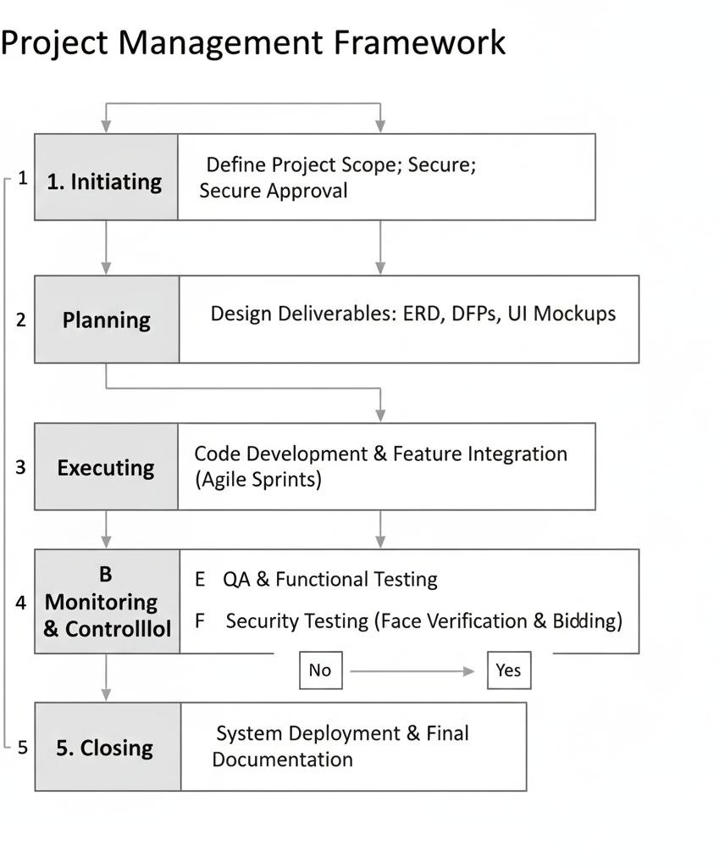
Figure 2. Project Framework of E-baligya

Graphic User Interface
This section presents the screen layouts and expected outputs of the proposed system e- Baligya – Digital Marketplace for Fishery Vendors with Face Verification System. The design aims to keep the interface clean and simple so both vendors and buyers can use the system comfortably. It also helps local fishery vendors who are new to digital platforms to navigate the app without difficulty.

The system provides several features for the admin, vendors, and customers. Below are the key interfaces included in the design:

Login Page
This screen allows users to enter their credentials to access the system. Vendors and admins can log in securely to manage their accounts and transactions.

Dashboard Page
The dashboard serves as the main hub for users. It shows quick access buttons and summaries such as number of orders, sales, recent transactions, and vendor updates.

Manage Products Screen
Vendors can add, edit, and update their product listings here. They can upload images of fish products, update stock, set prices, and manage availability.

Manage Orders Screen
This screen shows the list of incoming and completed orders. Vendors can track order status, confirm orders, or update delivery information.

Vendor Profile and Verification Page
Vendors can update their details, upload their verification documents, and check their approval status.

Customer List Screen (Admin)
Admins can view registered customers, track purchase history, and handle account issues if needed.

Vendor Monitoring Screen (Admin)
Admins can check vendor activities, inventory levels, and verify uploaded documents to ensure legitimacy.

Sales and Report Generation Page
Admin can view weekly and monthly reports related to transactions, vendor activities, and system analytics.


Figure 3. Vendors login page

Figure 4. Vendors Dashboard

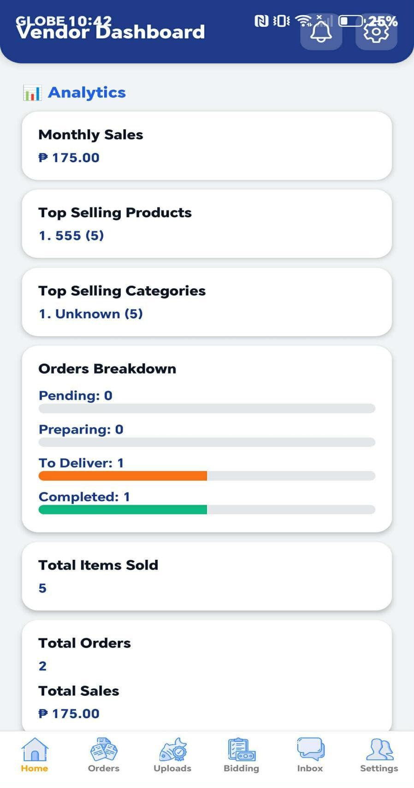

Figure 5. Vendors Product



Figure 6. Vendors Delivery page



Figure 7. Vendors Profile

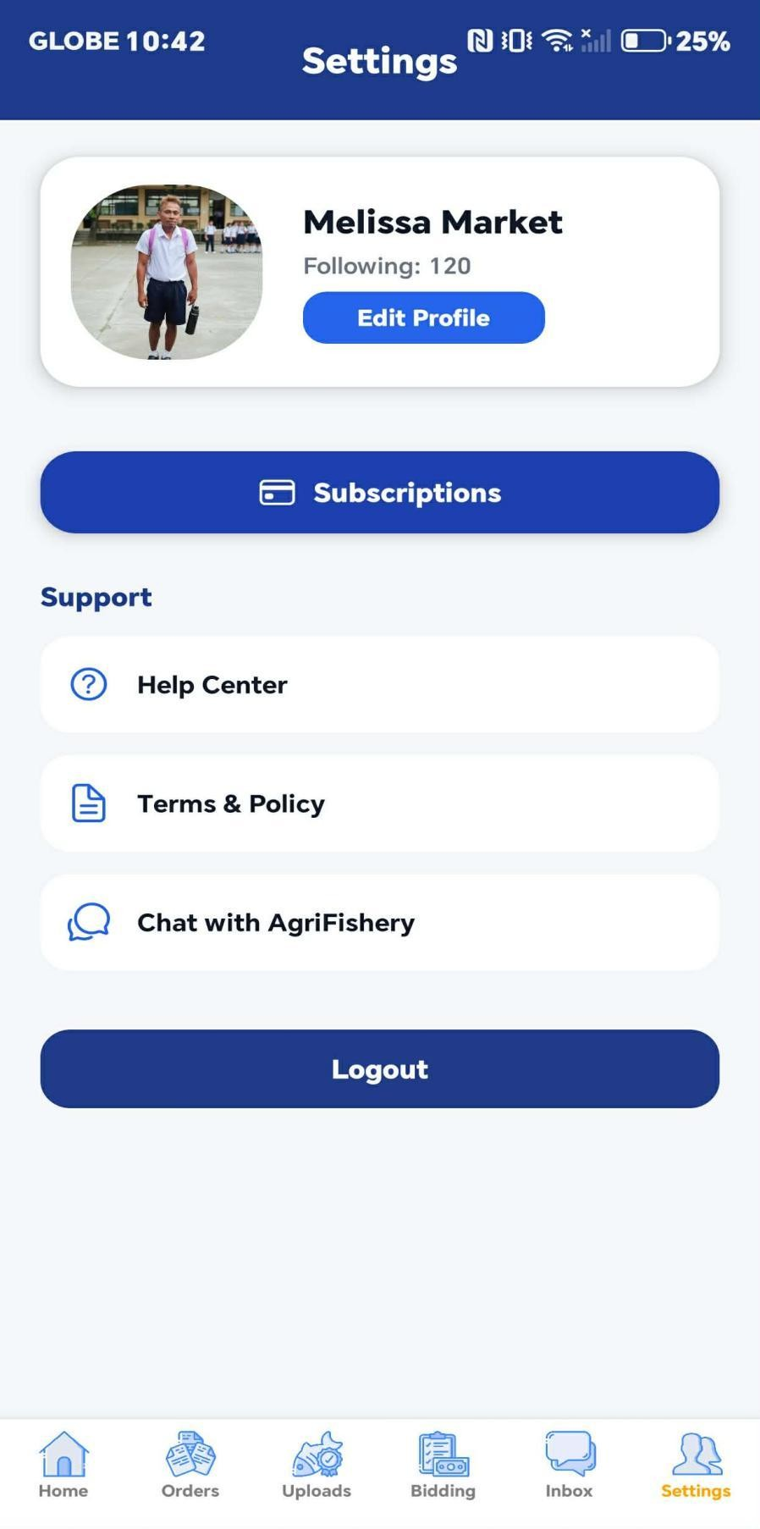

Figure 8. Customer Login



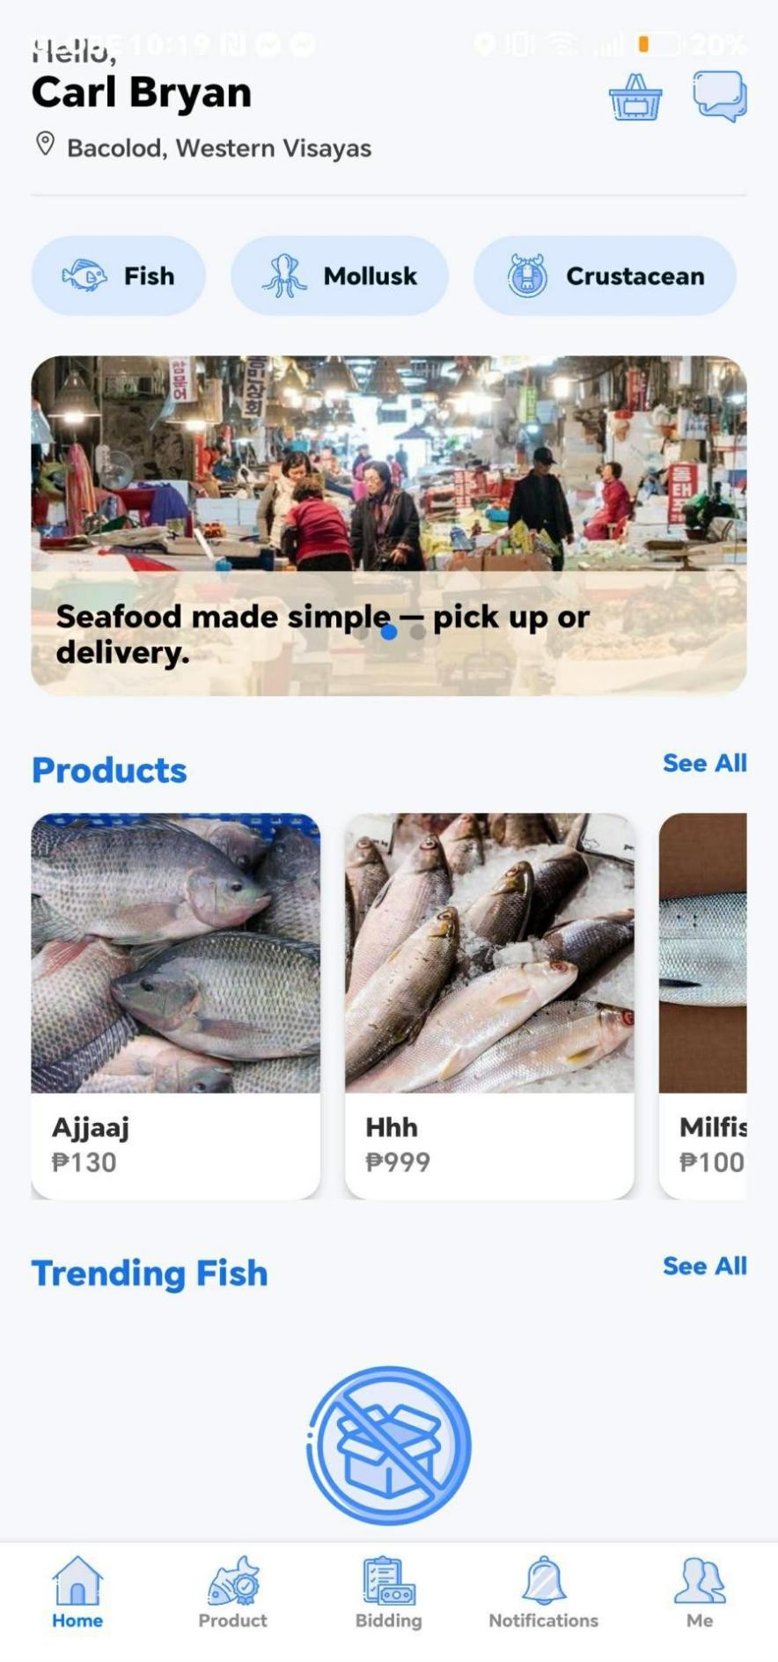
Figure 9. Customer Home page


Figure 10. Customer Product page


Figure 11. Customer Bidding page

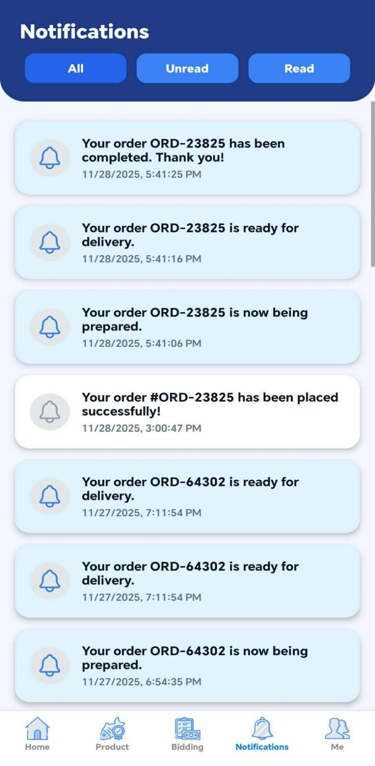
Figure 12. Customer Notifications




Figure 13. Customer Profile

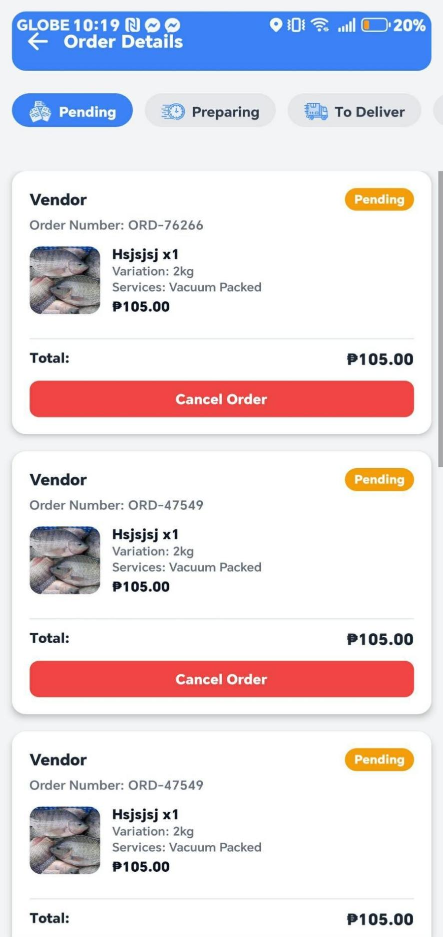
Figure 14. Customer Ordering page

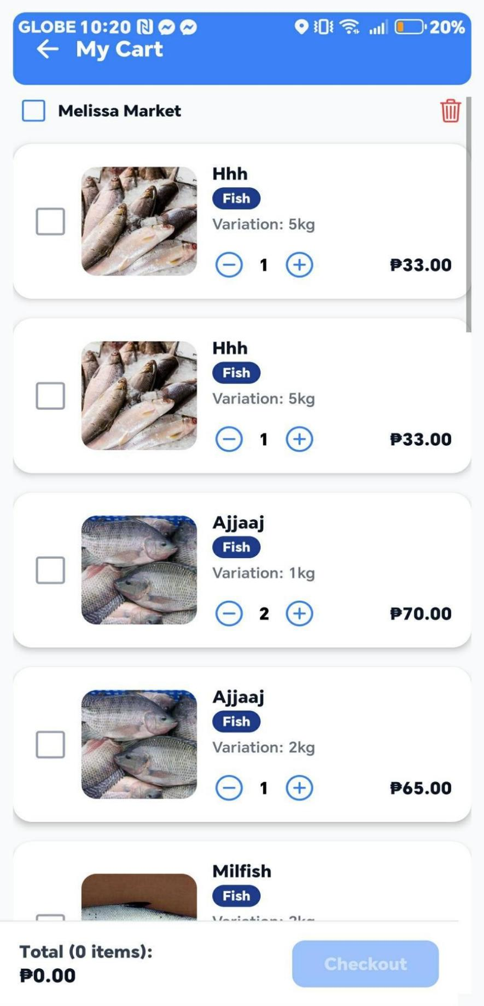
Figure 15. Customer Add to cart page





The admin side of e-Baligya includes the following key features:

Admin Dashboard – This page serves as the main control center for the admin. It shows system statistics such as the number of active vendors, registered customers, pending vendor requests, and recent transactions. From here, the admin can easily navigate to different management tools.

Vendor Request Management – The admin can review vendor applications, check their uploaded documents, and decide whether to approve or decline their request. This helps ensure that the sellers on the platform are verified and legitimate.

Customer Records Monitoring – This feature provides a list of all registered customers. The admin can check account details, transaction history, and activity logs when needed.

Reports and System Review – The admin can generate and review reports such as sales summaries, vendor performance, customer activity, and platform analytics. This helps track the overall performance of the system.

Employee Management – The admin can view and monitor registered employees, track their activities, and manage their access levels.

Login Page for Super Admin and Employees – The system includes a secure login screen for both super admin and employee roles. Each login type grants access to the proper tools based on their responsibilities.

Figure 16. Super Admin Login


Figure 17. Dashboard
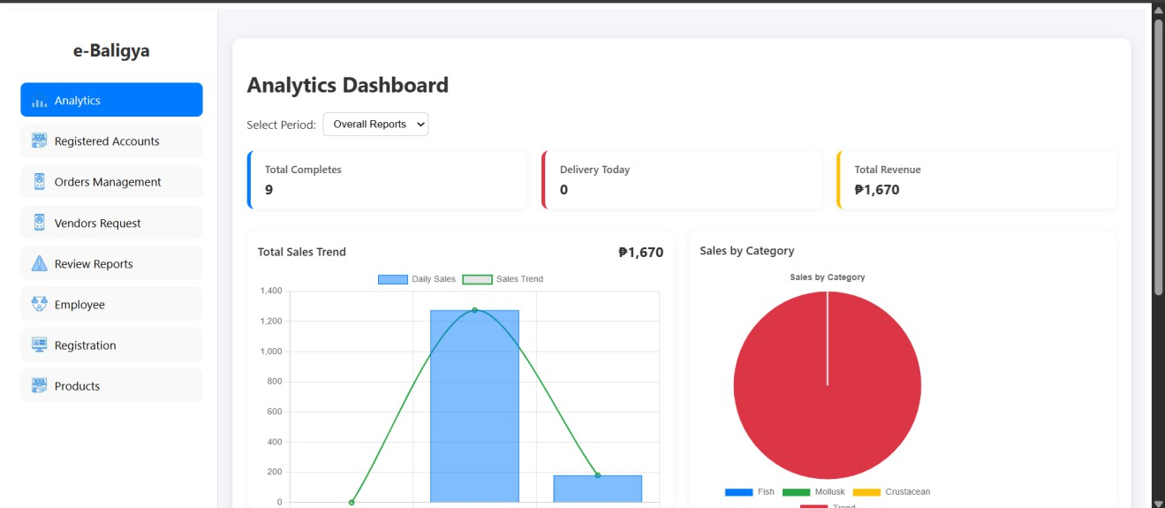
Figure 18. Registered Customer
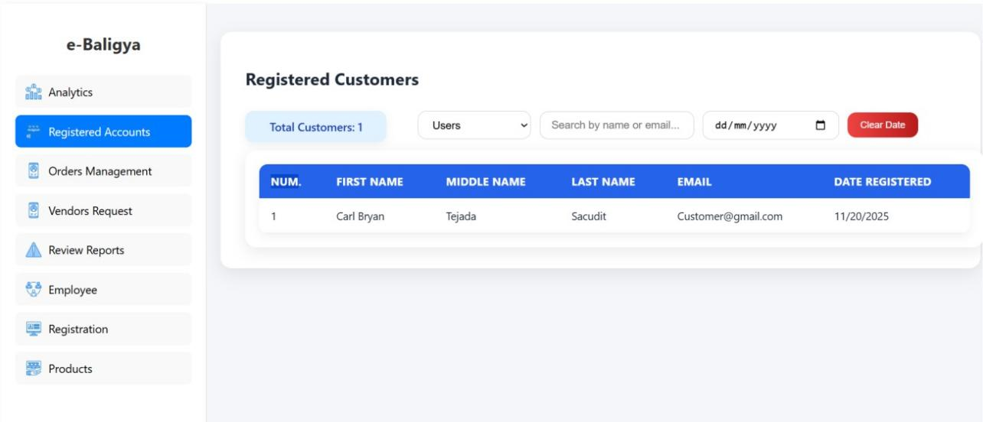

Figure 19. Vendor Request
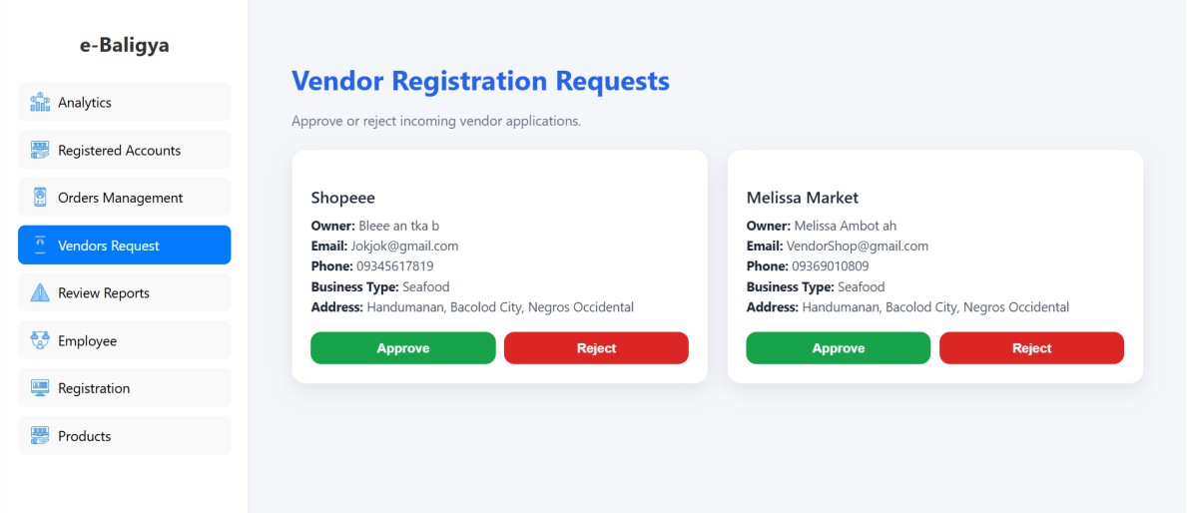

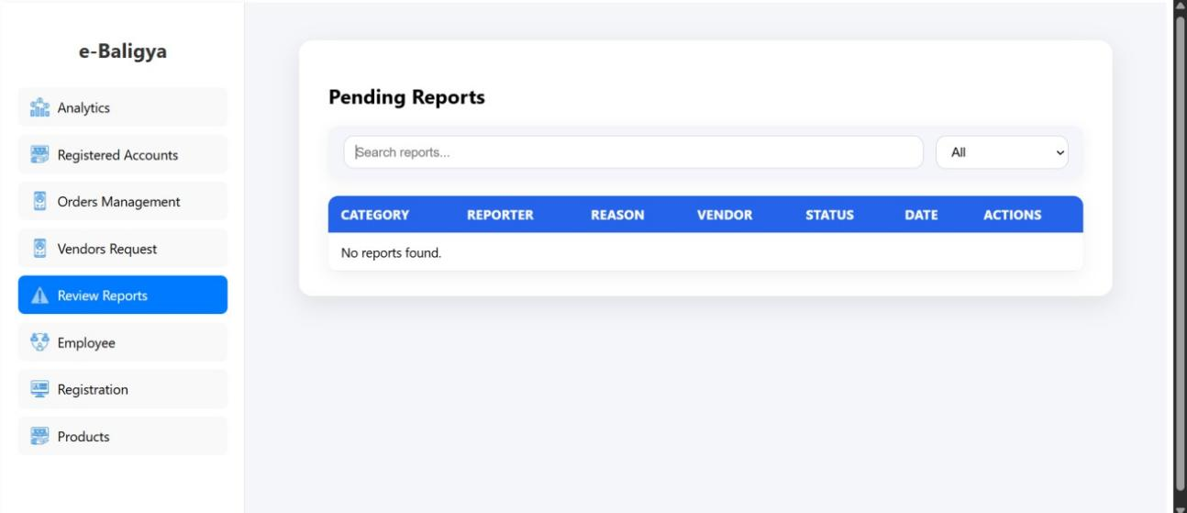
Figure 20. Review Reports

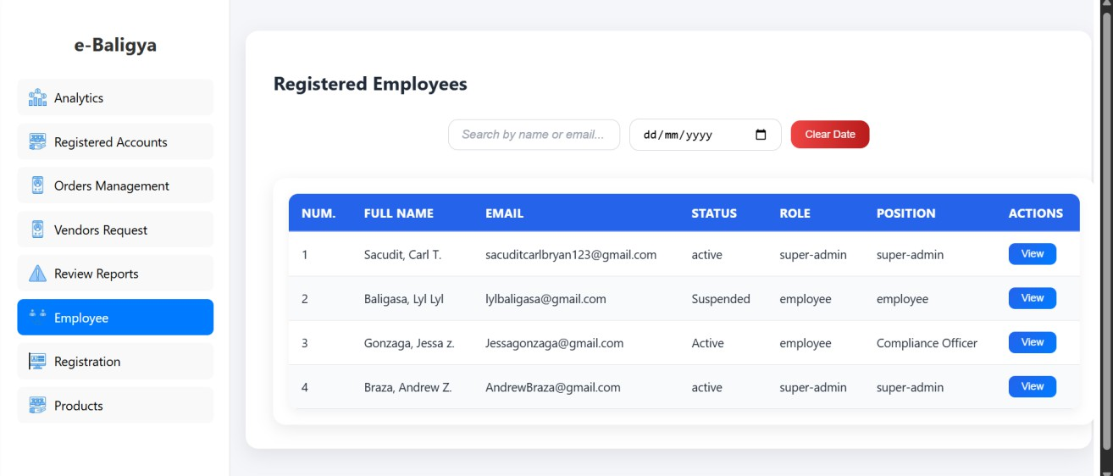
Figure 21. Registered Employee
Figure 22. Employee Registration
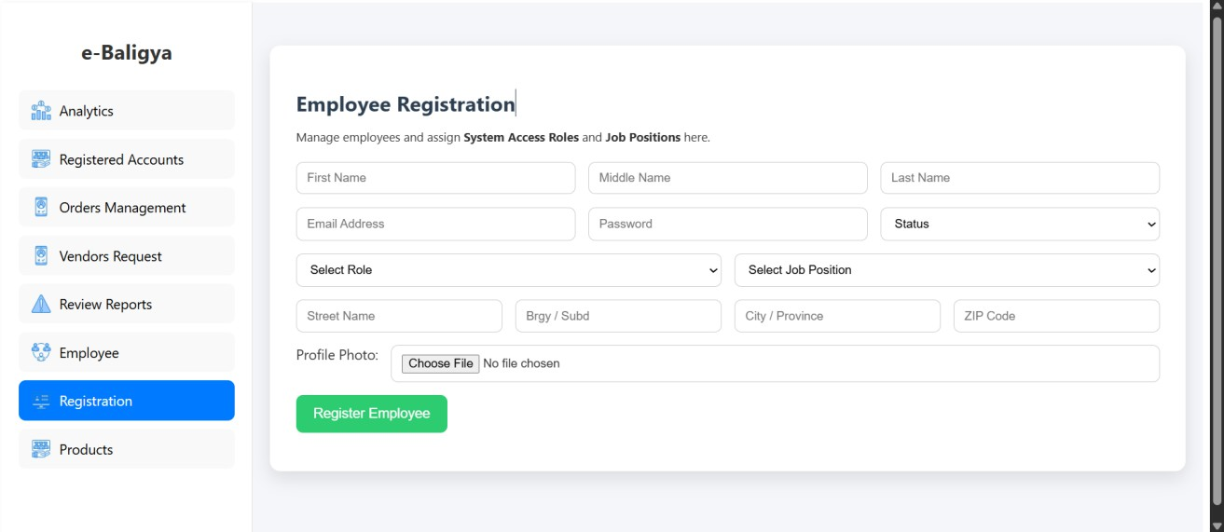
Figure 23. Employee Dashboard

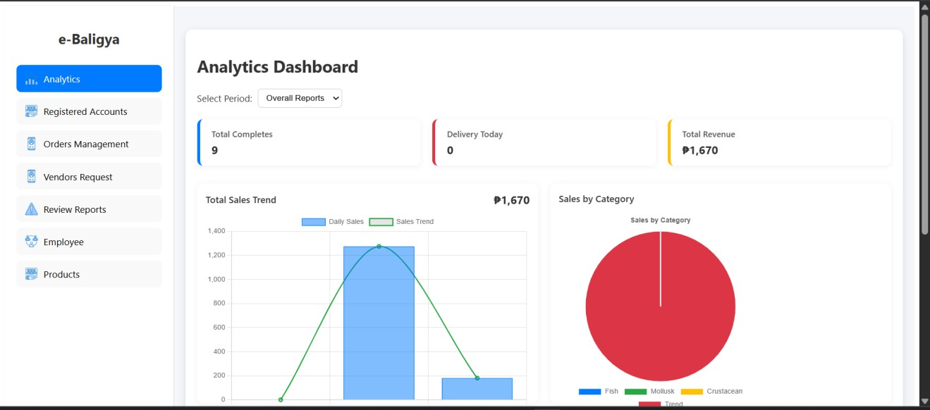

Figure 24. Employee Vendor Request

Data Flow Diagram Level 0

The DFD Level 0 (Context Diagram) establishes the systemic boundary of the e- Baligya Digital Marketplace, stating that this system is the centralized platform mediating all communication and critical transactions between the two primary external entities: the Vendor/Seller (the fishery vendors) and the Customer (buyers). This high-level view confirms the system's scope, demonstrating that all essential data, such as Product Details from vendors and Order/Bid Placement from customers, must pass through the unified process, "1.0 e-Baligya Vendor System," to ensure validation, security, and record-keeping before data like Status Updates or Order Confirmation are returned to the respective users.

The diagram's primary purpose is to define the scope and boundary of the study, illustrating the crucial data inputs and outputs that link the marketplace to its users.
Figure 25. Data Flow Diagram Level 0

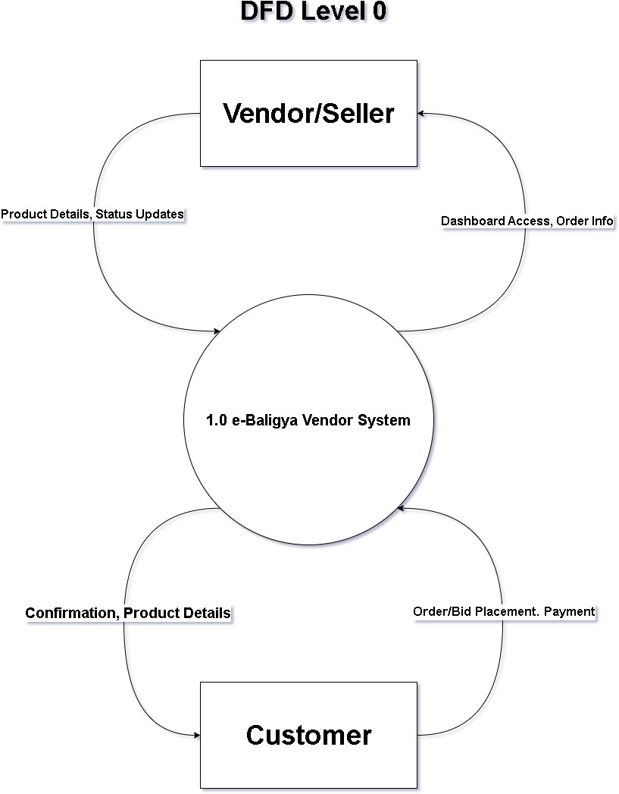

Data Flow Diagram Level 1

The DFD Level 1 (System Overview) then decomposes the central system into its core functional processes, providing a detailed view of the internal logic and data movement required to support the vendor’s sales workflow. This diagram illustrates
or represents the three sequential stages of data transformation required to process a sale efficiently in the marketplace: P1.0 Listing, P2.0 Selling, and P3.0 Fulfilling. The flow is initiated when data is captured and stored in D1: Product Data, then utilized by P2.0 Selling to create a transaction record in D2: Sales Records, and finally managed by P3.0 Fulfilling, which reads from and updates D2 until the order is complete. This Level 1 analysis visually validates that all operational steps in the marketplace are supported by
logical data storage and processing mechanisms, confirming the system's ability to handle both standard and bidding transactions efficiently.

Figure 26. Data Flow Diagram Level 1
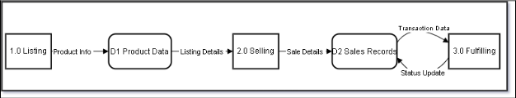

Super Admin Flow Chart

This flowchart shows the process after the super admin logs into the system. When the login credentials match, the system directs the super admin to the dashboard. From there, the super admin can oversee the entire platform, review registered customers, check vendor requests, monitor employee accounts, and view reports. The super admin can also update system records or remove users when needed.

Figure 27. Super Admin Flow Chart
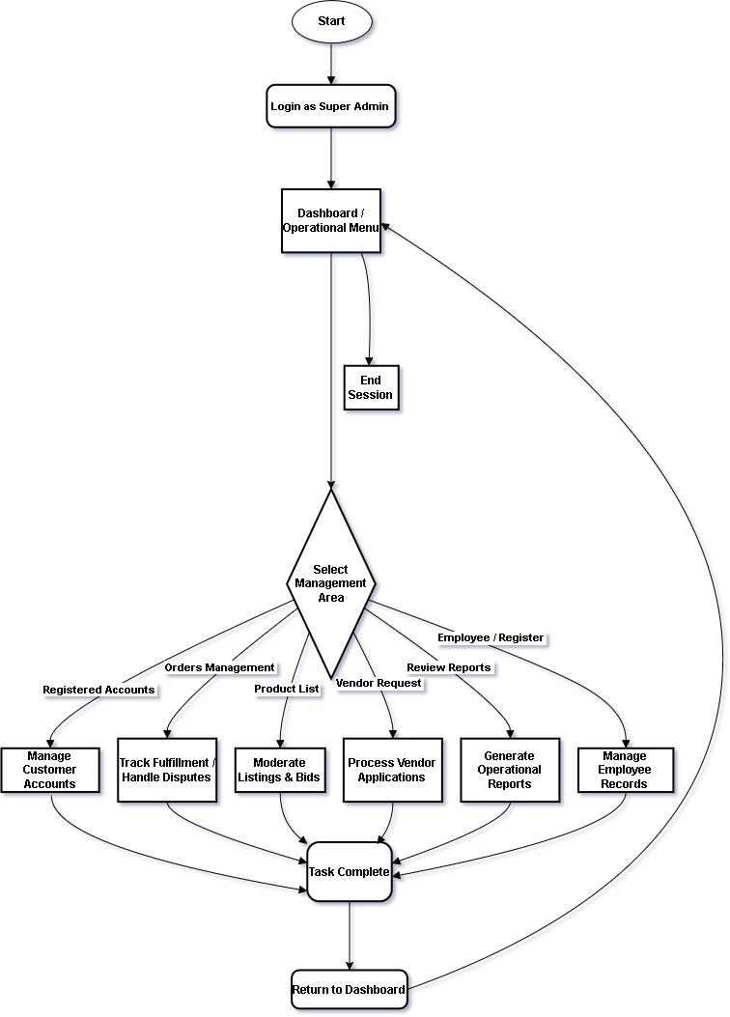

Admin Flow Chart

This flowchart presents the steps followed by the admin when accessing the system. After entering valid login details, the admin is redirected to the dashboard. From the dashboard, the admin can review vendor applications, approve or decline their requests,
and monitor vendor activities. The admin can also check customer records, view reports, and handle employee-related tasks.

Figure 28. Admin Flow Chart

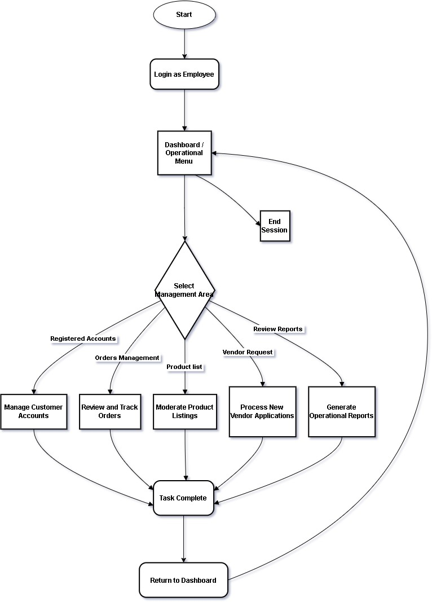

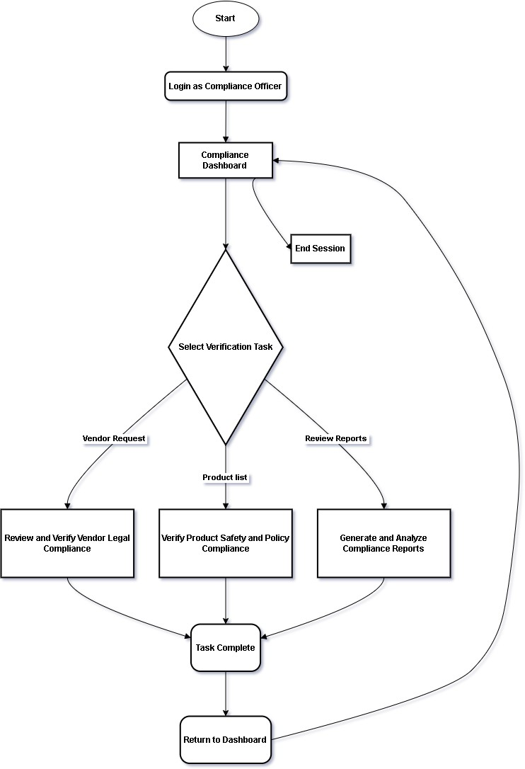

User Flow Chart

This flowchart shows the process for customer and vendor users. New users can register an account and proceed to log in. Once logged in, customers can browse products, place orders, join bidding, and manage their profiles. Vendors can update product listings, check deliveries, and handle customer orders.

Figure 28. User Flow Chart
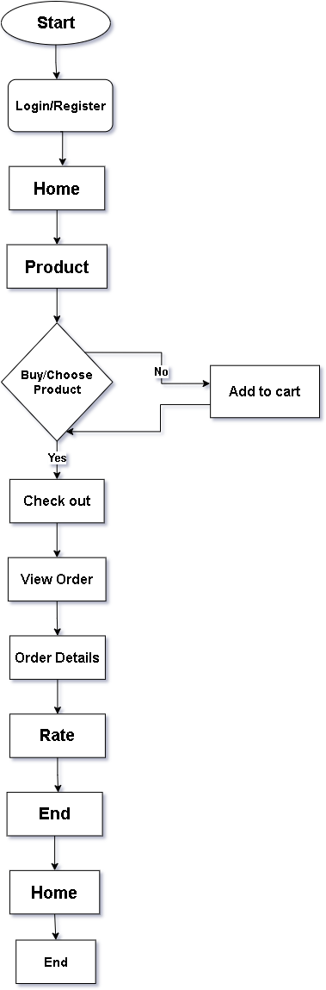

Vendors Flow Chart

This flowchart explains the steps a vendor follows when using the system. After logging in, the vendor is brought to the dashboard where they can manage every part of their shop. Vendors can add or update product listings, adjust prices, and change the stock depending on availability. They can also check incoming orders, review order details, update delivery status, and communicate with customers when needed. The vendor can view their profile, update business information, and monitor their overall performance. The process repeats as vendors handle new orders, refresh their inventory, and continue managing their shop through the system.

Figure 28. Vendor Flow Chart
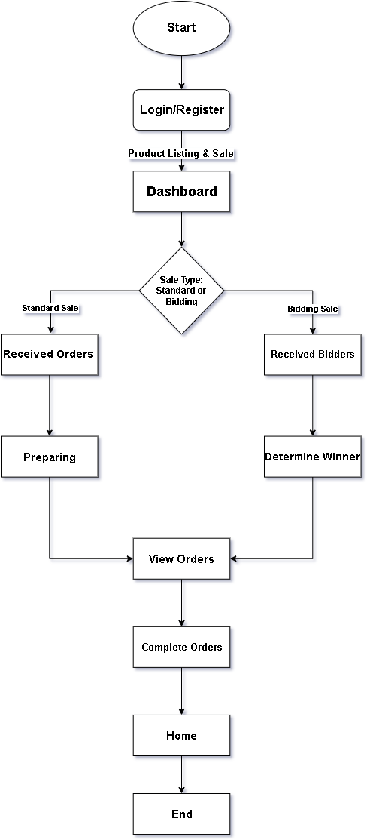

Entity Relationship Diagram

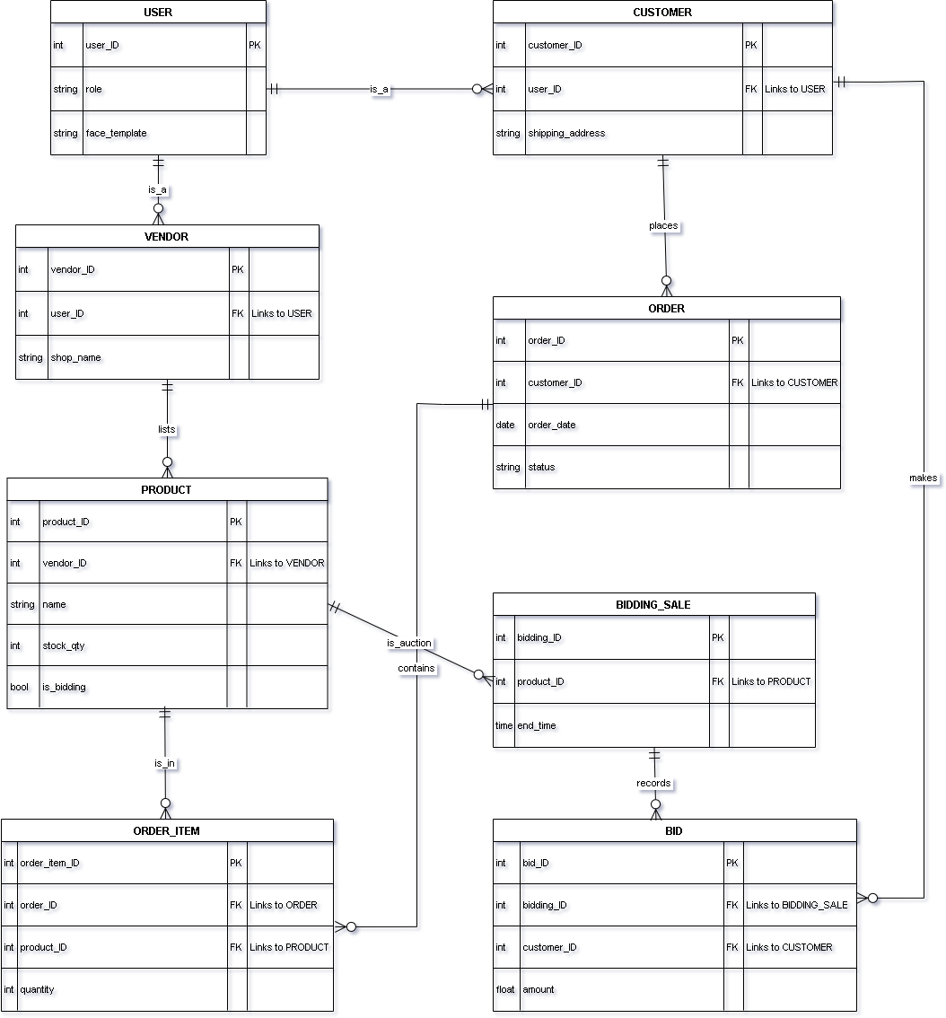

System Functionalities
This section presents the context diagram and the decomposition diagrams, which explain how each part of the system works and how users interact with it. These diagrams help show the overall flow of information between customers, vendors, employees, and administrators. They also break down the major functions of e-Baligya into smaller processes so it’s easier to understand how the system handles products, orders, vendor requests, reports, and user data. These visuals guide both the development and operations of the system by showing how each function connects and what outputs are expected during use.

System Development Method

System Design
The development of the e-Baligya - Digital Marketplace for Fishery Vendors with Face Verification System was guided by the Agile Scrumban methodology. The e-Baligya - Digital Marketplace for Fishery Vendors with Face Verification System was developed using the Agile Scrumban methodology, a robust, hybrid framework specifically selected for its ability to manage the project's dual complexity: integrating an innovative security feature and meeting a rigorous academic timeline.

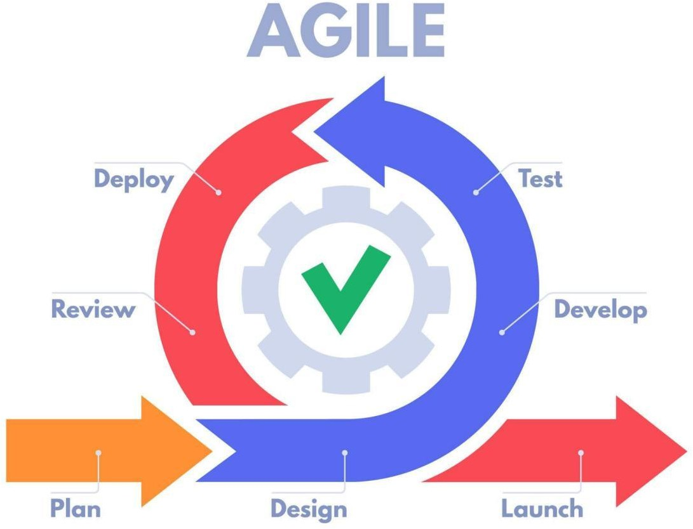

The Scrum component of this methodology dictates that all system development is executed through short, iterative cycles called Sprints. Each Sprint is dedicated to coding, integrating, and thoroughly testing a small, specific part of the system—for example, developing the product listing and transaction flow or implementing the crucial Face Verification algorithm. By delivering a tested, working Increment every few weeks, the team effectively mitigates the technical risk associated with the security module; any issues found are corrected immediately, preventing costly, time-consuming failures at the end of the project. This continuous focus on functional delivery ensures the system's design is validated in real-time.

Finally, the Kanban element introduces a parallel, visible workflow dedicated to thesis documentation. This structure ensures that writing and revising the Capstone chapters— from the Review of Related Literature to the Results and Discussion—happen concurrently with system development. This process prevents the common problem of rushing all documentation at the end. By synchronizing the technical output (the e-Baligya system) with academic requirements (the thesis), and guaranteeing that all necessary revisions are quickly approved by the adviser, Agile Scrumban ensures the timely completion and submission of both the verified, functional application and the accurate final thesis.

CHAPTER IV RESULTS AND DISCUSSIONS

The Results and Discussion for the e-Baligya system design demonstrate that the architecture successfully meets all core project objectives, particularly regarding security and transactional complexity. The design validates the project's scope by clearly mapping the system's operational flow from 1.0 Listing to 2.0 Selling to 3.0 Fulfilling, ensuring that all sales and status updates are tracked centrally in the data stores (D1 Product Data and D2 Sales Records). Crucially, the system supports robust Role-Based Access Control (RBAC) for users, vendors, and administrative roles, which is secured by the mandatory Face Verification module for identity confirmation. This biometric security layer is the primary defense against fraud and enhances accountability for sensitive tasks, such as managing orders and placing high-value bids. Furthermore, the system efficiently handles specialized transaction types, providing separate data structures for the complex Bidding process (supporting 'My Bids') and the standard ORDERS (including 'Cancelled Orders' and 'Completed Orders'), allowing for streamlined vendor management, accurate fulfillment tracking, and comprehensive reporting (like 'Reports Product' and 'Report Bidding Product'). This structure confirms that the final e-Baligya architecture is robust, secure, and operationally efficient for the fishery digital marketplace.

Development and Testing

The Development phase for the e Baligya system utilized an Agile/Scrum methodology, breaking the system build into iterative Sprints to facilitate continuous integration and feedback, focusing first on core functionality before tackling complex modules. Development tasks included translating the ERD into a functional database structure and integrating the Face Verification API and the specialized Bidding System logic. This execution phase was rigorously governed by the Testing phase (Monitoring & Controlling), which involved several layers of verification: Unit Testing ensured individual functions were sound; Integration Testing verified seamless communication between modules (e.g., customer order to vendor dashboard); and Functional Testing confirmed all user requirements were met. Crucially, Security Testing was performed specifically on the Face Verification module to guarantee identity integrity and security resistance. This entire process was managed via a Quality Assurance (QA) loop, where any code that failed a test was immediately logged and sent back to Development for correction and re-testing, ensuring that only fully verified and accepted features progressed to the final deployment stage.

System Testing

The System Testing phase rigorously evaluates the fully integrated e- Baligya system to ensure it meets all functional, non-functional, and critical security requirements before release. This stage validates the entire business logic through Functional Testing, confirming that every module, from Manage Product Listings to Deliver Orders, performs its required task and that the end-to-end transaction flows, including both standard sales and the complex Bidding System logic, operate correctly. Simultaneously, Non-Functional Testing assesses quality factors like Performance Testing (checking speed under load, especially during peak bidding moments) and Usability Testing (ensuring the interface is intuitive). Crucially, Security Testing is performed on the sensitive Face Verification module to ensure integrity, accuracy, and resilience against bypass attempts, while general system vulnerabilities are scanned to protect D2 Sales Records and user data. This final comprehensive evaluation confirms that the system is stable, secure, and ready for deployment.

System Evaluation

The System Evaluation for the e-Baligya Digital Marketplace confirms that the design successfully meets all project objectives by integrating security and efficient transaction management within a single architecture. The system supports the complete sales lifecycle, as evidenced by the DFD flow of Listing, Selling, and Fulfilling, which ensures all status updates and sales records are tracked consistently. Crucially, the system's security efficacy is validated by the Face Verification module, which provides a high degree of non-repudiation and accountability essential for managing bids and preventing fraud, and is complemented by robust Role-Based Access Control (RBAC) for users, vendors, and administrative staff. Operationally, the design promotes efficiency by clearly separating logic for standard ORDERS from the complex Bidding System using distinct ERD entities, thereby streamlining vendor order fulfillment and ensuring clean data for accurate administrative Reporting.

Implementation Plan

The Implementation Plan for the e-Baligya Digital Marketplace guides the project's transition from design to a working system across approximately 15 weeks, strictly adhering to the Agile/Scrum methodology and the formal Project Management Framework. The phased execution begins by translating the ERD into a functional database structure and initiating Core System Development (User Roles and product listings). Subsequent sprints focus on building the complex Transaction and Bidding Logic and integrating the critical Face Verification API into the authentication flow, ensuring the system supports the dual sales model required. Development is continuously followed by the System Testing and QAphase, where rigorous Security Testing is performed on the biometrics and end-to-end sales cycles are validated against the DFD's Fulfilling process, ensuring all bugs are resolved via the mandatory feedback loop before the final Deployment and Closing phase.

PHASE | ACTIVITY | DURATION IN WEEKS | KEY DELIVERABLES | STATUS
1. Foundation & Design Review | Final review and approval of design documents (ERD, DFDs, Flowcharts). Setup development  environment (Version Control, Cloud). | 1 week | Finalized Design Documents; Project Repository Setup. | Planned
2. Core System Development | Installation of base user infrastructure, coding of Authentication (Login, RBAC), and implementation of static Product Listing  and inventory tracking. | 3 weeks | Functional Login/Registration Module; Basic Vendor Dashboard. | Planned
3. Transaction & Bidding Logic | Development of the Shopping Cart, checkout process, standard ORDER management, and the core Bidding  System logic. | 4 weeks | Functional Bidding  System Logic;Complete ORD ER  Processing Core. | Planned
4. Security & Fulfillment Integration | Integration of  the Face Verification API into authentication points. Coding vendor fulfillment updates (Deliver Orders/Completed  Orders) and customer notification systems. | 4 weeks | Face Verification Integrated; Complete Order Fulfillment Cycle; Functional Notification System. | Planned
5. System Testing & QA | Execution of Functional, Integration, and Security  Testing(biometric resilience). Bug resolution and verification against project requirements. | 2 weeks | Completed Test Reports; Resolved Bug List; System Passes Definition of Done. | Planned

6.  Deployment & Closing | Final system deployment to the hosting environment. User Acceptance Testing (UAT).  Finalization of Capstone Manuscript and Oral Defense preparation. | 1 week | Deployed System Link; Final Project Report; User's Guide. | Planned

CHAPTER V
CONCLUSIONS AND RECOMMENDATIONS

This chapter presents the conclusions drawn from the research, requirements analysis, system design, and early development stages of e-Baligya: A Digital Marketplace for Fishery Vendors with Face Verification System. The conclusions reflect the objectives of the study and show how the proposed platform responds to long-standing issues faced by small-scale fishery vendors in Bacolod City and Negros. The insights gathered from the literature, interviews, and the PIECES Framework highlight the need for a modern digital solution that can make seafood trading more organized, secure, and accessible.
Recommendations for system enhancement and future expansion are also provided to
support the platform’s continued improvement.

Conclusions

The findings from the review of existing selling practices and the analysis of vendor workflows revealed several weaknesses in the traditional marketplace setup. Many fishery vendors rely on manual communication, handwritten records, and in-person transactions, which often lead to unstable pricing, inconsistent supply, limited customer reach, and difficulty tracking orders or inventory. These problems showed the need for a digital platform that can support both vendors and customers by offering organized product listings, secure vendor identification, and a clear transaction process. The study confirmed that a centralized digital marketplace can help address the challenges faced by local fishery sellers in Bacolod and nearby areas.

The results from the system design and requirements gathering also showed that e- Baligya has the capacity to streamline the selling process through its planned features. The use of React and React Native allows the platform to handle real-time updates, while Firebase provides secure authentication and reliable data storage. The modules developed in the system design stage—such as vendor registration with face verification, product management, order processing, and price guidance through the Decision Support System—match the needs identified during the early phases of the study. The system diagrams, including the IPO models, DFDs, and user flowcharts, further confirm that the platform can support the full cycle of online selling, from posting items to completing orders.

The conceptualization of the face verification feature also played an important role in the system’s development. Vendors in traditional markets usually have no formal identification process, which sometimes results in fake seller accounts or unreliable profiles on social media marketplaces. By adding secure face verification, the system strengthens identity assurance and builds trust between buyers and sellers. This feature also supports safety, reduces fraudulent activities, and creates a safer buying experience for customers who may not be familiar with digital marketplaces.

Overall, the study confirms that e-Baligya is a practical and helpful solution for the community of fishery vendors who want to shift to digital selling. The system addresses the most common issues in traditional marketplaces by providing real-time product updates, secure vendor verification, organized inventory management, and a more accessible selling environment. The combination of mobile and web platforms gives flexibility to both vendors and customers. With its planned features and the strong foundation formed in Chapters 1–3, e-Baligya shows promise for full development, future testing, and long-term implementation as a modern marketplace tool for local fishery sellers.

Recommendations

To strengthen the performance and long-term use of e-Baligya, the researchers recommend enhancing the Decision Support System by adding more accurate pricing and demand data to guide vendors in setting fair product prices. Improving the interface for both mobile and web is also important, especially for vendors who have limited experience with digital tools. Simple layouts, clearer buttons, and easier navigation can help users adapt more comfortably.

Security can be further improved by adding extra verification options such as OTP-based login or two-factor authentication. Regular updates to database rules and encryption settings are also advised to protect user accounts and transaction records.

The researchers also recommend providing short training sessions or user guides for vendors and market staff. This will help them understand the features better and maintain proper use of the system. Continuous feedback collection is also encouraged to identify issues early and support ongoing improvements.

For future development, the system may be expanded to include more analytics tools, delivery coordination features, or stronger connections with local government programs and fishery groups. Integrating additional verification methods or exploring wider marketplace functions can also support the platform’s growth and long-term sustainability.

REFERENCES

Alahmadi, D. H., & Jamjoom, A. A. (2022). Decision support system for handling control decisions and decision-maker related to supply chain. Journal of Big Data, 9(1). https://doi.org/10.1186/s40537-022-00653-9

Añabieza, M., Pajaro, M., Reyes, G., Tiburcio, F., & Watts, P. (2010). Philippine alliance of fisherfolk: ecohealth practitioners for livelihood and food security. EcoHealth, 7(3), 394-399. https://link.springer.com/article/10.1007/s10393-010-0334-x

Barboza, A., Macusi, E. D., Borazon, E. Q., Santos, M. D., Muallil, R. N., & Nallos, I. M. (2024). Small-scale fisheries (SSF) management and conservation schemes and their application in the Philippines. Marine Policy, 161, 106018. https://www.sciencedirect.com/science/article/abs/pii/S0308597X24000162

Baticados, D. B. (2015). Reaching the poor through aquaculture: The case of technology adoption in rural communities at west central Philippines. In Resource Enhancement and Sustainable Aquaculture Practices in Southeast Asia: Challenges in Responsible Production of Aquatic Species (pp. 251-260). https://core.ac.uk/download/pdf/77980947.pdf

Bayudan‐Dacuycuy, C., & Dacuycuy, L. B. (2022). Harnessing the potential of online marketplaces in the Philippines: Insights from the National Information and Communications Technology Household Survey. Asia & the Pacific Policy Studies, 9(3), 288-316. https://onlinelibrary.wiley.com/doi/full/10.1002/app5.365

Belgium, S., & Gorunescu, F. (2020). How can intelligent decision support systems help the medical research? In Intelligent decision support systems—a journey to smarter healthcare (pp. 71–102). Springer, Berlin, Heidelberg.

Cánovas‐Molina, A., & García‐Frapolli, E. (2022). A review of vulnerabilities in worldwide small‐scale fisheries. Fisheries Management and Ecology, 29(5), 491-
501. https://onlinelibrary.wiley.com/doi/abs/10.1111/fme.12538

Chen, J., Lan, Y. C., & Chang, Y. W. (2023). Consumer behaviour in cross‐border e‐ commerce: Systematic literature review and future research agenda. International Journal of Consumer Studies, 47(6), 2609-2669.
https://onlinelibrary.wiley.com/doi/abs/10.1111/ijcs.12969

Cordova, W., Lim, C. T. N., Ong, H. T., Caraan, H. S., Cruz, G. A. R. D., & Jimenez, E.
F. C. (2025). Digital Innovation and Entrepreneurial Success in the Philippine MSME Sector: Challenges and Opportunities. Economics-Innovative and Economics Research Journal, 13(3), 69-82. https://sciendo-parsed.s3.eu-central- 1.amazonaws.com/

Department of Tourism. (2023). Tourism development plan 2023–2028. Department of Tourism, Republic of the Philippines. https://pdp.depdev.gov.ph/wp- content/uploads/2023/09/Philippine-Development-Plan-2023-2028.pdf

Fabinyi, M., Belton, B., Dressler, W. H., Knudsen, M., Adhuri, D. S., Aziz, A. A., ... & Vandergeest, P. (2022). Coastal transitions: Small-scale fisheries, livelihoods, and maritime zone developments in Southeast Asia. Journal of Rural Studies, 91, 184-
194. https://www.sciencedirect.com/science/article/pii/S0743016722000286

Huynh, T. (2021). A flashcard mobile application development with Flutter. Theseus. https://www.theseus.fi/handle/10024/499862

Islam, M. M., & Chuenpagdee, R. (2022). Towards a classification of vulnerability of small-scale fisheries. Environmental Science & Policy, 134, 1-12. https://www.sciencedirect.com/science/article/abs/pii/S1462901122001095

Jeyachandran, P. (2024). A Comparative Analysis of Fraud Prevention Techniques in E- Commerce Platforms. SSRN. https://ssrn.com/abstract=5076793

Muallil, R. N., Mamauag, S. S., Cababaro, J. T., Arceo, H. O., & Aliño, P. M. (2014). Catch trends in Philippine small-scale fisheries over the last five decades: The fishers’ perspectives. Marine Policy, 47, 110-117.
https://www.sciencedirect.com/science/article/abs/pii/S0308597X14000463

Muallil, R. N., Mamauag, S. S., Cabral, R. B., Celeste-Dizon, E. O., & Aliño, P. M. (2014). Status, trends and challenges in the sustainability of small-scale fisheries in the Philippines: Insights from FISHDA (Fishing Industries' Support in Handling Decisions Application) model. Marine Policy, 44, 212-221.
https://www.sciencedirect.com/science/article/abs/pii/S0308597X13001929

Park, C. Y., Villafuerte, J., & Yap, J. T. (2021). Managing the Development of Digital Marketplaces in Asia. Asian Development Bank. https://aric.adb.org/pubs/digitalmarket/managing-development-digital- marketplaces-asia.pdf

Rosales, N., Vigonte, F., & Abante, M. V. (2024). Digital Transformation and Elastic Demand: Assessment on the Impact of E-commerce Growth on Consumer Goods in the Philippines. SSRN. https://papers.ssrn.com/sol3/papers.cfm?abstract_id=4742048

Samonte, M. J. C., Soberano, M. B. P., Yamat, K. C., & Namoco, E. A. (2024). An In- Depth Analysis of E-Commerce System Architecture and Integration and Security Measures to Mitigate Data Breach and Order Scams in the Philippines. In International conference on WorldS4 (pp. 251-264). Springer Nature Singapore. https://link.springer.com/chapter/10.1007/978-981-97-9324-2_20

Shree, D., Singh, R. K., Paul, J., Hao, A., & Xu, S. (2021). Digital platforms for business- to-business markets: A systematic review and future research agenda. Journal of Business Research, 137, 354-365.
https://www.sciencedirect.com/science/article/abs/pii/S0148296321005932

Tahiluddin, A., & Terzi, E. (2021). An overview of fisheries and aquaculture in the Philippines. Journal of Anatolian Environmental and Animal Sciences, 6(4), 475-
486. https://dergipark.org.tr/en/pub/jaes/issue/66598/944292

Takagi, S. (2020). Literature survey on the economic impact of digital platforms. International Journal of Economic Policy Studies, 14(2), 449-464.
https://link.springer.com/article/10.1007/s42495-020-00043-0

