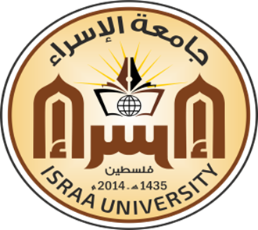
DEPD1222
Organic Chemistry
First Semester 2020-2021

Course Outline
- Structure and bonding
- Alkanes
- Alkenes and Alkynes
- Aromatic Compounds
- Alcohols, Phenols, Ethers, and Their Sulfur Analogs
- Aldehydes and ketones
- Carboxylic acids and carboxylic acid derivatives
- Amines

Text Book
- Power point Presentations (Lectures)
- Patrick, G. L. (2004). instant notes in Organic Chemistry. 2nd Edition. Garland Science/BIOS Scientific Publishers.
- John E. McMurry. (2010). Fundamentals of Organic Chemistry, 7th. Cengage Learning.

Evaluation and Grading
Quizzes | 30 point
Homework’s | 20 Point
Final Exam | 50 point
Total | 100 Point

Assistant professor
Dr. Mohammed Laqqan

