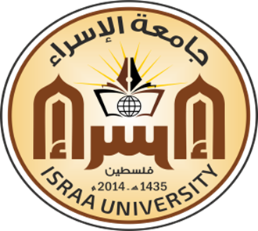
BMET3313
Molecular Biology
First Semester 2020-2021

Course Outline
- The structure of DNA and Genome organization
- From gene to protein: The genetic code and protein structure
- DNA replication, Repair, and telomere maintenance.
- Recombinant DNA
- Genetic Testing
- Transcription and RNA Processing.
- Mechanisms of translation
- Abnormal Cell Growth (Cancer)
- Apoptosis

Text Book
- Power point Presentations (Lectures)
- Allison LA. Fundamental molecular biology. Blackwell Pub.; 2007.
- Bruce A, Alexander J, et al., Molecular Biology of the Cell 6 Edition, W. W. Norton & Company, 2014

Evaluation and Grading
Quizzes | 30 point
Homework’s | 10 Points
Presentation | 10 Points
Final Exam | 50 point
Total | 100 Points

Assistant professor
Dr. Mohammed Laqqan

