Cairo University  
Faculty of Computers and Information



**CS251**

**Software Engineering I**

IM3 School

Software Requirements Specifications

Mariam Ibrahim

Mai Hesham

Mai Samir

Israa Abd Elnaby

Nov/2016

Table of Contents

**Team4**

1. **Introduction4**
   1. Purpose4
   2. Audience4
2. Introduction to system……………………………………………………………………………………………………………………………5
   1. Purpose…………………………………………………………………………………………………………………………………………5
   2. Scope………………………………………………………………………………………………………………………………………………5
   3. Definitions, acronyms, and abbreviations……………………………………………………………………………………….5
3. Functional Requirements……………………………………………………………………………………………………………………….6
   1. ResgisterAsAStudent………………………………………………………………………………………………………………………6
   2. RegisterAsATeacher……………………………………………………………………………………………………………………….6
   3. PlayGame……………………………………………………………………………………………………………………………………….6
   4. WriteComment……………………………………………………………………………………………………………………………….6
   5. ReplayComment……………………………………………………………………………………………………………………………..6
   6. EditProfile……………………………………………………………………………………………………………………………………….6
   7. CreateGame……………………………………………………………………………………………………………………………………6
   8. DeleteGame……………………………………………………………………………………………………………………………………6
   9. EditGame…………………………………………………………………………………………………………………………...............6
   10. TryGame……………………………………………………………………………………………………………………………..6
   11. ShowScore…………………………………………………………………………………………………………………………..6
4. Nonfunctional Requirements………………………………………………………………………………………………………………….7
5. Use Case Model……………………………………………………………………………………………………………………………………..8
6. Use Case Table……………………………………………………………………………………………………………………………………….8
   1. ResgisterAsAStudent………………………………………………………………………………………………………………………8
   2. RegisterAsATeacher……………………………………………………………………………………………………………………..10
   3. PlayGame……………………………………………………………………………………………………………………………………..11
   4. WriteComment…………………………………………………………………………………………………………………………….13
   5. ReplayComment……………………………………………………………………………………………………………………………14
   6. EditProfile…………………………………………………………………………………………………………………………………….16
   7. CreateGame……………………………………………………………………………………………………………………………….…17
   8. DeleteGame………………………………………………………………………………………………………………………………….19
   9. EditGame………………………………………………………………………………………………………………………….............20
   10. TryGame……………………………………………………………………………………………………………………………22
   11. ShowScore………………………………………………………………………………………………………………………..24
7. Ownership Report………………………………………………………………………………………………………………………………..25

#### Team

|  |  |  |  |
| --- | --- | --- | --- |
| ID | Name | Email | Mobile |
| 20140262 | Mariam Ibrahim | mariamibrahimshahin@outlook.com | +2001153910691 |
| 20140283 | Mai Hesham | maihesham19@yahoo.com | +2001206634431 |
| 20140282 | Mai Samir | maisamir84@yahoo.com | +2001114766301 |
| 20140055 | Israa Abd Elnaby | israa.tobgy@gmail.com | +2001090815675 |

1. Introduction:

#### That software requirement specification document describes architecture, all the details and requirements that the software developer needs to build or create the required software system without getting wrong or confusing. It includes supporting requirement information like use cases models and diagrams.

#### Purpose:

#### The purpose of the software requirement specification document is to give the software developer who is going to build this system the ability to build it as required and it gives him/her the whole view about the requirements that needed to build the system by providing a clear description that has necessary information of the system and to well understand what it is going to be built.

#### Audience:

#### The people who are needed to read this software requirement specification document would be like software developers, project consultants and team managers.

1. Introduction to software system

## That system has a useful influence on students who are interested in coding because the project is going to produce a website which has different categories of simple games that would be helpful for students to learn and that would help teachers to create their own ideas of games for their students.

#### Purpose:

#### Nowadays, Computer science is one of the important and intelligent science so it must be taught to our students, the purpose of this website is to give you the opportunity to teach our students and children with a funny and entertaining way through simple games and it gives the teachers the chance to show their creativity by creating their own games to teach their students.

#### Scope:

#### The scope of the project is that would be a free website and it has only 2 kinds of people who can access and use that website who can be classified to students and teachers but they can't change the structure of the website, The website has a multiple languages and simple structure and it has only 4 categories of games.

#### Definitions, acronyms and abbreviations

|  |  |
| --- | --- |
| Account | The account must be created with valid email and password and there are 2 kinds of accounts for example the student has a different interact with website than the teacher. |
| Website | The project would be implemented in order to satisfy the scope of that system. |
| UML | Standardized modeling language which provides visualization for that website and the interaction with other actors within their functions |

1. Functional Requirements

#### RegistrationAsAStudent:

#### Student has to register in website as a student and enter his/her personal information.

#### RegistrationAsATeacher:

#### Teacher has to register in website as a teacher and enter his/her personal information.

#### PlayGame:

#### User have to choose the specific game to play then the system allow the user to start the game that he/she selected

#### WriteComment:

#### That allows the student to comment on the game he or she is interested in.

#### ReplayComment:

#### The teacher can replay only on his/her game that he/she made.

#### EditProfile:

#### User need to add new information or new picture in his/her account.

#### CreateGame:

#### User must be register as teacher to create a new game in website and the teacher has to choose type of a game and enter the content of game includes the questions and their answers.

#### DeleteGame:

#### The teacher has to login as a teacher to have an access to delete his/her game that he had created.

#### EditGame:

#### The teacher has to login as a teacher to have an access to edit his/her game that he had created.

#### TryGame:

#### The teacher has to try the game to figure out the errors and able to correct it before anybody else.

#### ShowScore:

#### It allows the student to show his/her score in website and it updates automatically after the player plays a game.

1. Non Functional Requirements

|  |  |
| --- | --- |
|  | Details |
| Performance | Start game will be done within 40 second.Send confirm mail will done in 10second. |
| Validation | System in registration will be sure that user enter all data correctly like enter unique username, unique email and password has Letters, numbers and no symbols.System in login will search in data base to be sure that the user enters the correct email and password. |
| Security | Send a confirm URL to user's email to confirm his / her account |
| Accessibility | The website has the ability to be accessed from any browsers and from any phone.The website provides access by disabilities or special needs because it includes games which can be played by these people |
| Privacy | It is required to write your name, age and gender in this website with public option but for the other personal information it is not required to write it with public or private option.It prevents abuses on the website when you write anything like comment or replay to a comment or in your personal information. |
| Usability | The user interface of the system should be user friendly. |
| Reliability | The system will be available 100% of the time. |
| Portability | Website is usable in different environments. |
| Serviceability | System must support by technical support personnel. |

#### 

#### Use Case Model

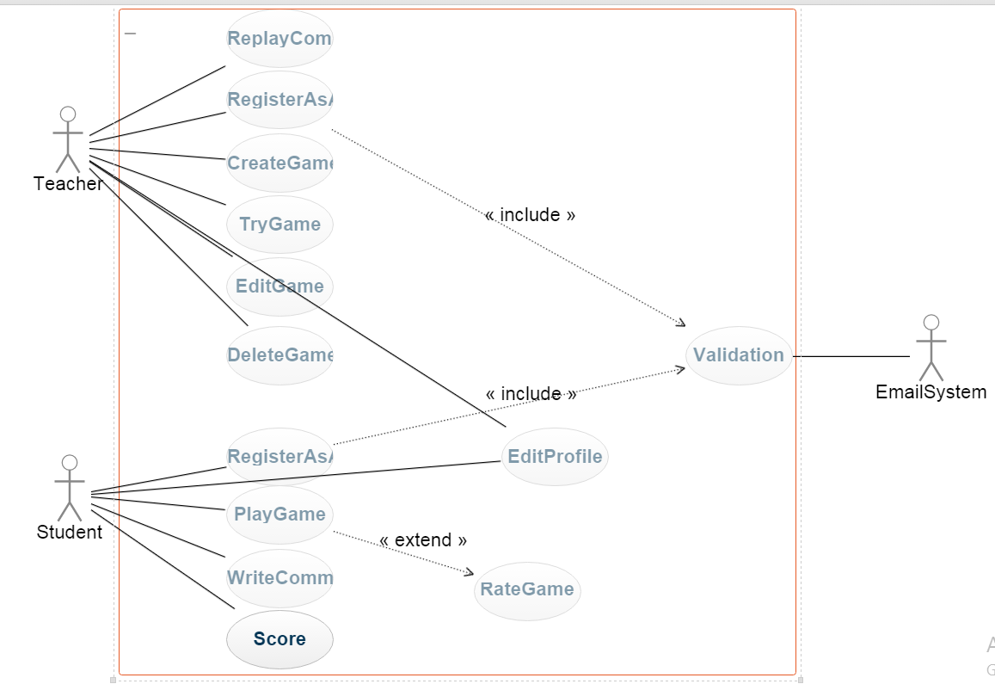

#### Use Case Tables

* 1. **RegistrationAsAStudent:**

Includes

EmailSystem

Student

|  |  |  |
| --- | --- | --- |
| Use Case ID: | 1 | |
| Use Case Name: | RegistrationAsAStudent | |
| Actors: | Student | |
| Pre-conditions: | The student must fill the requirements like (Username, Password) correctly. | |
| Post-conditions: | The user can login and access the contents of the website and can select a game or can make his/her allowed functions | |
| Flow of events: | **User Action** | **System Action** |
| The user has to register as student |  |
|  | The system will display the form to user to enter his/her email and password |
| The user will enter his username and password |  |
|  | The system will valid the user's input and will replay with the confirmation or an error |
| The user can use the website |  |
| Exceptions: | **User Action** | **System Action** |
| The user will enter his/her username and password and they are not correct |  |
|  | The system will display the position of the error |
| Includes: | Validations | |
| Notes and Issues: | The validation function would be between the system and the user, it will send message to the email the user entered to verify, and for the other side it has a data to check if the data that the user entered is unique or not. | |

#### RegistrationAsATeacher:

Includes

Teacher

EmailSystem

|  |  |  |
| --- | --- | --- |
| Use Case ID: | 2 | |
| Use Case Name: | RegistrationAsATeacher | |
| Actors: | Teacher | |
| Pre-conditions: | The teacher must fill the requirements like (Username, Password) correct. | |
| Post-conditions: | The user can login and access the contents of the website and can create ,delete , remove or try a game | |
| Flow of events: | **User Action** | **System Action** |
| The user has to register as a teacher. |  |
|  | The system will display the form to user to enter his/her email and password |
| The user will enter his username and password |  |
|  | The system will valid the user's input and will replay with the confirmation or an error |
| The user can use the website |  |
| Exceptions: | **User Action** | **System Action** |
| The user will enter his/her username and password and they are not correct |  |
|  | The system will display the position of the error |
| Includes: | Validations | |
| Notes and Issues: | The validation function would be between the system and the user, it will send message to the email the user entered to verify, and for the other side it has a data to check if the data that the user entered is unique or not. | |

#### PlayGame:

Includes

Student

|  |  |  |
| --- | --- | --- |
| Use Case ID: | 3 | |
| Use Case Name: | PlayGame | |
| Actors: | Student | |
| Pre-conditions: | Student must log in the website. | |
| Post-conditions: |  | |
| Flow of events: | **User Action** | **System Action** |
| User will choose type of game that he/she want to play. |  |
|  | System send problem that user will solve it. |
| User will enter his/her answer. |  |
|  | System check if the answer is correct or not.  System send a correct answer if it was wrong.  If the answer is correct ,system will increase user score  System will ask user if he/she want to try another game. |
| User will enter his answer if he/she wants to try a game or close it. |  |
|  | If user close game system will show his/her score and ask him to rate the game. |
| Exceptions: | **User Action** | **System Action** |
| User will close the game. |  |
|  | Ask user to Rate the game. |
| Includes: | RateGame | |
| Notes and Issues: | The user has to rate the games he just finish and that rate will be helpful for other users. | |

#### WriteComment:

Student

|  |  |  |
| --- | --- | --- |
| Use Case ID: | 4 | |
| Use Case Name: | WriteComment | |
| Actors: | Student | |
| Pre-conditions: | The user must register as student, login in website.  Student must try the game and have a score on it. | |
| Post-conditions: | Student is able to ask question or add anything he want on a comment and interact with the teacher. | |
| Flow of events: | **User Action** | **System Action** |
| User will choose type of game that he/she want to play. |  |
|  | System enters the student to the game. |
| Student tries the game and then writes a comment for it. |  |
|  | System publishes the comment below the game. |
| Exceptions: | **User Action** | **System Action** |
| Try to write comment without playing this game |  |
|  | system refuse request and display message that "cant rate or write a comment in game don't play it before" |
| Includes: |  | |
| Notes and Issues: |  | |

#### ReplayComment:

Teacher

|  |  |  |
| --- | --- | --- |
| Use Case ID: | 10 | |
| Use Case Name: | ReplayComment | |
| Actors: | Teacher | |
| Pre-conditions: | The user must register as teacher, login in website.  The user must choose the game she/he made by his/her own and see the comments on it. | |
| Post-conditions: | Teacher is able to respond to student's questions and comments for his game and he could interact with them and help them. | |
| Flow of events: | **User Action** | **System Action** |
| Teacher will choose the list of games that she created by his/her own. |  |
|  | System will display all games that created by teacher. |
| The teacher will choose a game. |  |
|  | The system will enter the teacher to the game. |
| The Teacher will see the comments on the game and reply to them. |  |
| Exceptions: | **User Action** | **System Action** |
| Teacher will choose a game that not created by him/her and try to reply on the comments for it. |  |
|  | The system will refuse this request and display error message. |
| Includes: |  | |
| Notes and Issues: |  | |

#### EditProfile:

Teacher

Student

|  |  |  |
| --- | --- | --- |
| Use Case ID: | 5 | |
| Use Case Name: | EditProfile | |
| Actors: | User | |
| Pre-conditions: | User must log in the website. | |
| Post-conditions: |  | |
| Flow of events: | **User Action** | **System Action** |
| User will enter to edit her/his information. |  |
|  | System will show the user his/her information and will allow the user to change his/her personal information. |
| User will change her/his information and enter submit. |  |
|  | System will change user information into new information.  Send success message. |
| Exceptions: | **User Action** | **System Action** |
| User will close her/his personal account  Or move to another page. |  |
|  | System reset information into old information. |
| Includes: |  | |
| Notes and Issues: |  | |

#### CreateGame:

Teacher

|  |  |  |
| --- | --- | --- |
| Use Case ID: | 6 | |
| Use Case Name: | CreateGame | |
| Actors: | teacher | |
| Pre-conditions: | The user must register as teacher , login in website and choose a specific category | |
| Post-conditions: | The teacher can see comments in his own game , replay in this comments and See the rate ,teacher can edit or delete this game | |
| Flow of events: | **User Action** | **System Action** |
| Teacher request to create a new game |  |
|  | System will display categories in website |
| The user will choose specific category |  |
|  | The system will display how teacher can enter the questions and the answers |
| The teacher will enter the questions and the answers and choose create |  |
| Exceptions: | **User Action** | **System Action** |
| teacher enter data in wrong way |  |
|  | The system will display the position of the error |
| Includes: |  | |
| Notes and Issues: |  | |

#### DeleteGame:

teacher

|  |  |  |
| --- | --- | --- |
| Use Case ID: | 7 | |
| Use Case Name: | DeleteGame | |
| Actors: | Teacher | |
| Pre-conditions: | The user must register as teacher, login in website.  the game will delete , was created by the teacher | |
| Post-conditions: | Student can't play this game again | |
| Flow of events: | **User Action** | **System Action** |
| Teacher choose list of own games |  |
|  | System will display all games that created by teacher |
| The teacher will choose a game |  |
|  | The system will display a list of setting belong to selected game |
| The teacher will choose delete game |  |
|  | System will delete game |
| Exceptions: | **User Action** | **System Action** |
| teacher choose a game that not created by him/her |  |
|  | The system refuse this request and display error message |
| Includes: |  | |
| Notes and Issues: |  | |

#### EditGame:

Teacher

|  |  |  |
| --- | --- | --- |
| Use Case ID: | 8 | |
| Use Case Name: | EditGame | |
| Actors: | Teacher | |
| Pre-conditions: | The user must register as a teacher, login in website.  The game will be edited by the teacher who created it. | |
| Post-conditions: |  | |
| Flow of events: | **User Action** | **System Action** |
| Teacher will choose list of own games. |  |
|  | System will display all games that created by teacher. |
| The teacher will choose a game. |  |
|  | The system will display a list of setting belong to selected game. |
| The teacher will choose edit game. |  |
|  | System will display the data in game to change it by teacher. |
| Teacher will edit data in game and choose save. |  |
|  |  | System will save changes. |
| Exceptions: | **User Action** | **System Action** |
| Teacher will choose a game that not created by him/her. |  |
|  | The system will refuse this request and display error message. |
| Includes: |  | |
| Notes and Issues: |  | |

#### TryGame:

Teacher

|  |  |  |
| --- | --- | --- |
| Use Case ID: | 9 | |
| Use Case Name: | TryGame | |
| Actors: | Teacher | |
| Pre-conditions: | The user must register as teacher, login in website.  The user could try games in the website those made by another teachers. | |
| Post-conditions: | Teacher will know how games work and he can decide what type of game he will create. | |
| Flow of events: | **User Action** | **System Action** |
| Teacher will choose list of own games. |  |
|  | System will send problem that user will solve it. |
| User will enter his/her answer. |  |
|  | System will check if the answer is correct or not.  System will send a correct answer if it was wrong.  System will ask user if he/she want to try another game. |
| User will enter his answer if he/she wants to try a game or close it. |  |
|  | If the answer is yes the system will get the teacher to the home page. |
| Exceptions: | **User Action** | **System Action** |
|  |  |
|  |  |
| Includes: |  | |
| Notes and Issues: |  | |

* 1. **ShowScore:**

|  |  |  |
| --- | --- | --- |
| Use Case ID: | 10 | |
| Use Case Name: | ShowScore | |
| Actors: | Student | |
| Pre-conditions: | The user must register as student, login in website. | |
| Post-conditions: |  | |
| Flow of events: | **User Action** | **System Action** |
| User will choose show score from home page that he/she want to play. |  |
|  | System will display page has all games that user played and scores in each play |
| Exceptions: | **User Action** | **System Action** |
| Try to show score without playing any game |  |
|  | system will display empty page has message "you don't play and game ,try to play " |
| Includes: |  | |
| Notes and Issues: |  | |

#### Ownership Report:

|  |  |
| --- | --- |
| Item | **Owners** |
| Content structure.  Team Information.  Introduction (Purpose-Audience).  Introduction to system (Purpose-Scope-Definitions, acronyms and abbreviations).  Nonfunctional Requirements (Accessibility-Privacy).  Use Case Model.  Table (RegisterAsAStudent). | Mariam Ibrahim |
| Nonfunctional Requirements (Performance-validation-security)  Tables (RegisterAsATeacher- CreateGame-DeleteGame-EditGame)  Use Case UML for each Use Case | Mai Hesham |
| Nonfunctional Requirements (PlayGame- EditProfile)  Tables(Portability-Serviceability) | Mai Samir |
| Tables (TryGame-WriteComment-ReplayComment).  Nonfunctional Requirements (Reliability-Usability). | Israa Abd Elnaby |