1. Compress a file by compress, gzip, zip commands and decompress it again. State the differences between compress and gzip commands.

-gzip needs the tar at first but compress no
- size using compress is higher than gzip
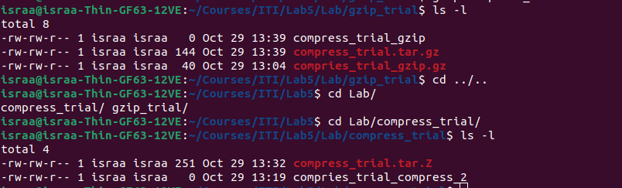

2. What is the command used to view the content of a compressed file.

Additional info :
it it is for a tar file it will print data about the tar dir at first then the content of the file

3. Backup /etc directory using tar utility.

4. Starting from your home directory, find all files that were modified in the last two day.

5. Starting from /etc, find files owned by root user.
6. Find all directories in your home directory.

7. Write a command to search for all files on the system that, its name is “.profile”.

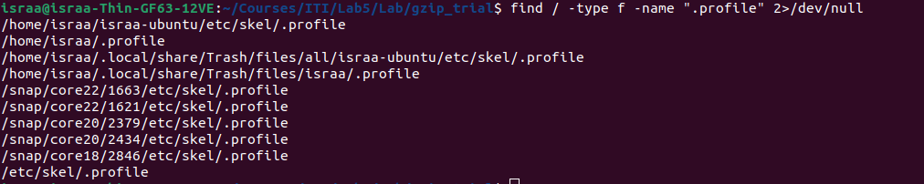

8. Identify the file types of the following: /etc/passwd, /dev/pts/0, /etc, /dev/sda

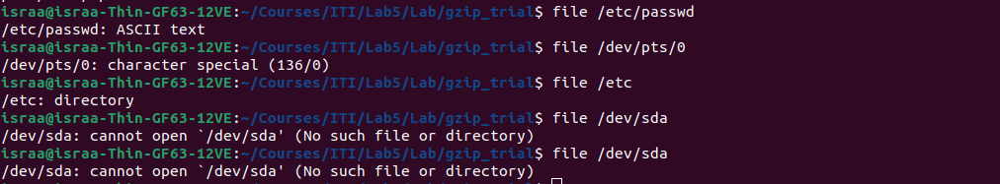

9. List the inode numbers of /, /etc, /etc/hosts.

add-id

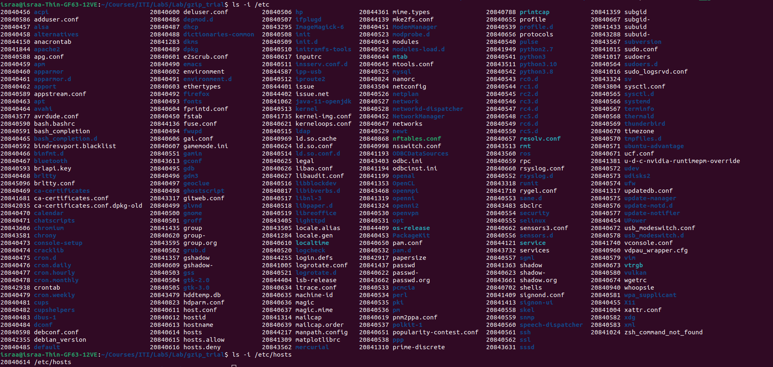

10. Copy /etc/passwd to your home directory, use the commands diff and cmp, and Edit in the file you copied, and then use these commands again, and check the output.

Before :
after:
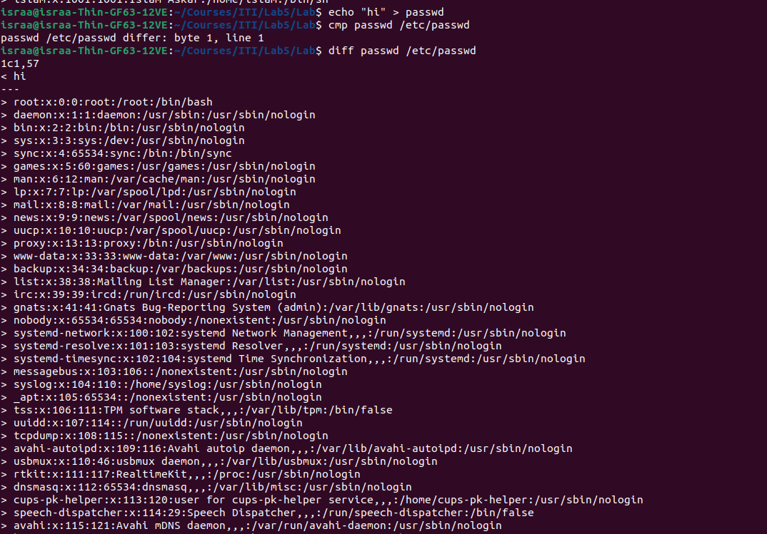
11. Create a symbolic link of /etc/passwd in /boot.
12. Create a hard link of /etc/passwd in /boot. Could you? Why?

This error because they are in different partitions
Both can be solved with sudo

