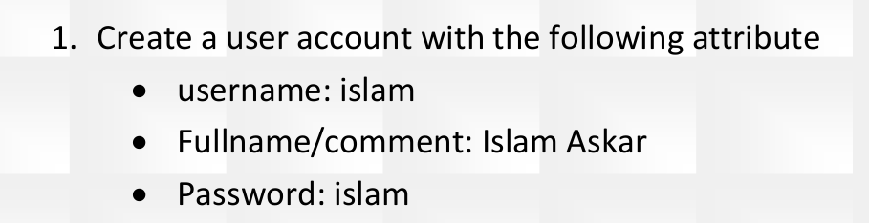
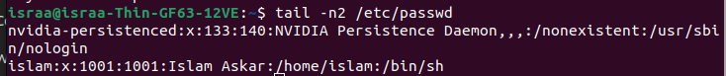

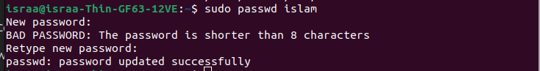

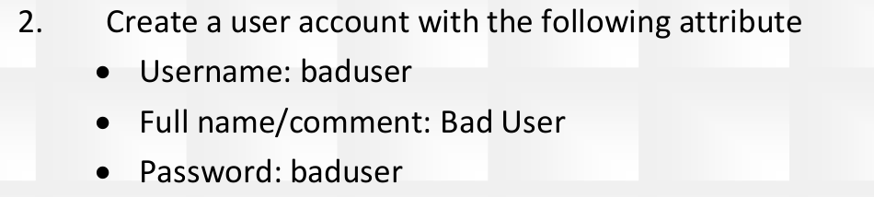

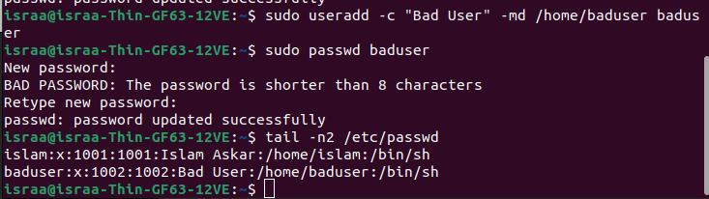

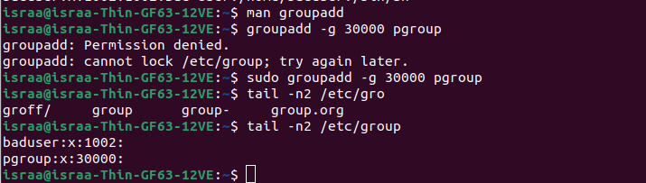

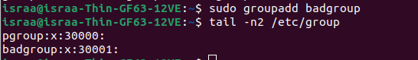

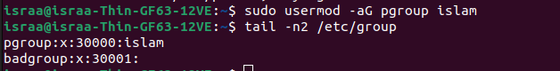

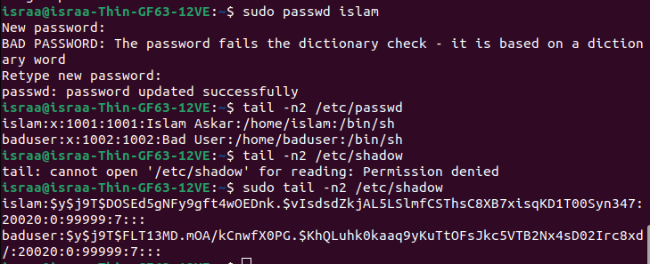

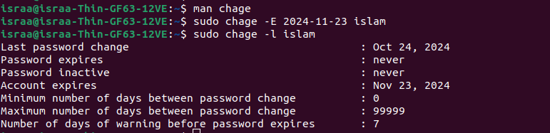

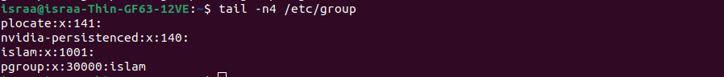

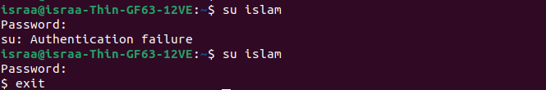

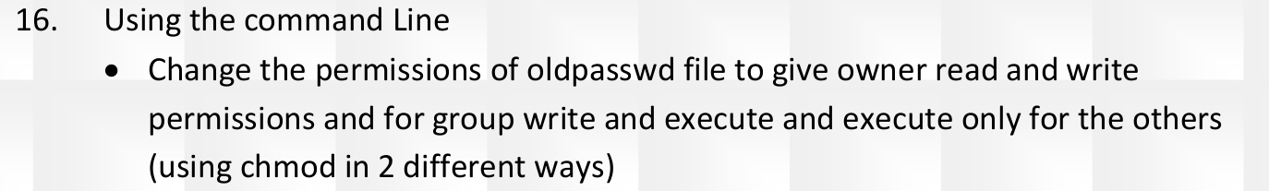

For the directory it is 775
and for the file it is 664

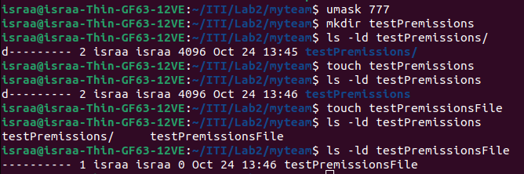
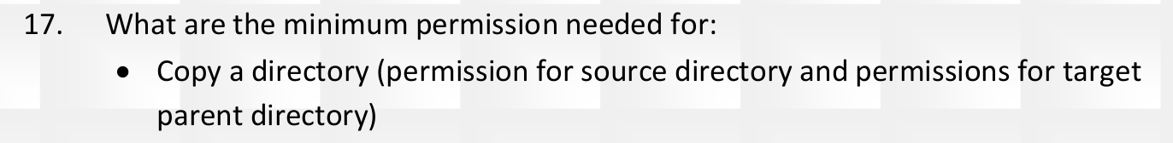

to copy dir → for parent it needs rx for the directory wx

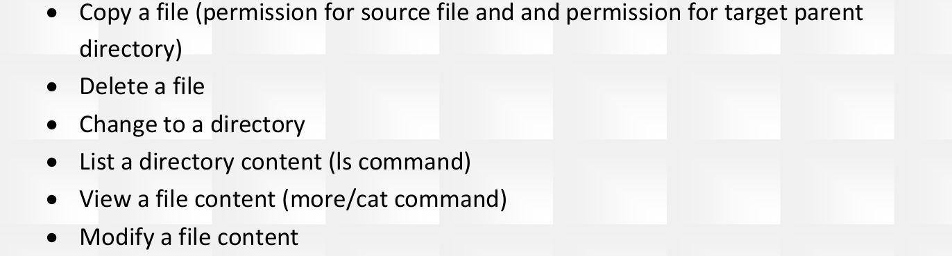
To copy file → parent wx and file read only .
Delete file → parent wx and the file do not need premissions.
change to a directory → excutable .
List a directory content → folder needs to be rx
view file content → r
modify file -> w

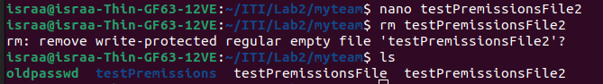

can not delete it or write over it
you can delete it

file → not by defaul , run the command
directory → view it content and open it available by default

