Logs:

Logging is the process of keeping logs of various events that occure during project execution

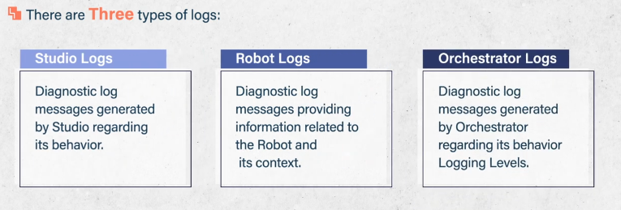

Robot execution logs :  
  
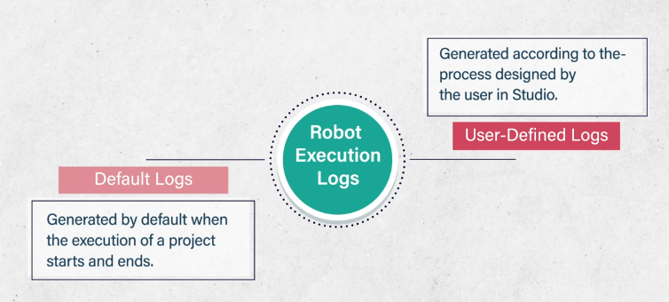  
  
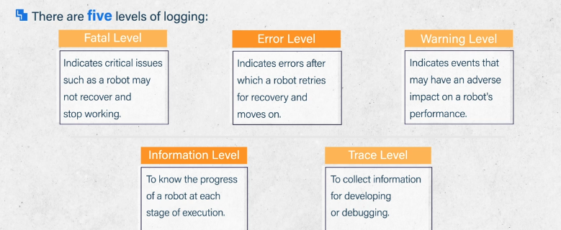

We used 2 activities:

* Write line, Log Message
* In log Message you can choose the level of log

There are 2 default logs : start and end