**Restaurant Analysis**

**Analysis Contributers**

**Moaz Ahmed**

**Israa Mohamed**

**Amr Jamal**

**Submited to**

**Sarah Besheer**

**Cleaning Stage:**

· Importing Libraries

· Loading Data

· Initial Data Inspection

· Inspecting Data Columns

· Standardizing Date Format

· Displaying Updated Date Values

· Inspecting Data Shape

· Getting DataFrame Information

· Descriptive Statistics (data.describe())

· Counting Unique Values

· Checking for Missing Values

· Identifying Duplicate Entries

· Dropping Unnecessary Column["order_id", "transaction_amount"]

· Show Counting value for [item_name , item_type , item_price , quantity , transaction_type , received_by , time_of_sale ]

· Filling Missing Values in transaction_type with the most frequent transaction type identified

· Calculate total cost

· dates got cleaned

· also we got rid of redundant columns.

**Objectives Stage:**

* The objective of itcnt bar plot is to visually represent the frequency or count of different categories in the itcnt variable. The plot helps in comparing the values across different categories and identifying the most or least common categories within the dataset.
* Calculate total quantity sold for each item_name within the Fastfood category.
* Create a bar plot to visualize the total quantity of each fast food item sold, using skyblue bars with black edges for clarity.
* Summarize total quantity sold for each Fastfood item.
* Visualize these quantities using a bar plot with skyblue bars and black edges to compare sales of different fast food items.
* Calculate the total quantity sold for each Beverages item.
* Visualize these quantities using a bar plot with skyblue bars and black edges to compare the sales of different beverage items.
* Set the aesthetic style of the plots to "whitegrid" for improved visual clarity.
* Create a bar plot to display the total cost by item_name, using sum as the estimator to aggregate revenue.
* Rotate x-axis labels for better readability and label the axes appropriately.
* Provide a clear title, "Total Cost by Item Name," to summarize the plot's content
* Convert the date column to datetime format for accurate time-series analysis.
* Aggregate total cost by date to compute daily revenue.
* Create an area plot to visualize daily total cost over time, using skyblue for the fill and Slateblue for the line.
* Label the axes and provide a title, "Daily Total Cost Over Time (Area Plot)," for clear interpretation of the plot's content.
* Create a histogram to visualize the distribution of total_cost in the dataset.
* Use 30 bins to segment the data, with a Kernel Density Estimate (KDE) overlay for a smooth distribution curve.
* Apply a purple color to enhance visual appeal.
* Label the axes and provide a title, "Distribution of Total Cost," for clear interpretation of the plot's content.
* Aggregate total cost by item_type to analyze the contribution of each category to overall revenue.
* Create a pie chart to visualize the proportion of total cost by item type, with percentage labels for clarity.
* Set the starting angle to 140 degrees for optimal presentation and ensure a circular shape by using an equal aspect ratio.
* Label the chart with the title "Proportion of Total Cost by Item Type" for clear understanding of the data representation.
* Create a count plot to visualize the frequency of different transaction_type categories in the dataset.
* Use the Set2 color palette to enhance visual differentiation between transaction types.
* Label the axes and provide a title, "Count of Transaction Types," for clear interpretation of the plot's content.

**Analysis Stage:**

We analyzed first the quantities of the item types. After that we analyzed the food categories it turns out it’s beverages and fast food only. We analyzed each one solely.

* We found out that the count of the fast food (total qunatiites buyed) is quite alot, so we included 3 fast food items in the sales in contrast to the beverage where we added only 2 items for the beverages, here’s the plot of the quantities of both the fast food and the beverages.  
  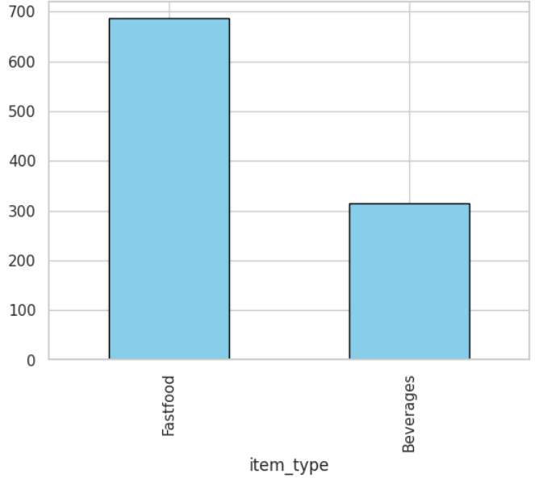
* For the fast food analysis we primarily focused on the maximum 3 fast food items to put in the sales, after analyzing we ended with a plot that summarizes the needed info as shown.
* For the beverages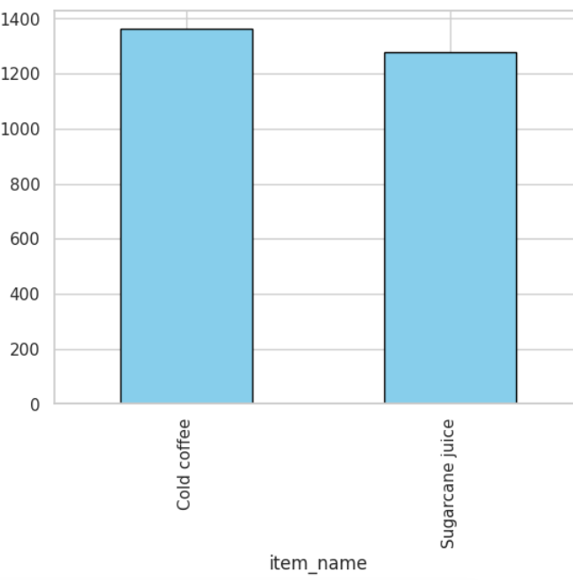
* After analyzing both quantities we also need cost analysis wich can be summarized in this bar chart   
  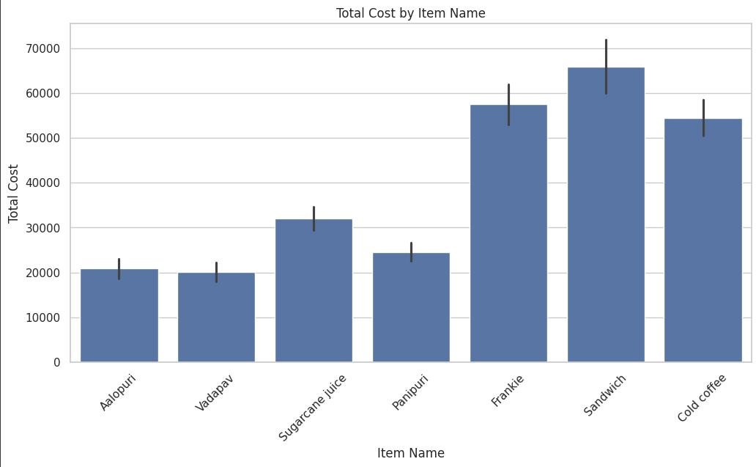

It’s clearly sandwich and frankie and cold coffee is making the most of revenue but also panipury is frequently buyed so we need to consider it in the sales

* After the analysis we can see that we want sandwich, frankie and panipuri in the sale.
* For the beverages we have the cold coffee and the sugarcane to put in the sale
* We also analyzed the date and the purchase and the total cost  
  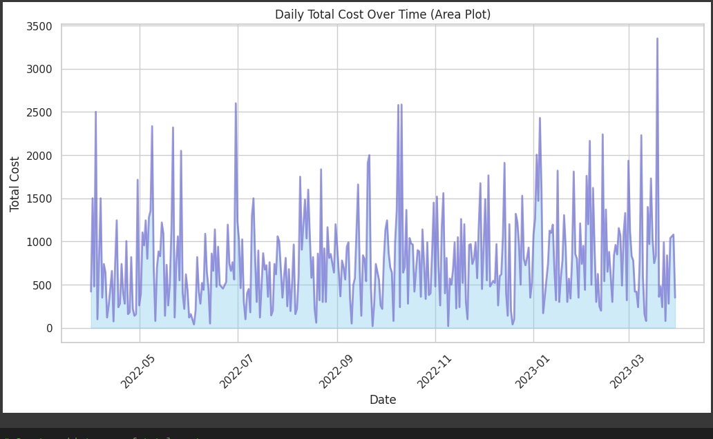
* Also most of the purchase comes from in place purchase  
  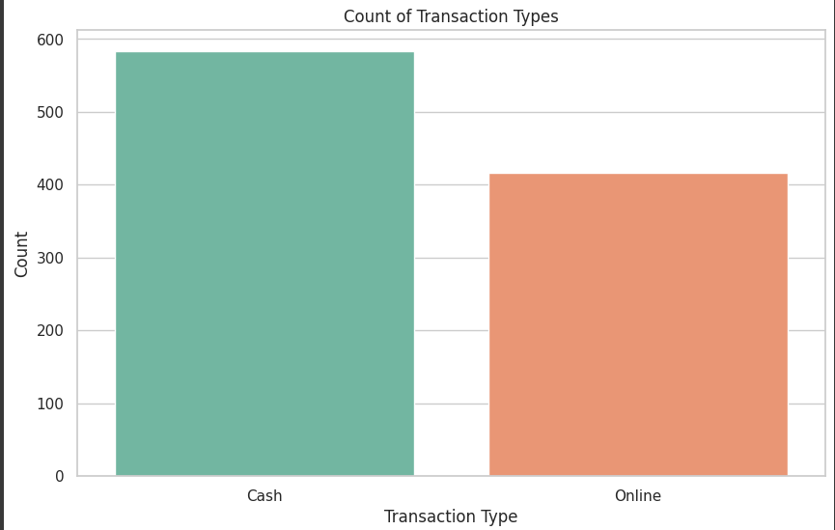

### Analysis of Total Costs by Item Type

we analyze total costs based on item types:

1. Calculate Costs: We sum the total costs for each item type.
2. Create Pie Chart: A pie chart visualizes how much each item type contributes to the total costs.
3. Understand Results: Each slice of the pie represents the percentage of total costs for that item type.
4. Business Decisions: This analysis helps decide which item types to promote or focus on.
5. Next Steps: Further exploration could include looking at trends over time or customer preferences.

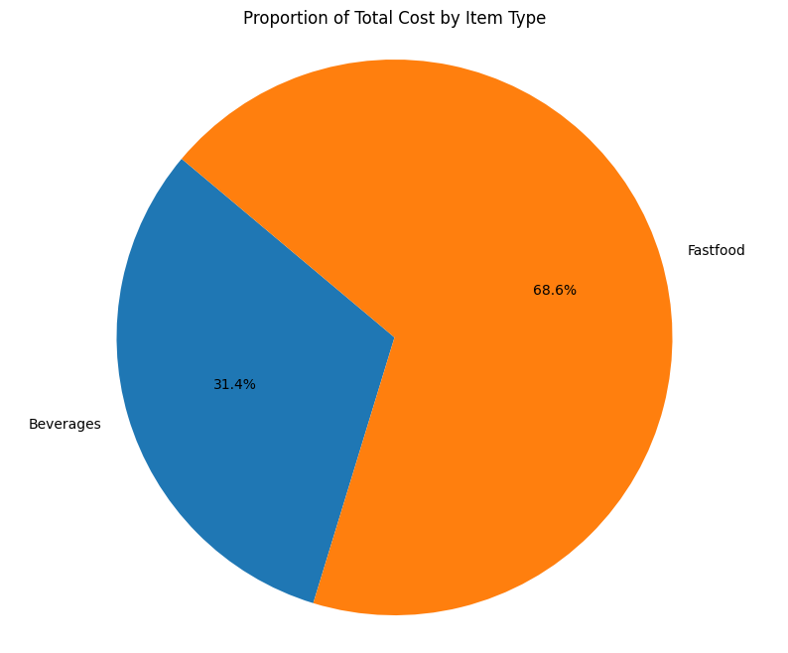

### Analysis of Total Cost Distribution

In this code, we look at how total costs are distributed:

1. Create Histogram: We make a histogram to show how often different total cost values occur.
2. Set Parameters: The histogram uses 30 bins and includes a smooth curve to highlight trends.
3. Interpret Results: This helps us see common price ranges and any unusual values.
4. Insights: Understanding the distribution can reveal customer spending habits.
5. Next Steps: We could compare this distribution with other item types or transaction types.

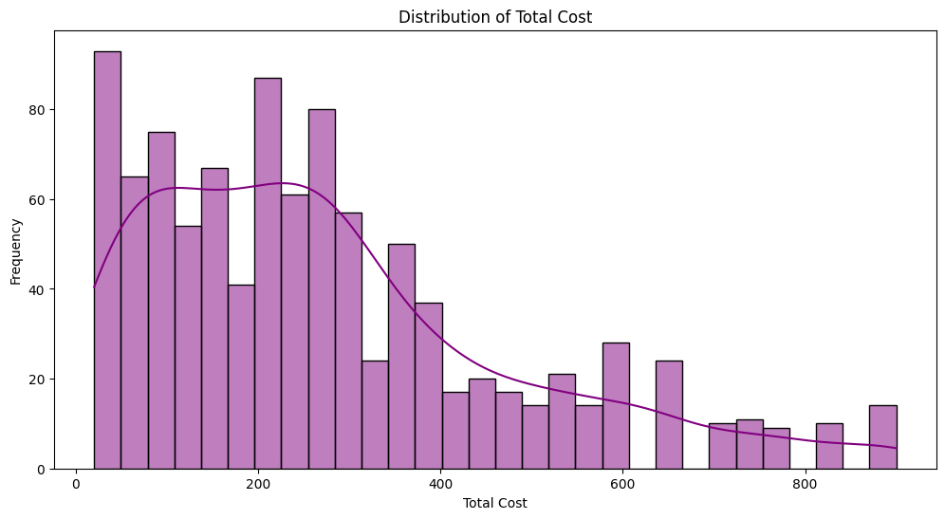

**Conclusion:**

Based on our analysis of both fast food and beverages, we recommend focusing on key items that show high sales potential. For fast food, sandwich, frankie, and panipuri are the top performers, while cold coffee and sugarcane are the standout beverages. To drive sales, we propose the following combo offers:

* Panipuri + Cold Coffee: 48
* Panipuri + Sugarcane: 36
* Frankie + Cold Coffee: 72
* Frankie + Sugarcane: 60
* Sandwich + Cold Coffee: 80
* Sandwich + Sugarcane: 68

These combinations are designed to appeal to customer preferences while offering a balanced price structure. The focus on in-place purchases highlights the importance of tailoring these deals to in-store customers to maximize revenue.