SOILNET · SOIL DOCTOR
Operational Manual
How the smart farming system works, from the sensor in the soil to the advice on your screen
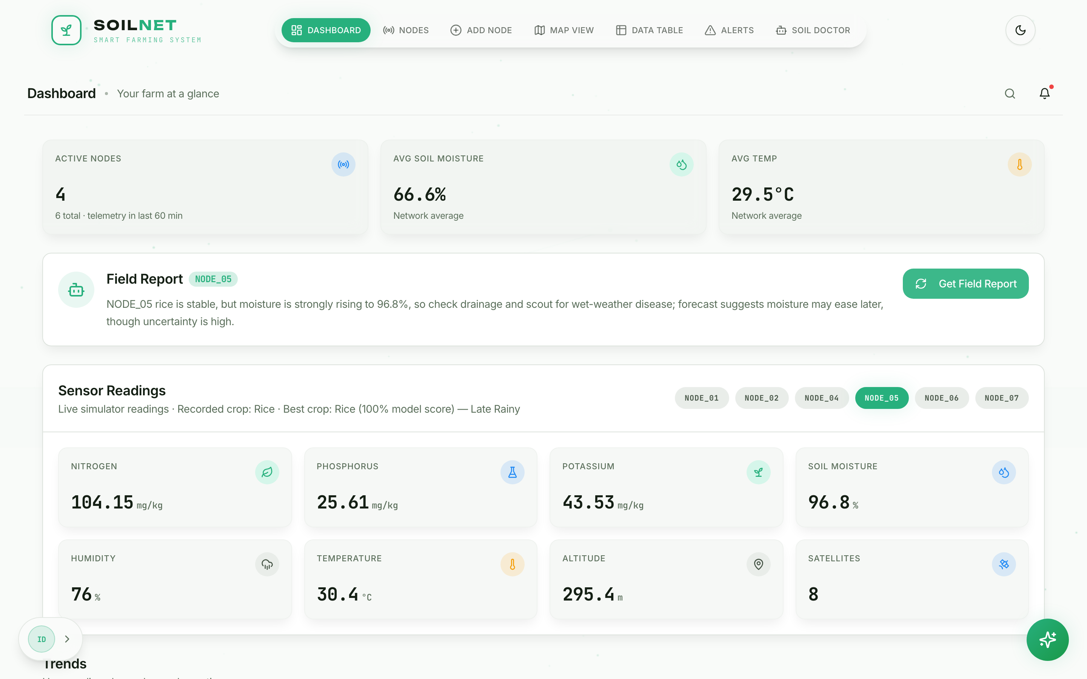

What this manual covers
Pages 2–3 — what the system does and how to switch it on.
Pages 4–7 — using each screen: Dashboard, Nodes, Map, Data Table, Alerts and Soil Doctor.
Pages 8–9 — how Soil Doctor reaches an answer, and how to keep its models up to date.
Page 10 — what to do when something goes wrong, and a list of plain-word meanings.

Version 2.0 · October 2026 · For farm operators, extension staff and project evaluators

1. What the system does
SoilNet watches the soil for you. Small devices pushed into the ground, called nodes, measure the soil every minute. The system stores those measurements, studies how they change, and explains in plain language what they mean and what to do next. The part that explains is called Soil Doctor.

What each node measures
Measurement | What it tells you | Unit
Nitrogen, phosphorus, potassium | The three main plant foods in the soil | mg/kg
Soil moisture | How wet the soil is around the roots | %
Temperature and humidity | How warm and how damp the field is | °C and %

How the pieces fit together
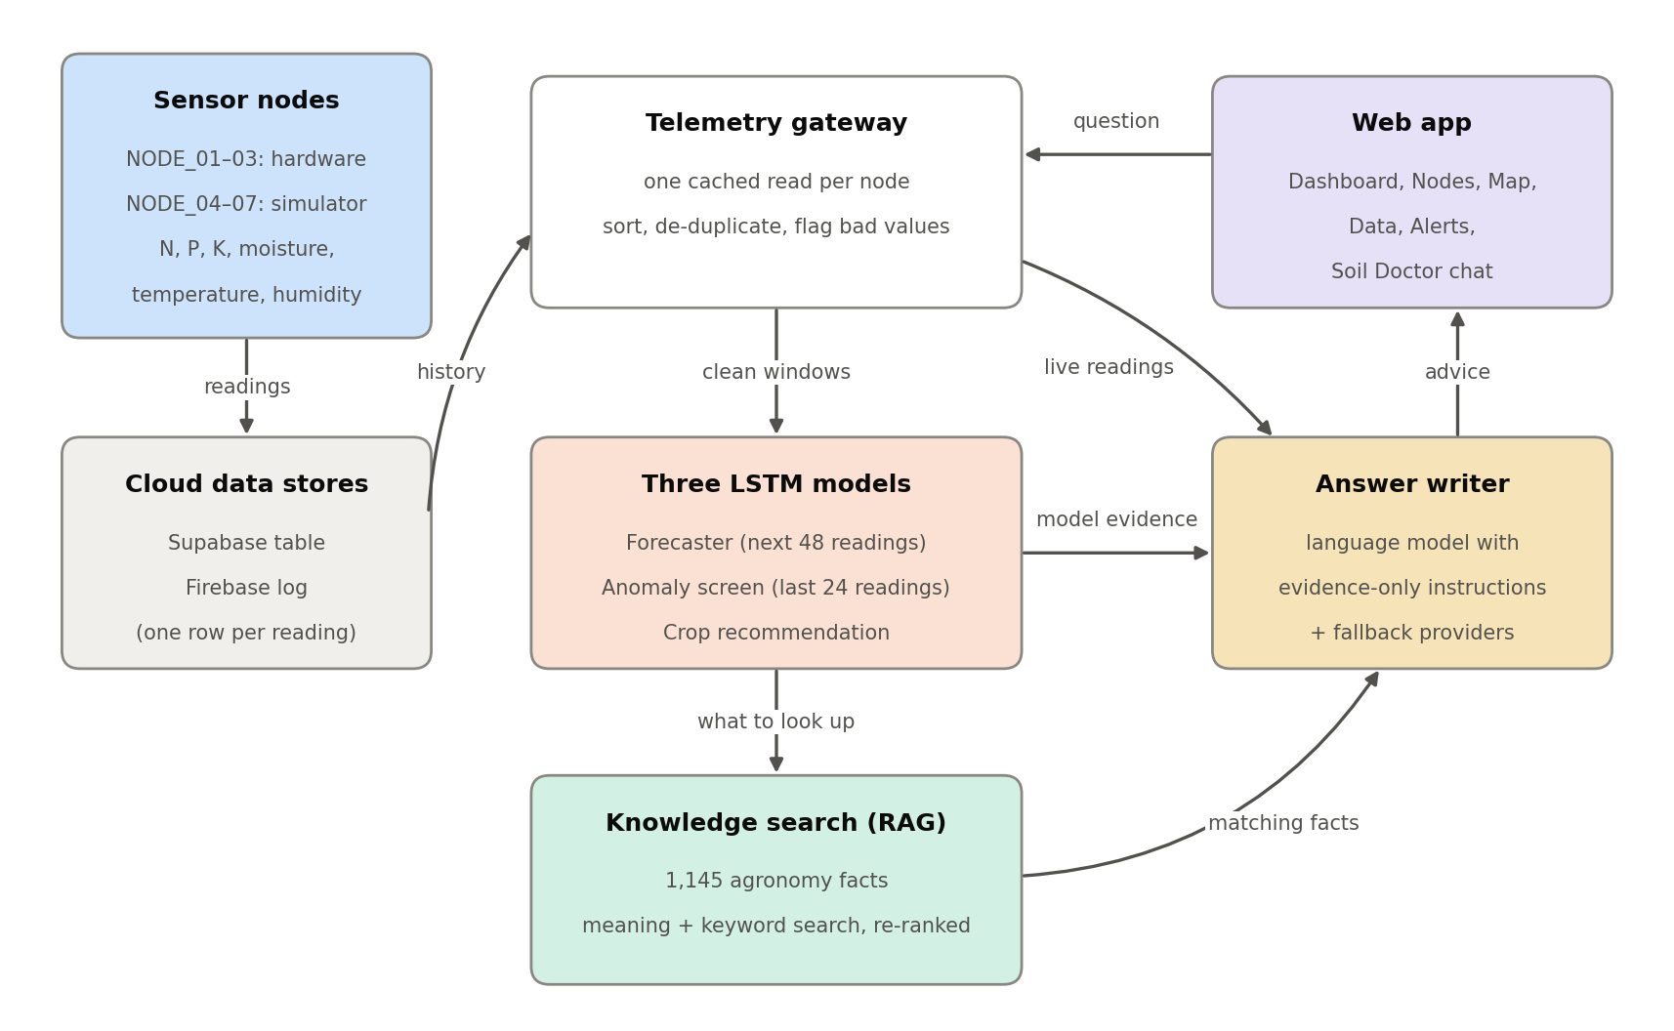
Figure 1. Readings travel from the nodes, through three pattern-learning models, to Soil Doctor.
Part | What it does, in plain words
Sensor nodes | Take a reading every minute. NODE_01 to NODE_03 are real devices; NODE_04 to NODE_07 are practice nodes produced by a simulator program.
Cloud data stores | Keep every reading safely online so nothing is lost when a computer is switched off.
Three LSTM models | An LSTM is a computer model that learns from readings in the order they happened. One model estimates the next 48 minutes, one checks whether the newest readings look unusual, and one suggests a suitable crop.
Knowledge search | A library of 1,145 farming facts taken from trusted guides. The system looks up the facts that match what is happening in your field.
Answer writer | A language program that turns the readings, the model results and the matching facts into advice. It is told to use only that evidence and never to invent numbers.

2. Starting the system
The system has three programs. Start them in this order, each in its own terminal window opened in the project folder. Leave all three windows open while you work.
Step | Type this command | What you should see
1. Start the engine (backend) | uvicorn backend.main:app --port 8000 | After about 30 seconds: Startup complete. Backend is ready. Then a line saying the LSTM models are warmed up.
2. Start the web app | npm run dev | A line showing the address http://localhost:8080.
3. Start the practice nodes | python sensor_simulator.py | Every minute: Sent … telemetry for NODE_04 and the other practice nodes.

Check that everything is ready
Open http://localhost:8000/health in your browser. You should see "status":"ready" and the word available beside forecaster, anomaly_screen and crop_recommendation.
If a model says not_trained, follow Section 8 to train it.

First-time setup (done once)
- Install the software the system depends on: pip install -r backend/requirements.txt and npm install.
- Copy the file .env.example to a new file called .env, and fill in the database addresses and the language-service key you were given.
- Build the farming-facts library: python -m backend.scripts.ingest_agronomic_knowledge.

Stopping the system
Click each terminal window and press Ctrl + C. Stored readings stay safe in the cloud. Real nodes keep sending readings even when your computer is off.
Good to know
Step 3 is only needed for the practice nodes. Real nodes send readings on their own.
The forecast needs 48 readings in a row from a node (about 48 minutes) before it can estimate what comes next. The crop suggestion and the pattern check need 24.
If you change the .env file, stop and restart the engine so it picks up the change.

3. Signing in and the Dashboard
Open http://localhost:8080 in your browser. Sign in with your e-mail address and password, or create an account from the same screen. After signing in you land on the Dashboard.
Figure 2. The Dashboard: farm totals at the top, the Field Report in the middle, and the readings of one node below.
On the screen | What it means
Active Nodes | How many nodes sent a reading in the last 60 minutes, out of the total.
Avg Soil Moisture / Avg Temp | The average across all nodes that are reporting now.
Field Report | Press Get Field Report for a short written summary of the chosen node. It is produced only when you press the button and is kept for 30 minutes.
Sensor Readings | The latest values for one node. Click a node name on the right (NODE_01, NODE_04 …) to switch node.
Trends (scroll down) | Charts of how each reading has changed over time.

Tip
The menu bar at the top takes you to every screen. The round green button at the bottom right opens a small Soil Doctor chat from any page, for quick questions.

4. The Nodes page
The Nodes page shows one card for each node. This is the best place to see, at a glance, what the three models think about each part of the farm.
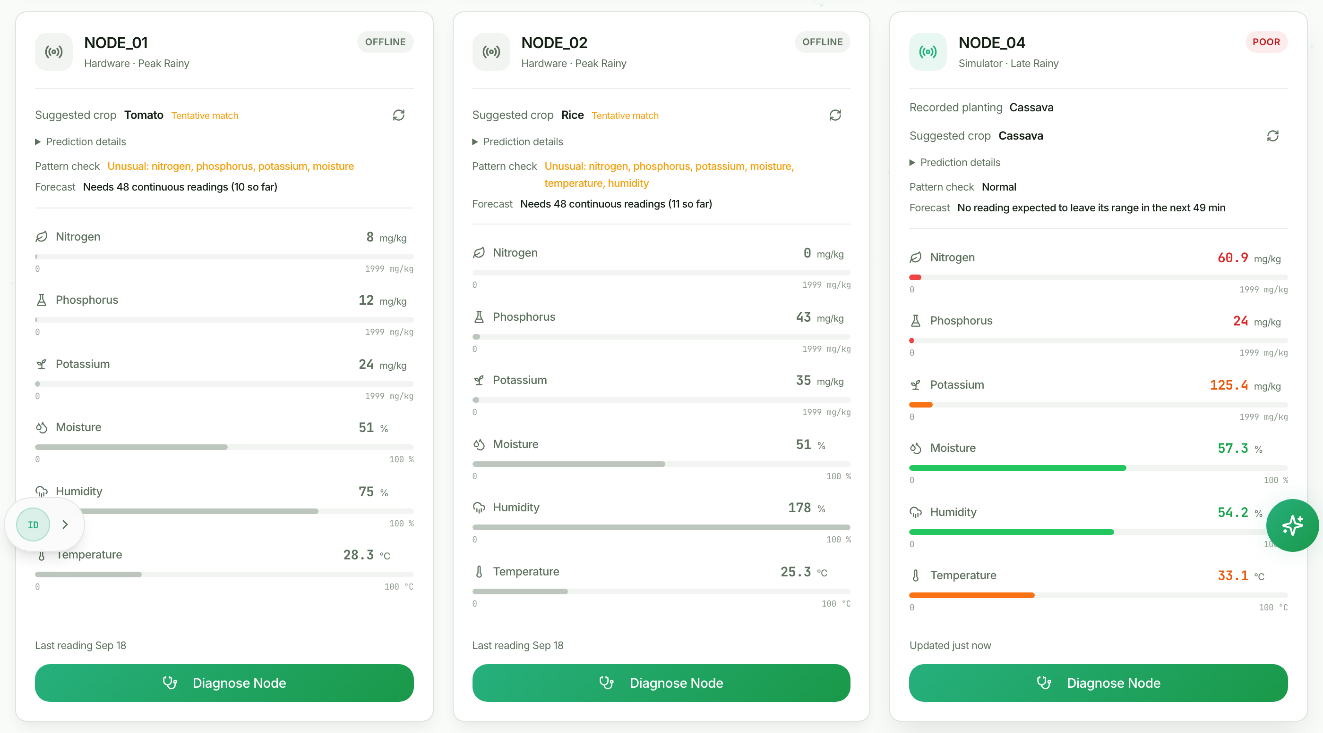
Figure 3. Node cards. Each card shows the suggested crop, the two model checks and the six readings.
On the card | What it means | What to do
Badge: GOOD, FAIR, POOR, OFFLINE | Compares the latest reading with the alert limits you set in Settings. OFFLINE means no reading in the last 60 minutes. | POOR or FAIR: open Alerts to see which reading is outside its limit. OFFLINE: check the node's power and connection.
Suggested crop | The crop model's best match for this soil, from the last 24 readings. Tentative match means the model is unsure. | Use it when planning the next planting, not as a judgement on the current crop.
Pattern check | Normal: the newest readings look like what the model has learned. Unusual: they do not, and the card names the sensors involved. | Unusual: check that the probe is firmly in the soil and clean, then look at the field.
Forecast | Whether any reading is expected to leave its healthy range in the next 48 minutes or so. | Treat it as an early warning. Confirm with the next readings before acting.
Coloured bars | Green is within your limits, orange is outside, red is far outside. | Press Diagnose Node to ask Soil Doctor about this node.

5. Map, Data Table, Alerts and Settings

Map View
The map shows where each node sits in the field. Choose a measurement on the right, such as Soil moisture, and each marker turns green (within your limits), orange (below) or red (above). Click a marker to read what that location means.
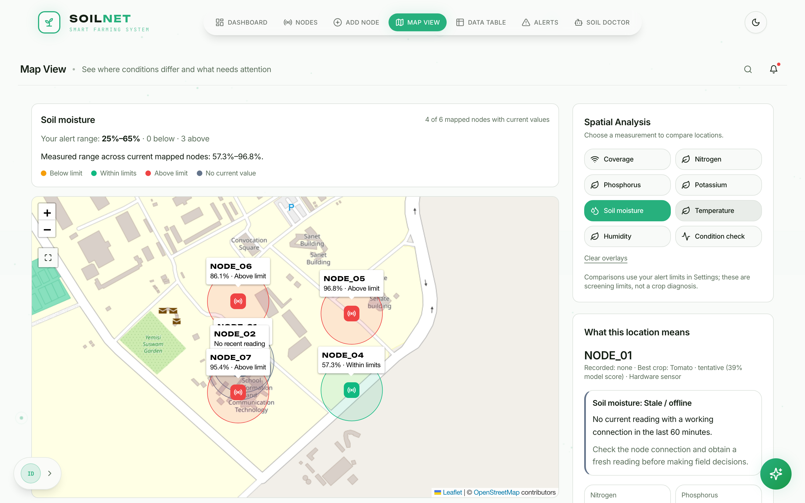
Figure 4. Map View comparing soil moisture across the nodes.

Data Table
Every reading, newest first. Pick a start and end date and press Apply to look at a past period. The Train Anomaly Model button teaches the pattern check again from all stored readings (see Section 8).

Alerts and Settings
Alerts lists every reading that is outside your limits, with the node, the time and the value. Press Thresholds to open Settings, where you set the lowest and highest acceptable value for each measurement.
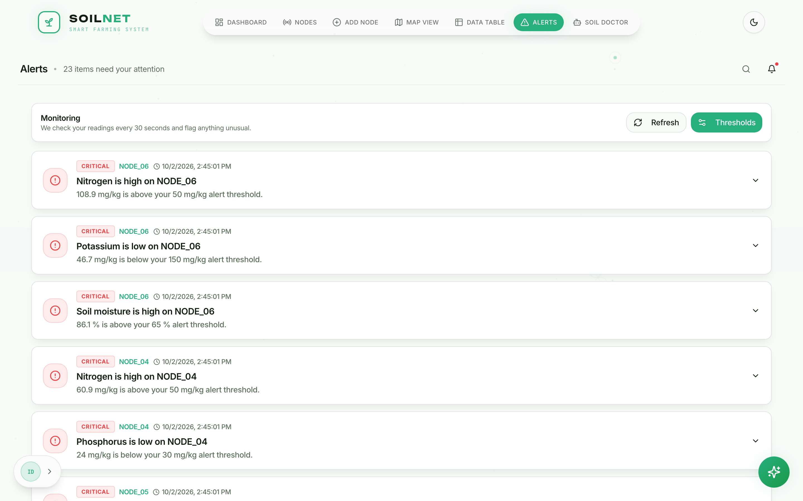
Figure 5. Alerts. Each line says which node, which reading and how far it is from your limit.
Why a card can say POOR while Soil Doctor says the field is fine
The coloured badges and alerts use one set of limits for every node, the ones in Settings. Soil Doctor uses crop-specific ranges: for example, very wet soil is normal for lowland rice but a problem for maize. Set your limits in Settings to suit the crop you grow most, and ask Soil Doctor when a node grows something different.

6. Asking Soil Doctor
Open Soil Doctor from the menu bar. Choose one of the four options.
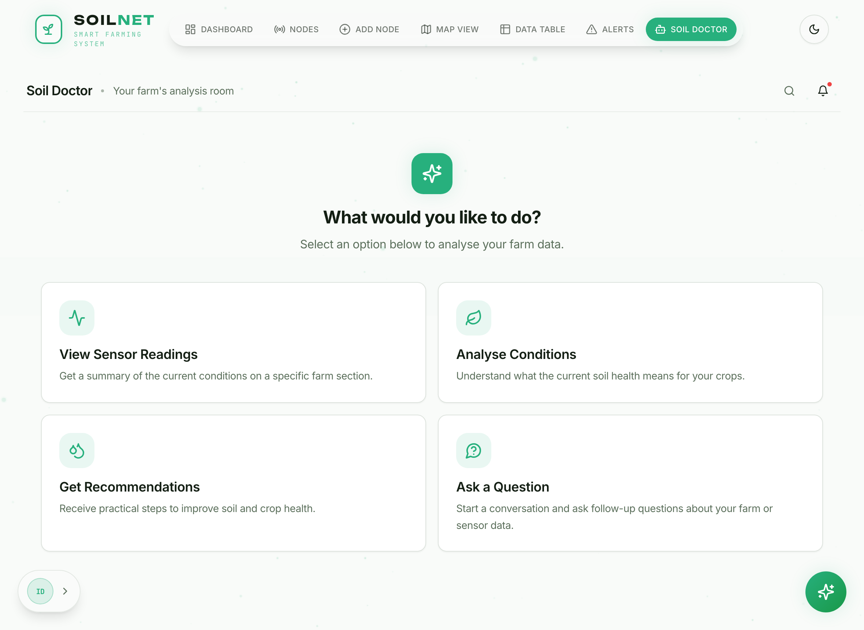
Figure 6. Soil Doctor's starting screen.
Option | Use it when you want…
View Sensor Readings | the latest numbers for one node, with no interpretation.
Analyse Conditions | an explanation of what the readings mean for the health of that part of the field.
Get Recommendations | practical steps to improve conditions at one node.
Ask a Question | to type your own question and keep a conversation going.
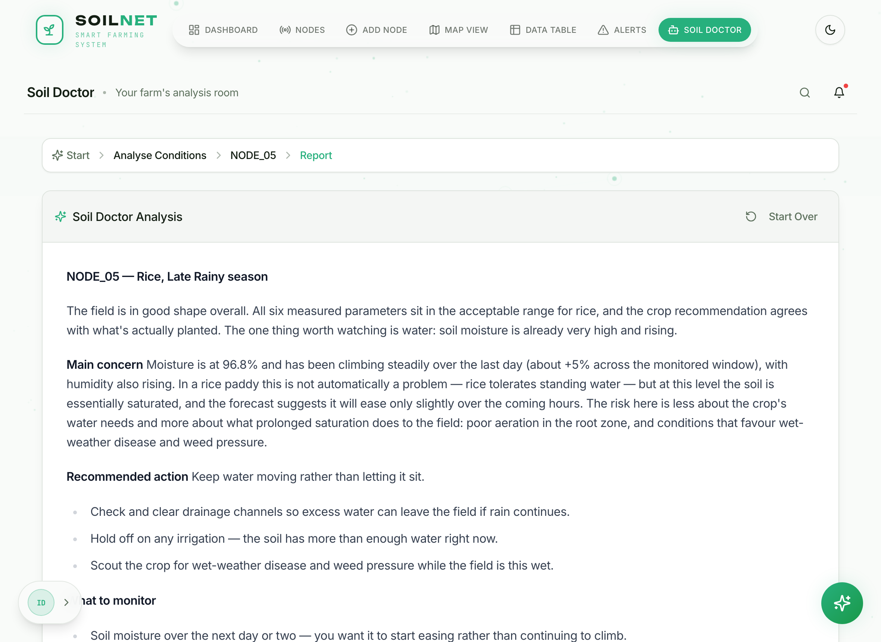
Figure 7. An analysis of one node. The answer starts with the overall finding, then the main concern, the action and what to watch.
Getting the best answers
Name the node (for example “How is NODE_05?”). Soil Doctor then studies that node's history and model results.
Ask one thing at a time. Follow-up questions keep the earlier conversation in mind.
Soil Doctor will say when it is unsure, when readings are old, or when a forecast is only a rough estimate. That caution is deliberate: it is told never to invent a number, a crop or a treatment amount.

7. How Soil Doctor reaches an answer
Every answer follows the same eight steps. Nothing is guessed: each step adds evidence that the next step uses.
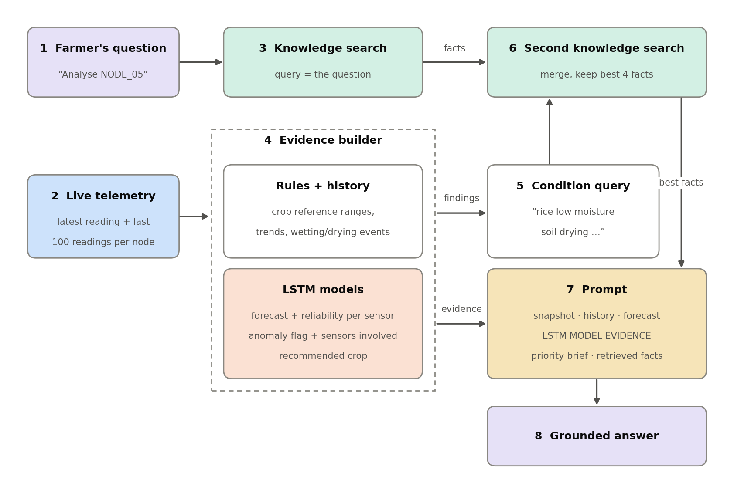
Figure 8. From question to answer.
Step | What happens
1–2 | Your question arrives, and the system collects the latest reading and the last 100 readings of each node involved.
3 | It searches the farming-facts library for facts that match your question.
4 | It builds the evidence. Simple rules compare readings with the crop's healthy range and look for trends such as drying or sudden wetting. The three LSTM models add a forecast, a pattern check and a crop suggestion.
5–6 | It writes a second search from what it found (for example “rice, low moisture, soil drying”) and looks up facts for those conditions, then keeps the four best facts.
7–8 | The answer writer receives the readings, the history, the model results and the facts, and writes the advice.

How much to trust each model
Model | What it is good for | Its limits
Forecast | An early warning that a reading may leave its healthy range. | Each sensor's forecast is tested against simple guesses. If it is not clearly better, Soil Doctor calls it a rough level estimate and will not base an action on it alone.
Pattern check | Spotting readings that do not look like normal ones, such as a loose or faulty probe. | It says something is unusual, not why. Always look at the sensor and the field.
Crop suggestion | Comparing your soil with seven crops (cassava, maize, potato, rice, sugarcane, tomato, wheat). | It is a planning aid. It does not consider markets, seed supply or pests.

8. Keeping the models up to date
The models learn from stored readings. As more readings arrive, teaching them again (retraining) helps them follow how your soil really behaves. Retrain about once a month, after adding a new node, or after a node has been repaired.
Model | How to retrain | Time
Pattern check | Data Table page → Train Anomaly Model; or python -m backend.ml.lstm_anomaly_trainer | about 5–10 minutes
Forecast | python -m backend.ml.train_lstm_forecaster | about 5–15 minutes

Run the commands in a new terminal window in the project folder. The engine picks up a newly trained model by itself; you do not need to restart it. To see whether training has finished, open http://localhost:8000/api/v1/ml/training-status, and to see how well each model did, open http://localhost:8000/api/v1/ml/status.
Reading the forecast's report card
After training, the forecast is tested on readings it has never seen and compared with two simple guesses: “the next reading equals the last one” and “the next reading equals the recent average”.
A sensor is marked informative only if the model beats the better guess by at least 5%. Otherwise Soil Doctor treats that sensor's forecast as a rough estimate. Expect more sensors to become informative as real field readings build up.

Daily and weekly routine
When | What to do
Each morning | Open the Dashboard: are all nodes active? Open Alerts and read anything marked CRITICAL.
Each day | On the Nodes page, look for Unusual pattern checks and OFFLINE badges. Press Get Field Report for the node you care most about.
Each week | Ask Soil Doctor to analyse each node. Clean and re-seat any probe that keeps showing unusual readings.
Each month | Retrain the pattern check and the forecast. Review your alert limits in Settings.

9. When something goes wrong
What you see | Likely reason | What to do
A node shows OFFLINE | No reading in the last 60 minutes. | Practice nodes: check that the simulator window is still running. Real nodes: check power, signal and that the probe is connected.
Forecast says “Needs 48 continuous readings” | The node was recently restarted or missed some readings. | Wait. The forecast returns once 48 readings in a row have arrived.
Suggested crop says “More readings needed” | Fewer than 24 readings are stored for the node. | Wait about 24 minutes.
Soil Doctor replies “couldn't complete the analysis” | The engine is not running or the internet connection dropped. | Check the engine window and open the health address from Section 2.
An answer ends with “AI-written interpretation was unavailable” | The language service could not be reached, so a rule-based report was given instead. | The report is still based on your readings. Try again later for a fuller answer.
Health page shows a model as not_trained | The model files are missing. | Retrain the model (Section 8).
Pattern check stays “Unusual” on a real node | The probe may be loose, dirty or faulty. | Clean and re-seat the probe. If it continues, compare with a manual soil test.

Plain-word glossary
Word | Meaning
Node | A sensor device in the field. Each has a name such as NODE_05.
Reading | One set of measurements taken by a node at one moment.
LSTM model | A computer model that learns from readings in the order they happened, so it can notice patterns over time.
Forecast | The model's estimate of readings in the near future. It is an estimate, not a promise.
Pattern check (anomaly screen) | A test of whether the newest readings look like normal ones.
Knowledge search (RAG) | Looking up trusted farming facts and giving them to the answer writer so that its advice is based on them.
Threshold / limit | The lowest or highest acceptable value you set for a measurement.
Backend / engine | The program that does the analysis behind the web pages.

