Sprint 1 Review

Sprint 1: 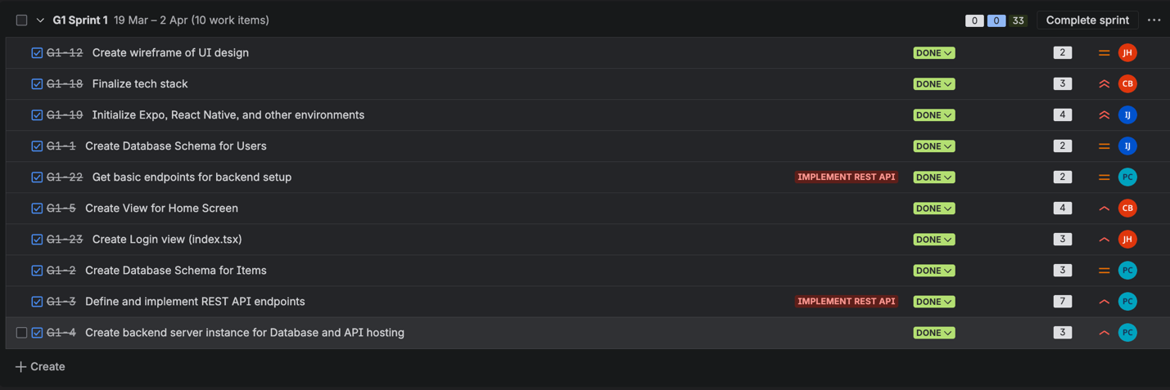
Youtube Link: https://www.youtube.com/watch?v=hwXtU9jyfG4

Info for Next Sprint
Jira Link: https://ijauregui222.atlassian.net/jira/software/projects/G1/boards/1/backlog

