Prompt 1:
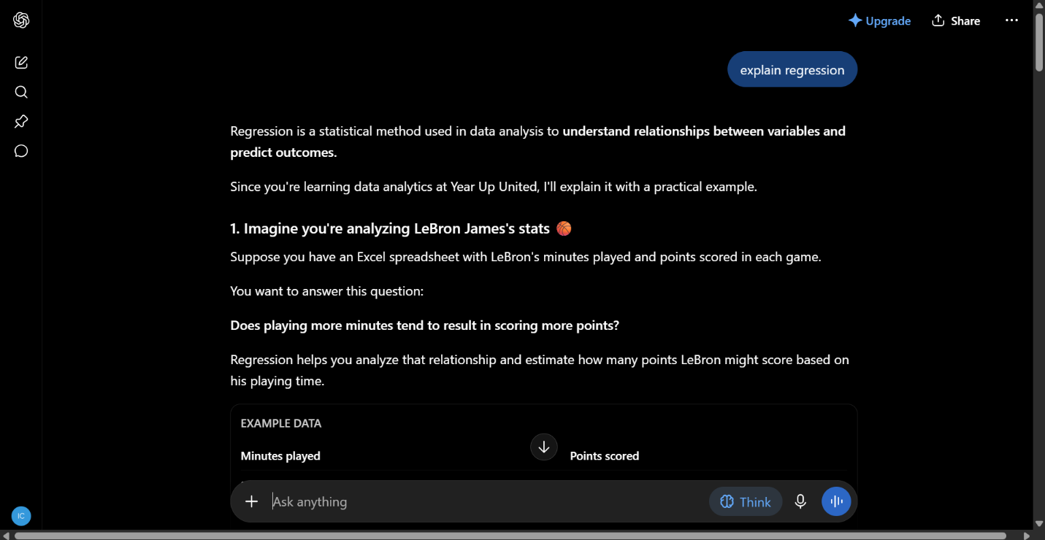
Prompt 2:
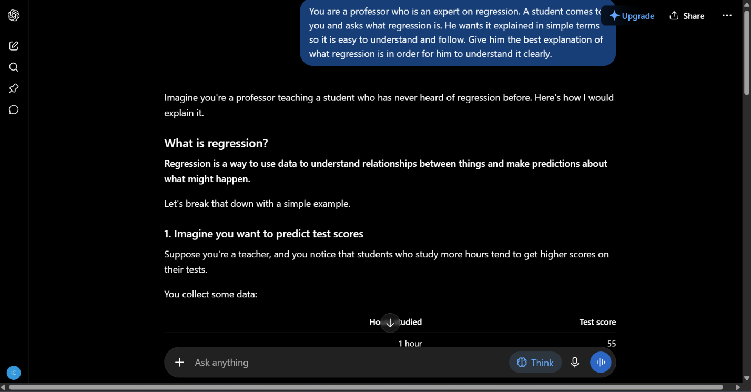
The second prompt gave me a much easier to follow explanation. I believe it’s because of how I mentioned the scenario that ChatGPT was in and how to explain it to a student as if ChatGPT was a professor.

Prompt 1:
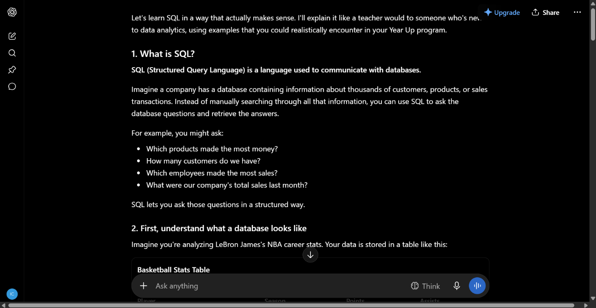
Prompt 2:
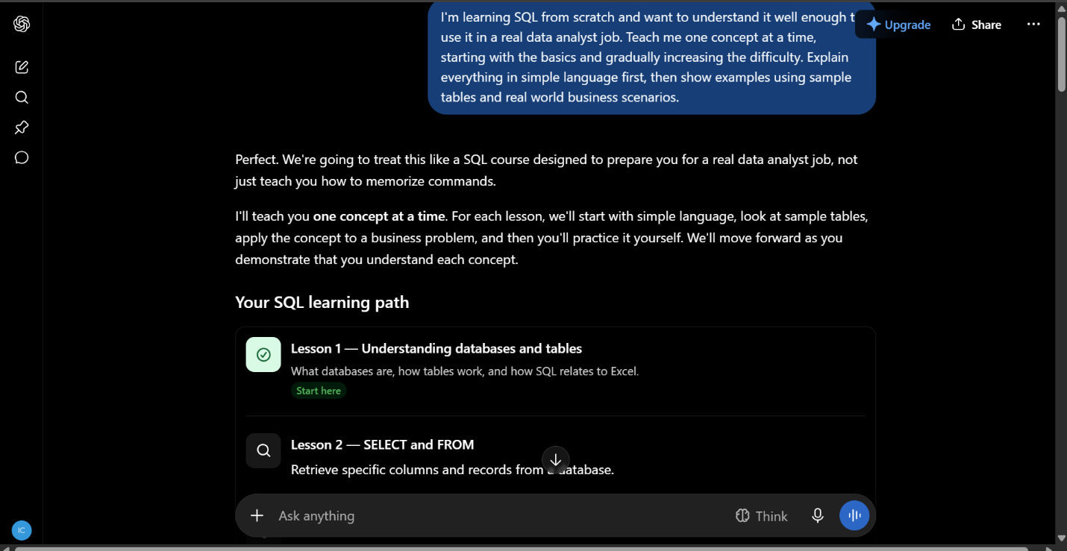
I really like the difference with this one. ChatGPT gave me a learning path for me to follow in the second prompt which is super helpful. It also made it easier to understand and follow.

Prompt 1:
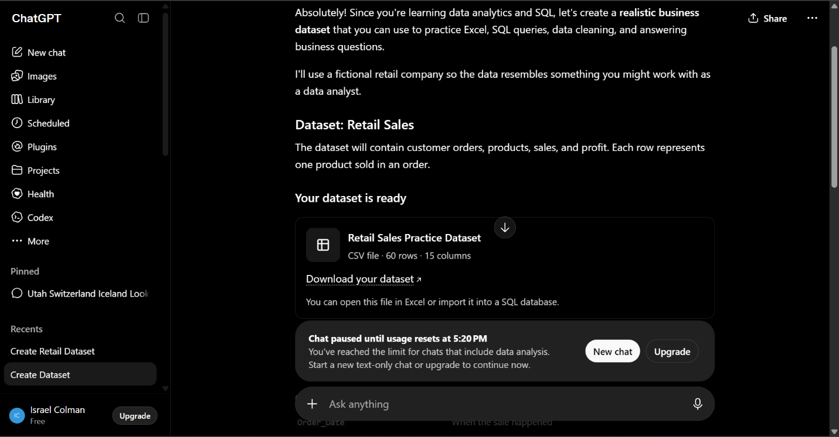
Prompt 2:
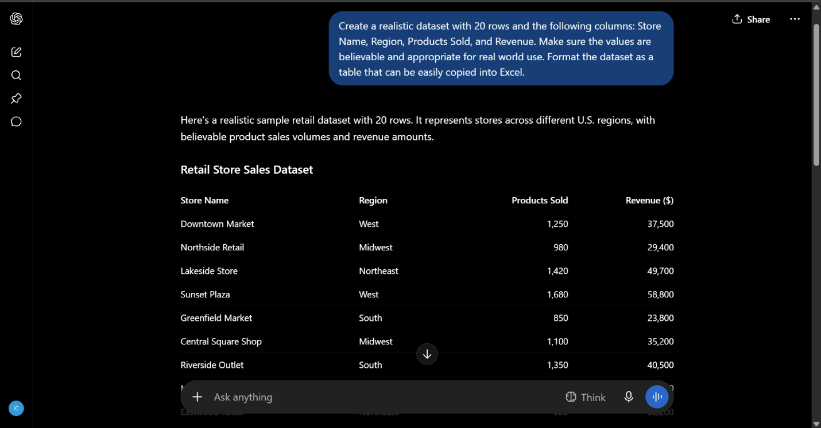I didn’t mind the first simple prompt for this one. However the second prompt is more tailored to my specific needs and explanation. It again is much simpler to follow and gave just what I needed.

