Preliminary Research Concept on Urban Micrometeorology for AAM
Israel Gebresilasie Kimo

Introduction
Micrometeorology is a part of meteorology that deals with observations and processes at small scales of time and space, approximately smaller than 1 km and one day (Foken et al., 2008). This region is characterized by different small-scale meteorological processes such as turbulence, wind shear, wind gusts, surface friction, and wind load. These processes affect UAV operations in dense urban airspaces. Wind shear and turbulence caused by buildings in the vicinity of airports have been identified as causes of aircraft instability during landing and takeoff for some time (Krüs et al., 2003). Therefore, in order to realize safe flight operations, careful study of turbulence modeling, simulation, and validation, as well as taking these processes into account in the design of advanced air mobility systems, is essential. In this concept note, I describe my understanding of these processes one by one.

Atmospheric Turbulence

Governing Equations (RANS)

Atmospheric turbulence is initially represented by the Navier–Stokes equation, which is derived from Newton’s second law of motion. This law states that the acceleration of the atmosphere is equal to the summation of the forces causing motion in the atmosphere. These forces are the pressure gradient force, gravitational force, friction (viscous force), and Coriolis force
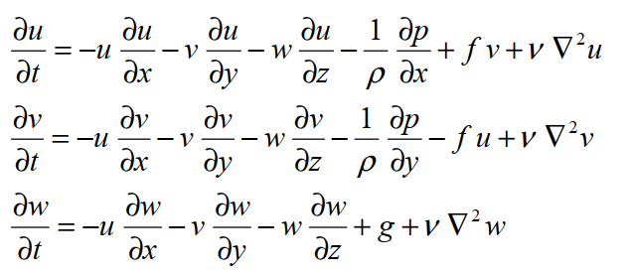.
Even though the above equation represents motion in the atmosphere for zonal, meridional, and vertical components, it lacks turbulent representation; therefore, modification has to take place by introducing Reynolds’s decomposition, as indicated by Foken et al. (2008). 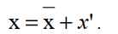
The application of Reynolds’s decomposition requires some averaging rules for the turbulent value x′ (a represents a constant), which are termed Reynolds’s postulates:
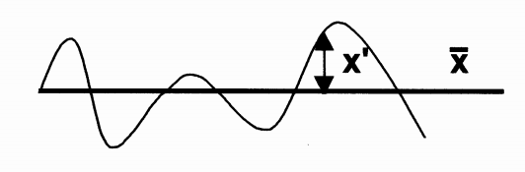
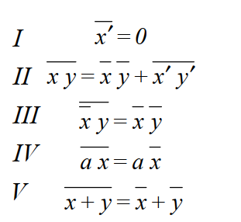
After applying Reynolds’s decomposition, Reynolds averaging rules (postulates), the Boussinesq approximation, and Einstein summation notation to the Navier–Stokes equations, we obtain the turbulent equations (RANS) (Foken et al., 2008).
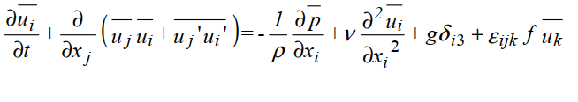

Computational Fluid Dynamics (CFD)
CFD numerically solves the governing Navier–Stokes equations to simulate fluid motion, and turbulence is either directly resolved or parameterized using approaches such as Reynolds-Averaged Navier–Stokes (RANS) or Large Eddy Simulation (LES), depending on the desired level of temporal and spatial resolution and computational cost ( Al-Khalidy.. et al 2018)

Turbulence Modeling and Closure
The quality of CFD simulation depends on the selected turbulence model. In practical problems the turbulence model should be as simple as the relevant physics will permit For most real world building problems turbulence is, in principle, described by the Reynolds Averaged Navier-Stokes (RANS) equations [6].
According to Chaudhry [16] the three-dimensional Reynolds-Averaged Navier–Stokes (RANS) using the k–e turbulence model is one of the most suitable numerical methods for built environment simulations. The model solves for two governing equations, the kinetic energy and turbulent dissipation.

2.3.1 Closure Techniques
The transition from the equation of motion for the mean stream to the turbulent flow gives a system of differential equations with more unknown parameters than equations. To solve the system of equations, assumptions have to be made to calculate the unknown parameters. These assumptions, for example the covariance terms, are called closure techniques (Foken et al., 2008).
After Reynolds averaging, the RANS equations contain more unknowns than equations. This is called the closure problem. The assumptions used to model these unknown turbulent terms are called closure techniques. In RWIND, closure is achieved using turbulence models such as k -ε and k-ω, which replace unknown turbulent terms with modeled expressions.
The Reynolds-averaged Navier–Stokes equations contain unknown Reynolds stress terms, leading to the closure problem. Closure techniques, such as the k -ε and k-ω models used in RWIND, parameterize these terms by relating them to mean flow variables through an eddy-viscosity assumption.

RWIND-Based Urban Flow Simulation

2.4.1 Initial and Boundary Conditions

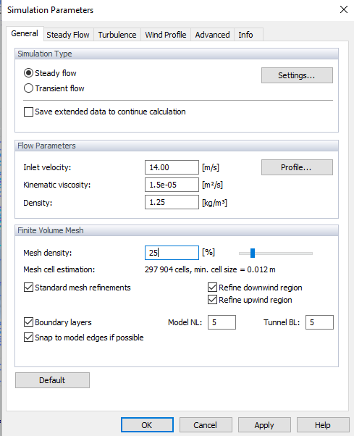

All the required initial condition for this simulation is based on RWING3 guide line obtained from https://www.dlubal.com/en/downloads-and-information/documents/online-manuals/rwind-3/005631

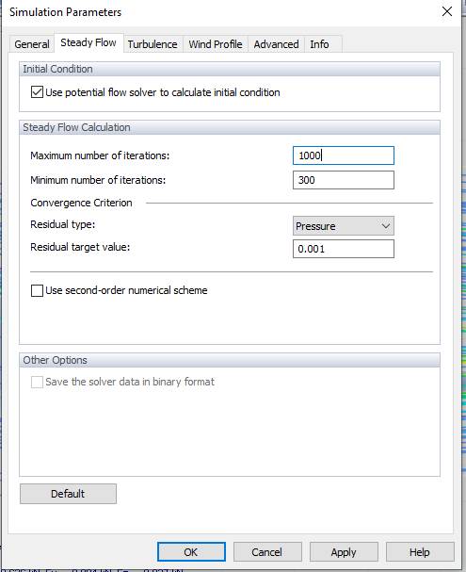

Use potential flow solver to calculate initial condition Check this box (ON)
This is standard practice in RANS simulations (especially in wind engineering) because: RWIND 3 Manual mentions using potential flow for initial field helps solver start from a physically meaningful state. RWIND 3 Online Manual (Dlubal) — see “Initial condition” section
https://www.dlubal.com/en/downloads-and-information/documents/online-manuals/rwind-3/005640

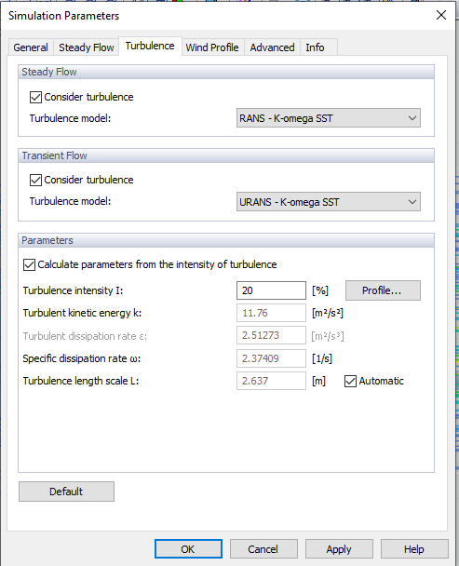

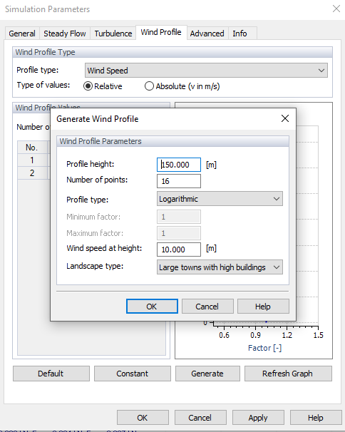
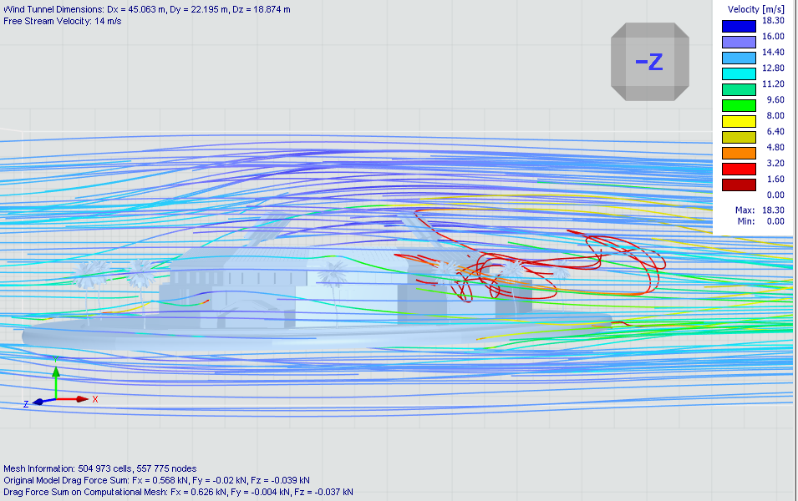
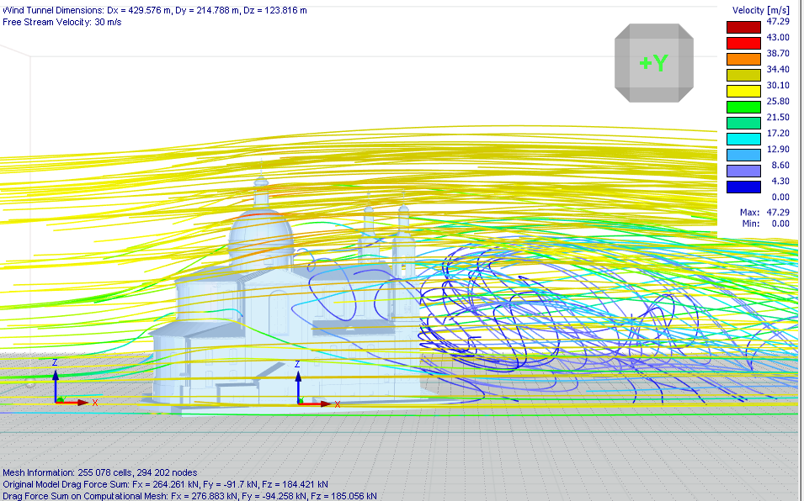

2.5 Conceptual framework

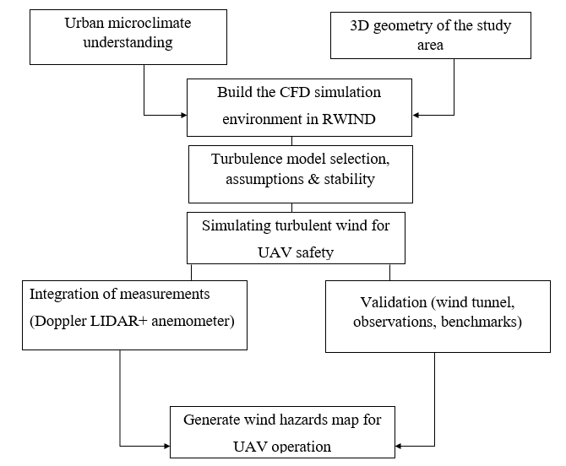
Figure 1 Conceptual framework linking urban micrometeorology, CFD modeling, and UAV wind safety assessment.
The CFD framework is based on the Reynolds-Averaged Navier–Stokes (RANS) equations with appropriate turbulence closure models (e.g., k − ε and k -ω.) Atmospheric stability assumptions and model uncertainties are considered when interpreting turbulence intensity and wind hazard maps for UAV operations.

References

Al-Khalidy, N. (2018). Building Generated Wind Shear and Turbulence Prediction Utilising Computational Fluid Dynamics. WSEAS Transactions on Fluid Mechanics, 13, 126-135
Foken, T., & Mauder, M. (2008). Micrometeorology (Vol. 2, p. 306). Berlin: Springer.
https://www.dlubal.com/en/downloads-and-information/documents/online-manuals/rwind-3/005640?utm_
Krüs, H. W., Haanstra, J. O., Van Der Ham, R., & Schreur, B. W. (2003). Numerical simulations of wind measurements at Amsterdam Airport Schiphol. Journal of Wind Engineering and Industrial Aerodynamics, 91(10), 1215-1223.
RWIND 3 Online Manual (Dlubal) — see “Initial condition” section
https://www.dlubal.com/en/downloads-and-information/documents/online-manuals/rwind-3/005640

