Retrieves information (SSN, first name and last name) about students who take the course ‘Database Management Systems’ :
/*Query1*/
SELECT Student.SSN,FirstName,LastName
FROM Student,Enrolls,Course
WHERE Student.SSN = Enrolls.SSN AND Enrolls.CourseNo = Course.CourseNo AND CourseName = 'Database Management Systems';
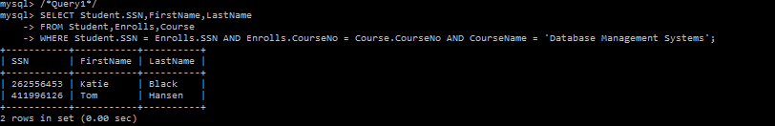
Retrieves the courses that have more than 2 sections and only returns distinct values.
/* Query2 */
SELECT Course.CourseName AS 'Course',COUNT(DISTINCT Section.SectionNo) AS '# of Sections'
FROM Course,Section
WHERE Course.CourseNo = Section.CourseNo
GROUP BY Course.CourseNo
HAVING COUNT(DISTINCT Section.SectionNo) > 2;
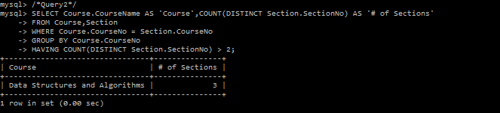
Lists each course number, course name and section number which have 3 or more students in the section.
/* Query3 */
SELECT Enrolls.CourseNo,Enrolls.SectionNo,Course.CourseName
FROM Enrolls,Course
WHERE Enrolls.CourseNo = Course.CourseNo
GROUP BY Enrolls.CourseNo,Enrolls.SectionNo
HAVING COUNT(DISTINCT Enrolls.SSN) >= 3;
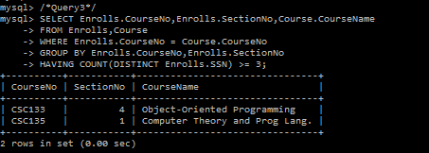

Retrieves the information (SSN, first name, and last name) of students who got Grade ‘A’ in at least 3 exams and orders by SSN.
/* Query4 */
SELECT Student.SSN,Student.FirstName,Student.LastName
FROM Student INNER JOIN Takes ON Student.SSN = Takes.SSN
GROUP BY Student.SSN,Student.FirstName,Student.LastName,Takes.Result
HAVING COUNT(Takes.Result) >= 3 AND Takes.Result = 'A'
ORDER BY Student.SSN;
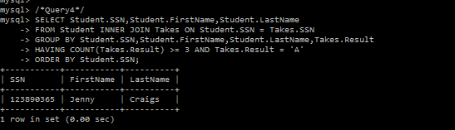

Obtains information (exam number, exam date, course number and section number) about exams taking place in building ‘RVR’. Also gets the room’s capacity and room number.
/* Query5 */
SELECT Exam.ExamNo, Exam.E_Date, Exam.CourseNo, Exam.SectionNo, ClassRoom.Capacity, ClassRoom.RoomNo
FROM (SELECT *
FROM ConductedIn
WHERE ConductedIn.Building = 'RVR'
) AS rvr
INNER JOIN Exam ON rvr.CourseNo = Exam.CourseNo AND rvr.SectionNo = Exam.SectionNo
AND rvr.ExamNo = Exam.ExamNo
INNER JOIN ClassRoom ON rvr.RoomNo = ClassRoom.RoomNo AND rvr.Building = ClassRoom.Building;

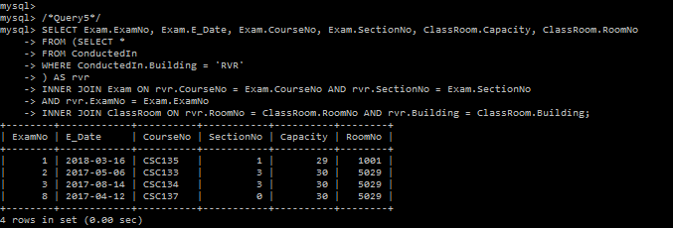

Retrieves information (SSN, first name and last name) about students who are enrolled in both the course ‘CSC133’ and ‘CSC137’.
/* Query6 */
SELECT Student.SSN, Student.FirstName, Student.LastName
FROM Student,Enrolls
WHERE Student.SSN IN (SELECT Student.SSN
FROM Student,Enrolls
WHERE Student.SSN = Enrolls.SSN AND Enrolls.CourseNo = 'CSC133')
AND Student.SSN = Enrolls.SSN AND Enrolls.CourseNo = 'CSC137';

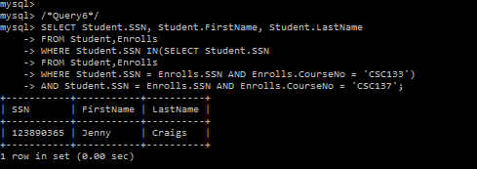

Gets the information (SSN, first name and last name) about students who take the course ‘Data structure and algorithms’. Also gets the section number in which they have enrolled in the course, as well as the instructor of the section.
/* Query7 */
SELECT Student.SSN, Student.FirstName, Student.LastName, Section.SectionNo, Section.Instructor
FROM Student,Enrolls,Course,Section
WHERE Student.SSN = Enrolls.SSN AND Enrolls.CourseNo = Course.CourseNo
AND Enrolls.CourseNo = Section.CourseNo AND Enrolls.SectionNo = Section.SectionNo
AND Course.CourseName = 'Data Structures and Algorithms';
