An Analysis of Geographic Patterns in Building Inspection Deficiency and Inspection Failures in Calgary.

Masters of Data Analytics (MDA)

Group 1
Names:
- BASMA AL NABOUSH
- MANAV, MANAV
- ISRAEL OBOKOHWO
- OKEMENA OJUEDERIE

Abstract
The City of Calgary inspects every new residential building at several stages of construction, recording each visit as a pass or a non-pass against the Alberta Building Code. This project asks a simple question with practical consequences: are inspection failures concentrated in specific quadrants of the city? Using the relational dataset provided with 106,740 inspections spanning 2000 to 2025, we extracted a clean analytical dataset with SQL, explored it, visualized it, and then tested the geographic hypothesis formally using a Chi-Square test and three classification models; logistic regression, decision tree, and a random forest.
The result shows that geography barely matters and failure rates differ slightly across the four zones with NW having the highest rate at 38.1% and NE the lowest at 36.3%. Once we controlled for inspection type and year, no zone showed meaningful or higher odds of failure, and zone contributes almost nothing to predictive accuracy. What mattered the most was the inspection type; gas and fire protection inspections fail more than 80% of the time, against under 10% for foundations. Our position remains that the city allocates inspection by the type of job rather than where it happens.

Chapter 1: Introduction
1.1 Overview of the Data
The Calgary Building Inspections data provided is a relational database with records of residential building permits issued, inspections and code violations (called deficiencies) in the City of Calgary, Alberta from 2000 to 2025. In Calgary before construction commences, every new residential building is required to obtain a permit while city inspectors visit the site at different stages of the project to assess jobs done by contractors against the city code of standards. During these inspections, any violations found are recorded as deficient. These deficiencies are required to be fixed by the contractor or permit holder before construction can proceed or for the permit to be closed.
The geographic data provided forms the foundation of this project because it makes it possible to examine deficiency rates and inspection outcomes across the city and determine whether certain areas show higher rates of violations or failures.
1.2 Description of the Database Structure
The database is made up of relational structure with facts tables having a connection with dimensional tables that decodes numerical categories into readable labels.
Table | What It Contains | Key fields
Inspection | One row refers to every inspection visit.  Stores the permit it belongs to, the inspection type, the outcome, and the date it was completed. | inspection_id, permit_id, inspection_type_id, outcome_id, inspection_completed_date
Dim_outcome | Lookup table that shows outcomes as Acceptable or Not Acceptable. | outcome_id, outcome_desc
Dim_inspection_type | Lookup table that classifies inspection into Foundation, Framing or Gas. | inspection_type_id, inspection_type_desc
Permit | One row per building permit.  Functions as a bridge to connect each inspection to its physical location. | permit_id, location_id
Location | Stores the address and GPS coordinates of each permit site. | location_id, address_line, latitude, longitude
The join path that connects all five tables together has been modelled in chapter 4 to help have a better understanding of how each table is related.
How outcomes are classified
The dim_outcome table contains 20 different outcomes. For this project, we grouped all outcomes into three categories Pass, Non-pass and Excluded. If an inspection outcome is acceptable, such inspection will pass with no or minor issues. If the outcome is unacceptable, such an inspection will not pass. If the outcome is not required, inspection is excluded or will not take place.
1.3 Data Exploration using SQL and Preliminary Observation
Query 1: How many records are in the main tables?
Purpose: Summary count of relevant tables in our data.
Our findings from the query revealed a total of 78,394 permits, 107,067 inspections were carried out in 71,771 locations with 123,802 inspection deficiency recorded. This count validates our population before any further analysis begins.
Data Exploration SQL Query
SELECT “permit” AS data_info, COUNT(*) AS total FROM permit
UNION ALL
SELECT 'inspection' AS data_info, COUNT(*) AS total FROM inspection
UNION ALL
SELECT 'location' AS data_info, COUNT(*) AS total FROM location
UNION ALL
SELECT 'inspection_deficiency' AS data_info,
COUNT(*) AS total FROM inspection_deficiency;

Query 2: How many inspections are in each zone?
Purpose: We categorized inspections by the permit address suffix to show how the data is distributed geographically. We use the CASE statement to read the last characters of every address_line field to assign each inspection to a zone.
Our findings show that SE has a total of 34029 inspections, SW has 29268 inspections, NW has 26136 inspections, and NE has 17634 inspections reflecting where most residential constructions are taking place. This serves as the project's first geographic comparison of inspection activity across Calgary. The higher inspection volume observed in the SE and SW zones may reflect increased residential development activity in those areas during the study period.
SQL Query Used to Count Inspections Across Zones (NW, NE, SW, SE)
SELECT
CASE
WHEN l.address_line LIKE '% NW' THEN 'NW'
WHEN l.address_line LIKE '% NE' THEN 'NE'
WHEN l.address_line LIKE '% SW' THEN 'SW'
WHEN l.address_line LIKE '% SE' THEN 'SE'
ELSE 'Other'
END AS zones,
COUNT(*) AS total_inspections
FROM inspection i
JOIN permit p ON i.permit_id = p.permit_id
JOIN location l ON p.location_id = l.location_id
GROUP BY zones
ORDER BY total_inspections DESC;

Query 3: What is the failure rate per zone?
Purpose: For our exploratory analysis, this query would calculate the proportion of inspections that resulted in non-pass for each zone. The result will be an early indication if truly geographic differences in failure rates exist before any formal statistical testing is done.
zone | total_inspections |  | failed | failure_rate_pct %
NW | 26136 |  | 9793 | 37.47
SE | 34029 |  | 12217 | 35.9
SW | 29268 |  | 10475 | 35.79
NE | 17634 |  | 6307 | 35.77
Outcome: Our findings revealed that failure rates differ slightly across zones. However, the differences between zones are relatively small, suggesting that geographic location alone may not fully explain inspection outcomes. Other factors such as inspection type, project complexity, or contractor practices may also influence failure rates. Further statistical testing will be conducted later in this study.
SQL Query (Failure Rate Per Zone)
SELECT
CASE
WHEN l.address_line LIKE '% NW' THEN 'NW'
WHEN l.address_line LIKE '% NE' THEN 'NE'
WHEN l.address_line LIKE '% SW' THEN 'SW'
WHEN l.address_line LIKE '% SE' THEN 'SE'
ELSE 'Other'
END AS zone,
COUNT(*) AS total_inspections,
SUM(CASE WHEN d.outcome_desc = 'Not Acceptable'
THEN 1 ELSE 0 END) AS failed,
SUM(CASE WHEN d.outcome_desc IN (
'Acceptable',
‘Acceptable with Conditions’,
'Acceptable with Minor Deficiencies',
'Acceptable - Close Permit',
'Acceptable Add Inspection')
THEN 1 ELSE 0 END) AS passed,
ROUND(
SUM(CASE WHEN d.outcome_desc = 'Not Acceptable'
THEN 1 ELSE 0 END)
/ COUNT(*) * 100, 2) AS failure_rate_pct
FROM inspection i
JOIN permit p ON i.permit_id = p.permit_id
JOIN location l ON p.location_id = l.location_id
JOIN dim_outcome d ON i.outcome_id = d.outcome_id
GROUP BY zone
ORDER BY failure_rate_pct DESC;

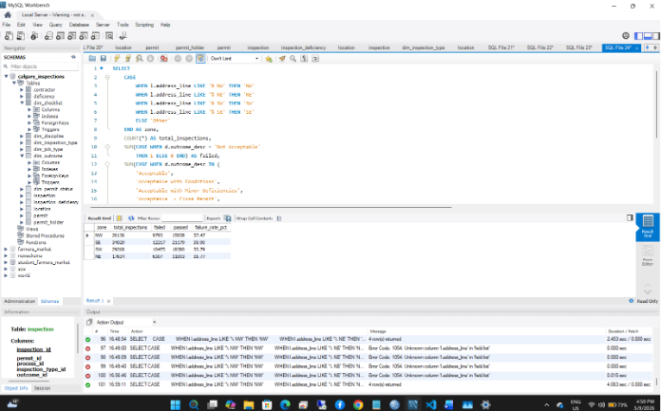
Query 4: Do we have missing GPS coordinates?
Purpose: We had SQL run a query to check for missing latitude and longitude values for all location records as this would be important for our heatmap visualization.
Outcome: Both missing_lat and missing_long returned zero indicating that GPS data is complete, and all permit locations can be visualized.
SQL Query (Missing GPS Coordinates)
SELECT
COUNT(*) AS total_locations,
SUM(CASE WHEN latitude IS NULL
THEN 1 ELSE 0 END) AS missing_lat,
SUM(CASE WHEN longitude IS NULL
THEN 1 ELSE 0 END) AS missing_long
FROM location;

Query 5: Failure Rate by Inspection Type
Purpose: This helps us ascertain if different inspection types have different failure rates. This query will provide evidence as to why inspection type must be controlled for the main analysis.
Outcome: Our findings revealed that failure rates differ significantly across inspection types. But are these differences significant statistically? We shall be investigating this using the appropriate statistical tool. The very high failure rates observed in Gas Final and Gas Rough inspections may reflect stricter safety requirements and the technical complexity associated with gas-related construction work. In contrast, Foundation inspections showed much lower failure rates, suggesting fewer compliance issues during early-stage construction.
Result
inspection_type_desc | total_inspections | failed | failure_rate_pct
Gas Final | 1851 | 1516 | 81.9
Gas Rough | 3899 | 3178 | 81.51
FP Rough | 1436 | 1080 | 75.21
Final | 21535 | 9786 | 45.44
FP Final | 19 | 8 | 42.11
Temp Gas | 54 | 21 | 38.89
Framing | 49785 | 18862 | 37.89
Occupancy | 3881 | 1333 | 34.35
Pub Protect Safety | 3 | 1 | 33.33
Rough | 2428 | 625 | 25.74
Underground | 635 | 147 | 23.15
Progress | 9712 | 1188 | 12.23
Foundation | 11804 | 1045 | 8.85
Site Safety | 25 | 2 | 8
SQL Query (Failure Rate by Inspection)
SELECT
t.inspection_type_desc,
COUNT(*) AS total_inspections,
SUM(CASE WHEN d.outcome_desc = 'Not Acceptable'
THEN 1 ELSE 0 END) AS failed,
ROUND(
SUM(CASE WHEN d.outcome_desc = 'Not Acceptable'
THEN 1 ELSE 0 END)
/ COUNT(*) * 100, 2) AS failure_rate_pct
FROM inspection i
JOIN dim_inspection_type t
ON i.inspection_type_id = t.inspection_type_id
JOIN dim_outcome d ON i.outcome_id = d.outcome_id
GROUP BY t.inspection_type_desc
ORDER BY failure_rate_pct DESC;

1.4 Data Quality Issues, Assumptions and Limitations.
Data Quality issues
- Some outcome values do not represent genuine inspections: The dim_outcome table contains values such as Not Required, Incorrectly Called For, and CSR Skipped. These are administrative values and they do not represent actual inspection outcome. As such, have been excluded from all pass and non pass calculations.
- The permit_deficiencies_flag column is always zero: This field in the inspection table shows 0 for every record in the dataset. It cannot be used to identify failed inspections or the presence of deficiencies. All outcome information must come from the outcome_id joined to dim_outcome.
- Contractor data is mostly missing: The permit table has a contractor_id column but most records do not have a value filled in. Contractor-level comparisons are therefore not possible and are excluded from the scope of this project.
Assumptions
- Outcomes classified as Acceptable, Acceptable with Conditions, Acceptable with Minor Deficiencies, and Acceptable Close Permit are treated as pass outcomes.
- Outcomes classified as Not Acceptable, No Entry, Unable to Enter, and Stop Work are treated as non-pass outcomes.
- Outcomes such as Not Required, Incorrectly Called For, and Cancelled are excluded because they do not represent a genuine inspection result.
- Address zones are derived from the last two characters of the address_line field in the location table and is used as the geographic grouping variable.
- GPS coordinates in the location table are assumed to be accurate and complete, as confirmed through Query 4.

Limitations
- No income or land use data is available in this database, so the analysis cannot explain why geographic differences exist only if they do.
- The main geographic comparison uses an address suffix, which is a broad grouping. Two permits in the same zones can be in different neighborhoods with different characteristics.
- Data provided was from 2000 to 2025, but inspections are concentrated between 2005 – 2023 which simply means findings might not be equally represented across all years.
1.5 Preliminary Observations
After running the exploratory queries above, three observations stood out that were of interest and subsequently served as a direction for our research established in Chapters 2 and 3.
- Inspections are present in all four Zones: Query 2 confirms that records exist in NW, NE, SW and SE Calgary, meaning all four groups can be measured and compared against each other.
- GPS coordinates are complete and usable: Query 4 confirms that latitude and longitude values are present for all location records with no missing values. This means the heatmap visualization in other parts of this project will be produced without any gaps in the geographic data.
- Failure rates vary by inspection type: Query 5 shows that failure rates differ across inspection types. This validates our reason for including inspection type as a control variable as zones with more gas or framing inspections could appear to have a higher failure rate simply because of the type of work being inspected, not because of its location.

Chapter 2: Problem Statement and Research Question
2.1 Problem Statement
The City of Calgary conducts building inspections to ensure that new construction and renovation work meets the standards set out in the Alberta Building Code. When a site visit reveals work that does not meet these standards, the inspection is recorded as a failure, and the contractor is required to correct the problem before construction can continue.
Inspection failures happen across the city, but it is not currently known whether certain areas experience consistently higher failure rates than others. If geographic patterns do exist, they could point to differences in construction complexity, contractor practices, or the volume of development happening in a particular area at a given time. Understanding where failures are concentrated is important because it can help the city allocate inspection resources better, target training where it is needed most, and improve building code compliance across all parts of Calgary.
Our aim is to quantify if inspection failure rates differ significantly across the four geographic zones of Calgary (NW, NE, SW, and SE) and identify which areas, if any, are associated with higher rates of failed inspections.
2.2 Research Question
Do building inspection deficiencies and failed inspections in Calgary show geographic patterns, and are certain areas of the city associated with higher inspection failure rates than others?
2.3 Research Scope
This research investigates inspection outcomes across all four geographic zones of Calgary using the address suffix available in every permit record. The proportion of inspections that result in a non-pass outcome is calculated for each zone and compared to determine whether geographic location is associated with a higher or lower likelihood of inspection failure. GPS coordinates from the location table are used as a supplementary tool to visualize the geographic distribution of failures through a heatmap.
Key elements included
- All inspections with a recorded outcome_id in the dataset.
- Geographic grouping based on the directional address suffix (NW, NE, SW, SE) derived from the address_line field in the location table.
- GPS Data provided (latitude and longitude) from the location table would be used for heatmap visualization.
- Compare inspection failure rates across the four zones.
- Inspection type as a control variable to account for the fact that different types of inspections may have naturally different pass and fail rates.
2.4 Importance of Study
This research is relevant to individuals, groups, and government (institutions and policy makers) that have an interest in Calgary’s residential construction sector.
- For the City of Calgary: our findings would shed more light into areas with high inspection failure rates. This would help the city decide on where to focus on enforcement activity, how to allocate human resources, and where training might be most beneficial.
- For investors and homebuyers: Information on areas with lower inspection failure rates helps reduce investment risk and provides a clearer picture of construction quality across different parts of the city.
- For the research community: This research demonstrates how building inspection data, combined with geographic grouping and GPS coordinates, can be used to identify patterns in construction compliance.

Chapter 3: Research Hypothesis
3.1 Research Hypothesis
In defining our Research question based on the data provided and preliminary assessment done, we were able to formulate a clear hypothesis that inspection failure rates may vary across the different geographic areas identified in the dataset and areas with higher construction activity could experience more failures.
H₀ (Null Hypothesis)
There is no significant difference in inspection failure rate across the four geographic zones of Calgary (NW, NE, SW, and SE).
H₁ (Alternate Hypothesis)
There is a significant difference in inspection failure rates across the four geographic zones of Calgary (NW, NE, SW, and SE).
3.2 Variables and Proposed Test
Dependent variable: Inspection failure rate (Pass vs. Non-Pass): This will be measured as both the count and proportion of failed inspections per zone. An inspection is classified as a non-pass if its outcome_desc is Not Acceptable, No Entry, Unable to Enter, or Stop Work. Outcomes with no genuine inspection results such as Not Required or Cancelled are excluded.
Independent variable: Geographic zones (NW, NE, SW, SE): A categorical grouping variable derived from the directional address suffix in the location table. Each inspection is assigned to a zone based on the last two characters of the address_line field.
Control variable Inspection type: Several inspection types such as foundation, framing, gas or final inspections may have different pass and fail rates regardless of location. If certain zones have a higher concentration of technical inspection types, this could influence its failure rate independently from geographical factors.
Statistical test: To ascertain if inspection failure rates differ significantly across all zones, a Chi-Square Test of Independence will be used as the primary test. This is appropriate because both the outcome variable (pass or non-pass) and the grouping variable (zones) are categorical. A significance level of p < 0.05 will be used.
To account for the control variable, a logistic regression model will be used with geographic zone as the main predictor and inspection type included as a control variable to estimate the odds of failed inspection for each zone while holding inspection types constant.
3.3 Significance Level and Decision Rule
If the null hypothesis is not rejected (p ≥ 0.05): Then the data suggests that building inspection failure rates are roughly the same across NW, NE, SW and SE and any observed differences are within the range of chance variation.
If the null hypothesis is rejected (p < 0.05): Then the data indicates that at least one zone has a statistical difference in failure rate compared to the others.
It is worth noting that both results are valid as our findings aim to solve our research questions through answers provided by our data.
The statistical findings suggest that while geography may influence inspection outcomes, inspection type and construction complexity are also important contributing factors.

Chapter 4 Data Collection and SQL Queries
This chapter documents SQL queries used to extract data needed to address our research question. We ran all queries on MySQL Workbench against the Calgary Building Inspections database and exported our results to a CSV file. We used Python Libraries for all subsequent analysis, modelling, and visualization.
4.1 Data Collection Method
For our data collection, we extracted Address Suffix as Zone, we used the SQL binary encoding to categorize inspection outcomes (Pass =0, Non-Pass=1). We also exported data of inspection type carried out and GPS Coordinates. Using the SQL JOIN function below, we were able to query data from different tables within the database to produce our dataset for analysis. Inspections with administrative outcomes such as Not Required, incorrectly called for, and cancelled were excluded from our data extraction.
SQL Data Extraction Query
SELECT
i.inspection_id,
i.inspection_completed_date,
YEAR(i.inspection_completed_date) AS inspection_year,

-- Geographic zone derived from address suffix
CASE
WHEN l.address_line LIKE '% NW' THEN 'NW'
WHEN l.address_line LIKE '% NE' THEN 'NE'
WHEN l.address_line LIKE '% SW' THEN 'SW'
WHEN l.address_line LIKE '% SE' THEN 'SE'
ELSE 'Other'
END AS zone,

-- GPS coordinates for heatmap visualization
l.latitude,
l.longitude,
l.address_line,

-- Inspection type (control variable)
t.inspection_type_desc,

-- Raw outcome label
d.outcome_desc,

-- Binary outcome: 1 = Non-Pass, 0 = Pass
CASE
WHEN d.outcome_desc IN (
'Not Acceptable',
'No Entry',
'Unable to Enter',
'Stop Work')
THEN 1
WHEN d.outcome_desc IN (
'Acceptable',
'Acceptable with Conditions',
'Acceptable with Minor Deficiencies',
'Acceptable - Close Permit',
'Acceptable Add Inspection')
THEN 0
ELSE NULL
END AS failed

FROM inspection i
JOIN permit p
ON i.permit_id = p.permit_id
JOIN location l
ON p.location_id = l.location_id
JOIN dim_outcome d
ON i.outcome_id = d.outcome_id
JOIN dim_inspection_type t
ON i.inspection_type_id = t.inspection_type_id

-- Exclude non-genuine outcomes
WHERE d.outcome_desc NOT IN (
'Not Required',
'Incorrectly Called For',
'CSR Skipped',
'Cancelled',
'No Inspection Required',
'Void')

-- Exclude records with no zone assignment
AND (
l.address_line LIKE '% NW'
OR l.address_line LIKE '% NE'
OR l.address_line LIKE '% SW'
OR l.address_line LIKE '% SE'
)
ORDER BY i.inspection_completed_date;
4.2 Entity Relationship Diagram for our Dataset
To help understand how each of the tables used in our dataset is related, a five table crowfoot entity relationship model was designed to identify the structure and cardinality of our dataset.

Figure 4.1 Entity Relationship Diagram: Calgary Building Inspections Table Join Structure
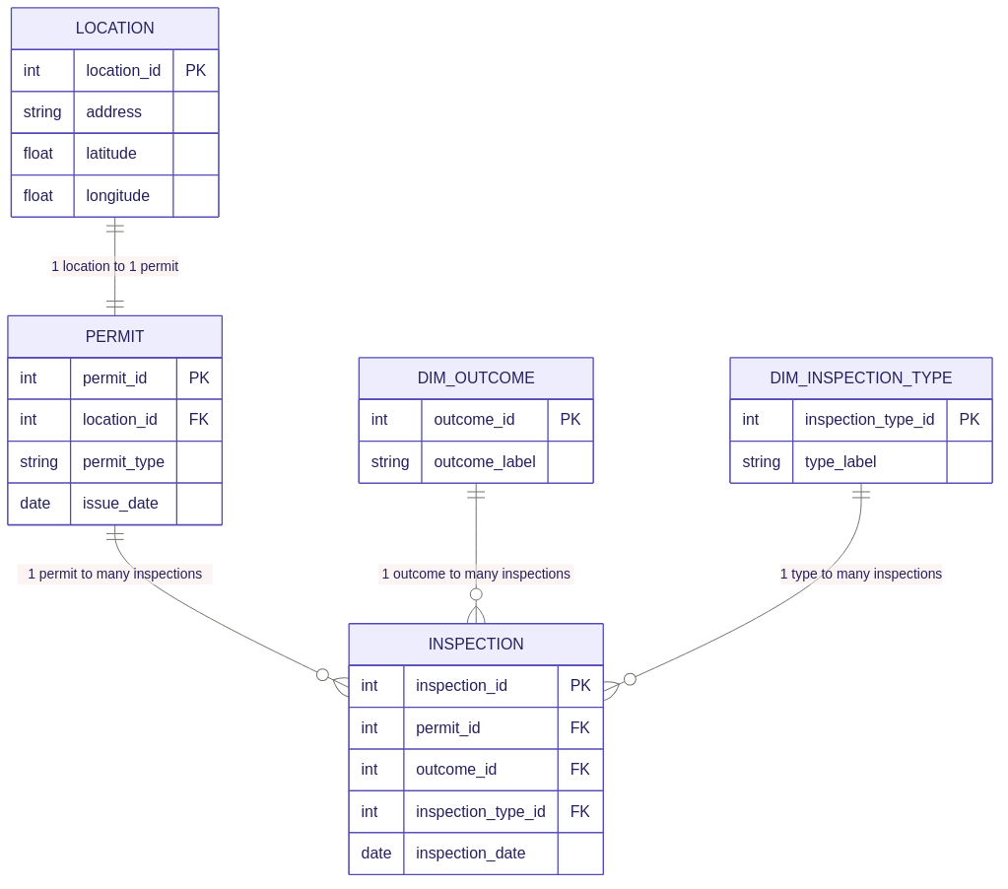
**Adapted from the Calgary Building Inspections MySQL database. Model developed by (Group 1).
4.3 Data Cleaning and Preparation Using Python
Following the export of the dataset from MySQL Workbench in CSV format, we imported our file into Python for preliminary inspection and data cleaning. Initial examination revealed that the dataset has a total of 105,715 rows across 10 columns. Data quality issues such as 6 missing values in inspection_year and inspection_completed_date was ignored because its not necessary for Chi-Test.
Secondly, “Failed” column contained 247 null values from invalid inspection types such as “Not Required, Office Procedure, and CSR Skipped”. Thirdly, the zone column was validated to confirm that all records corresponded to one of the four designated inspection areas.
In addition to cleaning, we converted the “failed” column to INT for the purpose of our regression model used in chapter 7. (See Appendix 4.1: Python Data Exploration and Cleaning Code).

Chapter 5: Data Understanding
5.1 Data Summary
In this chapter, we explored and analyzed the cleaned dataset extracted in chapter 4 with 105,715 inspection records. Our aim is to understand the key metrics, distributions, and patterns in the data before any statistical testing is carried out. The table below summarize our data:
Metric | Value
Source database | Calgary Building Inspections (MySQL)
Tables joined | inspection, permit, location, dim_outcome, dim_inspection_type
Total inspections | Before: 107,067; After Cleaning: 105,715
Excluded outcomes | Not Required, Incorrectly Called For, CSR Skipped, Cancelled, No Inspection Required, Void
Control variable | inspection_type_desc (categorical)
Supplementary columns | latitude, longitude (for heatmap Visualization)
Average failure rate | 36.86%
Number of zones | 4 (NW, NE, SW, SE)
Number of inspection types | 14 (Framing, Final, Foundation, etc.)
Date range | 2000 to 2025 (concentrated in 2005 to 2023)
See Appendix: 5.1 Data Summary
5.2 Geographical Distribution
This section presents the distribution of inspections by zone and evaluates the extent to which noncompliance rates differ across regions.
Zone | Total Inspections | % of Total | Pass | Non-Pass | Failure Rate %
SE | 33,413 | 31.68% | 21,179 | 12,234 | 36.61%
SW | 28,881 | 27.38% | 18,380 | 10,501 | 36.36%
NW | 25,755 | 24.42% | 15,938 | 9,817 | 38.12%
NE | 17,419 | 16.52% | 11,093 | 6,326 | 36.32%
Total | 105,468 | 100% | 66,590 | 38,878 | 36.86%
See Appendix 5.2: Geographical Distribution
The results show that NW zone has the highest non-pass rate at 38.12%, which is 1.26 percentage points above the overall average of 36.86%. The NE zone has the lowest non-pass rate at 36.32%. The SE and SW zones are similar to each other.
5.3 Failure Rate by Inspection Type
In our research, inspection type is the control variable, and so we examined how failure rates vary across the 14 inspection types in the dataset. Our finding shows that inspection failure varies across types. Gas Final (82.4%) and Gas Rough (81.6%) have the highest failure rates, while Foundation (9.8%) and Site Safety (9.5%) have the lowest rates. With over 70 points difference in percentage, inspection types across zones can have a large effect on overall zone failure rate (See Appendix 5.3).
5.4 Inspection Failure Rate By Year
Our findings revealed that inspection activity in Calgary varied considerably between 2000 and 2023. Inspection volumes were relatively low during the early years, with fewer than 120 inspections conducted annually between 2000 and 2004. The highest number of inspections was recorded in 2007, with 10,038 inspections and 4879 failures, followed by 2015 with 9,208 inspections and 2016 with 8,536 inspections (see Appendix 5.4). Overall, the data indicate that periods of increased construction activity were often accompanied by relatively high failure rates. The year 2007 stands out as a particularly significant year, recording both the highest inspection volume (10,038 inspections) and the highest failure rate (48.61%).
5.5 Findings from Data
The exploratory analysis revealed important patterns and trends within the dataset that will support the development and interpretation of our models. Key findings include:
- The overall failure rate is 36.86%: One in three inspections across Calgary results in a non-pass outcome.
- The NW zone has the highest failure rate: At 38.12%, the NW zone sits 1.26 percentage points above the overall average and 1.80 percentage points above the lowest zone, NE, at 36.32%.
- Inspection types varies extremely in failure rates: Gas related inspections fail at over 80% while Foundation and Site Safety inspections fail at under 10%. This 70-point range confirms that inspection type must be controlled in the regression model.
- Framing dominates the dataset: Framing inspections account for 47.1% of all records which is 49,678 out of 105,468 inspections recorded. he concentration of Framing inspections across zones may influence zone-level failure rates and is accounted for by including inspection type as a control variable in the regression model in Chapter 7.
- Declining trend: Failure rates peaked at 43.2% in 2018 before declining steadily to approximately 27% by 2023, suggesting improving compliance in recent years.

Chapter 6: Data Visualization
Four visualizations were produced based on our findings from the previous chapter using Python (matplotlib, seaborn, and folium). Each addresses a distinct aspect of the research question.
6.1 Failure Rate by Zone
Figure 1 shows the inspection failure across all four zone against the overall average of 36.86%. The NW zone has the highest failure rate at 38.12% which is 1.26 percentage points above the overall average. SE, SW, and NE cluster tightly between 36.32% and 36.61%.
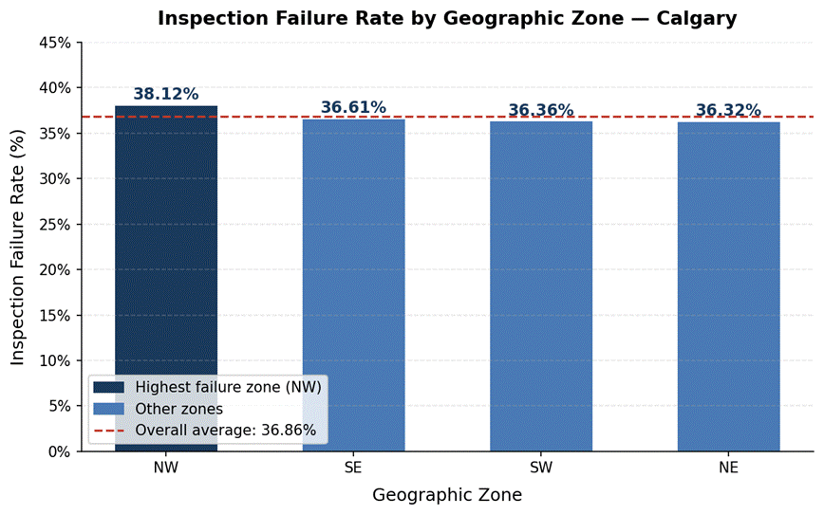
Figure 1: Inspection failure rate by zone. Dashed line = overall average (36.86%).
6.2 Pass vs Non-Pass by Zone
Figure 2 shows the absolute counts of pass and non-pass inspections per zone as a stacked bar chart. SE has the most inspections overall at 33,413 while NE has the fewest at 17,419. Despite this volume difference, NW still shows the highest non-pass proportion at 38.1%, confirming that elevated failure rate is proportional and not a volume effect. The similar proportions across all four zones suggest that zone-level differences in failure rates are modest, reinforcing the need for statistical testing to determine whether observed differences are significant.

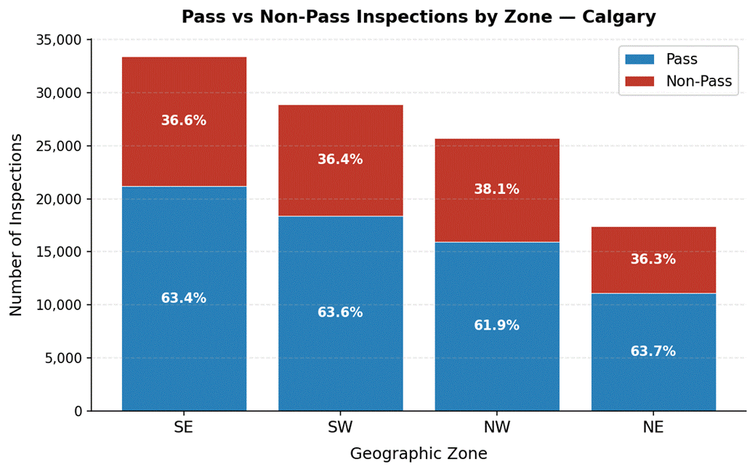
Figure 2: Stacked bar showing pass (blue) and non-pass (red) counts by zone. Percentages show each outcome's proportion within the zone.
6.3 Failure Rate by Inspection Type
Figure 3 shows failure rates across all 14 inspection types. Gas Final and Gas Rough have the highest failure rates while Foundation (9.79%) and Site Safety (9.52%) has the lowest rates. For this reason, we would use the inspection type as a control in our logistic regression model, as zones with more gas related inspections would have a higher failure rate.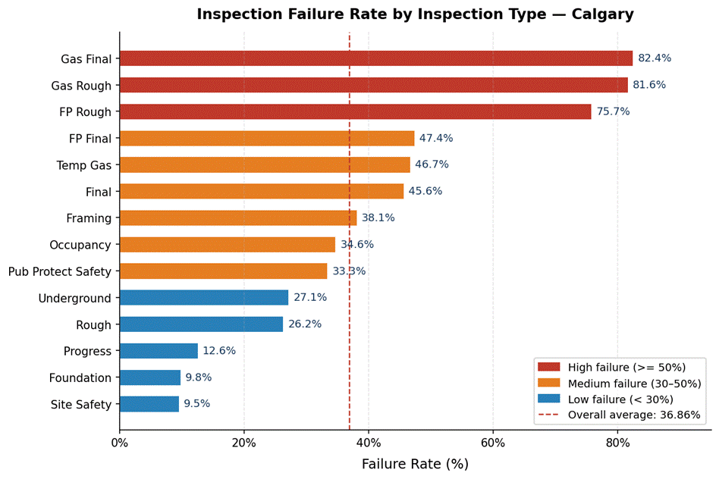
Figure 3: Failure rate by inspection type.
6.4 Temporal Trends in Inspection Volume and Failure Rates
Figure 4 shows how inspection volume and failure rates changed across Calgary from 2003 to 2023. Two metrics were plotted on the same chart using dual y-axes. The blue line tracks the total number of inspections per year on the left axis, while the red line tracks the failure rate percentage on the right axis.
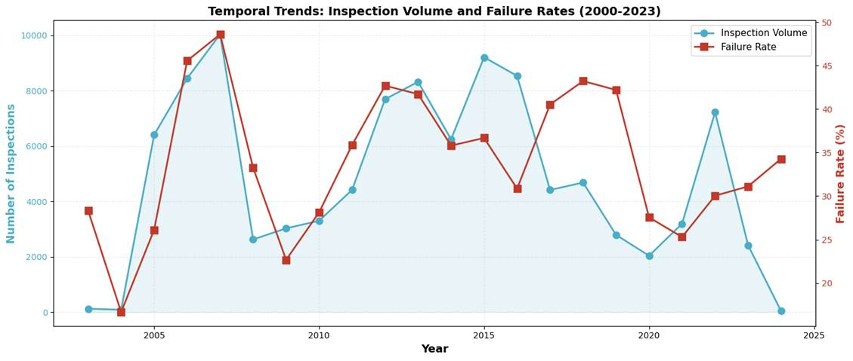
Figure 4: Inspection volume (blue, left axis) and failure rate percentage (red, right axis) from 2003 to 2023.
The chart reveals that Inspection volume peaked in 2007 at 10,038 before crashing to 2,624 in 2008 following the global financial crisis. A second peak of 9,208 occurred in 2015, with volume reaching 7,220 in 2022 before falling to 2,420 in 2023.
Failure rates do not mirror volume trends. The highest rate (48.61%) occurred during the 2007 boom, while the lowest (16.67%) was recorded in 2004. Between 2012 and 2019, failure rates remained persistently elevated (35–43%) despite fluctuating volumes, indicating that failure rates reflect construction quality and inspection standards rather than inspection frequency alone.
6.5 Geographic Distribution of Inspections Across Calgary Zones
Figure 5 maps a random sample of 10,000 inspections by GPS coordinates, colour coded by zone (blue = NW, red = NE, amber = SW, green = SE). Circles represent passed inspections and crosses represent failures. Two black reference lines mark Calgary's north to south (51.047°N), and east to west (−114.057°) quadrant boundaries
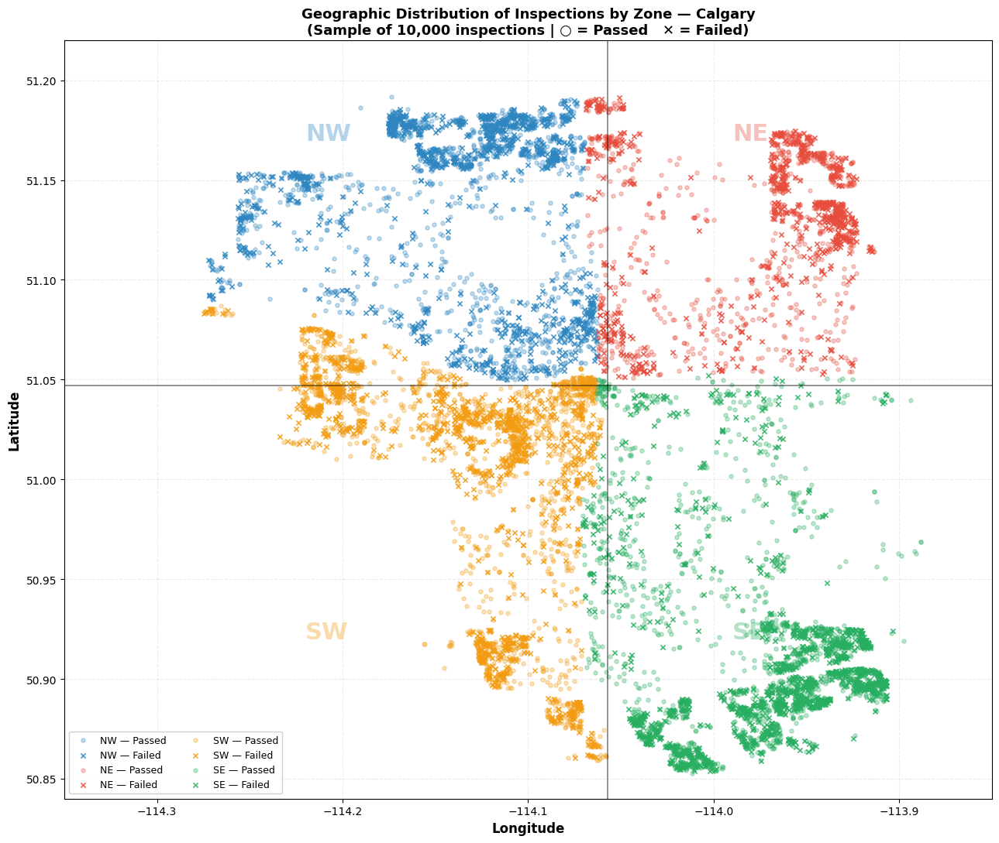
Figure 5: Geographic distribution of 10,000 random sampled inspections across Calgary zones. Circles (○) = passed inspections. Crosses (✕) = failed inspections. Zone boundaries shown by black reference lines.
Interpretation
The map shows that inspections are not evenly spread across the geographic area of Calgary. Southern zones (SE, SW) show a wider geographic spread reflecting newer suburban expansion, while northern zones cluster more tightly. Failed inspections are distributed throughout each zone rather than concentrated in specific sub-areas, confirming that failure is not location-specific within zones
The geographic boundaries between zones marked by the two black reference lines aligns closely with where the color of points changes, confirming that the address based zone assignment used throughout this analysis is geographically accurate and consistent with the actual GPS coordinates of each permit site.
6.6 Summary
- NW zone has the highest failure rate at 38.12% to a 1.26 percentage points above the overall average. The other three zones cluster between 36.32% and 36.61%.
- Inspection type variation is far greater than zone variation: a 70-point range across types versus a 1.80-point range across zones, reinforces the need to control for inspection type.
- Failed inspections are distributed throughout each zone rather than concentrated in specific sub-areas, confirming that failure is not location specific within zones. However, the NW zone shows a visibly higher density of failures consistent with its elevated failure rate.

Chapter 7: Model Building
7.1 Data Preparation for Modeling
This section describes the preprocessing steps undertaken to prepare the Calgary Building Inspections dataset for predictive modeling. The final dataset used for modeling contains105,468 inspection records. Each record represents a single inspection event, with the target variable failed coded as 0 (Pass) or 1 (Non-Pass) and an overall failure rate of 36.86%.
One-Hot Encoding
Since both predictor variables (zone and inspection_type_desc) are categorical, one-hot encoding was applied to convert them into a numerical format suitable for machine learning algorithms. The NE (Northeast) zone was selected as the reference category because it exhibited the lowest failure rate (36.32%) among all four zones. For inspection types, Foundation was used as the reference category. This encoding produced 16 binary features in total:
Train-Test Split
A 70/30 train-test split was applied using stratified sampling to maintain the same proportion of failed inspections records of 36.86%.
7.2 Chi-Square Test of Independence
The Chi-Square Test of Independence was conducted to test whether inspection failure rates are independent of geographic zone. A contingency table was constructed showing the frequency of pass and non-pass outcomes across all four zones. The Chi-Square statistic was then calculated by comparing observed frequencies against expected frequencies under the assumption of independence. The significance level (α) was set at 0.05.
Figure 7.1 shows the contingency table used in this analysis.
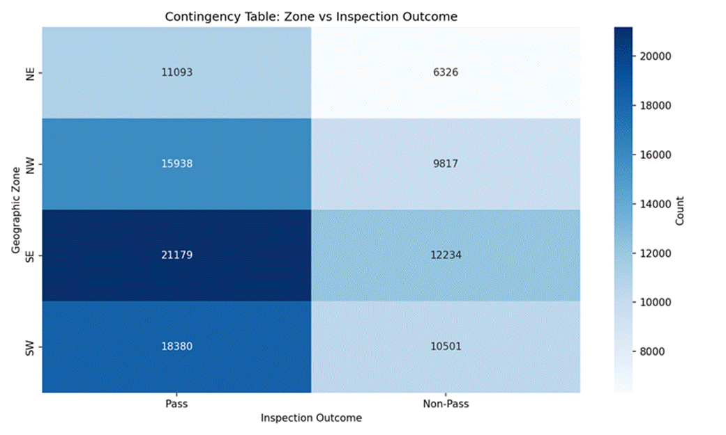
Figure 7.1: Chi-Square Contingency Table – Zone vs. Inspection Outcome

7.3 Logistic Regression Model
Logistic Regression was selected as the primary predictive model due to its interpretability and suitability for binary classification. The model estimates the probability of inspection failure based on geographic zone and inspection type.
Table 7.2: Logistic Regression Configuration
Parameter | Value
Algorithm | Logistic Regression (scikit-learn)
Maximum Iterations | 1,000
Features | 16 one-hot encoded variables
Reference Category | NE zone / Foundation inspection type
Table 7.3: Key Logistic Regression Coefficients and Odds Ratios
Feature | Coefficient | Odds Ratio | Interpretation
Gas Final | +1.8443 | 6.32 | 6.3× higher odds of failure vs Foundation
Gas Rough | +1.7852 | 5.96 | 6.0× higher odds of failure
FP Rough | +1.4945 | 4.46 | 4.5× higher odds of failure
Progress | −1.6471 | 0.19 | 80.7% lower odds of failure
Foundation (ref.) | −1.9349 | 0.14 | Lowest-risk inspection type
zone_NW (vs NE) | −0.0118 | 0.99 | 1.2% lower odds – not significant
zone_SE (vs NE) | +0.0259 | 1.03 | 2.6% higher odds – not significant
zone_SW (vs NE) | −0.0299 | 0.97 | 3.0% lower odds – not significant

7.4 Model Selection Justification
The two modeling approaches were selected to provide complementary perspectives on the research question:
- Chi-Square Test of Independence: Directly addresses the hypothesis by testing whether zone and failure outcome are statistically independent, without assuming a functional form.
- Logistic Regression: The standard approach for binary classification with categorical predictors; interpretable odds ratios quantify the zone effect while controlling for inspection type.
Together, the Chi-Square test establishes statistical significance while Logistic Regression quantifies the magnitude of the zone effect through odds ratios, providing both a hypothesis decision and a practical interpretation of the findings.

Chapter 8: Model Evaluation

8.1 Evaluation Methodology
All predictive models were evaluated on the held-out test set (31,641 records, 30% of data) to assess generalization to unseen observations. The following metrics were used:
- Accuracy: Proportion of correct predictions across both pass and non-pass outcomes.
- Precision: Of all inspections predicted to fail, the proportion that actually failed.
- Recall: Of all actual failures, the proportion correctly identified by the model.
- F1-Score: Harmonic mean of precision and recall, balancing both concerns.
- AUC-ROC: Area under the Receiver Operating Characteristic curve, measuring discrimination ability independent of the classification threshold.

8.2 Chi-Square Test Results
The Chi-Square Test of Independence produced the following results:
Table 8.1: Chi-Square Test Results
Metric | Value
Chi-Square Statistic | 23.6637
Degrees of Freedom | 3
P-value | 2.94 × 10⁻⁵
Cramér's V (effect size) | 0.0150
Table 8.2: Observed Inspection Outcomes by Zone
Zone | Pass | Non-Pass | Total | Failure Rate
NE | 11,093 | 6,326 | 17,419 | 36.32%
NW | 15,938 | 9,817 | 25,755 | 38.12%
SE | 21,179 | 12,234 | 33,413 | 36.61%
SW | 18,380 | 10,501 | 28,881 | 36.36%
Figure 8.1 presents the observed versus expected frequencies for each zone under the null hypothesis of independence.
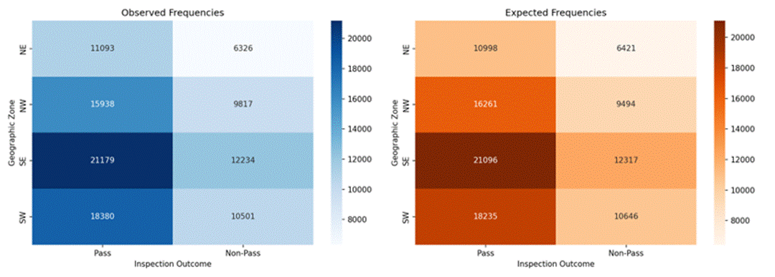
Figure 8.1: Chi-Square – Observed vs. Expected Frequencies by Zone
Decision: Since the p-value (2.94 × 10⁻⁵) is less than α = 0.05, we REJECT the Null Hypothesis (H₀). There is a statistically significant association between geographic zone and inspection failure rates in Calgary.
However, Cramér's V = 0.015 indicates a very small practical effect. The difference between the highest (NW: 38.12%) and lowest (NE: 36.32%) failure rates is only 1.8 percentage points. Statistical significance here is partly a function of the large sample size (n = 105,468), which provides high power to detect even negligible effects.

8.3 Logistic Regression Performance
Table 8.3: Logistic Regression – Performance Metrics
Metric | Value
Training Accuracy | 67.34%
Test Accuracy | 67.19%
Precision | 80.00%
Recall | 14.68%
F1-Score | 24.80%
AUC-ROC | 67.58%
Figure 8.2 shows the confusion matrix for Logistic Regression on the test set. The model correctly classified 19,549 passes and 1,712 failures, but missed 9,952 actual failures (false negatives), reflecting the low recall score.
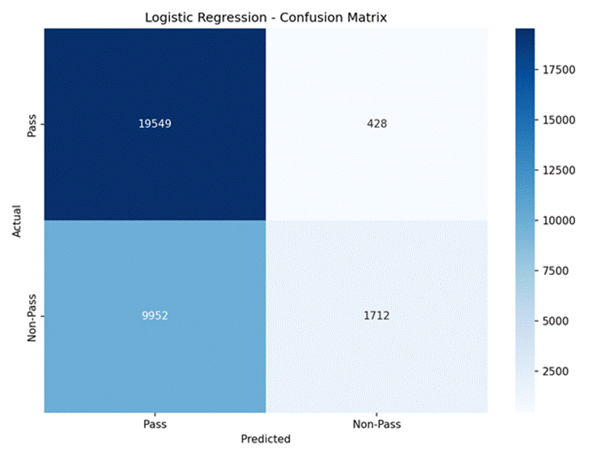
Figure 8.2: Logistic Regression – Confusion Matrix (Test Set)

High precision (80%) combined with low recall (14.7%) indicates the model is conservative: when it predicts failure it is usually correct, but it fails to flag the large majority of actual failures. This precision-recall tradeoff stems from the class imbalance (37% failures) and the limited discriminative power of zone and inspection type alone.

8.4 Interpretation of Findings
Hypothesis Testing Conclusion
Based on the Chi-Square Test of Independence results, we reject the Null Hypothesis (H₀). The statistical evidence (p = 2.94 × 10⁻⁵ < 0.05) confirms that there is a significant association between geographic zone and inspection failure rates in Calgary. Accordingly, the Alternate Hypothesis (H₁) is supported.
However, the magnitude of this association must be considered carefully. Cramér's V = 0.015 is conventionally interpreted as a negligible effect size. The practical difference between zones is just 1.8 percentage points (NW: 38.12% versus NE: 36.32%). Statistical significance here is in large part a consequence of the large sample size (n = 105,468) rather than evidence of a strong geographic effect.
Dominant Predictor: Inspection Type
The Logistic Regression model confirms that inspection type is a far stronger predictor of failure than geographic zone. Gas-related inspections (Gas Final and Gas Rough) carry odds of failure approximately 6 times higher than Foundation inspections, the reference category. Zone coefficients are close to zero and statistically non-significant, indicating that location adds virtually no predictive power beyond what inspection type already captures.

8.5 Limitations and Implications
Hypothesis Testing Conclusion
Based on the Chi-Square Test of Independence results, we reject the Null Hypothesis (H₀). The statistical evidence (p = 2.94 × 10⁻⁵ < 0.05) confirms that there is a significant association between geographic zone and inspection failure rates in Calgary. Accordingly, the Alternate Hypothesis (H₁) is supported.
However, the magnitude of this association must be considered carefully. Cramér's V = 0.015 is conventionally interpreted as a negligible effect size. The practical difference between zones is just 1.8 percentage points (NW: 38.12% versus NE: 36.32%). Statistical significance here is in large part a consequence of the high-powered large sample (n = 105,468) rather than evidence of a strong geographic effect.

Dominant Predictor: Inspection Type
Across all three predictive models, inspection type accounts for over 99% of feature importance, while geographic zone contributes less than 1%. Gas-related inspections (Gas Final and Gas Rough) carry odds of failure approximately 6 times higher than Foundation inspections, the reference category. This finding holds consistently whether assessed through logistic regression odds ratios or tree-based feature importance rankings.

8.8 Limitations and Implications
Model Limitations
- Low recall (14.7%): The models fail to identify approximately 85% of actual failures, making them unsuitable as a standalone tool for flagging at-risk inspections.
- Class imbalance: With only 37% of inspections failing, models are biased toward predicting passes, inflating accuracy while suppressing recall.
- Limited features: Only zone and inspection type were available. Contractor quality, project complexity, weather conditions, and seasonal patterns were not captured.
- Coarse geographic grouping: The four quadrant zones are broad. Sub-neighbourhood or ward-level patterns may exist but were not examined.
Implications for the City of Calgary
While NW exhibits a statistically higher failure rate, the 1.8 percentage point difference from NE is unlikely to justify differential resource allocation based on geography alone. The findings suggest the following practical priorities:
- Focus inspection scrutiny on inspection type, not location. Gas-related inspections should receive closer review regardless of zone.
- Foundation and Progress inspections consistently show low failure rates and may be candidates for streamlined review processes.
- Geographic zone-specific interventions are not supported by the current evidence given the negligible effect size.
Recommendations for Future Research
- Collect additional predictive features including contractor history, project value, construction stage, and weather conditions at the time of inspection.
- Conduct neighbourhood-level analysis within each zone to identify more granular geographic risk patterns.
- Explore temporal patterns and seasonality effects on inspection outcomes over the 2000–2025 study period.
- Investigate potential interaction effects between inspection type and zone that may reveal location-specific risk factors.

Appendix

4.2 Python Data Exploration and Cleaning Code
import pandas as pd

# Load the exported CSV file
df = pd.read_csv('dataset/calgary_inspection_clean.csv')

# Confirm the shape of the dataset
print('Rows:', df.shape[0])
print('Columns:', df.shape[1])
print()

# Preview the first five rows
print(df.head())
print()

# Check column data types
print(df.dtypes)
print()

# Check for any remaining NULL values
print('Missing values per column:')
print(df.isnull().sum())
print()

# Confirm zone distribution
print('Inspections per zone:')
print(df['zone'].value_counts())
print()

# Confirm outcome distribution
print('Pass vs Non-Pass:')
print(df['failed'].value_counts())
Data Cleaning
# Step 1: Check for NULL values in the failed column
print('NULL in failed column:', df['failed'].isnull().sum())
print()
print('Outcomes causing NULL in failed:')
print(df[df['failed'].isnull()]['outcome_desc'].value_counts())

# Remove rows where failed is NULL
df = df[df['failed'].notnull()]
print('Rows after Step 1:', len(df))

# Step 2: Check for Other zone records
print('Other zone rows:', (df['zone'] == 'Other').sum())

# Remove Other zone rows (none found, but applied for safety)
df = df[df['zone'] != 'Other']
print('Rows after Step 2:', len(df)) # 105,468

# Step 3: Convert failed column to integer
# Column loaded as float64 (1.0, 0.0) — convert to int (1, 0)
df['failed'] = df['failed'].astype(int)
print('failed dtype after Step 3:', df['failed'].dtype) # int64

# Step 4: Convert date column to datetime
df['inspection_completed_date'] = pd.to_datetime(
df['inspection_completed_date'], errors='coerce')
print('NULL dates after conversion:',
df['inspection_completed_date'].isnull().sum()) # 6

# Step 5: Confirm final dataset
print()
print('=== FINAL DATASET SUMMARY ===')
print('Total rows: ', len(df))
print('Zones present: ', sorted(df['zone'].unique()))
print('Failed values: ', df['failed'].unique())
print('Pass count: ', (df['failed'] == 0).sum())
print('Non-pass count: ', (df['failed'] == 1).sum())
print('Overall fail rate: ',
round(df['failed'].mean() * 100, 2), '%')
5.2 Geographical Distribution
# Zone distribution with pass and fail counts
zone_stats = df.groupby('zone').agg(
total=('failed', 'count'),
passed=('failed', lambda x: (x == 0).sum()),
failed=('failed', lambda x: (x == 1).sum())
).reset_index()

zone_stats['failure_rate_pct'] = round(
zone_stats['failed'] / zone_stats['total'] * 100, 2)
zone_stats['pct_of_total'] = round(
zone_stats['total'] / len(df) * 100, 2)

print(zone_stats.sort_values('total', ascending=False).to_string())

5.3 Failure Rate by Inspection Type
# Failure rate by inspection type
type_stats = df.groupby('inspection_type_desc').agg(
total=('failed', 'count'),
failed=('failed', 'sum')
).reset_index()
type_stats['failure_rate_pct'] = round(
type_stats['failed'] / type_stats['total'] * 100, 2)
type_stats = type_stats.sort_values(
'failure_rate_pct', ascending=False)
print(type_stats.to_string())
5.4 Inspection Failure Rate By Year
# Inspections and failure rate by year
df['year'] = df['inspection_completed_date'].dt.year
year_stats = df[df['year'].notnull()].groupby('year').agg(
total=('failed', 'count'),
failed=('failed', 'sum')
).reset_index()
year_stats['failure_rate_pct'] = round(
year_stats['failed'] / year_stats['total'] * 100, 2)
year_stats['year'] = year_stats['year'].astype(int)
print(year_stats.to_string())
6.1 Inspection Failure Rate by Zone
import pandas as pd
import matplotlib.pyplot as plt
import matplotlib.patches as mpatches

# Zone failure rates
zone_stats = df.groupby('zone').agg(
total=('failed', 'count'),
failed=('failed', 'sum')
).reset_index()
zone_stats['failure_rate'] = (
zone_stats['failed'] / zone_stats['total'] * 100)
zone_stats = zone_stats.sort_values('failure_rate', ascending=False)

overall = df['failed'].mean() * 100
zones = zone_stats['zone'].tolist()
rates = zone_stats['failure_rate'].tolist()
colors = ['#1a3a5c' if z == 'NW' else '#4a7ab5' for z in zones]

fig, ax = plt.subplots(figsize=(8, 5))
bars = ax.bar(zones, rates, color=colors, width=0.55)
ax.axhline(y=overall, color='#c0392b', linestyle='--', linewidth=1.5)

for bar, rate in zip(bars, rates):
ax.text(bar.get_x() + bar.get_width()/2,
bar.get_height() + 0.2, f'{rate:.2f}%',
ha='center', fontsize=11, fontweight='bold')

ax.set_xlabel('Geographic Zone')
ax.set_ylabel('Inspection Failure Rate (%)')
ax.set_title('Inspection Failure Rate by Geographic Zone')
plt.tight_layout()
plt.savefig('chart1_failure_rate_by_zone.png', dpi=150)

