PESTEL Analysis of Canada’s E-Commerce & Retail Sector
Part 2: Final Analytical Report

University of Niagara Falls Canada
Master of Data Analytics
Group 6
September 2026

Contents
Executive Summary 3
1. Methodology 4
1.1 Data Scope and PESTEL Design 4
1.2 Data Preparation and Derived Measures 4
1.3 Missing Values, Imputation and Outlier Policy 4
1.4 Statistical Methods 4
2. Data Quality and Analytical Safeguards 5
3. Analysis and Results: Sector Trend 6
4. Analysis and Results: Regime Comparison 7
5. Economic PESTEL Relationships 9
6. Supporting Explanatory Regression 11
7. Social and Technological PESTEL Results 12
8. Environmental Impact Analysis: Risks and Opportunities 13
9. Strategic Insights and Recommendations 14
9.1 Use normalized growth for capacity and investment planning 14
9.2 Build an inflation-sensitive commercial strategy 14
9.3 Treat consumer confidence as an early-warning indicator 14
9.4 Compete on experience rather than digital access 14
9.5 Align fulfillment with demographic and urban growth 14
9.6 Institutionalize PESTEL monitoring 14
10. Limitations 15
11. Future Improvements 15
12. Conclusion 15
References 17
Appendix A. Reproducibility Note 18

Executive Summary
This report evaluates how Economic, Social, and Technological PESTEL factors shaped Canada’s retail e-commerce sector from January 2017 through December 2025. The analysis uses the consolidated Part 1 dataset, containing 108 monthly observations, and applies descriptive statistics, trend analysis, period comparisons, correlation analysis, and a supporting explanatory time-series regression. The analytical design deliberately separates monthly Economic indicators from annual Social and Technological indicators when statistical independence requires it.
The clearest finding is the structural expansion of Canadian e-commerce. Annual retail e-commerce sales increased from approximately CAD 15.76 billion in 2017 to CAD 59.24 billion in 2025. This represents an increase of roughly 276% and a compound annual growth rate of about 18.0%. E-commerce sales per capita increased by about 230%, substantially faster than the approximately 14.0% increase in Canada’s population. The sector is therefore not simply larger because Canada has more people; online retail activity per resident also increased substantially.
The growth path, however, was highly uneven. The pandemic created an exceptional digital acceleration, with 2020 annual e-commerce sales increasing by approximately 75%. That surge was followed by a normalization phase: annual sales declined by about 8.6% in 2022 before recovering by 27.7% in 2024. Growth slowed again to about 2.9% in 2025. These results show that the pandemic caused a durable level shift in online retail, but its extraordinary growth rate is not an appropriate long-run planning benchmark.
Inflation emerged as an important Economic risk signal. CPI inflation reached 8.1% year over year in June 2022, while the 2022–2023 inflation and normalization period recorded the weakest e-commerce growth of the four analytical regimes. Spearman correlation shows a strong negative full-period association between inflation and e-commerce YoY growth. Consumer confidence is positively associated with e-commerce growth after the exceptional pandemic period is separated, making it useful as a monitoring indicator even though it does not remain independently significant in the multivariable time-series model.
Social and Technological factors point to a more mature digital market. Canada’s population increased materially and its urban population share rose by approximately 1.47 percentage points, expanding the addressable market and supporting denser fulfillment networks. At the same time, internet use and mobile subscriptions remained very high and close to saturation. Future e-commerce growth is therefore less likely to come from bringing consumers online for the first time and more likely to depend on conversion, retention, mobile experience, value positioning, fulfillment performance, and customer experience.
Table 1. Executive evidence and strategic meaning
Evidence | Strategic meaning
2017–2025 e-commerce CAGR ≈ 18.0% | E-commerce is structurally larger and should remain a core retail capability.
2020 annual growth ≈ 75%; 2022 annual growth ≈ −8.6% | Pandemic growth should not be extrapolated as the normal baseline.
Inflation peaked at 8.1% YoY in June 2022 | Purchasing-power pressure and price sensitivity are material external risks.
Population +14.0%; urban share +1.47 pp | A larger and more urban market supports customer-base and fulfillment expansion.
Internet/mobile access remained very high | Competitive advantage shifts from access to customer experience, conversion and retention.

1. Methodology

1.1 Data Scope and PESTEL Design
The analysis retains the three PESTEL dimensions selected in Part 1: Economic, Social, and Technological. Canada is the consistent national unit of analysis. The study period covers January 2017 through December 2025, providing nine complete calendar years and 108 monthly rows in the consolidated dataset.
Table 2. Analytical variables by PESTEL dimension
PESTEL | Variables used | Analytical role
Economic | CPI index, CPI YoY/MoM, Consumer Confidence Index, HFCE, e-commerce sales | Short-run demand, purchasing power, sentiment and spending conditions
Social | Total population, urban population, urban share | Addressable market size and urban concentration
Technological | Mobile subscriptions per 100, internet users % | Digital access and technology maturity

The Part 1 integration strategy combined monthly Economic series with annual Social and Technological series. Annual indicators were repeated across the twelve months of each year so that a consolidated monthly dataset could be created. This structure is retained for consistency, but the Part 2 analysis does not treat those repeated annual values as independent monthly observations. Social and Technological statistics are therefore evaluated in an annual analytical view.

1.2 Data Preparation and Derived Measures
The source dataset is not overwritten. Analytical variables are derived in memory in the Jupyter notebook. E-commerce sales are expressed in CAD millions for reporting, while year-over-year growth is calculated to reduce seasonal effects and avoid misleading correlations between upward-trending level series. Additional measures include inflation-adjusted e-commerce sales, HFCE YoY growth, e-commerce sales per capita, and consumer-confidence changes.
Four contextual periods are used to organize the results: pre-pandemic (2017–2019), pandemic acceleration (2020–2021), inflation and normalization (2022–2023), and the recent environment (2024–2025). These regimes are not assumed to be causal by themselves; they are used to interpret major macroeconomic shifts that are visible in the data.

1.3 Missing Values, Imputation and Outlier Policy
The consolidated dataset contains no missing values after Part 1 preparation. However, absence of missingness does not mean every value is directly observed. The Part 1 documentation states that HFCE for July–December 2025 was imputed using an OLS time-and-season model, while 2025 mobile subscriptions and internet use were forward-filled from 2024. These values are retained in the dataset but are explicitly treated as imputed observations in interpretation and sensitivity analysis.
Potential outliers are screened using the 1.5 × IQR rule. Outliers are not deleted automatically. The 2022 inflation spike and pandemic-era e-commerce growth are genuine external shocks and are analytically important. Robust and non-parametric methods are therefore preferred where assumption tests indicate non-normality or unequal variances.

1.4 Statistical Methods
- Descriptive statistics: mean, median, standard deviation, range and coefficient of variation.
- Trend analysis: monthly trajectories, annual totals, annual growth, CAGR, inflation-adjusted growth and per-capita e-commerce sales.
- Period comparisons: Shapiro–Wilk and Levene diagnostics, followed by Kruskal–Wallis and Holm-adjusted pairwise Mann–Whitney tests because normality and equal-variance assumptions are not satisfied.
- Relationship analysis: Pearson and Spearman correlations, with Spearman emphasized when shocks and non-normality are present.
- Supporting explanatory regression: e-commerce YoY growth as the dependent variable, with lagged e-commerce growth, inflation, confidence, HFCE growth and a pandemic indicator. HAC/Newey–West standard errors are used to reduce the impact of serial correlation and heteroskedasticity on inference.
The analysis is designed to support environmental interpretation and strategic decision-making. It does not claim causal identification and does not use advanced predictive or machine-learning methods.

2. Data Quality and Analytical Safeguards
The notebook begins with date-range, duplicate, missing-value, and type checks. It also verifies that annual Social and Technological variables have only one distinct value within each calendar year, confirming that their monthly repetition is an integration device rather than monthly measurement. The derived urban-population percentage is rechecked against Urban Population ÷ Total Population × 100 for internal consistency.
Table 3. Outlier-screen summary
Variable | IQR outliers | Interpretation / treatment
CPI YoY % | 10 of 108 | Concentrated in the 2022 high-inflation episode; retained as genuine macroeconomic shock.
CPI MoM % | 5 of 108 | Includes unusually large monthly price movements around major shocks; retained.
Consumer Confidence | 0 | No IQR outliers.
HFCE level | 0 | No IQR outliers in the level series.
E-commerce sales level | 0 | No IQR outliers in nominal sales levels.
E-commerce YoY growth | 11 of 96 | Concentrated around pandemic acceleration and normalization; retained as substantive events.

This treatment is important for a PESTEL case study. Removing the largest shocks simply because they are statistically unusual would suppress the environmental events that decision-makers need to understand. The analytical response is therefore to preserve the observations and use methods that are less sensitive to distributional violations.
A second safeguard concerns common time trends. Raw e-commerce sales, population, CPI, and HFCE all rise over much of the sample. Large correlations among their levels can therefore be driven by time rather than by a substantive relationship. The main Economic relationship analysis uses year-over-year growth and confidence levels rather than relying on simple level-to-level correlations.
A third safeguard concerns mixed frequencies. The monthly consolidated dataset is retained for the Economic analysis and dashboard continuity, but annual Social and Technological variables are collapsed to one observation per year for statistical interpretation. This prevents an annual number repeated twelve times from creating an artificial monthly sample size.

3. Analysis and Results: Sector Trend
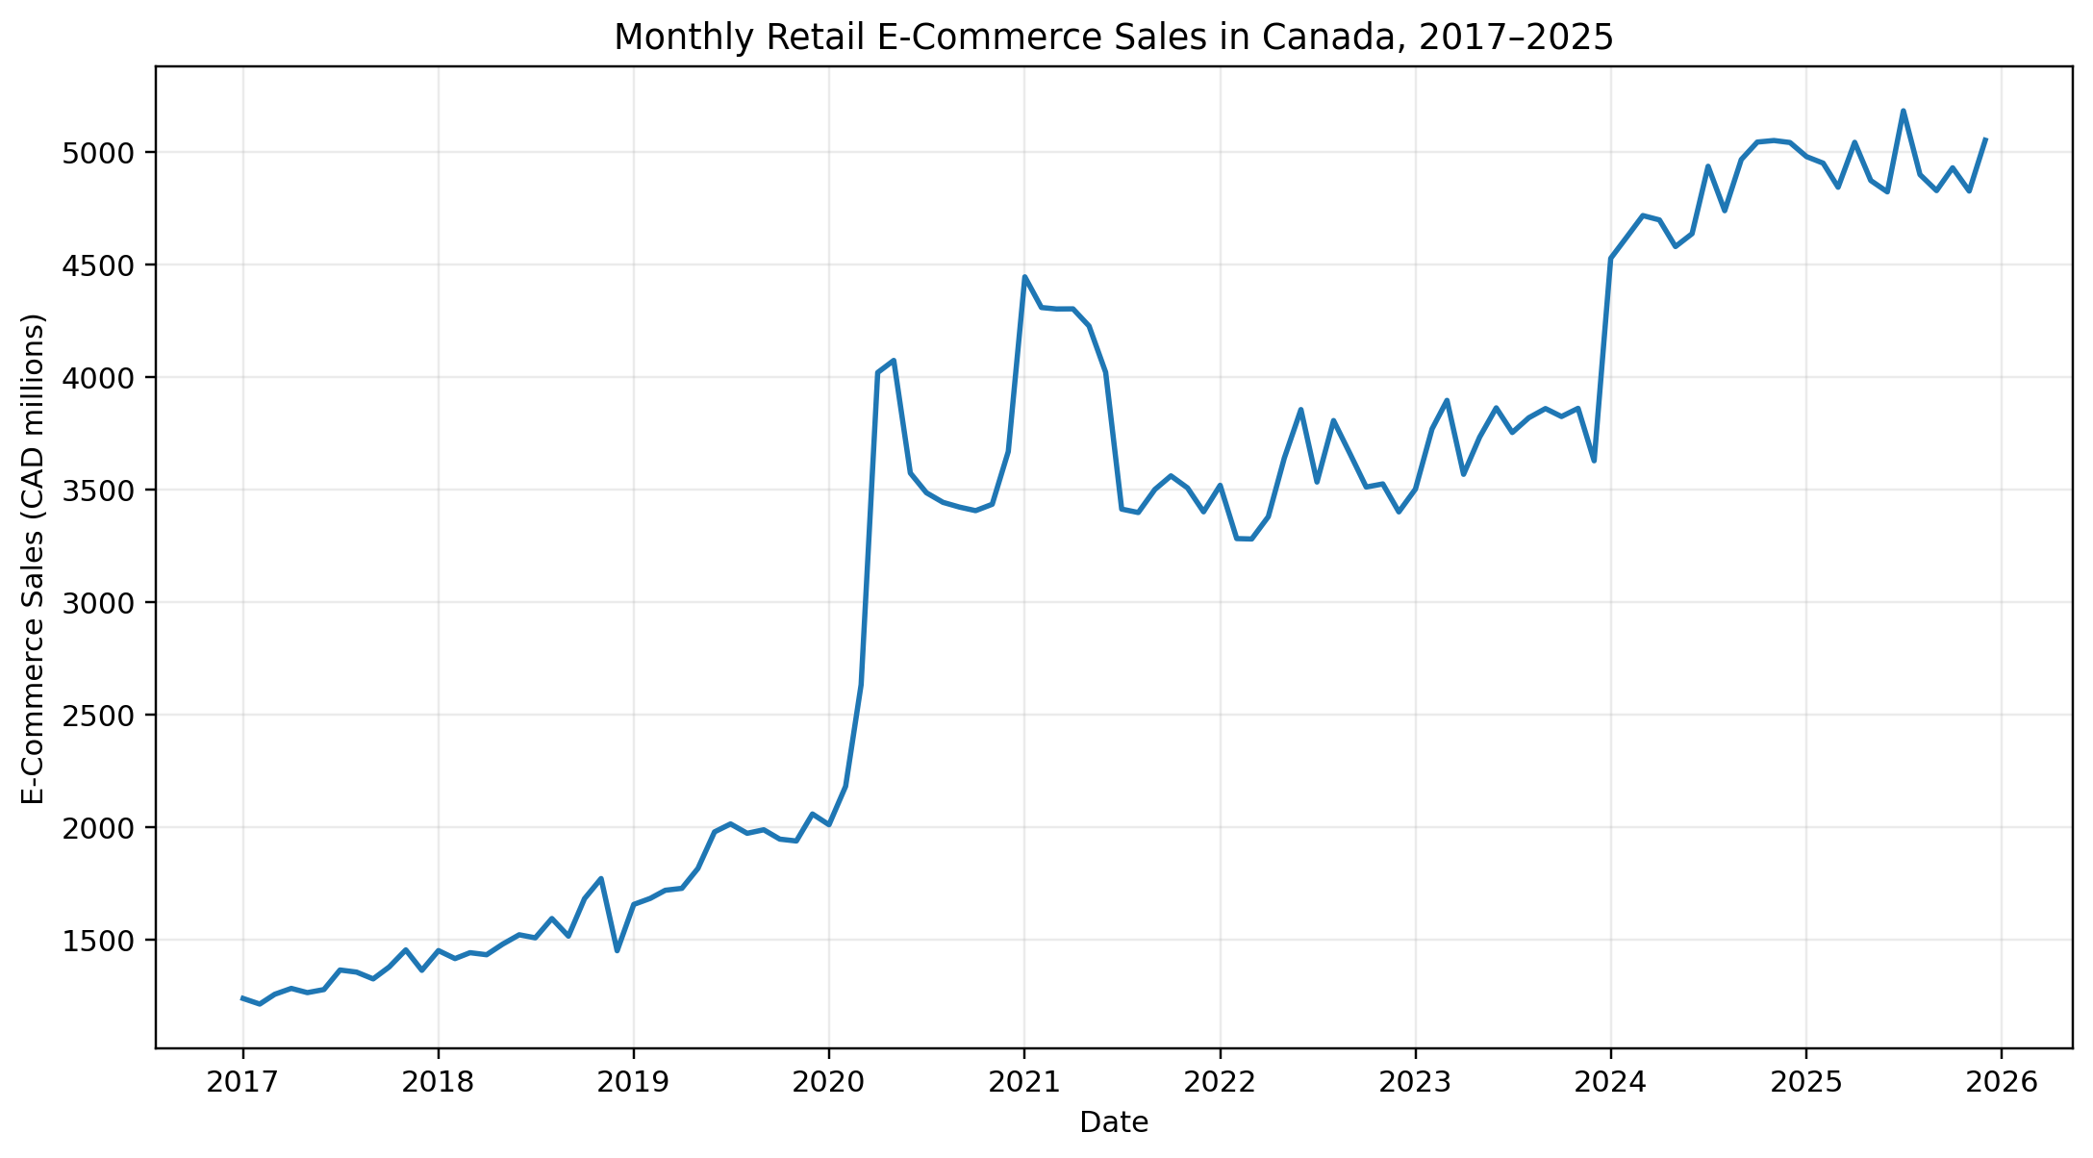
Figure 1. Monthly retail e-commerce sales in Canada, 2017–2025.
Monthly e-commerce sales increased from a low of roughly CAD 1.21 billion in early 2017 to a peak of approximately CAD 5.18 billion in 2025-07-01. The series shows a pronounced upward shift in 2020, followed by normalization, stabilization, and renewed growth in 2024–2025.
Table 4. Annual e-commerce performance
Year | Sales (CAD B) | Annual growth | Sales per capita (CAD)
2017 | 15.76 |  | 431
2018 | 18.25 | 15.8% | 492
2019 | 22.49 | 23.2% | 598
2020 | 39.35 | 75.0% | 1035
2021 | 46.39 | 17.9% | 1213
2022 | 42.39 | -8.6% | 1088
2023 | 45.08 | 6.3% | 1126
2024 | 57.57 | 27.7% | 1395
2025 | 59.24 | 2.9% | 1422

The annual pattern confirms that the sector’s long-run expansion was interrupted by major regime shifts. Growth was already strong before the pandemic, accelerated dramatically in 2020, remained positive in 2021, turned negative in 2022, improved modestly in 2023, and rebounded strongly in 2024. The much slower 2025 growth rate suggests that the market is moving toward a more mature post-pandemic trajectory.
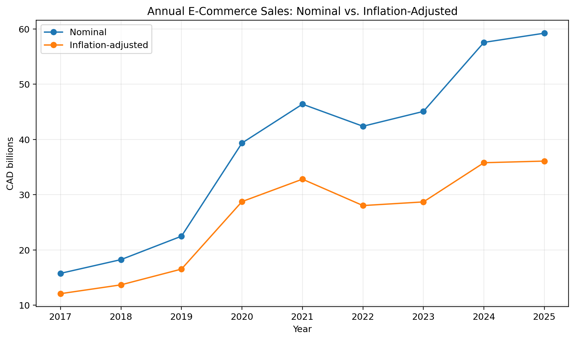
Figure 2. Annual nominal and inflation-adjusted e-commerce sales.
The gap between nominal and inflation-adjusted performance becomes more important after the 2021–2022 inflation increase. In 2022, nominal annual e-commerce sales declined by approximately 8.6%, while inflation-adjusted sales declined by about 14.6%. In 2025, nominal growth was about 2.9%, but real growth was only about 0.8%. For strategic planning, nominal revenue growth should therefore not be mistaken for equivalent growth in real purchasing activity.

4. Analysis and Results: Regime Comparison
Table 5. E-commerce and economic conditions by analytical period
Period | Avg monthly sales (CAD M) | Avg YoY growth | Median YoY growth | Avg inflation | Avg CCI
Pre-pandemic (2017–2019) | 1569 | 19.6% | 18.3% | 1.9% | 100.91
Pandemic acceleration (2020–2021) | 3572 | 49.9% | 58.3% | 2.1% | 99.38
Inflation & normalization (2022–2023) | 3644 | -0.4% | 1.5% | 5.3% | 97.85
Recent environment (2024–2025) | 4867 | 15.4% | 15.0% | 2.2% | 98.83

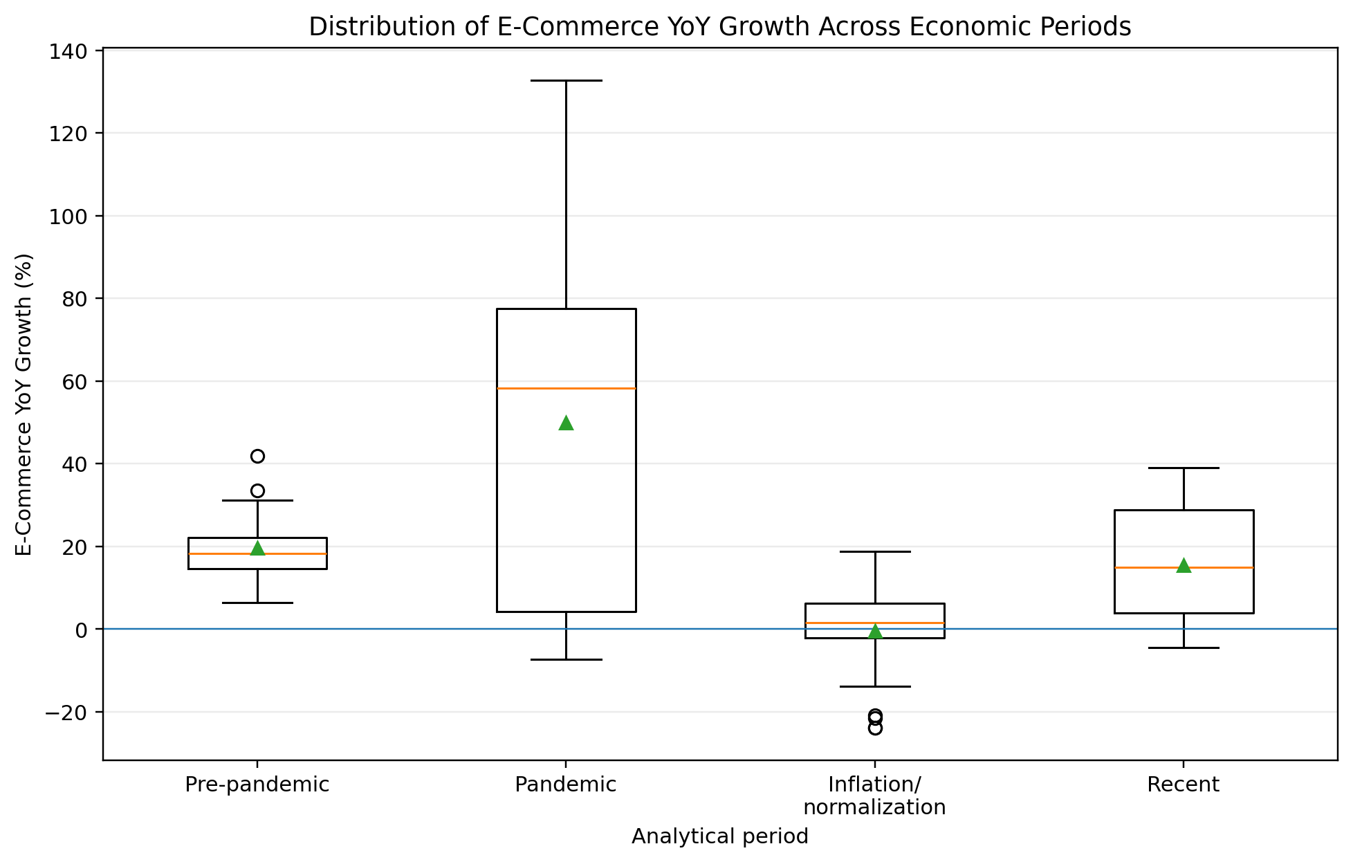
Figure 3. Distribution of e-commerce YoY growth across analytical periods.
The distributional tests justify a non-parametric comparison. Overall e-commerce YoY growth is non-normal, and Levene’s test rejects equal variances across the four periods. The Kruskal–Wallis result is statistically significant (H ≈ 29.50, p < .001), indicating that e-commerce growth distributions differ across at least some periods.
Holm-adjusted pairwise tests show that the 2022–2023 inflation and normalization period differs significantly from the pre-pandemic period, the pandemic period, and the 2024–2025 recent period. By contrast, the recent period is not statistically different from the pre-pandemic period after multiple-comparison adjustment. This supports a practical interpretation: the market has moved away from the extraordinary pandemic surge and toward a more normalized growth regime, although at a substantially higher absolute sales level than before 2020.
Because monthly observations are serially related, the non-parametric tests are treated as supportive rather than definitive causal evidence. The later regression uses time-series-robust standard errors and a lagged growth term as an additional check.
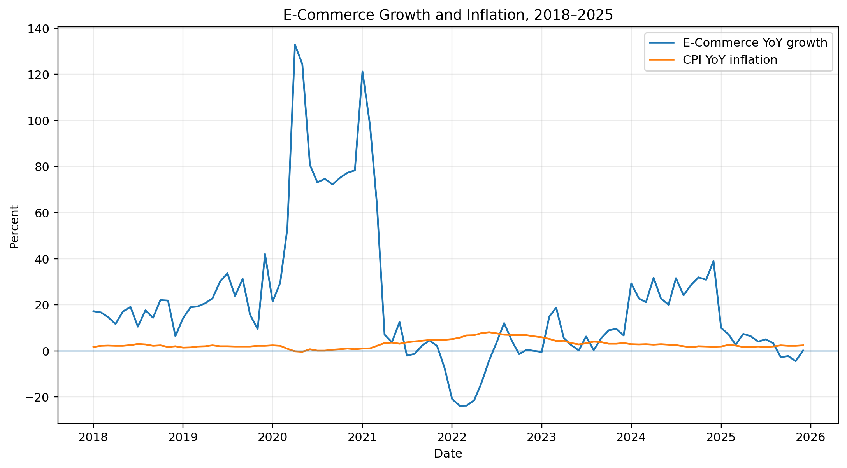
Figure 4. E-commerce YoY growth and CPI YoY inflation, 2018–2025.
The temporal overlay highlights the central Economic risk pattern. The extraordinary 2020–2021 e-commerce expansion occurred before the peak inflation episode. As inflation moved toward its 2022 peak, e-commerce growth had already begun to normalize and subsequently became negative in several months. The visual pattern does not prove causation, but it is consistent with purchasing-power pressure and post-pandemic channel normalization occurring together.

5. Economic PESTEL Relationships
Table 6. Correlations with monthly e-commerce YoY growth
Economic factor | n | Pearson r | Pearson p | Spearman ρ | Spearman p
CPI YoY inflation | 96 | -0.658 | 0.0000 | -0.705 | 0.0000
Consumer confidence | 96 | 0.050 | 0.6262 | 0.328 | 0.0011
HFCE YoY growth | 96 | -0.795 | 0.0000 | -0.579 | 0.0000

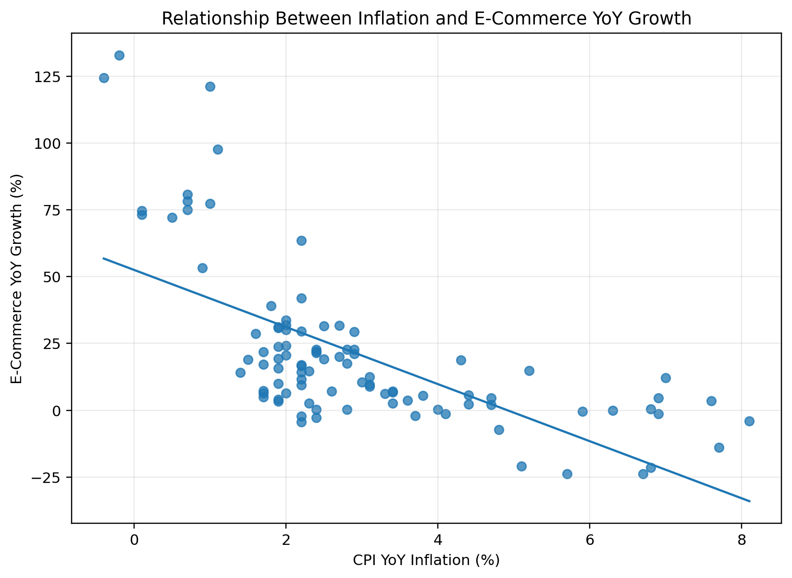
Figure 5. Inflation and e-commerce YoY growth.
Inflation has a strong negative association with e-commerce growth across the full period (Spearman ρ ≈ −0.705, p < .001). The relationship remains negative in the 2022–2025 sample and when the pandemic years are excluded. This consistency makes inflation a meaningful environmental risk indicator, even though the analysis does not claim that inflation alone caused the observed change in e-commerce growth.
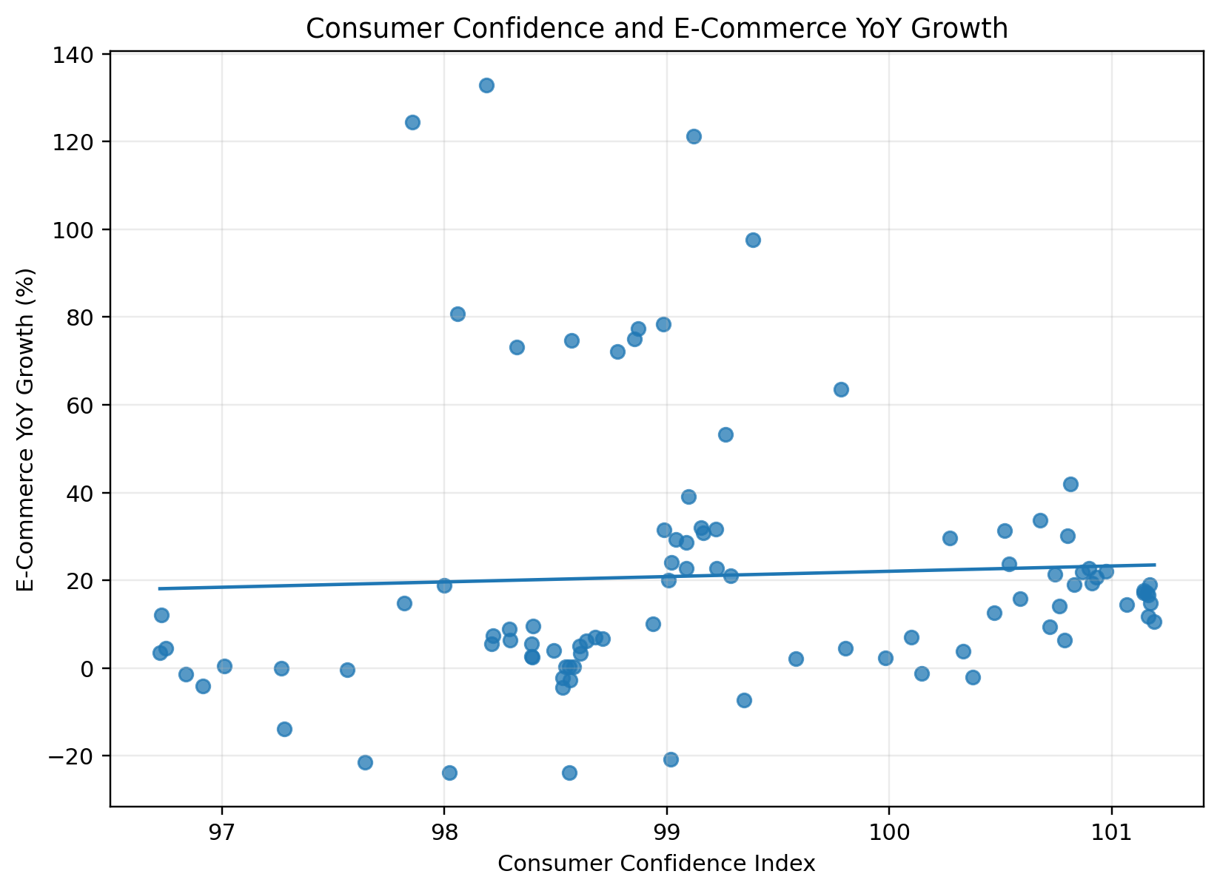
Figure 6. Consumer confidence and e-commerce YoY growth.
Consumer confidence illustrates why pandemic context matters. The full-period Pearson correlation is weak because 2020 produced very high e-commerce growth at the same time that confidence fell sharply. Spearman correlation is positive overall, and the positive relationship becomes stronger when 2020–2021 are excluded. This supports using confidence as a strategic monitoring signal rather than treating it as a stable one-variable predictor.
HFCE YoY growth has a negative full-period relationship with e-commerce growth. That result requires careful interpretation. During the pandemic, aggregate household consumption fell while consumers shifted a much larger share of activity toward online channels. During reopening, HFCE recovered while online growth normalized. The negative coefficient therefore captures channel substitution and regime change, not a claim that higher household consumption is inherently harmful to online retail.

6. Supporting Explanatory Regression
A dynamic explanatory regression is estimated to assess whether the Economic relationships remain once short-run persistence and the pandemic regime are considered simultaneously. The dependent variable is monthly e-commerce YoY growth. Independent variables are one-month lagged e-commerce YoY growth, CPI YoY inflation, consumer confidence, HFCE YoY growth, and a 2020–2021 pandemic indicator. HAC/Newey–West standard errors use a 12-month maximum lag.
Table 7. Dynamic OLS model with HAC robust standard errors
Term | Coefficient | Robust SE | p-value | 95% CI
Intercept | -30.744 | 123.606 | 0.8041 | [-276.345, 214.858]
Lagged e-commerce YoY growth | 0.558 | 0.120 | 0.0000 | [0.320, 0.795]
CPI YoY inflation | 1.393 | 1.409 | 0.3257 | [-1.408, 4.193]
Consumer confidence | 0.447 | 1.199 | 0.7101 | [-1.935, 2.829]
HFCE YoY growth | -2.291 | 0.419 | 0.0000 | [-3.124, -1.458]
Pandemic dummy | 8.690 | 3.556 | 0.0165 | [1.624, 15.755]

The model has R² ≈ 0.879 and adjusted R² ≈ 0.872. The lagged e-commerce-growth term is positive and statistically significant, confirming strong short-run persistence. The pandemic indicator remains positive and statistically significant after the other factors are included, supporting the interpretation that 2020–2021 represented an exceptional acceleration rather than ordinary trend growth.
HFCE YoY growth remains negative and statistically significant. This is consistent with the channel-substitution explanation discussed earlier. Inflation and consumer confidence are not statistically significant once the dynamic term, HFCE growth, and pandemic regime are included together. Consequently, the report does not overstate the bivariate correlations as independent causal effects.
Diagnostics show meaningful improvements after including lagged growth, with Durbin–Watson near 1.78. However, the Breusch–Pagan test indicates heteroskedasticity and the 12-lag Ljung–Box test still finds some longer-horizon residual dependence. Residual normality is also imperfect. These findings justify the use of HAC robust errors and reinforce the decision to use the model as supporting explanatory evidence rather than a forecasting or causal model.
Multicollinearity is not severe among the substantive regressors: VIF values are below conventional concern thresholds. The high condition number is driven largely by variable scaling and the confidence index being centered near 100. The notebook reports the diagnostics explicitly so that the model’s strengths and limitations are transparent.

7. Social and Technological PESTEL Results
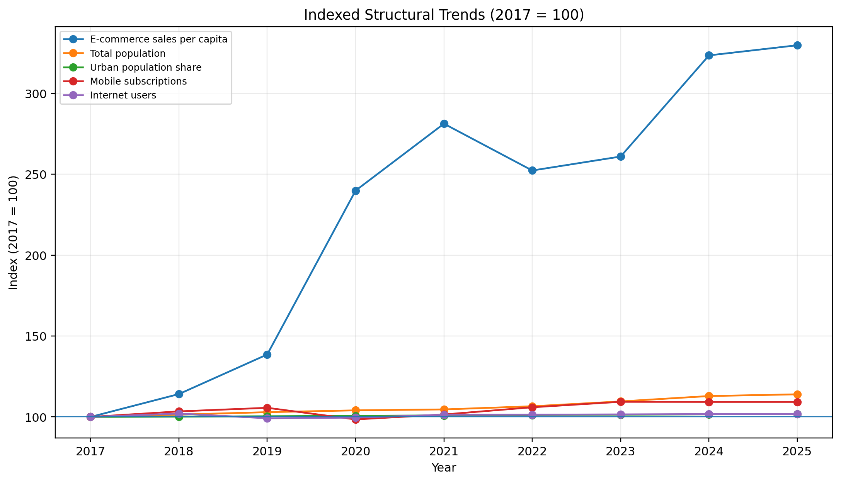
Figure 7. Indexed structural trends, 2017 = 100.
Canada’s total population increased by approximately 14.0% between 2017 and 2025, while the urban population share increased by about 1.47 percentage points. These trends expand the national addressable market and support delivery density in large urban regions. Over the same period, e-commerce sales per capita increased by approximately 230%, far outpacing population growth.
Technology indicators show a mature digital-access environment. Mobile subscriptions and internet use were already high at the beginning of the study and remained near saturation. When the forward-filled 2025 technology values are excluded, annual Spearman correlations between e-commerce per capita and mobile/internet access are positive but not statistically convincing in the very small annual sample. This does not imply that technology is unimportant; rather, it indicates that year-to-year variation in access is now too small to explain most of the sector’s growth.
The strategic meaning is significant. In an earlier stage of digital development, increasing internet penetration could directly enlarge the pool of potential online shoppers. In Canada’s current environment, the majority of consumers are already connected. Competitive advantage therefore shifts toward mobile usability, search and discovery, conversion, payments, personalization, loyalty, delivery reliability, returns, omnichannel integration, and the ability to serve a geographically dispersed population efficiently.
The Social dimension remains more expansionary. Population growth adds potential customers, and continued urbanization can improve the economics of last-mile delivery by increasing order density. However, national aggregation masks regional differences. Rapid population growth in some provinces and metropolitan areas may create opportunities that are not visible in a single national series.

8. Environmental Impact Analysis: Risks and Opportunities
The evidence does not support a single-driver explanation of Canadian e-commerce. Instead, the sector is shaped by interacting short-run Economic shocks and long-run Social and Technological conditions. The major risks and opportunities are summarized below.
Table 8. Evidence-based PESTEL risk and opportunity assessment
PESTEL factor | Evidence | Risk / opportunity | Sector impact
Inflation | 8.1% YoY peak in June 2022; negative association with e-commerce YoY growth | Risk | Purchasing-power pressure, higher price sensitivity, weaker real growth and margin pressure.
Pandemic / regime change | 2020 annual growth ≈ 75%; 2022 annual growth ≈ −8.6% | Risk and structural opportunity | Created durable digital adoption but makes pandemic growth a poor benchmark for planning.
Consumer confidence | Positive relationship becomes clearer outside 2020–2021 | Monitoring opportunity | Useful early-warning signal for discretionary demand; should be combined with other indicators.
Population growth | +14.0% from 2017 to 2025 | Opportunity | Expands the addressable customer base and potential transaction volume.
Urbanization | +1.47 percentage points | Opportunity | Supports delivery density, pickup networks and efficient fulfillment in urban markets.
Digital access saturation | Internet/mobile indicators remain very high | Opportunity and maturity risk | Broad access enables e-commerce, but future growth must come from engagement and execution rather than access expansion.

The strongest Economic risk is not simply “inflation is high.” The more useful strategic interpretation is that high inflation changes the quality of demand. Nominal sales can remain elevated while real purchasing activity weakens, and consumers become more sensitive to price, promotions, shipping fees, and discretionary category choices. This makes real-growth monitoring more informative than nominal revenue alone.
The strongest structural opportunity is that e-commerce remains far above its pre-pandemic level even after normalization. Digital retail should therefore be treated as a permanent capability. The strategic challenge is no longer whether to participate in e-commerce, but how to compete profitably in a mature, highly connected market.

9. Strategic Insights and Recommendations

9.1 Use normalized growth for capacity and investment planning
Retailers should not extrapolate 2020–2021 growth rates into long-term business cases. The pandemic accelerated channel substitution, but 2022 and 2025 demonstrate that growth can normalize quickly even while absolute sales remain high. Capacity planning should therefore combine long-run structural growth with a normalized post-pandemic growth range and stress scenarios for demand shocks.

9.2 Build an inflation-sensitive commercial strategy
Management dashboards should monitor CPI inflation alongside nominal e-commerce sales, real e-commerce growth, conversion, average basket value, discount rate, and category mix. When inflation increases, value communication, targeted promotions, private-label or lower-price assortment, shipping economics, and margin discipline become strategically important. The report’s negative inflation relationship supports this recommendation, while the multivariable model cautions against treating CPI as a standalone predictor.

9.3 Treat consumer confidence as an early-warning indicator
Consumer confidence should be incorporated into environmental monitoring because its relationship with e-commerce growth becomes more consistent outside the pandemic regime. A deterioration in confidence can signal pressure on discretionary demand. However, management should combine it with inflation, household spending, and internal conversion metrics rather than making decisions from the confidence index alone.

9.4 Compete on experience rather than digital access
High internet and mobile penetration imply that access is not the primary growth bottleneck. Incremental gains are more likely to come from mobile-first design, faster checkout, personalization, loyalty, trust, payment flexibility, better delivery visibility, simpler returns, and omnichannel integration. Technology investment should therefore be evaluated by its effect on conversion and lifetime value rather than by its ability to create basic online access.

9.5 Align fulfillment with demographic and urban growth
A larger and more urban Canadian population creates both demand and logistics opportunities. Retailers should align distribution capacity, micro-fulfillment, pickup locations, and delivery partnerships with high-growth metropolitan markets. At the same time, national strategies must account for Canada’s large geography and the higher cost of serving lower-density regions.

9.6 Institutionalize PESTEL monitoring
The strongest use of this analysis is not a one-time conclusion. The selected indicators should become a recurring environmental monitoring framework. Decision-makers should track inflation, confidence, household consumption, e-commerce growth, population, urbanization, and digital-access measures on the frequencies at which they are actually published. Significant deviations from historical ranges should trigger a review of pricing, demand forecasts, marketing intensity, and fulfillment plans.

10. Limitations
- Mixed-frequency data: monthly Economic indicators coexist with annual Social and Technological indicators. The report mitigates this by using annual analytical views for annual variables, but the consolidated source file remains mixed-frequency.
- Imputation: HFCE values for July–December 2025 are model-imputed, while 2025 internet and mobile values are forward-filled. These observations are useful for continuity but less certain than directly observed data.
- Small annual sample: Social and Technological analysis is based on only nine annual observations, and only eight directly observed years for the technology indicators. Annual p-values therefore have limited power and are interpreted cautiously.
- Structural break: the COVID-19 period altered both the level and composition of household spending. Full-period relationships may therefore represent multiple regimes rather than one stable economic process.
- Residual time-series issues: the explanatory model uses HAC robust errors and lagged growth, but some longer-horizon dependence and heteroskedasticity remain.
- National aggregation: the dataset does not separate provinces, demographic groups, retail categories, or firm types. National results may conceal important geographic or sector differences.
- Causal limitation: the analysis is observational and cannot establish that the PESTEL variables caused the observed e-commerce changes.
- Omitted variables: interest rates, unemployment, disposable income, total retail sales, household debt, shipping costs, exchange rates, and regulatory changes could improve explanatory depth.

11. Future Improvements
- Add total retail sales and calculate e-commerce share of total retail. This would separate overall retail expansion from channel-share change.
- Add Bank of Canada policy rates, unemployment, disposable income, household debt-service ratios, and wage growth to deepen the Economic analysis.
- Replace imputed 2025 observations with directly published values when later official releases become available.
- Extend the historical period backward to improve statistical power and reduce the influence of the pandemic on full-sample relationships.
- Introduce provincial data to identify high-growth geographic markets and link population growth more directly to fulfillment strategy.
- Add category-level e-commerce data to distinguish discretionary, essential, durable, and service-related demand responses.
- If assignment scope expands, consider formal interrupted time-series or structural-break methods rather than advanced machine-learning prediction.

12. Conclusion
The evidence shows that Canadian retail e-commerce moved from rapid pre-pandemic expansion into an extraordinary pandemic acceleration, followed by normalization, inflation pressure, and then renewed growth. By 2025, the market was substantially larger than in 2017, both in total dollars and on a per-capita basis. The central strategic message is therefore not that e-commerce growth has ended, but that the basis of growth has changed.
Economic conditions matter because a mature e-commerce sector is still exposed to consumer purchasing power and sentiment. Inflation was highest during the period in which e-commerce growth was weakest, and the negative relationship remains visible outside the pandemic sample. Consumer confidence is a useful contextual indicator, although the multivariable regression shows that its independent effect is not stable once dynamic growth and household-spending conditions are considered.
Social conditions remain expansionary: population growth and urbanization enlarge the market and can improve delivery density. Technological conditions are enabling but mature. High internet and mobile penetration mean that future performance depends less on basic digital access and more on execution — conversion, customer experience, loyalty, fulfillment, value positioning, and operational resilience.
For decision-makers, the highest-value strategy is therefore to combine normalized growth planning with active PESTEL monitoring. E-commerce should be treated as a permanent retail capability, but investment decisions should be grounded in real rather than nominal growth, inflation-sensitive demand, consumer confidence, demographic expansion, and the realities of a digitally saturated market.

References
Bank of Canada. (n.d.). Consumer price index. https://www.bankofcanada.ca/rates/price-indexes/cpi/
Organisation for Economic Co-operation and Development. (n.d.). Consumer confidence index (CCI). https://www.oecd.org/en/data/indicators/consumer-confidence-index-cci.html
Smith, P. (n.d.). Consumption monthly. https://philipsmith.ca/Consumption_monthly/
Statistics Canada. (n.d.). Monthly retail trade e-commerce sales, Table 20-10-0056-03. https://www150.statcan.gc.ca/t1/tbl1/en/tv.action?pid=2010005603
World Bank. (n.d.). Population, total – Canada (SP.POP.TOTL). World Development Indicators.
World Bank. (n.d.). Urban population – Canada (SP.URB.TOTL). World Development Indicators.
World Bank / International Telecommunication Union. (n.d.). Mobile cellular subscriptions per 100 people (IT.CEL.SETS.P2). World Development Indicators.
World Bank / International Telecommunication Union. (n.d.). Individuals using the Internet (% of population) (IT.NET.USER.ZS). World Development Indicators.

Appendix A. Reproducibility Note
The companion Jupyter notebook reproduces the data checks, feature engineering, descriptive statistics, visualizations, period tests, correlation analysis, sensitivity analysis, annual structural analysis, regression estimation, and model diagnostics reported in this document. The original Excel workbook is loaded by filename from the working directory, and the source dataset is not overwritten.

