Predicting Credit Default Risk
Group 6 Written Report
Python Assignment - Data Analytics Workflow, Visualization, and Machine Learning
Date: June 13, 2026

Executive Summary
This project analyzed historical loan application data to predict credit default risk. The main applications dataset contains 85,000 records and 22 columns, while the supplementary inquiries dataset contains 45,000 records and 8 columns. The prediction target was created as target_default = 1 when the final loan outcome was Charged Off and 0 otherwise. The data was balanced, with a default rate of 50.00%.
After cleaning mixed text/numeric fields, handling missing values, and engineering features such as repayment term, interest rate, revolving utilization, and employment tenure, two classification models were trained: Logistic Regression and Random Forest. The models produced similar performance, with Random Forest slightly stronger by ROC-AUC in this run. The model should be viewed as a decision-support tool rather than a replacement for human credit review.

1. Dataset and Target Variable
The main dataset, creditrisk_applications_final.csv, contains borrower, loan, credit profile, and final loan outcome information. Each row represents a completed credit application. The supplementary dataset, creditrisk_inquiries_final.csv, contains inquiry-level information such as application date, screening score, debt-to-income text, region, and employment tenure. The inquiries dataset did not include a final default outcome or a common application identifier, so it was used for supplementary data understanding rather than model training.
The binary target variable was defined as follows:
Outcome condition | Target value
outcome_status = Charged Off | target_default = 1
All other outcomes | target_default = 0

2. Data Cleaning and Preparation
The cleaning process focused on preparing the data for meaningful analysis and reproducible modeling. The key cleaning actions were:
- Created target_default from outcome_status.
- Converted interest rate, repayment term, debt-to-income ratio, revolving utilization, and employment tenure into usable numeric features.
- Converted inquiry application_date into a date field.
- Checked missing values and duplicates in both datasets.
- Dropped duplicate rows where present.
- Kept rows with missing predictor values and handled them inside the modeling pipeline using median imputation for numeric fields and most-frequent imputation for categorical fields.
Dataset | Field with missing values | Missing count
Applications | employment_tenure_text | 8,676
Applications | annual_income_usd | 680
Applications | debt_to_income_ratio | 709
Applications | revolving_utilization_text | 892
Inquiries | request_title | 9
Inquiries | screening_score | 4,524
Inquiries | region_code | 21
Inquiries | employment_tenure_text | 2
A major modeling assumption was to exclude last_payment_amount_usd because it is a repayment/outcome-related field that would not normally be known at the time of application. Including it could create target leakage and make the model appear more accurate than it would be in real lending use.

3. Exploratory Data Analysis Findings
The EDA focused on default distribution and how default risk varied across borrower, loan, and credit characteristics. Since the target was evenly split between charged-off and fully paid loans, the classification task did not suffer from severe class imbalance.
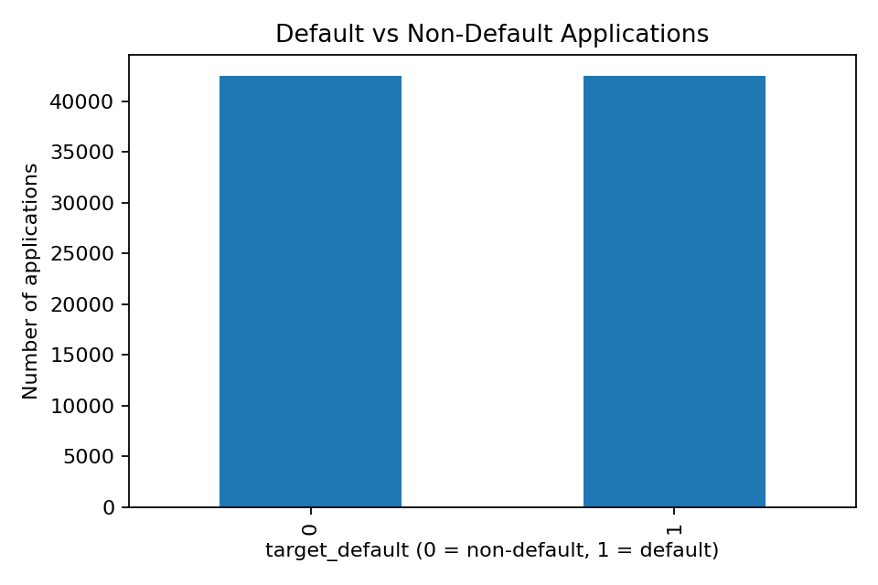
Figure 1. Distribution of default and non-default applications.
Group | Requested amount | Interest rate | Annual income | DTI | Credit score low | Revolving util.
Non-default | $12,000 | 11.53 | $65,000 | 17.54 | 690 | 50.6
Default | $14,400 | 14.65 | $60,000 | 20.50 | 680 | 54.7
Median comparisons showed that defaulted applications tended to have higher requested amounts, higher interest rates, higher debt-to-income ratios, lower credit scores, and higher revolving utilization. These patterns are consistent with credit-risk intuition because borrowers facing higher credit costs and higher existing debt burdens are generally more likely to default.
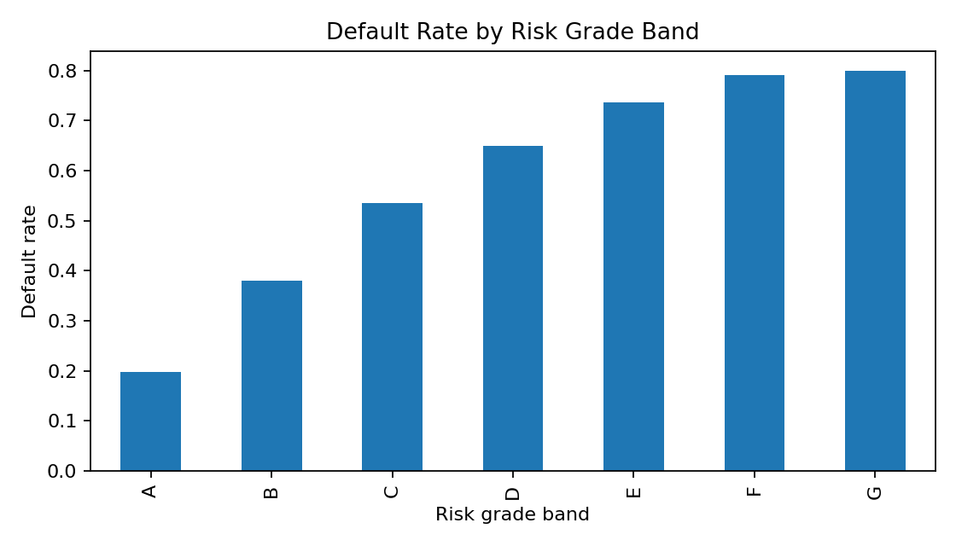
Figure 2. Default rate by risk grade band.
Risk grade band | Default rate | Applications
G | 79.94% | 947
F | 79.13% | 2,741
E | 73.63% | 8,311
D | 64.97% | 14,775
C | 53.51% | 25,111
B | 38.05% | 21,169
A | 19.80% | 11,946
Default risk also varied by loan purpose, housing status, and region. These variables were therefore retained as categorical predictors in the final model. The report presents the most meaningful default-rate patterns rather than every intermediate calculation.
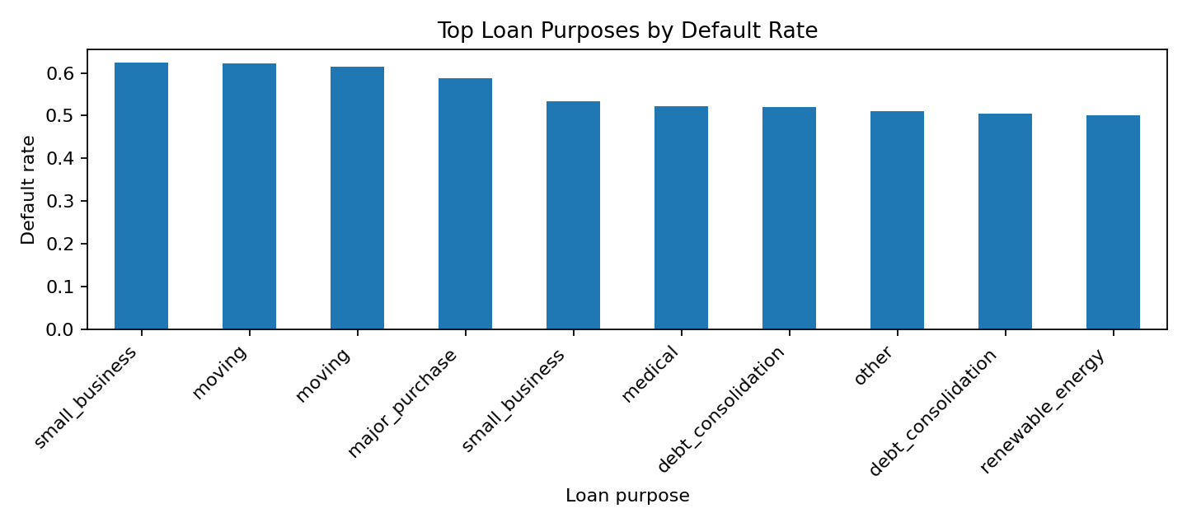
Figure 3. Loan purposes with the highest observed default rates.

4. Supplementary Inquiry Dataset Review
The inquiries dataset covered inquiry records dated from 2007-05-26 to 2009-04-23. Because it did not include the final default outcome and had no common application ID to link it to the applications dataset, it was not used in the predictive model. It was still reviewed to satisfy the requirement that both datasets play a role in the analysis.
The inquiry data was used to inspect missing values, convert application dates, clean debt-to-income values, and summarize screening score patterns by region. This helped provide supplementary context about pre-application credit inquiry characteristics.

5. Feature Engineering and Selection
Feature engineering transformed mixed or text fields into model-ready variables. The main engineered variables were repayment_term, interest_rate, revolving_utilization, debt_to_income_ratio, and employment_tenure_years.
Feature group | Variables used
Numeric predictors | requested_amount_usd, monthly_installment_usd, interest_rate, repayment_term, annual_income_usd, debt_to_income_ratio, credit_score_low, credit_score_high, open_credit_lines, public_records_count, revolving_utilization, employment_tenure_years
Categorical predictors | risk_grade_band, housing_status, income_verification_status, loan_purpose, region_code
Excluded variables | outcome_status, target_default, last_payment_amount_usd, original text columns replaced by cleaned numeric fields
Categorical features were one-hot encoded. Numeric values were imputed using the median and scaled using StandardScaler. Categorical missing values were imputed using the most frequent value. These steps were placed inside a scikit-learn pipeline to make the analysis reproducible.

6. Model Building
The cleaned applications dataset was split into training and testing sets using an 80/20 split. The split was stratified by target_default so that both training and testing sets preserved the same proportion of default and non-default cases.
Two models were built:
- Logistic Regression: used as an interpretable baseline model for binary classification.
- Random Forest Classifier: used to capture non-linear relationships and interactions among predictors.

7. Model Evaluation
Model | Accuracy | Precision | Recall | F1-score | ROC-AUC
Logistic Regression | 0.6623 | 0.6588 | 0.6734 | 0.6660 | 0.7230
Random Forest | 0.6621 | 0.6588 | 0.6725 | 0.6655 | 0.7237
Both models performed similarly. Logistic Regression achieved a ROC-AUC of 0.7230, while Random Forest achieved a ROC-AUC of 0.7237. Because Random Forest was slightly stronger by ROC-AUC, it is recommended as the stronger predictive model in this run. Logistic Regression remains useful as a simpler benchmark that is easier to explain to non-technical stakeholders.
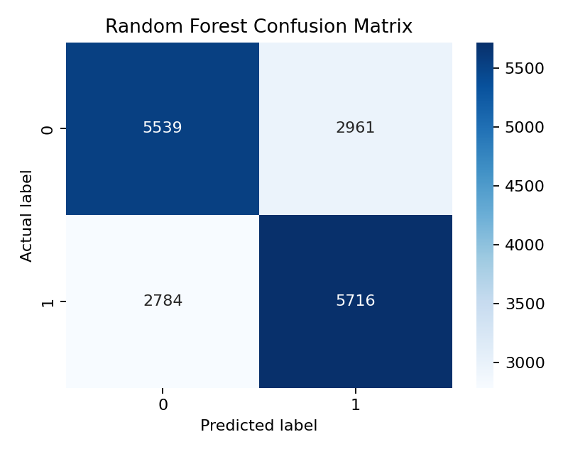
Figure 4. Random Forest confusion matrix on the test set.
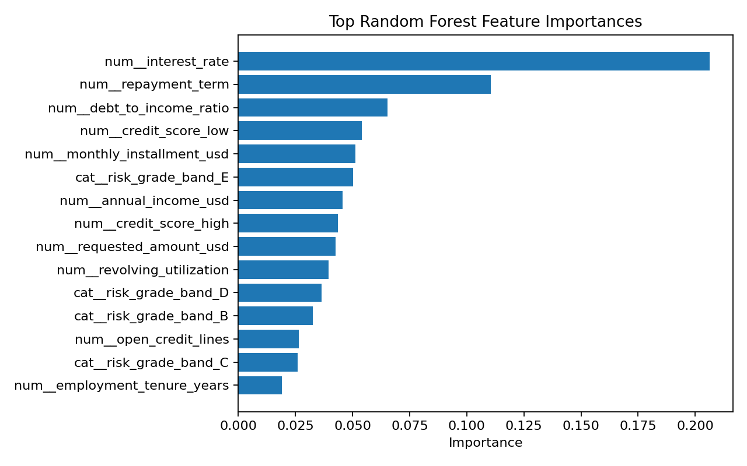
Figure 5. Most important Random Forest predictors.

8. Business Insights and Recommendations
The analysis supports the following business insights:
- Applicants with higher interest rates, higher debt-to-income ratios, lower credit scores, and higher revolving utilization showed greater observed default risk.
- Risk grade, loan purpose, housing status, and region were meaningful categories for segmenting default risk.
- The model can help lenders prioritize applications for additional review, identify higher-risk borrower profiles, and support more consistent credit-risk screening.
- The model should not automatically approve or reject applicants. It should support decision-making alongside policy rules, affordability checks, and human review.

9. Limitations and Future Work
- The model was trained on historical data and may reflect past lending decisions or borrower conditions.
- The inquiry dataset could not be joined to the main applications dataset due to the absence of a common identifier.
- Some variables, such as risk grade and interest rate, may partly reflect lender assessment rather than only borrower characteristics.
- The current analysis used a single train/test split. Future work should include cross-validation and threshold tuning.
- Future improvements could include additional models such as gradient boosting, fairness checks across borrower groups, and more detailed error analysis of false positives and false negatives.

10. Conclusion
This project completed the required data analytics workflow for predicting credit default risk. The work included data cleaning, EDA, visualization, feature engineering, classification modeling, model comparison, and business interpretation. Random Forest was the recommended model by ROC-AUC, although Logistic Regression performed similarly and remains useful for explainability. The final model can support credit-risk decision-making by highlighting applications with higher predicted default risk, while its limitations should be considered before operational use.

