UNIVERSITY OF NIAGARA FALLS CANADA
Master of Data Analytics
DAMO-520-21 — Marketing Analytics

Marketing Analytics Problem Assignment: Part 1
Customer Segmentation of Credit Card Holders:
A Data Enrichment Plan and k-Means Segmentation Analysis

Submitted by: Group 6
ISSA, Nabeel
MUSA, Yusuf
NASIRU, Arafat Adekolajo
OBOKOHWO, Israel
OJUEDERIE, Okemena

Submitted to: Dr. Mohamad Makki

August 3, 2026

Part A: Data Enrichment Plan
Purchasing_data.xlsx surveys 4,362 people, collected in September 2021. It records how people pay for things, how many credit cards they hold and carry a balance on, whether they use Buy Now Pay Later (BNPL), what they look for in a card, and basic demographics like age, income, and education.. It is usable, but has gaps to close before it can guide today's decisions.

1. Missing or Outdated Information
The data is nearly five years old and predates a real shift in how people pay. Credit cards are now the most-used method in the United States, at 35 percent of payments against 30 percent for debit, and the share preferring credit in person has risen from 24 percent in 2016 to 38 percent (Federal Reserve Financial Services, 2025a). The survey lists Venmo but neither Zelle nor FedNow, the latter of which moved $245 billion in the second quarter of 2025 alone (Federal Reserve Financial Services, 2025b).
Some of the missing data includes:
- Psychological Data: Records on how they feel about debt, brand loyalty and trust in institutions.
- Credit Limit variable: Lack of Credit Limit variable makes it impossible for us to determine individual credit utilization which happens to be one of the strongest financial risk that cannot be calculated from balance alone.
- Customer Tenure and Satisfaction Score: lack of data on how long a customer has been with an instituition or how satisfied they are with products and services makes it impossible to differentiate a new customer from a loyal long standing customer.
To close these gaps, the following should be added: current data on payment mix and credit use, a short set of attitude questions on debt and price sensitivity, credit limit information, customer tenure and a satisfaction measure, and passive engagement data such as app visit frequency and offer response.
2. Proposed Data Sources
The primary source is a survey of current cardholders. Attitudes cannot be pulled from any system the company already runs, so they must be asked. This gives the measures needed to group customers by why they spend, not only what they spend.
Secondary source: the company's own transaction and account records, checked against published industry reports on payment trends. Transaction records add credit limit, tenure, and actual spend by category without asking the customer anything, and update on their own. Industry reports give market context: 53.6 million people took a BNPL loan in 2023 across six major providers (CFPB, 2025), and card balances reached $1.28 trillion by end-2025 (Federal Reserve Bank of New York, 2026).

3. Data Collection Method
The survey would go out by email and as a short in-app prompt, reaching customers who bank mainly online and those who do not. It would collect four variables, each tied to a way of grouping customers:
- How often the customer uses a digital wallet or BNPL service, measuring digital engagement.
- The main reason the customer picked their current card, measuring brand loyalty.
- How comfortable the customer is carrying a balance, measuring attitude toward debt.
- Which spending categories the customer uses their card for most, measuring product preference.
To keep the data usable, questions would be tested on a small group first to catch confusing wording, the same rating scale would be used throughout, and the survey would be kept under ten minutes, so people answer carefully rather than rushing.

4. Sampling Plan
We used stratified random sampling, using the company existing account tiers such as standard, premium, business as the groups. A plain random sample could end up with mostly standard tier customers, leaving smaller but valuable tiers underrepresented; sampling inside each tier separately prevents that.
This supports validity, since customers are still picked at random inside each tier rather than skewed toward the most engaged; reliability, since the same tiers and steps can be reused on a regular schedule for fair comparison over time; and generalizability, since the known size of each tier lets results be weighted back up to the full customer base rather than only those who responded. The current dataset has neither customer IDs nor weights, so its results cannot be projected.

Part B: Customer Segmentation in R

Step 1: Selected Segmentation Variables

Four variables from the dataset were used for segmentation: number of credit cards owned (Q02), typical monthly credit card balance (Q03), share of purchases made by credit card (Q05), and personal income (D11). These four cover both credit behavior and spending capacity. Balance and share of purchases separate people who carry a balance from people who pay in full. Card count shows how many products someone already holds, which matters for cross sell. Income shows what a customer can likely afford. Together they point to which product to offer someone and how to price or message it. All four are ordered categorical items, recoded to numeric category midpoints so a distance based method could be applied.

Step 2: Data Preparation and Segmentation Method
Missing data was diagnosed before any rows were dropped, and the answer changes how the results must be read. Of the 2,268 people lacking the four variables, 1,631 did not quit instead they said they do not use credit cards in Q01, so the questionnaire skipped them past Q02 to Q05 automatically. The pattern is the same as everyone missing Q02 said no to credit cards, and no cardholder is missing Q02. Only the other 637 abandoned the survey. After removing incomplete rows, 2,094 cases remained.
This segmentation therefore describes cardholders only. The 1,631 excluded are not missing data but a different population: 66.3 percent use debit, 60.1 percent cash, 43.5 percent PayPal, none credit. They are a real cash-and-debit group and a plausible acquisition target, but no credit-based model can describe them, so they are handled in the recommendations.
The remaining variables were standardised, since income and balance would otherwise dominate the distance calculation, and k-means was run with 25 random starts. The number of groups was judged on four measures rather than one (Table 1, Figures 1 and 2). Within-group spread falls smoothly with no clear elbow; the silhouette score stays flat between 0.262 and 0.290; and the gap statistic picks k = 6. No measure singles out k = 4 — the data forms a gradient, not four islands. Four was chosen because four campaigns can be resourced where seven cannot, and because the solution was later confirmed against variables held back from the model.

Table 1. Cluster diagnostics across candidate solutions.
k | Avg. silhouette | WCSS | % between-cluster SS | Gap statistic
2 | 0.262 | 6,123 | 26.9 | 0.502
3 | 0.279 | 4,855 | 42.0 | 0.543
4 (selected) | 0.274 | 4,074 | 51.3 | 0.574
5 | 0.283 | 3,469 | 58.6 | 0.592
6 | 0.281 | 3,065 | 63.4 | 0.636
7 | 0.290 | 2,778 | 66.8 | 0.626
8 | 0.286 | 2,513 | 70.0 | 0.627

Step 3: Visualising the Segments
Figure 3 plots customers by monthly balance and share of purchases on credit card: Group 1 sits lowest, Groups 2 and 3 higher and close together, and Group 4 separates sideways at about five times any other balance. Figure 4 shows sizes from 776 down to 290, and Figure 5 shows Group 1 near a $50,000 median income against roughly $88,000 for the rest; the $125,000 ceiling there is the midpoint given to the top income band, not a real limit.

Step 4: Segment Interpretation and External Validation

Table 2. Segment profiles on the four segmentation variables (N = 2,094).
Segment | n | Avg. cards | Avg. balance | Avg. % on card | Avg. income
1. Low-Intensity Card Users | 776 | 2.0 | $1,412 | 23.8% | $48,582
2. Multi-Card Optimizers | 382 | 5.0 | $2,164 | 63.0% | $82,919
3. Convenience / Premium Payers | 646 | 2.1 | $2,235 | 73.8% | $87,713
4. High-Balance Revolvers | 290 | 3.5 | $10,384 | 51.9% | $92,500

Group 1, Low-Intensity Card Users, holds the fewest cards and lowest balances and puts under a quarter of purchases on a card. Wording matters: because non-cardholders were skipped out, every member does hold a card. They are light users, not cash preferers — the cash preferers are the 1,631 excluded. Group 2, Multi-Card Optimizers, holds five cards on strong income while keeping balances low, consistent with chasing rewards. Group 3, Convenience/Premium Payers, puts the most on a card on a low balance, meaning they clear it monthly. Group 4, High-Balance Revolvers, carries nearly five times anyone else's balance on moderate use.
These labels were tested against five variables kept out of the grouping (Table 3, Figure 7). Group 3 pays in full most often at 46.7 percent, confirming the convenience label. Group 4 pays in full least at 18.6 percent and uses BNPL most at 59.0 percent despite the highest income — a stretched profile balance alone only hinted at. All three differences are significant: credit score, F(3, 1944) = 53.16; paying in full, chi-square(12) = 209.09; BNPL use, chi-square(12) = 63.58; all p < .001. Since none shaped the grouping, this is independent evidence the groups are real.

Table 3. External validation on variables not used to construct the segments.
Segment | Mean credit score | % always pays in full | % used BNPL | % aged 65+ | % graduate degree
1. Low-Intensity Card Users | 695 | 29.0 | 36.7 | 26.2 | 9.7
2. Multi-Card Optimizers | 756 | 38.7 | 40.3 | 33.2 | 17.5
3. Convenience / Premium Payers | 743 | 46.7 | 47.5 | 21.1 | 20.0
4. High-Balance Revolvers | 713 | 18.6 | 59.0 | 15.2 | 23.8

Marketing Recommendations
The groups differ in both balance and how they use credit, so no single offer suits all four; Table 4 gives each a strategy. The priority is Group 4: 290 customers, 13.8 percent of the sample, holding about $3.0 million in revolving balances here alone. Their highest income, lowest rate of paying in full and heaviest BNPL use make them a consolidation opportunity, best met by a balance transfer with a fixed repayment plan.

Table 4. Recommended strategy by segment.
Segment | Recommended strategy
1. Low-Intensity Card Users | Lead with no-fee cards and cash back on everyday essentials. This group already limits card use and carries the lowest balances, so messaging should emphasise cost saving rather than points or perks.
2. Multi-Card Optimizers | Offer a sign-up bonus with rotating category rewards. This group already manages five cards and actively pursues rewards, so a richer point structure outperforms a basic cash-back proposition.
3. Convenience / Premium Payers | Offer a premium rewards or travel card with bonus dining and travel categories. With the highest pay-in-full rate and second-highest credit score, this group will not respond to debt-management messaging.
4. High-Balance Revolvers | Offer balance transfer or a lower-rate product with a structured payoff plan. A rewards card encouraging additional spend would work against this group's interest and against portfolio credit quality.

Limitations
Four limitations apply. First, the groups are not equally solid. Re-running the analysis on 100 random resamples (Figure 8) gives stability scores of 0.497, 0.500, 0.782 and 0.814 for Groups 1 to 4; above 0.75 is solid, below 0.60 is not a separate group (Hennig, 2007). Groups 3 and 4 are ready for campaigns; Groups 1 and 2 sit in the crowded middle, so their recommendations are provisional.
Second, the answer depends on the method. All four inputs are ordered categories, and using midpoints assumes equal gaps between them, which is not true. Repeating the work with Gower distance and medoids, which makes no such assumption, gives only moderate agreement (0.312), so this is one defensible split rather than the only one. Third, Group 4 rests almost entirely on the highest balance bands; changing the value given to the open-ended "more than $10,000" band keeps agreement above 0.81, but its size ranges from 174 to 336.
Fourth, the data is self-reported, collected once in September 2021, covers cardholders only, and carries no IDs or weights. Part A tackles each: transaction records replace self-report, a repeatable stratified design allows weighting and comparison over time, and a debt-attitude measure strengthens the dimension this analysis finds strongest but measures with one question.

Conclusion
Four groups were found among 2,094 cardholders and tested against behaviour held back from the model. Two are solid and ready to act on, with High-Balance Revolvers the clearest opportunity. The work also surfaced a fifth group no credit-based model can serve — the 1,631 cash-and-debit respondents skipped by the survey — the strongest case for the plan in Part A.

References
Consumer Financial Protection Bureau. (2025). The Buy Now, Pay Later market. https://www.consumerfinance.gov/data-research/research-reports/the-buy-now-pay-later-market/
Federal Reserve Bank of New York. (2026). Household debt and credit report. Center for Microeconomic Data. https://www.newyorkfed.org/microeconomics/hhdc
Federal Reserve Financial Services. (2025). 2025 findings from the Diary of Consumer Payment Choice. https://www.frbservices.org/news/research/2025-findings-from-the-diary-of-consumer-payment-choice
Federal Reserve Financial Services. (2025b). FedNow Service: Two years of growth and innovation. https://www.frbservices.org/news/fed360/issues/071625/fednow-service-two-years-growth-innovation
Hennig, C. (2007). Cluster-wise assessment of cluster stability. Computational Statistics & Data Analysis, 52(1), 258–271.
Kaufman, L., & Rousseeuw, P. J. (1990). Finding groups in data: An introduction to cluster analysis. John Wiley & Sons.
Tibshirani, R., Walther, G., & Hastie, T. (2001). Estimating the number of clusters in a data set via the gap statistic. Journal of the Royal Statistical Society: Series B, 63(2), 411–423.

Appendix A: Figures
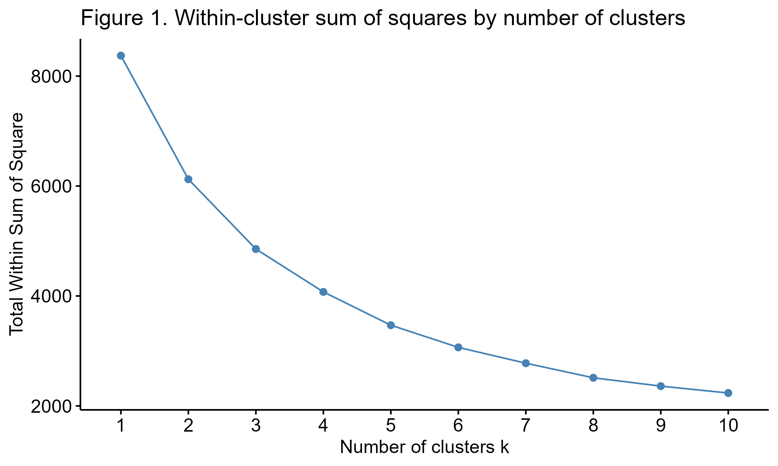
Figure 1. Within-cluster sum of squares by number of clusters. The decline is smooth, with no pronounced elbow at any value of k.
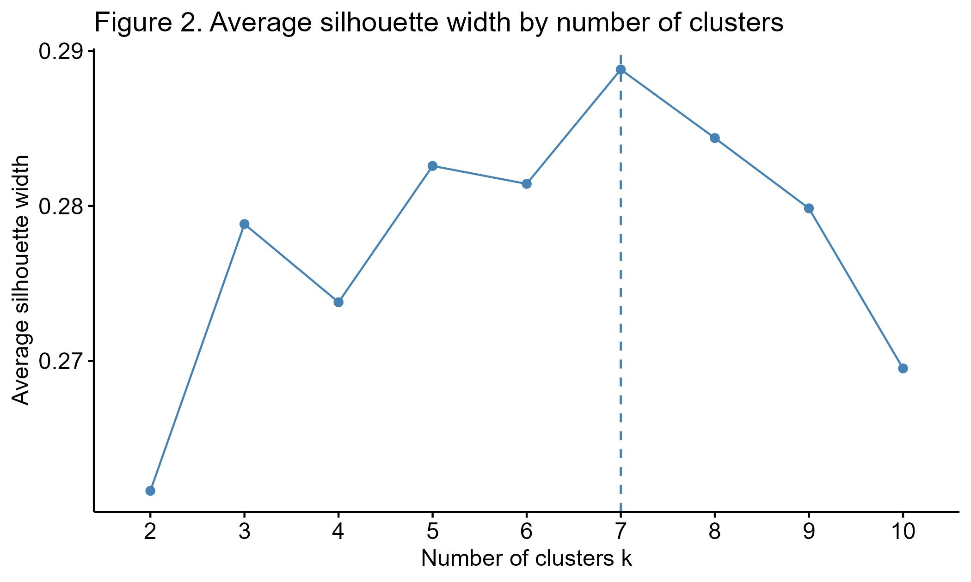
Figure 2. Average silhouette width by number of clusters. Values remain between 0.262 and 0.290 across the full range, indicating weak natural separation.

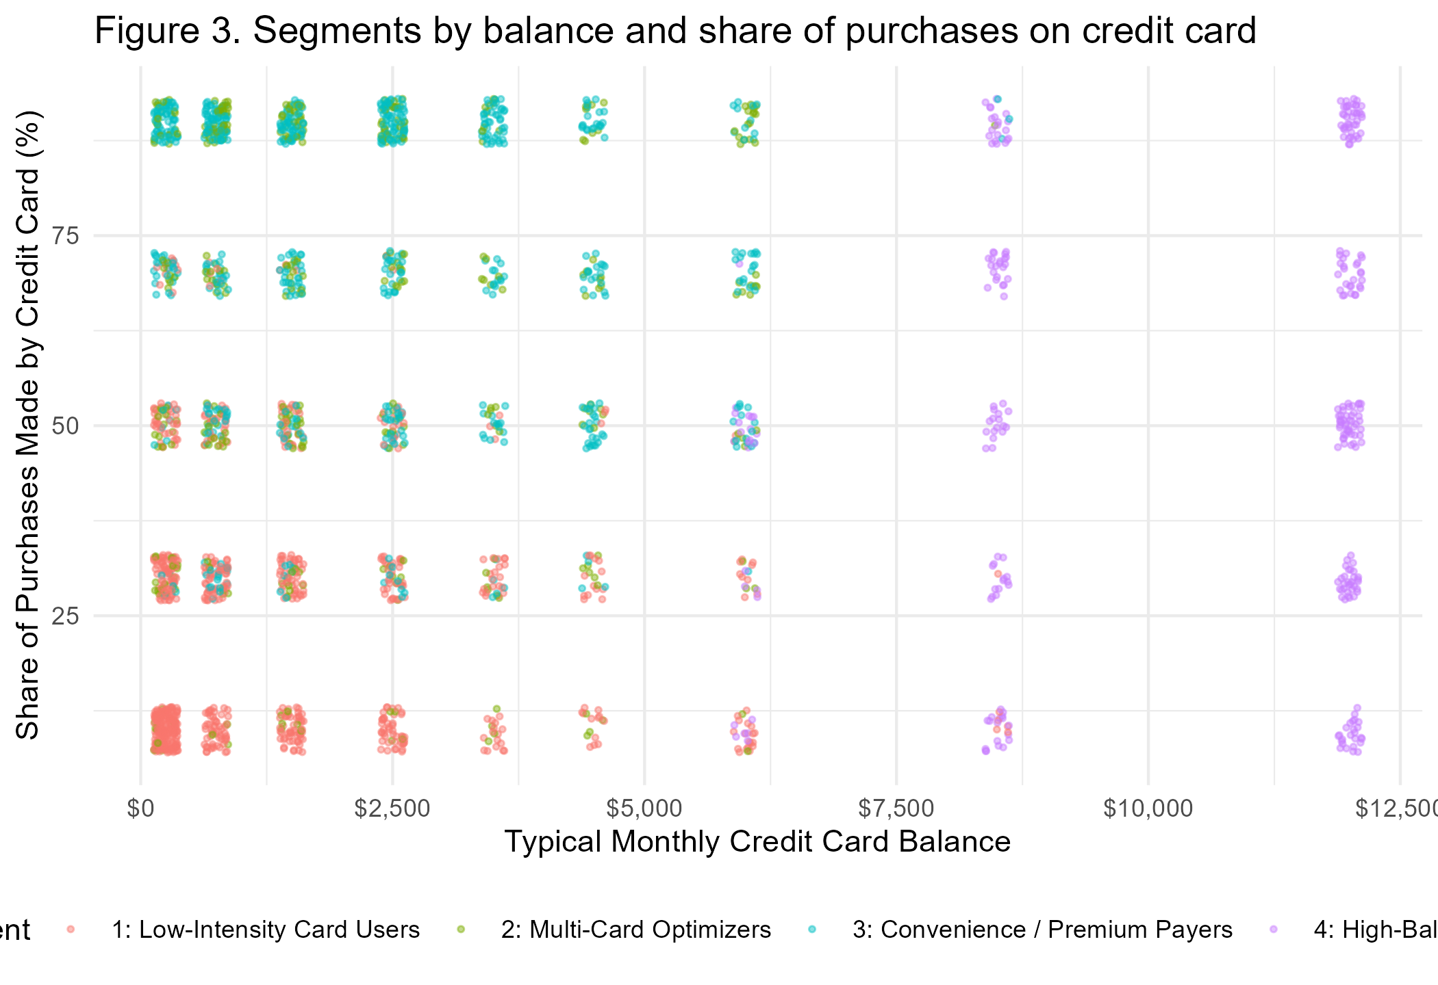
Figure 3. Segments by monthly credit card balance and share of purchases made by credit card. Points are jittered to reveal overlapping discrete categories.
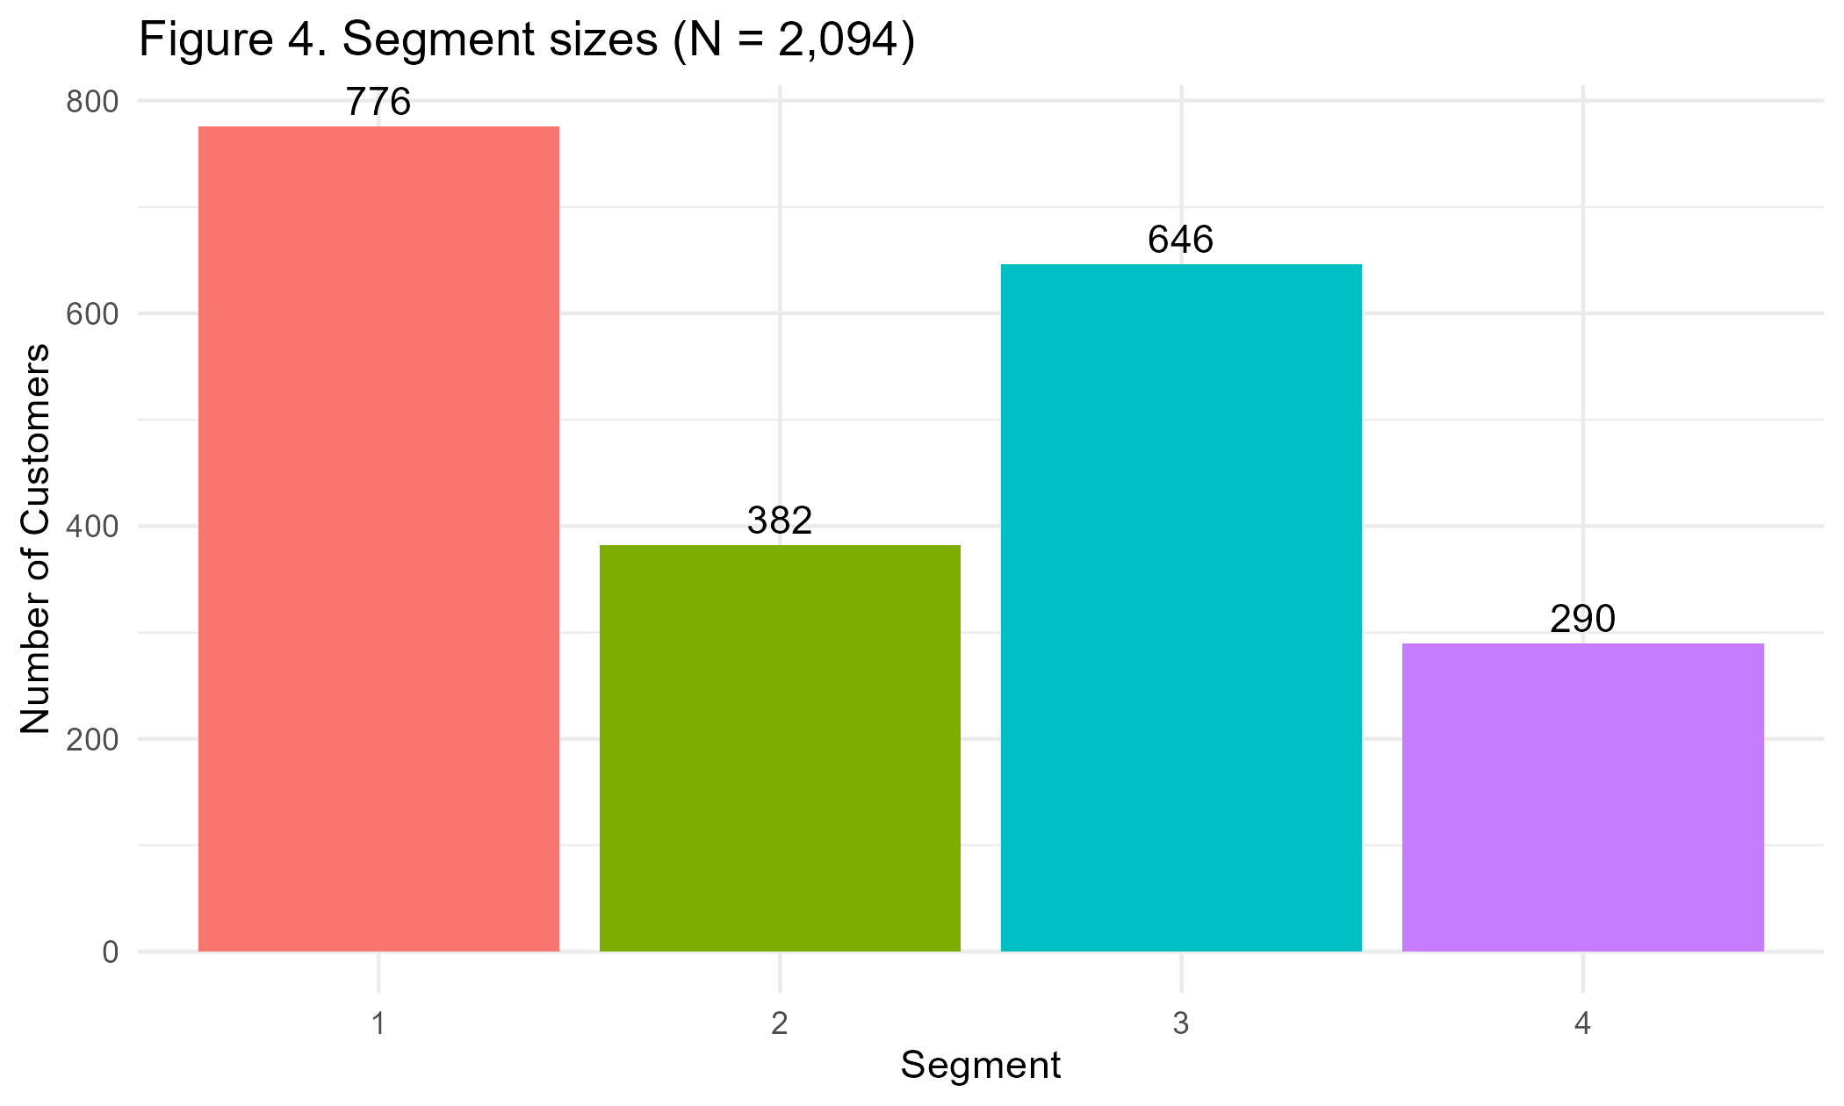
Figure 4. Number of customers assigned to each segment (N = 2,094).

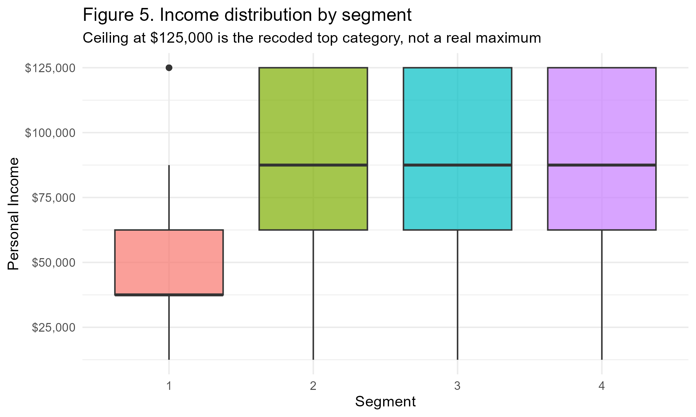
Figure 5. Distribution of personal income within each segment. The $125,000 ceiling is the recoded midpoint of the top income band.
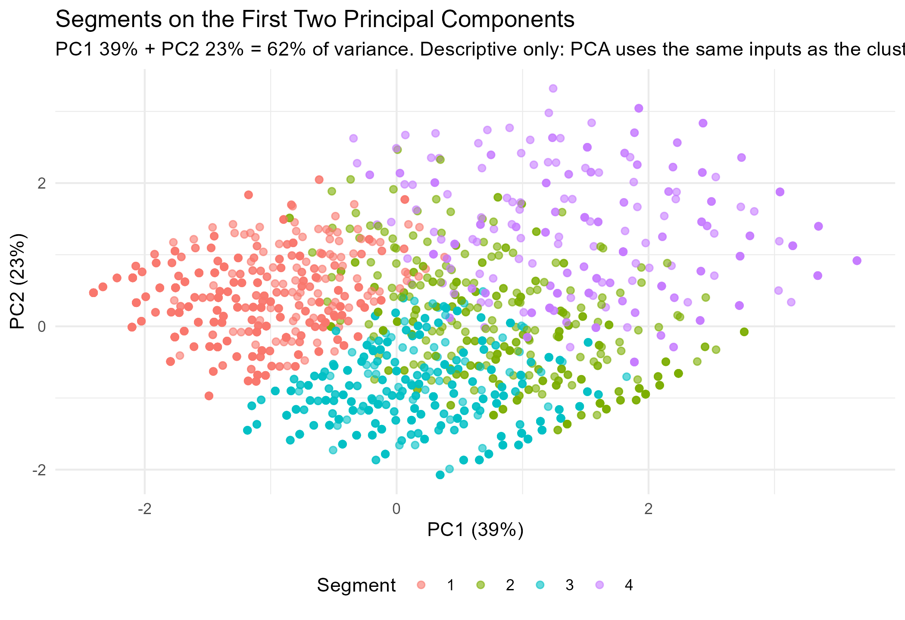
Figure 6. Segments projected onto the first two principal components (62.0% of total variance). Descriptive only; PCA uses the same inputs as the clustering.

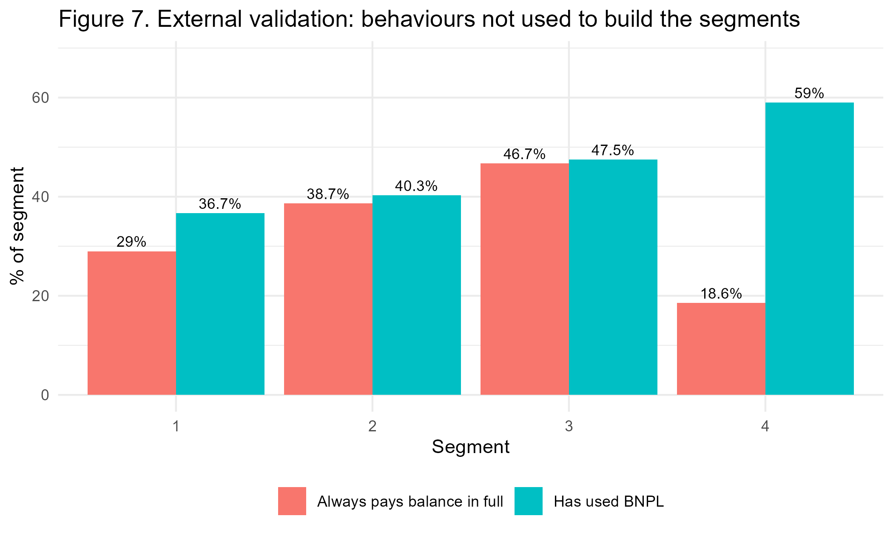
Figure 7. External validation. Neither pay-in-full behaviour nor BNPL use was supplied to the clustering algorithm, yet both differ significantly across segments.
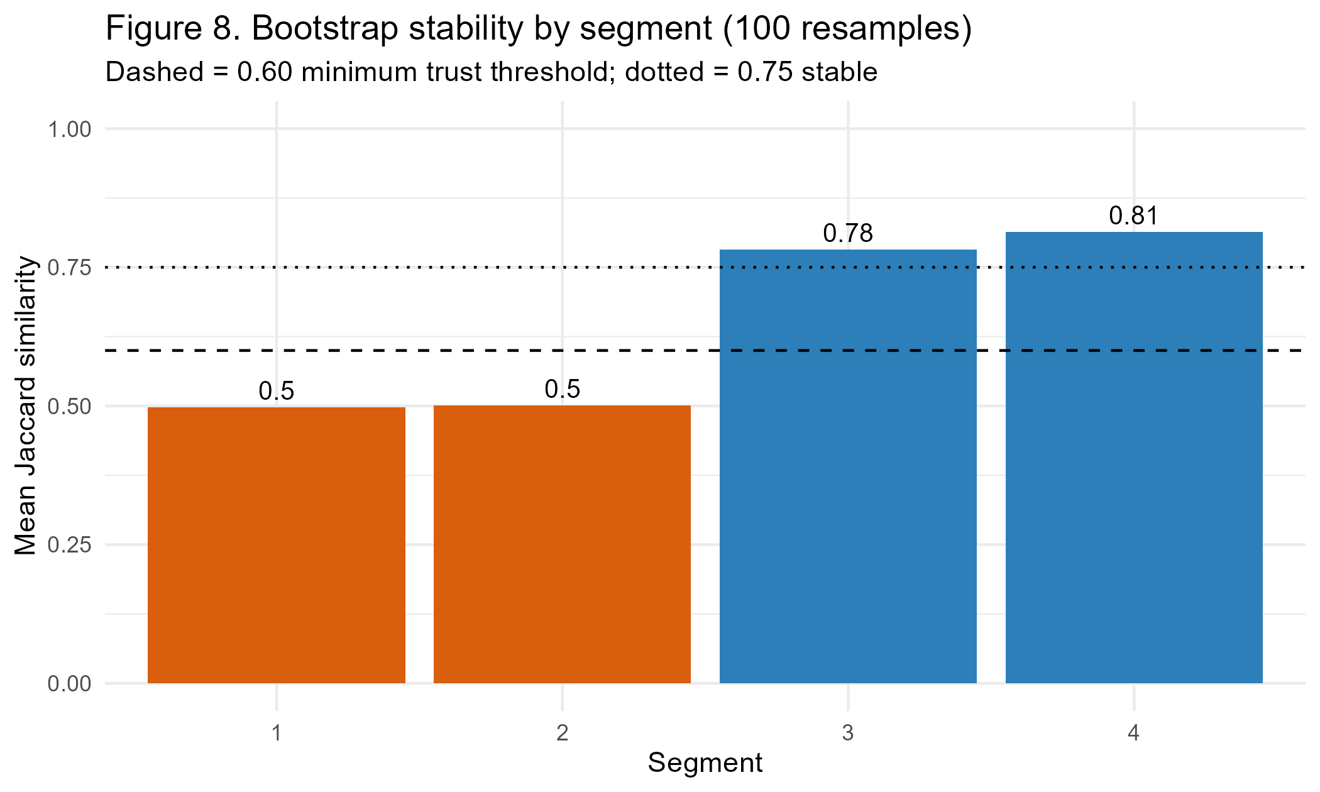
Figure 8. Bootstrap cluster stability over 100 resamples. Clusters 1 and 2 fall below the 0.60 threshold and are treated as provisional.

