Healthcare Data Warehouse: Power BI Analysis

CPSC-510-22
Data Warehousing & Visualization

ISRAEL OSE OBOKOHWO
NF1041893

University of Niagara Falls

August, 2026
Dataset Description
The source data models hospital and clinic activity as a set of eight files: one fact table (FactEncounter, 1,500 rows) and seven dimension tables (Date, Patient, Provider, Facility, Diagnosis, Procedure, and Payer). Each row in FactEncounter represents a single patient encounter and carries the billing amounts, length of stay, and a readmission flag, alongside foreign keys to every dimension. The dimensions describe 479 distinct patients, 10 facilities across four states, 40 providers, 20 diagnosis codes grouped into Acute or Chronic, and 15 procedures grouped into Lab, Surgery, or Imaging.
Summary of ETL Steps (Power Query)
First, I Imported all eight tables and renamed each for readability (e.g. DimDate to Calendar Table, DimPatient to Patient Table, DimFacility to Facility Table), so it could be interpreted easily.
Profiled every table using the column quality and column distribution tools. This is where the DischargeDateID corruption surfaced: roughly a quarter of encounters carried a DischargeDateID that does not correspond to a real calendar date. I rebuilt DischargeDateID from AdmissionDateID and LengthOfStay using Date.AddDays, then converted the result back to the yyyymmdd integer key so it still joins to the Calendar table. This replaced the corrupted values without discarding the underlying admission or stay data.
I also added calculated columns to the Calendar table “Start of the Year, Start of the Quarter, Start of the Month, Month Name, and Week of the Year” using the built-in Date functions in Power Query.
I created Patient Profile in the Patient table by combining Gender, AgeGroup, and State with a comma separator, giving a single readable descriptor per patient for use in tooltips and matrix rows.
I converted the numeric ReadmissionFlag into a readable Readmission Category column (Yes for 1, No for 0) using a conditional column.
I checked every table for missing values, empty strings, and inconsistent types; none of the dimension tables required further cleaning beyond correct type assignment (whole number keys, text categories).
Data Model
The model follows a star schema. FactEncounter sits at the centre and connects to every dimension through single-direction, one-to-many relationships on the surrogate keys (PatientID, ProviderID, FacilityID, DiagnosisID, ProcedureID, PayerID). The Calendar table connects on AdmissionDateID as the active relationship, which drives all time-based visuals and time-intelligence measures. A second relationship from DischargeDateID to Calendar is kept inactive, since a fact table can only actively relate to a date table once, and is invoked explicitly with USERELATIONSHIP where a discharge-based view is needed. Calendar is marked as an official Date Table on FullDate, which enables the built-in time-intelligence functions used in Section 4.
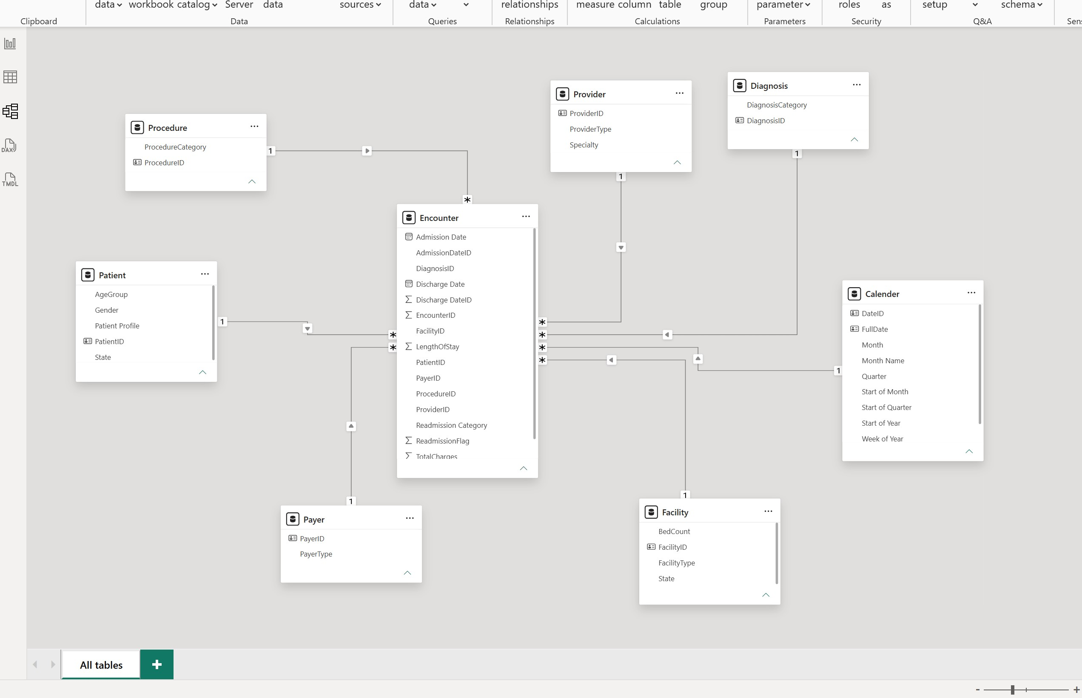
Figure 1. Star schema in Power BI Model view: FactEncounter (Encounter) at the centre, six dimension tables and the Calendar date table on the edges.
DAX Measures
Twenty-five measures were built, covering every required family with margin to spare: 8 Math and statistical, 5 Counting, 4 Logical and conditional, 4 using CALCULATE to modify filter context, and 4 Time intelligence measures. The full list with purpose and logic is in Table 1.
# | Measure | Type | Purpose and logic
1 | Total Encounters | Counting | COUNTROWS of the fact table; total hospital activity volume.
2 | Total Charges | Math/stat | SUM of gross amounts billed across all encounters.
3 | Total Cost | Math/stat | SUM of the cost incurred to deliver those encounters.
4 | Distinct Patients | Counting | DISTINCTCOUNT of PatientID so repeat visitors are not double counted.
5 | Avg Length of Stay | Math/stat | AVERAGE stay duration in days, an operational efficiency indicator.
6 | Median Charge | Math/stat | MEDIAN charge, unaffected by extreme values unlike the mean.
7 | Charge Std Dev | Math/stat | STDEV.P of charges; shows how tightly billing clusters.
8 | Avg Charge per Encounter | Math/stat | Total Charges divided by encounter count, a per-case revenue figure.
9 | Contribution Margin | Math/stat | Total Charges minus Total Cost; gross profit in dollars.
10 | Margin % | Math/stat | Contribution Margin as a share of Total Charges.
11 | Readmitted Encounters | Counting | COUNTROWS filtered to ReadmissionFlag = 1.
12 | Encounters per Patient | Counting | Total Encounters divided by Distinct Patients; utilisation intensity.
13 | Active Facilities | Counting | DISTINCTCOUNT of FacilityID appearing in the fact table.
14 | Readmission Rate | Logical | DIVIDE(Readmitted, Total Encounters) to handle a zero denominator safely.
15 | Margin Status | Logical | SWITCH(TRUE()) bands margin into Above Target, On Target, Below Target.
16 | Readmission Alert | Logical | IF flags any grouping exceeding an 18% readmission rate.
17 | High Cost Encounters | Logical | Counts encounters above the 75th-percentile charge ($36,506).
18 | Hospital Charges | CALCULATE | Filter context modified to hospital facilities only.
# | Measure | Family | Purpose and logic
19 | Clinic Charges | CALCULATE | Filter context modified to clinic facilities only.
20 | % of Total Charges | CALCULATE | CALCULATE with ALL removes the facility filter for a share-of-total.
21 | Chronic Readmission Rate | CALCULATE | Readmission Rate applied within a Chronic diagnosis filter.
22 | Charges YTD | Time intel. | TOTALYTD accumulates charges from the start of the calendar year.
23 | Charges PY | Time intel. | SAMEPERIODLASTYEAR shifts filter context back one year.
24 | Charges YoY % | Time intel. | Compares current to prior-year charges as a growth percentage.
25 | Encounters Rolling 90 Days | Time intel. | DATESINPERIOD gives a trailing 90-day count, smoothing short-term noise.
Table 1. All 25 DAX measures, grouped by required function type.

Actionable Insights
Discharge dates were unreliable for a quarter of all encounters.
Profiling FactEncounter found 373 of 1,500 rows (24.9%) with a DischargeDateID that did not correspond to a real calendar date, for example 20211040 (month 10, day 40). Every affected row still had a valid AdmissionDateID and LengthOfStay, so the fix was to regenerate DischargeDateID with Date.AddDays rather than drop the rows. Any report built on the original discharge dates before this fix would have understated activity for one in four encounters.
Imaging procedures readmit patients at nearly one and a half times the rate of Lab work.
Imaging carries a 20.1% readmission rate versus 14.1% for Surgery and 13.9% for Lab, visible on the Clinical Overview page. By specialty, Pediatrics (18.0%) and Cardiology (16.9%) sit above the 18% alert threshold band, while Internal Medicine (12.9%) is the most stable. This points to Imaging follow-up protocols as the first place to investigate for readmission reduction.
Margin percentage is essentially flat across facility type, but volume is not.
Clinics and Hospitals both convert charges to margin at about 39.6-39.7%, so the Margin % measure alone does not distinguish them. Clinics process more encounters (787 vs 713) and bill more total charges ($19.1M vs $17.2M), so the volume difference, not efficiency, is what separates the two facility types financially.
Lab work drives almost half of total billing despite being the lowest-readmission category.
Lab procedures account for 44.9% of the $36.29M in total charges, ahead of Surgery (33.8%) and Imaging (21.3%). Combined with the readmission finding above, Lab is both the safest and the most revenue-significant procedure category, while Imaging is smaller in volume but carries disproportionate clinical risk.
Revenue is fairly evenly spread across states, with New York narrowly leading.
NY facilities bill $10.97M (30.2% of total), IL $10.79M, CA $7.48M, and FL $7.04M. No single state dominates the portfolio, which the bar chart on the Executive Overview page confirms visually; this reduces concentration risk if any one state's facility performance were to decline.
Limitations and Optimization
Limitation: the dataset is a flat, static extract with no slowly-changing-dimension history, so patient or facility attributes (e.g. state, age group) are treated as always having been true, which is a simplification for any patient who moved or aged into a new bracket. The corrected DischargeDateID is also a modelled estimate (Admission + LengthOfStay), not the original source value, so any downstream discharge-based reporting inherits that assumption.
Optimization applied: Calendar was marked as an official Date Table with a single active relationship to FactEncounter on AdmissionDateID, leaving the DischargeDateID relationship inactive. This keeps the default filter path unambiguous for every time-based visual and measure, avoids the circular-filter risk of two simultaneous active date relationships, and still lets the small number of discharge-based analyses reach Calendar on demand through USERELATIONSHIP, so a second date table was not needed.

