DAMO-510-14 Predictive Analytics
Summer 2026
Take-Home Assignment 2
Predictive Maintenance: Machine Failure Prediction
AI4I 2020 Predictive Maintenance Dataset
Israel Obokohwo
Student number: NF1041893
Assigned random seed: 93
Every split, fold, model initialisation and resampling step in this study uses seed 93.
30 August 2026

1. Introduction and problem framing
A machining line rarely fails without warning. It fails after torque, spindle speed, tool wear and process heat have drifted into a combination it cannot hold, and this study asks whether those quantities, read live, carry enough warning to act on. The target is Machine failure, 1 on 339 of 10,000 records and 0 on the remaining 9,661.
The users are not analysts. The maintenance team decides which machines to pull from this week's schedule while a supervisor decides if an alarm justifies stopping a job in the middle of an operation. Both operations have a cost if two errors are made. A false negative would be a machine deemed healthy but failed on the job, costing an unplanned stoppage and a line idle behind it. A false positive is an inspection that finds nothing. Treating those as comparable is what a 0.5 threshold silently does.
Therefore, I weight recall and the precision-recall curve most heavily, and report accuracy only because it is required. At a 3.39 per cent positive rate (Figure A1), predicting no failure everywhere scores 96.61 per cent accuracy while catching nothing. PR-AUC is my selection metric: its baseline is the base rate itself, and it responds to false alarms in a way ROC-AUC does not when the negative class outnumbers the positive by 28.5 to one.

2. Data audit and leakage assessment
The file is the original UCI archive copy, 10,000 rows by 14 columns, saved untouched before anything changed: two identifiers, one categorical predictor, five numeric sensors, the target and five failure-mode flags (Table B1). There are no missing cells and no duplicated rows, and process temperature exceeds air temperature on every record. Rotational speed has 418 readings beyond 1.5 interquartile ranges, reaching 2886 rpm (Table B2); I kept them, because they form a continuous right tail and removing them would delete part of the low-torque failure region found in Section 3.
UDI is a row counter with 10,000 unique values, encoding position in the file and nothing about the machine. Product ID is subtler: its 10,000 unique values make it useless as a category, and its first character reproduces Type on 100 per cent of rows, so it is a redundant copy of a variable I keep. I dropped both (Table B6).

2.1 The five failure mode flags
TWF, HDF, PWF and OSF deserve more than a one-line dismissal, so I tested the relationship. Their logical OR reproduces Machine failure on 9,991 of 10,000 records, 99.91 per cent (Table B5). The disagreement is entirely one sided: 0 records where a mode fires and the target is 0, and 9 where the target is 1 and no mode fires. Individually, TWF fires 46 times and all 46 are failures; HDF 115 times, PWF 95 and OSF 98, every one a failure (Tables B3 and B4).
This is a mathematical issue as the operational case is separate and stronger: these flags are diagnoses assigned after an engineer has established why a machine failed, so on a running machine none of them exists. A model trained on them would score almost perfectly in cross-validation and have nothing to read when asked to predict.
RNF behaves differently. It fires on 19 records, one of which carries a failure label, and that row also has TWF set; where RNF fires alone, 0 of 18 are failures. It is no part of the target's definition, a documented quirk of this dataset, so keeping it would import 18 rows of noise into a problem with only 339 positives. The nine records where the target is 1 with no mode set stay in: I have no basis for deleting labelled failures, and Section 7 shows they matter.

3. Exploratory findings
No single sensor separates the classes. Torque is strongest at a univariate AUC of 0.770 and process temperature manages 0.564 (Table B7, Figure A2), so a single-threshold alarm rule is not available. Torque and rotational speed correlate at -0.875 and the two temperatures at 0.876, giving variance inflation factors near 4.3 (Tables B8, B9 and B15, Figure A3). That is irrelevant to the tree models and not to logistic regression, so I kept the L2 penalty on and read those coefficients with caution.
The most useful finding is where failures sit in the torque and speed plane (Figure A4). 100 of the 339 failures have torque at or above 60 Nm with the spindle at or below 1,500 rpm, and another 36 have torque at or below 25 Nm above 1,800 rpm. Those are opposite corners. Binning the mechanical power they imply makes it explicit: failure rates of 4.00 per cent in the lowest decile, 1.32 per cent across deciles four to seven, and 16.90 per cent in the highest (Table B10, Figure A5). Risk is U-shaped in power, and a linear boundary cannot enclose two opposite corners of a plane. This predicted the result in Section 6 before any model was fitted.
Heat dissipation teaches the same lesson differently (Figure A6). A temperature gap below 8.6 K alone carries a 1.82 per cent failure rate and a spindle below 1,380 rpm alone carries 8.27 per cent. Together they carry 100 per cent: all 115 records meeting both failed (Table B11). Neither margin comes close to the joint condition, which is the structure an additive model must approximate with main effects it does not have.
Two smaller findings completed the picture. Tool wear behaves as a step rather than a slope, 2.21 per cent below 50 minutes against 28.57 per cent in the 240 to 260 band (Table B14, Figure A8). Failure rate varies by grade too, 3.92 per cent for L against 2.09 per cent for H, which is not a property of the grade: the overstrain limit moves from 11,000 for L to 13,000 for H, and above its own limit every grade fails 100 per cent of the time (Tables B12 and B13, Figure A7).

4. Preprocessing and feature development
Six predictors remain: product grade and the five sensors. I split 10,000 rows into 8,000 for training and 2,000 for testing, stratified on the target at seed 93, giving 271 failures in training and 68 in test (Table B16). An unstratified draw could land ten failures away from expectation, moving recall by several points for reasons unconnected to any model.
Everything else happens inside a scikit-learn Pipeline, so each transformer is fitted on the training folds and applied to the validation fold. Three steps are common to all four models: dropping the identifiers and flags, one-hot encoding the grade, and median imputation, which is redundant here and kept because a deployed model will meet sensor dropouts a static file does not contain (Table B17). One step is deliberately model-specific. I standardise for logistic regression only, because the L2 penalty is scale sensitive and torque in newton metres beside a wear-torque product in the thousands would be penalised wildly differently, while trees split on rank order and would only lose readable units.

4.1 The engineered features and their evidence
I built three features from the physics the documentation describes rather than from trial and error (Table B18): mechanical power in watts, torque times angular velocity with rpm converted to radians per second; the temperature differential, process minus air; and the wear-torque product. Each corresponds to a documented failure mode.
I fixed the retention rule before running anything: keep a feature if dropping it costs at least 0.005 cross-validated PR-AUC in either model, or if it ranks in the top half of the Random Forest importance table. All evidence comes from the training partition, because choosing features on the test set is a selection leak even before a model is fitted. Adding all three lifts the forest from 0.7381 to 0.8847 and logistic regression from 0.4108 to 0.4449 (Tables B19 to B21, Figures A9 and A10). Leave-one-out costs are 0.0383, 0.0516 and 0.0163 (Tables B22 and B23), so all three were retained.
One result cut against expectation and I am reporting it rather than burying it. Dropping the wear-torque product improves logistic regression by 0.0219 while costing the forest 0.0163; the rule retained it on the forest evidence, and Section 8 shows why the two disagree. Replacing the raw temperatures with their difference scored 0.8895 against 0.8847, well inside the fold standard deviation, so I kept the readings an operator can check.

5. Modelling approach and tuning
Before fitting anything I established what the models had to beat (Table B24, Figure A11). Predicting no failure everywhere gives 96.60 per cent accuracy and catches none of the 68 test failures; stratified guessing gives 94.15 per cent and finds 4. More usefully, two rules a planner could apply today: tool wear above 200 minutes catches 20 failures at 13.3 per cent precision, and power outside the 3,500 to 9,000 W band catches 22 at 100 per cent precision for an F1 of 0.4889, the number the models had to beat.
I declared the selection metric before searching: cross-validated PR-AUC over 5-fold StratifiedKFold with shuffle and random_state 93. ROC-AUC is reported but not used to select, because its false-positive-rate axis is dominated by the 9,661 healthy records, so fifty extra false alarms barely move it while mattering greatly to the crew.
Each model was fitted at library defaults, then searched: exhaustive grids of 16 and 140 configurations for logistic regression and the Decision Tree, and randomised search with 80 draws for the ensembles, whose spaces run to 1,800 and 116,640 combinations. That is 316 configurations and 1,580 fits (Tables B25 to B27 and B57 to B60). The search paid off very unevenly (Table B28, Figure A12). The Decision Tree gained 0.2061 PR-AUC, from 0.6906 to 0.8967, almost entirely by being stopped from growing to purity at depth 6 with ten samples per leaf. XGBoost gained 0.0227 and the forest 0.0165. Logistic regression gained -0.0005, because no amount of tuning changes what a linear boundary can represent.

5.1 Class imbalance
I held each tuned structure fixed and varied only the imbalance treatment, comparing none against class weighting, SMOTE, and SMOTE with undersampling. The resampler sits inside the pipeline, so it is refitted on each training fold and never touches the fold being scored, the only way SMOTE can be used without inflating the result. The trade-off is large and runs one way (Tables B29 and B30, Figures A13 and A14). Class weighting moves logistic regression from 0.2177 recall to 0.8415, which sounds decisive until precision falls from 0.7598 to 0.1695. For the forest, recall goes from 0.8156 to 0.8562 while precision falls from 0.9747 to 0.6041. In all twelve combinations recall rises and precision falls, and none improves the ranking: PR-AUC changes by -0.0291 and -0.0296 respectively, and every one of the twelve is negative. I retained no treatment, on the rule that the highest cross-validated PR-AUC wins (Table B31). These interventions relocate the 0.5 cut-off on a ranking they do not otherwise change, which is a threshold decision wearing a resampling costume. Section 7 makes the same move directly, where it can be tuned against a cost.

6. Results and model comparison
The test set was scored once, after every decision above (Tables B32 and B33, Figures A15 to A17). At the default 0.5 threshold the Decision Tree leads every point metric: accuracy 0.9925, precision 1.0000, recall 0.7794, F1 0.8760, catching 53 of 68 failures with 0 false alarms. The Random Forest catches the same 53 with 1 false alarm, XGBoost 51, logistic regression 15.
The ranking metrics disagree, and that is the most interesting result here. The forest leads on ROC-AUC, 0.9792 against 0.9709, and PR-AUC, 0.9048 against 0.8849. The reason is visible in the predicted probabilities: the tuned tree emits only 10 distinct values on the test set, one per reachable leaf, where the forest emits 1,920 (Table B35). A model with 10 possible scores has 10 possible operating points, so the tree's advantage at 0.5 is a fact about where its leaves happened to fall, not a property that survives being asked for more recall.
So which model is best splits on what the plant intends to do (Table B34). One that will run at a fixed default and never revisit it should take the Decision Tree, also the cheapest to explain. One wanting to choose its own balance between the 15 missed failures and the inspections that reducing them would cost needs a dial with positions on it, and only the forest and XGBoost have one. Accuracy separates nothing: the four span 0.9720 to 0.9925 while differing threefold in failures caught, and the do-nothing baseline sits at 0.9660. Logistic regression is weakest everywhere, 0.5408 PR-AUC against 0.9048, which is Section 3 coming true on held-out data.

6.1 Does any of this survive a change of conditions?
I ran two checks that change the analytical conditions rather than recomputing the same numbers (Tables B52 to B54, Figure A25). The first re-runs the whole protocol under ten seeds, each driving both the partition and every model's initialisation. The forest wins 10 of the ten on PR-AUC, averaging 0.9034 with a standard deviation of 0.0135 and a range of 0.8725 to 0.9248; its seed 93 value of 0.9048 sits well inside that, and logistic regression is last on all ten. That spread warns how precisely to read any single figure here.
The second deletes the three engineered features and refits. The forest falls from 0.9048 to 0.7859 PR-AUC and the Decision Tree loses 0.3233 (Tables B55 and B56), so the feature work is doing real work rather than decorating the pipeline. This check qualifies my recommendation rather than reinforcing it: without the engineered features XGBoost takes first place at 0.8252 against 0.7859. Part of the forest's lead is that it exploits these particular features better than the alternatives do, and I would not claim it wins on any feature set.

7. Threshold and error analysis
I swept the Random Forest across eleven thresholds and then at 0.01 resolution (Tables B36 and B37, Figure A18). Choosing among them needs a cost and this dataset contains none, so I state one: a missed failure costs ten false alarms. An unplanned stoppage against an inspection that finds nothing makes an order of magnitude plausible for a machining line. It is assumed, not sourced.
That sweep shows the shape of the trade-off and is the wrong place to pick a number from, because a threshold chosen on the test set has seen the data it is then scored on. So I repeated the selection on out-of-fold predictions from the training partition alone, same five folds and same seed, and carried the winner across untouched (Tables B61 and B62). That gives 0.23. At the default the forest misses 15 failures and raises 1 false alarm for an expected cost of 7,550. At 0.23 it misses 11 and raises 6, for 5,800. The move buys 4 fewer missed failures for 5 extra inspections across 2,000 records, with recall rising from 0.7794 to 0.8382 while precision falls from 0.9815 to 0.9048. For comparison, the threshold that is optimal on the test set itself is 0.14 and would have cost 5,550, so the honest out-of-fold choice gives up 250 units, about 5 per cent, which is the size of the optimism avoided.
I then tested how much of that depends on the assumed ratio, and the answer is uncomfortable (Table B38, Figure A19). At 2:1 and 5:1 the optimum is 0.32, at 10:1 it is 0.14, and at 20:1 and above it collapses to 0.02 where recall reaches 0.956 and precision falls to 0.363. The argmin is genuinely unstable. What is stable is the comparison against the default: across that whole range the recommended 0.23 never costs more than 110.6 per cent above the best achievable, where the default reaches 184.5 per cent (Table B39). So I recommend 0.23, while noting that the defensible part of the claim is the direction, not the decimal place.

7.1 Ten real mistakes
At that threshold the forest makes 6 false positives and 11 false negatives. I took the five it was most confident about and the five it was least worried by (Tables B40 to B45, Figures A20 and A21). The false positives are barely errors. Their median wear-torque product is 6,350 against a healthy median of 3,984 and a failure median of 6,916, and 4 of the five are L-grade, which carries the lowest overstrain limit. Case FP1, UDI 4856, ran at 46.2 Nm and 1375 rpm with a 8.6 K gap and was scored 0.574; three come from one production run, UDI 4856 to 4863. These are machines operating in the conditions under which failures happen that happened not to fail, and a planner would want them inspected.
The false negatives matter more, and they point at the data rather than the model. All five sit inside the safe 3,500 to 9,000 W power band, their median wear-torque product is 6,426 against a failure median of 6,916, and the highest probability the forest gave any of them was 0.029, which is not a near miss. The explanation is in Section 2: three of these five, UDI 1438, 8507, 5537, are among the nine records labelled as failures with none of the four documented modes set. They carry a failure label with no signature in any sensor provided, so no threshold reaches them.

8. Interpretation
The three tree-based models have learned close to the same thing. Spearman rank correlation between their importance orderings is 0.939 for the tree against the forest and 0.952 for the forest against XGBoost; against logistic regression the same correlations fall to 0.276 and 0.479 (Tables B47 to B50). Rotational speed, mechanical power and the temperature gap are placed consistently by all four, with a rank spread of two or less (Table B51, Figures A22 and A23).
The sharpest disagreement is the wear-torque product, ranked 1 by the Decision Tree, 1 by the forest and 8 by logistic regression. This is not a dispute about how a machine works. A linear model applies one monotone coefficient to a variable, and Section 3 showed the dangerous value of that product depends on the grade, so the trees carve out a region while the regression compromises across all of them. The same mechanism explains its treatment of power: asked to represent a U shape with one coefficient, it settles in the middle and captures neither tail.
Set against Section 3 the agreement is good: the models put torque, speed, power, the wear-torque product and the temperature gap at the top, and grade is minor everywhere. It is reasonable in machine terms. A spindle turning slowly against high torque is drawing power near its design limit, and a process a few degrees above ambient is not shedding heat.

9. Final recommendation
I recommend the Random Forest, operated at 0.23 rather than 0.5. On the held-out test set it flags 63 of 2,000 records, of which 57 are real failures and 6 false alarms, so a crew acting on every alarm inspects 63 machines and finds 57 real problems: 83.8 per cent of failures caught at 90.5 per cent precision.
The case against the Decision Tree was the hardest, because it beats the forest on every point metric at 0.5 and is far easier to explain. I chose against it on operational grounds: with 10 reachable leaves it offers 10 operating points, so a plant that later wants 90 per cent recall has to refit rather than turn a dial. A single tree is also the least stable under resampling, and the forest's averaging buys the finer ranking. XGBoost sits close behind on PR-AUC, 0.8734 against 0.9048, and I would have no objection to it beyond more hyperparameters to maintain for no measured gain.
Logistic regression is the model I would most like to recommend, because a coefficient table is something a supervisor can argue with and a forest is not. It finds 15 of 68 failures against 57 for the forest, and no amount of interpretability compensates for missing 78 per cent of what it exists to catch, so I keep its coefficients as an explanatory companion rather than a decision rule (Table B46, Figure A24). The recommendation carries no resampling, for the reasons in Section 5.1.

10. Limitations and future work
Four limitations, two specific to what I found. The first is the nine records labelled as failures with no failure mode set, three of which appear among my five worst false negatives. They are unlearnable from the features provided and cap recall at a level no threshold can lift, worth roughly four points on a test set holding 68 failures. The second is that AI4I 2020 is synthetic: its failure modes come from documented rules on exactly the variables supplied, which is why an operator rule already reaches 0.4889 F1 and the forest 0.9048 PR-AUC. Real data has drift and modes nobody wrote a rule for, so I expect a drop and cannot size it from this file.
The third is the cost ratio: everything downstream of the 10:1 assumption inherits it, and the optimum moved from 0.32 to 0.02 across a plausible range. The fourth is that the data has no time dimension. Each row is a snapshot with no machine identifier, so tool wear is the only history and I could not build a trend. My random split is optimistic for the same reason: a deployment predicts forward in time.
Three things I would investigate next. Validating the cost ratio with the maintenance team would firm up the number the recommendation is most exposed to, and costs a conversation rather than a model. Second, the four failure modes are separate mechanisms, so a multi-class model predicting which one is developing would tell a technician where to look. Third, calibration: I have treated the forest's scores as probabilities and they are known to be poorly calibrated, so isotonic scaling would put the threshold on a real one.

11. Analytical Decision Record
Twelve decisions that shaped the analysis, each one demonstrated in the submitted code and outputs.
Decision | Evidence considered | Alternatives | Final choice | Consequence
Exclude TWF, HDF, PWF and OSF as leakage | OR of the four reproduces the target on 9,991 of 10,000 rows (99.91%), with 0 rows where a flag fires and the target is 0. They are also post-hoc diagnoses unavailable at prediction time. | Keep them and report near-perfect scores; keep a subset; engineer a lagged version. | Excluded all four. | Test PR-AUC drops from near 1.0 to 0.9048, which is the honest number for the deployable problem.
Exclude RNF on separate grounds | RNF fires 19 times; only 1 is a failure and that row also has TWF set. On 18 rows where it fires alone, 0 are failures. | Group it with the other four; keep it as a predictor. | Excluded, but as noise rather than leakage. | Avoids importing 18 rows of unpredictable signal into a problem with only 339 positives.
Drop Product ID rather than encode it | 10,000 unique values, and its first character equals Type on 100% of rows. | Target encoding; use only the leading character; keep as categorical. | Dropped; kept Type instead. | Removes a redundant copy of a retained variable and thousands of useless levels.
Keep the high rotational-speed readings | 418 values beyond 1.5 IQR, maximum 2886 rpm, forming a continuous tail rather than a separate cluster. | Winsorise; remove; log-transform. | Kept unchanged. | Preserves the low-torque high-speed failure corner holding 36 of 339 failures.
Scale for logistic regression only | The L2 penalty is scale sensitive; tree splits are rank based. | Scale everything; scale nothing; use a scale-free penalty. | StandardScaler inside the logistic pipeline only. | Coefficients become comparable across predictors while the tree models keep readable units.
Build three physics-based engineered features | Adding them lifts cross-validated PR-AUC from 0.7381 to 0.8847 for the forest; leave-one-out costs are 0.0383, 0.0516 and 0.0163. | Raw sensors only; polynomial expansion; automated feature selection. | Retained all three under a rule fixed in advance. | Held-out ablation confirms 0.1189 PR-AUC of the forest's performance depends on them.
Keep the raw temperatures alongside their difference | The leaner variant scored 0.8895 against 0.8847, inside a quarter of the fold standard deviation. | Replace the pair with the difference; drop process temperature. | Kept all three temperature columns. | No measured loss, and operators can check the raw readings on the machine. Costs some readability in the coefficient table.
Select on PR-AUC rather than accuracy or ROC-AUC | Majority-class accuracy is 96.61%; the negative class outnumbers the positive 28.5 to one. | Accuracy; F1; ROC-AUC; recall at fixed precision. | Cross-validated average precision, declared before searching. | Rankings are compared on the axis the plant pays for, and the threshold stays a separate decision.
Grid search for two models, randomised for two | Spaces of 16 and 140 configurations enumerate honestly; the ensembles span 1,800 and 116,640. | Grid everywhere with a smaller space; Bayesian optimisation. | 316 configurations, 1,580 fits in total. | Decision Tree gained 0.2061 PR-AUC from tuning; logistic regression gained -0.0005.
Retain no class-imbalance treatment | All twelve interventions reduced cross-validated PR-AUC. Recall rose and precision fell in every one. | class_weight='balanced'; SMOTE; SMOTE with undersampling. | None retained; imbalance handled at the threshold instead. | Keeps recall a controllable decision with a visible price rather than a side effect of a resampler.
Recommend the Random Forest over the Decision Tree | The tree leads every point metric at 0.5, the forest leads PR-AUC 0.9048 against 0.8849 and offers 1,920 operating points against 10. | Decision Tree for interpretability; XGBoost; an ensemble of both. | Random Forest. | Gives up some explainability to keep the threshold adjustable. Qualified by the ablation, where XGBoost leads without the engineered features.
Operate at 0.23 rather than 0.50 | Cost-minimising under an assumed 10:1 ratio; saves 2,000 units on the test set and is never worse than the default across ratios from 2:1 to 50:1. | 0.50; the F1-optimal 0.32; 0.02 under a 20:1 assumption. | 0.23, with the assumption stated. | Recall 0.8382 against 0.7794, precision 0.9048 against 0.9815. The weakest link in the study, since the ratio is assumed.

Appendix A: Figures
Every figure is rendered at 300 dpi and the source file is named beneath each caption. All are produced by the scripts in src/ under seed 93.
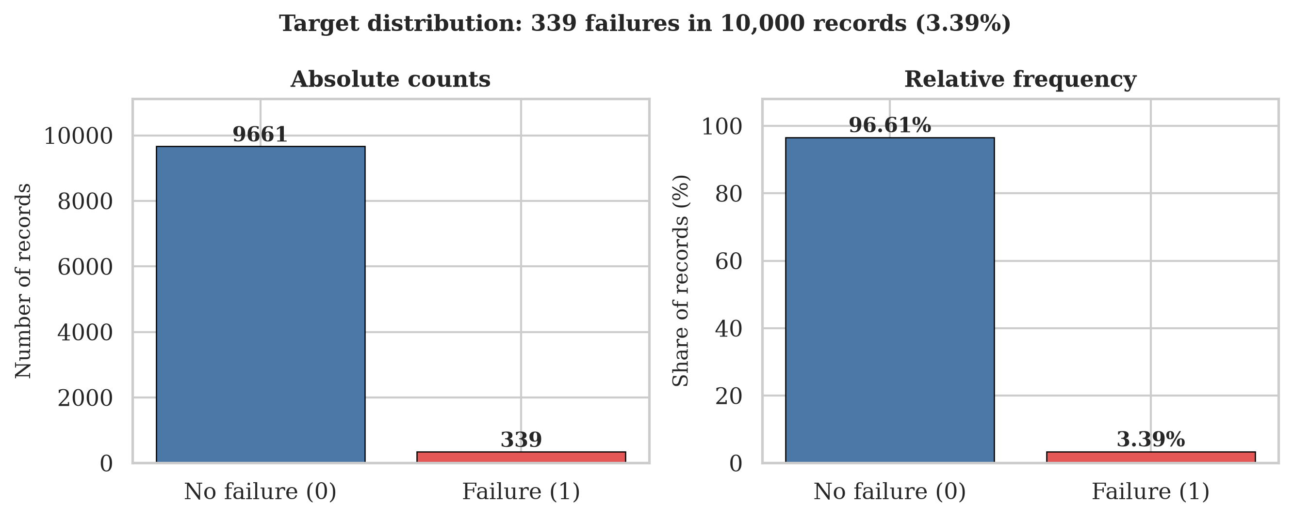
Figure A1. Distribution of the target variable. 339 of 10,000 records are failures, a positive rate of 3.39 per cent. This single fact is why accuracy is reported in this study but never used to choose anything.
Source: outputs/figures/fig01_target_distribution.png
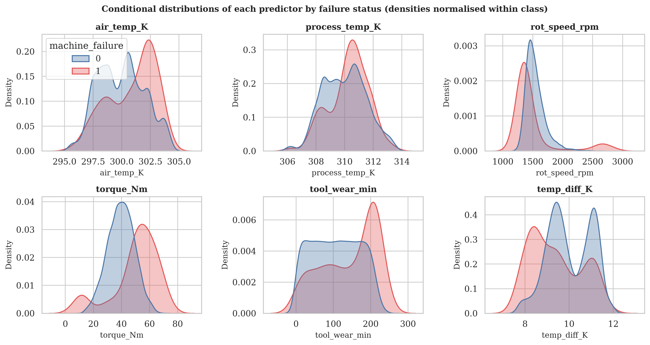
Figure A2. Each raw predictor's distribution conditioned on failure status, normalised within class so the rare class stays visible. The heavy overlap on every panel is the point: no single sensor separates the classes on its own.
Source: outputs/figures/fig02_conditional_distributions.png

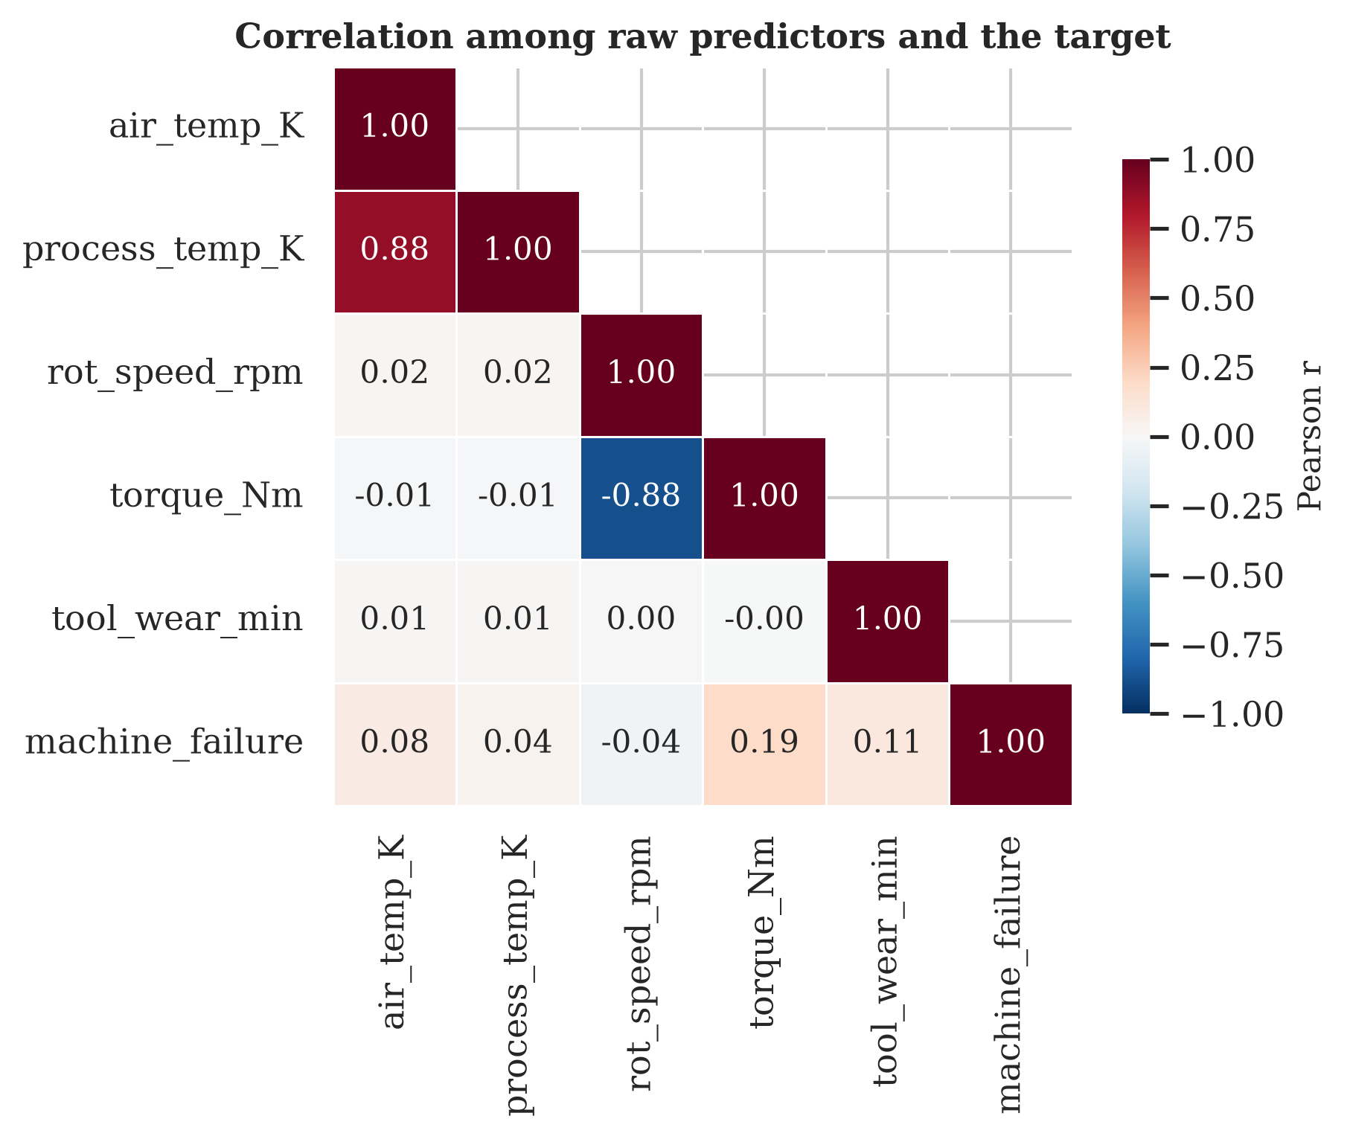
Figure A3. Pearson correlations among the raw predictors and the target. Air and process temperature correlate at 0.876 and torque and rotational speed at -0.875, which shapes both the feature engineering and the reading of the logistic coefficients.
Source: outputs/figures/fig03_correlation_heatmap.png
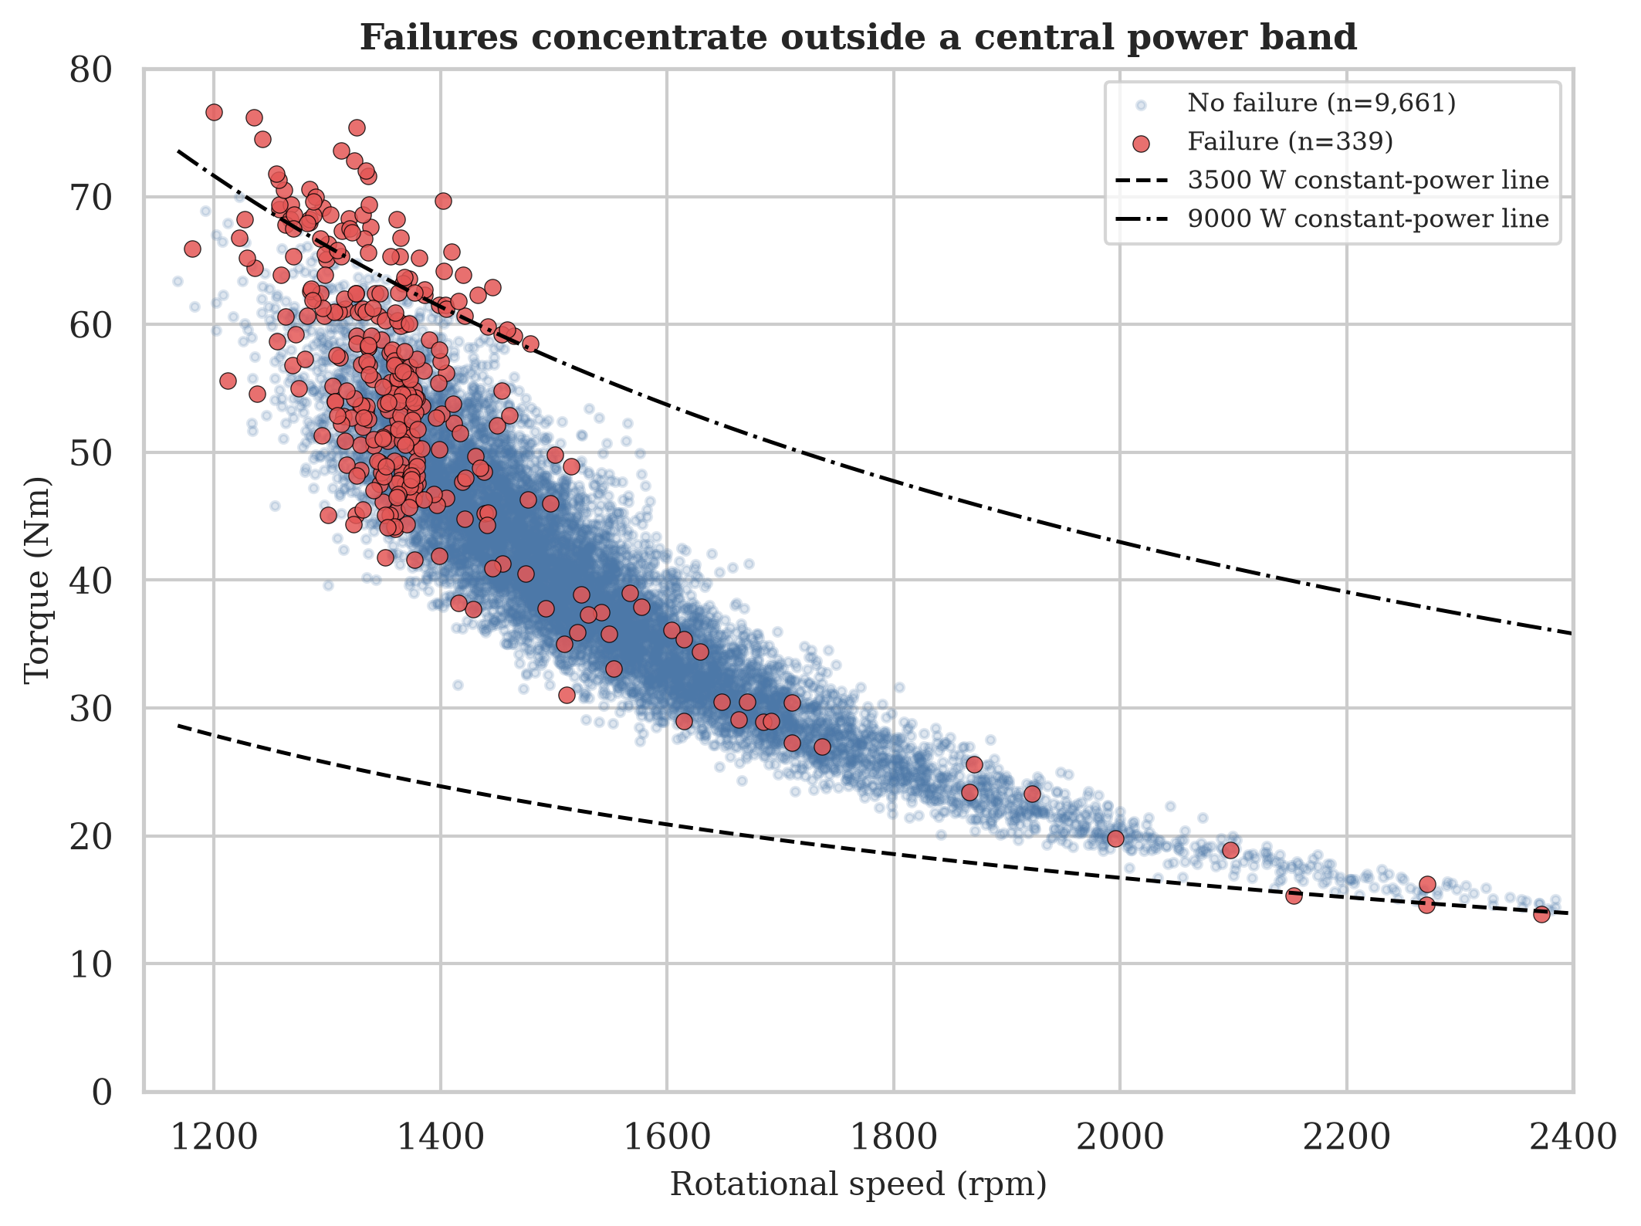
Figure A4. Torque against rotational speed, with failures overlaid and two constant-power reference lines. Failures cluster outside the band between them, at both the high-torque and the low-torque extreme. A linear boundary cannot enclose two opposite corners of this plane.
Source: outputs/figures/fig04_torque_vs_speed.png

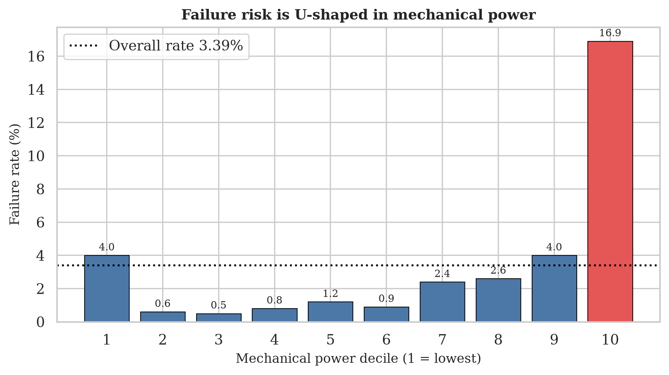
Figure A5. Failure rate by decile of mechanical power. The rate is 4.00 per cent in the lowest decile, falls to 1.32 per cent across the middle, and reaches 16.90 per cent in the highest. This U shape is the clearest single argument in the study for non-linear models.
Source: outputs/figures/fig05_failure_rate_by_power_decile.png
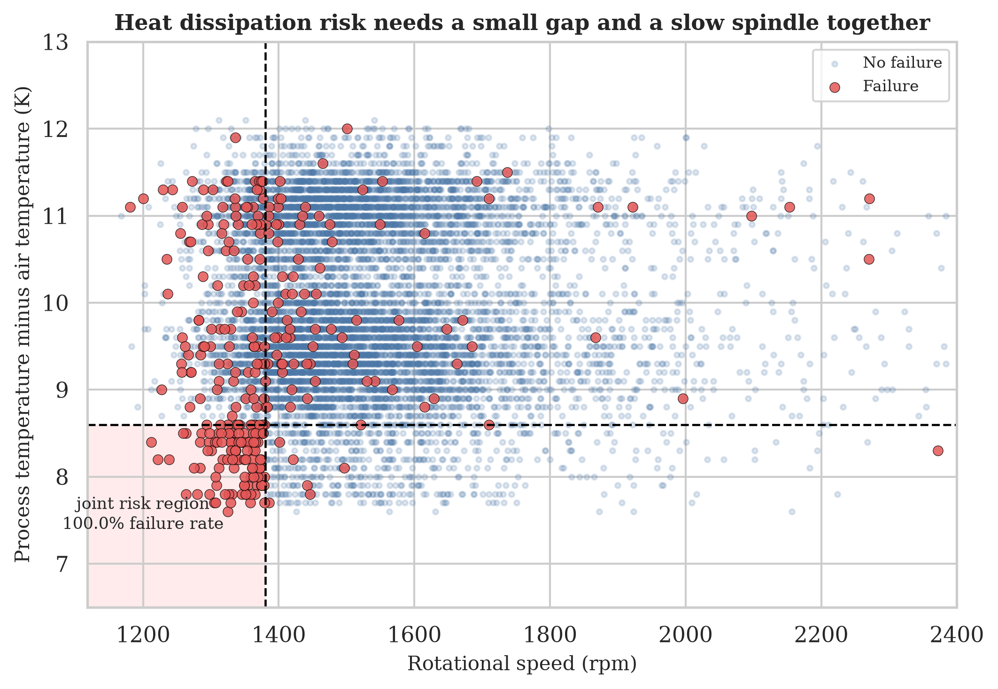
Figure A6. Process-minus-air temperature gap against rotational speed. The shaded region where the gap is below 8.6 K and the spindle is turning below 1,380 rpm contains 115 records, all 115 of which failed. Neither condition alone is alarming.
Source: outputs/figures/fig06_tempgap_vs_speed.png

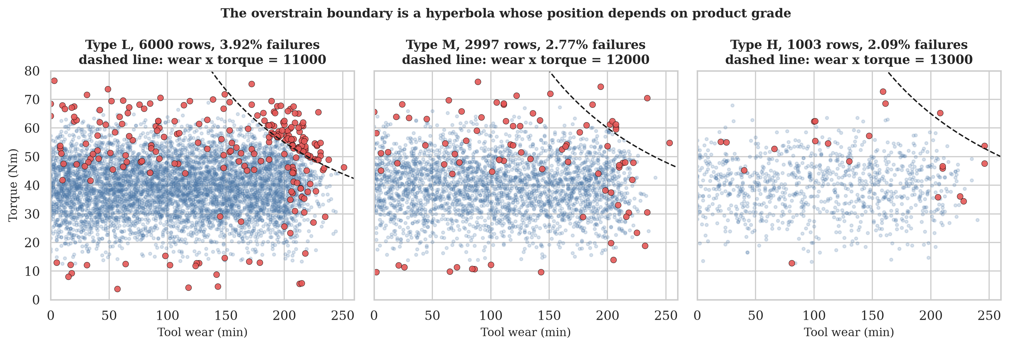
Figure A7. Tool wear against torque, split by product grade, with the documented overstrain limit drawn as a hyperbola. The limit moves with grade, which is why the wear-torque product and the grade are both retained.
Source: outputs/figures/fig07_wear_torque_by_type.png
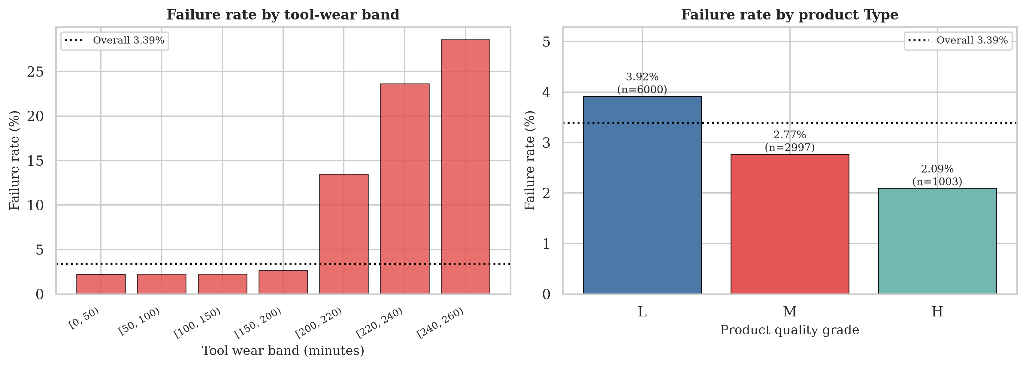
Figure A8. Failure rate by tool-wear band and by product grade. Wear behaves as a step rather than a slope: 2.21 per cent below 50 minutes against 28.57 per cent in the 240 to 260 band.
Source: outputs/figures/fig08_wear_bands_and_type.png

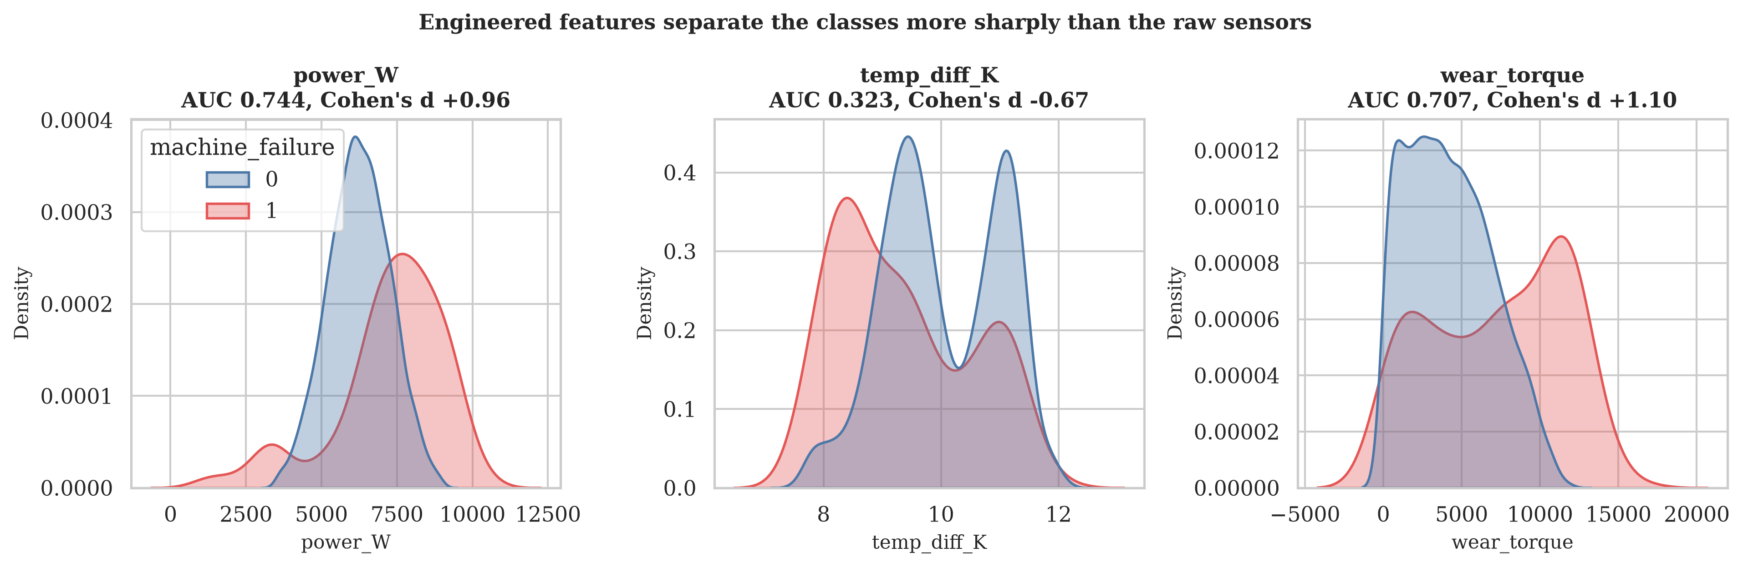
Figure A9. Conditional distributions of the three engineered features on the training partition only. Compare against Figure A2: the separation is visibly sharper than any raw sensor achieves.
Source: outputs/figures/fig09_engineered_feature_separation.png
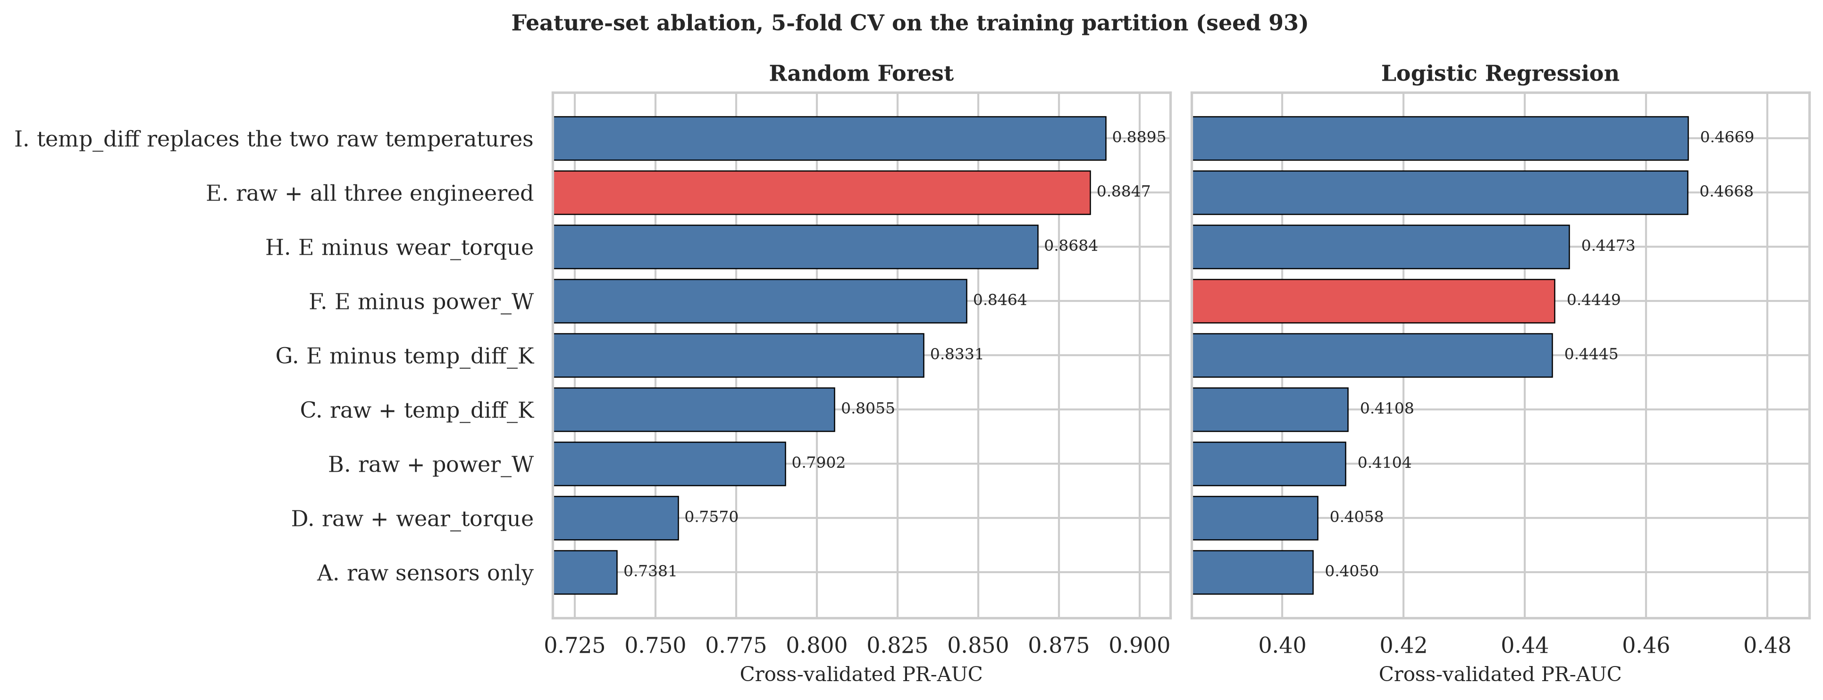
Figure A10. Cross-validated PR-AUC for nine feature sets, measured on the training partition with 5-fold StratifiedKFold at seed 93. Set E, the retained one, is highlighted. The Random Forest gains 0.147 over raw sensors alone.
Source: outputs/figures/fig10_feature_ablation.png

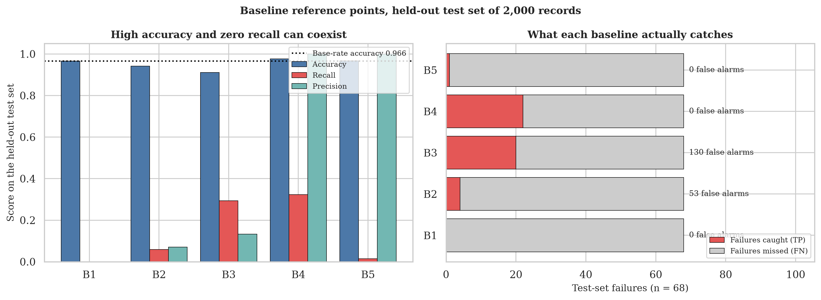
Figure A11. Five baselines on the held-out test set. The left panel shows how accuracy and recall can move in opposite directions; the right shows what each baseline actually catches out of the 68 test failures.
Source: outputs/figures/fig11_baseline_comparison.png
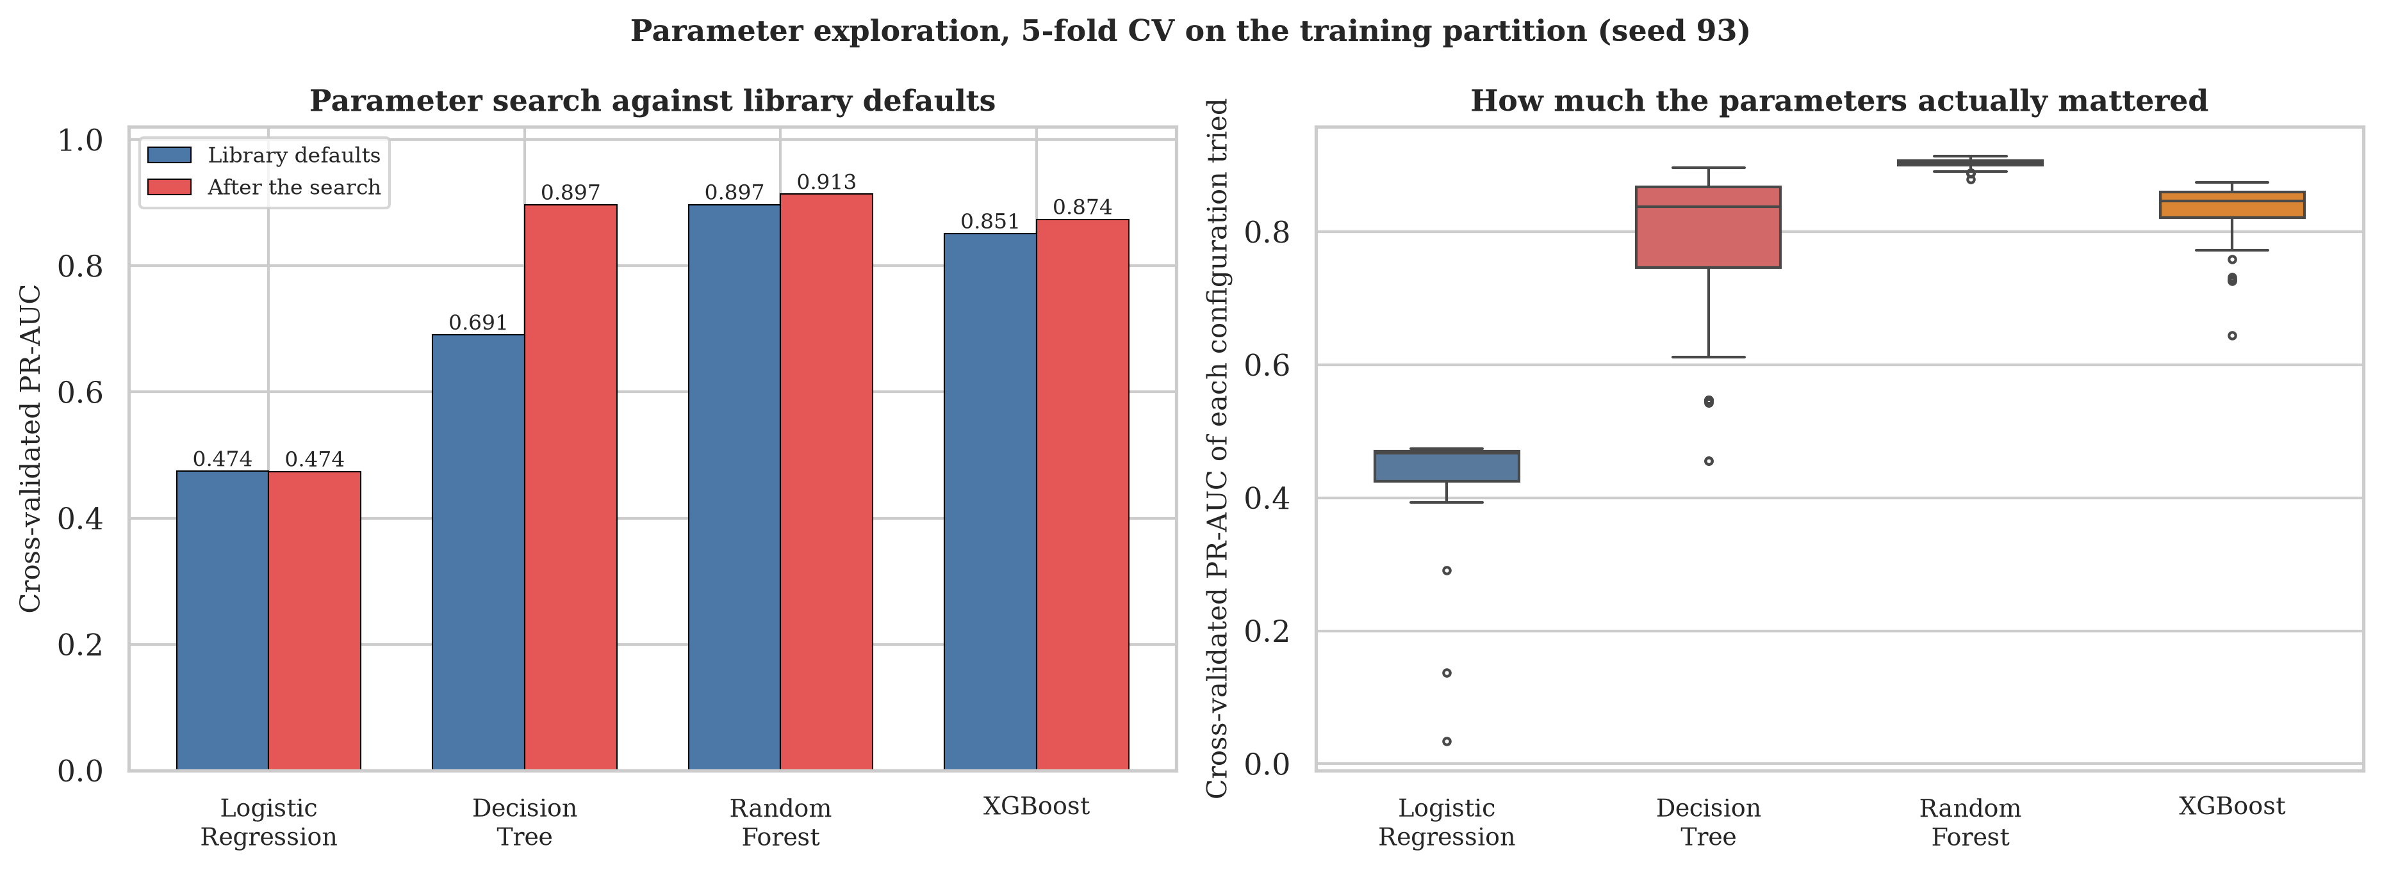
Figure A12. Left: cross-validated PR-AUC at library defaults against the tuned configuration for each model. Right: the spread of every configuration tried, which shows how much the parameters mattered for each learner.
Source: outputs/figures/fig12_tuning_summary.png

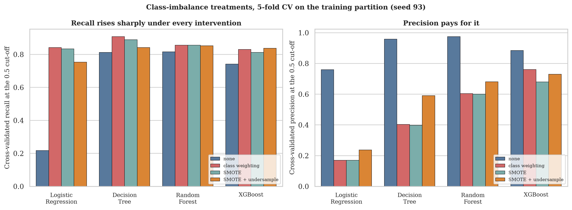
Figure A13. Recall and precision under four imbalance treatments, cross-validated on the training partition. Every intervention raises recall and every one lowers precision.
Source: outputs/figures/fig13_imbalance_recall_precision.png
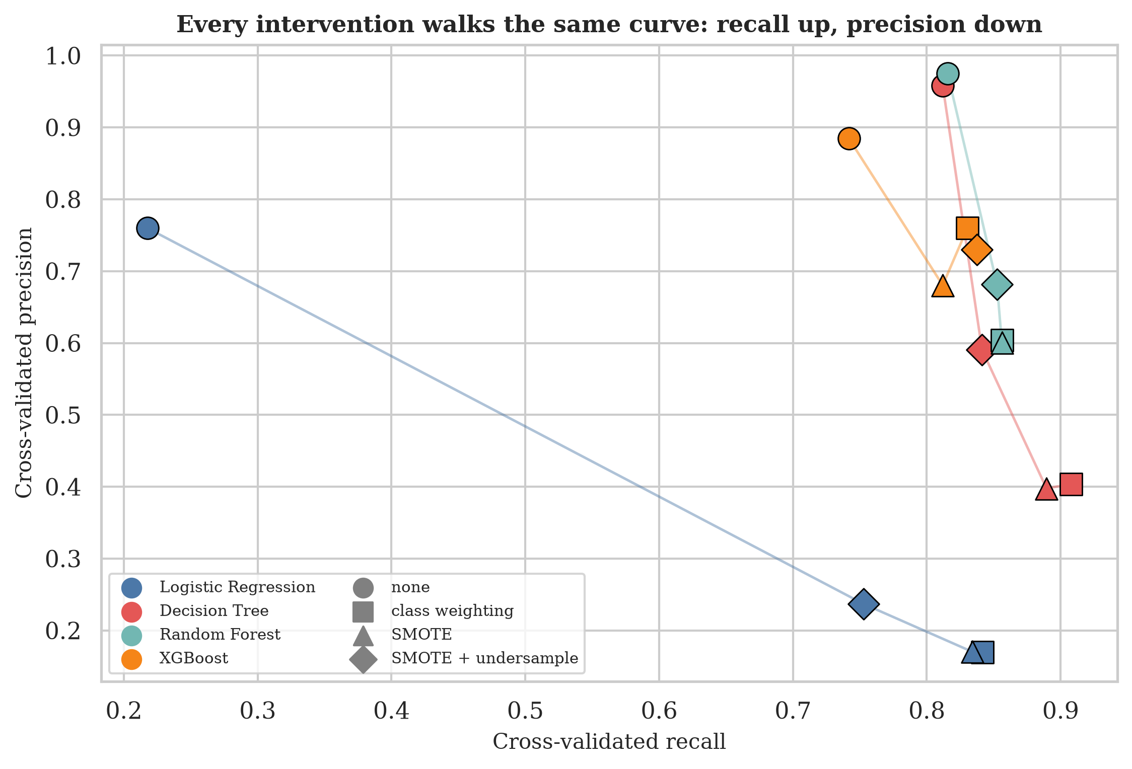
Figure A14. The same sixteen results plotted as precision against recall. Each model traces a curve rather than jumping to a better position, which is the evidence that these treatments move the operating point rather than improving the underlying ranking.
Source: outputs/figures/fig14_imbalance_tradeoff_scatter.png

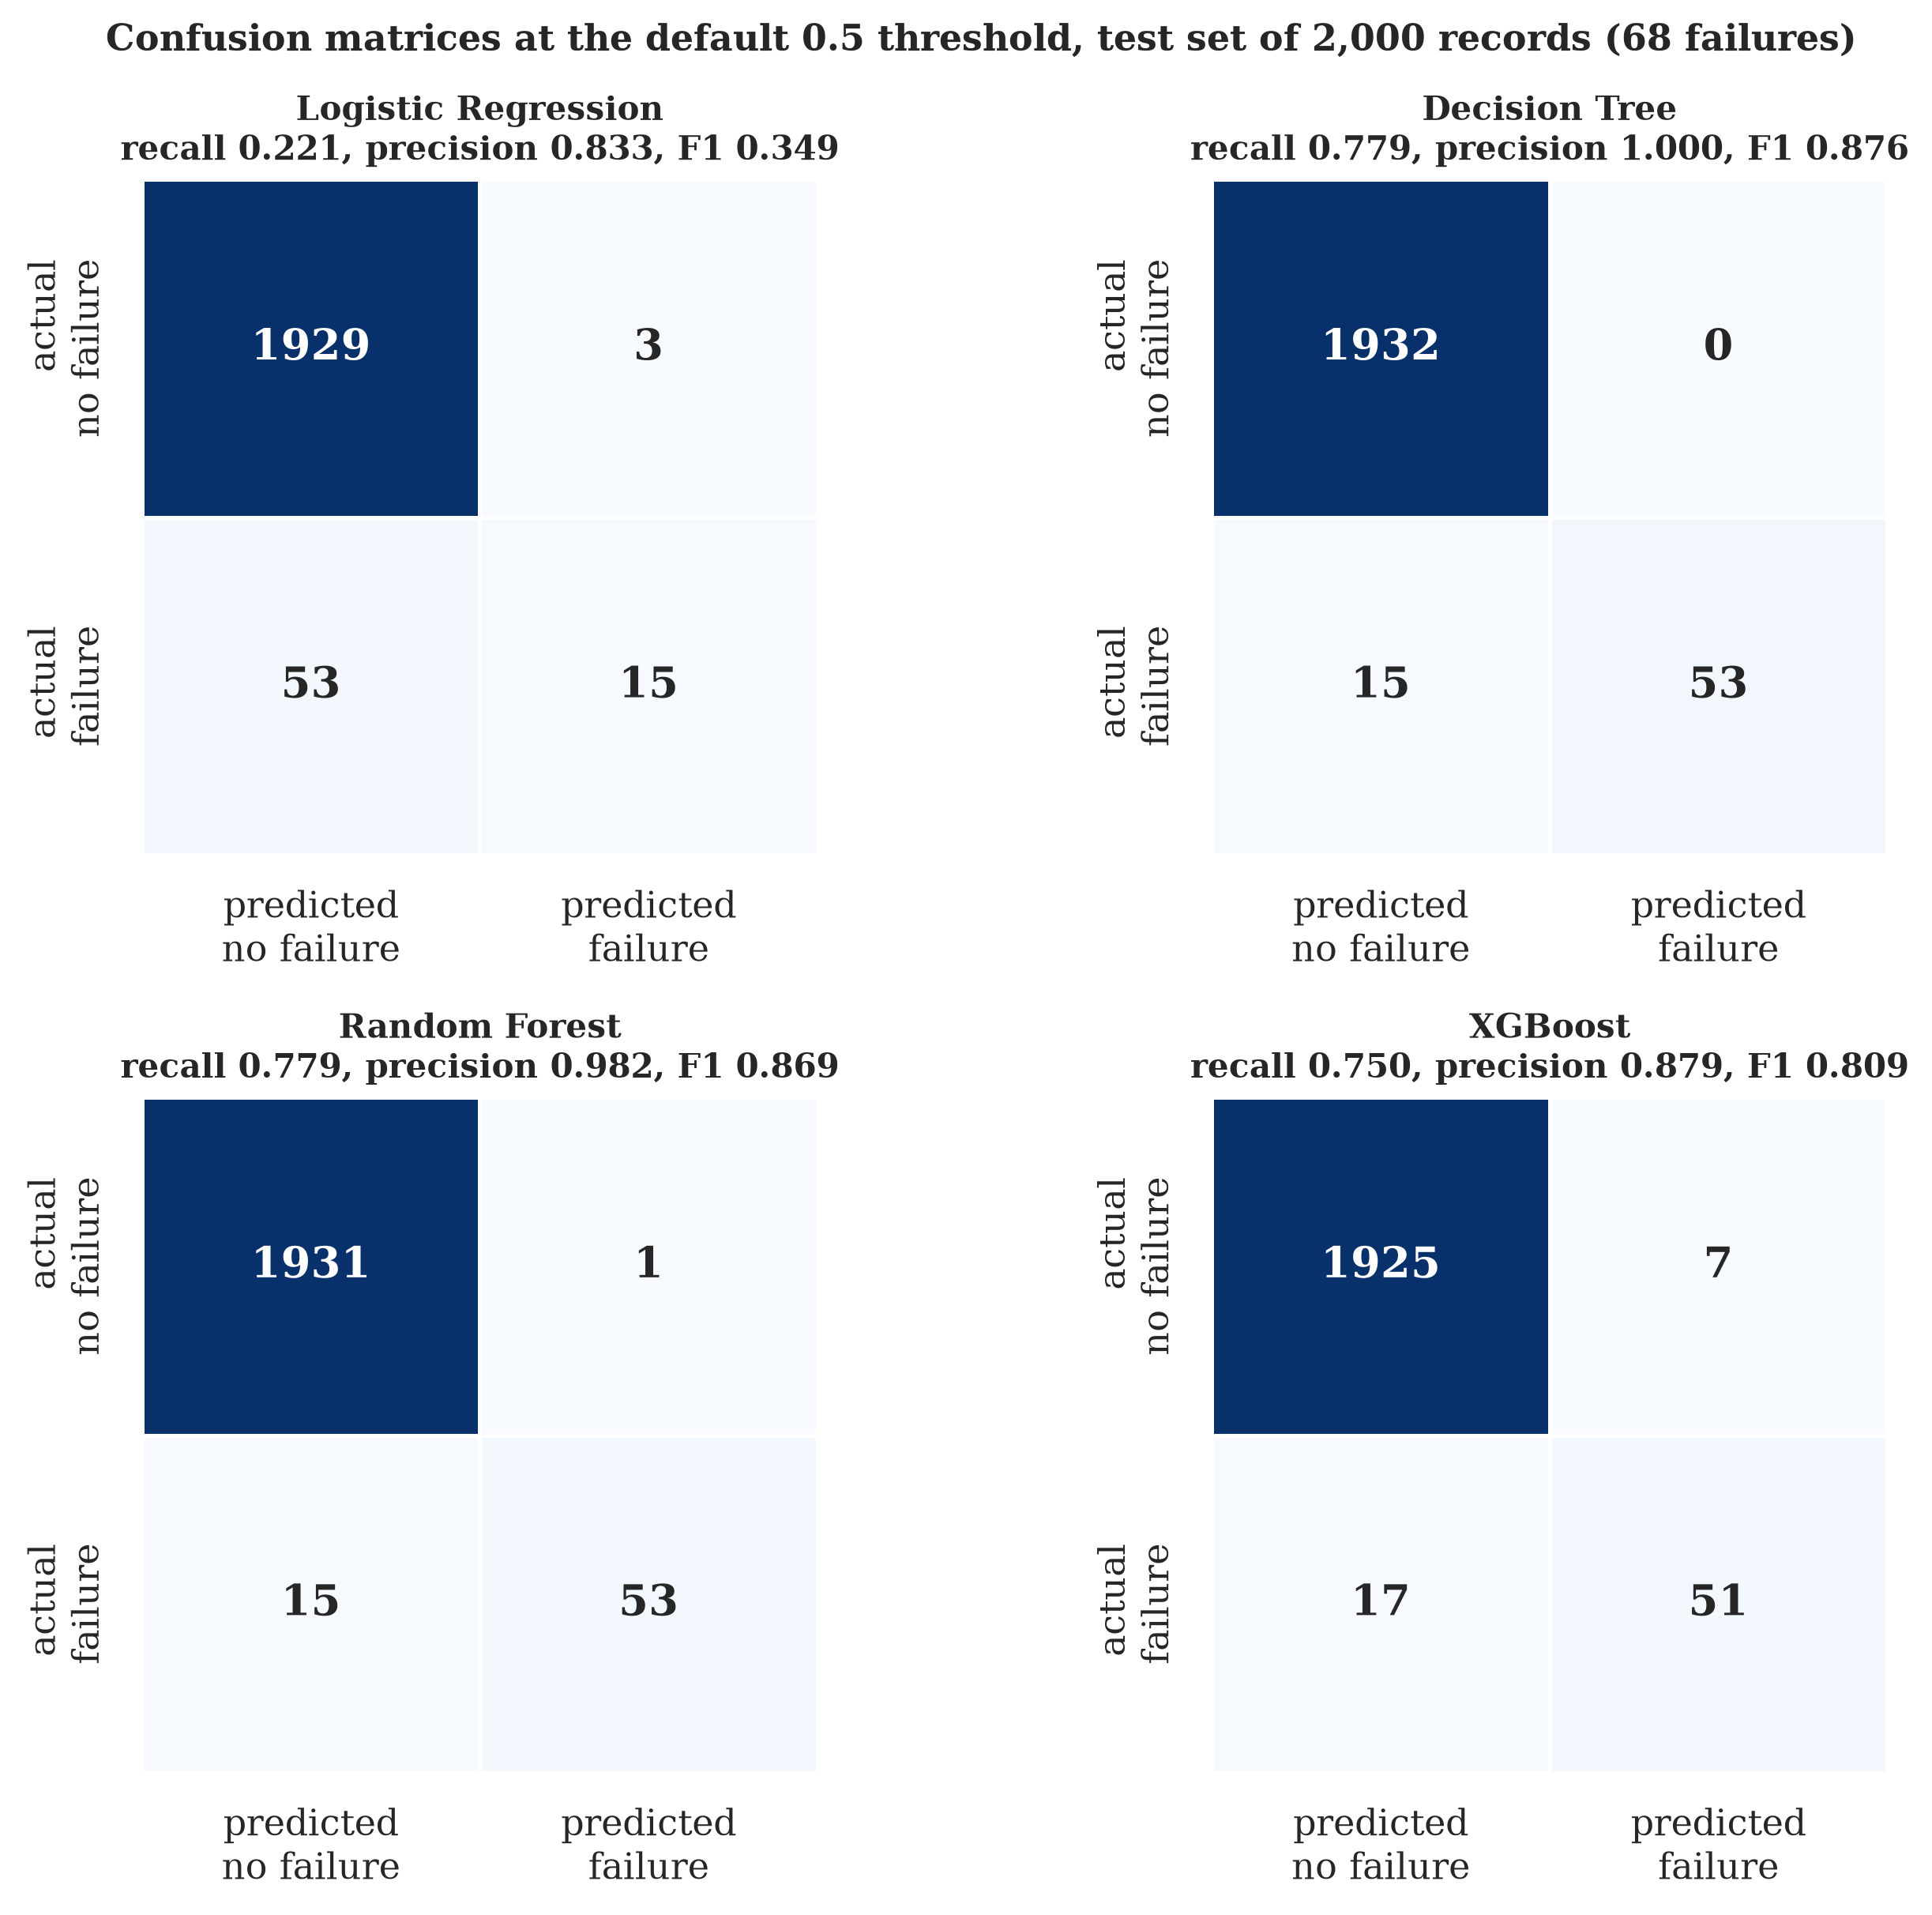
Figure A15. Confusion matrices for the four final models at the default 0.5 threshold on the 2,000-record test set. The Decision Tree and the Random Forest both catch 53 of 68 failures and differ by one false alarm.
Source: outputs/figures/fig15_confusion_matrices.png
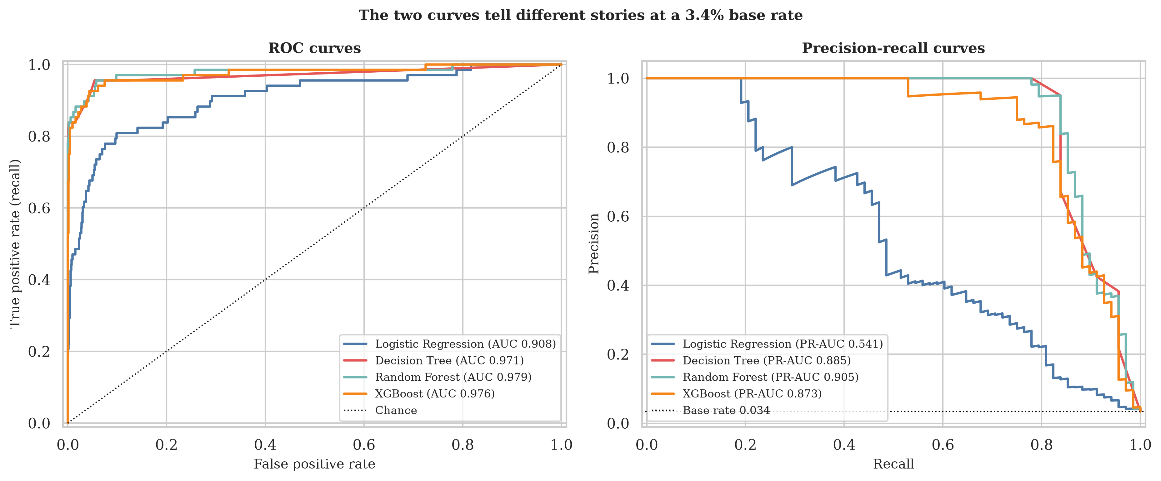
Figure A16. ROC curves and precision-recall curves for all four models. The ROC panel compresses the differences; the PR panel, whose baseline is the 3.4 per cent base rate, separates them.
Source: outputs/figures/fig16_roc_and_pr_curves.png

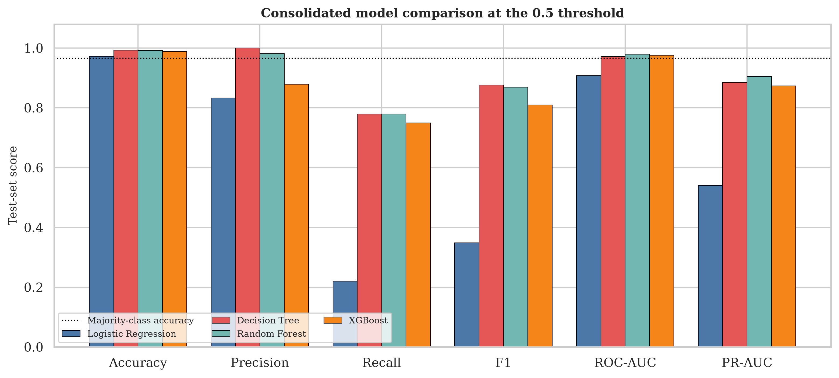
Figure A17. All six reported metrics side by side. Accuracy spans 0.9720 to 0.9925 across four models of visibly different quality, which is the clearest possible demonstration that it should not be the deciding metric.
Source: outputs/figures/fig17_metric_comparison.png
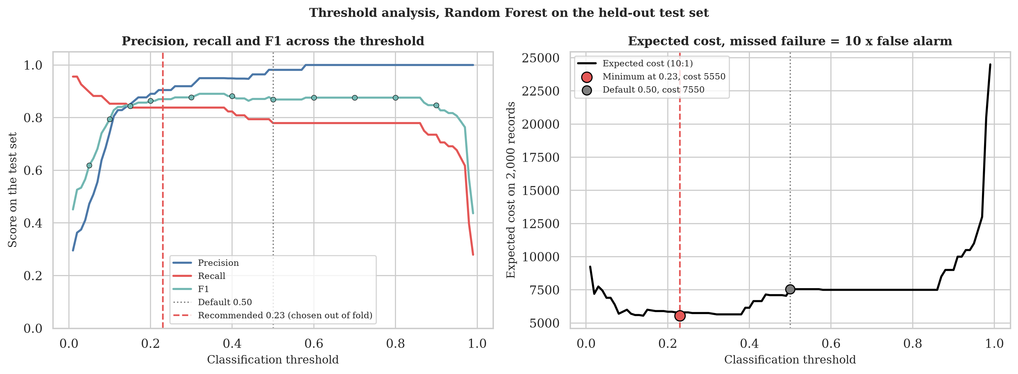
Figure A18. Precision, recall and F1 for the Random Forest across the full threshold range, with the eleven swept thresholds marked, and the expected-cost curve under the assumed 10:1 ratio. The minimum sits at 0.14.
Source: outputs/figures/fig18_threshold_curves.png

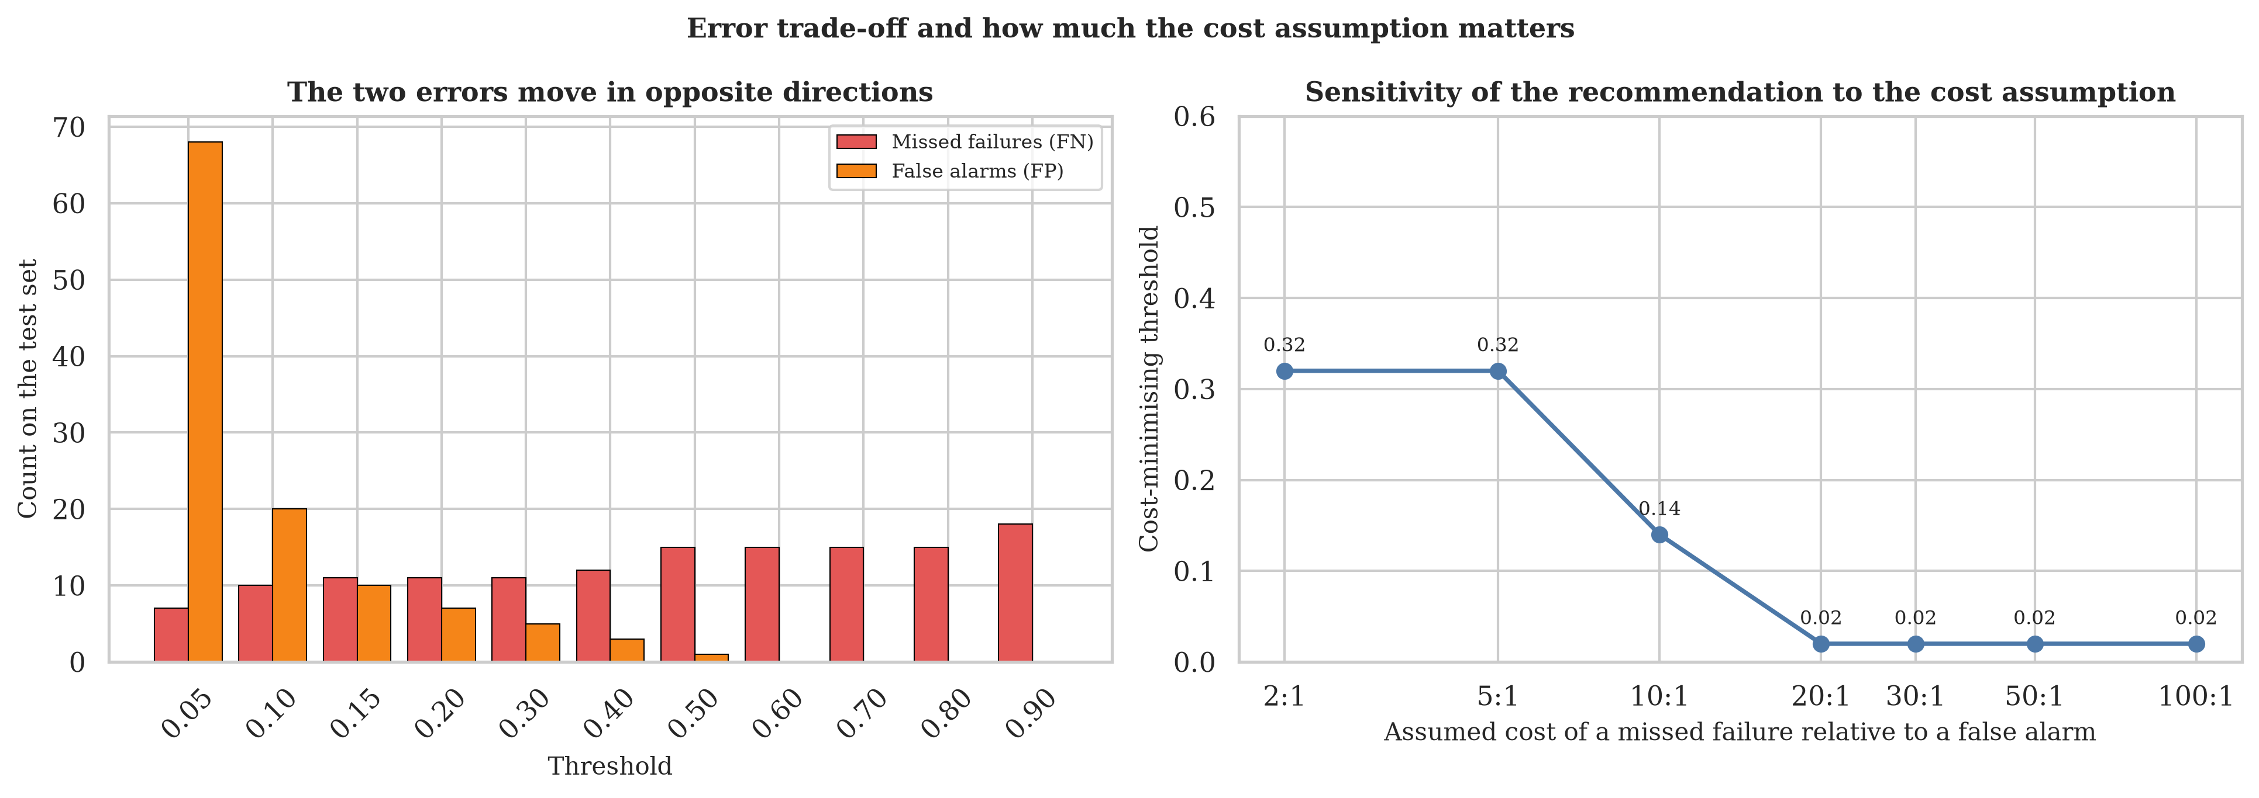
Figure A19. Left: false negatives and false positives at each swept threshold. Right: how the cost-minimising threshold moves as the assumed cost ratio changes, which is the weakest link in the recommendation.
Source: outputs/figures/fig19_threshold_errors_and_sensitivity.png
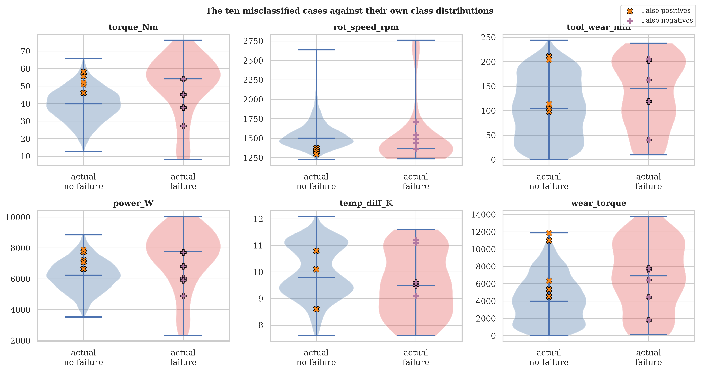
Figure A20. The five false positives and five false negatives plotted against the test-set distributions of the class each truly belongs to. The false positives sit in the failure region; the false negatives sit in the healthy region.
Source: outputs/figures/fig20_misclassification_cases.png

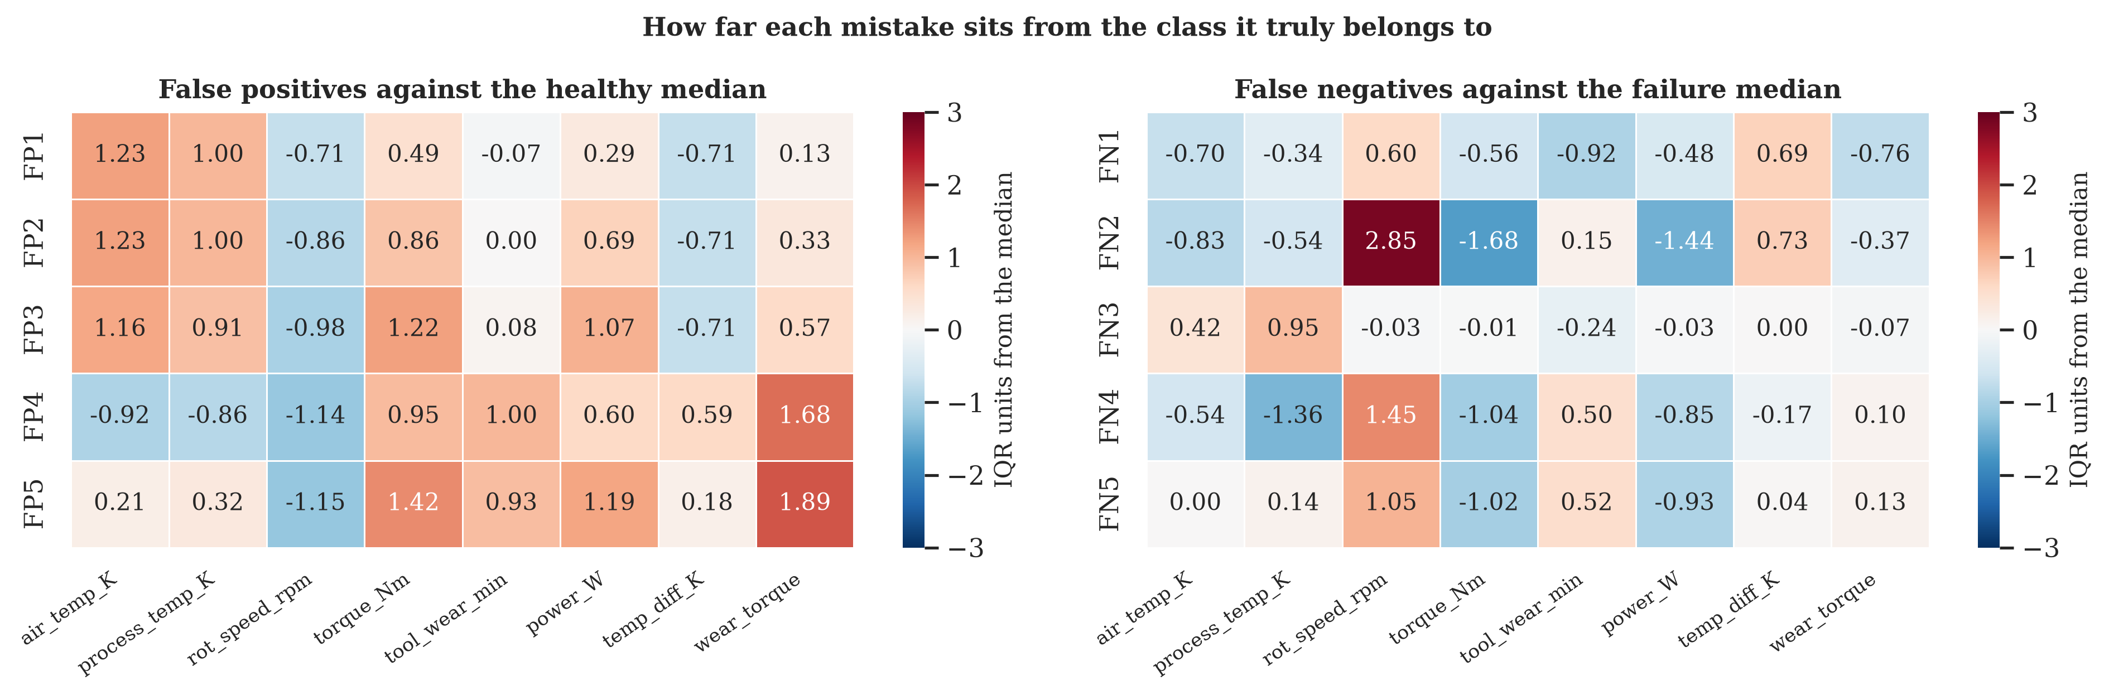
Figure A21. How far each misclassified case sits from the median of its own true class, measured in that class's interquartile range. Red indicates above the median, blue below.
Source: outputs/figures/fig21_misclassification_deviation.png
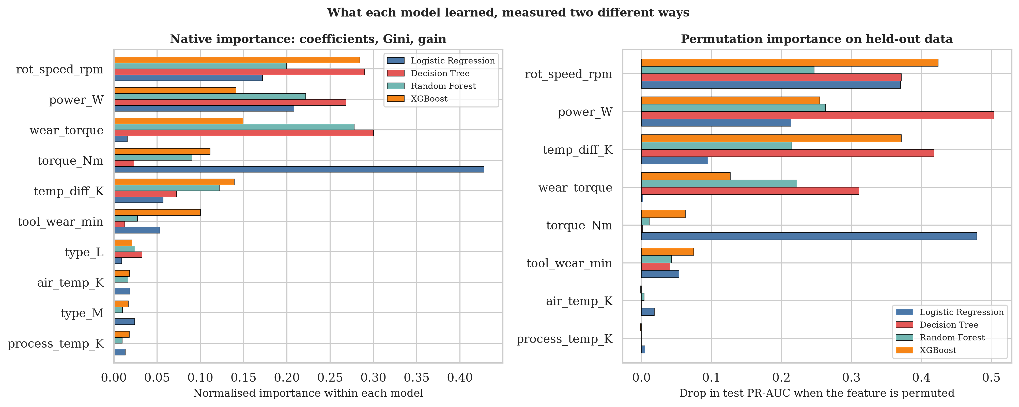
Figure A22. Native importance (standardised coefficients, Gini, gain) beside permutation importance measured on the held-out test set. The three tree-based models agree closely; logistic regression does not.
Source: outputs/figures/fig22_importance_comparison.png

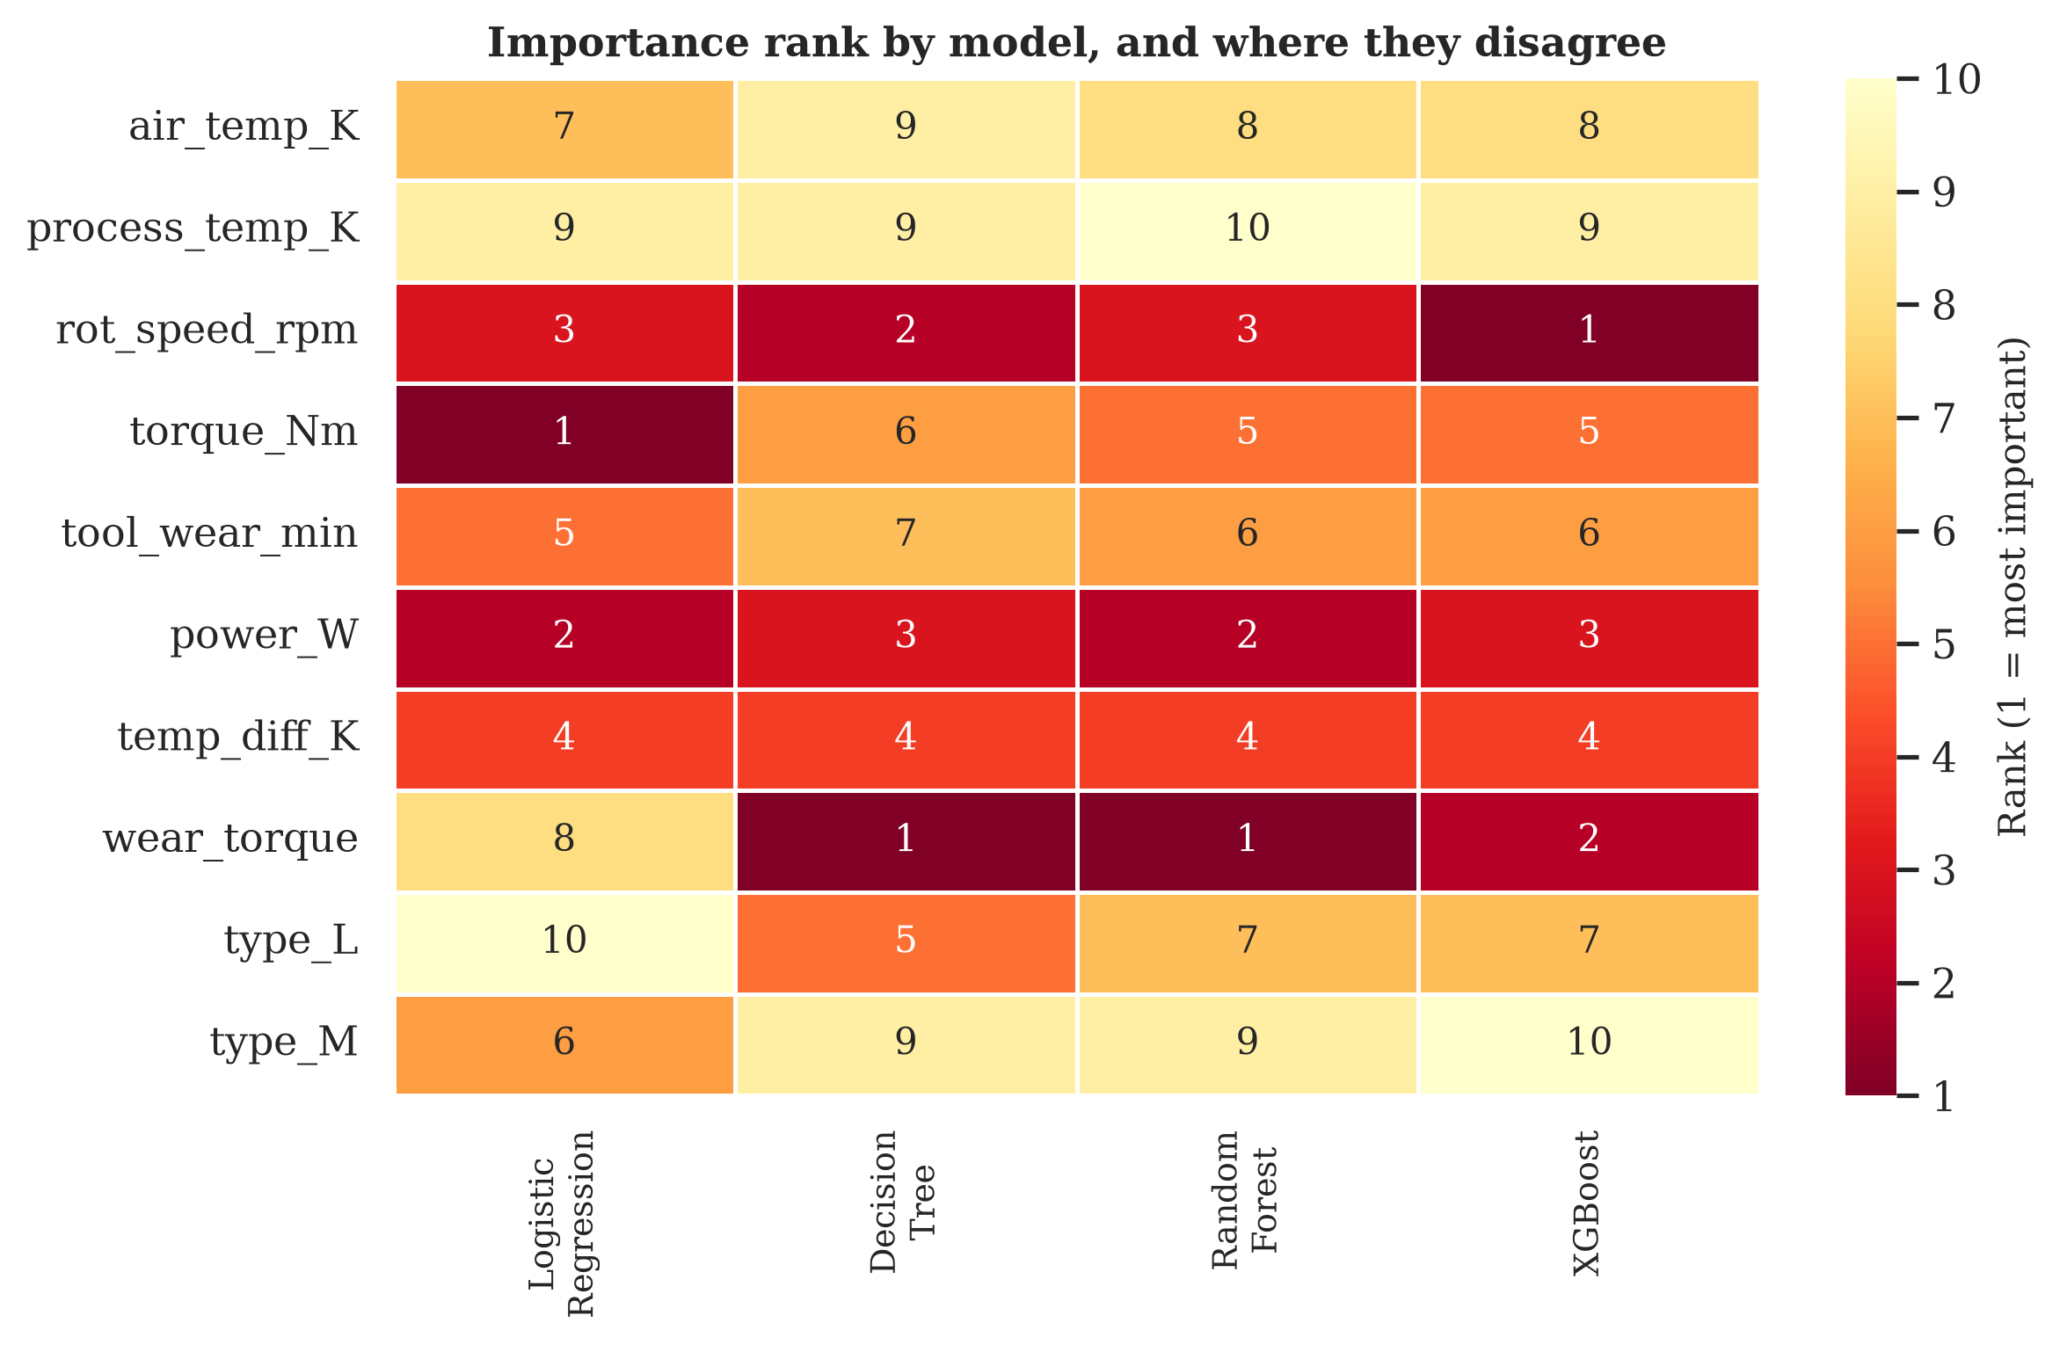
Figure A23. Importance rank of every feature under each model. The wear-torque product ranks first for the Decision Tree and the Random Forest and eighth for logistic regression, a spread of seven places.
Source: outputs/figures/fig23_importance_rank_heatmap.png
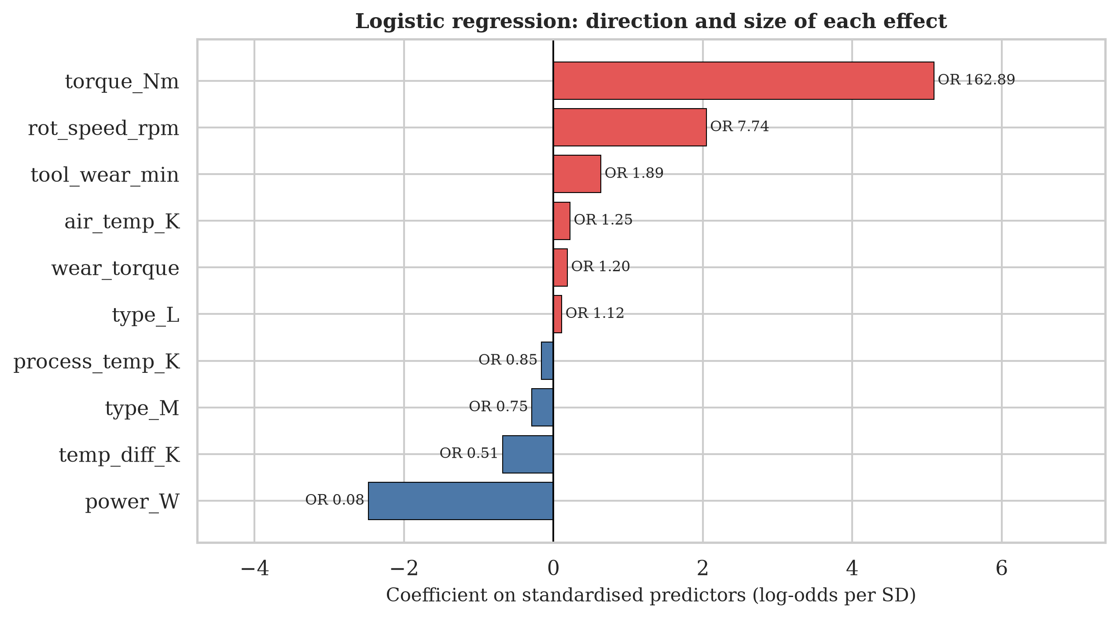
Figure A24. Logistic regression coefficients on standardised predictors, with the odds ratio per standard deviation annotated. Direction and size are readable here in a way they are not for the ensembles.
Source: outputs/figures/fig24_logistic_coefficients.png

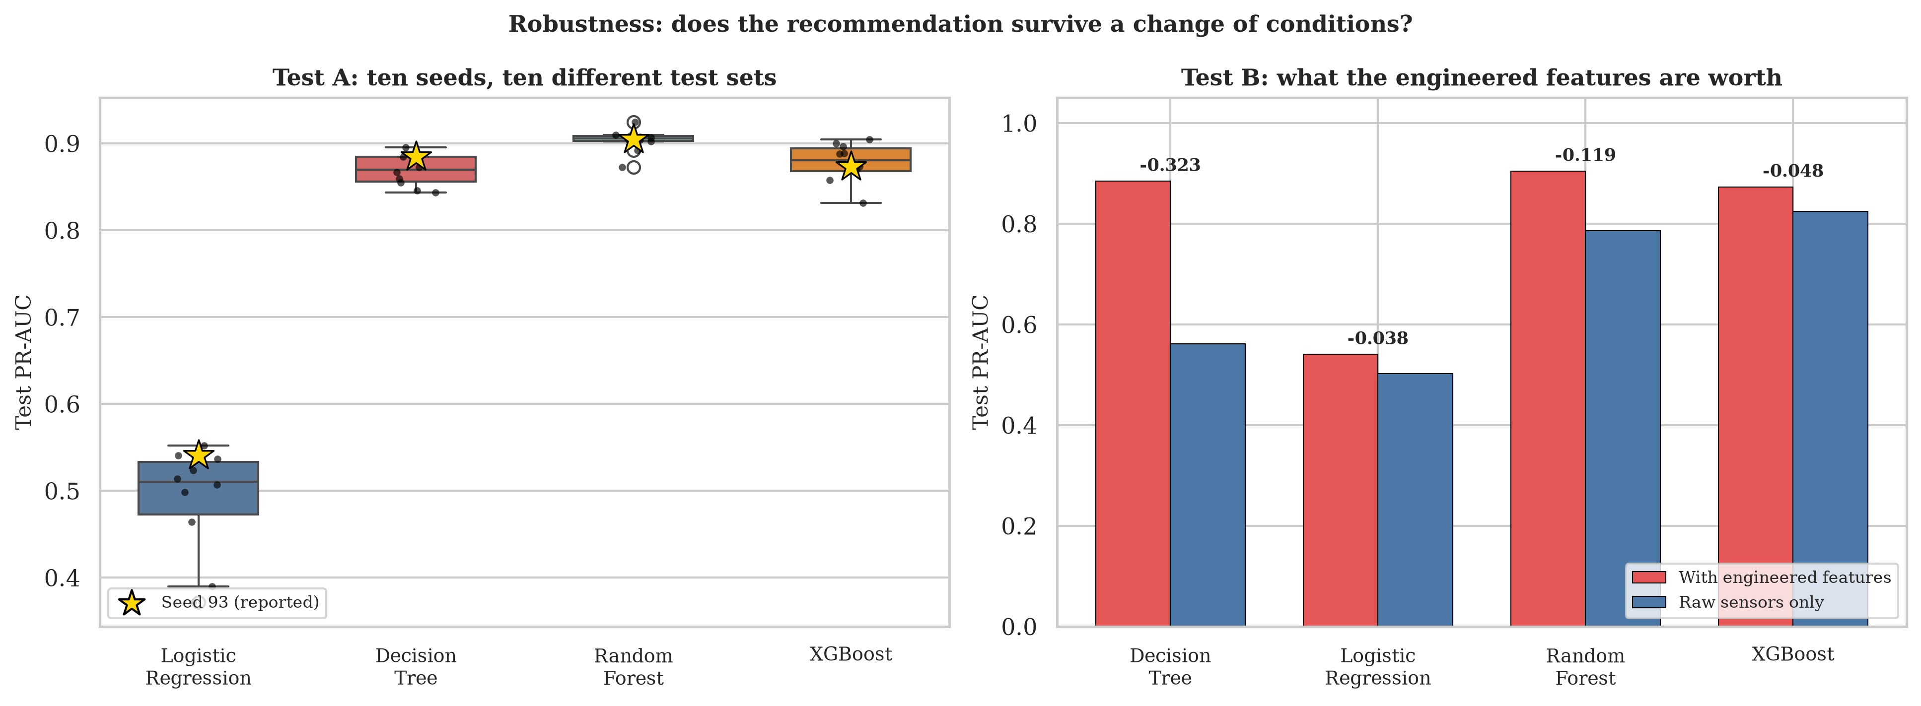
Figure A25. Left: test PR-AUC for each model across ten seeds, with seed 93 starred. Right: what the three engineered features are worth on held-out data. The label above each pair is the loss from removing them.
Source: outputs/figures/fig25_robustness.png

Appendix B: Tables
Every table below is also written to outputs/tables/ as a CSV file by the script that produced it.
Table B1. Variable dictionary for the raw file: type, cardinality, missingness and the role I assigned to each column.
variable | dtype | n_unique | n_missing | pct_missing | example_values | assigned_role
UDI | int64 | 10000 | 0 | 0.0 | 1, 2, 3 | identifier
Product ID | str | 10000 | 0 | 0.0 | M14860, L47181, L47182 | identifier
Type | str | 3 | 0 | 0.0 | M, L, H | categorical predictor
Air temperature [K] | float64 | 93 | 0 | 0.0 | 298.1, 298.2, 298.3 | numeric predictor
Process temperature [K] | float64 | 82 | 0 | 0.0 | 308.6, 308.7, 308.5 | numeric predictor
Rotational speed [rpm] | int64 | 941 | 0 | 0.0 | 1551, 1408, 1498 | numeric predictor
Torque [Nm] | float64 | 577 | 0 | 0.0 | 42.8, 46.3, 49.4 | numeric predictor
Tool wear [min] | int64 | 246 | 0 | 0.0 | 0, 3, 5 | numeric predictor
Machine failure | int64 | 2 | 0 | 0.0 | 0, 1 | target
TWF | int64 | 2 | 0 | 0.0 | 0, 1 | post-hoc failure-mode label (leakage)
HDF | int64 | 2 | 0 | 0.0 | 0, 1 | post-hoc failure-mode label (leakage)
PWF | int64 | 2 | 0 | 0.0 | 0, 1 | post-hoc failure-mode label (leakage)
OSF | int64 | 2 | 0 | 0.0 | 0, 1 | post-hoc failure-mode label (leakage)
RNF | int64 | 2 | 0 | 0.0 | 0, 1 | post-hoc failure-mode label (leakage)
Source: outputs/tables/tbl01_variable_dictionary.csv
Table B2. Descriptive statistics and quality checks for the five numeric sensors, including counts of values outside 1.5 interquartile ranges.
variable | count | mean | std | min | 25% | 50% | 75% | max | skew | kurtosis | n_iqr_outliers | n_nonpositive
Air temperature [K] | 10000.0 | 300.005 | 2.0 | 295.3 | 298.3 | 300.1 | 301.5 | 304.5 | 0.114 | -0.836 | 0 | 0
Process temperature [K] | 10000.0 | 310.006 | 1.484 | 305.7 | 308.8 | 310.1 | 311.1 | 313.8 | 0.015 | -0.5 | 0 | 0
Rotational speed [rpm] | 10000.0 | 1538.776 | 179.284 | 1168.0 | 1423.0 | 1503.0 | 1612.0 | 2886.0 | 1.993 | 7.393 | 418 | 0
Torque [Nm] | 10000.0 | 39.987 | 9.969 | 3.8 | 33.2 | 40.1 | 46.8 | 76.6 | -0.01 | -0.013 | 69 | 0
Tool wear [min] | 10000.0 | 107.951 | 63.654 | 0.0 | 53.0 | 108.0 | 162.0 | 253.0 | 0.027 | -1.167 | 0 | 120
Source: outputs/tables/tbl02_numeric_quality.csv
Table B3. Behaviour of the five failure-mode flags against the target. Four of them fire only on failures; RNF does not.
flag | n_fired | pct_of_rows | n_fired_and_failure | n_fired_but_no_failure | pct_fired_that_are_failures
TWF | 46 | 0.46 | 46 | 0 | 100.0
HDF | 115 | 1.15 | 115 | 0 | 100.0
PWF | 95 | 0.95 | 95 | 0 | 100.0
OSF | 98 | 0.98 | 98 | 0 | 100.0
RNF | 19 | 0.19 | 1 | 18 | 5.26
Source: outputs/tables/tbl03_failure_flag_behaviour.csv
Table B4. Every observed combination of the five flags with its row count and failure rate. Read alongside Table B5.
TWF | HDF | PWF | OSF | RNF | n_rows | n_failures | failure_rate_pct
0 | 0 | 0 | 0 | 0 | 9652 | 9 | 0.09
0 | 1 | 0 | 0 | 0 | 106 | 106 | 100.0
0 | 0 | 1 | 0 | 0 | 80 | 80 | 100.0
0 | 0 | 0 | 1 | 0 | 78 | 78 | 100.0
1 | 0 | 0 | 0 | 0 | 42 | 42 | 100.0
0 | 0 | 0 | 0 | 1 | 18 | 0 | 0.0
0 | 0 | 1 | 1 | 0 | 11 | 11 | 100.0
0 | 1 | 0 | 1 | 0 | 6 | 6 | 100.0
0 | 1 | 1 | 0 | 0 | 3 | 3 | 100.0
1 | 0 | 0 | 1 | 0 | 2 | 2 | 100.0
1 | 0 | 0 | 0 | 1 | 1 | 1 | 100.0
1 | 0 | 1 | 1 | 0 | 1 | 1 | 100.0
Source: outputs/tables/tbl04_flag_combination_crosstab.csv
Table B5. The leakage evidence in seven lines. This table is the basis for excluding the five flags.
check | result
OR(TWF,HDF,PWF,OSF) == Machine failure | 9991/10000 rows (99.91%)
rows: mode fires, target = 0 | 0
rows: target = 1, no mode fires | 9
OR(all five incl. RNF) == Machine failure | 9973/10000 rows (99.73%)
RNF rows total | 19
RNF fires alone | 18
RNF fires alone and target = 1 | 0
Source: outputs/tables/tbl05_leakage_summary.csv
Table B6. Include or exclude decision for all thirteen non-target columns, with the reason for each.
variable | decision | reason
UDI | Exclude | Row counter 1 to 10000, unique on every row. Carries the sort order of the file and nothing about machine condition.
Product ID | Exclude | Quality letter plus serial number, 10000 unique values. Its first character duplicates Type, so it adds a redundant copy of a variable I already keep, plus thousands of useless levels.
Type | Include | Three-level product quality rating L/M/H, a genuine design characteristic known before the machine runs.
Air temperature [K] | Include | Ambient process condition, measured live.
Process temperature [K] | Include | Machine-side temperature, measured live.
Rotational speed [rpm] | Include | Live sensor reading.
Torque [Nm] | Include | Live sensor reading.
Tool wear [min] | Include | Cumulative minutes of tool use, known live.
TWF | Exclude | Tool-wear failure mode. Post-hoc label assigned after a failure is diagnosed; also part of the OR that defines the target.
HDF | Exclude | Heat-dissipation failure mode, same argument.
PWF | Exclude | Power failure mode, same argument.
OSF | Exclude | Overstrain failure mode, same argument.
RNF | Exclude | Random failure flag. Not part of the OR that defines the target and essentially unpredictable, so it is noise at prediction time.
Source: outputs/tables/tbl06_inclusion_decisions.csv
Table B7. Single-variable separation between the classes for eight candidate predictors, ranked by distance from chance.
variable | mean_no_failure | mean_failure | median_no_failure | median_failure | cohens_d | univariate_auc | mannwhitney_p
torque_Nm | 39.63 | 50.168 | 39.9 | 53.7 | 1.077 | 0.7702 | 2.26e-64
rot_speed_rpm | 1540.26 | 1496.487 | 1507.0 | 1365.0 | -0.244 | 0.2333 | 9.71e-63
power_W | 6244.548 | 7282.819 | 6243.046 | 7611.43 | 0.988 | 0.7457 | 1.65e-53
wear_torque | 4213.843 | 7187.938 | 3952.8 | 7681.8 | 1.072 | 0.7044 | 1.34e-37
temp_diff_K | 10.022 | 9.404 | 9.8 | 9.3 | -0.621 | 0.3376 | 2.4e-24
tool_wear_min | 106.694 | 143.782 | 107.0 | 165.0 | 0.586 | 0.6621 | 2.9199999999999998e-24
air_temp_K | 299.974 | 300.886 | 300.0 | 301.6 | 0.458 | 0.6327 | 8.66e-17
process_temp_K | 309.996 | 310.29 | 310.0 | 310.4 | 0.199 | 0.5637 | 6.49e-05
Source: outputs/tables/tbl07_univariate_separation.csv
Table B8. Pearson correlation matrix for the raw predictors and the target.
variable | air_temp_K | process_temp_K | rot_speed_rpm | torque_Nm | tool_wear_min | machine_failure
air_temp_K | 1.0 | 0.876 | 0.023 | -0.014 | 0.014 | 0.083
process_temp_K | 0.876 | 1.0 | 0.019 | -0.014 | 0.013 | 0.036
rot_speed_rpm | 0.023 | 0.019 | 1.0 | -0.875 | 0.0 | -0.044
torque_Nm | -0.014 | -0.014 | -0.875 | 1.0 | -0.003 | 0.191
tool_wear_min | 0.014 | 0.013 | 0.0 | -0.003 | 1.0 | 0.105
machine_failure | 0.083 | 0.036 | -0.044 | 0.191 | 0.105 | 1.0
Source: outputs/tables/tbl08_correlation_matrix.csv
Table B9. Variance inflation factors for the five raw sensors, computed by regressing each on the other four.
variable | r_squared_on_others | VIF
air_temp_K | 0.7677 | 4.3
process_temp_K | 0.7676 | 4.3
rot_speed_rpm | 0.7658 | 4.27
torque_Nm | 0.7657 | 4.27
tool_wear_min | 0.0002 | 1.0
Source: outputs/tables/tbl09_multicollinearity_vif.csv
Table B10. Failure rate by decile of mechanical power, with the power range of each decile.
power_decile | n | failures | power_min | power_max | failure_rate_pct
1 | 1000 | 40 | 1148.4 | 4914.7 | 4.0
2 | 1000 | 6 | 4915.0 | 5382.9 | 0.6
3 | 1000 | 5 | 5383.0 | 5717.2 | 0.5
4 | 1000 | 8 | 5718.1 | 6007.6 | 0.8
5 | 1000 | 12 | 6008.1 | 6270.8 | 1.2
6 | 1000 | 9 | 6271.2 | 6546.6 | 0.9
7 | 1000 | 24 | 6546.6 | 6833.2 | 2.4
8 | 1000 | 26 | 6833.4 | 7176.1 | 2.6
9 | 1000 | 40 | 7176.5 | 7640.6 | 4.0
10 | 1000 | 169 | 7640.6 | 10469.9 | 16.9
Source: outputs/tables/tbl10_failure_rate_by_power_decile.csv
Table B11. The heat-dissipation interaction: failure rate under each combination of a small temperature gap and a slow spindle.
condition | n_rows | n_failures | failure_rate_pct
gap < 8.6 K AND speed < 1380 rpm | 115 | 115 | 100.0
gap < 8.6 K only | 605 | 11 | 1.82
speed < 1380 rpm only | 1245 | 103 | 8.27
neither | 8035 | 110 | 1.37
Source: outputs/tables/tbl11_heat_dissipation_interaction.csv
Table B12. Record count and failure rate by product quality grade.
type | n | failures | mean_wear_torque | failure_rate_pct
H | 1003 | 21 | 4280.9 | 2.09
L | 6000 | 235 | 4341.5 | 3.92
M | 2997 | 83 | 4272.3 | 2.77
Source: outputs/tables/tbl12_failure_rate_by_type.csv
Table B13. Records above and below the documented overstrain limit for each grade, with failure rates on both sides.
type | documented_limit | n_above | failures_above | rate_above_pct | n_below | failures_below | rate_below_pct
L | 11000 | 87 | 87 | 100.0 | 5913 | 148 | 2.5
M | 12000 | 9 | 9 | 100.0 | 2988 | 74 | 2.48
H | 13000 | 2 | 2 | 100.0 | 1001 | 19 | 1.9
Source: outputs/tables/tbl13_overstrain_threshold_by_type.csv
Table B14. Failure rate by tool-wear band, showing the step at roughly 200 minutes.
wear_bin | n | failures | failure_rate_pct
[0, 50) | 2349 | 52 | 2.21
[50, 100) | 2271 | 51 | 2.25
[100, 150) | 2290 | 52 | 2.27
[150, 200) | 2289 | 61 | 2.66
[200, 220) | 660 | 89 | 13.48
[220, 240) | 127 | 30 | 23.62
[240, 260) | 14 | 4 | 28.57
Source: outputs/tables/tbl14_failure_rate_by_wear_bin.csv
Table B15. Mean, standard deviation and median of every predictor by failure status.
variable | statistic | no_failure | failure
air_temp_K | mean | 299.97 | 300.89
air_temp_K | std | 1.99 | 2.07
air_temp_K | median | 300.0 | 301.6
process_temp_K | mean | 310.0 | 310.29
process_temp_K | std | 1.49 | 1.36
process_temp_K | median | 310.0 | 310.4
rot_speed_rpm | mean | 1540.26 | 1496.49
rot_speed_rpm | std | 167.39 | 384.94
rot_speed_rpm | median | 1507.0 | 1365.0
torque_Nm | mean | 39.63 | 50.17
torque_Nm | std | 9.47 | 16.37
torque_Nm | median | 39.9 | 53.7
tool_wear_min | mean | 106.69 | 143.78
tool_wear_min | std | 62.95 | 72.76
tool_wear_min | median | 107.0 | 165.0
temp_diff_K | mean | 10.02 | 9.4
temp_diff_K | std | 0.99 | 1.16
temp_diff_K | median | 9.8 | 9.3
power_W | mean | 6244.55 | 7282.82
power_W | std | 1011.39 | 1851.14
power_W | median | 6243.05 | 7611.43
wear_torque | mean | 4213.84 | 7187.94
wear_torque | std | 2709.74 | 4234.04
wear_torque | median | 3952.8 | 7681.8
Source: outputs/tables/tbl15_descriptives_by_class.csv
Table B16. The stratified 80/20 split at seed 93, with failure counts and rates in each partition.
partition | n_rows | n_failures | failure_rate_pct
train | 8000 | 271 | 3.388
test | 2000 | 68 | 3.4
total | 10000 | 339 | 3.39
Source: outputs/tables/tbl16_train_test_split.csv
Table B17. Every preprocessing step, whether it is common to all four models or specific to one, and its justification.
step | scope | applies_to | justification
Drop UDI, Product ID | Common | All four | Identifiers with no operational meaning; Product ID also duplicates Type.
Drop TWF, HDF, PWF, OSF, RNF | Common | All four | Post-hoc failure-mode labels; the first four reproduce the target on 99.91% of rows, so keeping them would hand the answer to the model.
Median imputation, numeric block | Common | All four | Redundant on this extract (zero missing cells) and retained as an operational safeguard for live sensor dropouts.
One-hot encode type, drop first | Common | All four | Three levels only. One-hot costs two columns and avoids asserting that the L to M to H spacing is equal, which an ordinal code would.
Engineered features | Common | All four | power_W, temp_diff_K, wear_torque. Row-wise, so leakage-free.
Standardisation | Model-specific | Logistic Regression only | The L2 penalty shrinks coefficients in proportion to their scale, so an unscaled torque in Nm and a wear-torque product in the thousands would be penalised very differently. Trees split on rank order, so scaling them would change nothing but would hide the units.
Class-imbalance treatment | Model-specific | Compared in stage 07 | class_weight for LR/DT/RF, scale_pos_weight for XGBoost, SMOTE inside the cross-validation pipeline. Never applied to a validation fold.
Source: outputs/tables/tbl17_preprocessing_plan.csv
Table B18. Formula and reasoning for each of the three engineered features.
feature | formula | reasoning | type
power_W | torque_Nm x rot_speed_rpm x 2*pi/60 | Mechanical power in watts. Torque times angular velocity is the textbook definition, and rpm has to be converted to radians per second first. The AI4I documentation defines its power failure mode as this quantity falling outside a 3,500 to 9,000 W band, so the quantity is physically meaningful rather than a fishing expedition. | Combines two originals
temp_diff_K | process_temp_K - air_temp_K | The temperature the machine adds above ambient. A small gap means heat is not being carried away. The two raw temperatures correlate at r = 0.876, so their difference is the part of the pair that actually varies with machine condition. | Combines two originals
wear_torque | tool_wear_min x torque_Nm | A proxy for accumulated overstrain: a blunt tool pushed hard. The documented overstrain mode fires when this product passes a limit that itself depends on product grade, which is a multiplication a linear model cannot form on its own. | Combines two originals
Source: outputs/tables/tbl18_engineered_feature_definitions.csv
Table B19. Distributional evidence for each candidate feature, measured on the training partition only.
feature | engineered | median_no_failure | median_failure | cohens_d | univariate_auc | point_biserial_r | p_value | auc_distance_from_chance
rot_speed_rpm | False | 1507.0 | 1365.0 | -0.261 | 0.2272 | -0.0472 | 9.06e-53 | 0.2728
torque_Nm | False | 39.8 | 53.6 | 1.065 | 0.7713 | 0.1892 | 3.1699999999999997e-52 | 0.2713
power_W | True | 6244.29 | 7557.79 | 0.961 | 0.7441 | 0.1713 | 1.3099999999999999e-42 | 0.2441
wear_torque | True | 3947.6 | 7810.5 | 1.098 | 0.7066 | 0.1949 | 5.25e-31 | 0.2066
temp_diff_K | True | 9.9 | 9.2 | -0.667 | 0.3229 | -0.1199 | 3.08e-23 | 0.1771
tool_wear_min | False | 107.0 | 172.0 | 0.611 | 0.6698 | 0.1099 | 1.82e-21 | 0.1698
air_temp_K | False | 300.0 | 301.7 | 0.476 | 0.6368 | 0.0858 | 1.71e-14 | 0.1368
process_temp_K | False | 310.0 | 310.4 | 0.194 | 0.5626 | 0.0351 | 0.000453 | 0.0626
Source: outputs/tables/tbl19_feature_evidence_separation.csv
Table B20. Gini importance of every feature in a Random Forest fitted to the training partition.
feature | gini_importance | engineered | rank
rot_speed_rpm | 0.201 | False | 1
torque_Nm | 0.1888 | False | 2
power_W | 0.1716 | True | 3
tool_wear_min | 0.1415 | False | 4
wear_torque | 0.1215 | True | 5
temp_diff_K | 0.0984 | True | 6
air_temp_K | 0.0457 | False | 7
process_temp_K | 0.0252 | False | 8
type_M | 0.0034 | False | 9
type_L | 0.0028 | False | 10
Source: outputs/tables/tbl20_feature_evidence_rf_importance.csv
Table B21. Cross-validated PR-AUC for nine feature sets under both a Random Forest and a logistic regression.
feature_set | n_numeric_features | rf_cv_pr_auc | rf_sd | lr_cv_pr_auc | lr_sd | rf_gain_vs_raw | lr_gain_vs_raw
A. raw sensors only | 5 | 0.7381 | 0.0269 | 0.4108 | 0.0447 | 0.0 | 0.0
B. raw + power_W | 6 | 0.7902 | 0.0271 | 0.4669 | 0.0302 | 0.0521 | 0.0561
C. raw + temp_diff_K | 6 | 0.8055 | 0.0525 | 0.4104 | 0.0451 | 0.0674 | -0.0004
D. raw + wear_torque | 6 | 0.757 | 0.0152 | 0.4058 | 0.0477 | 0.0189 | -0.005
E. raw + all three engineered | 8 | 0.8847 | 0.0213 | 0.4449 | 0.0407 | 0.1466 | 0.0341
F. E minus power_W | 7 | 0.8464 | 0.0331 | 0.405 | 0.0477 | 0.1083 | -0.0058
G. E minus temp_diff_K | 7 | 0.8331 | 0.0259 | 0.4445 | 0.0406 | 0.095 | 0.0337
H. E minus wear_torque | 7 | 0.8684 | 0.0345 | 0.4668 | 0.0303 | 0.1303 | 0.056
I. temp_diff replaces the two raw temperatures | 6 | 0.8895 | 0.0191 | 0.4473 | 0.0382 | 0.1514 | 0.0365
Source: outputs/tables/tbl21_feature_ablation.csv
Table B22. The cost in cross-validated PR-AUC of dropping each engineered feature from the full set.
dropped_feature | rf_pr_auc_without | rf_cost_of_dropping | lr_pr_auc_without | lr_cost_of_dropping
power_W | 0.8464 | 0.0383 | 0.405 | 0.0399
temp_diff_K | 0.8331 | 0.0516 | 0.4445 | 0.0004
wear_torque | 0.8684 | 0.0163 | 0.4668 | -0.0219
Source: outputs/tables/tbl22_leave_one_out_cost.csv
Table B23. Retain or drop verdict for each engineered feature against the rule stated in advance.
feature | verdict | rf_importance_rank | max_ablation_cost_pr_auc
power_W | Retained | 3 | 0.0399
temp_diff_K | Retained | 6 | 0.0516
wear_torque | Retained | 5 | 0.0163
Source: outputs/tables/tbl23_feature_decision.csv
Table B24. Five baselines scored on the held-out test set under the common evaluation framework.
model | accuracy | precision | recall | f1 | roc_auc | pr_auc | TN | FP | FN | TP
B1 Majority class (always predict no failure) | 0.966 | 0.0 | 0.0 | 0.0 | 0.5 | 0.034 | 1932 | 0 | 68 | 0
B2 Stratified random guess (seed 93) | 0.9415 | 0.0702 | 0.0588 | 0.064 | 0.5157 | 0.0361 | 1879 | 53 | 64 | 4
B3 Operator rule: tool wear >= 200 min | 0.911 | 0.1333 | 0.2941 | 0.1835 | 0.6317 | 0.1044 | 1802 | 130 | 48 | 20
B4 Operator rule: power outside 3,500 to 9,000 W | 0.977 | 1.0 | 0.3235 | 0.4889 | 0.8164 | 0.4424 | 1932 | 0 | 46 | 22
B5 Logistic regression on torque alone | 0.9665 | 1.0 | 0.0147 | 0.029 | 0.7659 | 0.3757 | 1932 | 0 | 67 | 1
Source: outputs/tables/tbl24_baseline_results.csv
Table B25. Cross-validated performance of all four models at library defaults.
model | cv_average_precision | sd_average_precision | cv_roc_auc | sd_roc_auc | cv_recall | sd_recall | cv_precision | sd_precision | cv_f1 | sd_f1 | cv_accuracy | sd_accuracy | fit_seconds
Logistic Regression | 0.4744 | 0.0359 | 0.9197 | 0.0116 | 0.2177 | 0.0318 | 0.7457 | 0.0933 | 0.3339 | 0.0315 | 0.9708 | 0.001 | 0.07
Decision Tree | 0.6906 | 0.0299 | 0.9103 | 0.0118 | 0.8267 | 0.0243 | 0.8287 | 0.0376 | 0.8269 | 0.0181 | 0.9883 | 0.0014 | 0.14
Random Forest | 0.897 | 0.0172 | 0.9757 | 0.0131 | 0.8082 | 0.0337 | 0.9612 | 0.0142 | 0.8774 | 0.0141 | 0.9924 | 0.0007 | 1.22
XGBoost | 0.851 | 0.0389 | 0.9798 | 0.0041 | 0.7456 | 0.0955 | 0.8698 | 0.0575 | 0.7992 | 0.0642 | 0.9875 | 0.0034 | 0.37
Source: outputs/tables/tbl25_default_model_cv.csv
Table B26. Cross-validated performance of all four models in their selected configurations.
model | cv_average_precision | sd_average_precision | cv_roc_auc | sd_roc_auc | cv_recall | sd_recall | cv_precision | sd_precision | cv_f1 | sd_f1 | cv_accuracy | sd_accuracy | fit_seconds
Logistic Regression (tuned) | 0.4739 | 0.0315 | 0.9194 | 0.012 | 0.2177 | 0.0318 | 0.7598 | 0.111 | 0.3349 | 0.0314 | 0.9709 | 0.0012 | 0.13
Decision Tree (tuned) | 0.8967 | 0.0164 | 0.9746 | 0.0098 | 0.8119 | 0.0293 | 0.9583 | 0.0338 | 0.8782 | 0.0147 | 0.9924 | 0.0009 | 0.14
Random Forest (tuned) | 0.9135 | 0.0189 | 0.9844 | 0.0066 | 0.8156 | 0.0282 | 0.9747 | 0.0239 | 0.8874 | 0.0112 | 0.993 | 0.0006 | 34.63
XGBoost (tuned) | 0.8737 | 0.0439 | 0.9825 | 0.006 | 0.7418 | 0.0895 | 0.8845 | 0.0424 | 0.8049 | 0.0631 | 0.988 | 0.0035 | 2.16
Source: outputs/tables/tbl26_tuned_model_cv.csv
Table B27. The chosen parameters for each model, how many configurations were evaluated to reach them, and the search time.
model | n_configurations_tried | search_seconds | selected_parameters | cv_pr_auc
Logistic Regression | 16 | 0.7 | C=1, penalty=l2, solver=liblinear | 0.4739
Decision Tree | 140 | 2.1 | criterion=gini, max_depth=6, min_samples_leaf=10, min_samples_split=2 | 0.8967
Random Forest | 80 | 100.0 | max_depth=8, max_features=0.6, min_samples_leaf=1, min_samples_split=2, n_estimators=600 | 0.9135
XGBoost | 80 | 10.4 | colsample_bytree=1.0, gamma=0.5, learning_rate=0.03, max_depth=6, min_child_weight=1, n_estimators=800, reg_lambda=5, subsample=1.0 | 0.8737
Source: outputs/tables/tbl27_selected_configurations.csv
Table B28. What the parameter search bought, model by model.
model | default_cv_pr_auc | tuned_cv_pr_auc | improvement | default_cv_recall | tuned_cv_recall
Logistic Regression | 0.4744 | 0.4739 | -0.0005 | 0.2177 | 0.2177
Decision Tree | 0.6906 | 0.8967 | 0.2061 | 0.8267 | 0.8119
Random Forest | 0.897 | 0.9135 | 0.0165 | 0.8082 | 0.8156
XGBoost | 0.851 | 0.8737 | 0.0227 | 0.7456 | 0.7418
Source: outputs/tables/tbl28_default_vs_tuned.csv
Table B29. All sixteen model-by-treatment combinations, cross-validated on the training partition.
model | treatment | average_precision | average_precision_sd | roc_auc | roc_auc_sd | recall | recall_sd | precision | precision_sd | f1 | f1_sd | accuracy | accuracy_sd
Logistic Regression | none | 0.4739 | 0.0315 | 0.9194 | 0.012 | 0.2177 | 0.0318 | 0.7598 | 0.111 | 0.3349 | 0.0314 | 0.9709 | 0.0012
Logistic Regression | class weighting | 0.4448 | 0.0405 | 0.9284 | 0.0136 | 0.8415 | 0.0499 | 0.1695 | 0.0096 | 0.2821 | 0.0154 | 0.8549 | 0.0063
Logistic Regression | SMOTE | 0.4347 | 0.0361 | 0.9285 | 0.0148 | 0.834 | 0.0367 | 0.1703 | 0.0104 | 0.2827 | 0.0156 | 0.8564 | 0.008
Logistic Regression | SMOTE + undersample | 0.4503 | 0.0363 | 0.928 | 0.0143 | 0.7528 | 0.0248 | 0.2369 | 0.0125 | 0.3602 | 0.015 | 0.9093 | 0.0053
Decision Tree | none | 0.8967 | 0.0164 | 0.9746 | 0.0098 | 0.8119 | 0.0293 | 0.9583 | 0.0338 | 0.8782 | 0.0147 | 0.9924 | 0.0009
Decision Tree | class weighting | 0.8444 | 0.0423 | 0.9292 | 0.0244 | 0.9078 | 0.0259 | 0.4038 | 0.0254 | 0.5586 | 0.026 | 0.9512 | 0.0043
Decision Tree | SMOTE | 0.7934 | 0.081 | 0.9497 | 0.0221 | 0.8895 | 0.0543 | 0.3976 | 0.0637 | 0.5469 | 0.0615 | 0.9491 | 0.0103
Decision Tree | SMOTE + undersample | 0.8057 | 0.0685 | 0.9539 | 0.0175 | 0.8413 | 0.0649 | 0.5904 | 0.088 | 0.6898 | 0.0685 | 0.9739 | 0.0074
Random Forest | none | 0.9135 | 0.0189 | 0.9844 | 0.0066 | 0.8156 | 0.0282 | 0.9747 | 0.0239 | 0.8874 | 0.0112 | 0.993 | 0.0006
Random Forest | class weighting | 0.8839 | 0.0226 | 0.9845 | 0.0033 | 0.8562 | 0.0371 | 0.6041 | 0.0241 | 0.7075 | 0.0155 | 0.976 | 0.0019
Random Forest | SMOTE | 0.8485 | 0.0403 | 0.981 | 0.0028 | 0.8561 | 0.0412 | 0.6003 | 0.042 | 0.7049 | 0.0372 | 0.9756 | 0.0037
Random Forest | SMOTE + undersample | 0.8859 | 0.0291 | 0.9828 | 0.0049 | 0.8525 | 0.0258 | 0.6813 | 0.0496 | 0.7562 | 0.0337 | 0.9812 | 0.0035
XGBoost | none | 0.8737 | 0.0439 | 0.9825 | 0.006 | 0.7418 | 0.0895 | 0.8845 | 0.0424 | 0.8049 | 0.0631 | 0.988 | 0.0035
XGBoost | class weighting | 0.8708 | 0.031 | 0.9811 | 0.0027 | 0.8304 | 0.0352 | 0.7602 | 0.0587 | 0.7919 | 0.0327 | 0.9851 | 0.0028
XGBoost | SMOTE | 0.8686 | 0.0328 | 0.9774 | 0.0036 | 0.8119 | 0.054 | 0.6804 | 0.0473 | 0.7386 | 0.0358 | 0.9805 | 0.003
XGBoost | SMOTE + undersample | 0.8734 | 0.0315 | 0.9806 | 0.005 | 0.8376 | 0.0613 | 0.7298 | 0.0418 | 0.7797 | 0.0489 | 0.984 | 0.0034
Source: outputs/tables/tbl29_imbalance_study_full.csv
Table B30. Change in each metric relative to the untreated model, for every intervention.
model | treatment | recall_change | precision_change | f1_change | pr_auc_change | roc_auc_change
Logistic Regression | class weighting | 0.6238 | -0.5903 | -0.0528 | -0.0291 | 0.009
Logistic Regression | SMOTE | 0.6163 | -0.5895 | -0.0522 | -0.0392 | 0.0091
Logistic Regression | SMOTE + undersample | 0.5351 | -0.5229 | 0.0253 | -0.0236 | 0.0086
Decision Tree | class weighting | 0.0959 | -0.5545 | -0.3196 | -0.0523 | -0.0454
Decision Tree | SMOTE | 0.0776 | -0.5607 | -0.3313 | -0.1033 | -0.0249
Decision Tree | SMOTE + undersample | 0.0294 | -0.3679 | -0.1884 | -0.091 | -0.0207
Random Forest | class weighting | 0.0406 | -0.3706 | -0.1799 | -0.0296 | 0.0001
Random Forest | SMOTE | 0.0405 | -0.3744 | -0.1825 | -0.065 | -0.0034
Random Forest | SMOTE + undersample | 0.0369 | -0.2934 | -0.1312 | -0.0276 | -0.0016
XGBoost | class weighting | 0.0886 | -0.1243 | -0.013 | -0.0029 | -0.0014
XGBoost | SMOTE | 0.0701 | -0.2041 | -0.0663 | -0.0051 | -0.0051
XGBoost | SMOTE + undersample | 0.0958 | -0.1547 | -0.0252 | -0.0003 | -0.0019
Source: outputs/tables/tbl30_imbalance_tradeoff.csv
Table B31. The retention decision for each model against the rule stated in advance.
model | best_pr_auc_treatment | best_pr_auc | untreated_pr_auc | gap | untreated_sd | within_one_sd | retained
Logistic Regression | none | 0.4739 | 0.4739 | 0.0 | 0.0315 | True | none
Decision Tree | none | 0.8967 | 0.8967 | 0.0 | 0.0164 | True | none
Random Forest | none | 0.9135 | 0.9135 | 0.0 | 0.0189 | True | none
XGBoost | none | 0.8737 | 0.8737 | 0.0 | 0.0439 | True | none
Source: outputs/tables/tbl31_imbalance_retention_decision.csv
Table B32. The consolidated model comparison. Accuracy, precision, recall, F1, ROC-AUC, PR-AUC and the full confusion counts on the held-out test set.
model | accuracy | precision | recall | f1 | roc_auc | pr_auc | TN | FP | FN | TP | imbalance_treatment
Logistic Regression | 0.972 | 0.8333 | 0.2206 | 0.3488 | 0.9075 | 0.5408 | 1929 | 3 | 53 | 15 | none
Decision Tree | 0.9925 | 1.0 | 0.7794 | 0.876 | 0.9709 | 0.8849 | 1932 | 0 | 15 | 53 | none
Random Forest | 0.992 | 0.9815 | 0.7794 | 0.8689 | 0.9792 | 0.9048 | 1931 | 1 | 15 | 53 | none
XGBoost | 0.988 | 0.8793 | 0.75 | 0.8095 | 0.9757 | 0.8734 | 1925 | 7 | 17 | 51 | none
Source: outputs/tables/tbl32_model_comparison.csv
Table B33. The exact configuration of each final model, for reproduction.
model | parameters | imbalance_treatment
Logistic Regression | C=1, penalty=l2, solver=liblinear | none
Decision Tree | criterion=gini, max_depth=6, min_samples_leaf=10, min_samples_split=2 | none
Random Forest | max_depth=8, max_features=0.6, min_samples_leaf=1, min_samples_split=2, n_estimators=600 | none
XGBoost | colsample_bytree=1.0, gamma=0.5, learning_rate=0.03, max_depth=6, min_child_weight=1, n_estimators=800, reg_lambda=5, subsample=1.0 | none
Source: outputs/tables/tbl33_final_model_specifications.csv
Table B34. Strongest and weakest model under each of the six reported criteria.
criterion | strongest_model | value | weakest_model | weakest_value
accuracy | Decision Tree | 0.9925 | Logistic Regression | 0.972
precision | Decision Tree | 1.0 | Logistic Regression | 0.8333
recall | Decision Tree | 0.7794 | Logistic Regression | 0.2206
f1 | Decision Tree | 0.876 | Logistic Regression | 0.3488
roc_auc | Random Forest | 0.9792 | Logistic Regression | 0.9075
pr_auc | Random Forest | 0.9048 | Logistic Regression | 0.5408
Source: outputs/tables/tbl34_strongest_weakest_by_criterion.csv
Table B35. How many distinct probabilities each model produces on the test set, which is how many operating points it offers.
model | distinct_probabilities_on_test | available_operating_points
Logistic Regression | 2000 | 2000
Decision Tree | 10 | 10
Random Forest | 1920 | 1920
XGBoost | 1937 | 1937
Source: outputs/tables/tbl35_probability_granularity.csv
Table B36. The eleven swept thresholds with precision, recall, F1, false positives, false negatives and expected cost.
threshold | predicted_failures | TP | FP | FN | TN | precision | recall | f1 | expected_cost
0.05 | 129 | 61 | 68 | 7 | 1864 | 0.4729 | 0.8971 | 0.6193 | 6900.0
0.1 | 78 | 58 | 20 | 10 | 1912 | 0.7436 | 0.8529 | 0.7945 | 6000.0
0.15 | 67 | 57 | 10 | 11 | 1922 | 0.8507 | 0.8382 | 0.8444 | 6000.0
0.2 | 64 | 57 | 7 | 11 | 1925 | 0.8906 | 0.8382 | 0.8636 | 5850.0
0.3 | 62 | 57 | 5 | 11 | 1927 | 0.9194 | 0.8382 | 0.8769 | 5750.0
0.4 | 59 | 56 | 3 | 12 | 1929 | 0.9492 | 0.8235 | 0.8819 | 6150.0
0.5 | 54 | 53 | 1 | 15 | 1931 | 0.9815 | 0.7794 | 0.8689 | 7550.0
0.6 | 53 | 53 | 0 | 15 | 1932 | 1.0 | 0.7794 | 0.876 | 7500.0
0.7 | 53 | 53 | 0 | 15 | 1932 | 1.0 | 0.7794 | 0.876 | 7500.0
0.8 | 53 | 53 | 0 | 15 | 1932 | 1.0 | 0.7794 | 0.876 | 7500.0
0.9 | 50 | 50 | 0 | 18 | 1932 | 1.0 | 0.7353 | 0.8475 | 9000.0
Source: outputs/tables/tbl36_threshold_sweep.csv
Table B37. The same sweep at 0.01 resolution. Every fifth row is shown here; the complete table is in outputs/tables/.
threshold | predicted_failures | TP | FP | FN | TN | precision | recall | f1 | expected_cost
0.01 | 220 | 65 | 155 | 3 | 1777 | 0.2955 | 0.9559 | 0.4514 | 9250.0
0.06 | 118 | 60 | 58 | 8 | 1874 | 0.5085 | 0.8824 | 0.6452 | 6900.0
0.11 | 72 | 58 | 14 | 10 | 1918 | 0.8056 | 0.8529 | 0.8286 | 5700.0
0.16 | 66 | 57 | 9 | 11 | 1923 | 0.8636 | 0.8382 | 0.8507 | 5950.0
0.21 | 64 | 57 | 7 | 11 | 1925 | 0.8906 | 0.8382 | 0.8636 | 5850.0
0.26 | 62 | 57 | 5 | 11 | 1927 | 0.9194 | 0.8382 | 0.8769 | 5750.0
0.31 | 61 | 57 | 4 | 11 | 1928 | 0.9344 | 0.8382 | 0.8837 | 5700.0
0.36 | 60 | 57 | 3 | 11 | 1929 | 0.95 | 0.8382 | 0.8906 | 5650.0
0.41 | 58 | 55 | 3 | 13 | 1929 | 0.9483 | 0.8088 | 0.873 | 6650.0
0.46 | 56 | 54 | 2 | 14 | 1930 | 0.9643 | 0.7941 | 0.871 | 7100.0
0.51 | 54 | 53 | 1 | 15 | 1931 | 0.9815 | 0.7794 | 0.8689 | 7550.0
0.56 | 54 | 53 | 1 | 15 | 1931 | 0.9815 | 0.7794 | 0.8689 | 7550.0
0.61 | 53 | 53 | 0 | 15 | 1932 | 1.0 | 0.7794 | 0.876 | 7500.0
0.66 | 53 | 53 | 0 | 15 | 1932 | 1.0 | 0.7794 | 0.876 | 7500.0
0.71 | 53 | 53 | 0 | 15 | 1932 | 1.0 | 0.7794 | 0.876 | 7500.0
0.76 | 53 | 53 | 0 | 15 | 1932 | 1.0 | 0.7794 | 0.876 | 7500.0
0.81 | 53 | 53 | 0 | 15 | 1932 | 1.0 | 0.7794 | 0.876 | 7500.0
0.86 | 53 | 53 | 0 | 15 | 1932 | 1.0 | 0.7794 | 0.876 | 7500.0
0.91 | 48 | 48 | 0 | 20 | 1932 | 1.0 | 0.7059 | 0.8276 | 10000.0
0.96 | 44 | 44 | 0 | 24 | 1932 | 1.0 | 0.6471 | 0.7857 | 12000.0
Source: outputs/tables/tbl37_threshold_fine_sweep.csv
Table B38. Where the cost-minimising threshold lands under seven different assumptions about the cost ratio.
cost_ratio_FN_to_FP | optimal_threshold | recall | precision | missed_failures | false_alarms
2 | 0.32 | 0.8382 | 0.95 | 11 | 3
5 | 0.32 | 0.8382 | 0.95 | 11 | 3
10 | 0.14 | 0.8529 | 0.8406 | 10 | 11
20 | 0.02 | 0.9559 | 0.3631 | 3 | 114
30 | 0.02 | 0.9559 | 0.3631 | 3 | 114
50 | 0.02 | 0.9559 | 0.3631 | 3 | 114
100 | 0.02 | 0.9559 | 0.3631 | 3 | 114
Source: outputs/tables/tbl38_cost_ratio_sensitivity.csv
Table B39. Excess cost, as a percentage above the best achievable, from holding six candidate thresholds fixed while the true ratio varies.
cost_ratio_FN_to_FP | excess_pct_at_0.10 | excess_pct_at_0.14 | excess_pct_at_0.20 | excess_pct_at_0.23 | excess_pct_at_0.32 | excess_pct_at_0.50
2 | 60.0 | 24.0 | 16.0 | 12.0 | 0.0 | 24.0
5 | 20.7 | 5.2 | 6.9 | 5.2 | 0.0 | 31.0
10 | 8.1 | 0.0 | 5.4 | 4.5 | 1.8 | 36.0
20 | 26.4 | 21.3 | 30.5 | 29.9 | 28.2 | 73.0
30 | 56.9 | 52.5 | 65.2 | 64.7 | 63.2 | 121.1
50 | 97.0 | 93.6 | 111.0 | 110.6 | 109.5 | 184.5
Source: outputs/tables/tbl39_threshold_regret.csv
Table B40. Median of every predictor within each test-set class, the reference used in the misclassification analysis.
variable | median_no_failure | median_failure
air_temp_K | 300.1 | 301.0
process_temp_K | 310.1 | 310.4
rot_speed_rpm | 1503.0 | 1367.0
torque_Nm | 39.9 | 54.15
tool_wear_min | 105.0 | 146.0
power_W | 6241.4 | 7761.32
temp_diff_K | 9.8 | 9.5
wear_torque | 3984.0 | 6916.5
Source: outputs/tables/tbl40_test_class_medians.csv
Table B41. The five false positives with their UDI, product identifier, sensor readings and predicted probability.
case | UDI | Product ID | type | air_temp_K | process_temp_K | rot_speed_rpm | torque_Nm | tool_wear_min | power_W | temp_diff_K | wear_torque | machine_failure | predicted_probability
FP1 | 4856 | L52035 | L | 303.7 | 312.3 | 1375 | 46.2 | 98 | 6652.32 | 8.6 | 4527.6 | 0 | 0.5741
FP2 | 4859 | L52038 | L | 303.7 | 312.3 | 1349 | 51.0 | 105 | 7204.61 | 8.6 | 5355.0 | 0 | 0.4897
FP3 | 4863 | L52042 | L | 303.5 | 312.1 | 1326 | 55.7 | 114 | 7734.41 | 8.6 | 6349.8 | 0 | 0.4495
FP4 | 8605 | L55784 | L | 297.4 | 308.2 | 1297 | 52.1 | 211 | 7076.3 | 10.8 | 10993.1 | 0 | 0.3193
FP5 | 5989 | H35402 | H | 300.7 | 310.8 | 1296 | 58.2 | 204 | 7898.72 | 10.1 | 11872.8 | 0 | 0.3025
Source: outputs/tables/tbl41_false_positive_cases.csv
Table B42. The five false negatives, same columns.
case | UDI | Product ID | type | air_temp_K | process_temp_K | rot_speed_rpm | torque_Nm | tool_wear_min | power_W | temp_diff_K | wear_torque | machine_failure | predicted_probability
FN1 | 1438 | H30851 | H | 298.8 | 309.9 | 1439 | 45.2 | 40 | 6811.27 | 11.1 | 1808.0 | 1 | 0.0006
FN2 | 8507 | L55686 | L | 298.4 | 309.6 | 1710 | 27.3 | 163 | 4888.63 | 11.2 | 4449.9 | 1 | 0.0018
FN3 | 5537 | M20396 | M | 302.3 | 311.8 | 1363 | 54.0 | 119 | 7707.58 | 9.5 | 6426.0 | 1 | 0.0068
FN4 | 2245 | M17104 | M | 299.3 | 308.4 | 1542 | 37.5 | 203 | 6055.42 | 9.1 | 7612.5 | 1 | 0.0215
FN5 | 6257 | L53436 | L | 301.0 | 310.6 | 1493 | 37.8 | 206 | 5909.9 | 9.6 | 7786.8 | 1 | 0.0291
Source: outputs/tables/tbl42_false_negative_cases.csv
Table B43. Each false positive's distance from the healthy median, in interquartile-range units.
case | UDI | air_temp_K | process_temp_K | rot_speed_rpm | torque_Nm | tool_wear_min | power_W | temp_diff_K | wear_torque
FP1 | 4856 | 1.23 | 1.0 | -0.71 | 0.49 | -0.07 | 0.29 | -0.71 | 0.13
FP2 | 4859 | 1.23 | 1.0 | -0.86 | 0.86 | 0.0 | 0.69 | -0.71 | 0.33
FP3 | 4863 | 1.16 | 0.91 | -0.98 | 1.22 | 0.08 | 1.07 | -0.71 | 0.57
FP4 | 8605 | -0.92 | -0.86 | -1.14 | 0.95 | 1.0 | 0.6 | 0.59 | 1.68
FP5 | 5989 | 0.21 | 0.32 | -1.15 | 1.42 | 0.93 | 1.19 | 0.18 | 1.89
Source: outputs/tables/tbl43_false_positive_deviation_from_class_median.csv
Table B44. Each false negative's distance from the failure median, in interquartile-range units.
case | UDI | air_temp_K | process_temp_K | rot_speed_rpm | torque_Nm | tool_wear_min | power_W | temp_diff_K | wear_torque
FN1 | 1438 | -0.7 | -0.34 | 0.6 | -0.56 | -0.92 | -0.48 | 0.69 | -0.76
FN2 | 8507 | -0.83 | -0.54 | 2.85 | -1.68 | 0.15 | -1.44 | 0.73 | -0.37
FN3 | 5537 | 0.42 | 0.95 | -0.03 | -0.01 | -0.24 | -0.03 | 0.0 | -0.07
FN4 | 2245 | -0.54 | -1.36 | 1.45 | -1.04 | 0.5 | -0.85 | -0.17 | 0.1
FN5 | 6257 | 0.0 | 0.14 | 1.05 | -1.02 | 0.52 | -0.93 | 0.04 | 0.13
Source: outputs/tables/tbl44_false_negative_deviation_from_class_median.csv
Table B45. All ten misclassified cases in one table.
case | UDI | Product ID | type | air_temp_K | process_temp_K | rot_speed_rpm | torque_Nm | tool_wear_min | power_W | temp_diff_K | wear_torque | machine_failure | predicted_probability | error_type
FP1 | 4856 | L52035 | L | 303.7 | 312.3 | 1375 | 46.2 | 98 | 6652.32 | 8.6 | 4527.6 | 0 | 0.5741 | False positive
FP2 | 4859 | L52038 | L | 303.7 | 312.3 | 1349 | 51.0 | 105 | 7204.61 | 8.6 | 5355.0 | 0 | 0.4897 | False positive
FP3 | 4863 | L52042 | L | 303.5 | 312.1 | 1326 | 55.7 | 114 | 7734.41 | 8.6 | 6349.8 | 0 | 0.4495 | False positive
FP4 | 8605 | L55784 | L | 297.4 | 308.2 | 1297 | 52.1 | 211 | 7076.3 | 10.8 | 10993.1 | 0 | 0.3193 | False positive
FP5 | 5989 | H35402 | H | 300.7 | 310.8 | 1296 | 58.2 | 204 | 7898.72 | 10.1 | 11872.8 | 0 | 0.3025 | False positive
FN1 | 1438 | H30851 | H | 298.8 | 309.9 | 1439 | 45.2 | 40 | 6811.27 | 11.1 | 1808.0 | 1 | 0.0006 | False negative
FN2 | 8507 | L55686 | L | 298.4 | 309.6 | 1710 | 27.3 | 163 | 4888.63 | 11.2 | 4449.9 | 1 | 0.0018 | False negative
FN3 | 5537 | M20396 | M | 302.3 | 311.8 | 1363 | 54.0 | 119 | 7707.58 | 9.5 | 6426.0 | 1 | 0.0068 | False negative
FN4 | 2245 | M17104 | M | 299.3 | 308.4 | 1542 | 37.5 | 203 | 6055.42 | 9.1 | 7612.5 | 1 | 0.0215 | False negative
FN5 | 6257 | L53436 | L | 301.0 | 310.6 | 1493 | 37.8 | 206 | 5909.9 | 9.6 | 7786.8 | 1 | 0.0291 | False negative
Source: outputs/tables/tbl45_misclassified_cases_combined.csv
Table B46. Logistic regression coefficients on standardised predictors, with odds ratios per standard deviation.
feature | coefficient | odds_ratio_per_sd | abs_coefficient
torque_Nm | 5.093 | 162.8852 | 5.093
power_W | -2.4782 | 0.0839 | 2.4782
rot_speed_rpm | 2.0464 | 7.7404 | 2.0464
temp_diff_K | -0.6801 | 0.5066 | 0.6801
tool_wear_min | 0.6345 | 1.8861 | 0.6345
type_M | -0.2878 | 0.7499 | 0.2878
air_temp_K | 0.2213 | 1.2477 | 0.2213
wear_torque | 0.1858 | 1.2042 | 0.1858
process_temp_K | -0.1591 | 0.8529 | 0.1591
type_L | 0.1102 | 1.1165 | 0.1102
Source: outputs/tables/tbl46_logistic_coefficients.csv
Table B47. Each model's own importance measure, normalised to sum to one so the four can be compared.
feature | Logistic Regression | Decision Tree | Random Forest | XGBoost
air_temp_K | 0.0186 | 0.0 | 0.0165 | 0.0182
process_temp_K | 0.0134 | 0.0 | 0.0097 | 0.018
rot_speed_rpm | 0.172 | 0.2899 | 0.1994 | 0.2845
torque_Nm | 0.4281 | 0.0233 | 0.0906 | 0.1115
tool_wear_min | 0.0533 | 0.0127 | 0.0274 | 0.1002
power_W | 0.2083 | 0.2684 | 0.2217 | 0.1414
temp_diff_K | 0.0572 | 0.0727 | 0.1219 | 0.1392
wear_torque | 0.0156 | 0.3003 | 0.278 | 0.1492
type_L | 0.0093 | 0.0327 | 0.0245 | 0.0209
type_M | 0.0242 | 0.0 | 0.0102 | 0.017
Source: outputs/tables/tbl47_native_importance_normalised.csv
Table B48. Permutation importance on the held-out test set, scored by average precision over 30 repeats.
feature | Logistic Regression | Decision Tree | Random Forest | XGBoost
air_temp_K | 0.0186 | 0.0 | 0.0039 | -0.0012
process_temp_K | 0.0051 | 0.0 | -0.0001 | -0.0016
rot_speed_rpm | 0.3704 | 0.3713 | 0.2468 | 0.4242
torque_Nm | 0.4792 | 0.0015 | 0.0111 | 0.0629
tool_wear_min | 0.0537 | 0.0411 | 0.0431 | 0.0749
power_W | 0.2137 | 0.5037 | 0.2634 | 0.255
temp_diff_K | 0.0952 | 0.4179 | 0.2148 | 0.3716
wear_torque | 0.0021 | 0.3107 | 0.2221 | 0.1269
type (categorical, permuted as one column) | 0.0035 | 0.1017 | 0.0804 | 0.087
Source: outputs/tables/tbl48_permutation_importance.csv
Table B49. Importance rank of every feature under each model.
feature | Logistic Regression | Decision Tree | Random Forest | XGBoost
air_temp_K | 7 | 9 | 8 | 8
process_temp_K | 9 | 9 | 10 | 9
rot_speed_rpm | 3 | 2 | 3 | 1
torque_Nm | 1 | 6 | 5 | 5
tool_wear_min | 5 | 7 | 6 | 6
power_W | 2 | 3 | 2 | 3
temp_diff_K | 4 | 4 | 4 | 4
wear_torque | 8 | 1 | 1 | 2
type_L | 10 | 5 | 7 | 7
type_M | 6 | 9 | 9 | 10
Source: outputs/tables/tbl49_importance_ranks.csv

Table B50. Spearman rank correlation between every pair of models' importance orderings.
model_a | model_b | spearman_rho | p_value
Logistic Regression | Decision Tree | 0.276 | 0.44
Logistic Regression | Random Forest | 0.479 | 0.162
Logistic Regression | XGBoost | 0.491 | 0.15
Decision Tree | Random Forest | 0.939 | 5.73e-05
Decision Tree | XGBoost | 0.939 | 5.73e-05
Random Forest | XGBoost | 0.952 | 2.28e-05
Source: outputs/tables/tbl50_importance_rank_agreement.csv
Table B51. Mean rank and rank spread for every feature, identifying the consistent and the contested.
feature | mean_rank | rank_spread | min_rank | max_rank
rot_speed_rpm | 2.25 | 2 | 1 | 3
power_W | 2.5 | 1 | 2 | 3
wear_torque | 3.0 | 7 | 1 | 8
temp_diff_K | 4.0 | 0 | 4 | 4
torque_Nm | 4.25 | 5 | 1 | 6
tool_wear_min | 6.0 | 2 | 5 | 7
type_L | 7.25 | 5 | 5 | 10
air_temp_K | 8.0 | 2 | 7 | 9
type_M | 8.5 | 4 | 6 | 10
process_temp_K | 9.25 | 1 | 9 | 10
Source: outputs/tables/tbl51_importance_consistency.csv
Table B52. Test-set results for all four models under all ten seeds.
seed | is_primary | model | accuracy | precision | recall | f1 | roc_auc | pr_auc | FP | FN | TP | recall_at_rec_threshold | precision_at_rec_threshold
93 | True | Logistic Regression | 0.972 | 0.8333 | 0.2206 | 0.3488 | 0.9075 | 0.5408 | 3 | 53 | 15 | 0.4706 | 0.5818
93 | True | Decision Tree | 0.9925 | 1.0 | 0.7794 | 0.876 | 0.9709 | 0.8849 | 0 | 15 | 53 | 0.8382 | 0.9048
93 | True | Random Forest | 0.992 | 0.9815 | 0.7794 | 0.8689 | 0.9792 | 0.9048 | 1 | 15 | 53 | 0.8382 | 0.9048
93 | True | XGBoost | 0.988 | 0.8793 | 0.75 | 0.8095 | 0.9757 | 0.8734 | 7 | 17 | 51 | 0.8235 | 0.8116
7 | False | Logistic Regression | 0.9715 | 0.72 | 0.2647 | 0.3871 | 0.9302 | 0.552 | 7 | 50 | 18 | 0.5147 | 0.5385
7 | False | Decision Tree | 0.9935 | 1.0 | 0.8088 | 0.8943 | 0.9643 | 0.885 | 0 | 13 | 55 | 0.8235 | 0.9825
7 | False | Random Forest | 0.994 | 1.0 | 0.8235 | 0.9032 | 0.9699 | 0.9076 | 0 | 12 | 56 | 0.8529 | 0.8788
7 | False | XGBoost | 0.99 | 0.9 | 0.7941 | 0.8438 | 0.9743 | 0.87 | 6 | 14 | 54 | 0.8382 | 0.8143
21 | False | Logistic Regression | 0.9665 | 0.52 | 0.1912 | 0.2796 | 0.8927 | 0.3714 | 12 | 55 | 13 | 0.4118 | 0.3944
21 | False | Decision Tree | 0.9905 | 0.9623 | 0.75 | 0.843 | 0.9454 | 0.8434 | 2 | 17 | 51 | 0.7647 | 0.963
21 | False | Random Forest | 0.9915 | 0.9636 | 0.7794 | 0.8618 | 0.9741 | 0.8725 | 2 | 15 | 53 | 0.7794 | 0.9464
21 | False | XGBoost | 0.9895 | 0.9273 | 0.75 | 0.8293 | 0.963 | 0.858 | 4 | 17 | 51 | 0.7941 | 0.8438
42 | False | Logistic Regression | 0.9685 | 0.6316 | 0.1765 | 0.2759 | 0.9243 | 0.4641 | 7 | 56 | 12 | 0.4853 | 0.5
42 | False | Decision Tree | 0.992 | 1.0 | 0.7647 | 0.8667 | 0.9705 | 0.8727 | 0 | 16 | 52 | 0.8235 | 0.9492
42 | False | Random Forest | 0.9925 | 0.9649 | 0.8088 | 0.88 | 0.9832 | 0.9026 | 2 | 13 | 55 | 0.8235 | 0.918
42 | False | XGBoost | 0.991 | 0.931 | 0.7941 | 0.8571 | 0.9826 | 0.9001 | 4 | 14 | 54 | 0.8235 | 0.8889
55 | False | Logistic Regression | 0.9715 | 0.6897 | 0.2941 | 0.4124 | 0.9126 | 0.5234 | 9 | 48 | 20 | 0.5 | 0.5484
55 | False | Decision Tree | 0.9925 | 0.9649 | 0.8088 | 0.88 | 0.9639 | 0.855 | 2 | 13 | 55 | 0.8235 | 0.9492
55 | False | Random Forest | 0.994 | 0.9667 | 0.8529 | 0.9062 | 0.9805 | 0.9098 | 2 | 10 | 58 | 0.8529 | 0.9508
55 | False | XGBoost | 0.991 | 0.9464 | 0.7794 | 0.8548 | 0.9776 | 0.8884 | 3 | 15 | 53 | 0.8235 | 0.8615
101 | False | Logistic Regression | 0.9725 | 0.7826 | 0.2647 | 0.3956 | 0.914 | 0.4984 | 5 | 50 | 18 | 0.4265 | 0.4754
101 | False | Decision Tree | 0.9915 | 0.9474 | 0.7941 | 0.864 | 0.981 | 0.8668 | 3 | 14 | 54 | 0.8382 | 0.9048
101 | False | Random Forest | 0.9935 | 0.9825 | 0.8235 | 0.896 | 0.9933 | 0.9248 | 1 | 12 | 56 | 0.8529 | 0.8529
101 | False | XGBoost | 0.991 | 0.9167 | 0.8088 | 0.8594 | 0.9889 | 0.889 | 5 | 13 | 55 | 0.8088 | 0.8088
202 | False | Logistic Regression | 0.9715 | 0.7037 | 0.2794 | 0.4 | 0.9064 | 0.5139 | 8 | 49 | 19 | 0.5147 | 0.5224
202 | False | Decision Tree | 0.993 | 0.95 | 0.8382 | 0.8906 | 0.9632 | 0.8864 | 3 | 11 | 57 | 0.8382 | 0.95
202 | False | Random Forest | 0.994 | 0.9828 | 0.8382 | 0.9048 | 0.9614 | 0.9072 | 1 | 11 | 57 | 0.8529 | 0.9206
202 | False | XGBoost | 0.99 | 0.9138 | 0.7794 | 0.8413 | 0.9604 | 0.8966 | 5 | 15 | 53 | 0.8529 | 0.8286
314 | False | Logistic Regression | 0.966 | 0.5 | 0.1324 | 0.2093 | 0.9022 | 0.3899 | 9 | 59 | 9 | 0.4118 | 0.459
314 | False | Decision Tree | 0.9925 | 0.9649 | 0.8088 | 0.88 | 0.9742 | 0.8957 | 2 | 13 | 55 | 0.8235 | 0.9492
First 30 rows of 40 shown. The complete table is at outputs/tables/.
Source: outputs/tables/tbl52_robustness_seed_results.csv
Table B53. Mean, standard deviation and range of test PR-AUC across the ten seeds, with the seed 93 value alongside.
model | pr_auc_mean | pr_auc_sd | pr_auc_min | pr_auc_max | recall_mean | recall_sd | f1_mean | f1_sd | pr_auc_at_seed_93
Random Forest | 0.9034 | 0.0135 | 0.8725 | 0.9248 | 0.8147 | 0.0252 | 0.8884 | 0.0166 | 0.9048
XGBoost | 0.8779 | 0.0225 | 0.8315 | 0.9048 | 0.7765 | 0.0206 | 0.8377 | 0.0236 | 0.8734
Decision Tree | 0.8695 | 0.0183 | 0.8434 | 0.8957 | 0.7882 | 0.0287 | 0.8706 | 0.0166 | 0.8849
Logistic Regression | 0.4898 | 0.0627 | 0.3714 | 0.552 | 0.2368 | 0.059 | 0.3487 | 0.0748 | 0.5408
Source: outputs/tables/tbl53_robustness_seed_summary.csv
Table B54. How many of the ten partitions each model won on PR-AUC.
model | seeds_won_on_pr_auc
Random Forest | 10
Source: outputs/tables/tbl54_robustness_win_counts.csv
Table B55. Full test-set results with and without the three engineered features.
model | accuracy | precision | recall | f1 | roc_auc | pr_auc | TN | FP | FN | TP | feature_set
Logistic Regression | 0.972 | 0.8333 | 0.2206 | 0.3488 | 0.9075 | 0.5408 | 1929 | 3 | 53 | 15 | with engineered
Decision Tree | 0.9925 | 1.0 | 0.7794 | 0.876 | 0.9709 | 0.8849 | 1932 | 0 | 15 | 53 | with engineered
Random Forest | 0.992 | 0.9815 | 0.7794 | 0.8689 | 0.9792 | 0.9048 | 1931 | 1 | 15 | 53 | with engineered
XGBoost | 0.988 | 0.8793 | 0.75 | 0.8095 | 0.9757 | 0.8734 | 1925 | 7 | 17 | 51 | with engineered
Logistic Regression | 0.971 | 0.8571 | 0.1765 | 0.2927 | 0.8999 | 0.5023 | 1930 | 2 | 56 | 12 | raw sensors only
Decision Tree | 0.9765 | 0.7692 | 0.4412 | 0.5607 | 0.9074 | 0.5616 | 1923 | 9 | 38 | 30 | raw sensors only
Random Forest | 0.982 | 0.9211 | 0.5147 | 0.6604 | 0.972 | 0.7859 | 1929 | 3 | 33 | 35 | raw sensors only
XGBoost | 0.985 | 0.913 | 0.6176 | 0.7368 | 0.9754 | 0.8252 | 1928 | 4 | 26 | 42 | raw sensors only
Source: outputs/tables/tbl55_ablation_full.csv
Table B56. The ablation summarised: what each model loses when the engineered features are removed.
model | pr_auc_raw_sensors_only | pr_auc_with_engineered | recall_raw_sensors_only | recall_with_engineered | f1_raw_sensors_only | f1_with_engineered | roc_auc_raw_sensors_only | roc_auc_with_engineered | pr_auc_loss_without_engineered | recall_loss_without_engineered
Decision Tree | 0.5616 | 0.8849 | 0.4412 | 0.7794 | 0.5607 | 0.876 | 0.9074 | 0.9709 | 0.3233 | 0.3382
Logistic Regression | 0.5023 | 0.5408 | 0.1765 | 0.2206 | 0.2927 | 0.3488 | 0.8999 | 0.9075 | 0.0385 | 0.0441
Random Forest | 0.7859 | 0.9048 | 0.5147 | 0.7794 | 0.6604 | 0.8689 | 0.972 | 0.9792 | 0.1189 | 0.2647
XGBoost | 0.8252 | 0.8734 | 0.6176 | 0.75 | 0.7368 | 0.8095 | 0.9754 | 0.9757 | 0.0482 | 0.1324
Source: outputs/tables/tbl56_ablation_summary.csv
Table B57. Complete cross-validation results for every logistic regression configuration. First 15 rows shown; the full file is in outputs/tables/.
mean_fit_time | param_clf__C | param_clf__penalty | param_clf__solver | mean_test_score | std_test_score | rank_test_score
0.03497 | 1.0 | l2 | liblinear | 0.47394 | 0.03145 | 1
0.02876 | 0.5 | l2 | liblinear | 0.47324 | 0.03515 | 2
0.09598 | 0.5 | l1 | liblinear | 0.472 | 0.03452 | 3
0.09826 | 1.0 | l1 | liblinear | 0.47126 | 0.03463 | 4
0.02587 | 5.0 | l2 | liblinear | 0.46942 | 0.03577 | 5
0.05018 | 0.1 | l1 | liblinear | 0.46781 | 0.03581 | 6
0.02537 | 10.0 | l2 | liblinear | 0.46716 | 0.03402 | 7
0.09721 | 10.0 | l1 | liblinear | 0.46714 | 0.03399 | 8
0.09151 | 5.0 | l1 | liblinear | 0.46707 | 0.03376 | 9
0.02201 | 100.0 | l2 | liblinear | 0.46641 | 0.03448 | 10
0.12294 | 100.0 | l1 | liblinear | 0.46606 | 0.03446 | 11
0.03155 | 0.1 | l2 | liblinear | 0.43508 | 0.02772 | 12
0.01347 | 0.01 | l1 | liblinear | 0.39278 | 0.05265 | 13
0.02028 | 0.01 | l2 | liblinear | 0.29128 | 0.03311 | 14
0.01545 | 0.001 | l2 | liblinear | 0.13678 | 0.02315 | 15
Source: outputs/tables/cv_lr_full_results.csv
Table B58. Complete cross-validation results for every Decision Tree configuration. First 15 rows shown.
mean_fit_time | param_clf__criterion | param_clf__max_depth | param_clf__min_samples_leaf | param_clf__min_samples_split | mean_test_score | std_test_score | rank_test_score
0.04041 | gini | 6.0 | 10 | 2 | 0.89667 | 0.0164 | 1
0.03739 | gini | 6.0 | 10 | 10 | 0.89667 | 0.0164 | 1
0.04111 | gini | 6.0 | 20 | 2 | 0.89073 | 0.02128 | 3
0.03662 | gini | 6.0 | 20 | 10 | 0.89073 | 0.02128 | 3
0.03598 | gini | 6.0 | 5 | 10 | 0.88601 | 0.02695 | 5
0.03969 | gini | 6.0 | 5 | 2 | 0.88601 | 0.02695 | 5
0.0398 | entropy | 6.0 | 10 | 10 | 0.88439 | 0.0198 | 7
0.03651 | entropy | 6.0 | 10 | 2 | 0.88439 | 0.0198 | 7
0.03879 | gini | 6.0 | 1 | 2 | 0.88375 | 0.01422 | 9
0.03353 | gini | 6.0 | 1 | 10 | 0.88375 | 0.01422 | 9
0.04226 | gini | 8.0 | 20 | 2 | 0.88233 | 0.02232 | 11
0.04039 | gini | 8.0 | 20 | 10 | 0.88233 | 0.02232 | 11
0.04413 | gini | 8.0 | 10 | 10 | 0.87999 | 0.02827 | 13
0.04154 | gini | 8.0 | 10 | 2 | 0.87999 | 0.02827 | 13
0.03912 | entropy | 5.0 | 10 | 10 | 0.87997 | 0.02411 | 15
Source: outputs/tables/cv_dt_full_results.csv
Table B59. Complete cross-validation results for every Random Forest configuration. First 15 rows shown.
mean_fit_time | param_clf__n_estimators | param_clf__min_samples_split | param_clf__min_samples_leaf | param_clf__max_features | param_clf__max_depth | mean_test_score | std_test_score | rank_test_score
8.17042 | 600 | 2 | 1 | 0.6 | 8.0 | 0.91349 | 0.0189 | 1
3.95579 | 300 | 10 | 3 | 0.6 | 8.0 | 0.91288 | 0.01863 | 2
4.0506 | 300 | 10 | 2 | 0.6 | 8.0 | 0.91273 | 0.01936 | 3
2.75624 | 200 | 5 | 5 | 0.6 | 12.0 | 0.91065 | 0.01955 | 4
5.84509 | 400 | 10 | 3 | 0.6 |  | 0.91014 | 0.01945 | 5
4.47553 | 400 | 2 | 1 | 0.6 | 6.0 | 0.91002 | 0.01559 | 6
3.12452 | 200 | 10 | 10 | 0.6 | 12.0 | 0.90998 | 0.02097 | 7
2.93708 | 200 | 5 | 10 | 0.6 | 12.0 | 0.90998 | 0.02097 | 7
4.40162 | 400 | 2 | 2 | 0.6 | 6.0 | 0.90991 | 0.0154 | 9
4.32917 | 300 | 2 | 10 | 0.6 | 12.0 | 0.90929 | 0.02136 | 10
2.97243 | 200 | 10 | 2 | 0.6 |  | 0.90909 | 0.02015 | 11
3.01054 | 300 | 2 | 2 | 0.6 | 6.0 | 0.90906 | 0.015 | 12
4.01849 | 400 | 5 | 3 | 0.6 | 6.0 | 0.90877 | 0.01466 | 13
8.58387 | 600 | 2 | 10 | 0.6 | 20.0 | 0.90874 | 0.02147 | 14
8.50821 | 600 | 5 | 10 | 0.6 | 20.0 | 0.90874 | 0.02147 | 14
Source: outputs/tables/cv_rf_full_results.csv
Table B60. Complete cross-validation results for every XGBoost configuration. First 15 rows shown.
mean_fit_time | param_clf__subsample | param_clf__reg_lambda | param_clf__n_estimators | param_clf__min_child_weight | param_clf__max_depth | param_clf__learning_rate | param_clf__gamma | param_clf__colsample_bytree | mean_test_score | std_test_score | rank_test_score
0.60872 | 1.0 | 5.0 | 800 | 1 | 6 | 0.03 | 0.5 | 1.0 | 0.87373 | 0.04393 | 1
0.65761 | 0.6 | 0.5 | 400 | 1 | 6 | 0.01 | 0.5 | 0.8 | 0.87149 | 0.03855 | 2
0.72657 | 1.0 | 5.0 | 600 | 1 | 5 | 0.03 | 0.0 | 1.0 | 0.86994 | 0.04617 | 3
0.54756 | 1.0 | 5.0 | 800 | 1 | 3 | 0.01 | 0.1 | 0.6 | 0.86931 | 0.03817 | 4
0.34436 | 1.0 | 1.0 | 600 | 3 | 6 | 0.2 | 0.5 | 1.0 | 0.86888 | 0.04119 | 5
0.22858 | 1.0 | 0.5 | 400 | 3 | 3 | 0.2 | 0.5 | 1.0 | 0.86871 | 0.04304 | 6
0.88714 | 0.6 | 1.0 | 600 | 3 | 8 | 0.01 | 0.1 | 1.0 | 0.86859 | 0.04395 | 7
0.44807 | 1.0 | 1.0 | 800 | 3 | 5 | 0.05 | 0.5 | 0.6 | 0.86787 | 0.04118 | 8
0.2443 | 1.0 | 1.0 | 200 | 5 | 6 | 0.03 | 0.0 | 1.0 | 0.86685 | 0.04209 | 9
0.31871 | 0.8 | 0.5 | 300 | 1 | 3 | 0.05 | 0.0 | 0.6 | 0.86626 | 0.03684 | 10
0.49107 | 0.6 | 5.0 | 300 | 1 | 6 | 0.05 | 0.1 | 0.6 | 0.86421 | 0.04103 | 11
0.77979 | 0.8 | 0.5 | 800 | 1 | 3 | 0.03 | 0.1 | 0.6 | 0.86401 | 0.04082 | 12
0.41084 | 0.6 | 5.0 | 300 | 1 | 8 | 0.1 | 0.5 | 0.8 | 0.86327 | 0.04835 | 13
0.45114 | 1.0 | 0.5 | 600 | 1 | 5 | 0.05 | 0.1 | 0.6 | 0.86274 | 0.04056 | 14
0.241 | 0.8 | 0.5 | 200 | 5 | 4 | 0.05 | 0.5 | 1.0 | 0.86127 | 0.04547 | 15
Source: outputs/tables/cv_xgb_full_results.csv
Table B61. Threshold sweep on out-of-fold predictions from the training partition. This is the sweep the recommended threshold was chosen from; Table B37 is the test-set sweep and is shown for comparison only. Every fifth row is shown here.
threshold | predicted_failures | TP | FP | FN | TN | precision | recall | f1 | expected_cost
0.01 | 958 | 263 | 695 | 8 | 7034 | 0.2745 | 0.9705 | 0.428 | 38750.0
0.06 | 475 | 245 | 230 | 26 | 7499 | 0.5158 | 0.9041 | 0.6568 | 24500.0
0.11 | 311 | 232 | 79 | 39 | 7650 | 0.746 | 0.8561 | 0.7973 | 23450.0
0.16 | 278 | 231 | 47 | 40 | 7682 | 0.8309 | 0.8524 | 0.8415 | 22350.0
0.21 | 259 | 231 | 28 | 40 | 7701 | 0.8919 | 0.8524 | 0.8717 | 21400.0
0.26 | 248 | 229 | 19 | 42 | 7710 | 0.9234 | 0.845 | 0.8825 | 21950.0
0.31 | 244 | 227 | 17 | 44 | 7712 | 0.9303 | 0.8376 | 0.8816 | 22850.0
0.36 | 238 | 225 | 13 | 46 | 7716 | 0.9454 | 0.8303 | 0.8841 | 23650.0
0.41 | 234 | 224 | 10 | 47 | 7719 | 0.9573 | 0.8266 | 0.8871 | 24000.0
0.46 | 229 | 223 | 6 | 48 | 7723 | 0.9738 | 0.8229 | 0.892 | 24300.0
0.51 | 227 | 221 | 6 | 50 | 7723 | 0.9736 | 0.8155 | 0.8876 | 25300.0
0.56 | 225 | 220 | 5 | 51 | 7724 | 0.9778 | 0.8118 | 0.8871 | 25750.0
0.61 | 224 | 219 | 5 | 52 | 7724 | 0.9777 | 0.8081 | 0.8848 | 26250.0
0.66 | 219 | 215 | 4 | 56 | 7725 | 0.9817 | 0.7934 | 0.8776 | 28200.0
0.71 | 214 | 213 | 1 | 58 | 7728 | 0.9953 | 0.786 | 0.8784 | 29050.0
0.76 | 211 | 210 | 1 | 61 | 7728 | 0.9953 | 0.7749 | 0.8714 | 30550.0
0.81 | 206 | 205 | 1 | 66 | 7728 | 0.9951 | 0.7565 | 0.8595 | 33050.0
0.86 | 197 | 196 | 1 | 75 | 7728 | 0.9949 | 0.7232 | 0.8376 | 37550.0
0.91 | 182 | 181 | 1 | 90 | 7728 | 0.9945 | 0.6679 | 0.7991 | 45050.0
0.96 | 147 | 147 | 0 | 124 | 7729 | 1.0 | 0.5424 | 0.7033 | 62000.0
Source: outputs/tables/tbl57_oof_threshold_sweep.csv
Table B62. The three candidate operating thresholds, each scored on the held-out test set: the one chosen out of fold, the one that happens to be optimal on the test set, and the library default.
selection_basis | threshold | test_recall | test_precision | test_FN | test_FP | test_expected_cost
out-of-fold, training partition only | 0.23 | 0.8382 | 0.9048 | 11 | 6 | 5800.0
test set (optimistic, shown for comparison) | 0.14 | 0.8529 | 0.8406 | 10 | 11 | 5550.0
library default | 0.5 | 0.7794 | 0.9815 | 15 | 1 | 7550.0
Source: outputs/tables/tbl58_threshold_selection_comparison.csv

