**Data Base Project**

**SQL Entries**

**Names:** Jerry Martinez & Israel Velasquez

**MIST 216:** Information Systems

**Professor**. Anyi Chen

May 9th, 2025

# **RAW MATERIAL**

## SQL #1

SELECT [Raw Material].[Raw Material ID], [Raw Material].[Raw Material Name],[Raw Material].[QOH]

FROM [Raw Material]

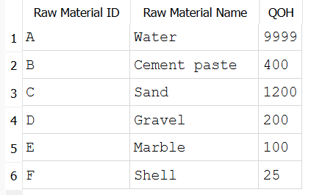

**Statement:** Identifying this information serves to figure out the amount of a specific material we had at hand in inventories.

## SQL #2

SELECT [Raw Material].[Raw Material ID], [Raw Material].[Raw Material Name],[Raw Material].[QOH]

FROM [Raw Material] WHERE [Raw Material].[QOH] < 400

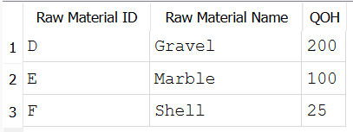

**Statement:** A manager could use this information to check if they have enough Raw Material on hand. They could then use that information to know whether they should order more Raw Materials, or stave off ordering for another day.

## SQL #3

SELECT [Raw Material].[Raw Material ID], [Raw Material].[Raw Material Name],[Raw Material].[QOH]

FROM [Raw Material] WHERE [Raw Material].[QOH] < 400 OR [Raw Material].[QOH] > 1200

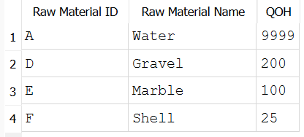

**Statement:** Served to identify the quantity at hand of specific material at a specified range. A quantity of either greater than 1200 and below 400.

# **BILL OF MATERIAL**

## SQL #1

SELECT [Bill of Material].[Concrete Type], [Bill of Material].[Raw Material ID],[Bill of Material].[Unit]

FROM [Bill of Material]

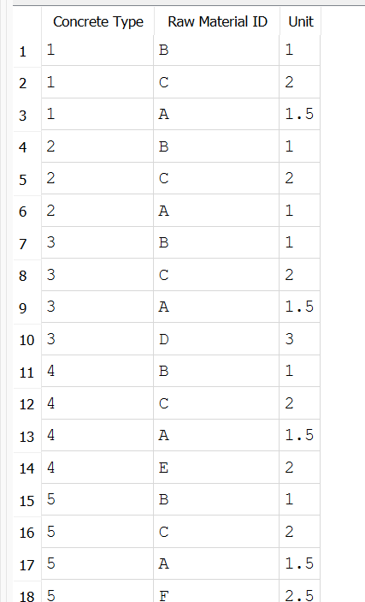

**Statement:** A manager would use this information to know exactly what items need to be ordered to repair or use a specific machine, and how much of that item needs to be ordered.

## SQL #2

SELECT [Bill of Material].[Concrete Type], [Bill of Material].[Raw Material ID],[Bill of Material].[Unit]

FROM [Bill of Material] WHERE CAST([Bill of Material].[Unit] as DOUBLE) <= 1

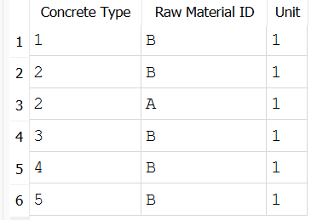

**Statement:** A manager would use this information to find out which materials require the least amount of shipments per use, and therefore need to be ordered the least.

## SQL #3

SELECT [Bill of Material].[Concrete Type], [Bill of Material].[Raw Material ID],[Bill of Material].[Unit]

FROM [Bill of Material] ORDER BY [Bill of Material].[Raw Material ID]

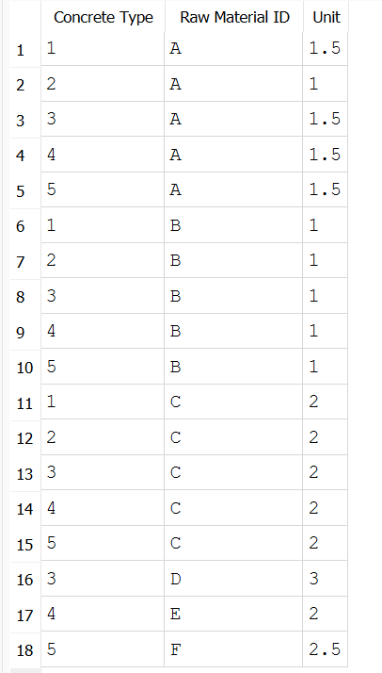

**Statement:** A manager would use this information to which Concrete Types use which Materials, and determine if they need more of anything specific when they need to ship more Raw Materials.

# **ORDER**

## SQL #1

SELECT [Order].[Order Number], [Order].[Order Date], [Order].[Customer Number], [Order].[Driver ID], [Order].[Truck ID], [Order].[Amount], [Order].[Concrete Type], [Order].[Delivery Address]

FROM [Order]

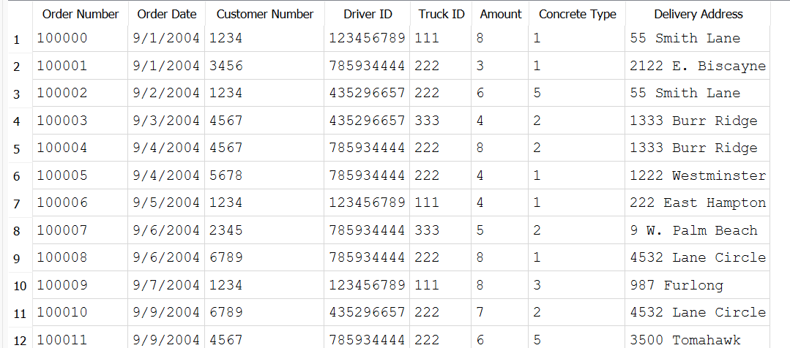

**Statement:** The information present serves to allocate deliveries sent to customers. In identifying where the delivery will be sent to, what the delivery contains, and as the truck and driver who will be delivering. It even shows the date on which the delivery was placed and it’s identification of it.

## SQL #2

SELECT [Order].[Order Date], [Order].[Customer Number], [Order].[Driver ID], [Order].[Truck ID], [Order].[Amount], [Order].[Concrete Type]

FROM [Order] ORDER BY [Order].[Truck ID], [Order].[Amount]

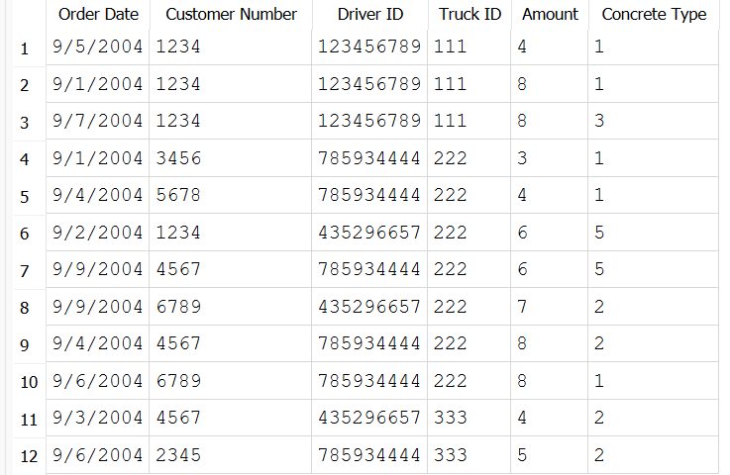

**Statement:** Information present provides information on the delivery. It shows what order it is and when it was placed. It also shows the identification of the delivery driver and the truck they will be drive in delivering the order. Order information is also present in showing what it is and how much of it is.

## SQL #3

SELECT [Order].[Order Number], [Order].[Order Date], [Order].[Driver ID], [Order].[Truck ID], [Order].[Amount]

FROM [Order] ORDER BY [Order].[Driver ID], [Order].[Truck ID], [Order].[Order Date]

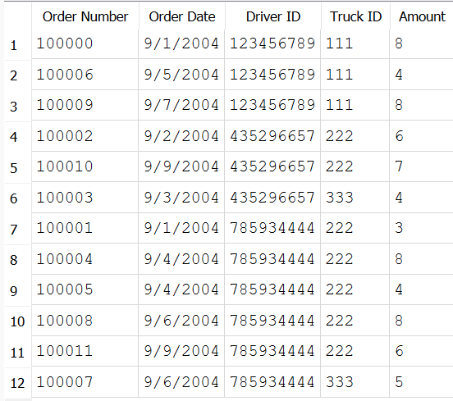

**Statement:** A manager would use this to figure out the schedule of their employees, and to figure out which truck they used for which period, and how many orders they used it for.