Statement of Research
Introduction
The research will focus on the intersection of climate science, dynamical systems, machine learning, and the statistics of extremes. Specifically, it will examine the ability of Echo State Networks (ESNs), also known as Reservoir Computing models, to reproduce extreme events in prototype weather and climate systems.
Motivation
Studies of extreme events are an important research area in climate and weather studies. There are several examples of the events such as very hot temperatures in summer or very low winter temperatures (Texas freeze in February 2021), extreme rain or drought, etc. In particular, the ability to accurately compute the statistics of extreme events in long-term time series is crucial, as it enables society to prepare for an impending threat in advance. However, the rarity of such events introduces significant difficulty, making the development of accurate predictive models especially challenging.
Weather and climate models are, typically, very complex and high-dimensional time-dependent models (dynamical systems) that are described by equations of fluid dynamics (partial differential equations) and models for other physical processes (like precipitation).
Machine learning has emerged as a promising and versatile tool for understanding and predicting a wide range of physical phenomena. Consequently, recent research has shifted from basic, deterministic computing graphs defined by domain experts to the training of neural networks on large datasets specific to the prediction task. Weather forecasting provides a clear example of this transformation: the historical reliance on sparse measurements from weather balloons is increasingly being replaced by high-resolution observations from satellites, radar, and global reanalysis products. A notable example of this convergence is GraphCast by Google DeepMind, a machine-learning model designed for global weather forecasting (DeepMind, 2023). Despite such advances and ongoing research efforts, standard machine learning algorithms remain poorly suited to predicting rare events, often underperforming on these cases because such events contribute only marginally to the overall cost function during training. The present research seeks to address this challenge by exploring architectures capable of reliably predicting rare events while preserving the ability to generalize across broader data distributions. In particular, Echo State Networks (ESNs), also known as Reservoir Computing models, will be investigated as a potential framework for capturing the statistics of extremes in complex dynamical systems.
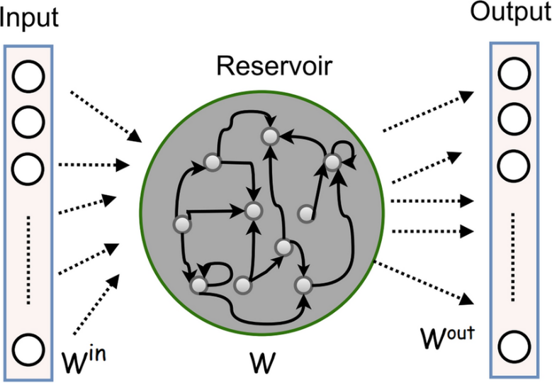
Methods
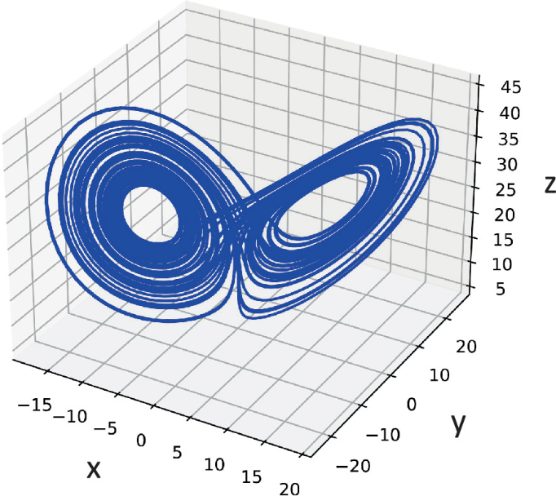
Echo State Networks (ESNs) have already demonstrated success in predicting time series generated by various fluid-dynamical models. ESNs belong to the broader class of reservoir computing approaches and share characteristics with neural networks. Every ESN is defined by three core components: (i) a recurrent structure that provides memory of past inputs, (ii) a reservoir, which acts as a high-dimensional randomized dynamical system that nonlinearly transforms the input signal, and (iii) an output layer, which constitutes the only part of the model that is explicitly trained. ESNs are known to generate predictions significantly faster than directly solving the underlying partial differential equations. With appropriate training, they can also achieve stability and accuracy comparable to, and in some cases exceeding, that of other machine learning algorithms. These properties suggest that ESNs hold considerable potential for application in producing future weather and climate forecasts.
pic 1 The “original” architecture of Echo State Networks
pic 2 The attractor of Lorenz63 chaotic system
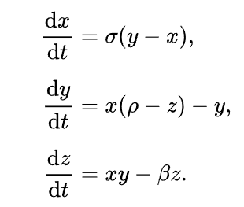
Weather and climate forecast data will be supplemented with simulations from the Lorenz63 differential equations, often referred to as the Lorenz63 chaotic system. The system is defined by three independent variables (x, y, z), which may also be denoted as indices (0, 1, 2). The data will be generated using the equations from figure 3, where σ=10, ρ=28, β=8/3. These are the most well-known parameters under which the Lorenz63 system exhibits chaotic behavior while maintaining a stable attractor. Additional hyperparameters influencing the training and testing time series will be identified during the research and development process and discussed in the final report.
pic 3 The ODE of Lorenz63 system
This research basically consists of the following stages.
- First, find out the best hyperparameters for generating training and test data using a physics-based climate model – Lorenz63.
- Second, train original (1-layer) ESN to reproduce the data. This model will be a baseline for further evaluations and references.
- Third, compare the statistics of extreme events in the original physics-based model and testing data generated by ESN. It is curious to see whether our model manage to reproduce the statistics of extreme events, because standard training algorithms are designed to reproduce the main bulk properties of the data, like mean, variance, etc., but extreme events are rare and Machine Learning models tend to make large errors for such events.
- Forth, if we have some extra time, we will put our efforts for solving the “reservoir issue” of ESN models. The common practice is to take very large and sparce reservoir for training ESNs. However, that usually leads to high computational expenses due to large matrix multiplication inside recurrent layer both during training and inference. We will try to minimize the size of reservoir. The obvious problem that we except to face is a decrease in prediction accuracy. In order to overcome this obstacle, we will introduce the “authors” ESN by adding more output layers for our model.
Evaluation
The study will employ statistical methods to evaluate the predictive performance of the models. Specifically, histograms and time series generated by the Lorenz63 system will be analyzed and compared with those produced by the Echo State Network (ESN). Furthermore, the Kolmogorov–Smirnov test will be applied to provide a rigorous comparison of histogram tails, which correspond to rare events. The Research will be regarded successful on the condition that the statistical properties of the system can be reproduced at will with a statistically significant level of confidence.
Resources
- Lorenz63 data generator based on the ordinary differential equation presented earlier
- Jupyter notebook and VScode environments
- General laptop hardware
Contributions
Josh Reed Lewis – proposal writing, ESN architecture development, visualizations, final report writing
Israel Trejo – proposal writing, ESN architecture development, visualizations, final report writing
Anton Erofeev – proposal writing, Lorenz63 generator development, ESN architecture exploration and modeling, final report writing

