RSA Encryption Algorithm - Explanation Report
developed by

This report explains the Python implementation of the RSA algorithm. The program demonstrates public-key cryptography concepts including key generation, encryption, and decryption, specifically designed to handle numeric messages.

1. Overview of RSA
RSA (Rivest–Shamir–Adleman) is an asymmetric cryptographic algorithm that uses two keys: a public key for encryption and a private key for decryption. It relies on the mathematical difficulty of factoring large prime numbers.

2. Program Structure
The program is object-oriented, built around an RSA class that encapsulates all the mathematical operations required for key generation and encryption/decryption.

3. Key Components
• RSA Class Initialization: Takes two prime numbers p and q, computes n = p × q and φ(n) = (p−1)(q−1).
• Key Generation: Randomly selects a public key exponent e such that gcd(e, φ(n)) = 1, and computes the private key d as the modular inverse of e mod φ(n).
• Encryption: The numeric message m is encrypted as c = m^e mod n.
• Decryption: The ciphertext c is decrypted as m = c^d mod n.
• Input Validation: Ensures p and q are prime, different, and large enough so that n > message.

4. Helper Functions
The `is_prime()` function verifies if a number is prime, and `get_primes_for_message()` ensures the user selects appropriate primes such that n > message.

5. Execution Flow
1. The user enters a numeric message.
2. The program prompts for two prime numbers (p and q).
3. It validates that n = p × q is greater than the message.
4. RSA keys are generated.
5. The message is encrypted and then decrypted to demonstrate correctness.

6. Error Handling
The program includes exception handling for invalid inputs, non-prime numbers, duplicate primes, and cases where n ≤ message.

7. Example Run
Example:
Message: 25
p = 13, q = 17 → n = 221
Public Key: (e, n) = (11, 221)
Private Key: (d, n) = (35, 221)
Encrypted: 25^11 mod 221 = 155
Decrypted: 18^131 mod 221 = 25
Terminal snapshot is following
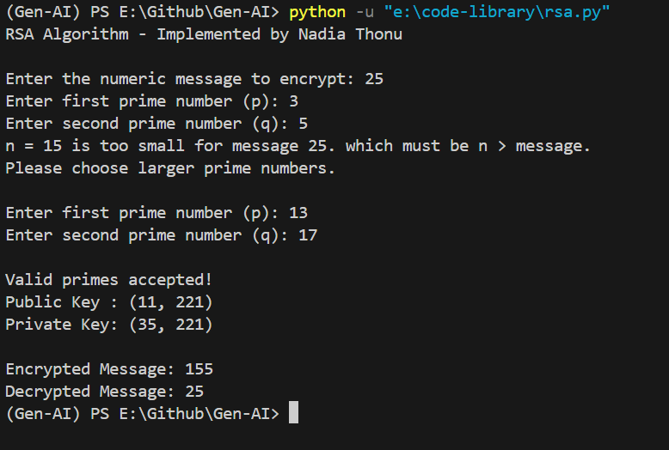
Figure 1. Example of RSA Algorithm.

8. Conclusion
This implementation of RSA provides a simplified demonstration of public-key cryptography for educational purposes. By requiring the user to select appropriate primes based on the message size, it reinforces understanding of RSA's mathematical foundations and its security constraints.

