Image Steganography Report

Introduction
This report explains the steganography technique used in my project, where I hide one grayscale image (2.jpg) inside another grayscale image (1.jpg). The program embeds the secret image into the cover image using 4-bit substitution and then extracts it again. All images are displayed on the screen, and no output files are saved automatically. I will later insert my own images into this report.

Images Used
• Cover Image: 1.jpg
• Secret Image: 2.jpg
Both images are converted to grayscale at the beginning of processing.

How the Method Works
Each grayscale pixel has a value between 0 and 255 (8 bits). To hide the secret image inside the cover image, I split the pixel values into two parts:
• Upper 4 bits (MSB) → More important information
• Lower 4 bits (LSB) → Less important information
The secret image is compressed to 4 bits per pixel by keeping only its upper 4 bits. These 4 bits are then placed into the lower 4 bits of the cover image. Since the LSBs are the least visually important, the cover image does not noticeably change.

My Example Explained
Step 1: I load 1.jpg (cover) and 2.jpg (secret). Both are converted to grayscale and the secret image is resized so both have the same width and height.
Step 2: I take the secret image and reduce it from 8 bits to 4 bits by dividing each pixel value by 16. This keeps only the most important part of the secret image.
Step 3: I remove the last 4 bits of the cover image by dividing it by 16 and then multiplying back. This clears space to insert the secret data.
Step 4: I combine both results — the cleared cover image and the reduced secret image — to create the stego image. The hidden image does not affect the visual appearance of the cover image too much.
Step 5: To extract the hidden image from the stego image, I take the last 4 bits (using modulo 16) and multiply the result by 16 to scale it back. This produces the extracted version of 2.jpg.

Displayed Outputs
My program displays the following images on the screen:
1. Grayscale cover image (1.jpg)
2. Grayscale secret image (2.jpg)
3. Stego image (1.jpg containing 2.jpg)
4. Extracted secret image (recovered 2.jpg)
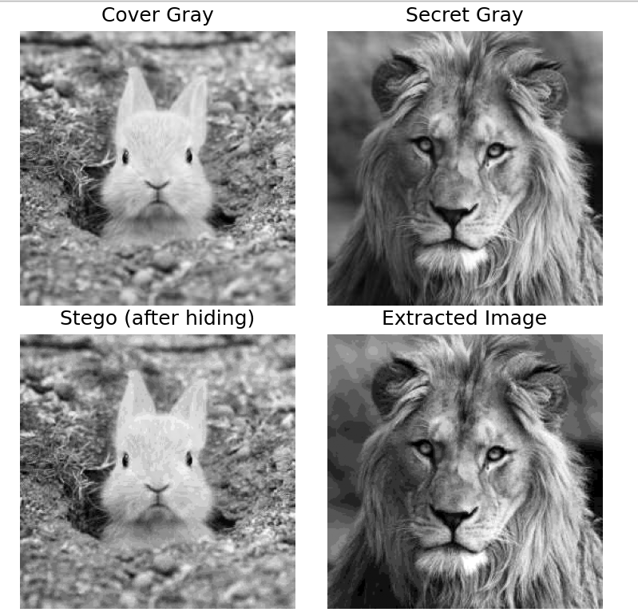
Figure 1. Original Image and Cover Image

Conclusion
This example demonstrates a simple and effective way to hide an image inside another using 4-bit grayscale steganography. Although the extracted image loses some detail due to storing only 4 bits, the overall structure is still visible. This method is useful for learning the basics of image steganography and bit manipulation.

