Freight Rate Prediction — Solution Report
Machine Learning Engineer assessment · trained on train-test.csv (48,000 loads, Jan–Oct 2025).

1. Summary
The target posted_rate is close to a deterministic function of distance (log-log R² = 0.97), so the interesting part of this problem is not model capacity but data quality and getting the residual 2–3% right. The final model is a log-linear regression with:
- log(distance) and log(distance)² — the dominant driver; the log-log relation is slightly convex.
- market_index, quote_signal, log(|weight|), equipment indicators.
- pickup-city and delivery-city fixed effects (up to ±6.5% and remarkably stable in time).
- a linear time trend (t = days since 2025-01-01) that captures a slow drift beyond market_index.

Fitted on 47,323 rows after flagging 677 (1.41%) training targets. The selected batch-inference policy fills null market signals with medians from supplied unlabeled features on that same date. This availability assumption is explicit for the 249 null-market validation loads and for the December chart inputs. The chronological holdout (train Jan–Aug → test Sep–Oct) compares this selected policy with the training-median reference, using the SAME fitted model and evaluation rows:
feature-imputation policy / evaluation | n | MAE | RMSE | MAPE | R²
same-date batch features / clean ← selected | 9,379 | $48.13 | $73.28 | 2.07% | 0.99716
same-date batch features / ALL ← selected | 9,523 | $104.08 | $632.66 | 4.58% | 0.82813
training-only medians / clean (reference) | 9,379 | $48.30 | $73.54 | 2.08% | 0.99714
training-only medians / ALL (reference) | 9,523 | $104.27 | $632.73 | 4.58% | 0.82809
The selected-policy metrics are regenerated by validation_signal_sensitivity.py; validate.py produces the reference-policy plots and rolling table. The family comparison below likewise uses reference imputation, not the selected-policy metric. Holdout labels enter only the evaluation mask/metrics, never the fit or same-date signal values. Hidden-set accuracy remains unknown.
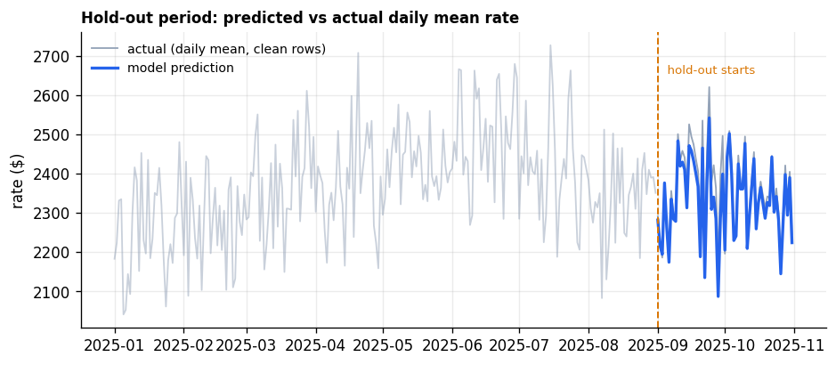
Reference-policy holdout: model prediction vs actual daily mean rate (clean rows).

2. Data-quality issues found and how I addressed them

2.1 Corrupted targets — the single most important finding
The symmetric multiplicative structure strongly suggests synthetic target corruption introduced for the challenge; this is an inference, not a known data-generating fact. In 677 rows (1.41%), the apparent target multipliers are far outside the core. Fitting a reference model and looking at actual/expected shows a sharp core (98.6% of rows within ±25% of prediction, σ ≈ 3.9% in log space) plus two well-separated multiplicative tails — ×0.17–×0.51 (337 rows) and ×2.09–×5.75 (340 rows) — near log-symmetric (−431 vs +419 in log space).
- These rows are not predictable from the features: a gradient-boosted classifier on all features scores 5-fold CV AUC = 0.494. The tail is not predictable from these features in this audit, so it should not drive training; that does not guarantee hidden targets are clean.
- Leaving them in does not materially move the coefficients — the two tails are near log-symmetric (−431 vs +419 in log space) — but it inflates all-row RMSE ~9× ($73 → $633) and hides the model's clean-core accuracy. They are detected with a MAD-based robust threshold (|residual| > 6·1.4826·MAD from a simple reference model) and excluded from training. The filter is applied only to labeled training data: validation and December rows are always predicted, never dropped.
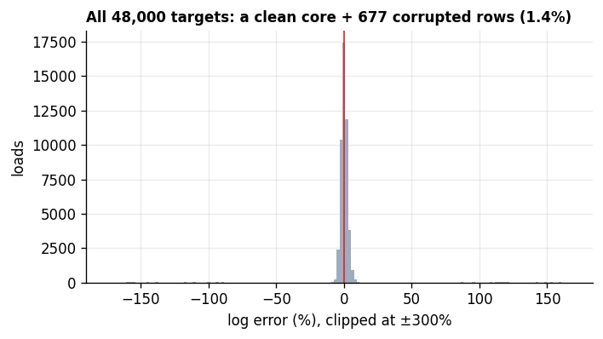
Residuals of all 48,000 targets against a reference model: clean core + 677 corrupted rows (clipped at ±300%).

2.2 Negative weights
292 rows have negative weight (down to –47,500 lb) sitting inside a clean 0–47,500 lb distribution. |weight| lands exactly in the valid range, so this is consistent with sign-flip corruption: corrected with abs().

2.3 Jittered lane distances and suspect city coordinates
Two further quirks, both investigated and deliberately left as-is:
- The same pickup→delivery lane reports distances with a median CV of 1.8%. Replacing them with a lane median has no measurable effect on fit (R² 0.99644 → 0.99644), so no repair was applied.
- City coordinates are displaced from real city locations: compared against the public GeoName city list with an automated, reproducible match (highest-population exact-name rule, 64/64 cities matched), the median error is ~127 miles and only 3 cities sit within 10 miles — far beyond the usual city-centre ambiguity (Boston and Providence even share a clipped longitude of −69.5). Whether this is deliberate corruption or a preprocessing artifact remains an inference; the displacement itself is a measured property of the data. I also tested whether the rate was generated from true city-to-city distances: that fits far worse (robust σ 0.183 vs 0.040), so the rate follows the distance column as given. Since no map-based features are used, the coordinates are harmless here.

2.4 Missing values
In the labeled training split, missing weight (0.62%) and market_index (0.78%) use training-partition medians. At inference, validation has 249/12,000 null market_index values: each is filled from supplied same-date validation FEATURE medians if available (otherwise the stored training median); missing weights still use the training median. No validation targets are read. This batch-feature availability assumption is evaluated against the training-median reference in section 1.

3. Validation strategy and data split
The task requires predicting future months (validation and December are future periods), so all evaluation here is chronological. For transparency, a random 80/20 split was also measured: it looks only ~5.7% better on clean MAE (46.76 vs 49.58) than the time split — there are 0 exact duplicate rows, and recurring pickup–delivery lanes (47,933 rows) are normal freight traffic, not duplicated feature vectors. All evaluation is therefore time-based:
- train Jan–Aug → test Sep–Oct — a two-month horizon, the closest available analogue of predicting November and December. The rolling metrics and plots below use training-median reference imputation; selected-policy two-month metrics are in section 1.
- rolling-origin: six consecutive folds, each training on everything up to the 1st and testing on the following month. This is how the time-trend treatment was chosen.
- the corruption threshold is estimated inside each fold, never on the test period.

train ends | test month | n (clean) | MAE | RMSE | MAPE | R²
2025-05-01 | 2025-06 | 4,851 | $42.67 | $60.44 | 1.82% | 0.998
2025-06-01 | 2025-07 | 4,720 | $48.83 | $75.95 | 1.92% | 0.997
2025-07-01 | 2025-08 | 4,847 | $68.77 | $95.40 | 2.81% | 0.995
2025-08-01 | 2025-09 | 4,691 | $51.55 | $72.43 | 2.20% | 0.997
2025-09-01 | 2025-10 | 4,606 | $55.79 | $86.10 | 2.28% | 0.996
2025-10-01 | 2025-11 | 4,773 | $40.70 | $59.12 | 1.80% | 0.998

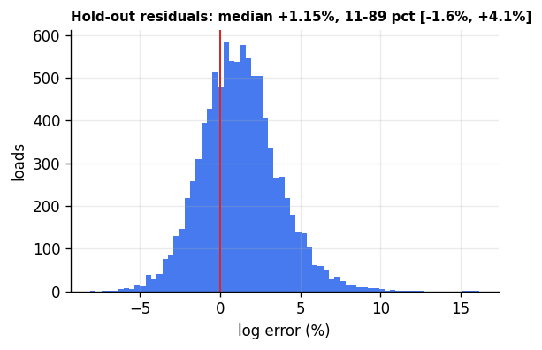
Hold-out log residuals (clean rows): centred on zero, 11th–89th percentile ≈ ±2%.
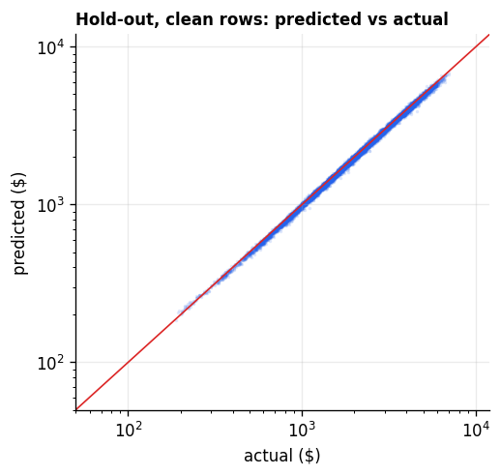
Predicted vs actual on the hold-out, clean rows (log-log axes).

4. Model choice — model families compared under future-like validation
In the exploratory phase I benchmarked regression, boosting and a hybrid. This first table reports earlier candidate configurations on an out-of-time holdout (not the final fixed-mask audit):
model | MAE (clean) | RMSE (clean) | R² (clean)
parametric OLS (city FE + trend) | $48.02 | $73.12 | 0.9972
OLS + GBM residual correction | $47.02 | $71.75 | 0.9973
HistGradientBoosting (log target) | $56.77 | $85.15 | 0.9962
HistGradientBoosting (raw $) | $59.26 | $87.47 | 0.9960
HistGradientBoosting (native categoricals) | $53.63 | $80.21 | 0.9966

Reference-imputation family audit, Sep–Oct holdout: every candidate uses the same fixed, model-independent clean mask for evaluation, alongside ALL holdout targets (including the flagged tail). No holdout row is used for fitting; this audit fits the compared candidates without robust target filtering, so linear+time below is not the cleaned shipped pipeline:
family | clean MAE | all-row MAE | all-row R²
linear log-model, no time | $103.45 | $158.61 | 0.81957
linear log-model + time ← chosen | $49.80 | $105.71 | 0.82827
GBM, no time | $94.01 | $149.26 | 0.82096
GBM + time | $95.56 | $150.64 | 0.82167
The complete auditable table (also mean and distance baselines, MAPE and clean R²) is reports/model_family_audit.csv, reproduced by optional model_family_audit.py. In the actual shipped pipeline, training-only target cleaning with reference imputation gives clean MAE $48.30 / all-row MAE $104.27; the selected same-date policy gives clean MAE $48.13 / all-row $104.08 (summary table). All-row numbers matter because hidden targets might also contain corruption; none is removed from validation or December predictions. The hybrid looked marginally better on one exploratory split, but across six rolling folds its average MAE change was −15.8% (worse on 4 of 6); we did not ship it. Among the evaluated models under this out-of-time protocol, the linear log-model with a time trend performed best; this is not a claim that regression is inherently superior to boosting. Hidden-validation accuracy is not available.

4.1 The time trend: what it is and why it is safe to extrapolate
After accounting for market_index, a slow drift remains. I compared four treatments on the rolling folds and the 2-month hold-out:
time treatment | mean MAE (6 folds) | 2-month hold-out MAE | comment
none | $72.39 | $102.78 | drifts out of calibration
linear trend on full history ← chosen | $50.92 | $48.02 | lowest average MAE
last-level offset (28 days) | $54.87 | $68.02 | over-reacts to the most recent month
linear trend on recent window (120 days) | $51.91 | $52.75 | similar, slightly worse

A second, complementary comparison — seven rolling two-month windows (closer to the actual two-month forecast horizon), scoring four time treatments on clean rows:
test window | no time | linear (+t) ← chosen | linear+anchor | anchor-only
Mar–Apr | 141.6 | 138.6 | 138.5 | 140.9
Apr–May | 264.4 | 248.3 | 248.5 | 264.8
May–Jun | 65.6 | 51.1 | 52.5 | 65.5
Jun–Jul | 69.9 | 56.3 | 56.3 | 66.5
Jul–Aug | 56.9 | 106.7 | 115.7 | 47.3
Aug–Sep | 93.3 | 55.8 | 49.3 | 74.4
Sep–Oct | 103.5 | 49.8 | 56.4 | 71.7
mean, all 7 folds | 113.6 | 100.9 | 102.5 | 104.4
mean, last 4 folds | 80.9 | 67.2 | 69.4 | 65.0

The linear trend wins 6 of these 7 windows; the single loss is Jul–Aug, where market_index fell and the fitted trend overshot (bias +4.1%). Preferring the most recent windows when judging that trade-off is a deployment assumption (validation and December are future months), stated as such — not a mathematical fact. The 'anchor-only' variant (last-30-day offset, no slope) was measured for comparison but is not part of the shipped pipeline.

At full fit the trend is +0.0213%/day (≈ +7.8%/year) and the model's mean residual over the last 28 days is +0.0001 in log space — i.e. the fitted trend line is exactly at the recent level, which is what makes extrapolating it two months into November–December defensible (with Jul–Aug the known exception).

5. Final model
log(posted_rate) = 1.0747 + 0.6864·log(distance) + 0.01430·log(distance)² + 0.14395·market_index + 0.01865·quote_signal + 0.08047·log(|weight|) + 0.12124·is_reefer + 0.08032·is_flatbed + 0.000213·t + pickup-city FEs + delivery-city FEs

term | coefficient | interpretation
log(distance) | 0.6864 | +1% distance ≈ +0.69% rate (plus convexity)
log(distance)² | 0.01430 | long hauls pay slightly more than proportional
market_index | 0.14395 | +0.1 in market index ≈ +1.44% rate
quote_signal | 0.01865 | small but highly significant (t=50)
log(|weight|) | 0.08047 | heavier loads cost slightly more
Reefer / Flatbed | +12.89% / +8.36% | vs Dry Van
t (days) | 0.000213 | ≈ +7.8%/year drift
city FEs | up to ±6.5% | e.g. Dallas/OKC/Houston up, Syracuse/Buffalo/Detroit down
fit | R² = 0.99872 | residual σ = 2.3% (robust 2.2%)

City effects were verified as stable over time — the Jan–Aug city effect estimates correlate 0.99 with the Sep–Oct estimates — which is what justifies using them for future months.
New markets: validation.csv contains 8 cities never seen in training (12.1% of its rows). Those rows get the prior-mean city effect (mean of the fitted city effects, ≈ +3.2%) rather than the baseline city's 0% — validated by leave-one-city-out ($66.7 clean MAE vs $78.2 for a zeros fallback; oracle $46.6). December chart inputs contain no unseen cities.

6. December predictions (scorer output)
The fixed December scenario is Lexington → Fort Wayne, 360 miles, Dry Van, 32,000 lb, with only the date changing. december-chart-inputs.csv omits market_index / quote_signal. The SUBMITTED predictions fill each missing signal with the median of that feature among supplied validation.csv rows on the SAME date (all 31 dates matched). No validation target/posting rate is read. This is not target leakage, but it assumes those same-date validation features were available when chart predictions were made. If they are unavailable at inference, training-only medians are the fallback. The 12,000 regular validation predictions also use supplied row features; 249 with null market_index get the same-date supplied validation-feature median (no target). If inference is strictly row-by-row without the day's other feature rows, this assumption does not hold for either prediction file.

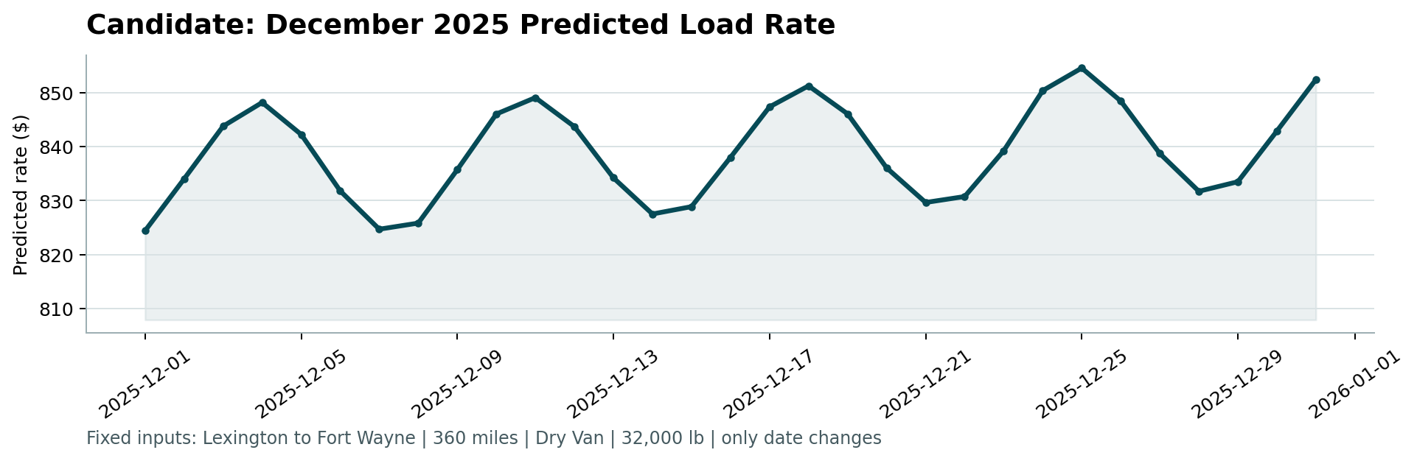
Official candidate_december.png — produced by the supplied score.py from the two submitted CSVs.
Sensitivity using the SAME frozen model; only the two missing signals change. Same-date-feature medians produce the submitted curve, whose daily waves reflect the available market signal; using training-only medians instead gives a flatter curve with a different peak. Neither the fallback rates nor the chart below were submitted as replacement predictions.
signal source | December mean | range | peak date
supplied same-date validation features (submitted) | $839.05 | $824.42–$854.51 | Dec 25
training-only medians (sensitivity) | $853.91 | $851.19–$856.65 | Dec 31
Same-date minus fallback: −$14.86 mean, $14.86 mean absolute difference, $27.57 maximum absolute difference (up to 3.235% of fallback). Exact daily values and signal medians: reports/december_signal_sensitivity.csv; re-run december_signal_sensitivity.py to regenerate.
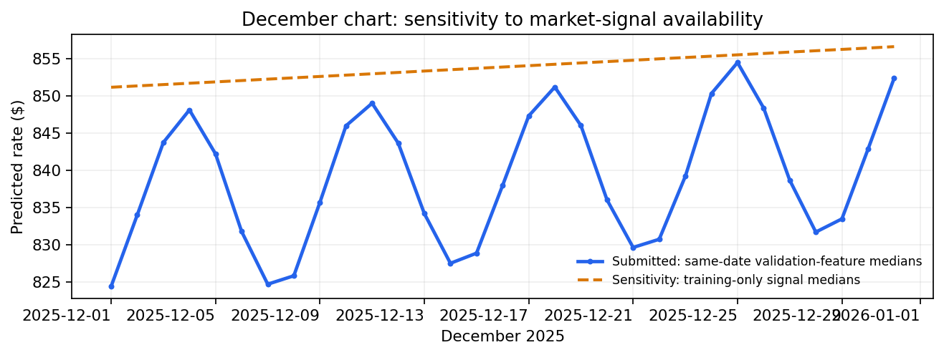
December feature-availability sensitivity; the official submitted series remains unchanged.
The scorer validates CSV structure, required IDs, prediction positivity and creates a chart. Passing it does not measure or establish accuracy against Spotter's hidden validation targets.

7. Deliverables and how to reproduce
- freight_rate_model.py — trains on data/train-test.csv and writes the 12,000-row CSV and the 31-row December CSV. Core fit/predict dependencies: pandas and numpy.
- validate.py — reproduces reference-imputation holdout/rolling metrics and charts (matplotlib).
- validation_signal_sensitivity.py — the selected vs reference holdout comparison.
- model_family_audit.py — optional fixed-mask clean/all-row family comparison; requires scikit-learn.
- december_signal_sensitivity.py — reproduces the same-date vs training-median sensitivity without changing either submitted output CSV.
- outputs/ — BOTH final CSVs; reports/ — this DOCX, official scorer chart, diagnostics and sensitivity chart. A Loom video/link still needs to be recorded and supplied by the candidate.

Commands:
python freight_rate_model.py --train data/train-test.csv --validation data/validation.csv --template data/validation-predictions-template.csv --december data/december-chart-inputs.csv --out outputs/validation_predictions.csv
python score.py --predictions outputs/validation_predictions.csv --december-predictions outputs/december-chart-inputs.csv
python validate.py; python validation_signal_sensitivity.py; python december_signal_sensitivity.py; python make_report.py

