

American International University-Bangladesh (AIUB)  
**Department of Computer Science  
Faculty of Science &Technology (FST)  
Fall 20_21**

**Section: H  
Group No: 04**

**Rare Handcraft Products and Famous Foods Buy, Sell, Distribution**

A software Engineering project submitted

By

|  |  |  |
| --- | --- | --- |
| Serial No. | Student Name | Student ID |
| 18 | CHOWDHURY ANANYA | 18-39028-3 |
| 17 | DEY DURJOY | 18-39013-3 |
| 03 | PRITHA,ISRAT JAHAN | 18-37868-2 |
| 04 | POLASH, MD. TANVIR RAHMAN | 18-37881-2 |

The project will be Evaluated for the following Course Outcomes

|  |  |
| --- | --- |
| Requirements Analysis (functional, quality, and project requirements) [5Marks] | **Total Marks** |
| System Design (UML, UI/UX design) [5Marks] |  |
| Test and Project Management Planning [5Marks] |
| Submission, Completeness, Spelling, Grammar and Organization [5Marks] |

**Submission Date:**

19.12.20

# PRODUCT AND PROJECT DESCRIPTION

## System Features

* List down the system functional requirements that describes the system’s functionalities

1. **Search**
   1. The users can search for any kind of available products in the search box.
   2. In the search box, if user want to search for any products, they will get suggestions for the products.
   3. If users can’t find any products, it will show “no products are found”.

**Priority Level:** High

**Precondition:** The user has to go to the homepage to enter in the search box.

**Cross-references:**

1. **Categories**
   1. Users can select categories from the options and they can select food sections or handcraft sections.
   2. If the user selects the food section, there will be options like fish, sweets, pitha, dry foods, and (etc. If needed).
   3. If the user selects the handcraft section, there will be options like terracotta, hand-made items, dinings and (etc. If needed).

**Priority Level:** Medium

**Precondition:** Users have to click the menu button first to select the category option.

**Cross-references:**

1. **Coins Section**
   1. Users will get coins as a bonus if they purchase some products from us and it will be added to his coin balance
   2. Users can also insert some coins through some online payment methods and use those coins to purchase products from us.
   3. If users return any product as if they feel, they don’t need it or it’s damaged, they will get some coins as a return

**Priority Level:** Medium

**Precondition:** Users have to purchase products or insert some money to activate it.

**Cross-references:**

1. **Cart Section**
   1. Customers can add products to the carts and they can also save there.
   2. If they enter later in the app, they can see the products in the cart and can buy from there.
   3. They can also select the quantity of the products if they want.

**Priority Level:** HIgh

**Precondition:** Customers have to select products to add that product to their cart.

**Cross-references:**

1. **Payment Section**
   1. If a customer order something, they have to confirm the payment method first.
   2. The customers Can choose a banking app/Credit-Masters card/Online Payment App.
   3. Then if they choose the Online payment app Our software will be connected with the other apps like bkash, rocket, and some others to verify their payment by entering orderid.
   4. After the payment, The customers will a confirmation message of their order.

**Priority Level:** HIgh

**Precondition:** Customers have to confirm the orders of the product and also the address to make payment

**Cross-references:** s

1. **Tracking** 
   1. Customers can track their product if they want to trace through our app.
   2. As each customer will get their orderid if their payment is completed, they can trace their products by entering the order.
   3. It will show how the process of their product is going on and also it will show the location of the products he has ordered.

**Priority Level:** Medium

**Precondition:** Customers have to enter their OrderId properly to see tracks of their order

**Cross-references:** 5.1,

1. **Adding Product**
   1. The sellers will add products by selecting the category of the product.
   2. They will also give all the details of the product with name and images and with their shop name.
   3. After proceeding with their product details, the admin will verify their product. And if they are relatable and suitable, they will added to our software database.

**Priority Level:** Medium

**Precondition:** Sellers have to login first to add their products to our software.

**Cross-references:**

1. **Return**
   1. If the Customers wants to return their received product they can to the return section.
   2. After entering the return section, they will see the received products and if they want to return any product from them, they have to select that product.
   3. There will also message note sections of what are the causes of return and the admin will verify if the problem is legit and they can make their return.

**Priority Level:** Medium

**Precondition:** Customers have to receive products to go to the return section otherwise it will show blank.

**Cross-references:**

## System Quality Attributes

* List down the quality attributes that describe how well the system should perform.

**Quality Attributes**

* **Performance:** The users of this software can expect to log in to the server within 5 seconds after they are verified. In performance we can also accept that, there will be enough storage to save all the important data and also the usage loads. And also our application can reload fast in lower kbps speed internet connections.
* **Availability:** Our application will be mainly available for 24 hours but from noon to night at local time, we can except, it will be available at least 99 percent.
* **Flexibility:** If we want to add some features or we want to change something in our app, there will be a maintenance programmer with highly experienced like one or two years and he can be able to make the changes within a day of our work time. he will help us to find errors easily and also he will be run the tests if needed.
* **Efficiency:** Our application will try to consume less disk space for running the application and also it will take less Ram to run the application efficiently and smoothly. We can expect that the users of our application will face less problem to run this app in lower configuration mobile phones and computer devices.
* **Portability:**  There will be different platforms like android apps, IOS applications, Web browsers, and the users can access our application.
* **Reliability:** Our software system will fulfill its assigned task in the given environment and all the users can expect a free of error inputs and outputs.
* **Interoperability:** In our software, users can be connected to the Bkash, rocket, or some online payment methods to pay for their ordered products, and also when creating an account they can be connected through their mail or Facebook account. From email or Facebook, we will get the verification of the actual user.
* **Integrity:** All the information of the users and also the product history will be highly secured and also the customers and the sellers can’t access all the databases rather than the admins.
* **Reusability:** If our software updates to a newer version, we can be able to use the previous versions of codes and functionalities.
* **Robustness:** If a user is about to change his address or information, but he forgets to save that information, there will be recovery options and all the information will be restored as he edited.
* **Maintainability:** For our software, there will a maintenance programmer who will be able to control all the functionalities if there has shown any issue in the software and the time to resolve those matters will be within 5-6 hours.

## Project Requirements

* List down the project constraints (e.g. time, budget, resources, environment, etc.) that should be followed in the project management.
* **Time:** We can expect to complete this project within 6 months and we think that it will be enough time to develop this project and run the project efficiently.
* **Budget:** Our software budget is estimated at 1.5 Million taka to build it.
* **Resources:** For our project, we need some skillful programmers and web developers and some people. Also we need a Farm-house and it will be well organized. We also need an alternative analyzer, expert judgment, and project estimating.
* **Environment:** We will develop our projects inPython language, MySQL, VSCode, Django in our back-end development. And for the front-end we will need HTML,CSS,JAVASCRIPT(REACT),Bootstrap. For hardware devices, we need some good computers to build this app. All the computers will be connected with wifi routers and also all the team members can be connected with others.
* **Tools:** We need UMLET tools to do our software diagrams and also we need pencil tools to design our software UI/UX design.

# SYSTEM DESIGN SPECIFICATION

## System Design

**Scenario:** In our E-commerceapplication customers and sellers can create account. After creating an account, the customer and seller can log in along with the admin. And after that, the system will verify the password and if the password is wrong, there will be an error. Then the customers can search and check products. And they can also check their coins and also they can insert coin my paying online. Also if any customers buy any food or handcraft product from us, they can make payments online or by cash on delivery. And if the payment is insufficient, the system will show an error. And if the order is also placed, they can also track their orders after confirmation and after receiving them, they can give a review of the products. The sellers will be able to add products and shop names with details and images and they will be verified by the admin. The admins can also remove and see the customers and sellers details and they can overview the activities.

* Identify and analyze various processes, **use-cases**, actors etc. of the system. And, use processes at various levels to draw the use-case diagram.

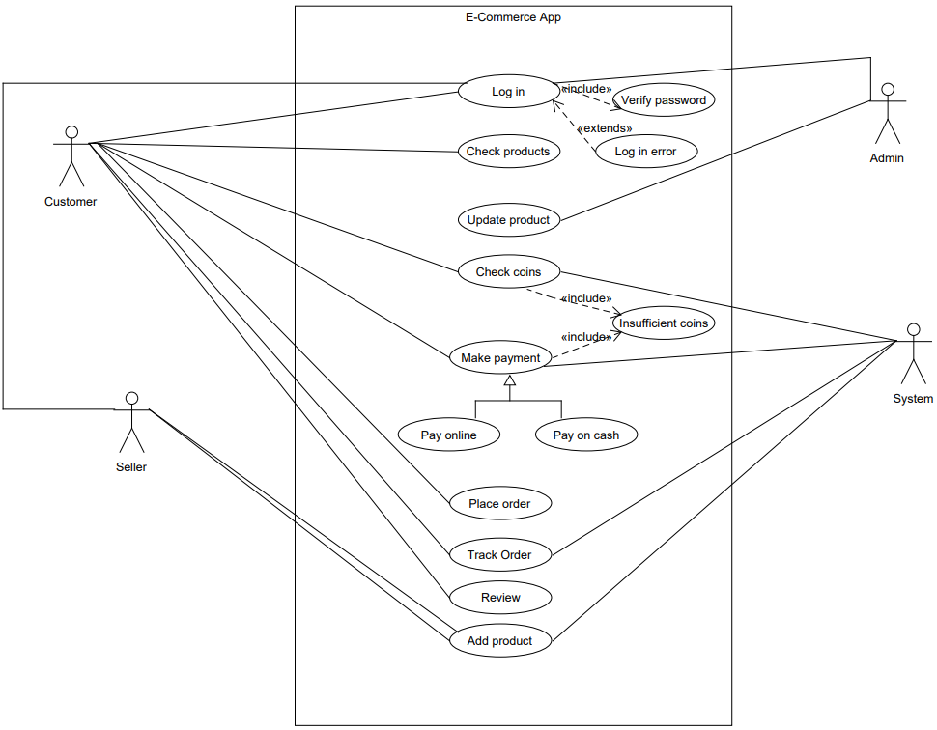

* Identify various elements such as classes, member variables, member functions, etc. of the class diagram. And, draw the **class diagram** as per the norms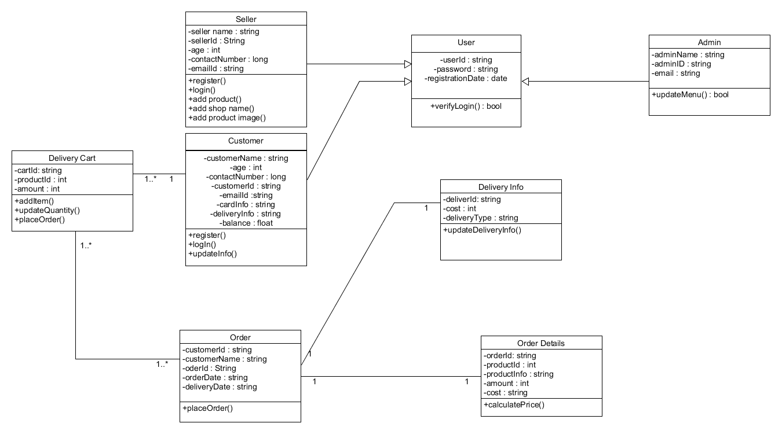
* Identify various elements such as controller class, objects, boundaries, messages etc. of the sequence diagram. And, Draw the **sequence diagram** as per the norms.

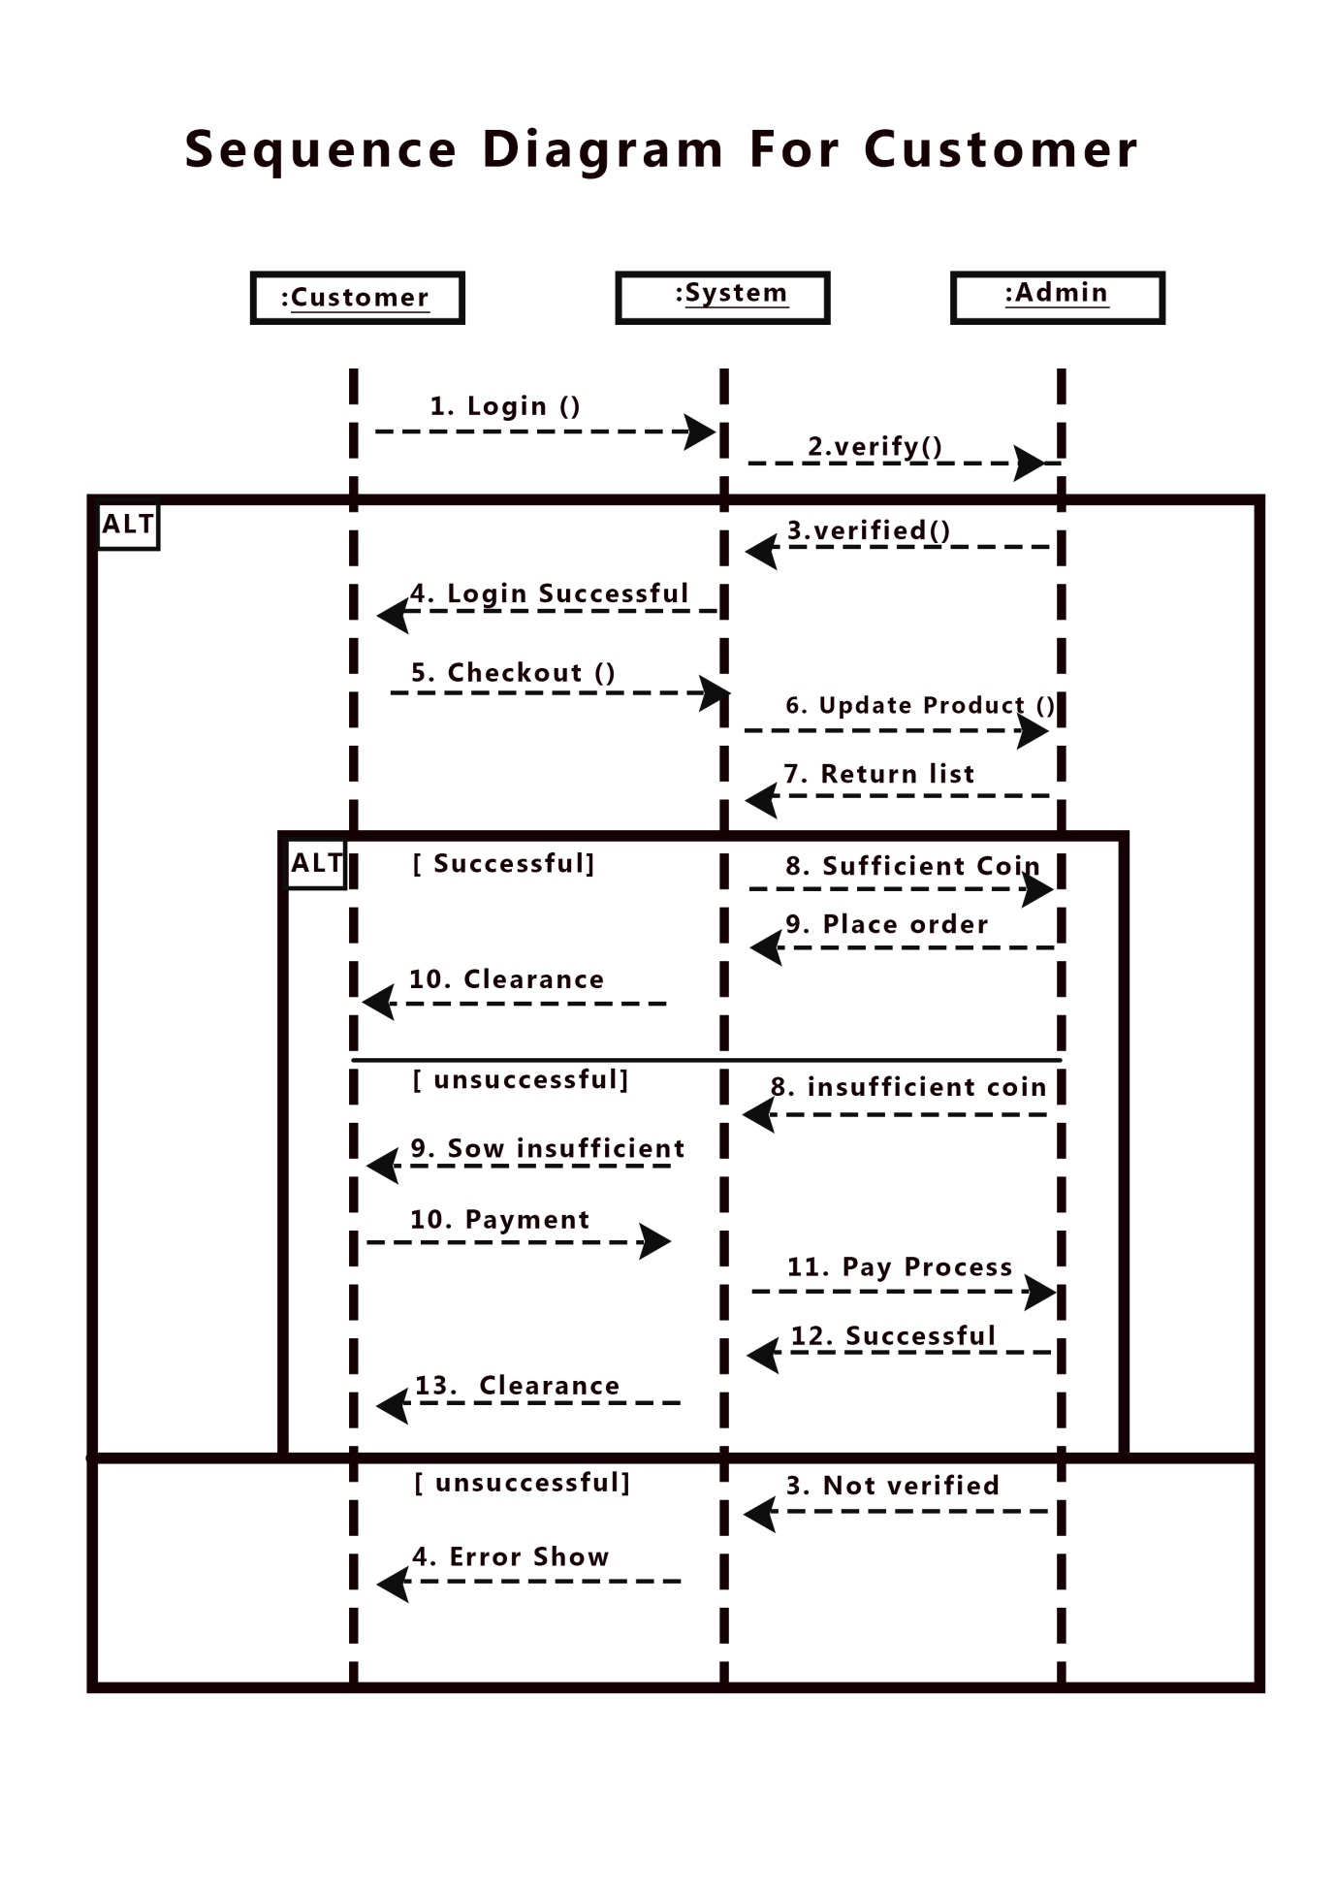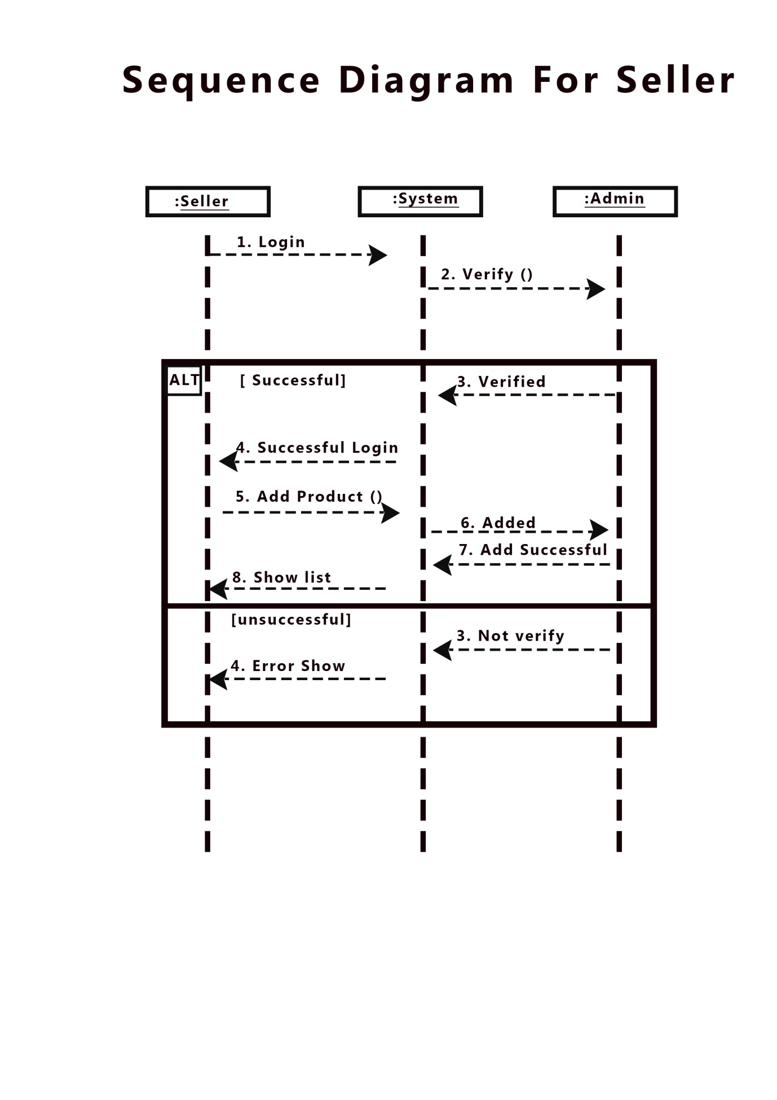

* Identify various actions and corresponding events of triggering actions. And, draw the **activity diagram** as per the norms. 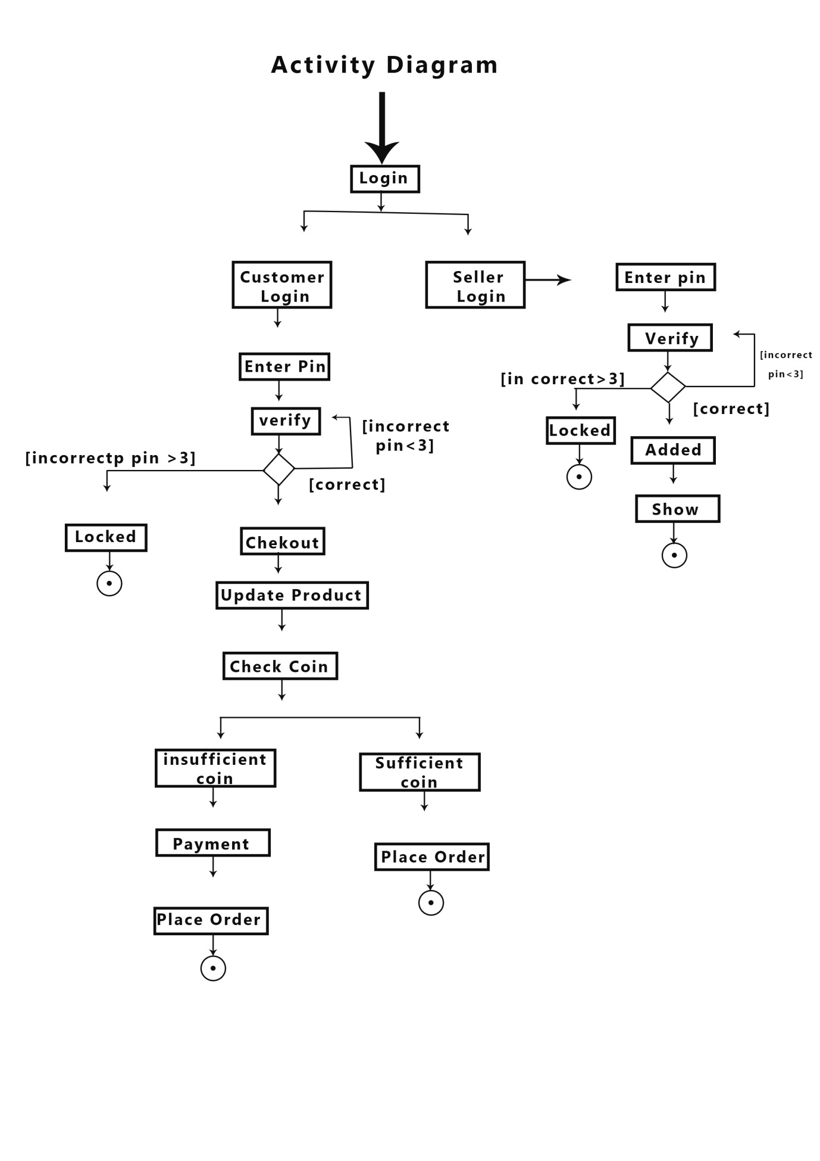
* Identify various entities, attributes, and data dictionary of the ER diagram. And, draw the activity diagram as per the norms.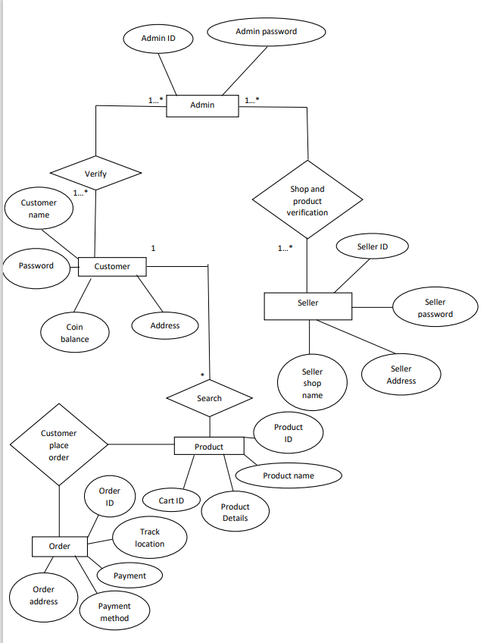

## UI/UX Design

* Design a prototype of your proposed solution using the selected tools based on the above-mentioned UI/UX design principles.

**For Customers:**

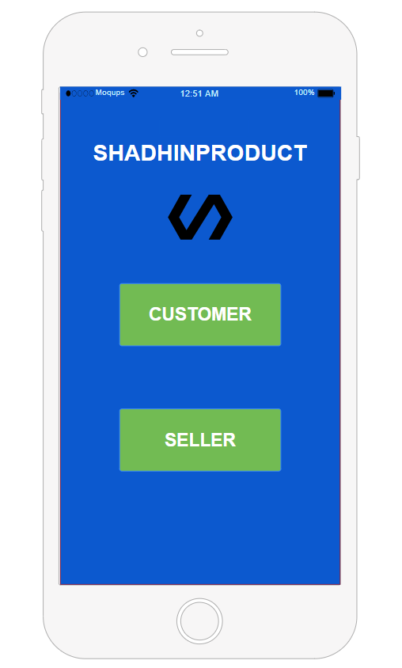

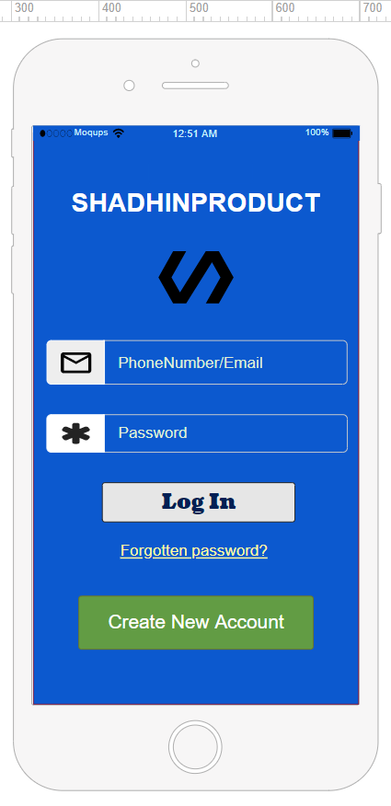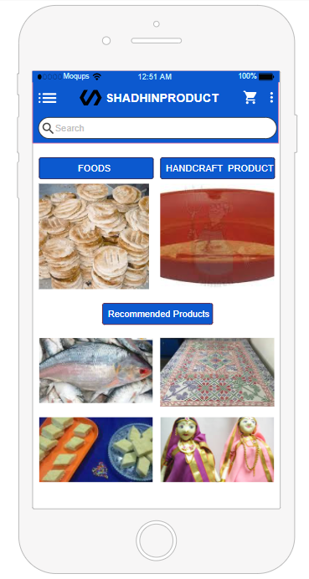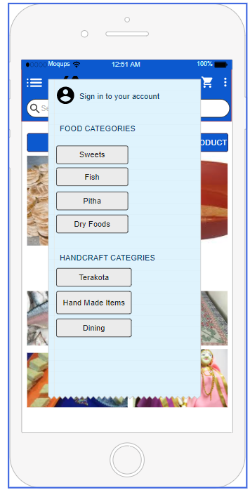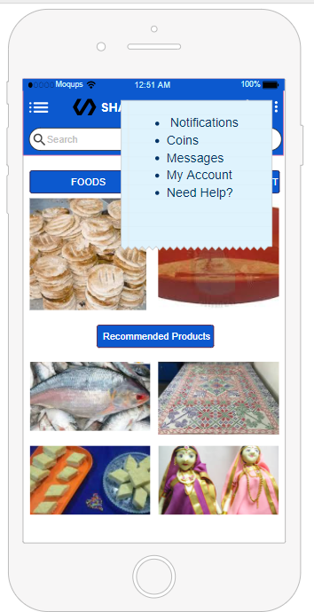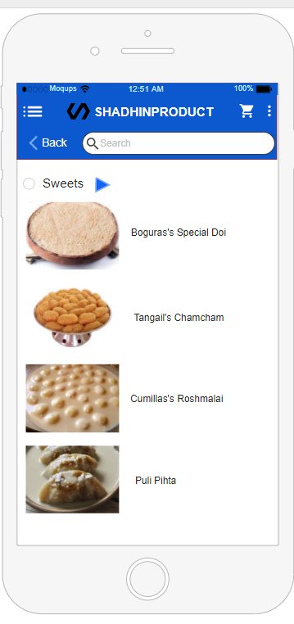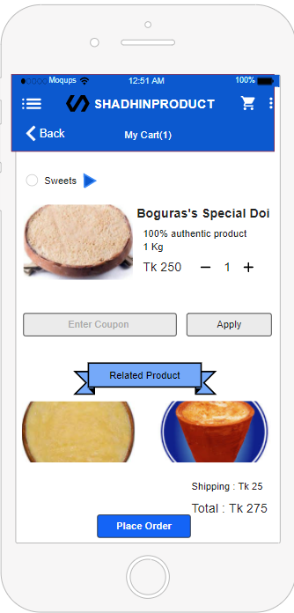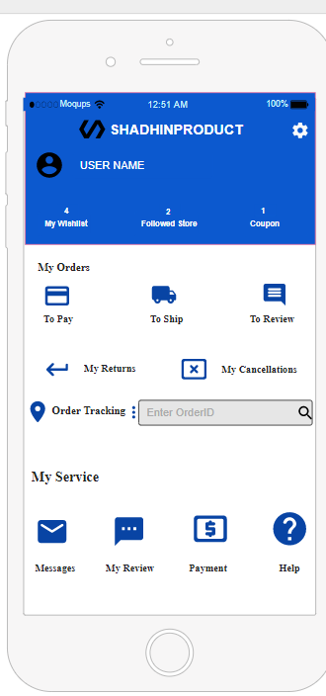

**For Sellers:**

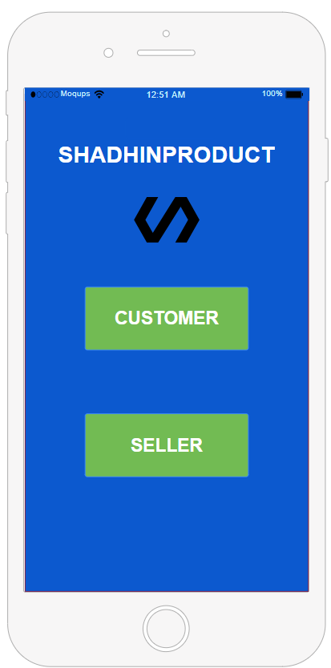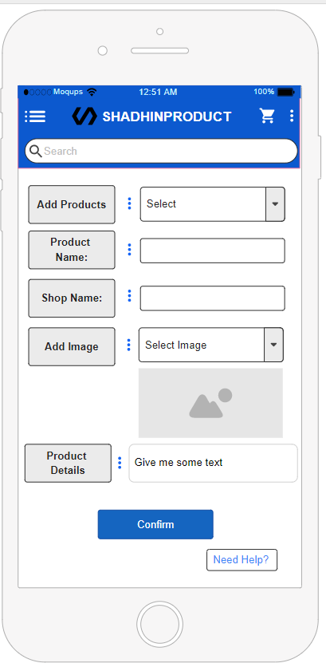

# SYSTEM TEST PLAN

* Select a particular system (Web/Desktop/Mobile/Device) and Identify various modules of the system so that they can be tested stand-alone.
* Prepare test cases of testing the selected elements of your identified software.

|  |  |  |  |  |  |
| --- | --- | --- | --- | --- | --- |
| Project Name: **Rare Handcraft Products and Famous Foods Buy, Sell, Distribution** | | | Test Designed by: Ananya Chowdhury | | |
| Test Case ID: FR_1 | | | Test Designed date: 15-12-20 | | |
| Test Priority (Low, Medium, High): High | | | Test Executed by: Durjoy Dey | | |
| Module Name: Search | | | Test Execution date: 16-12-20 | | |
| Test Title: Verify searching is work accurately or not. | | | | | |
| Description: Test search box. | | | | | |
| Precondition (If any): The user must have to go to the home page. | | | | | |
| Test Steps | Test Data | Expected Results | | Actual Results | Status (Pass/Fail) |
| 1. Go to the Home Page 2. Search any Desire Product in the Search Box | Naksikatha or Rosmolai or Doi etc. | User finds the product or it will show “no products are found”. | | As expected. | Pass |
| Post Condition: The user can find the desire product. | | | | | |

|  |  |  |  |  |  |
| --- | --- | --- | --- | --- | --- |
| Project Name: **Rare Handcraft Products and Famous Foods Buy, Sell, Distribution** | | | Test Designed by: Durjoy Dey | | |
| Test Case ID: FR_2 | | | Test Designed date:15-12-20 | | |
| Test Priority (Low, Medium, High): Medium | | | Test Executed by: Ayan Roy | | |
| Module Name: Categories | | | Test Execution date:16-12-20 | | |
| Test Title: verify categories functionalities | | | | | |
| Description: Test each category's functionalities. | | | | | |
| Precondition (If any): The user must have to go to the menu button and select the category. | | | | | |
| Test Steps | Test Data | Expected Results | | Actual Results | Status (Pass/Fail) |
| 1.Go to the Home page  2.Click the menu button | Fish, Pitha, dry foods, handcrafted products etc. | See the foods or  handcrafted product details. | | As expected, | Pass |
| Post Condition: The user can see the details of his/her desire foods or product. | | | | | |

|  |  |  |  |  |  |
| --- | --- | --- | --- | --- | --- |
| Project Name: **Rare Handcraft Products and Famous Foods Buy, Sell, Distribution** | | | Test Designed by: Ayan Roy | | |
| Test Case ID: FR_3 | | | Test Designed date: 15-12-20 | | |
| Test Priority (Low, Medium, High): Medium | | | Test Executed by: Ananya Chowdhury | | |
| Module Name: Coin sections | | | Test Execution date:16-12-20 | | |
| Test Title: verify coins are work perfectly or not? | | | | | |
| Description: Test coins numbers and it works perfectly or not. | | | | | |
| Precondition (If any): Users have to buy products or insert some money to activate it. | | | | | |
| Test Steps | Test Data | Expected Results | | Actual Results | Status (Pass/Fail) |
| 1.Go to the notification Section  2.click on the Coin section | Click the total amount on coin section | User should watch the total amount of the coins. | | As expected, | Pass |
| Post Condition: User can use their coins perfectly and they can also insert coin their account. | | | | | |

|  |  |  |  |  |  |
| --- | --- | --- | --- | --- | --- |
| Project Name: **Rare Handcraft Products and Famous Foods Buy, Sell, Distribution** | | | Test Designed by: Ananya Chowdhury | | |
| Test Case ID: FR_4 | | | Test Designed date:15-12-20 | | |
| Test Priority (Low, Medium, High): High | | | Test Executed by: Durjoy Dey | | |
| Module Name: Cart Section | | | Test Execution date: 16-12-20 | | |
| Test Title: Verify cart sections. | | | | | |
| Description: Test Cart sections count and when the user adds products to the Cart then the product is saved accurately or not. | | | | | |
| Precondition (If any): Users have to select products to add that product to their cart. | | | | | |
| Test Steps | Test Data | Expected Results | | Actual Results | Status (Pass/Fail) |
| 1.User at first Hope page  2. Then if they found any product that they will buy will add them to cart section. | Product (clicking add to cart). | The product should be added to the cart section. | | As expected, | Pass |
| Post Condition: Cart items count successfully and saved successfully. | | | | | |

|  |  |  |  |  |  |
| --- | --- | --- | --- | --- | --- |
| Project Name: **Rare Handcraft Products and Famous Foods Buy, Sell, Distribution** | | | Test Designed by: Durjoy Dey | | |
| Test Case ID: FR_5 | | | Test Designed date:15-12-20 | | |
| Test Priority (Low, Medium, High): High | | | Test Executed by: Ayan Roy | | |
| Module Name: Payment Section | | | Test Execution date: 16-12-20 | | |
| Test Title: verify every payment method and its functionality. | | | | | |
| Description: Test payment sections. | | | | | |
| Precondition (If any): The user has to confirm orders. | | | | | |
| Test Steps | Test Data | Expected Results | | Actual Results | Status (Pass/Fail) |
| 1. Add products in Cart 2. Choose payment method 3. Click the Place Order button | Price of product like 500 or 100 or 1500 etc. | Payment transfer successfully | | As expected, | Pass |
| Post Condition: Payment successful. | | | | | |

|  |  |  |  |  |  |
| --- | --- | --- | --- | --- | --- |
| Project Name: **Rare Handcraft Products and Famous Foods Buy, Sell, Distribution** | | | Test Designed by: Durjoy Dey | | |
| Test Case ID: FR_6 | | | Test Designed date:15-12-20 | | |
| Test Priority (Low, Medium, High): Medium | | | Test Executed by: Ananya Chowdhury | | |
| Module Name: Tracking | | | Test Execution date:16-12-20 | | |
| Test Title: verify tracking system. | | | | | |
| Description: Test tracking system because a user can track their product. | | | | | |
| Precondition (If any): Enter their order id properly. | | | | | |
| Test Steps | Test Data | Expected Results | | Actual Results | Status (Pass/Fail) |
| 1.Order place  2.Tracking section | Enter Order Id like 1001,1002 etc | Users will be able to see where their product is. | | As expected, | Pass |
| Post Condition: Users can track their product and they will know where their food or product is. | | | | | |

|  |  |  |  |  |  |
| --- | --- | --- | --- | --- | --- |
| Project Name: **Rare Handcraft Products and Famous Foods Buy, Sell, Distribution** | | | Test Designed by: Ananya Chowdhury | | |
| Test Case ID: FR_7 | | | Test Designed date:15-12-20 | | |
| Test Priority (Low, Medium, High): Medium | | | Test Executed by: Durjoy Dey | | |
| Module Name: Adding Product | | | Test Execution date:17-12-20 | | |
| Test Title: verify product added successfully or not. | | | | | |
| Description: Test when the seller add any kinds of product in their shop. | | | | | |
| Precondition (If any): Seller has to log in. | | | | | |
| Test Steps | Test Data | Expected Results | | Actual Results | Status (Pass/Fail) |
| 1.Login to the application  2.Select the category  3.Click add button | any kind of product like bag, nakshikatha etc or food | Show the added product or food | | As expected, | Pass |
| Post Condition: Seller can add their products. | | | | | |

|  |  |  |  |  |  |
| --- | --- | --- | --- | --- | --- |
| Project Name: **Rare Handcraft Products and Famous Foods Buy, Sell, Distribution** | | | Test Designed by: Durjoy Dey | | |
| Test Case ID: FR_8 | | | Test Designed date: 15-12-20 | | |
| Test Priority (Low, Medium, High): Medium | | | Test Executed by: Ananya Chowdhury | | |
| Module Name: Return | | | Test Execution date:16-12-20 | | |
| Test Title: verify Return sections. | | | | | |
| Description: Test return sections so that user can return their products. | | | | | |
| Precondition (If any): User must have to receive their products. | | | | | |
| Test Steps | Test Data | Expected Results | | Actual Results | Status (Pass/Fail) |
| 1. Order place 2. Receive products 3. Log in to the app 4. Return section | Input order Id  Like 1001 or 1002 etc. | Return successfully. | | As expected, | Pass |
| Post Condition: User can return their product or exchange their products. | | | | | |