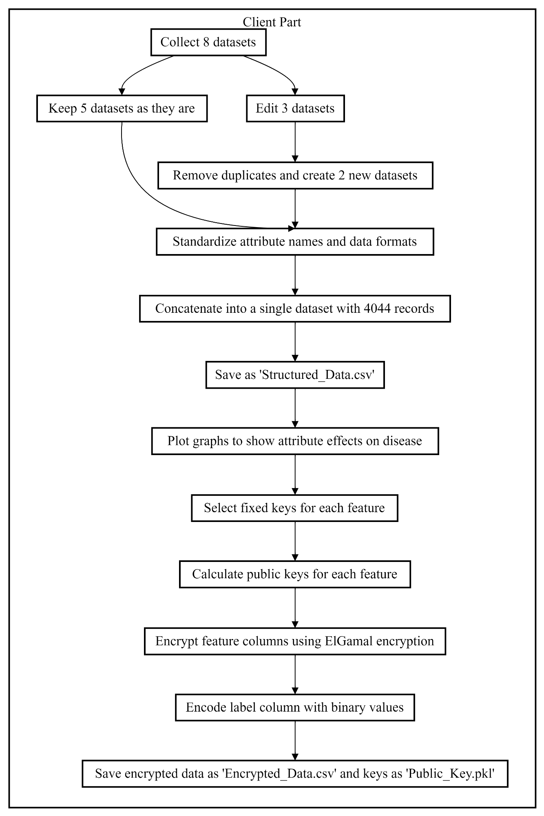

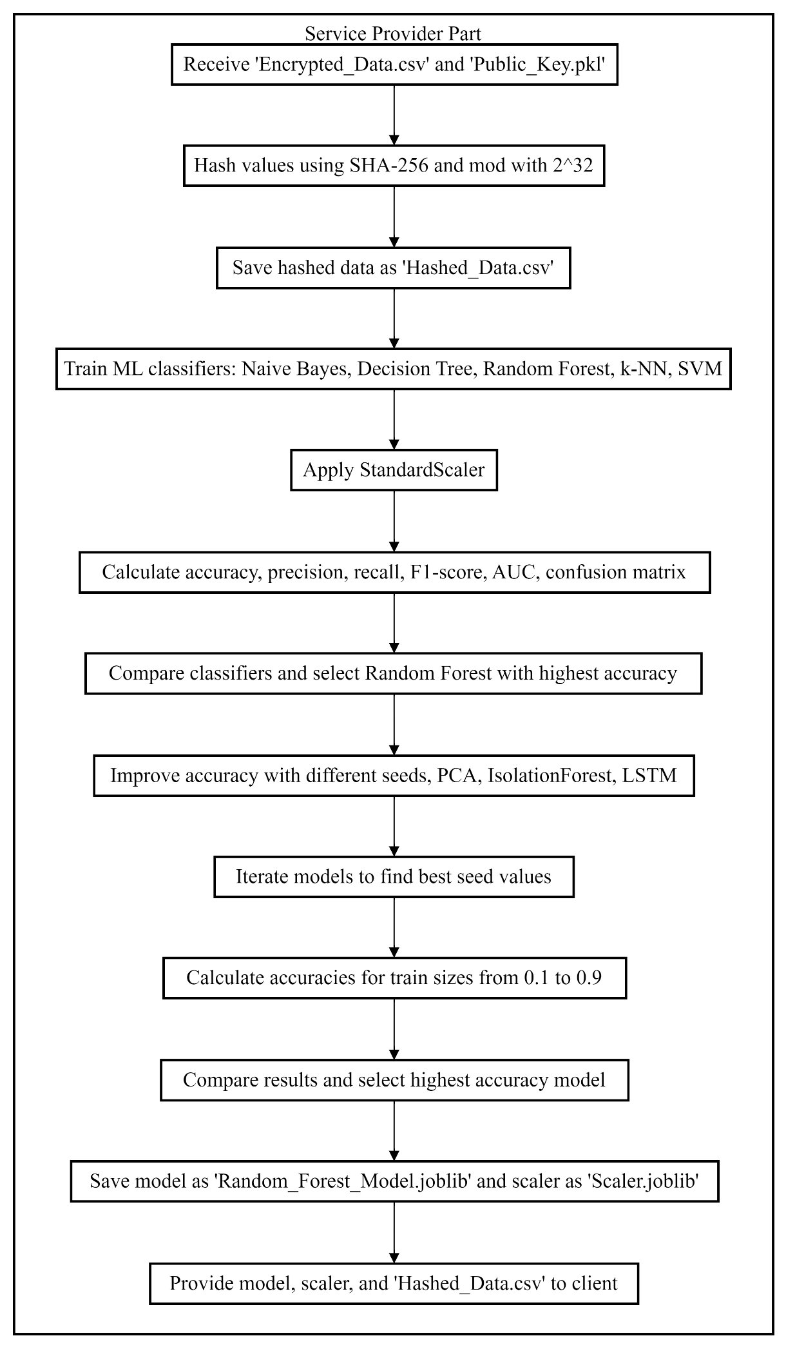
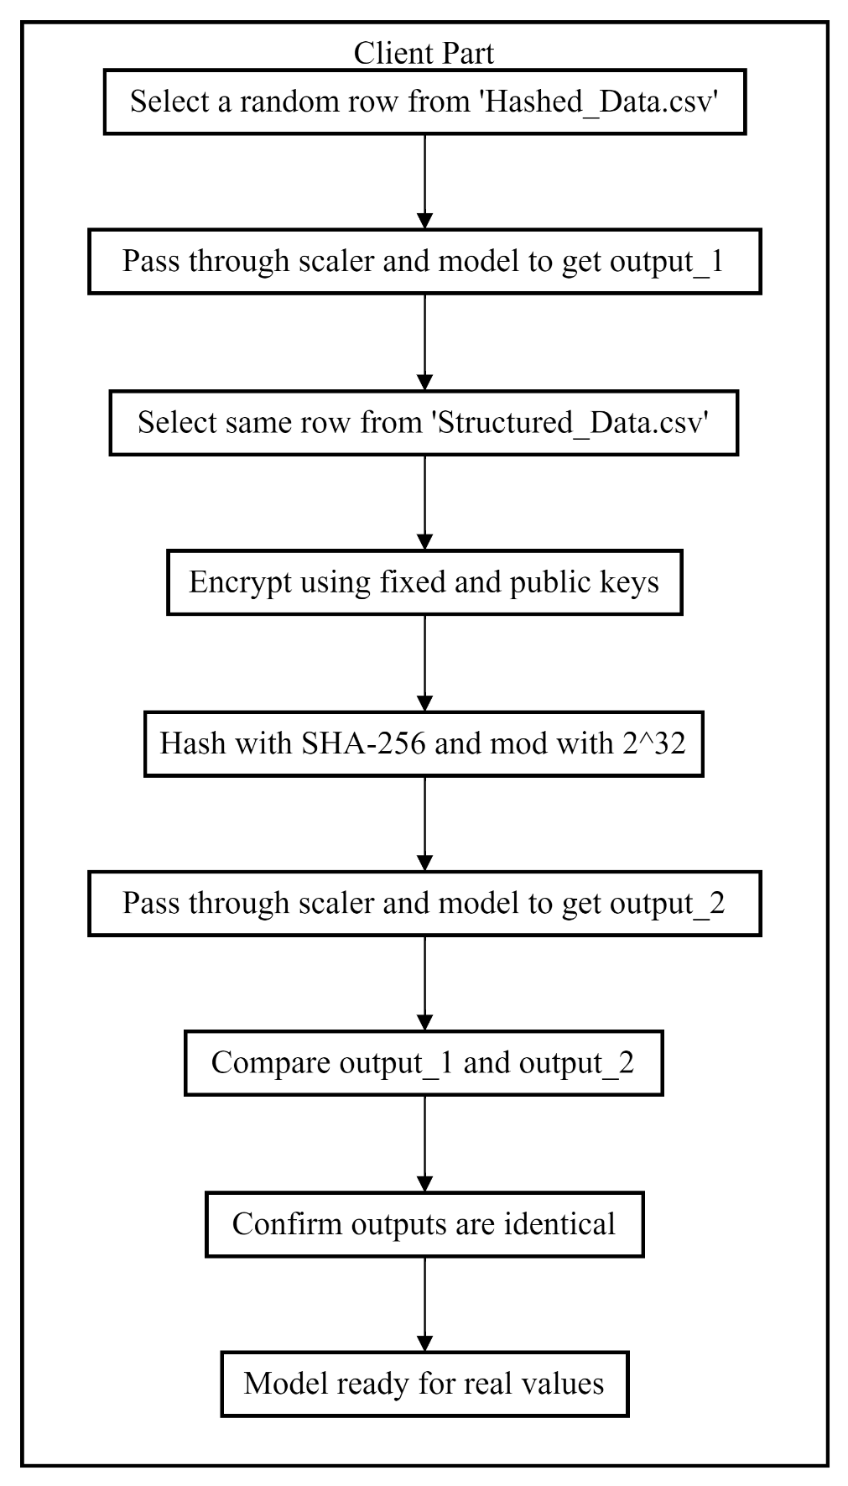

Part 1: Client Part
- Collected 8 datasets from the internet.
- Kept 5 datasets as they were and edited 3 datasets to remove duplicates, resulting in 2 new datasets.
- Standardized attribute names and data formats across all 7 datasets, then concatenated them into a single dataset containing a total of 4044 records. Saved this combined dataset as 'Structured_Data.csv'.
- Plotted graphs to show the effect of each attribute on the disease.
- Selected fixed keys for each feature individually to ensure deterministic output and calculated public keys for each of them.
- Encrypted all feature columns using the ElGamal partial homomorphic encryption algorithm with the calculated public keys and fixed keys to ensure the service provider has no access to the raw data. Encoded the label column with binary values. Saved the encrypted data as 'Encrypted_Data.csv' and the keys as 'Public_Key.pkl'.
Part 2: Service Provider Part
- Received the encrypted dataset 'Encrypted_Data.csv' and the keys 'Public_Key.pkl'.
- Hashed each value using the SHA-256 algorithm to get long integer values, then modded them with 232232 to make the data manageable for ML classifiers. Saved the results as 'Hashed_Data.csv'.
- Used ML classifiers that handle categorical values to train the model. The classifiers used were Naive Bayes, Decision Tree, Random Forest, k-Nearest Neighbors, and SVM.
- Applied StandardScaler and calculated accuracy, precision, recall, F1-score, AUC score, and confusion matrix for all classifiers.
- Compared the classifiers and found the highest accuracy with Random Forest.
- Improved accuracy by training with different seed values, using PCA, IsolationForest, and Deep Learning (Long Short-Term Memory).
- Iterated the PCA, IsolationForest, and LSTM models to find the best seed values for the highest accuracies.
- Calculated accuracies for train sizes ranging from 0.1 to 0.9.
- Compared the results and found the highest accuracy with RandomForestClassifier using the optimal seed values.
- Saved the model as 'Random_Forest_Model.joblib' and the scaler as 'Scaler.joblib'. Provided the model, scaler, and 'Hashed_Data.csv' to the client, along with the hashing technique for verification.
Part 3: Client Part
- To test the model, selected a random row from 'Hashed_Data.csv', passed it through the scaler and model provided by the service provider, and obtained an output (output_1).
- Selected the same row from 'Structured_Data.csv', encrypted it using the fixed and public keys, hashed it with SHA-256, modded it with 232232, passed it through the scaler and model, and obtained another output (output_2).
- Compared output_1 and output_2. They were identical, confirming that the model was working correctly.
- The model is now ready for testing with real values.

