

Project: Secured area verification

CSE 3104: Peripherals and interfacing laboratory



Submission Date: 8 June, 2023

|  |  |
| --- | --- |
| Submitted By: | |
| Nushrat Tarmin MeemRoll: 1907083Department: CSEYear: 3rdSemester: 1stGroup: B1 | Israt Tasnim EshaRoll: 1907090Department: CSEYear: 3rdSemester: 1stGroup: B1 |

**Objectives:**

1. To understand the connections of Arduino Uno, Servo Motor, LCD12c, IR Sensor, RFID, LED etc.
2. To control and restrict access to the secured area to authorized individuals only
3. Enhanced Security by implementing the RFID card and keypad password system
4. Tracking and Monitoring via IR Sensor
5. Integration with Existing Systems and Components
6. User-Friendly Interface using LCD12c

**Introduction:**

The secured area in various establishments, such as restricted areas, hotels, corporate offices, or exclusive events, often requires strict access control to ensure the privacy and security of high-profile individuals. To meet these requirements, a peripheral project proposing the implementation of an advanced verification system using RFID cards and a keypad password system. This introduction will provide an overview of the project, highlighting its significance and benefits:

**Arduino Uno:**

*Fig 1: Arduino Uno Basic Diagram*

The Arduino Uno is a widely-used microcontroller board that serves as a foundation for creating interactive electronic projects. It is equipped with digital and analog input/output pins, a USB interface for programming and communication, and is powered by the ATmega328P microcontroller. The Arduino Uno is known for its simplicity, versatility, and extensive community support, making it accessible to beginners and professionals alike for a variety of projects and applications.

**IR sensor:**

*Fig 2: IR Sensor*

An IR (Infrared) sensor is a device that detects and measures infrared radiation in its surrounding environment. Infrared radiation lies beyond the visible light spectrum, with longer wavelengths than those of visible light. IR sensors are commonly used in various applications for detection, proximity sensing, and remote control.

IR sensors typically consist of an IR emitter and an IR receiver. The emitter emits infrared radiation, and the receiver detects and measures the reflected or emitted infrared radiation.

**Servo Motor:**

A servo motor is a type of motor that is commonly used in various applications, including robotics, automation, and remote-controlled devices. It is a precise and efficient motor that provides accurate control over angular rotation. Unlike other types of motors, a servo motor is designed to rotate between specific angles rather than continuous rotation. It consists of a small DC motor, a gear system, and a control circuit. The control circuit receives electrical signals, usually in the form of pulse-width modulation (PWM), to determine the position or angle at which the motor should rotate. The servo motor's control circuit compares the desired angle with the current angle of the motor and adjusts the motor's rotation accordingly. This closed-loop control system allows for precise positioning and smooth movements.

*Fig 3: Servo Motor*

**12C LCD:**

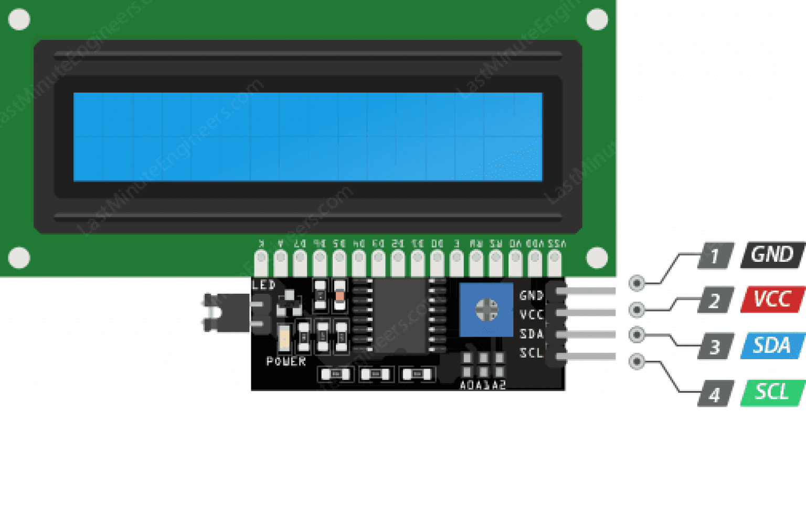

*Fig 4: 12C LCD*

An LCD (Liquid Crystal Display) is a widely-used display technology that employs liquid crystals to produce images or text. It consists of a layer of liquid crystals positioned between two transparent electrodes. The liquid crystals can be manipulated to control the polarization of light passing through them, enabling the display of different colors and intensities.

An I2C module, also referred to as an I2C interface or I2C adapter, is a hardware component that facilitates communication between devices using the I2C (Inter-Integrated Circuit) protocol. It typically includes circuitry for voltage level shifting, signal conditioning, and addressing, allowing multiple devices to communicate over a shared I2C bus. The module serves as an intermediary between the microcontroller or host device and the I2C devices, enabling reliable and efficient data transfer. It simplifies the implementation of I2C communication by providing standardized connectors or pins for easy integration with other devices.

**RFID:**

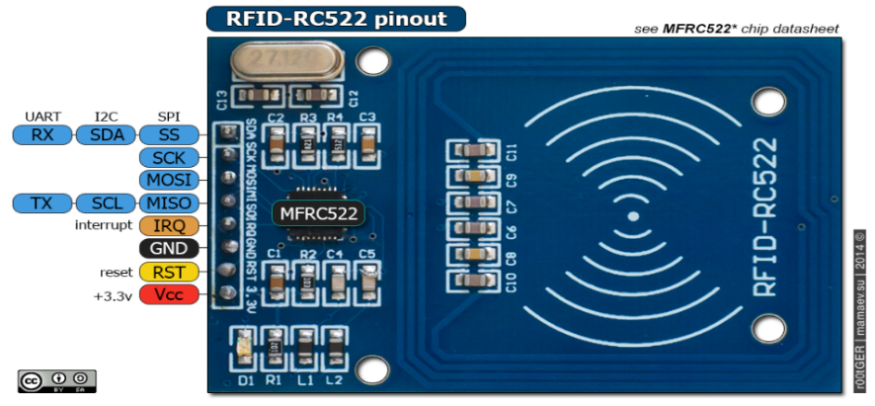

*Fig 5: RFID*

RFID (Radio Frequency Identification) is a technology that uses radio waves to wirelessly identify and track objects or individuals. It involves the use of RFID tags, which are small electronic devices that contain a unique identifier and can store data. These tags can be attached to or embedded in objects, products, or even people.

RFID systems consist of two main components:

**RFID Tags:** RFID tags are composed of a microchip and an antenna. The microchip holds the unique identifier and may also have additional storage for data. The antenna enables communication with RFID readers by transmitting and receiving radio waves.

**RFID Readers:** RFID readers are devices that emit radio waves and capture signals from nearby RFID tags. The reader consists of an antenna, a transceiver, and a processor. When an RFID tag comes into the range of the reader's radio waves, it receives the energy and responds by transmitting its unique identifier and any stored data back to the reader.

**4*4 Keypad:**

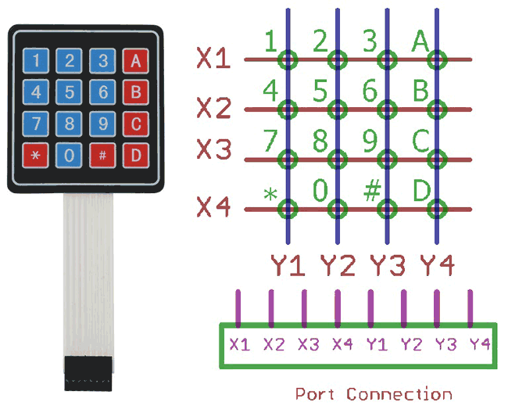

*Fig 6: 4*4 Keypad*

A 4x4 Matrix Keypad is a compact input device that consists of a grid of 16 buttons arranged in a 4x4 configuration. Each button represents a unique input. It is commonly used in electronic projects to provide user input for various applications. The keypad connects to a microcontroller or other input-processing device and allows users to enter data or make selections by pressing the corresponding buttons. The 4x4 Matrix Keypad is known for its simplicity, ease of use, and versatility in a wide range of projects requiring input from users.

**5mm LED:**

A 5mm LED (Light-Emitting Diode) refers to a type of LED with a diameter of 5 millimeters. LEDs are electronic devices that emit light when an electric current passes through them. The 5mm LED is a common size that is widely used in various applications, including indicator lights, electronic displays, lighting fixtures, and DIY electronics projects. They are available in different colors, such as red, green, blue, yellow, and white, and are known for their energy efficiency, long lifespan, and compact size. 5mm LEDs are easy to work with and are commonly used for visual signaling or as light sources in a variety of electronic devices.

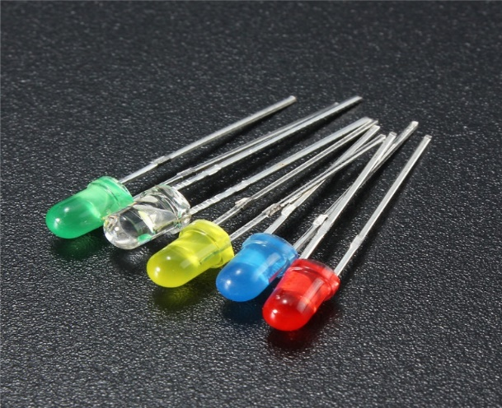

*Fig 7: LED*

**Apparatus Required:**

|  |  |  |
| --- | --- | --- |
| Name of Apparatus | Ratings | Quantity |
| Arduino Board | Board: Arduino Uno  Microcontroller: ATmega328P  Operating Voltage: 5V  Input Voltage (recommended): 7-12V  Flash Memory: 32 KB  SRAM: 2 KB  EEPROM: 1 KB  Clock Speed: 16 MHz | 1 |
| Infrared (IR) Sensor | - | 1 |
| LCD Display | Module: I2C-based LCD  Address: 0x27  Dimensions: 16x2 (16 characters per row, 2 rows) | 1 |
| Servo Motor | - | 1 |
| RFID Reader | Module: MFRC522 | 1 |
| Keypad | Configuration: 4x4 keypad | 1 |
| LED | Vf: 2V - 2.2V  If: 10mA - 20mA | 2 |
| Breadboard | V: 30V/ 50V  I: 3A-5A  P: 1W-5W | 1 |
| Jumper Wire | - | As Required |

**Software Required:**

Arduino IDE 2.1.0

**Circuit Diagram:**

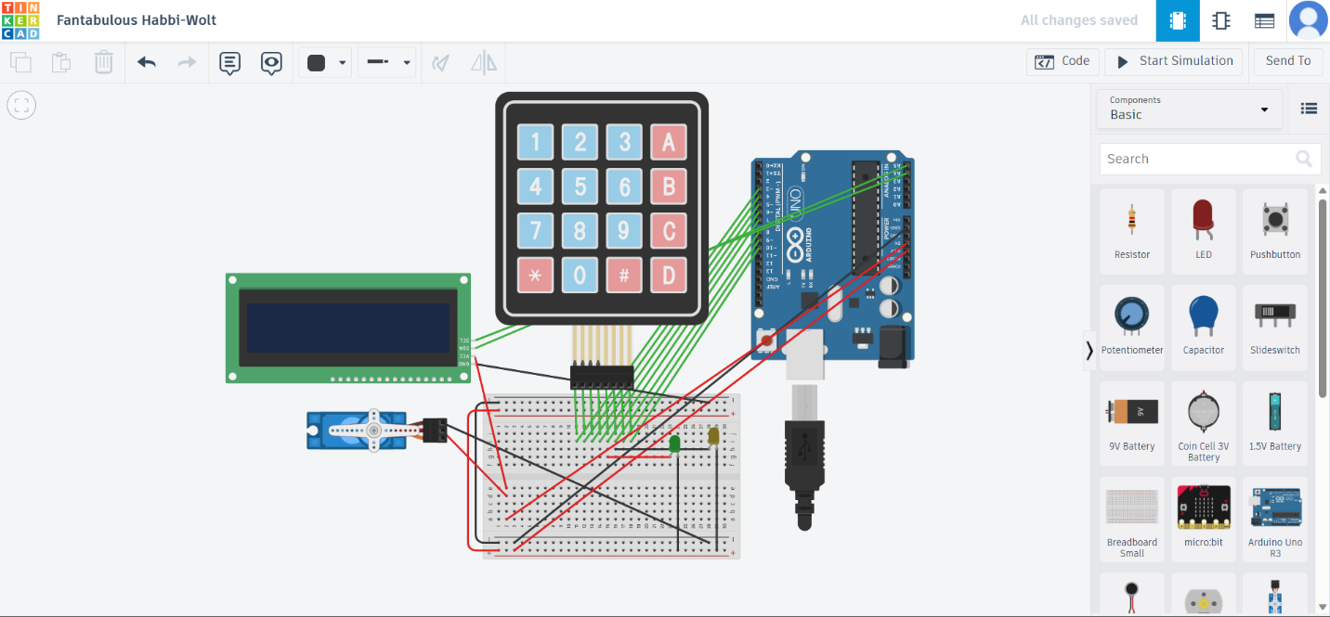

TinkerCad Diagram

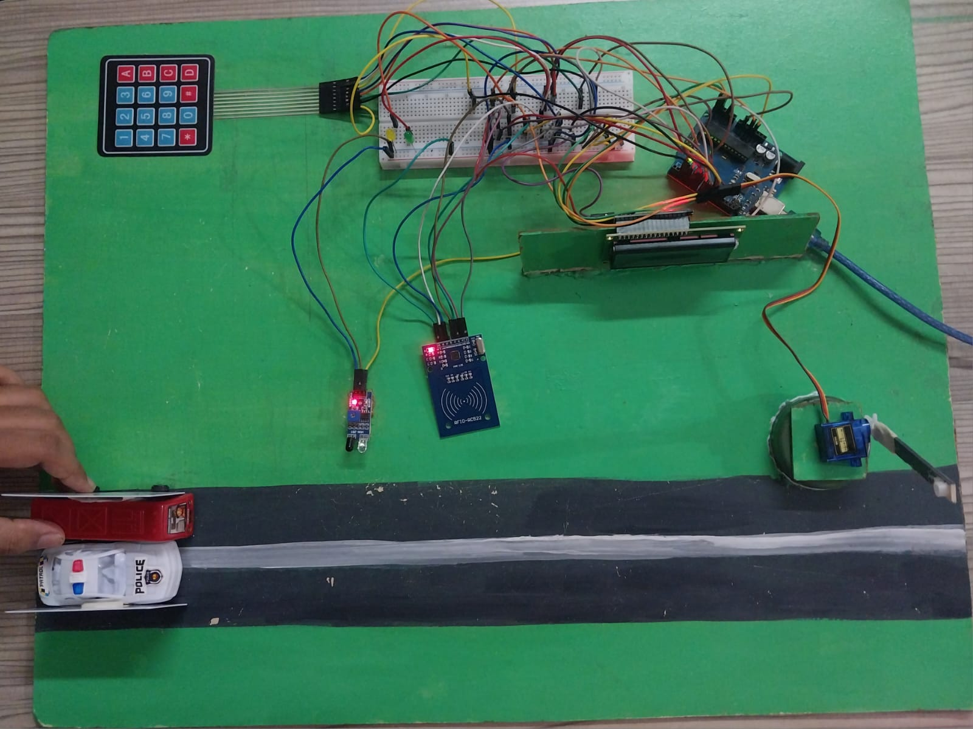

Top View

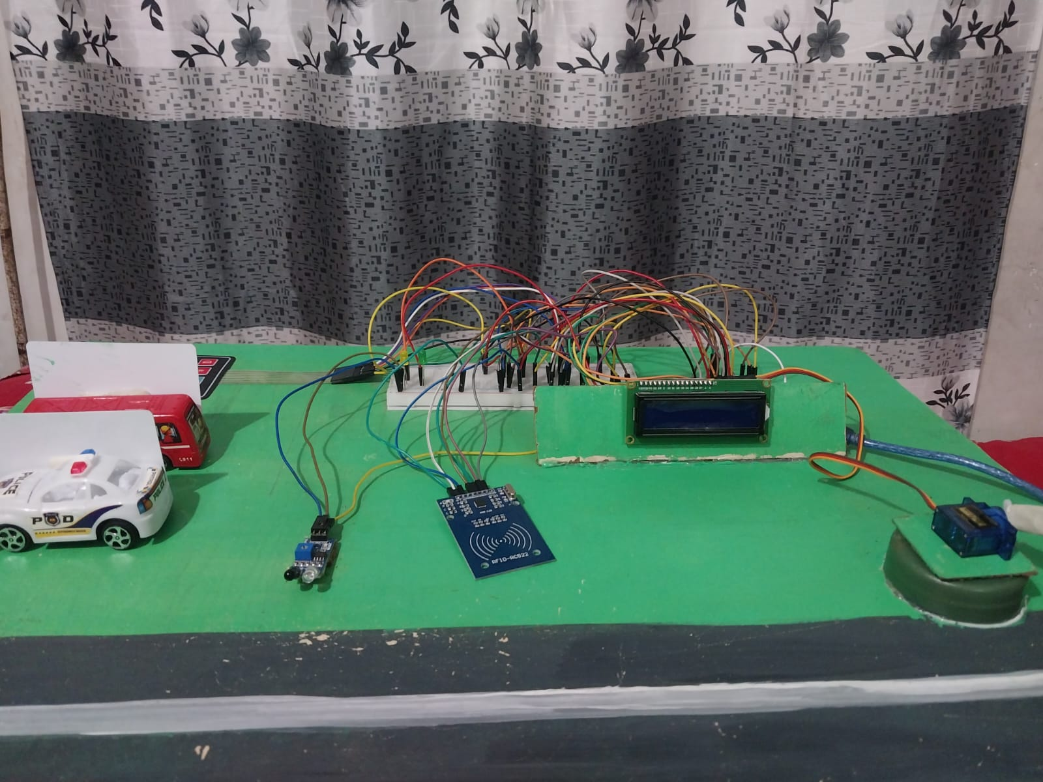

Front View

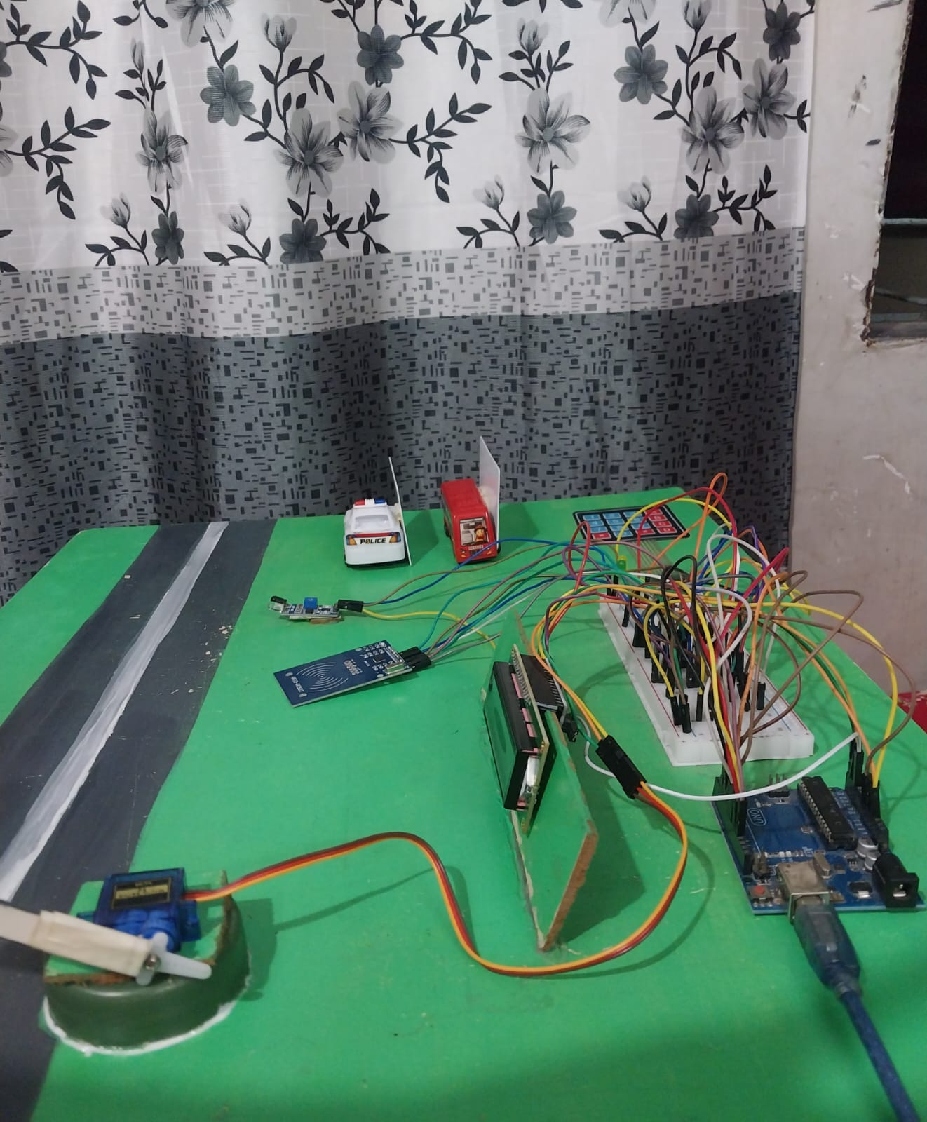

Side View

**Flow Chart:**

Start

IR Detection

Is Detected?

Yes

RFID Card Detection

Is Detected?

Yes

Keypad Input

Yes

Matched?

Count=1?

No

Yes

No

Print Thank You

End

**Pseudocode:**

* 1. Include the required libraries: Wire.h, LiquidCrystal_I2C.h, Servo.h, SPI.h, MFRC522.h, and Keypad.h
  2. Define constants and variables:
     1. Define the keypad configuration (rows, columns, keys, rowPins, and colPins)
     2. Define the MFRC522 pin numbers (RST_PIN and SS_PIN)
     3. Define the new UID for the RFID card (NEW_UID)
     4. Define the MFRC522 key (key)
     5. Define the IR sensor pin number (irPin)
  3. Initialize the Arduino board in the setup function:
     1. Initialize the serial communication
     2. Wait for the serial connection to be established
     3. Initialize the SPI bus
     4. Initialize the MFRC522 module
     5. Initialize the LCD
     6. Set the pin mode for the IR sensor and other pins
     7. Attach the servo motor and set its initial position
  4. Enter the main program loop in the loop function:
     + 1. Check if the IR sensor detects a person:
          1. Move the servo motor to close the gate
          2. Turn on the LCD backlight and display the person detection message
          3. Turn on the yellow LED
       2. Check if the person crosses the area of IR:
          1. Clear the LCD display
          2. Check if an RFID card is present:
          3. Display the card detection message on the LCD
          4. Read the card input using the keypad
          5. Display the entered code on the LCD
       3. Check if the entered code is correct:
          1. Display a "Thank you" message on the LCD
          2. Open the gate by moving the servo motor
          3. Turn on the green LED
          4. Turn off the LCD backlight
       4. If the code is incorrect:
          1. Display a "Wrong Password" message on the LCD
          2. Let the user to enter the code again

Check if the re-entered code is correct:

Display a "Thank you" message on the LCD

Open the gate by moving the servo motor

Turn on the green LED

Turn off the LCD backlight

If the code is still incorrect, display an "Entry blocked" message on the LCD

* + - 1. Change the UID of the RFID card to the new UID
      2. Halt the current RFID card communication
      3. Reinitialize the MFRC522 module
      4. Check if a new RFID card is present
  1. Define a function to wait for keypad input:
     1. Initialize an empty string for the keypad input
     2. While the length of the input is less than 4:
     3. Get the next keypad button pressed
     4. If the button is '#', exit the loop
     5. Otherwise, append the button to the input string
     6. Display the entered button on the LCD
     7. Return the keypad input
  2. End of the program

**Working Principle:**

**Components:**

1. **IR Sensor:** An infrared (IR) sensor is used to detect the presence of a person.
2. **LCD Display:** A 16x2 LCD display is used to provide visual feedback to the user
3. **Servo Motor:** A servo motor is used to control the gate or barrier.
4. **MFRC522 RFID Reader:** Used to detect and read RFID cards.
5. **Keypad:** A 4x4 keypad is connected to the Arduino for user input.

**Pin Configuration:**

1. **IR Sensor:** A2
2. **Keypad Rows:** 3, 4, 5, 6
3. **Keypad Columns:** 7, 8, 9, 10
4. **Servo Motor:** 2

**Other Libraries:**

1. **Wire:** Used for I2C communication with the LCD display.
2. **LiquidCrystal_I2C:** Library for controlling the LCD display using I2C.
3. **SPI:** Required for communication with the RFID reader.
4. **MFRC522:** Library for interacting with the MFRC522 RFID reader.
5. **Keypad:** Library for interfacing with the keypad.

.

**Functionality:**

The code sets up the required libraries, pins, and objects for the keypad, RFID reader, LCD display, and servo motor.

In the loop() function, it continuously checks the status of the IR sensor.

If a person is detected (IR sensor output is LOW), it closes the gate by moving the servo motor, turns on the LCD backlight, and displays a "Person detected" message on the LCD.

If the person crosses the IR area (IR sensor output is HIGH), it clears the LCD display and proceeds to check for an RFID card.

If an RFID card is detected (MFRC522 reader detects a new card present and reads its serial number), it lets the user to place the card on the RFID reader.

It waits for the user to enter a 4-digit code using the keypad and displays the entered code on the LCD.

If the entered code is correct, it displays a "Thank you" message on the LCD, opens the gate by moving the servo motor, turn on the green LED, turns off the LCD backlight, and waits for some time before reinitializing the RFID module.

If the entered code is incorrect, it displays a "Wrong Password" message on the LCD and lets the user to enter the code again.

If the re-entered code is correct, it performs the same actions as before.

If the re-entered code is still incorrect, it displays an "Entry blocked" message on the LCD.

After each RFID card interaction, the code sets a new UID for the card, halts the current card communication, and reinitializes the RFID module.

The code also defines a function, waitForKeypadInput(), which waits for the user to enter a 4-digit code using the keypad and returns the entered code as a string.

**Discussion:**

The implementation this peripheral project for secured area verification through an RFID card and keypad password system brings numerous benefits and considerations. More elaborate discussion of the key aspects and implications of this project are:

**Enhanced Security:**

The RFID card and keypad password system provide a robust and efficient access control mechanism, significantly enhancing the security of the secured area. The RFID cards, which contain unique identification information, act as electronic keys, allowing only authorized individuals to enter. The combination of the RFID card and the keypad password system adds an extra layer of security, ensuring that even if the card is lost or stolen, unauthorized individuals cannot gain access without the corresponding password.

**Convenience and Efficiency:**

The RFID card and keypad password system offer convenience and efficiency for persons and authorized personnel. Carrying a small RFID card is convenient compared to traditional physical keys or ID cards. The system eliminates the need for manual checks, reducing waiting times and enhancing the overall experience for persons. They can simply present their RFID card and enter their personalized keypad password, allowing for swift and hassle-free access to the secured area.

**Auditing and Tracking Capabilities:**

The project provides comprehensive auditing and tracking capabilities, contributing to a higher level of security and accountability. Every entry and exit using the RFID card and keypad password system is previously detected through IR Sensor and LED.

**Integration with Existing Systems:**

To create a comprehensive security infrastructure, the project can integrate the RFID card and keypad password system with existing security systems. Additionally, integration with LEDS (color) can trigger alerts whenever anyone tries to enter to that area. This integration strengthens the overall security measures, providing a multi-layered approach to protect the secured area.

**User-Friendly Interface:**

To ensure optimal user experience, the project has focused on developing a user-friendly interface for the RFID card and keypad password system. Clear instructions and intuitive operation have been implemented through LCD12c.

Moreover, the project aims to provide a convenient and efficient means of access for persons while ensuring strict control over the area. With the implementation of this system, authorized individuals can swiftly enter the secured zone without unnecessary delays, eliminating the need for manual checks or physical keycards.

**Conclusion:**

In conclusion, this peripheral project for secured area verification through an RFID card and keypad password system provides enhanced security, access control flexibility, convenience, auditing capabilities, integration with existing systems, and a user-friendly interface. By considering these factors and implementation of this project has effectively ensured the privacy, safety, and convenience of their persons while maintaining a high level of security in the restricted area.