**SOFTWARE DESIGN SPECIFICATION FOR ONLINE FASHION STORE.**

Prepared by

**Israt Jahan**

**Id: 1620565042**

**Nazmus Sakib Roohi**

**Id: 1520742642**

**Mainul Islam Fahim  
 Id: 1620410042**

Table of Contents

1. **Introduction**

1.1 Purpose

* 1. Scope
  2. Audience, Definitions, Acronyms and Abbreviations
     1. Audience Definitions
     2. Acronyms and Abbreviations
  3. Intended Use
  4. Risk Definition

**2. Overall Description**

2.1 Product Perspective

2.2 Product Functions

2.3 User Characteristics

2.4 Constraints

2.5 Operating Environment

2.6 Assumptions

**3. Use Cases and Activity Flow**

**4. System Analysis**

4.1. ER Diagrams

4.2. Data Flow Diagrams

**5. Classes**

5.1. Internal Data Structures

**7. User Interface**

**8. Testing**

8.1. Unit Testing

8.1.1. Log In

8.1.2. Log In and Start Shopping

8.1.3. View Online Help

8.1.4. Payment

8.1.5. Shipping

8.1.6. Logout

8.2. Integration Testing

**9. Conclusions**

**10. References**

# 1. Introduction

**1.1 Purpose**

* The Online Fashion Store (OFS) web application is intended to provide complete solutions for vendors as well as customers through a single gateway using the internet as the sole medium. It will enable vendors to setup online fashion shops (garments, accessories etc.), customer to browse through the shop and purchase them online without having to visit the shop physically. The administration module will enable a system administrator to approve and reject requests for new shops and maintain various lists of shop category
* This document is meant to discuss the features of OFS, so as to serve as a guide to the developers on one hand and a software validation document for the prospective client on the other.

**1.2 Scope**

**Initial functional requirements will be: -**

* Secure registration and profile management facilities for Customers
* Browsing through the e-store to see the items that are there in each category of products like garments (ethnic , western etc) and accessories.
* Adequate searching mechanisms for easy and quick access to particular products and services.
* Creating a Shopping cart so that customers can shop ‘n’ no. of items and checkout finally with the entire shopping carts. Customers can add or delete items in the cart.
* Regular updates to registered customers of the OFS about new arrivals.
* Uploading ‘Most Purchased’ Items in each category of products in the Shop.
* Strategic data and graphs for Administrators and Shop owners about the items that are popular in each category and age group.
* Maintaining database of regular customers of different needs.
* Shop employees are responsible for internal affairs like processing orders, assure home delivery, getting customer's delivery-time feedback, updating order's status and answering client's queries online.
* Feedback mechanism, so that customers can give feedback for the product or service which they have purchased. Also facility rating of individual products by relevant customers.
* Adequate payment mechanism and gateway for all popular credit cards, cheques and other relevant payment options, as available from time to time.

**Initial non functional requirements will be: -**

* Secure access of confidential data (user’s details).
* 24 X 7 availability
* Better component design to get better performance at peak time
* Advertisement space where it will effectively catch the customer’s attention and as a source of revenue.
* In addition to the above mentioned points, the following are planned to be delivered if deemed necessary:
* Warehousing within the very ambits of the project
* More payment gateways.
* Dynamic price model by which prices can be changed based on demand and supply
* Each customer can build a “scrapbook”, where they can have a collection of garments and accessories to create a specific look basing on inbuilt templates. The scrapbook created will be visible to other users who can like and/or comment on the style.
* This list is by no means, a final one. The final list will be dictated by implementation constraints, market forces and most importantly, by end user demands.

**1.3 Audience Definitions, Acronyms and Abbreviations**

**1.3.1 Audience Definitions**

The intended readers of this document are the developers of the site, testers, website owners, managers and coordinators.

**1.3.2 Acronyms and Abbreviations**

|  |  |
| --- | --- |
| **Acronym** | **Meaning** |
| OFS | Online Fashion Store |
| JAVA EE | Java Enterprise Edition 5 |
| HTTP | Hypertext Transfer Protocol |
| HTTPS | Secure Hypertext Transfer Protocol |
| TCP/IP | Transmission Control Protocol/Internet Protocol |

## 1.4 Intend Use

## E-commerce refers to the process of buying

## and selling goods and services online. And it's

## important because it allows retailers to both

## better serve existing customers (by making

## shopping easier for them) and find totally new

## audiences (ones that may not ever enter their

## physical location).

## The main advantage of online shopping is that

## it enables reduce your monthly expenses

## Most online stores offer lower prices, as

## opposed to offline stores, as well as offer

## various bargains that help save even more

## money. The easiest way to pay less is to

## compare prices.

## 1.5 Technologies to be used

* Programming languages:
* JAVA EE: Java Enterprise Edition is a programming platform— part of the Java Platform-for developing and running distributed multi-tier architecture Java applications, based largely on modular software components running on an application server.
* HTML, XML: Hyper Text Markup Language and Extensible markup Language are the predominant markup languages for web pages. It provides a means to describe the structure of text-based information in a document and to supplement that text with interactive forms, embedded images, and other objects.
* JavaScript: A client side scripting language used to create dynamic web content and user interface.

**Tools & Development Environment**

* Apache Tomcat 6.0.18 Server: Apache Tomcat is a Servlet container developed by the Apache Software Foundation (ASF). Tomcat implements the Java Servlet and the JavaServer Pages (JSP) specifications from Sun Microsystems, and provides a "pure Java" HTTP web server environment for Java code to run.
* ECLIPSE J2EE: Eclipse is a toolkit which is designed for the creation of complex projects, providing fully dynamic web application utilizing EJB’s. This consist of EJB tools , CMP ,data mapping tools & a universal test client that is designed to aid testing of EJB’s.
  1. **Risk Definition**

One of the features of the modern holiday season is the increase in online shopping. When presented the choice between traffic filled parking lots, packed malls and snail-paced lines or the convenience of shopping online, most people choose the latter. When you can do your holiday shopping without leaving the house, it can be a bit of a no-brainer.

There are risks to online shopping though. Which means your do need to take care. Luckily, there is simple risk management system you can follow for online shopping. When you buy on the web, you need to follow the five Ps.

**Passwords**

The first rule of any online risk management process is to use secure passwords. The most common mistake is to use the same password for everything. That may make it easier to remember them, but it’s also a huge security risk. When you set up passwords for sites where you’ll be spending money make sure you use a different, more complex, password. With so much online shopping done through mobile, make sure you password protect your devices with a separate password too.

**Pricing**

Take care when choosing which sites and which sellers you buy from. Keep an eye on pricing. If a price on an unfamiliar website seems too good to be true, it probably is.

**Protection**

If you do find something on a site you’ve never used before, you need to make sure that the checkout is secure. This also goes back to standard online risk management. Whenever you’re inputting personal information, but especially if you’re entering financial info, make sure the URL starts ‘https’ rather than ‘http’. That means the site is using a secure server.

Payment Method

In risk management, if you can’t prevent a risk you should try to mitigate potential damage. Some payment methods offer one or both of those options. PayPal offers great protection for online shoppers, as they protect your purchase for 45 days after a sale. Alternatively, if you don’t use PayPal it’s advisable to use a prepay credit card or a low limit card that’s only for online shopping. That way if your details are compromised, the damage will be limited.

**Privacy**

The final P is yet another that would make a list of standard online risk management tips. Privacy is important to everyone, but many people give it away all too freely online. Most online forms have minimum requirements for information sharing, it’s important that you don’t share more than you have to. This is especially true in locations that take payment details.

Online shopping can be a real timesaver. It can make holiday shopping easy and even enjoyable. Just make sure you use the right risk management measures, so you can enjoy the rest of the holidays too.

2. Overall Description

2.1 Product Perspective

* OFS is aimed towards the vendors who want to reach out to the maximum cross-section of customer and common people who can be potential customer. This project envisages bridging the gap between the seller, the retailer and the customer. OFS should be user-friendly, ‘quick to learn’ and reliable software for the above purpose. OFS is intended to be a stand-alone product and should not depend on the availability of other software. It should run on both UNIX and Windows based platform.

**2.2 User Classes**

* User: Administrator
* Functions: The Administrator is the super user and has complete control over all the activities that can be performed. The application notifies the administrator of all shop creation requests, and the administrator can then approve or reject them. The administrator also manages the list of available product categories. The administrator can also view and delete entries in the guestbook.
* User: Shop Owner
* Functions: Any user can submit a shop creation request through the application. When the request is approved by the Administrator, the requester is notified, and from there on is given the role of Shop Owner. The Shop Owner is responsible for setting up the shop and maintaining it. The job involves managing the sub-categories of the items in the shop. Also, the shop owner can add or remove items from his shop. The Shop Owner can view different reports that give details of the sales and orders specific to his shop. The Shop Owner can also decide to close shop and remove it from the website.
* User: Customer/Guests
* Functions: A Customer can browse through the shops and choose products to place in a virtual shopping cart. The shopping cart details can be viewed and items can be removed from the cart. To proceed with the purchase, the customer is prompted to login. Also, the customer can modify personal profile information (such as phone number and shipping address) stored by the application. The customer can also view the status of any previous orders, and cancel any order that has not been shipped yet.
* User: Employees
* Functions: Purchase department under a Purchase manager to overlook purchasing activities if warehousing needs arise.
* Functions: Sales department under a Sales manager who will look after the sale of products and services, the most important activity.
* Functions: Accounts department under an Accounts manager to look after the accounting activities of the enterprise

## 2.3User characteristics

* The user should be familiar with the Shopping Mall related terminology like Shopping cart/Checking out/Transaction etc.
* The user should be familiar with the Internet.

## 2.4Constraints

* There is no maintainability of back up so availability will get affected.
* Limited to HTTP/HTTPS.
* Real-life credit card validation and Banking system is not implemented.
* No multilingual support

**2.5 Operating Environment**

The OFS is a website that shall operate in all famous browsers, for a model we are taking Microsoft Internet Explorer versions 7.0, 8.0 and 9.0 .

**2.6 Assumptions**

* Client/User has an active Internet Connection

or has access to one to view the Website.

* Client/User runs an operating system which

Supports Internet Browsing.

* Our website will not be violating any Internet

Ethnic or Cultural Rules and won't be blocked

by the Telecom companies.

# 3. Use cases and activity flow

**Activity Flow associated with the system administrator.**

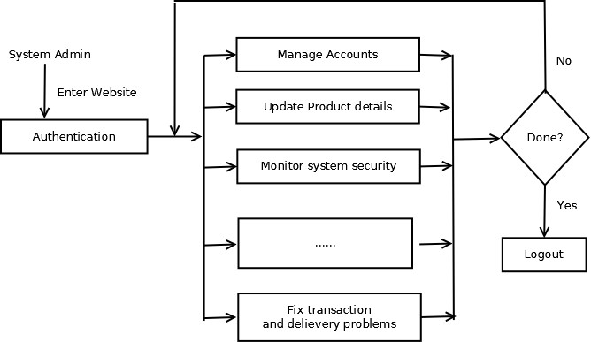

**Activity Flow associated with a shop owner**

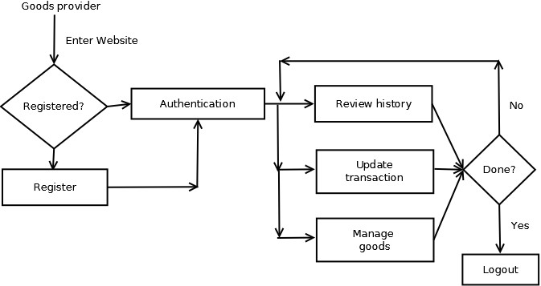

**Activity Flow associated with a registered user.**

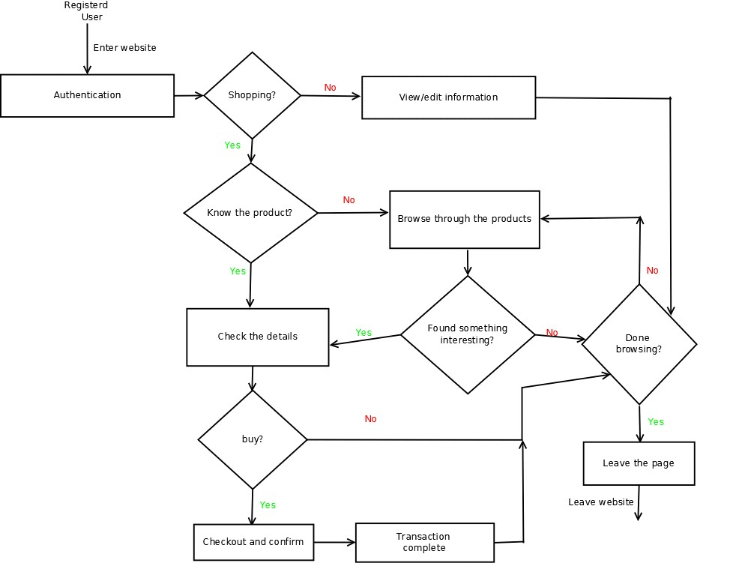

**Activity Flow associated with an unregistered user.**

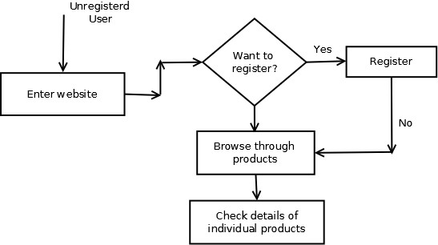

# 4. System Analysis

## 4.1 ER Diagram

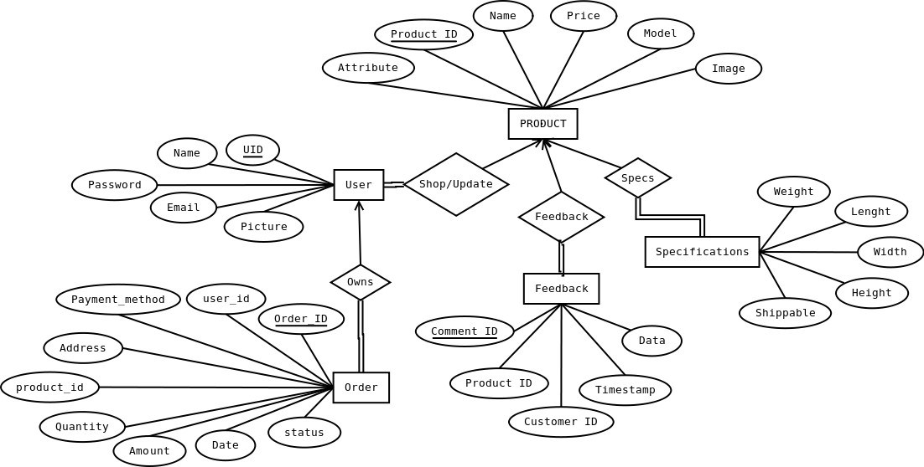

## 4.2 Data flow diagrams

These data flow diagrams represent the how information is moved from action to action for each user group. They show how information flows for each user and the paths they take as they complete various actions specific to their workflow.

**Users:**

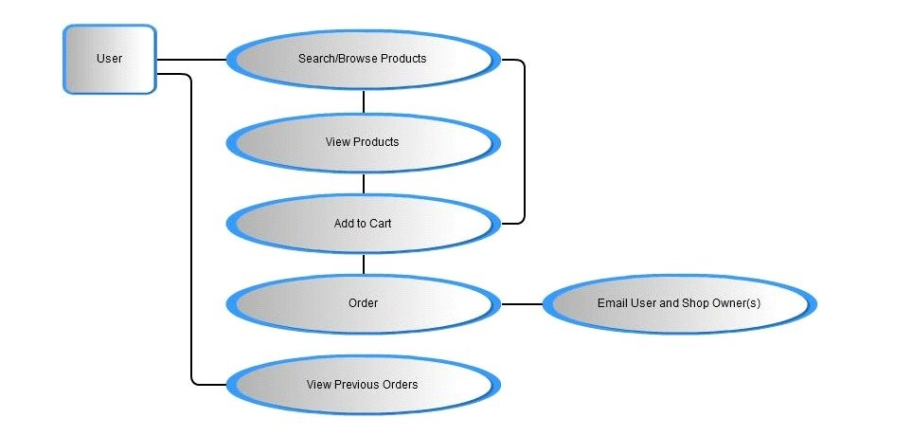

**Shop Admins:**

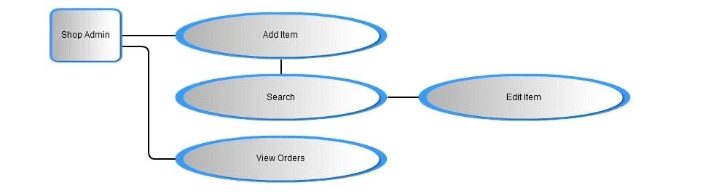

**Administrators:**

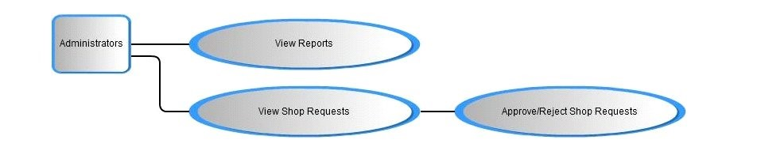

# 5. Classes

The following classes are used to design an online shopping mall. A class diagram is used to represent the relationship between the classes in a Unified Modeling Language (UML).

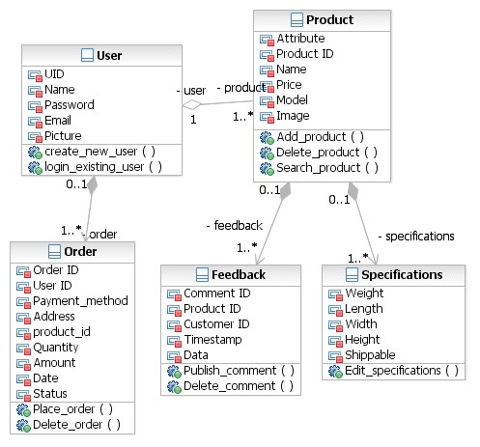

Class Diagram

* **User Class**

The user class is used to store the details of all the users. It is used to create a new user or help an existing user login.

There are two types of users: admin and a normal user. Every user can place an order or search for a product. The admin can add and delete products as well.

* **Order Class**

The order class contains the details of the placed order. This class is used to place or delete an order. The order class is notified when an order is placed or deleted by a user.

* **Product Class**

The product class contains the details of the products in the online shopping mall. This class will be notified when the user searches for a product or the admin adds or deletes a product.

* **Feedback Class**

The feedback class contains the details of the comments posted on the various products. This class is responsible for posting comments on products and deleting them by users.

* **Specifications Class**

The specifications class contains the various specifications of the products. This class is used to edit the specifications of the products.

## 5.1 Internal Data Structures

The Internal Data Structures are the member variables of each class. The following are the internal data structures used in each of the classes.

* **User Class**
* **UID:** this is the unique identifier of each user
* **Name:** the name of the user
* **Password:** the password of the user
* **Email:** the email id of the user
* **Picture:** the picture uploaded by the user
* **Order Class**
* **Order ID:** the order ID associated with that particular order
* **User ID:** the ID of the user who placed the order
* **Payment method:** the mode of payment
* **Address:** the shipping address of the user
* **Product_id:** the ID of the product that was ordered
* **Quantity:** the number of items that were ordered
* **Amount:** the cost of the order
* **Date:** the date the order was placed
* **Status:** the current status of the order, whether the order was shipped or still in the processing stage
* **Product Class**
* **Attribute:** the description of the product
* **Product ID:** the unique ID of the product
* **Name:** the name of the product
* **Price:** the price of the product
* **Model:** the model number of the product
* **Image:** a picture of the product
* **Feedback Class**
* **Comment ID:** the ID of the comment published
* **Product ID:** the ID of the product on which the comment was made
* **Customer ID:** the ID of the customer who made the comment
* **Timestamp:** the time when the comment was made
* **Data:** the string that was posted as a comment
* **Specifications**
* **Weight:** the weight of the product
* **Length:** the length of the product
* **Width:** the width of the product
* **Height:** the height of the product
* **Shippable: whether the product is shippable or not**

# 8. Testing

## 8.1 Unit testing

For not doing break the functionality of existing the system, we will test individual use cases and list down test cases for each of the use case.

### **8.1.1 Log in**

1. Identification and Password properly initiated, encrypted, and

validated

1. MySql injection test
2. Checking for uppercase, lowercase, number, special character

in ID and password

1. Either of ID and password not blank
2. Checking for overlapping ID
3. Checking for weak passwords
4. Not available to minors without permission from parents
5. Checking for e-mail notification about making ID and initiating

password

### **8.1.2 Login and start shopping**

1. Correctly validated before staring a shopping
2. Not possible to check out products which is already in

progress

1. Displaying list of all available products
2. Checking for newest version products place on first page.
3. Checking for exact number of products stocks
4. Checking for available coupon information
5. Checking for visibility about previous history of search
6. Checking for system about suggestion for newest version of

products

**8.1.3 View online help**

a. Help documentation appropriate to every occasion

### **8.1.4 Payment**

1. Certification username and card information for security
2. Consumer payment for money in proper order.
3. Certification for expiration month and year
4. Certification about CVS number
5. Checking the maximum limit of credit card
6. Checking for signature

### **8.1.5 Shipping**

1. Checking for available address information
2. Checking for private information and updated address
3. Chargeable or no chargeable for shipping
4. Checking for number about comment to deliveryman
5. Checking about time for shipment
6. Check about comment when the consumer will not be in home

**8.1.6 Logout**

1. Search history saved properly after logout
2. Checking out information saved in database
3. Customer redirected to the login screen
4. Checking e-mail system about purchasing information

## 8.2 Integration testing

We consider the online shopping mall system as a black box and white box; also check up all of the parts. Also, we will conduct as following orders; creating test plans, performing code review of the application modules that integrate the application block, executing the use cases of the application, performing load testing, performing stress testing, performing globalization testing and perform security testing.

* System compatible with different web browsers (Google chrome, Fire fox, and IE)
* System compatible with different Operating System (Widows, Linux, and Mac)
* System compatible with 32 bit or 64 bit operation
* Stress testing against a large number of customers
* Stress testing against a large number of purchasing in one products
* Stress testing against security hazard from hackers

**10. References**

* http://krex.k-state.edu/dspace/bitstream/2097/1109/1/ChaitanyaMittapelli2008.pdf
* http://www.ietymec.org/papers/N12.pdf
* http://osmlite.googlecode.com/files/OSM_SRS_v0.1.dochttp://osmlite.googlecod

e.com/files/OSM_SRS_v0.1.doc

* http://www.it.iitb.ac.in/~kamlesh/Page/Reports/oos-project-report.pdf
* http://www.scribd.com/doc/15442179/Shopping-Cart-Software-RequirementHYPERLINK "http://www.scribd.com/doc/15442179/Shopping-Cart-Software-

Requirement-Specification"Specification

* http://www.ietymec.org/papers/N12.pdf
* http://osmlite.googlecode.com/files/OSM_SRS_v0.1.dochttp://osmlite.googlecod

e.com/files/OSM_SRS_v0.1.doc

* http://www.it.iitb.ac.in/~kamlesh/Page/Reports/oos-project-report.pdf