Simple Calculator implemented using State design pattern

***State Design Diagram:***

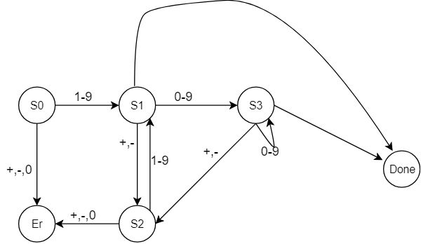

|  |  |  |
| --- | --- | --- |
| ***States*** | ***Operation at States*** | ***Error Cases*** |
| ***S0*** | ***N=0***  ***T=0***  ***previousOperator =’ ‘*** | ***Values other than 1-9 will result in error.*** |
| ***S1*** | ***N=c*** | ***Valid values are 0-9, +, -. Error thrown for any other value*** |
| ***S2*** | ***If t==0{***  ***N =0***  ***previousOperator =c***  ***}***  ***Else{***  ***T = T previousOperator N***  ***previousOperator = c***  ***}*** | ***Values other than 1-9 will result in error.*** |
| ***S3*** | ***N = N * 10 +c*** | ***Valid values are 0-9, +, -. Error thrown for any other value*** |
| ***Done*** | ***T = T previousOperator N*** |  |
| ***Error*** | ***Display error message and exit program*** |  |