Hidden layers = 10

Learning rate = 0.3

Momentum = 0.2

Epochs = 500

Validation threshold = 20

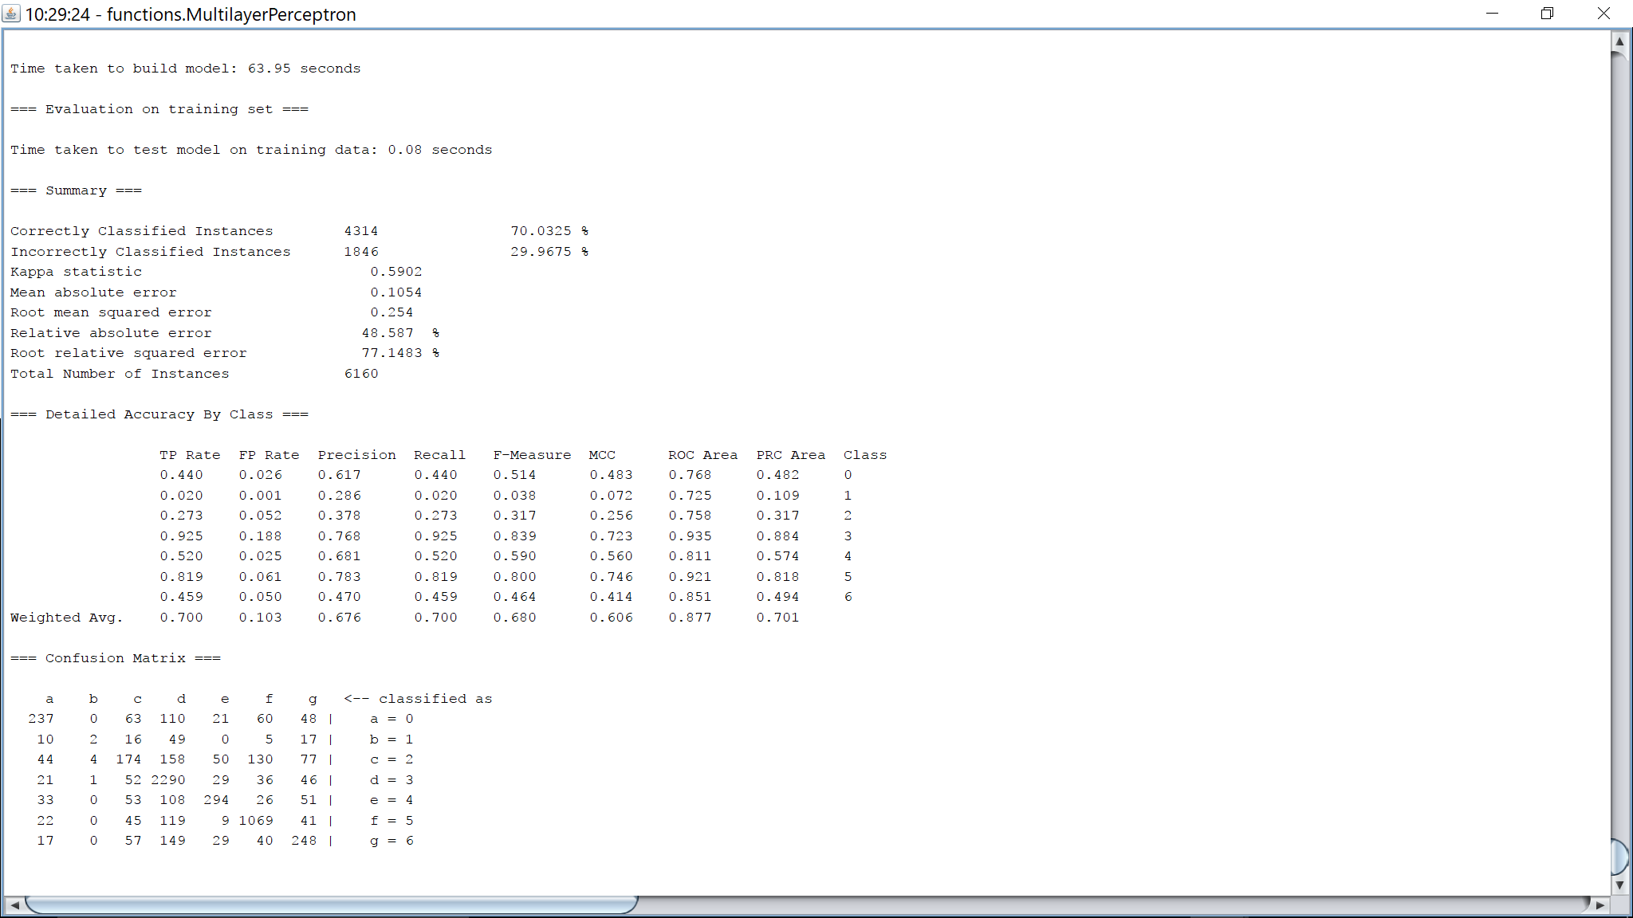

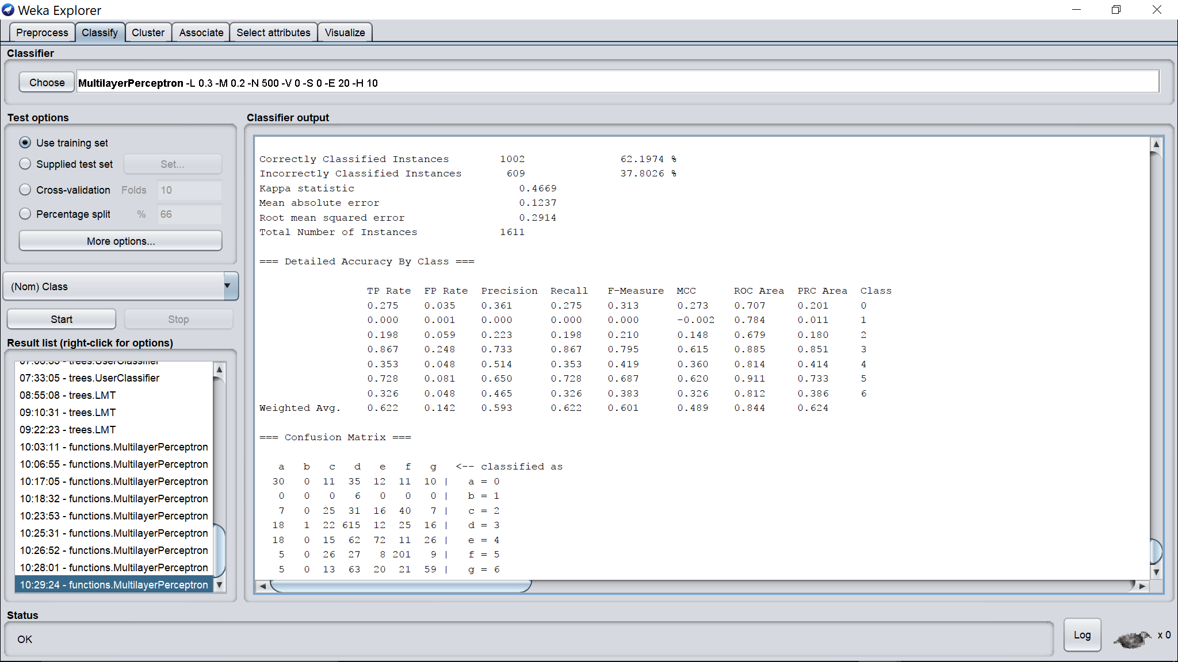

Hidden layers = 10

Learning rate = 0.3

Momentum = 0.2

Epochs = 50

Validation threshold = 20

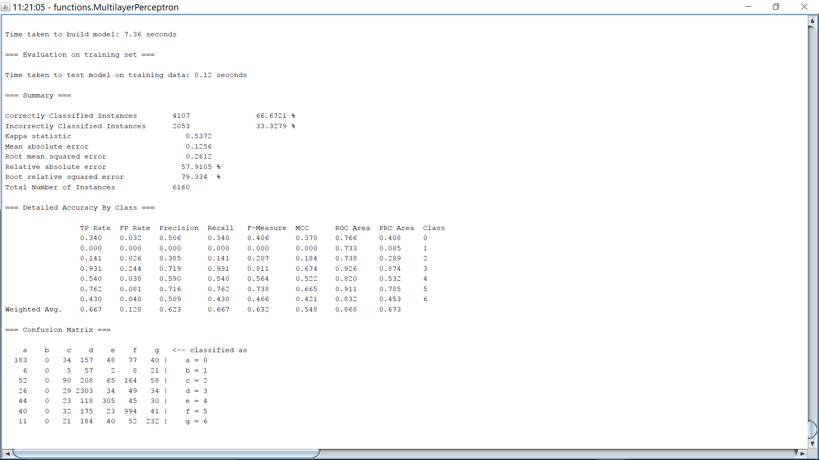

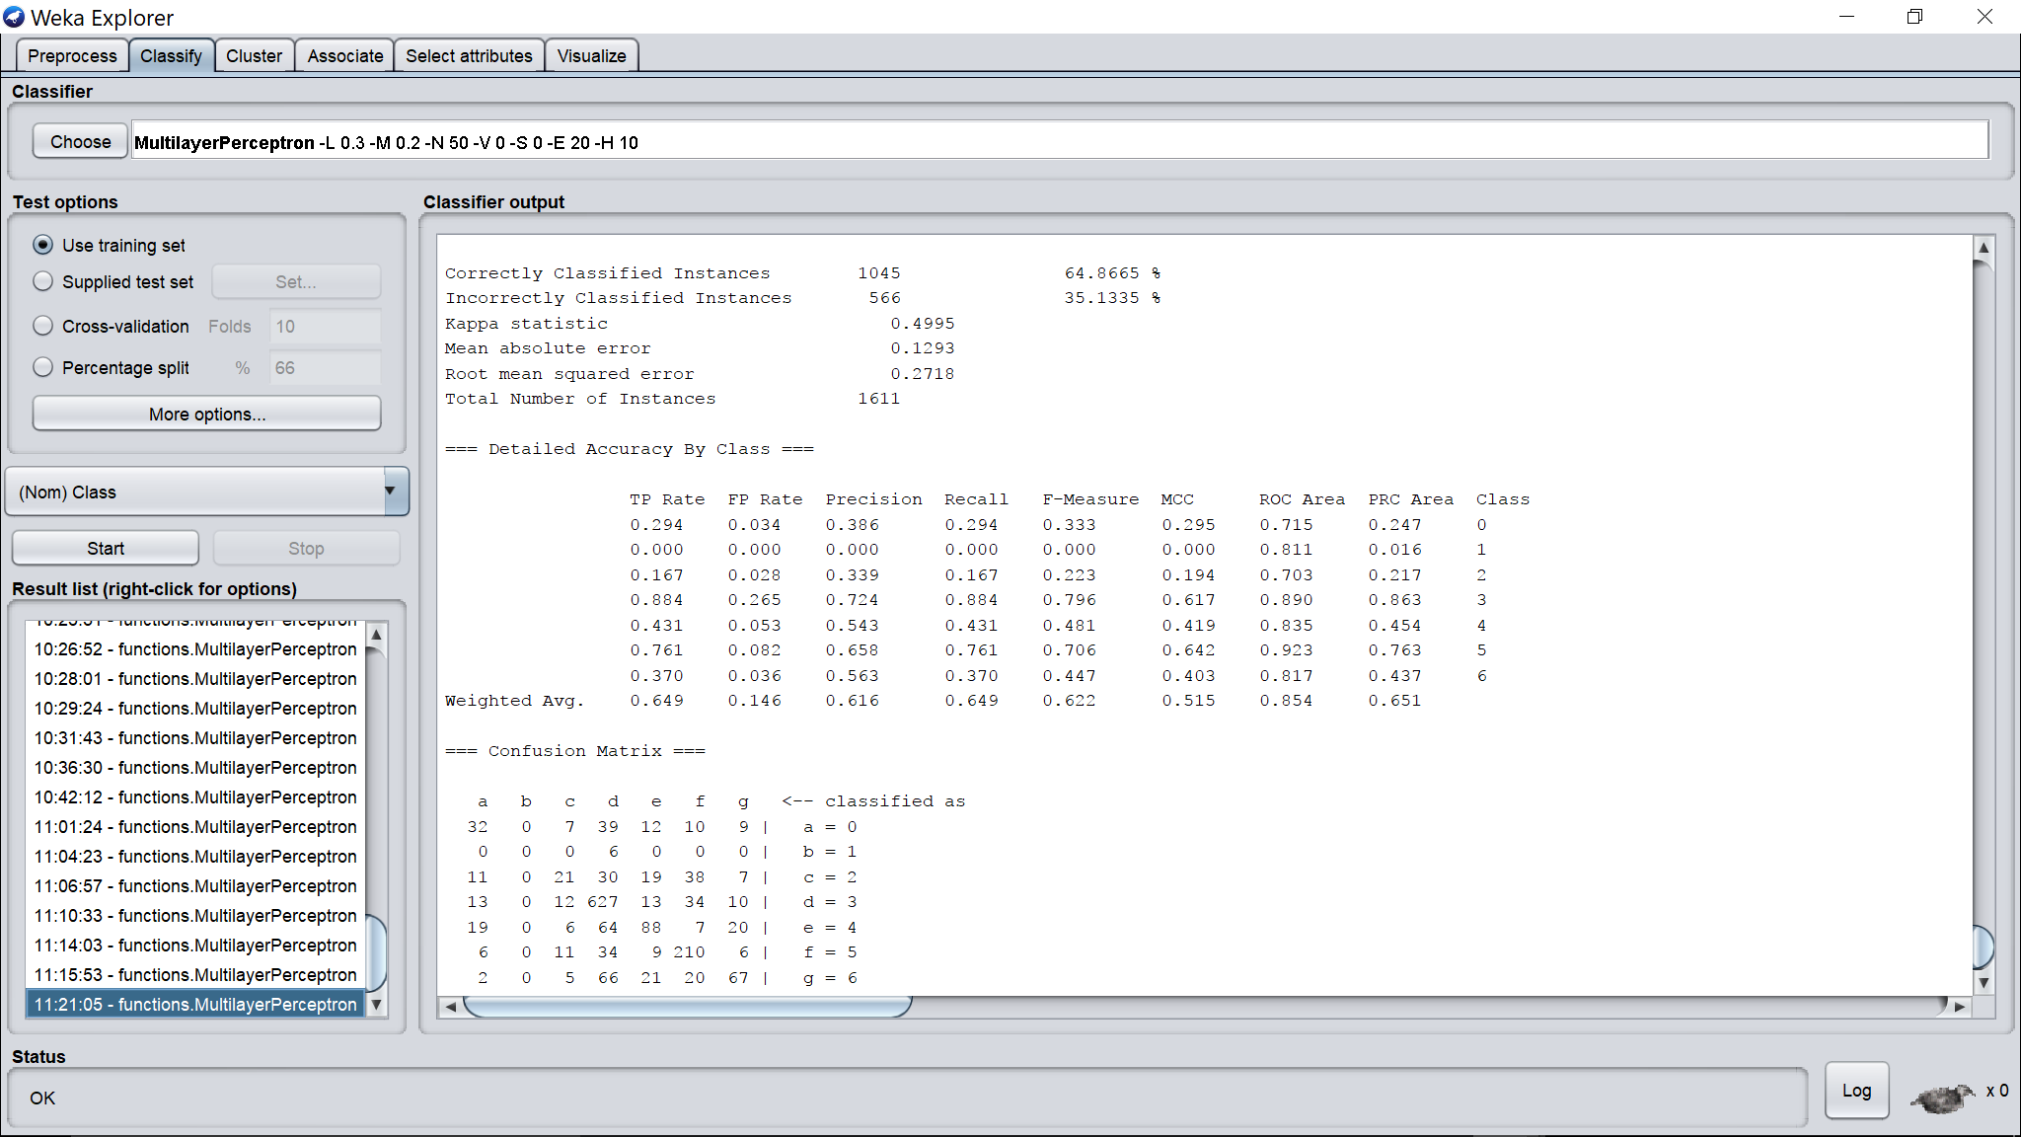

Hidden layers = 10

Learning rate = 0.3

Momentum = 0.2

Epochs = 100

Validation threshold = 20

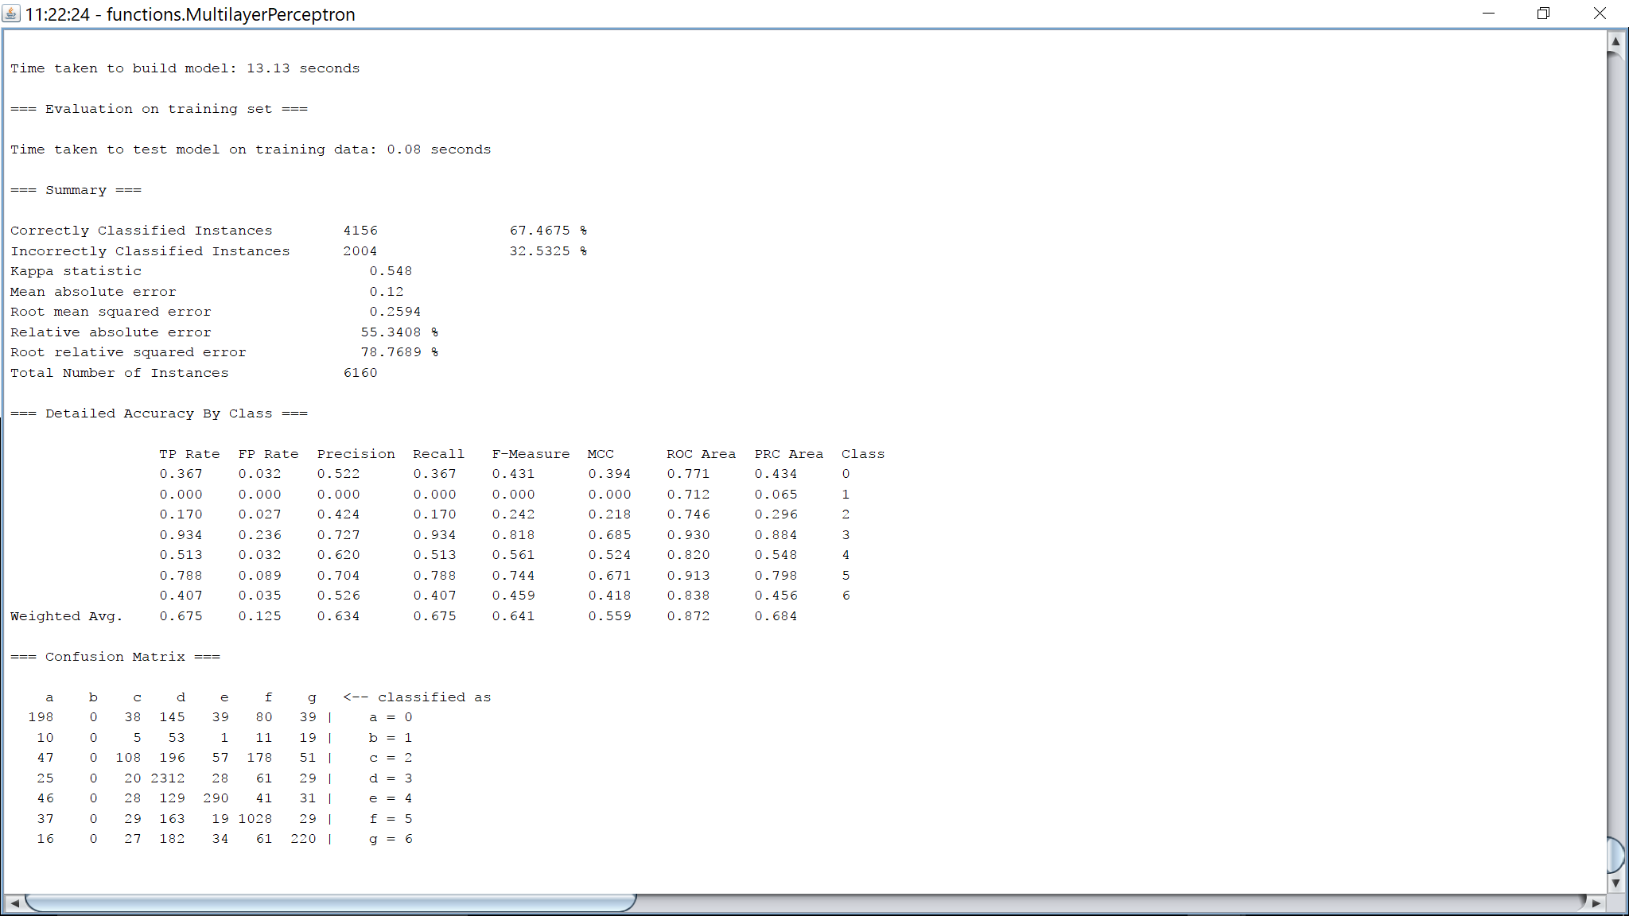

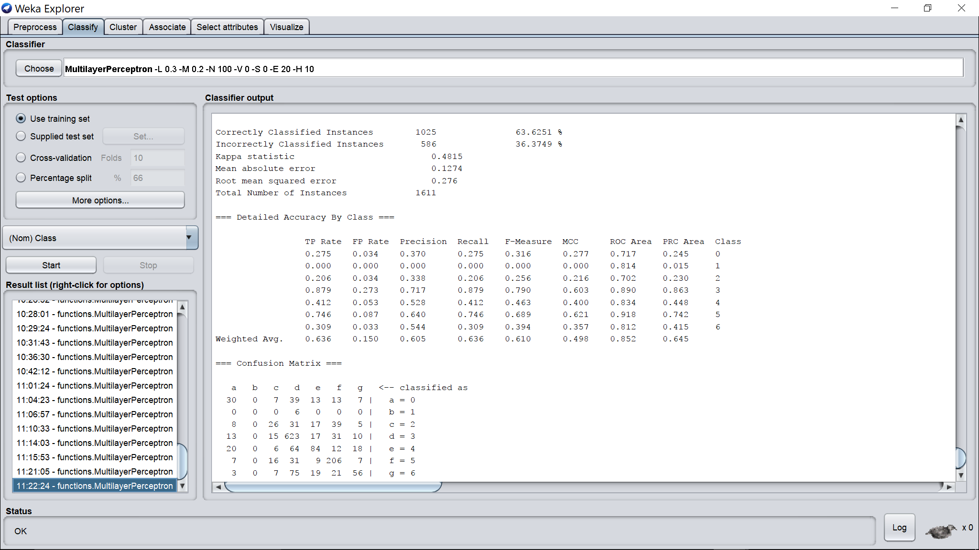

Hidden layers = 10

Learning rate = 0.3

Momentum = 0.2

Epochs = 200

Validation threshold = 20

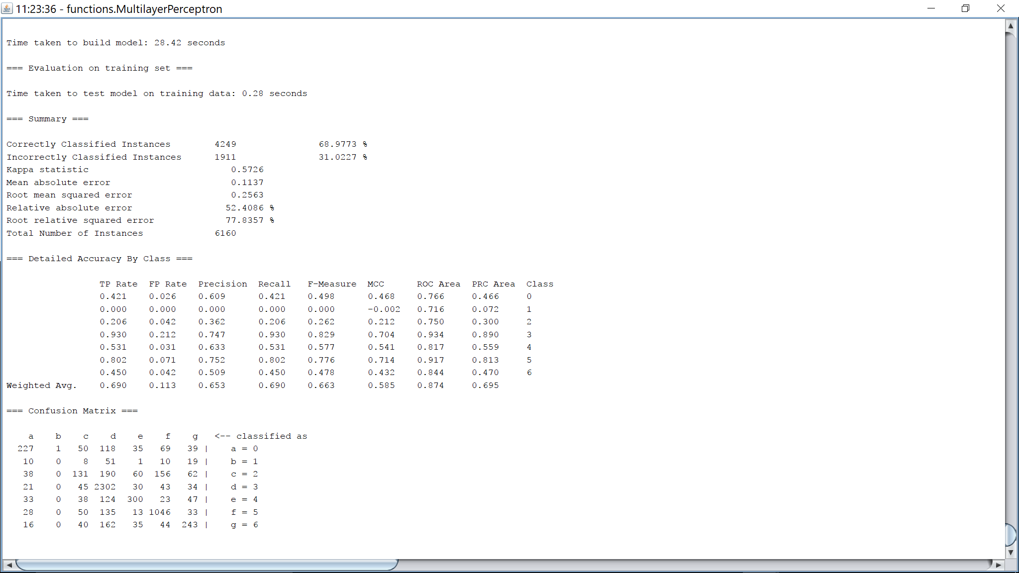

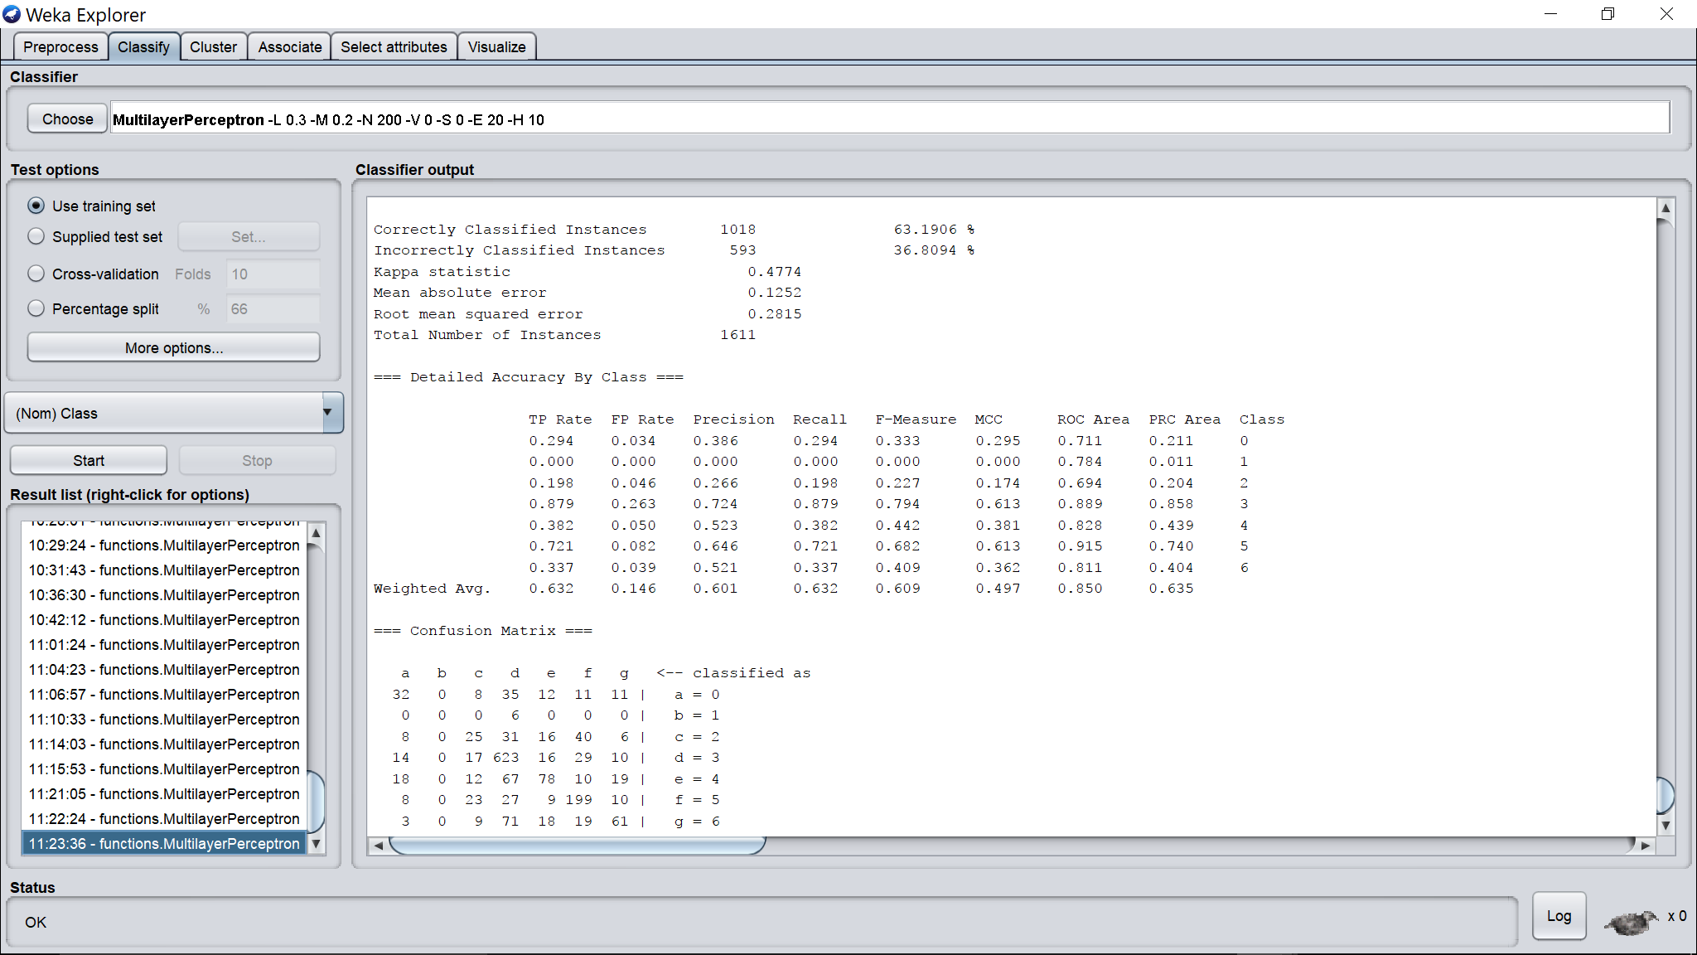

Hidden layers = 10

Learning rate = 0.3

Momentum = 0.2

Epochs = 1000

Validation threshold = 20

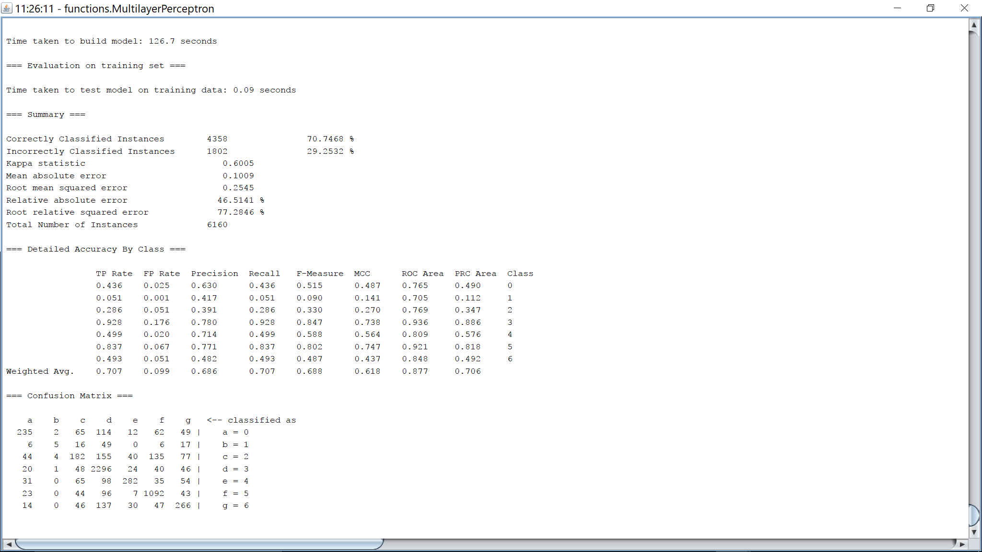

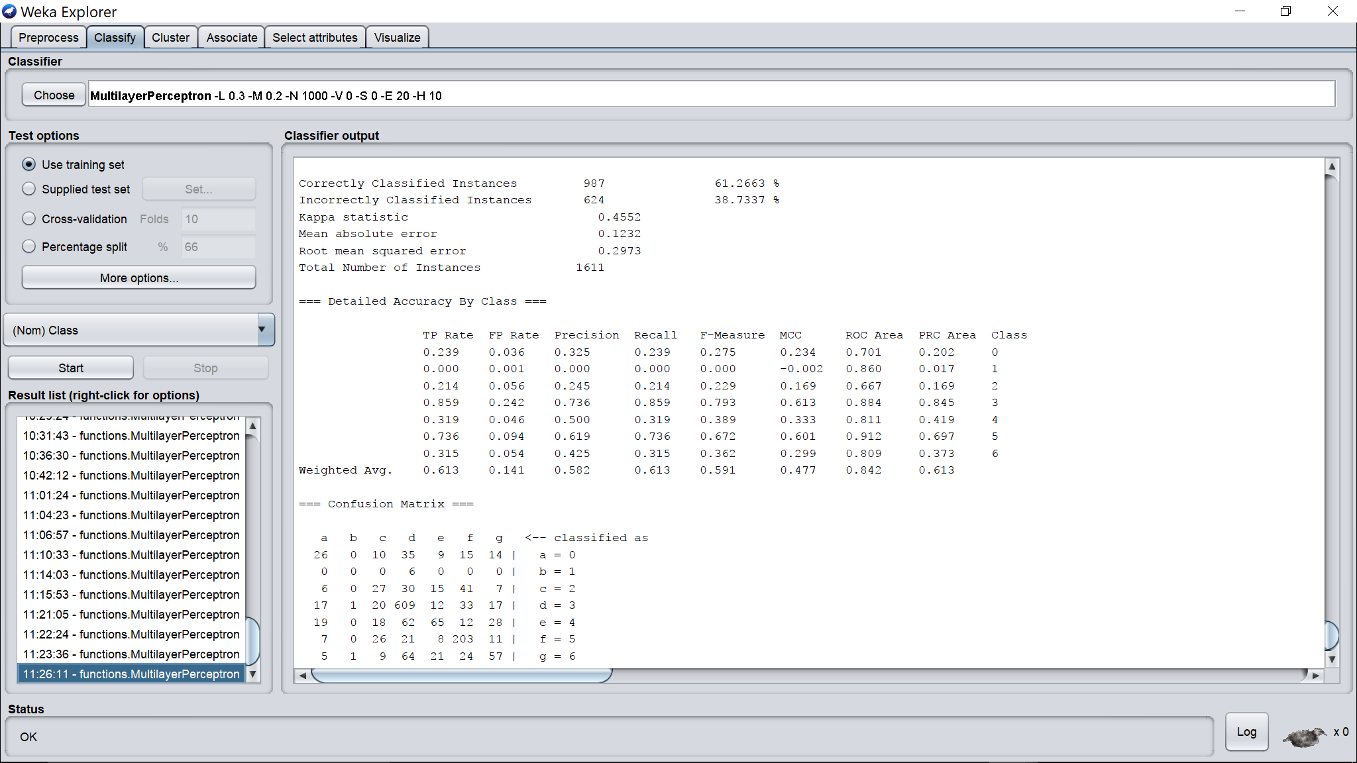

Hidden layers = 10

Learning rate = 0.3

Momentum = 0.2

Epochs = 2000

Validation threshold = 20

