COE 420 - Project Idea

Abdulwahab Sahyoun - 47562

Firas Sardast - 47500

Karim Chehab - 49659

Issa Haddad - 47102

# Requirements (What does it do)

* Provides ticket prices for a particular country based on ***personalized preferences.***
* Allows the ***user*** to customize their ***vacation plans and destinations.***
* ***Displays price variations*** over a period of time to give an ***overview of the price flow***.
* ***Suggests and recommends*** flights across multiple airlines based on the current monthly scope.

# Features (Elements - How are functions delivered?)

* Ticket prices are displayed using ***lists of multiple vendors.***
* Personal preferences are shown on a separate ***Personal Settings menu***.
* Price variations are displayed in ***graphs & charts***.
* Suggestions are presented on the ***main page*** (can be expanded on a separate page to list more suggestions or details).
* List of countries are displayed in a navigation menu.

# Specifications (Technical details – How we plan to do it)

* User schedules are saved in an online ***user account*** ***database***.
* Ticket prices are fetched from an ***airline database.***
* The user picks their vacation dates from a ***calendar*** element and sets their destinations from a ***list menu*** (The user can also search destinations).
* Suggestions are ***collated in a separate database*** table linked to each user. These suggestions are ***analyzed in the app*** and then stored in the database. They are fetched whenever needed (to support multiple devices).

# Illustrations

Recommendations

Ticket Price Overview

Ticket Price Overview

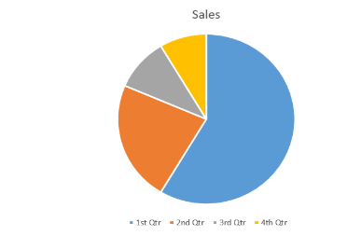

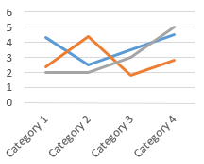



Recommendations